Terminal 91: Documents Available for Review & Comment
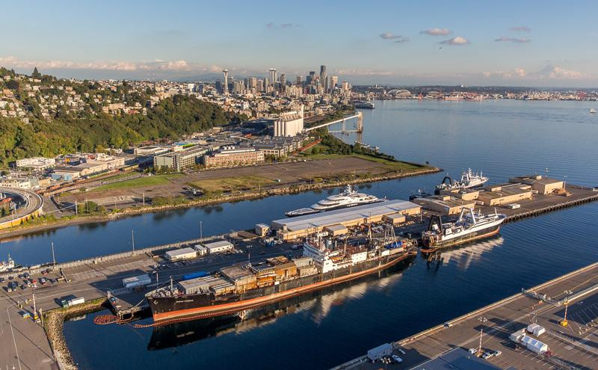
Aerial view of Terminal 91 on Elliot Bay in Seattle

Comments accepted:
April 6 – May 8, 2023

Submit comments:
Online: ecology.wa.gov/
Terminal91Comments
By mail:
Christa Colouzis, Site Manager
Department of Ecology
Northwest Region Office
P.O. Box 330316
Shoreline, WA 98133
christa.colouzis@ecy.wa.gov
Phone: 425-324-1850

Document review:
ecology.wa.gov/Terminal91

Site info:
Facility Site ID: 24768
Site Cleanup ID: 2674

Public Outreach Contact:
Janelle Anderson, Community Outreach Specialist
janelle.anderson@ecy.wa.gov
Phone: 425-301-6454

We want to hear from you!
We’re overseeing the cleanup of contamination at Terminal 91, located at 2001 W. Garfield St. in Seattle, Washington. We invite you to review and comment on the following documents:
- Amended Agreed Order: A legal document requiring the Port of Seattle to plan how they’ll clean up contamination.
- Interim Action Work Plan (IAWP): A plan outlining a partial cleanup that will be done before the final cleanup.
- Public Participation Plan: A plan encouraging community involvement in cleanup decisions.
Visit ecology.wa.gov/Terminal91 to view these documents.

Public Meetings
At this time, there are no public meetings scheduled for this comment period. To request a public meeting, please call 425-301-6454 or email janelle.anderson@ecy.wa.gov.

Translations available
- Español: Para solicitar una copia de este documento en español, por favor comuníquese con Janelle Anderson al 425-301-6454 o janelle.anderson@ecy.wa.gov.
- 中文：如需中文版文件，请致电(425) 301-6454联系Janelle Anderson, 或发送邮件邮箱 janelle.anderson@ecy.wa.gov。
- 한국어: 이 문서의 한국어 버전을 원하시면 담당자 Janelle Anderson (425) 301-6454 janelle.anderson@ecy.wa.gov 에게 연락하십시오.
- Tiếng Việt: Để yêu cầu một bản sao của tài liệu này bằng tiếng Việt, vui lòng liên lạc Liêm Nguyễn tại 360-790-4730 hoặc email liem.nguyen@ecy.wa.gov.

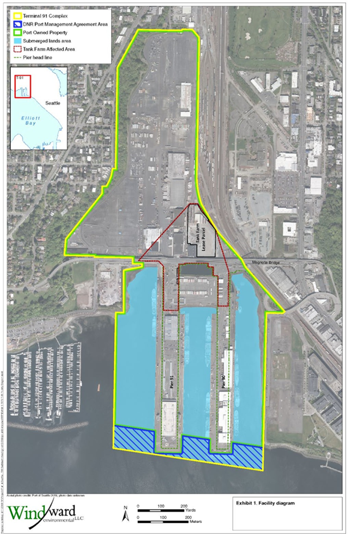
Figure 1: Aerial photo of Terminal 91.

Site Background
Terminal 91 (T91) is in an industrial area of Seattle’s Interbay neighborhood. Interbay is in the valley between Queen Anne Hill and Magnolia. The Great Northern Railroad filled parts of Interbay with dirt and debris in the early 1900s; filling continued through the 1940s. The four-acre tank farm operated between the 1920s and 2005, when the Port of Seattle removed the tanks.

T91 Owner and Operator Timeline:
1800s–1941: Various companies, individuals and the Port of Seattle owned the property.
1926–1941: Oil companies operated on part of the property.
1941: The U.S. Navy took possession, renamed it Terminal 91, and used the existing aboveground fuel tanks (tank farm) for fuel and oil.
1970s: The Port bought Terminal 91 and leased the tank farm to Burlington Environmental Inc. (BEI).
1971–1995: BEI recovered waste oil and treated wastewater under a RCRA Treatment, Storage, and Disposal (TSD) permit.
1995: BEI terminated their lease.

Contamination

Tank farm and uplands
The tank farm and uplands cleanup at this site are complete. The remedy involved excavation, building and tank demolition, repaving, and installing an underground slurry wall to keep remaining groundwater contamination from entering Elliott Bay.

Submerged lands
Historic land use and industrial practices contaminated the sediment (mud) under Elliot Bay at this site.
Our initial investigation found the following contaminants at levels of concern:
- Metals: arsenic, copper, lead, mercury, and zinc—these are toxic.
- Tributyltin—this is toxic.
- Polycyclic aromatic hydrocarbons (PAHs)—can cause cancer.
- Phthalates—harmful to reproduction.
- Semi-volatile organic compounds (SVOCs)—can cause cancer.
- Polychlorinated biphenyls (PCBs)—some of these can cause cancer.
- Discarded military munitions (DMMs)—can explode and cause harm.

Cleanup
The Port of Seattle must clean up the contamination at the site. There are six phases in the cleanup process: remedial investigation, feasibility study, cleanup plan, cleanup design, cleanup implementation, and monitoring and site use controls. Interim actions or partial cleanups can occur at any time. There will be opportunities for public comment at each stage, except for cleanup implementation.
We apply both the Resource Conservation and Recovery Act (RCRA) and the Model Toxics Control Act (MTCA) regulations to clean up hazardous waste sites. The cleanup protects human health and the environment from dangerous wastes and chemicals.
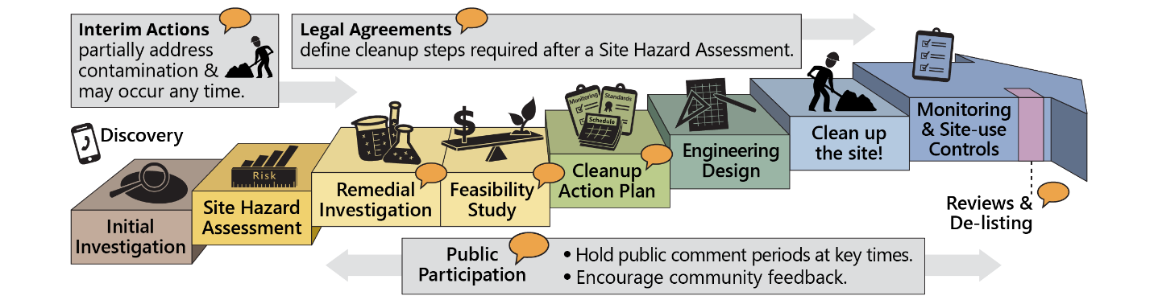
Figure 4: Formal cleanup process infographic (English)
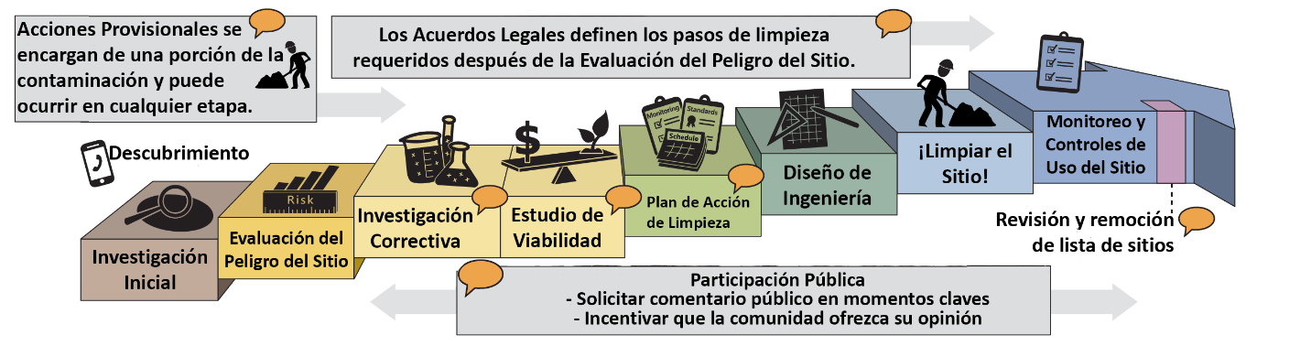
Figure 5: Formal cleanup process infographic (Spanish)
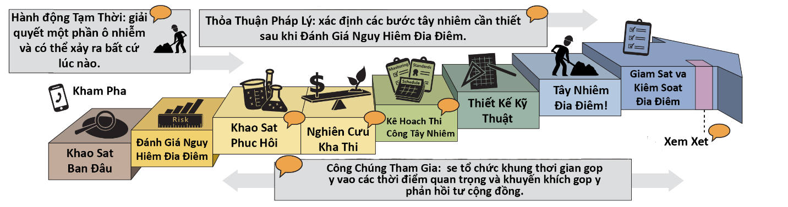
Figure 6. Formal cleanup process infographic (Vietnamese)
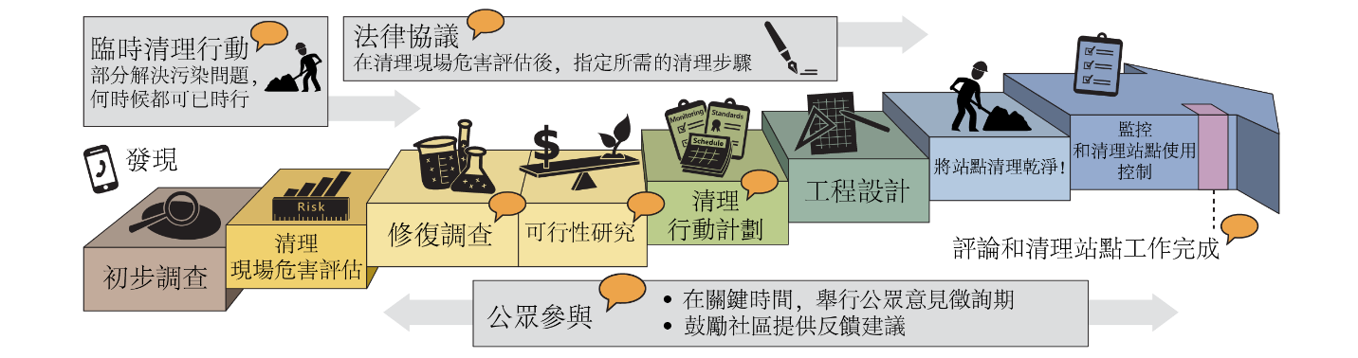
Figure 7. Formal cleanup process infographic (Chinese)

What happens next?
The public comment period is open from April 6 to May 8, 2023. After the comment period ends, we’ll review and consider all comments we receive. The documents may change based on your comments. After considering all comments, the documents will become final. When there are new documents about the site, we’ll notify you about additional public comment periods.

Document review locations
In-person document review is available. Our office is open to the public. However, we encourage you to
make an appointment.
Washington State Department of Ecology, Northwest Region Office
15700 Dayton Ave N.
Shoreline, WA 98133-9716
Reception (24-hour): 206-594-0000

To schedule an appointment, please contact:
Michael Hart
michael.hart@ecy.wa.gov
Public Disclosure Coordinator

Questions about accessing information?
Contact Janelle Anderson:
425-301-6454
janelle.anderson@ecy.wa.gov.

You can also review documents on our website: ecology.wa.gov/Terminal91.
To submit your comments, questions, or concerns about any of these documents, visit ecology.wa.gov/Terminal91Comments.

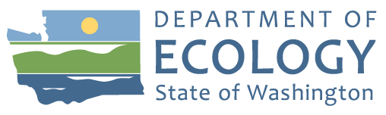
Northwest Region Office
P.O. Box 330316
Shoreline, WA 98133-9716
Tel: 206-594-0000

Terminal 91 Cleanup
Documents ready for public review and comment

Public Comment Period: April 6–May 8
We’re overseeing the cleanup of contamination at Terminal 91, located at 2001 W. Garfield St. in Seattle, Washington. We invite you to review and comment on the following documents:
- Amended Agreed Order
- Interim Action Work Plan (IAWP)
- Public Participation Plan
Visit ecology.wa.gov/Terminal91Comments to learn more or submit comments.
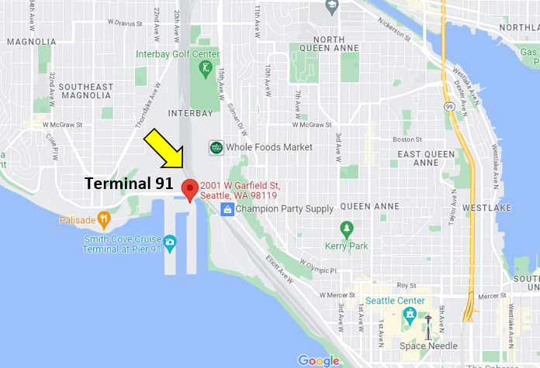
Figure 2: Google Map location of Terminal 91.

ADA Accessibility
To request an ADA accommodation, contact Ecology by phone at 360-407-6700
or email hwtrpubs@ecy.wa.gov, or visit ecology.wa.gov/accessibility.
For Relay Service or TTY call 711 or 877-833-6341.

