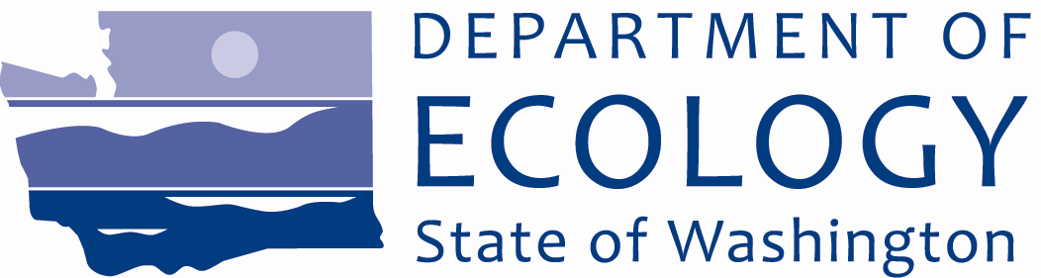
September 2014

Site Cleanup Documents Available for Public Review and Comment

Comments Invited
September 8 – October 7, 2014
Submit Comments and Technical Questions to:
Susannah Edwards - Site Manager
Department of Ecology
Toxics Cleanup Program
PO Box 47600
Olympia, WA 98504-7600
(360) 407-6798
Susannah.edwards@ecy.wa.gov

Document Review Locations
Anacortes Public Library
1220 10th Street
Anacortes, WA 98221
(360) 293-1910
http://library.cityofanacortes.org/client/default

Ecology Headquarters
300 Desmond Drive SE
Lacey, WA 98503
By appointment only:
Contact Carol Dorn
Carol.Dorn@ecy.wa.gov
(360) 407-7224

Anacortes Port Log Yard Website
https://fortress.wa.gov/ecy/gsp/Sitepage.aspx?csid=3604

Facility Site ID #: 21898438
Cleanup Site ID #: 3604

A PUGET SOUND INITIATIVE Site
Reaching the goal of a healthy, sustainable
Puget Sound

Ecology Wants Your Input!
The Department of Ecology is asking for your comments on plans to clean up a site on Puget Sound. The Anacortes Port Log Yard is one of several properties located on the waterfront in Fidalgo Bay that have been studied for clean up under the State’s Puget Sound Initiative.
The Site is generally located northwest of 718 4th Street in Anacortes, Skagit County, Washington.
You are invited to:
- Review the draft Agreed Order and the draft Public Participation Plan (PPP) for the Site.

- Send your comments to Ecology for consideration. Comments will be accepted from September 8 – October 7, 2014.
See the box on the right for details about where to review documents and submit comments.

Site Background

The Site is owned by the Port of Anacortes (Port) and was historically used for log handling from the mid-1960’s to about 2004. Operations included log rafting and the transfer of logs from water to upland sorting and handling areas on Pier 2. From 1978 to 1979 the Port leased the area to Forest Sales, Inc. for similar uses.

Following the closure of the facility in 2004, the Port led an investigation to assess potential impacts from decades of log handling activities. The investigation found surface sediments containing up to 75 percent wood debris by volume within a matrix of silt and fine sand.

In addition to wood waste, the investigation found levels of organic carbon and volatile solids above recommended levels.

Further investigations from 2008 to 2010 found that sediment samples failed to meet Ecology’s regulatory levels: the Sediment Cleanup Objective and Cleanup Screening Levels criteria for benthic invertebrate community health (i.e., living in or near marine sediments). These investigations also indicated the site may contain dioxins/furans at levels that exceed human health risk based sediment cleanup levels.

Overview of the draft Agreed Order
The proposed agreement, called an Agreed Order, is a legal document between Ecology and the Port which agrees to provide remedial action at the Site where there has been a release or threatened release of hazardous substances.

The draft Agreed Order describes the studies that the Potentially Liable Persons, the Port, agree to perform on the Site.

The draft Agreed Order provides guidance on the following studies and documents:

- Draft Remedial Investigation/Feasibility Study (RI/FS) – This document explains the work needed to look for, identify, and analyze contamination at the Site.

- Draft Final Cleanup Action Plan (DCAP) – This document uses RI/FS information to identify a preferred cleanup action at the Site and sets a schedule to remove and treat the contamination.

Overview of the draft Public Participation Plan (PPP)
Ecology is committed to providing the public with timely information and meaningful opportunities to participate in the cleanup process. The draft PPP outlines how citizens and interested parties can learn about and provide input on the cleanup.
Your comments and ideas are needed to improve the cleanup. The draft PPP explains how Ecology will:
- Notify the public when and where documents are available for review and comment.
- Notify the public about how they can get involved.
- Provide public participation opportunities.
- Consider public comments in cleanup decisions.

Why This Cleanup Matters

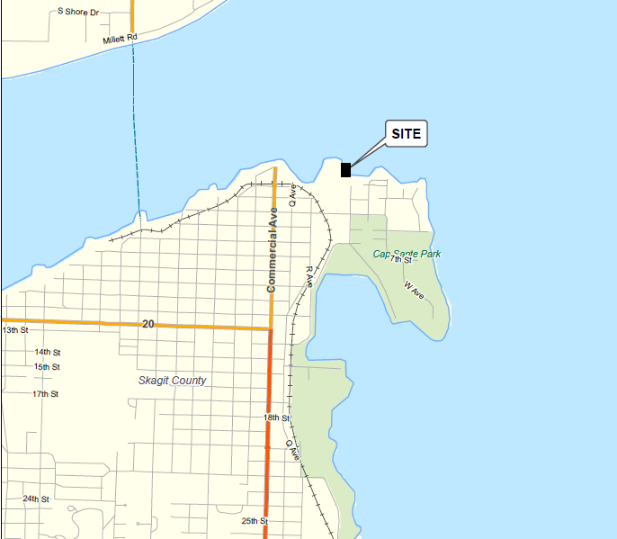
Protecting and restoring Puget Sound
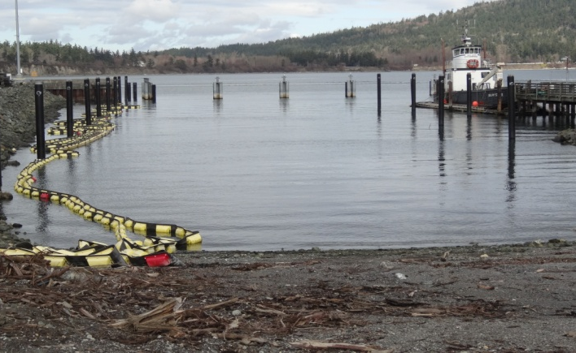
In 2007, Washington State established the Puget Sound Initiative to protect and restore Puget Sound. Several baywide areas in the Sound have been identified as high-priority cleanup areas as part of this Initiative, including Port Gamble, Dumas Bay, Padilla and Fidalgo Bays, Port Angeles, Budd Inlet, and Port Gardner Bay. This work includes cleaning up 50-60 sites within one-half mile of the Sound, including the Anacortes Port Log Yard Site. These cleanup actions will help to reduce pollution and restore habitat and shorelines in Puget Sound.
The Anacortes Log Yard Site is located at 718 4th Street, Anacortes, WA.
For more information about other cleanup sites, go to:
http://www.ecy.wa.gov/programs/tcp/sites_brochure/psi/overview/psi_baywide.html

What Happens Next?
Once the public comment period ends on October 7, 2014, Ecology will review and consider all comments received. The Agreed Order and PPP may be modified based on your comments. If future documents on the Site are developed, you will be notified of additional public comment periods.
Anacortes Port Log Yard, a former log transfer facility next to Pier 2, where logs were sorted and stored. Large accumulations of wood debris in the sediment affect the health of marine animals.

What can you do?
We appreciate your comments and concerns. Thank you.

For information about other Ecology public comment periods, meetings, and other events, please visit Ecology’s public events calendar at:
3.…....11
2.…....11
1.…....11
Read about the cleanup in this handout.
To get more detailed information, review the supporting documents at the locations listed on page one.
Write down your comments and questions. Send them to the Department of Ecology at the address shown on page one.
http://apps.ecy.wa.gov/pubcalendar/calendar. asp

Toxics Cleanup Program
PO Box 47600
Olympia, WA 98504-7600

Accommodation Requests:

To request ADA accommodation including materials in a format for the visually impaired, call Ecology at (360) 407-7170. Persons with impaired hearing may call Washington Relay Service at 711. Persons with speech disability may call TTY at 877-833-6341.

Anacortes Port Log Yard
Anacortes, Skagit County, WA

Ecology Seeks Public Comment on Site Cleanup Documents

Public Comment Period:
September 8 – October 7, 2014

Facility Site ID #: 21898438
Cleanup Site ID #: 3604

