**Site Cleanup:**

**March Point Landfill**

9663 South March Point Road, Anacortes

Skagit County, Washington

**PUBLIC PARTICIPATION PLAN**

**Prepared by:**

Washington State Department of Ecology

ECOLOGO-BW

**February 2017**

# 

# This plan is for you!

# This Public Participation Plan (PPP) is prepared for the March Point Landfill, sometime referred to as the Whitmarsh Landfill, Site cleanup as part of the requirements of the Model Toxics Control Act (MTCA). The PPP provides information about MTCA cleanup actions and requirements for public involvement, and identifies how the Washington State Department of Ecology (Ecology) will support public involvement throughout the cleanup. The PPP is intended to encourage coordinated and effective public involvement tailored to the community’s needs at the March Point Landfill Site.

For additional copies of this document, please contact:

Washington State Department of Ecology

Hun Seak Park, Site Manager

Toxics Cleanup Program

PO Box 47600

Olympia, WA 98504-7600

(360) 407-7189

Email: hunseak.park@ecy.wa.gov

#### To request ADA accommodation for disabilities, or printed materials in a format for the visually impaired, call Ecology at 360-407-7170. Persons with impaired hearing may call Washington Relay Service at 711. Persons with speech disability may call TTY at 877-833-6341.

#### Table of Contents

1.0: Introduction and Overview of the Public Participation Plan 1

2.0: Site Background 4

3.0: Community Profile 9

4.0: Public Participation Opportunities 10

Glossary 15

# 1.0: Introduction and Overview of the Public Participation Plan

This Public Participation Plan (PPP) explains how you can become involved in improving the health of your community. It describes public participation opportunities that will be available during this review period for a site on the Fidalgo/Padilla Bay waterfront – the March Point Landfill (Site). The Site is located at 9663 South March Point Road in Anacortes, Washington. These opportunities are part of a collaborative effort by the Washington State Department of Ecology (Ecology) and Whitmarsh Landfill Potentially Liable Person (PLP) Group, which consists of Skagit County, the Washington State Department of Natural Resources, Shell Oil Company and Texaco, Inc. to decide on cleanup actions for the Site. Current documents for review include:

* Draft Remedial Investigation/ Feasibility Study (RI/FS), which identifies the types, locations and amounts of contaminants at the Site and identifies and evaluates cleanup options for those contaminants

Cleanup actions, and the public participation process that helps guide them, are established in Washington’s Model Toxics Control Act (MTCA).[1] Under MTCA, Ecology is responsible for providing timely information and meaningful chances for the public to learn about and comment on important cleanup decisions before they are made. The goals of the public participation process are:

* To promote understanding of the cleanup process so that the public has the necessary information to participate.
* To encourage involvement through a variety of public participation opportunities.

This PPP provides a framework for open dialogue about the cleanup among community members, Ecology, and other interested parties. It outlines basic MTCA requirements for community involvement activities that will help ensure that this exchange of information takes place during the investigation and cleanup. These requirements include:

* Notifying the public about available reports and studies about the Site.
* Notifying the public about review and comment opportunities during specific phases of the cleanup investigation.
* Providing appropriate public participation opportunities to learn about cleanup documents, and if community interest exists, holding meetings to solicit input and identify community concerns.
* Considering public comments received during public comment periods.

In addition to these basic requirements, the PPP may include additional site-specific activities to meet the needs of your community. Based upon the type of proposed cleanup action, the level of public concern, and the risks posed by the Site, Ecology may decide that more public involvement opportunities are appropriate.

These opportunities form the basis for the public participation process. The intent of this PPP is to:

* Provide complete and current information to all interested parties.
* Let you know when there are opportunities to provide input.
* Provide opportunities to listen to and address community concerns.

## 

## Part of the Puget Sound Initiative

The Siteis one of several Fidalgo/Padilla Bay waterfront sites and is part of a larger cleanup effort called the Puget Sound Initiative (PSI). Washington State established the PSI to protect and restore Puget Sound. The PSI includes cleaning up 50-60 contaminated sites within one-half mile of the Sound. These sites are grouped in several bays around the Sound for “baywide” cleanup efforts. As other sites in the Fidalgo/Padilla baywide area move forward into investigation and cleanup, information about them will be provided to the community as well as people and groups who are interested.

## Roles and Responsibilities

Ecology will lead public involvement activities. Ecology maintains overall responsibility and approval authority for the activities outlined in this PPP. Ecology and Whitmarsh Landfill PLP Group are responsible for cleanup at the Site. Ecology will oversee all future cleanup activities and ensure that contamination on the Site is cleaned up to concentrations that are established in state regulations and that protect human health and the environment.

## Organization of this Public Participation Plan

The sections that follow in this PPP provide:

* Section 2: Background information about the March Point Landfill Site.
* Section 3: An overview of the local community that this PPP is intended to engage.
* Section 4: Public involvement opportunities in this cleanup.

This PPP addresses current conditions at the Site, but it is intended to be a dynamic working document that will be reviewed at each phase of the cleanup and updated as needed. Ecology and the Whitmarsh Landfill PLP Group urge the public to become involved in the cleanup process.

# 2.0: Site Background

## Site Description and Location

The Site is located at March Point Landfill in Anacortes, Skagit County, Washington, on Fidalgo/ Padilla bays (see Figure 1).

The Site, approximately 14 acres of upland, is located on the east side of March Point north of South March Point Road at the base of a bluff in the tidelands area of Padilla Bay.

**N**

**Padilla Bay**

**Padilla Bay Lagoon**

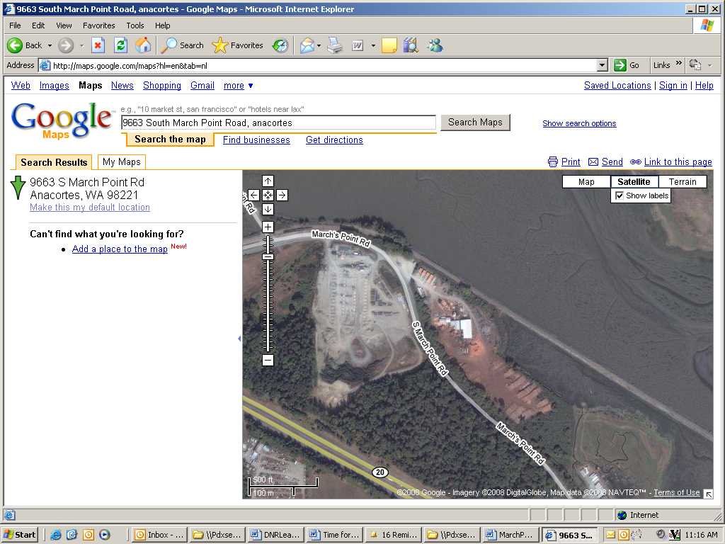

**Figure 1**: The March Point Landfill Site is shown in the above map, located at 9663 South March Point Road in Anacortes, Skagit County, WA.

## General Site History and Contaminants

March Point Landfill operated from 1950 until 1973, first as an unmonitored public dump and later as a county disposal area. Decades of household, commercial and industrial wastes were discarded at the Site. From the late 1980s to approximately August 2011, a sawmill operated at the Site. Wood waste up to 10 feet thick accumulated over large portions of the landfill.

Sediment and water samples have been collected from the Site since 1985. Marine sediment samples were contaminated with heavy metals, phthalates, phenols, polycyclic aromatic hydrocarbons (PAHs), dioxins and furans. Surface and seep (i.e., where water slowly oozes out from the ground) samples from the landfill contained metals including arsenic, lead, copper and mercury as well as petroleum compounds and polychlorinated biphenyls (PCBs). The majority of wood waste was removed in 2014 and 2015.

## The Cleanup Process

Washington State’s cleanup process and key opportunities for you to provide input are outlined in Figure 2 on page 14. The general cleanup process includes the following steps:

* Remedial Investigation (RI) – investigates the site for types, locations, and amounts of contaminants.
* Feasibility Study (FS) – identifies cleanup options for those contaminants.
* Cleanup Action Plan (CAP) – selects the preferred cleanup option and explains how cleanup will be conducted.

Each of these steps is generally documented in reports and plans that will be available for public review. Public comment periods of at least 30 calendar days are usually conducted for the following documents:

* Draft RI report
* Draft FS report
* Draft CAP

These comment periods may be conducted separately or combined.

Steps in the cleanup process and related documents are described in greater detail in the following subsections.

## Interim Actions

Interim actions may be completed during the cleanup if required by Ecology. An interim action partially addresses the cleanup of a site, and may be conducted if:

* It is technically necessary to reduce a significant threat to human health or the environment.
* It corrects a problem that may become substantially worse or cost substantially more to fix if delayed.
* It is needed to complete another cleanup activity, such as design of a cleanup plan.

## Overview of Remedial Investigation / Feasibility Study (RI/FS)

This draft RI/FS presents research findings and sampling results from studies completed between 2008 and 2009 and between 2010 and 2013. It also identifies and evaluates alternative cleanup approaches that could address residual contamination.

The RI/FS is intended to:

* Define the nature and extent of solid waste and landfill gas at the Site
* Define the nature and extent of soil, groundwater, surface water and seepage water migrating into Padilla Bay inner lagoon, and sediment contamination at the Site
* Define the potential for ongoing leachate/gas production and need for controls
* Define the need for shoreline protection along Padilla Bay, as solid waste from the Site is close to the bay
* Evaluate cleanup standards that apply to potential remedial alternatives developed during the FS
* Identify and evaluate technologies for cleanup, and any alternatives to these technologies
* Evaluate remedial technology alternatives and select a preferred alternative to clean up the Site
* Provide a schedule for implementation of the preferred remedial alternative

### Contaminants Found Through the RI

Contaminants found through the RI include solid waste, wood waste and landfill gas. Solid waste is approximately eight to sixteen feet thick and totals about 340,000 cubic yards. When the landfill closed in 1973, two to three feet of soil were placed over the solid waste. Most of the Site, except for the southwestern-most part, was then covered by wood waste up to 10 feet thick. In 2010, the highest methane concentrations were found near wood waste. Carbon dioxide, oxygen and nitrogen were also detected in samples from 2011-2012. The Washington Department of Natural Resources removed most wood waste in 2014 and 2015.

In soil, sediments, groundwater and surface water, the RI found metals (aluminum, antimony, arsenic, barium, cadmium, copper, iron, lead, manganese, mercury, nickel, silver, zinc), total petroleum hydrocarbons (TPHs), benzene, semi-volatile organic compounds (SVOCs), polychlorinated biphenyls (PCBs) and pesticides that exceeded preliminary cleanup levels (PCLs).

Shallow groundwater within the solid waste appears to be discharging into Padilla Bay’s inner lagoon along the shoreline. A silt layer currently limits the groundwater infiltration from the landfill to the underlying lower aquifer.

### Evaluation of Remedial Alternatives in the FS

The FS identified and evaluated seven remedial cleanup alternatives. All alternatives must protect human health and the environment, comply with cleanup standards, comply with applicable state and federal laws, and provide for compliance monitoring. Each alternative is also evaluated across seven criteria, including protectiveness of the environment, permanence of solution, long-term effectiveness, short-term risk, ease of technical and administrative implementation, public concerns and cost.

The seven alternatives are:

1. No Action
2. Restore existing soil cover by adding a 6-inch layer of topsoil over the Site
3. Place a liner made of plastic and clay over Site contaminants to prevent most water and other materials from passing through the liner
4. Install a high-density polyethylene (HDPE) cap
5. Install a HDPE cap anchored into bay mud
6. Install a polyvinyl chloride (PVC) cap as a barrier over Site contaminants
7. Excavate and dispose of solid waste offsite

Alternative 1 ranks lowest across all evaluation criteria except cost ($231,000) and short-term risk. Alternative 2 ranks the next lowest across all evaluation criteria except cost ($6.4 million) and short-term risk because it does not use a material to help limit erosion, does not eliminate pathways for potentially contaminated water to reach the bay and does not meet the Remedial Action Objectives (RAOs).

Alternative 7 would be most protective of the environment, most permanent and most effective since all solid waste would be removed from the Site and disposed of in a lined, engineered landfill. However, Alternative 7 would be most difficult to implement (technically and administratively), presents the highest short-term risk because it has the highest possibility of releasing contaminants to the bay during excavation and is the most expensive ($82.8 million).

Alternatives 3-5 would offer similar permanence and long-term effectiveness, while Alternatives 3, 4 and 6 would offer similar protectiveness of the environment, short-term risk and addressing of public concerns. Alternative 5 is also similar to Alternative 3 in short-term risk and addressing public concerns, but would potentially offer a higher degree of environmental protection than some other alternatives because it would use the HDPE membrane as a side barrier as well. Alternative 6 would be slightly less permanent than some other alternatives because plasticizers could be lost from the PVC geomembrane. It would also be less effective in the long-term than all alternatives except Alternative 1 because of the higher risk the PVC geomembrane could lose plasticizers, crack and leak. Of Alternatives 3-6, Alternative 3 is the least expensive ($12 million) compared to Alternatives 4-6 ($15.2-$15.3 million). For all of these alternatives, construction within the intertidal zone may present some challenges, but these challenges are standard in shoreline rehabilitation and/or restoration projects.

### Selection of a Preferred Alternative

The preferred remedial alternative is Alternative 3 which would minimize or eliminate infiltration of groundwater into the landfill while also minimizing discharge of groundwater from the landfill to the surface waters. Alternative 3 is more or as effective as most other alternatives at protecting human health and the environment by minimizing or eliminating the seeps of groundwater emanating from within the landfill and reducing the possibility of erosion of the solid waste. Construction of this preferred alternative would be practical and implementable both technically and administratively.

# 3.0: Community Profile

## Community Profile

Anacortes is Skagit County’s second largest city and its largest seaport. It is the principal city on Fidalgo Island. The current population is approximately 16,232 people (about 7,680 households)[2] situated within approximately 12 square miles. Located on Fidalgo/Padilla Bays, Anacortes has 12.5 miles of saltwater shoreline which support three Port of Anacortes marine terminals, a shipyard, several yacht and mid-size boat building and sales operations, and four private marinas. In addition to the City’s modern educational and health care facilities, four freshwater lakes and 3,300 acres of city-owned forestland and parks create a rural character in the community. The City's 2014 labor workforce was approximately 7,405, predominantly employed in manufacturing, accommodations/food service, retail and health care.[3]

## Key Community Concerns

An important part of this PPP is to identify key community concerns for the cleanup Site. Many factors are likely to raise community questions, such as the amount of contamination, how much contamination has been cleaned up and what remains, and future use of the Site. Community concerns often change over time as new information is learned and questions are answered. Identifying site-specific community concerns at each stage of the cleanup process helps ensure that they are adequately addressed. On-going key community concerns will be identified for the March Point Landfill Site through public comments and other opportunities, as detailed in Section 4.

# 

# 4.0: Public Participation Opportunities

Ecology and Whitmarsh Landfill PLP Group invite you to share your comments and participate in the cleanup in your community. As we work to meet our goals, we will evaluate whether this public participation process is successful. This section describes the public participation opportunities for the Site.

## Measuring Success

We want this public participation process to succeed. Success can be measured, at least in part, in the following ways:

* Number of written comments submitted that reflect understanding of the cleanup process and the Site.
* Direct, in-person feedback about the site cleanup or public participation processes, if public meetings are held.
* Periodic updates to this PPP to reflect community concerns and responses.

If we are successful, this process will increase:

* Community awareness about plans for cleanup and opportunities for public involvement.
* Public participation throughout the cleanup.
* Community understanding regarding how their input will be considered in the decision-making process.

### *Activities and Information Sources*

### Ecology Contacts

Ecology is the lead contact for questions about the cleanup in your community. The Ecology staff person identified in this section is familiar with the cleanup process and activities at the Site. For more information about public involvement or the technical aspects of the cleanup, please visit our website at https://fortress.wa.gov/ecy/gsp/Sitepage.aspx?csid=304, or contact:

Hun Seak Park, Site Manager

Department of Ecology

Toxics Cleanup Program

PO Box 47600

Olympia, WA 98504-7600

Phone: (360) 407-7189

Email: hunseak.park@ecy.wa.gov

### Ecology’s Webpage

Ecology has created a webpage to provide convenient access to information. Documents such as the draft RI/FS and draft PPP are posted as they are issued during the investigation and cleanup process. Visitors to the webpage can find out about public comment periods and possible meetings; download, print, and read information; and submit comments via email. The webpage also provides links to detailed information about the MTCA cleanup process. The March Point Landfill webpage is available at the following address:

<https://fortress.wa.gov/ecy/gsp/Sitepage.aspx?csid=304>

**Information Centers/Document Repositories**

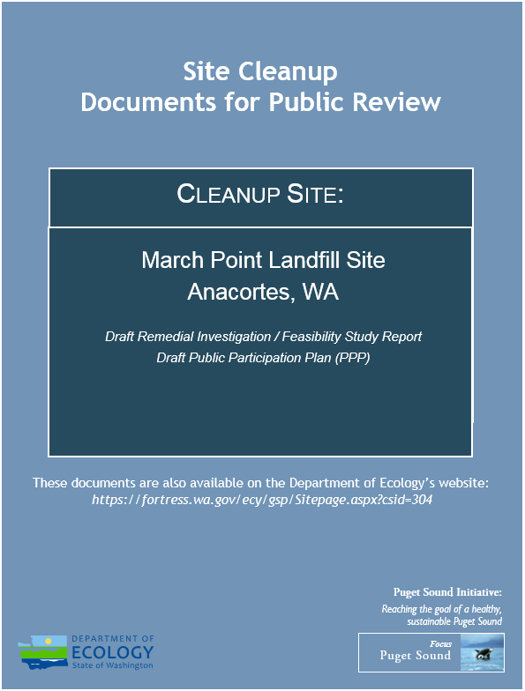The most comprehensive source of information about the Site is the information center, or document repository. Two repositories provide access to the complete list of site-related documents. All Siteinvestigation and cleanup activity reports will be kept in print at those two locations and will be available for your review. They can also be requested on compact disk (CD). Document repositories are updated before public comment periods to include the relevant documents for review. Documents remain at the repositories throughout the investigation and cleanup. For the Site, the document repositories are:

* **Anacortes Public Library**

1220 10th Street

Anacortes, WA 98221

Phone: (360) 293-1910

Website: http://library.cityofanacortes.org/

client/default

* **Padilla Bay National Estuarine Research**

**Reserve**

10441 Bayview-Edison Road

Mount Vernon, WA 98273

Phone: (360) 428-1558

Website: http://www.padillabay.gov

* **Department of Ecology Headquarters**

300 Desmond Drive  
Lacey, WA 98503

By appointment. Please contact Carol Dorn at (360) 407-7224 or Carol.Dorn@ecy.gov.

Look for document covers much like the illustration above.

### Public Comment Periods

Public comment periods provide opportunities for you to review and comment on major documents, such as the Draft Consent Decree, Draft RI, Draft FS, Draft CAP and Draft Public Participation Plan. The typical public comment period is 30 calendar days.

### *Notice of Public Comment Periods*

Notices for each public comment period will be provided by local newspaper and by mail. These notices indicate the timeframe and subject of the comment period, and explain how you can submit your comments.

For the March Point Landfill Site, a newspaper notice will be posted in the Anacortes American, Skagit Valley Herald and Clamdigger.

Notices are also sent by regular mail to the local community and interested parties. The local community typically includes all residential and business addresses within one-quarter mile of the Site, as well as potentially interested parties such as public health entities, environmental groups, and business associations.

*Fact Sheets*

One common format for public comment notification is a fact sheet. Like the newspaper notice, fact sheets explain the timeframe and purpose of the comment period, but also provide background and a summary of the document(s) under review. Future fact sheets will be prepared at key milestones in the cleanup process.

### MTCA Site Register

Ecology produces an electronic newsletter called the MTCA Site Register. This semi-monthly publication provides updates of the cleanup activities occurring throughout the state, including public meeting dates, public comment periods, and cleanup-related reports. Individuals who would like to receive the MTCA Site Register can sign up three ways:

* Call (360) 407-6848
* Send an email request to [spre461@ecy.wa.gov](mailto:spre461@ecy.wa.gov)
* Register online at <http://www.ecy.wa.gov/programs/tcp/pub_inv/pub_inv2.html>

### Mailing Lists

Ecology maintains both email and regular mail distribution lists throughout the cleanup process. The lists are created from carrier route delineations for addresses within one-quarter mile of the Site; potentially interested parties; public meeting sign-in sheets; and requests made in person or by regular mail or email. You may request to be on a mailing list by contacting the Ecology staff person listed earlier in this section.

### Optional Public Meetings

A public meeting will be held during a comment period if requested by ten or more people, or if Ecology decides it would be useful. Public meetings provide additional opportunity to learn about the investigation or cleanup, and to enhance informed comment. If you are interested in a public meeting about the Site, please contact the Ecology staff listed earlier in this section.

### Submitting Comments

### You may submit comments by regular mail or email during public comment periods to the Ecology Project Manager listed earlier in this section.

### Response to Comments

Ecology will review all comments submitted during public comment periods, and will modify documents as necessary. You will receive notice by regular mail or email that Ecology has received your comments, along with a general explanation about how the comments were addressed and where the revised document can be found.

### Other

Ecology is committed to the public participation process and will consider additional means for delivering information and receiving comments, including combining public comment periods for other actions (such as those associated with the State Environmental Policy Act).

## Public Participation Grants

You are eligible to apply for a Public Participation Grant from Ecology approximately every two years to provide funding for additional public participation activities. Those additional activities will not reduce the scope of the activities defined by this PPP. Activities conducted under this PPP would coordinate with the additional activities defined under the grant.

Visit [www.ecy.wa.gov/programs/swfa/grants/ppg.html](http://www.ecy.wa.gov/programs/swfa/grants/ppg.html) for more information about Ecology’s Public Participation Grants.

## Figure 2: Washington State Cleanup Process

**Interim Actions**

*(Can occur at any time up to Cleanup Action Plan)*

**Remedial Investigation and**

**Feasibility Study Report**

# Field Work Report

**Remedial Investigation Work Plan**

# 

* Public notice posted on website and newspaper and mailed to residents
* Opportunity to comment (at least 30 days)
* Comments response letter

Definitions:

Interim Action: An action that only partially addresses the cleanup of the site.

Remedial Investigation: Provides information on the extent and magnitude of contamination at a site.

**Feasibility Study:** Provides identification and analysis of site cleanup alternatives.

**Cleanup Action Plan:** A document that selects the cleanup action and specifies cleanup standards and other requirements for a particular site.

# Cleanup Implementation

Compliance Monitoring Plan

Operation and Maintenance Plan

Institutional Control Plan

# Cleanup Action Report

# Cleanup Action Plan

# KEY PUBLIC COMMENT PERIOD

# KEY PUBLIC COMMENT PERIOD

* Public notice posted on website and newspaper and mailed to residents
* Opportunity to comment (at least 30 days)
* Comments response letter

# Glossary

**Cleanup:** The implementation of a cleanup action or interim action.

**Cleanup Action:** Any remedial action except interim actions, taken at a site to eliminate, render less toxic, stabilize, contain, immobilize, isolate, treat, destroy, or remove a hazardous substance that complies with MTCA cleanup requirements, including but not limited to: complying with cleanup standards, utilizing permanent solutions to the maximum extent practicable, and including adequate monitoring to ensure the effectiveness of the cleanup action.

**Cleanup Action Plan:** A document that selects the cleanup action and specifies cleanup standards and other requirements for a particular site. The cleanup action plan, which follows the remedial investigation/feasibility study report, is subject to a public comment period. After completion of a comment period on the cleanup action plan, Ecology finalizes the cleanup action plan.

**Cleanup Level**: The concentration (or amount) of a hazardous substance in soil, water, air, or sediment that protects human health and the environment under specified exposure conditions. Cleanup levels are part of a uniform standard established in state regulations, such as MTCA.

**Cleanup Process:** The process for identifying, investigating, and cleaning up hazardous waste sites.

**Contaminant:** Any hazardous substance that does not occur naturally or occurs at greater than natural background levels.

**Feasibility Study:** Provides identification and analysis of site cleanup alternatives and is usually completed within a year. The entire Remedial Investigation/Feasibility Study (RI/FS) process takes about two years and is followed by the cleanup action plan. Remedial action evaluating sufficient site information to enable the selection of a cleanup action plan.

**Hazardous Site List:** A list of ranked sites that require further remedial action. These sites are published in the Site Register.

**Interim Action:** Any remedial action that partially addresses the cleanup of a site. It is an action that is technically necessary to reduce a threat to human health or the environment by eliminating or substantially reducing one or more pathways for exposure to a hazardous substance at a facility; an action that corrects a problem that may become substantially worse or cost substantially more to address if the action is delayed; an action needed to provide for completion of a site hazard assessment, state remedial investigation/feasibility study, or design of a cleanup action.

**Model Toxics Control Act:** Refers to RCW 70.105D. Voters approved it in November 1988. The implementing regulation is WAC 173-340 and was amended in 2001.

**Public Notice:** At a minimum, adequate notice mailed to all persons who have made a timely request of Ecology and to persons residing in the potentially affected vicinity of the proposed action; mailed to appropriate news media; published in the local (city or county) newspaper of largest circulation; and the opportunity for interested persons to comment.

**Public Participation Plan:** A plan prepared under the authority of WAC 173-340-600 to encourage coordinated and effective public involvement tailored to the public's needs at a particular site.

**Release:** Any intentional or unintentional entry of any hazardous substance into the environment, including, but not limited to, the abandonment or disposal of containers of hazardous substances.

**Remedial Action:** Any action to identify, eliminate, or minimize any threat posed by hazardous substances to human health or the environment, including any investigative and monitoring activities of any release or threatened release of a hazardous substance, and any health assessments or health effects studies conducted in order to determine the risk or potential risk to human health.

**Remedial Investigation:** Any remedial action that provides information on the extent and magnitude of contamination at a site. This usually takes 12 to 18 months and is followed by the feasibility study. The purpose of the Remedial Investigation/Feasibility Study is to collect and develop sufficient site information to enable the selection of a cleanup action.

1. The Model Toxics Control Act (MTCA) is the hazardous waste cleanup law for the State of Washington. The full text of the law can be found in Revised Code of Washington (RCW), Chapter 70.105D. The legal requirements and criteria for public notice and participation during MTCA cleanup investigations can be found in Washington Administrative Code (WAC), Section 173-340-600.
2. US Census Bureau, State & County QuickFacts, *available at* http://www.census.gov/quickfacts/table/PST045215/5301990 (Accessed 03/29/2016).
3. American Factfinder, City of Anacortes, Washington, *available at* http://factfinder.census.gov/faces/nav/jsf/pages/community_facts.xhtml (Accessed 03/29/2016).