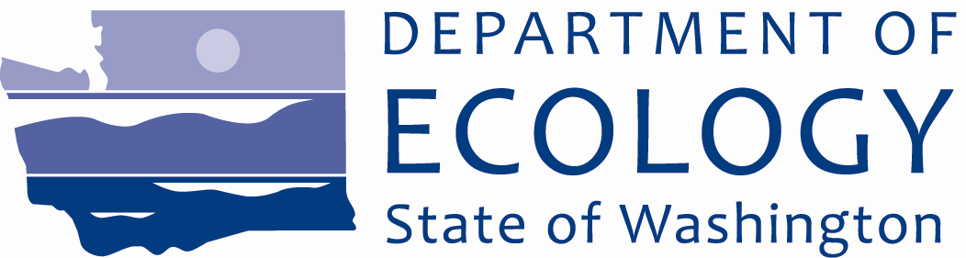

April 2012

# Proposed legal agreement ready for public review

The Washington Department of Ecology (Ecology) and the Port of Bellingham (Port) have completed a draft legal agreement, called an agreed order, for the Blaine Marina, Inc. site in Blaine. The draft agreed order is the first step in the process that will require the Port to conduct a cleanup at the site, with Ecology oversight.

**Public**

comment period

Comments accepted:

April 9 – May 9, 2012

Submit comments and technical questions to:

Jing Liu, Site Manager

WA Department of Ecology

3190 160th Avenue SE

Bellevue, WA 98008-5452

Phone: 425-649-4310

Email: Jing.Liu@ecy.wa.gov

Document at these review locations:

Department of Ecology

Bellingham Field office

1440 10th St., Suite 102

Bellingham, WA

**By appointment.** Call Linsay Albin at 360-715-5200.

Bellingham Public Library

210 Central Avenue.

Bellingham, WA

**Phone:** 360-778-7323

**Hours:** Mon.-Tues. 10 a.m.– 8 p.m. Wed.– Sat. 10 a.m.- 6 p.m.

Sun. closed.

Department of Ecology

Northwest Regional Office

3190 160th Ave. SE

Bellevue, WA

**By appointment.** Call Sally Perkins: 425-649-7190

Ecology’s Blaine Marina, Inc. Site web page:

<https://fortress.wa.gov/ecy/gsp/Sitepage.aspx?csid=63>

Facility Site ID: #2888

When final, the agreement will first require the Port to perform an interim cleanup action to repair a damaged bulkhead which is failing and at risk of spreading contamination to the waters of Blaine Harbor. It will then be required to study the environmental conditions of the site (called a remedial investigation) and analyze cleanup options (called a feasibility study). This information will be used to develop a draft cleanup action plan, which describes the selected cleanup method. Upon Ecology approval that plan will then be implemented at the site.

Ecology invites the public to review the proposed agreed order and submit comments from April 9 through May 9, 2012. (See right for details).

Site history, location and contaminants

The Blaine Marina, Inc. site is located in the western portion of the Blaine Harbor industrial area. Most of the site was originally tide flats and sub-tidal areas of Drayton Harbor. Prior to 1949, the aquatic lands were dredged to create a small boat harbor and marina. The upland industrial area was created at that time and was generally constructed of hydraulic fill with timber and riprap bulkheads along the shoreline. The marina was expanded several times since its original construction, but the footprint of the upland industrial area has remained largely unchanged. The Port has leased this property to Blaine Marina, Inc. for use as a tank farm and fueling facility since the 1950’s. In 1955, the tenant installed three aboveground storage tanks to store gasoline and diesel fuel for dispensing at the fueling dock, and also for filling tanker trucks for delivery of home heating oil. The fueling facility now supports commercial and recreational boating activities at the marina.

A section of a bulkhead along the western site boundary has partially failed and is at risk of failing further. The bulkhead supports an overwater building that has moved outward away from the shore due to its failing. This has also caused a large amount of eroded fill behind the bulkhead. Fuel lines run from the tanks through the damaged bulkhead and the overwater building to the fueling station located on an existing pier where marine vessels are fueled. If the bulkhead is not repaired and fails further, these lines could rupture and release more contamination to the waters of Blaine Harbor.

Environmental investigations between 1990 and 2007 have documented the release of diesel-range and oil-range petroleum hydrocarbons and petroleum associated compounds benzene, ethylbenzene, and xylene in both soil and groundwater. Some of these releases exceed standards of the state’s cleanup law, the Model Toxics Control Act, and pose a threat to human health and the environment, so they must be addressed.

One documented spill of 500 to 700 gallons of diesel fuel occurred on May 2, 1990, which was reportedly contained and removed. Another spill reportedly occurred sometime prior to 1986, although no written records of the spill are available. Additionally, the tenant reported that a fuel line elbow leading to the fuel dock was leaking and needed to be replaced.

Proposed interim action

The Port will prepare and submit to Ecology for review an interim action work plan with details on how it will repair the existing damaged bulkhead. The work plan will include a summary of existing site conditions and alternative interim actions considered, a description of the interim action design and construction requirements, and a proposed schedule and personnel roles and responsibilities. Upon approval by Ecology, the Port will implement the interim action work plan to repair the bulkhead, reconnect the fuel lines, and submit a report to Ecology when completed.

Following the interim action, the Port will conduct an investigation (called a remedial investigation) to determine the nature and extent of contamination at the site. When the investigation is complete, the Port will submit a report to Ecology that presents and evaluates cleanup alternatives to address the contamination (called a feasibility study). Based on these reports and Ecology approval, the Port will submit a draft cleanup action plan, which details the cleanup for the site. This plan will also go through a public comment process. If approved, it will be implemented by the Port with Ecology oversight.

## Public comment invited

Ecology is providing the proposed agreed order, and is asking for your comments.

You are invited to:

* **Review** the proposed agreed order;
* **Send** your comments to Ecology for consideration. **Comments will be accepted April 9 – May 9, 2012**.

## What happens next?

Once the public comment period ends, Ecology will review and consider all comments it receives. The proposed agreed order may be modified based upon your comments. If there are significant changes, Ecology will issue the document again for public review.

## Why this cleanup matters

Cleaning up the Blaine Marine, Inc. site is necessary to protect people, plants, birds and other life from exposure to harmful levels of contamination, based upon the intended uses of the site. All phases of the cleanup will be conducted under the Model Toxics Control Act, passed by citizen initiative in 1988 and enacted in 1989.

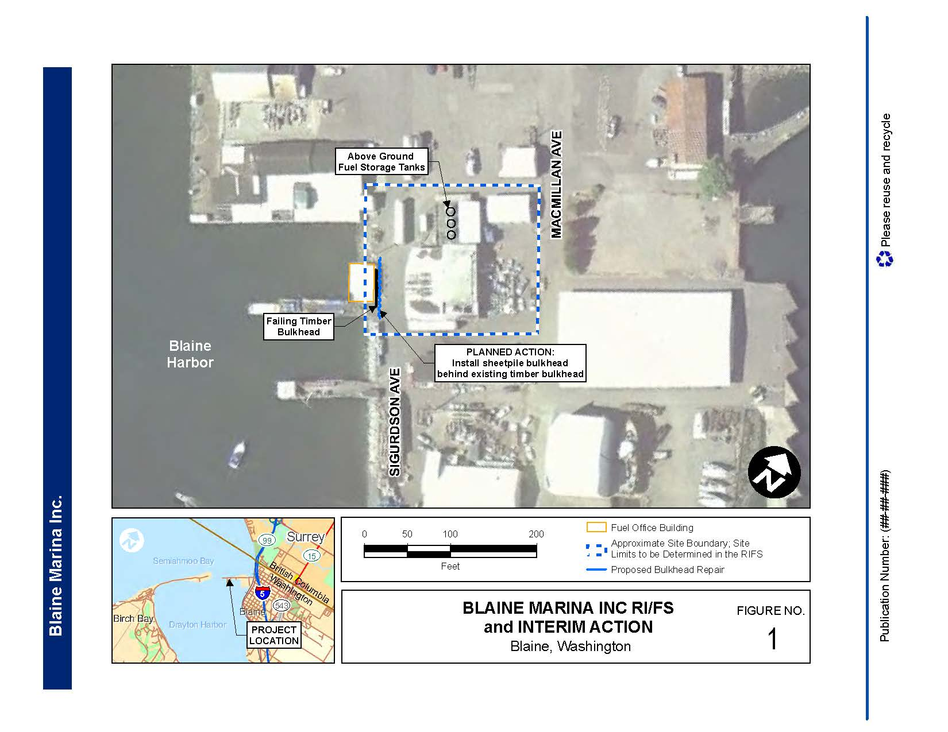

## What can you do?

* Read about the cleanup in this handout
* To get more detailed information, review the supporting documents at the locations listed in the column on Page 1 of this Fact Sheet. Write down your comments and questions. Send them to the Department of Ecology at the address provided on Page 1 of this mailer.

Long_Ecology-280 MCTA blue

3190 160th Avenue SE

Bellevue, WA 98008-5452

**Información en español:** El Departamento de Ecología (Ecología) del Estado de Washington está aceptando comentarios en un documento legal, llamado una orden acordada, entre el Puerto de Bellingham y Ecología. Este documento describiría un estudio ambiental y de limpieza para el sitio de “Blaine Marina, Inc.” Ecología aceptará los comentarios desde el 9 de abril al 9 de mayo de 2012. Favor de mandar sus comentarios por correo a Jing Liu, Department of Ecology, 3190 160th Avenue SE, Bellevue, WA 98008-5452.

Para más información en español, favor de contactar a Richelle Pérez a 360-407-7528 o por correo electrónico a [richelle.perez@ecy.wa.gov](mailto:richelle.perez@ecy.wa.gov). Refiere al sitio de “Blaine Marina, Inc.”

### Help with other formats?

To ask about obtaining this document in a version for the visually impaired, call Brad Petrovich at Ecology, 425-533-5537.

Persons with hearing loss, call 711 for Washington Relay Service.

Persons with a speech disability, call 877-833-6341.

Blaine Marina, Inc. Blaine, WA

Ecology seeks public comment on proposed agreed order

Public comment period: April 9 – May 9, 2012

### **Facility Site ID #: 2888**