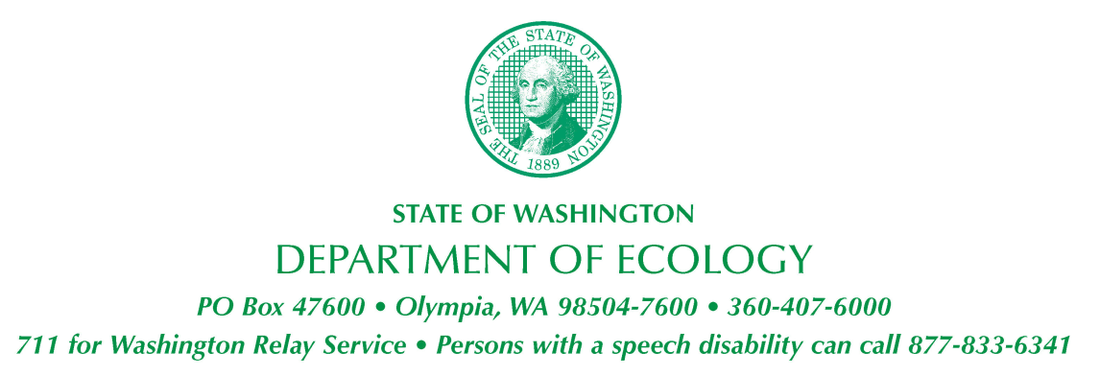

STATE ENVIRONMENTAL POLICY ACT
DETERMINATION OF NONSIGNIFICANCE

Date of Issuance: 5/12/2022

Lead Agency: Washington State Department of Ecology Toxics Cleanup Program (TCP)

Agency Contact:
J.G. Cook, Toxics Cleanup Program-HQ
Site Manager
Department of Ecology
PO Box 47600
Olympia, WA 98504-7600
360.763.2777
jason.cook@ECY.wa.gov

Description of proposal: The proposed excavation will occur on the Port of Everett Property (Port Property). This interim action comprises removal of contaminated soil due to past activities and land use associated with the former occupancy by a bulk fuel storage and distribution facility. Excavation limits and depths were predefined for the Site in 2020 & 2021, using Site-specific residual-saturation levels. The limits of the excavation are depicted in the DRAFT FINAL Exxon Mobil ADC-Port of Everett Property Interim Action Work Plan (Plates 12 and 13; Cardno). Excavation to these pre-determined limits and depths will remove all soil determined to be above the Ecology Site-specific residual saturation remediation levels on the Port Property. This interim action will be accomplished compliant with State law and City ordinances, and in accordance with applicable best management practices.

Location of proposal: The Site address location is 2717 & 2731 Federal Avenue, Everett, Washington.

The proposed remedial excavation outlined in this work plan will be conducted on the Port Property located at 2730 Federal Avenue, Everett, Washington (Snohomish County Parcels 29051900-301600, -302500, -302700, -302800, & -302900).

The Port Property is currently an asphalt-paved parking lot with no structures present.

The Site is comprised of City of Everett right-of-ways (former Everett Avenue to the north, Federal Avenue to the west, and land underneath the Terminal Avenue Overpass), the Port properties to the west (including the active port and the property leased and currently occupied by Everett Ship Repair), the BNSF parcel, and the BNSF railway corridor easement to the east of the Site.

Applicant/Proponent: The Department of Ecology Toxics Cleanup Program
Determination: The proposed interim action will have long-term beneficial effects on the Site and Port Property, as well as the surrounding areas by permanently removing environmental contamination. Ecology’s TCP has determined that these interim actions will not have a probable significant adverse impact on the environment and therefore a Determination of Non-significance (DNS) is appropriate. As such, an environmental impact statement (EIS) is not required under RCW 43.21C.030(2)c. This decision was made after review of a completed SEPA checklist and other supporting documents.

The SEPA Checklist (included in the Interim Action Work Plan - Appendix G) and complete DNS, as well as cleanup reports (including the Interim Action Work Plan) can also be reviewed on Ecology’s website using the following weblink: https://apps.ecology.wa.gov/cleanupsearch/site/5182.

Comment Period: This DNS is issued under WAC 197-11-340(2); the lead agency will not act on this proposal for 30 days from the date of publication listed below. Agencies, Tribes, and members of the public are invited to comment on the DNS. Written comments must be postmarked no later than June 13, 2022 and should be mailed to the ExxonMobil ADC Site Manager/Site Contact above or to the responsible official below:

Responsible Official:

Nicholas Acklam
Interim Section Manager – TCP HQ
Department of Ecology
PO Box 47600
Olympia, WA 98504-7600
360.628.1977
nicholas.acklam@ECY.wa.gov

Signature Nicholas M. Acklam Date 05/12/2022

