|  |  |
| --- | --- |
| **Bioremediation Pilot Test at Bangor Site F**  Work Plan  Prepared by:  Alison Suess, Chemist  Seattle District, U.S. Army Corps of Engineers  Mandy Michalsen, Engineer and Senior Technical Advisor  Engineer Research and Development Center, U.S. Army Corps of Engineers  Jeffrey Weiss, Geologist  Seattle District, U.S. Army Corps of Engineers  Dan Carlson, Physical Scientist  Seattle District, U.S. Army Corps of Engineers  Briana Niestrom, Project Manager  Seattle District, U.S. Army Corps of Engineers  **June 23, 2021**  NWSLOgo-02.gif | |
|  |  |
|  |  |

[This page is intentionally left blank.]

# LIST OF ACRONYMS AND ABBREVIATIONS

bgs below ground surface

COC chain of custody

Contractor Bethel-Tech JV

ft feet

HPLC high performance liquid chromatography

IDW investigation derived waste

ISB *in situ* bioremediation

MDL method detection limit

mM millimolar

NaHCO3 sodium bicarbonate

NAVFAC NW Naval Facilities Engineering Command Northwest

NWS Northwest Seattle (USACE)

PFAS Per- and Polyfluoroalkyl Substances

PSOHP Project Safety and Occupational Health Plan

PM project manager

RDX hexahydro-1,3,5-dinitro-1,3,5-triazine

RL reporting limit

TOC total organic carbon

UFP-QAPP Uniform Federal Policy Quality Assurance Project Plan

μg/L microgram per liter

USACE The U.S. Army Corps of Engineers Seattle District and U.S. Army Engineer Research and Development Center

# TABLE OF CONTENTS

LIST OF ACRONYMS AND ABBREVIATIONS iii

TABLE OF CONTENTS iv

LIST OF TABLES v

LIST OF FIGURES v

1. INTRODUCTION 6

2. TEST OBJECTIVES 6

3. LIST OF MATERIALS 7

4. METHODS 7

4.1 Work Plans and Health and Safety Plans 8

4.2 Contractor Installation of 8-Inch Diameter Test Well 8

4.2.1 Site Preparation 9

4.2.2 Drilling 9

4.2.3 Well Installation 9

4.2.4 Investigation Derived Waste (IDW) 9

4.2.5 Well Development 10

4.2.6 Equipment 10

4.2.7 Personnel 10

4.3 Contractor Site Work 11

4.4 Contractor Equipment Connections 11

4.4.1 F-EW-5 Plumbing Connection 11

4.4.2 Electrical Connection 11

4.5 Injection Equipment 12

4.6 Contractor Proof of Operability 12

4.7 Phase I Injection 13

4.7.1 Contractor Purchase and Receipt of Fructose and Bicarbonate 13

4.7.2 Contractor Fructose and Sodium Bicarbonate Metering 13

4.7.3 Contractor Maintenance and Support 14

4.7.4 Personnel 14

4.7.5 USACE Sampling and Groundwater Monitoring 15

4.8 Phase II Injection 19

4.8.1 USACE Collection of MW44 Water for Phase II Injection Solution 19

4.8.2 Contractor Purchase and Receipt of Fructose and Bicarbonate 19

4.8.3 Contractor Fructose and Sodium Bicarbonate Metering 19

4.8.4 Personnel 19

4.8.5 USACE Sampling and Groundwater Monitoring 20

4.9 Assessing Pilot Performance and RDX Degradation 25

4.10 USACE Groundwater Collection and Analysis Procedures 25

4.11 Standard Forms 26

5. PROJECT ORGANIZATION AND RESPONSIBILITIES 27

6. SCHEDULE 28

7. REFERENCES 30

FIGURES 31

APPENDICES…………………………../……………………………………………………………………………………………………………34

# LIST OF TABLES

Table 1. Groundwater Injections and Amendments by Test Phase 8

Table 2. Phase I Sampling Schedule 16

Table 3. Phase I Sample Quantities 18

Table 4. Phase II Sampling Schedule 22

Table 5. Phase II Sample Quantities 24

# LIST OF FIGURES

Figure 1. Bangor Site F Vicinity Map 32

Figure 2. Pilot Test Wells and Anticipated Radius of Influence 33

**LIST OF APPENDICES**

Appendix A. Field Forms

Appendix B. Per- and Polyfluoroalkyl Substances (PFAS) Analytical Results from Wells Within and Upgradient of the Site F Hotspot Pilot Test Area

Appendix C. Map Showing Wells Tested for PFAS

# INTRODUCTION

The U.S. Army Corps of Engineers Seattle District and U.S. Army Engineer Research and Development Center (collectively USACE) have completed multiple rounds of *in situ* bioremediation (ISB) pilot testing at Naval Base Kitsap, Bangor Site F (Figure 1), which collectively show (1) that ISB is capable of achieving RDX cleanup concentrations, and (2) that implementing ISB could significantly reduce aquifer cleanup time and cost at Site F. USACE previously developed and used a site-specific groundwater model to simulate performance of a full-scale bioremediation remedy at Site F (USACE 2015), which featured a number of new injection and extraction wells throughout the RDX plume that would circulate bioremediation amendment throughout targeted aquifer treatment areas. Naval Facilities Engineering Command Northwest (NAVFAC NW) has expressed interest in performing an ISB pilot to simulate a portion of a full-scale ISB remedy in the Site F aquifer, which would provide (1) full-scale bioremediation performance information for the Navy and the Navy’s remediation contractor to use when developing the full-scale ISB design, and (2) extended ISB performance monitoring to directly answer remaining questions regarding the transient nature of the RDX breakdown intermediates, ability to achieve cleanup levels, and longevity of treatment. This document describes materials and methods for Contractor-performed installation of an injection well and injection of water amended with fructose and bicarbonate, as well as USACE-performed groundwater monitoring.

# TEST OBJECTIVES

The ISB pilot study will first establish an *in situ* bioreactor by injecting a large quantity of fructose-amended groundwater to stimulate growth and activity of indigenous RDX degrading microbes in the Site F aquifer. A portion of the water currently extracted from well F-EW5 will be diverted to the ISB test location, fructose and bicarbonate will be added to F-EW5 groundwater, and then the amended F-EW5 groundwater will be injected into a newly constructed injection well. The ability to adjust and continuously record the rate of F-EW5 groundwater injected, and the ability to adjust and continuously record the rate of fructose and bicarbonate solution metered into the into F-EW5 groundwater being injected, is critical to test success.

After the amended groundwater injection has occurred and after reducing geochemical conditions have been achieved in the interrogated portion of the aquifer, indicating that the *in situ* “bioreactor” has been established, the bioreactor will be “challenged” by injecting a large quantity of RDX-containing groundwater into the injection well. This “challenge” phase will use RDX-containing groundwater from F-MW44 [contains 250 micrograms per liter (μg/L) RDX per January 2021 sampling event], and then the amended groundwater will be injected into the injection well. This pilot study will very closely simulate full-scale bioremediation performance.

Based on previous site-specific bioremediation test results, results of this pilot are expected to provide confirmation that full-scale bioremediation can achieve RDX cleanup objectives. Any deleterious findings, though not anticipated, will empower Navy with required information to ensure the full-scale system is properly designed and implemented. Note that we have included buffered injections to prevent aquifer acidification, which has been observed to inhibit RDX degradation in the Site F aquifer. The buffer quantity required herein was based on excess acid production measured during previous biostimulation tests performed in the Site F aquifer.

Field materials, procedures and analytical methods to be utilized to accomplish these objectives are described below.

# LIST OF MATERIALS

|  |  |
| --- | --- |
| 18,000-gallon tanks | submersible pumps and tubing |
| 1,500-gallon tanks | sump pumps and garden hose |
| 150-gallon tanks | high-flow transfer pump and tubing |
| 3,000-gallon tank | step ladder |
| sample containers | plastic sheeting |
| carbon substrate | personal protective equipment |
| chloride salts | QED MicroPurge basics MP20 Flow Cell |
| Generators | measurement forms |
| fuel and fuel containers | Batteries |
| flow cell calibration solutions | distilled water |
| water level meter | 1-gallon plastic Ziploc-type bags |
| ferrous iron Hach Kits | Ice |
| large graduated cylinder | garbage bags |
| sample containers | Sharpies |
| packing tape | field book |
| extension cord | pump control box |
| flow meter | heat trace tape |
| metering pump | Submersion heaters |
|  |  |

# METHODS

The Site F Bioremediation Pilot Test will include phased injections into the new injection well (Figure 2), followed by groundwater monitoring. The trench injection pilot will proceed in the following two phases:

* Phase I: Build the Reactor
  + Groundwater monitoring for background conditions prior to the start of the injection.
  + Phase I injection of water amended with fructose and sodium bicarbonate.
  + Continued groundwater monitoring during and after injection.
* Phase II: Test the Reactor
  + Groundwater monitoring for background conditions prior to the start of the injection.
  + Phase II injection of water with elevated RDX concentration, amended with fructose, sodium bicarbonate, and sodium chloride tracer.
  + Continued groundwater monitoring during and after injection.

A summary of the field tests is provided in Table 1.

Table 1. Groundwater Injections and Amendments by Test Phase

|  |  |  |  |  |
| --- | --- | --- | --- | --- |
| **Test Field Work Phase** | **Groundwater Injection Amendments and Concentrations** | **Injection Volume, Occurrence** | **Injection Well** | **Monitoring Wells** |
| Phase I Injection | Water from F-EW5  Fructose (25 mM)  Bicarbonate (10 mM) | 2,476,800- gallons, single injection | PT-INJ | F-PT-01, F-PT-02, F-PT-03, F-PT-04, F-DW01, F-DW02, F-MW48 |
| Phase II Injection | Water from F-MW44  Fructose (25 mM)  Bicarbonate (10 mM)  Chloride (2.8 mM, or 100 mg/L as the anion) | 147,000- gallons, single injection | PT-INJ | F-PT-01, F-PT-02, F-PT-03, F-PT-04, F-DW01, F-DW02, F-MW48 |

## Work Plans and Health and Safety Plans

The Contractor will prepare a Drill Work Plan and Health & Safety Plan for their drilling work, which will be reviewed by USACE according to the specifications in the Performance Work Statement. The Contractor will also prepare a Pilot Study Infrastructure Work Plan and Health & Safety Plan for all other work, which will be reviewed by USACE according to the specifications in the Performance Work Statement.

USACE has prepared this Work Plan to detail USACE work for this project, as well as to provide an overview of Contractor work. USACE will prepare a Project Safety and Occupational Health Plan (PSOHP) according to EMM 385-1-1 and an Activity Hazard Analysis (AHA) for work carried out by USACE employees.

## Contractor Installation of 8-Inch Diameter Test Well

The Contractor to USACE (Contractor) shall drill and install an 8-inch diameter well at the location shown on Figure 2. The drilling and well installation must be completed within two weeks of drilling starting to prevent project delays.

### Site Preparation

The site is accessible by unimproved dirt roads and the work area is relatively level but will likely require some brush clearing. The Contractor will be responsible for verifying there is adequate space for the equipment and work to be completed. The Contractor shall coordinate with USACE if additional clearing or grading is required to install the well or for fructose/sodium bicarbonate tank and metering. No trees may be removed during the project. The Contractor may need to remove protective bollards surrounding nearby wells and will be responsible for replacing bollards when work is complete.

USACE will complete the utility locates and the Navy dig permit. The Navy requires 30 days to complete the dig permit. USACE will need to be notified by the Contractor at least 30 days prior to drilling or earth work so that additional utility locates/clearance can be completed.

### Drilling

The Contractor shall drill a 12-inch diameter borehole up to 200 feet (ft) below ground surface (bgs). The lithology consists of very dense silts and sand with up to 4-inch diameter gravel and water level is approximately 130 ft bgs. Only water may be used during drilling; no mud or other additives. Water will be available from a hydrant located approximately two miles from the site. The driller will be responsible for transporting the water to the site. The driller must containerize all cuttings and water generated during drilling. No sampling will be completed during drilling.

### Well Installation

The Contractor will construct the well using 8-inch diameter schedule 80 PVC with 30 feet of machine slotted 20 slot screen. A filter pack consisting of 10-20 Colorado Silica Sand or equivalent will be placed around the screen and extend 2 feet above the top of the screen. Centralizers will be placed at the top and bottom of the screen and every 20 feet on the casing. The filter pack will be settled using swabbing inside the well during construction. An annular seal will be placed above the filter pack and include 5 feet of coated time release bentonite pellets above the sand and grout from the top of the pellets to 20 feet from ground surface. A cement surface seal will be placed in the top 20 feet of the annulus. The surface completion will consist of a protective steel casing with a 2 ft by 2 ft cement pad and three bollards. The driller shall install two 1 ½ inch diameter stilling tubes to approximately 180 ft bgs to allow for the installation of monitoring equipment in the well casing. The driller will install the stilling tubes after well development is completed.

### Investigation Derived Waste (IDW)

The driller shall containerize all IDW and separate the water and cuttings. The driller will transport the water to a treatment facility approximately ½ mile from the site. The driller will provide a filter to remove fines from the water and ensure no silt enters the treatment facility. The cuttings will be stockpiled on plastic sheeting and covered. USACE will characterize the cuttings and coordinate offsite disposal if necessary. It the cuttings are approved to be spread on site the driller will assist with spreading the cuttings on site.

### Well Development

The driller shall develop the well to remove fines and improve the connection with the surrounding formation. The development shall include swabbing and bailing and pumping. The swabbing shall include swabbing each five-foot section of screen for a minimum of 15 minutes and recording the amount of material that collects in the bottom of the well after each 15 minutes. The volume and type of material removed from the well shall be documented. Swabbing and bailing shall continue until less than 1-inch of material is brought in after 15 minutes of swabbing or after 8 hours of swabbing and bailing. Material brought in during swabbing shall be bailed out when the sump is full. After swabbing is complete the driller shall pump from within the screen. Development will include moving the pump through the screen and the pump should be turned off to allow the water column to flush back through the screen. An Imhoff cone will be used to measure the sand content in the discharge water and the pumping rate should be increased as the sand content in the discharge water decreases. Pumping shall continue until less than 1 mg/L of sediment is recorded in the discharge water or after a maximum of six hours of pumping. The driller will record the amount of sediment collected in the sump during pumping and remove all the sediment from the bottom of the well when pumping is completed. All water generated during development shall be containerized and stored on site until USACE can coordinate disposal at the treatment plant located approximately ½ mile away. The drillers will be responsible for transporting the water to the treatment plant.

### Equipment

The Contractor shall provide a drill rig capable of drilling a 12-inch diameter borehole to 200 ft bgs and installing the well within two weeks of drilling starting to prevent delays to the project. All drilling equipment shall be decontaminated prior to arriving on site and all well construction material must be new and free of contaminants.

### Personnel

The driller shall be licensed in the State of Washington and be experienced with installing 8-inch diameter wells in similar lithology. The driller and all personnel shall have up to date 40-hour HAZWOPER training. The drilling and construction must follow the WAC 173-160 requirements for drilling and installing wells. The driller will be responsible for filing start cards and well construction logs to the Washington State Department of Ecology. The USACE geologist will log the boring.

## Contractor Site Work

The Contractor shall complete earthwork necessary for the placement of tanks and equipment required for the injections. The location does not require tree cutting, which is not allowed for the project. The area is approximately 75 feet long by 20 feet wide. The approximate location is shown on Figure 2. The earthwork will include clearing, grading and preparing suitable subgrade as needed for amendment tanks and metering system. The clearing will include removing brush, logs and rocks. No tree removal will be allowed. All material removed must be placed on site in a location that does not obstruct access to existing roads or work areas. The Contractor will be responsible for determining the exact size of the area, grading necessary to level the area and type of rock, geofabric or other material necessary to create a suitable subgrade as needed. The Contractor shall also complete any clearing necessary to route water from F-MW44 to the injection well.

## Contractor Equipment Connections

### F-EW-5 Plumbing Connection

The Contractor shall connect to the effluent water line from F-EW5 (shown on Figure 2). The Contractor shall coordinate with USACE and the Navy for access to F-EW5 and minimize disruptions to the operation F-EW5. The connection must allow a portion of F-EW5 effluent to be routed to the injection location and the remaining water to go to the treatment plant. The assumed constant flow rate out of F-EW5 is 180 gallons per minute (gpm). The Contractor must route the water to the mixing location and then the injection well and ensure the injection rate will remain constant. The piping or hose can remain above ground; however, it will cross at least one access road that must remain open. The Contractor shall plumb the injection piping or hose into the injection well while still allowing access for water level monitoring and the ability to lock the wellhead when not in use.

### Electrical Connection

The Contractor shall provide power to the equipment used for the injections including pumps, mixing equipment and other miscellaneous equipment required for the injections. The Contractor shall determine the electrical load required and components necessary. The Contractor may connect to existing underground power at the site. The Contractor will be required to coordinate with USACE, the Navy and local utilities to use the existing power on site. The Contractor must use qualified electricians, per paragraph 1.6.8, for all design and work and follow appropriate electrical codes and standards.

## Injection Equipment

The Contractor will provide all equipment necessary to complete the injections. The Contractor will determine the equipment necessary to complete the nutrient injections based on the design requirements described in sections 4.7 and 4.8. The Contractor will provide a design in the work plan that lists all the equipment and specifications for the equipment. The equipment will include:

* Buffer System – A mixing, storage and metering system for dissolving sodium bicarbonate into solution and then metering it into the injected solution. The metering rate needs to be adjustable so that the final injected bicarbonate concentration remains ~ constant even if the injection rate changes during the Phase I and Phase II injections.
* Fructose Injection System – A storage and metering system to inject fructose at the required rate per sections 4.7 and 4.8 into the injected water and record the rate of injection. The metering rate needs to be adjustable so that the final injected fructose concentration remains ~ constant even if the injection rate changes during the Phase I and Phase II injections.
* Injection Sampling Port – Piping and injection sample port equipment and flow meter at the wellhead to allow for sampling the injected solution.
* Monitoring Equipment – Flow meters on each component of the injection system including F-EW5, F-MW44, fructose and sodium bicarbonate that can read both real time and total volumes injected. The flow meters must be rated for the injection ranges, specified in sections 4.7 and 4.8, and the viscosity of the material it will be measuring.
* F-MW44 Pump and Equipment – A submersible pump capable of continuously operating at 1-15 gpm at a depth of 200 ft and the necessary controllers and tubing to pump water from F-MW44 to tanks supplied by USACE. Approximately 18,000 to 21,000 gallons of water from F-MW44 will be staged on site and injected during Phase II.
* Automatic shutoff - A high water switch in the injection well that turns the system off if water level in the injection well is less than 10 feet below ground surface

## Contractor Proof of Operability

The Contractor shall operate the system with only water to demonstrate the system performs as designed prior to the injection of amended water. The Contractor shall install all components necessary for the injections and run the injection system at the designed flow rates for ratios of fructose, sodium bicarbonate and water. Water (from EW-5) will be used instead of fructose and sodium bicarbonate during the proof of operability and the proof of operability test need only be performed briefly (e.g. an hour or two as needed). The Contractor must show USACE how to adjust the flow rates and record the flow rate of each injection component. The proof of operability test should simulate how to operate the system during:

* Phase I, i.e. using metering equipment to meter water (water is stand in for fructose and sodium bicarbonate solution during proof of operability test) into flowing F-EW5 water for injection; and during:
* Phase II, i.e. using pump and equipment installed at F-MW44 to convey F-MW44 groundwater to pilot test area, combine F-MW44 groundwater with F-EW5 groundwater, and use metering equipment to meter water (again, water is stand in for fructose and sodium bicarbonate solution during proof of operability test) into the combined F-MW44 and F-EW5 flow for injection.

The Contractor’s proof of operability test shall provide USACE personnel with training required to turn on the system (i.e. begin an injection) and to turn off the system when the injections are complete. F-EW5 groundwater shall be used for the proof of operability test and the test should occur only as long as needed to simulate Phase I and II to ensure operability and for USACE personnel training completion. Any F-EW5 groundwater remaining in the tanks at the conclusion of the operability should be collected in the bicarbonate tank and used subsequently to prepare the bicarbonate solution, thus leaving the fructose tank empty and ready to receive the fructose material for Phase I.

## Phase I Injection

The Phase I injection will involve injecting fructose- and bicarbonate-amended water into the aquifer to stimulate growth of RDX degrading microbes. The water used will originate from well F-EW5. Phase I is expected to begin in October 2021 due to weather constraints and regulatory review of study. The Phase I injection is expected to last 43 calendar days; however, the time may vary depending on the injection rate. Phase I monitoring and sampling is expected to last 90 calendar days after the injection is completed.

### Contractor Purchase and Receipt of Fructose and Bicarbonate

The Contractor shall purchase 8,000 gallons of 42% high fructose corn syrup that meets the requirements in the attached fructose requirement. The Contractor shall purchase 13,900 pounds of sodium bicarbonate (NaHCO3). The Contractor will be responsible for delivery and storage of the fructose and sodium bicarbonate. The Contractor will ensure the delivery vehicles can access the site and transfer the chemicals to the on-site storage. The Contractor shall follow all applicable laws for storing chemicals, proper labeling and approval from the Navy for storing the chemicals on the site.

### Contractor Fructose and Sodium Bicarbonate Metering

The Contractor shall install all components necessary to meter fructose to achieve 25 millimolar (mM) fructose injection concentration and sodium bicarbonate injection concentration of 10 mM such that the water injected into the injection well during Phase I is 25 mM fructose and 10 mM bicarbonate. A nominal injection rate of 40 gpm is desired; however, the injection rate could vary during injection. Assuming water is injected at 40 gpm the dosing rate of fructose would be 0.13 gpm and assuming the bicarbonate solution in injection tank is 0.58 pounds per gallon then the dosing rate of bicarbonate solution would be 0.22 gpm. The fructose and bicarbonate injection concentrations must be kept constant, even when/if the injection rate fluctuates. The bicarbonate solution will need to be completely dissolved prior to metering during injections. The Contractor shall supply the tanks and mixing equipment to dissolve the bicarbonate and ensure the bicarbonate metering is continuous during the Phase I injection.

### Contractor Maintenance and Support

The Contractor shall ensure the system remains operational during the injection including the continued supply of fructose and sodium bicarbonate and available to complete any necessary repairs. The Contractor shall be available to mobilize to the site within one day to complete maintenance on the system.

### Personnel

The Contractor shall provide personnel for installation and operation of the injection. Continuous oversight is not required; however, personnel need to be available to check on the system and troubleshoot problems. All personnel must meet the requirements specified below and be experienced with system operations.

* The Contractor is responsible for ensuring all employees possess and maintain current Hazardous Waste Operations and Emergency Response (HAZWOPER) training under CFR 1910.120.
* The driller must be licensed in Washington State as specified in Washington Administrative Code (WAC) 173-160.
* The electrician must be licensed as specified in the Revised Code of Washington (RCW) 19.28 and WAC 296-46B.
* The Contractor must pre-screen candidates using the E-verify Program (http://www.uscis.gov/e-verify) website to meet the established employment eligibility requirements. The contractor must ensure that the candidate has two valid forms of Government issued identification prior to enrollment in the E-Verify system. An initial list of verified and eligible candidates must be provided to the USACE Contracting Officer’s Representative no later than three business days after the initial contract award.

The Contractor will be responsible for receiving fructose and sodium bicarbonate and preparing sodium bicarbonate solution to specific concentration. USACE will complete the day to day monitoring and manual adjustments of the system. An on-site field technician will not be required during the injections. The contractor shall be available for troubleshooting Contractor-supplied equipment as needed. The Contractor shall be available to mobilize and complete maintenance/repairs on the Contractor required equipment within 24 hours of notification from the Government.

### USACE Sampling and Groundwater Monitoring

**Water Level Monitoring:** USACE will install pressure transducers in the eight wells used during the test (F-PT-01, F-PT-02, F-PT-03, F-PT-04, F-DW01, F-DW02, F-MW48, and the injection well), as well as two background wells outside the area of influence of the test (F-PT-05 and F-MW-44) (Figure 2, page 37), and record the water level every 15 minutes to monitor the change in water level during the test. The pressure transducers will be installed a minimum of two week prior to injection, starting to collect background water levels. The data loggers will be downloaded once a week during the injection and once a month during the monitoring period. Manual readings of the monitoring wells using an electronic water level indicator will be collected prior to installing the transducers and during every groundwater sampling event.

**Injection Samples:** USACE personnel will collect nine water samples from the injection water periodically throughout injection (Tables 2 and 3). USACE will perform field measurements of groundwater parameters: dissolved oxygen, conductivity, temperature, and pH, and will test groundwater for Iron(II) with a Hach kit. USACE will collect samples for laboratory analysis of total organic carbon (TOC).

**Groundwater Temperature Monitoring:** USACE personnel will install temperature loggers every three feet in the screened portion of the injection and monitoring wells. The temperature loggers will be installed at least one month prior to the injections in test wells (F-PT-01, F-PT-02, F-PT-03, F-PT-04, F-DW01, F-DW02, F-MW48, and the injection well). The loggers will record the water temperature every 15 minutes and the data will be downloaded once a week during the injection and once a month during the monitoring period.

The injection water will be heated to create a temperature differential that can be observed in the test wells. The water will be heated by attaching heat tracer tape with a set temperature of 60 °C to the injection line that conveys the water from the mixing tanks to the injection well. The length of pipe that will have heat tape attached will be determined during the proof of operability stage. The goal is to increase the water temperature by 5 °C to create a signal that can be observed in the observation wells without significantly changing the viscosity of the water. The groundwater at the injection site is approximately 10 °C and the injection water prior to heating will be similar depending on the air temperature at the time of injection

Temperature data will be collected and used to observe the depth in the monitoring wells with the quickest response to the injection, and the longest duration of temperature increase.

**Groundwater Monitoring Samples:** USACE personnel will collect groundwater monitoring samples from the eight wells used during the test (F-PT-01, F-PT-02, F-PT-03, F-PT-04, F-DW01, F-DW02, F-MW48, and the injection well). Background samples (Round of Phase I) will be collected from all wells prior to injection, Rounds 2 through 5 of samples will be collected periodically during and after injection from the seven test wells, and a final round, which is also Round 1 of Phase II of samples will be collected from all wells approximately two months after the end of the injection (Tables 2 and 3). USACE will collect samples for laboratory analysis of TOC and explosives from the Method 8330B analytes list, with additional analytes MNX, DNX, and TNX.

**Groundwater Parameters**: USACE personnel will collect groundwater parameters, using methods described in section 4.10, from the test wells prior to collecting groundwater samples and several times during and after the injection. USACE personnel will perform field measurements of groundwater parameters: dissolved oxygen, conductivity, temperature, and pH, and will test groundwater for Iron(II) with a Hach kit.

Table 2. Phase I Sampling Schedule

|  |  |  |  |  |
| --- | --- | --- | --- | --- |
| **Phase** | **Date** | **Injection Sample Location, Round, and Analytes** | **GW Monitoring Sample Location, Round, and Analytes** | **Groundwater Quality Parameter**  **Monitoring Performed?** |
| Prior to Phase I Injection | Prior to 3/15/2022 | NA | Round 1:  Background, Injection, and Test Wells  (TOC, Explosives) | Yes,  Background Wells,  Test and Injection Wells |
| Phase I Injection | 3/15/2022 | Round 1:  Injection Solution  (TOC) | NA | Yes,  Test and Injection Wells |
| Day 1 |
| Phase I Injection | 3/17/2022 | Round 2:  Injection Solution  (TOC) | NA | Yes,  Test and Injection Wells |
| Day 3 |
| Phase I Injection | 3/21/2022 | Round 3:  Injection Solution  (TOC) | NA | Yes,  Test and Injection Wells |
| Day 7 |
| Phase I Injection | 3/24/2022 | Round 4:  Injection Solution  (TOC) | NA | Yes,  Test and Injection Wells |
| Day 10 |
| Phase I Injection | 3/28/2022 | Round 5:  Injection Solution  (TOC) | NA | Yes,  Test and Injection Wells |
| Day 14 |
| Phase I Injection | 3/31/2022 | Round 6:  Injection Solution  (TOC) | Round 2:  Subset Wells  (TOC, Explosives) | Yes,  Test and Injection Wells |
| Day 17 |
| Phase I Injection | 4/7/2022 | Round 7:  Injection Solution  (TOC) | NA | Yes,  Test and Injection Wells |
| Day 24 |
| Phase I Injection | 4/12/2022 | Round 8:  Injection Solution  (TOC) | NA | Yes,  Test and Injection Wells |
| Day 29 |
| Phase I Injection | 4/26/2022 | Round 9:  Injection Solution  (TOC) | Round 3:  Subset Wells  (TOC, Explosives) | Yes,  Test and Injection Wells |
| Day 43 |
| Phase I GW Monitoring  Day 24 | 5/18/2022 | NA | Round 4:  Injection and Test Wells  (TOC, Explosives) | Yes,  Test and Injection Wells |
| Phase I GW Monitoring | 6/22/2022 | NA | Round 5:  Injection and Test Wells  (TOC, Explosives) | Yes,  Test and Injection Wells |
| Day 58 |
| Phase I GW Monitoring | 7/20/2022 | NA | Round 1 (Phase II):  Background, Test and Injection Wells  (TOC, Explosives) | Yes,  Background Wells,  Test and Injection Wells |
| Day 89 |

1. Test Wells: F-PT-01, F-PT-02, F-PT-03, F-PT-04, F-DW01, F-DW02, F-MW48
2. Background Wells: F-PT-05, F-MW44
3. Subset Wells: Two selected test wells (likely DW-01 and PT-04) plus the injection well (on days when injection is not occurring.) The purpose of the subset wells is to get high-resolution data of aquifer changes over a short time after injection.

Table 3. Phase I Sample Quantities

|  |  |  |  |  |  |  |  |  |
| --- | --- | --- | --- | --- | --- | --- | --- | --- |
| **Phase Component** | **Analytes** | **Number of sampling events** | **Wells sampled per event** | **Sample locations** | **Number of Field Samples (no FD or MS/MSD)** | **Number of Matrix Spike/Matrix Spike Duplicates (MS/MSD)** | **Number of Field Duplicates (FD)** | **Number of Total Samples (With FD and MS/MSD)** |
| Phase I Injection Solution | TOC | 9 | 1 | Injection Port | 9 | see below | see below | see below |
| Phase I GW Monitoring During Injection (Two Background Wells) | TOC | 1 | 2 | Background Wells | 2 | see below | see below | see below |
| Explosives | 1 | 2 | Background Wells | 2 | see below | see below | see below |
| Phase I GW Monitoring Before and After Injection (Test and Injection Wells) | TOC | 3 | 8 | Test Wells | 24 | see below | see below | see below |
| Explosives | 3 | 8 | Test Wells | 24 | see below | see below | see below |
| Phase I GW Monitoring During Injection (Two Test Wells) | TOC | 2 | 2 | Subset Wells | 4 | see below | see below | see below |
| Explosives | 2 | 2 | Subset Wells | 4 | see below | see below | see below |
| Total for all Phase I in order to calculate MS/MSD/FD | Explosives | see above | see above | see above | 30 | 4 | 3 | 37 |
| TOC | see above | see above | see above | 39 | 4 | 4 | 47 |
| **Total Explosives** | | | | | | | | **37** |
| **Total TOC** | | | | | | | | **47** |

1. Field Duplicate (FD) samples will be collected at a rate of 1 per every 10 field samples.
2. Matrix Spike/Matrix Spike Duplicate (MS/MSD) samples will be collected at a rate of 1 pair per every 20 field samples.
3. Test Wells: F-PT-01, F-PT-02, F-PT-03, F-PT-04, F-DW01, F-DW02, F-MW48
4. Background Wells: F-PT-05, F-MW44
5. Subset Wells: Two selected test wells (likely DW-01 and PT-04) plus the injection well (on days when injection is not occurring.) The purpose of the subset wells is to get high-resolution data of aquifer changes over a short time after injection.

## Phase II Injection

The Phase II injection will involve injecting water with an elevated concentration of RDX, which is amended with fructose, bicarbonate, and chloride tracer, into the aquifer. The purpose is to assess RDX degradation and RDX degradation intermediates in the biostimulated aquifer. The water used will originate from well F-MW44, which contains approximately 250 ug/L RDX. Water from F-MW44 will be collected in tanks, chloride tracer will be added, and the water will be pumped to the metering station near F-MW48 for addition of fructose and bicarbonate.

Phase II is expected to begin in February 2023, approximately three months after last injection of Phase I. The Phase II injection is expected to last 10 calendar days; however, the time may vary depending on the injection rate. Phase II monitoring and sampling is expected to last 120 calendar days after the injection is completed.

### USACE Collection of MW44 Water for Phase II Injection Solution

Water from F-MW44 will be used for the Phase II injection solution. The original plan was that water from F-MW44 and F-EW5 would be mixed; however, due to a change in operation of the groundwater extraction and treatment system, the RDX concentration in water from F-MW44 has decreased, and undiluted water from F-MW44 must be used. USACE will acquire tanks, collect water from F-MW44, and will add chloride tracer to the water. The water will then be pumped to the Contractor’s metering station for addition of fructose and bicarbonate.

### Contractor Purchase and Receipt of Fructose and Bicarbonate

The Contractor will be responsible for receiving fructose and sodium bicarbonate and preparing sodium bicarbonate solution to specific concentration. The Contractor shall purchase 476 gallons of 42% high fructose corn syrup that meets the requirements in the attached fructose requirement. The Contractor shall purchase 900 pounds of sodium bicarbonate (NaHCO3).

### Contractor Fructose and Sodium Bicarbonate Metering

The second injection is expected to last 10 calendar days; however, the time may vary depending on the injection rate. The injection rate for Phase II is expected to be 10 gpm from tanks staged near MW44.

### Personnel

The Contractor shall ensure the system remains operational during the injection including the continued supply of fructose and sodium bicarbonate and available to complete any necessary repairs. The Contractor shall be available for troubleshooting Contractor-supplied equipment as needed. The Contractor shall be available to mobilize and complete maintenance/repairs on the Contractor required equipment within 24 hours of notification from the Government.

USACE will complete the day to day monitoring and manual adjustments of the system. A Contractor on-site field technician will not be required during the injections.

### USACE Sampling and Groundwater Monitoring

**Water Level Monitoring:** USACE will install pressure transducers in the eight wells used during the test (F-PT-01, F-PT-02, F-PT-03, F-PT-04, F-DW01, F-DW02, F-MW48, and the injection well), as well as two background wells outside the area of influence of the test (F-PT-05 and F-MW-44) (Figure 2, page 37), and record the water level every 15 minutes to monitor the change in water level during the test. The pressure transducers will be installed a minimum of two weeks prior to injection starting to collect background water levels. The data loggers will be downloaded once a week during the injection and once a month during the monitoring period. Manual readings of the monitoring wells using an electronic water level indicator will be collected prior to installing the transducers and during every groundwater sampling event.

**Injection Samples:** USACE personnel will collect ten water samples from the injection water periodically throughout injection (Tables 4 and 5). USACE will perform field measurements of groundwater parameters: dissolved oxygen, conductivity, temperature, and pH, and will test water for Iron(II) with a Hach kit. USACE will collect samples for laboratory analysis of TOC, anions (chloride tracer), and explosives from the Method 8330B analytes list, with additional analytes MNX, DNX, and TNT, from all injection samples.

**Groundwater Temperature Monitoring:** USACE personnel will install temperature loggers every three feet in the screened portion of the injection and monitoring wells. The temperature loggers will be installed at least one month prior to the injections in in test wells (F-PT-01, F-PT-02, F-PT-03, F-PT-04, F-DW01, F-DW02, F-MW48, and the injection well). The loggers will record the water temperature every 15 minutes and the data will be downloaded once a week during the injection and once a month during the monitoring period.

The injection water will be heated to create a temperature differential that can be observed in the test wells. The water will be heated by attaching heat tracer tape with a set temperature of 60 °C to the injection line that conveys the water from the mixing tanks to the injection well. The length of pipe that will have heat tape attached will be determined during the proof of operability stage. The goal is to increase the water temperature by 5 °C to create a signal that can be observed in the observation wells without significantly changing the viscosity of the water. The groundwater at the injection site is approximately 10 °C and the injection water prior to heating will be similar depending on the air temperature at the time of injection

Temperature data will be collected and used to observe the depth in the monitoring wells with the quickest response to the injection, and the longest duration of temperature increase.

**Groundwater Monitoring Samples:** USACE personnel will collect groundwater monitoring samples from the eight wells used during the test (F-PT-01, F-PT-02, F-PT-03, F-PT-04, F-DW01, F-DW02, F-MW48, and the injection well) (Tables 4 and 5). A total of 10 rounds of samples, including one background round prior to injection, will be collected from all 8 wells used during the test over the course of Phase II. Additionally, 15 samples will be collected from a subset of well (two test wells and the injection well, on days without injections) during and immediately following injection, within 20 days after injection, with samples weighted toward the days directly after injection. This high-frequency sampling of subset wells allows for analysis of tracer-corrected time course RDX concentrations and standard push-pull test data analysis methods (Istok et al. 1997, Haggerty et al. 1998) to extract a localized RDX degradation rate coefficient. USACE will collect samples for laboratory analysis of TOC, anions (chloride tracer), and explosives from the Method 8330B analytes list, with additional analytes MNX, DNX, and TNT.

The Phase I and II sample schedules are based on USACE knowledge at the time of UFP-QAPP finalization. USACE does not anticipate any deviations to the Phase I sample schedule. Learnings from Phase I results could prompt optimization in the Phase II sampling schedule to ensure the best data possible is obtained to meet data quality objectives. Any alterations to the Phase II sampling schedule will be proposed to all UFP-QAPP recipients in advance of Phase II sampling.

**Groundwater Parameters**: USACE personnel will collect groundwater parameters, using methods described in section 4.10, from the test wells prior to collecting groundwater samples and several times during and after the injection. USACE personnel will perform field measurements of groundwater parameters: dissolved oxygen, conductivity, temperature, and pH, and will test groundwater for Iron(II) with a Hach kit.

Table 4. Phase II Sampling Schedule

| **Phase** | **Date** | **Injection Sample Location, Round, and Analytes** | **GW Monitoring Sample Location, Round, and Analytes** | **Groundwater Quality Parameter**  **Monitoring Performed?** |
| --- | --- | --- | --- | --- |
| Phase I GW Monitoring  Day 89 (Background Sampling) | 7/20/2022 | NA | Round 1:  Background, Test and Injection Wells  (TOC, Anions, Explosives) | Yes,  Background Wells,  Test and Injection Wells |
| Phase II Injection  Day 1 | 7/27/2022 | Round 1:  Injection Solution  (TOC, Anions, Explosives) | NA | Yes,  Test Wells |
| Phase II Injection  Day 2 | 7/28/2022 | NA | NA | Yes,  Test Wells |
| Phase II Injection  Day 3 | 7/29/2022 | Round 2:  Injection Solution  (TOC, Anions, Explosives) | Round 2:  Subset Wells  (TOC, Anions, Explosives) | Yes,  Test Wells |
| Phase II Injection  Day 4 | 7/30/2022 | NA | NA | Yes,  Test Wells |
| Phase II Injection  Day 5 | 7/31/2022 | NA | NA | Yes,  Test Wells |
| Phase II Injection  Day 6 | 8/1/2022 | NA | Round 3:  Subset Wells  (TOC, Anions, Explosives) | Yes,  Test Wells |
| Phase II Injection  Day 7 | 8/2/2022 | NA | NA | Yes,  Test Wells |
| Phase II Injection  Day 8 | 8/3/2022 | NA | NA | Yes,  Test Wells |
| Phase II Injection  Day 9 | 8/4/2022 | Round 4:  Injection Solution  (TOC, Anions, Explosives) | NA | Yes,  Test Wells |
| Phase II Injection  Day 10 | 8/5/2022 | NA | Round 4:  Subset Wells  (TOC, Anions, Explosives) | Yes,  Test Wells |
| Phase II GW Monitoring  Day 1 | 8/6/2022 | NA | Round 5:  Injection and Subset Wells  (TOC, Anions, Explosives) | Yes,  Test and Injection Wells |
| Phase II GW Monitoring  Day 2 | 8/7/2022 | NA | Round 6:  Injection and Subset Wells  (TOC, Anions, Explosives) | Yes,  Test and Injection Wells |
| Phase II GW Monitoring  Day 3 | 8/8/2022 | NA | Round 7:  Injection and Subset Wells  (TOC, Anions, Explosives) | Yes,  Test and Injection Wells |
| Phase II GW Monitoring  Day 4 | 8/9/2022 | NA | Round 8:  Injection and Subset Wells  (TOC, Anions, Explosives) | Yes,  Test and Injection Wells |
| Phase II GW Monitoring  Day 5 | 8/10/2022 | NA | Round 9:  Injection and Subset Wells  (TOC, Anions, Explosives) | Yes,  Test and Injection Wells |
| Phase II GW Monitoring  Day 6 | 8/11/2022 | NA | Round 10:  Injection and Subset Wells  (TOC, Anions, Explosives) | Yes,  Test and Injection Wells |
| Phase II GW Monitoring  Day 9 | 8/12/2022 | NA | Round 11:  Test and Injection Wells  (TOC, Anions, Explosives) | Yes,  Test and Injection Wells |
| Phase II GW Monitoring  Day 11 | 8/15/2022 | NA | Round 12:  Injection and Subset Wells  (TOC, Anions, Explosives) | Yes,  Test and Injection Wells |
| Phase II GW Monitoring  Day 13 | 8/17/2022 | NA | Round 13:  Injection and Subset Wells  (TOC, Anions, Explosives) | Yes,  Test and Injection Wells |
| Phase II GW Monitoring  Day 15 | 8/19/2022 | NA | Round 14:  Injection and Subset Wells  (TOC, Anions, Explosives) | Yes,  Test and Injection Wells |
| Phase II GW Monitoring  Day 19 | 8/24/2022 | NA | Round 15:  Injection and Subset Wells  (TOC, Anions, Explosives) | Yes,  Test and Injection Wells |
| Phase II GW Monitoring  Day 26 | 8/31/2022 | NA | Round 16:  Test and Injection Wells  (TOC, Anions, Explosives) | Yes,  Test and Injection Wells |
| Phase II GW Monitoring  Day 33 | 9/7/2022 | NA | Round 17:  Injection and Subset Wells  (TOC, Anions, Explosives) | Yes,  Test and Injection Wells |
| Phase II GW Monitoring  Day 40 | 9/14/2022 | NA | Round 18:  Test and Injection Wells  (TOC, Anions, Explosives) | Yes,  Test and Injection Wells |
| Phase II GW Monitoring  Day 54 | 9/28/2022 | NA | Round 19:  Injection and Subset Wells  (TOC, Anions, Explosives) | Yes,  Test and Injection Wells |
| Phase II GW Monitoring  Day 68 | 10/12/2022 | NA | Round 20:  Test and Injection Wells  (TOC, Anions, Explosives) | Yes,  Test and Injection Wells |
| Phase II GW Monitoring  Day 81 | 10/25/2022 | NA | Round 21:  Test and Injection Wells  (TOC, Anions, Explosives) | Yes,  Test and Injection Wells |
| Phase II GW Monitoring  Day 98 | 11/11/2022 | NA | Round 22:  Test and Injection Wells  (TOC, Anions, Explosives) | Yes,  Test and Injection Wells |
| Phase II GW Monitoring  Day 119 | 12/2/2022 | NA | Round 23:  Background, Test and Injection Wells  (TOC, Anions, Explosives) | Yes,  Background Wells,  Test and Injection Wells |

1. Test Wells: F-PT-01, F-PT-02, F-PT-03, F-PT-04, F-DW01, F-DW02, F-MW48
2. Background Wells: F-PT-05, F-MW44
3. Subset Wells: Two selected test wells (likely DW-01 and PT-04) plus the injection well (on days when injection is not occurring.) The purpose of the subset wells is to get high-resolution data of aquifer changes over a short time after injection.

Table 5. Phase II Sample Quantities

|  |  |  |  |  |  |  |  |  |
| --- | --- | --- | --- | --- | --- | --- | --- | --- |
| **Phase** | **Analytes** | **Number of sampling events** | **Number of sample location** | **Sample locations** | **Number of Field Samples (no FD or MS/MSD)** | **Number of Matrix Spike/Matrix Spike Duplicates (MS/MSD)** | **Number of Field Duplicates (FD)** | **Number of Total Samples (With FD and MS/MSD)** |
| Phase II Injection Solution | Explosives | 4 | 1 | Injection Port | 4 | see below | see below | see below |
| TOC | 4 | 1 | Injection Port | 4 | see below | see below | see below |
| Anions | 4 | 1 | Injection Port | 4 | see below | see below | see below |
| Phase II GW Monitoring Before Injection and at Project End (Two Background Wells) | Explosives | 2 | 2 | Background Wells | 4 | see below | see below | see below |
| TOC | 2 | 2 | Background Wells | 4 | see below | see below | see below |
| Anions | 2 | 2 | Background Wells | 4 | see below | see below | see below |
| Phase II GW Monitoring Subset Wells (Two Test Wells + Injection Well) | Explosives | 15 | 3 | Subset Wells | 45 | see below | see below | see below |
| TOC | 15 | 3 | Subset Wells | 45 | see below | see below | see below |
| Anions | 15 | 3 | Subset Wells | 45 | see below | see below | see below |
| Phase II GW Monitoring (Test and Injection Wells) | Explosives | 8 | 8 | Test Wells, Injection Well | 64 | see below | see below | see below |
| Anions | 8 | 8 | Test Wells, Injection Well | 64 | see below | see below | see below |
| TOC | 8 | 8 | Test Wells, Injection Well | 64 | see below | see below | see below |
| Total for all Phase II in order to calculate MS/MSD/FD | Explosives | see above | see above | see above | 117 | 12 | 12 | 141 |
| Anions | see above | see above | see above | 117 | 12 | 12 | 141 |
| TOC | see above | see above | see above | 117 | 12 | 12 | 141 |
| **Total Explosives** | | | | | | | | **141** |
| **Total TOC** | | | | | | | | **141** |
| **Total Anions** | | | | | | | | **141** |

1. Field Duplicate (FD) samples will be collected at a rate of 1 per every 10 field samples.
2. Matrix Spike/Matrix Spike Duplicate (MS/MSD) samples will be collected at a rate of 1 pair per every 20 field samples.
3. Test Wells: F-PT-01, F-PT-02, F-PT-03, F-PT-04, F-DW01, F-DW02, F-MW48
4. Background Wells: F-PT-05, F-MW44
5. Subset Wells: Two selected test wells (likely DW-01 and PT-04) plus the injection well (on days when injection is not occurring.) The purpose of the subset wells is to get high-resolution data of aquifer changes over a short time after injection.

## Assessing Pilot Performance and RDX Degradation

Data will be evaluated using multiple approaches in order to accomplish project objectives. The first approach will involve using tracer-corrected time course RDX concentrations measured during Phase II in the injection well and standard push-pull test data analysis methods (Istok et al. 1997, Haggerty et al. 1998) to extract a localized RDX degradation rate coefficient. The second approach will involve integrating RDX concentrations measured during Phase II in the interrogated portion of the aquifer over time to extract a “bulk” RDX degradation rate coefficient. Single well and integrated time series RDX nitroso derivative (MNX, DNX and TNX) concentrations measured in the injection well and all monitoring wells will be evaluated by to determine their fate over extended timeframes under biostimulated conditions. Radius of influence will be analyzed using the Theis method and similar pumping test analysis to fit observed data with analytical solutions. Collectively, this large-scale bioremediation pilot will provide additional performance data to inform design and performance monitoring of a future full-scale ISB system.

## Per- and Polyfluoroalkyl Substances Assessment

The Navy’s long term monitoring contractor will sample groundwater from Site F wells and analyze the samples for per-and polyfluoroalkyl substances (PFAS). The PFAS sampling will occur in April 2022 and annually thereafter (CH2M Hill, 2021). The PFAS sampling protocol is addressed in a separate Sampling and Analysis Plan (CH2M Hill). The Navy’s contractor will analyze for 18 PFAS analytes, including PFOS, PFOA, and PFBS, using liquid chromatography tandem mass spectrometry (LC-MS/MS) compliant with DoD Quality Systems Manual Table B-15. The contractor’s laboratory holds DoD and state accreditation. Third party data validation will be performed.

USACE will compare the concentrations of the analyzed PFAS obtained from the Navy’s annual sampling over the course of the test and will describe the results and any changes in concentrations over the course of the test. This analysis will be included in the final report.

The analytical results for PFAS compounds from the April 2022 sampling of wells F-MW44 and F-MW48 (i.e., wells within the footprint of the pilot test) are presented in Appendix B, along with wells F-MW38, F-MW51, EMW-21U, EMW-22U, EMW-23U and EMW-24L, located 600 – 800 feet upgradient of the pilot test footprint. Appendix C presents a map of the wells tested for PFAS compounds. For all wells, no PFAS compounds were detected during the April 2022 sampling event.

## USACE Groundwater Collection and Analysis Procedures

Background samples will be collected using a submersible pump using low-flow sampling techniques (subsequent samples will be collected at a low-flow rate after purging for an adequate amount of time, which is determined by the stabilization time during background sampling). The low flow sampling will be conducted in accordance with the USEPA “*Low Stress (low flow) purging and sampling procedure for the collection of groundwater sampled from monitoring wells*” (EPA 2017). Water levels will be monitored during low-flow sampling. Stabilization parameters pH, specific conductivity, temperature, dissolved oxygen, and oxidation reduction potential will be measured using an in-line flow cell (QED MicroPurge® Flow Cell Model MP20) that will be calibrated each morning prior to use. Turbidity, while not considered a stabilization parameter, will also be measured. Fe (II) will be measured using a Hach Iron (Ferrous) Color Disc Test Kit, Model IR-18C following stabilization.

The initial flow rates will be closely monitored during purging. Well purge flow rates will be calculated by dividing volume purged by elapsed time. After determining the optimum flow rate, the controller will be adjusted, or throttled to the desired pump flow rate. For low-flow sampling, the flow rate should be no greater than 500 milliliters/minute. Micropurge flow cell data will be recorded every two minutes while monitoring for stabilization prior to sample collection.

At each well, low-flow purging will continue until three consecutive measurements of the stabilization parameters meet stabilization requirements. Stabilization parameter requirements are as follows:

pH +/- 0.2 units

Specific Conductivity +/- 0.020 mS/cm

Temperature +/- 0.2 ºC

DO +/- 0.2 mg/l

ORP +/- 20 mV

Samples of injected test solutions and groundwater for laboratory analysis will be collected in amber glass or HDPE bottles as appropriate, shipped on ice, and stored at 2-6 °C until analysis.

RDX and its transformation product concentrations will be determined by high performance liquid chromatography (HPLC) using EPA Method 8330B. At a minimum, the laboratory required method detection limit (MDL[1]) shall be 0.25 μg/L and the reporting limit (RL) shall be 0.5 μg/L. Samples will be analyzed for chloride and bromide using EPA Method 300.0. Samples will be analyzed for TOC using SW-846 Test Method 9060A.

Samples will be packaged in insulated coolers for shipment to the lab. Each cooler will be lined with plastic bubble wrap for shock absorption, and sample bottles will be individually protected by bubble wrap to protect against breakage. Each sample bottle will be placed in its own plastic Ziploc bag. A large plastic garbage bag will be used inside the cooler to contain the sample bottles in case of breakage. All samples will be placed in the shipping coolers and denoted on the Chain of Custody (COC) form accompanying each cooler. A photo of each completed COC form will be taken. Completed COC forms will be taped to the inside of each cooler lid. The coolers will be shipped via standard overnight FedEx service to the analytical laboratory. The sampling team lead shall call or email the laboratory POC each day samples are shipped in order to alert the lab to samples to arrive the next day. The laboratory point-of-contact shall call or email USACE, Seattle District confirming receipt of each shipment.

The nearest FedEx shipment location is the FedEx Office Print and Ship Center in Silverdale, Washington at 10854 NW Myhre Pl, Silverdale, WA 98383. The business is open 7:30 AM to 9:00 PM during the week, with the latest drop-off time for express shipments at 4:05 PM. Coolers will be shipped to the appropriate lab, cooled from 2-6 °C with wet ice, in a timeline that will meeting the sample holding times, under chain of custody control.

## Standard Forms

Example chain of custody and purge log forms are provided in Appendix A. A field notebook will be maintained to document all field activities discussed in this work plan. The field notebook will be filled out in ink and dedicated to the project. Each page will be dated and numbered consecutively. Required information for each day field work is completed includes; onsite personnel, field activities completed (sampling, water levels, etc.), time onsite, off site and time of each field activity. A photo record of the field book will be maintained by taking photos of each days’ field notes and archiving the photos.

# PROJECT ORGANIZATION AND RESPONSIBILITIES

Key USACE personnel responsible for executing the trench pilot test are listed below.

**USACE Project Manager: Briana Niestrom (206) 764-3498.** The USACE Project Manager (PM) is the primary liaison with the Navy and the Contractor for this field program, and is responsible for keeping the USACE team, Navy, and Contractor informed of project schedule, budget, and changes. She has overall responsibility for achieving the technical objectives of this project. Responsibilities will also include adherence to data quality objectives, analytical methods and laboratories, and approval of QA/QC procedures.

**Field Team Leader: Jeffrey Weiss (206) 764-3312.** The Field Team Leader is responsible for the on-site performance of the injections and sample collection, packaging and shipment to lab, and ensuring the injections and sampling are completed correctly. He will confirm that all personnel have received the required health and safety training, ensure the necessary personal protective equipment and supplies are used, and correct any unsafe work practices (duties of the site safety officer). He will contribute to data analysis and report preparation.

**Project Scientists: Jenny Phillippe** **(206) 764-6965 and Dan Carlson (206) 764-6899.** The Project Scientists are responsible for maintaining the project schedule and ensuring on-time preparation of documents such as the Work Plan, Uniform Federal Policy Quality Assurance Project Plan (UFP-QAPP), and Final Report. They are responsible for preparing USACE equipment and supplies, coordinating fieldwork with the Field Team Leader, and coordinating with the full project team. They will work with the USACE chemist to ensure analytical data is of acceptable quality for use during data analysis. They will contribute to data analysis and report preparation.

**Project Chemist: Alison Suess (206) 764-3264 (Backup: Jacob Williams (206) 316-3157).** The Project Chemist is responsible for leading preparation of the UFP-QAPP and for ensuring analytical data is of acceptable quality for use during data analysis. She will contribute to data analysis and report preparation.

**Senior Technical Advisor: Mandy Michalsen (206) 764-3324.** The Senior Technical Advisor provides guidance to the project team for the field test execution, adaptive management, and data analysis and interpretation. The Senior Technical Advisor is responsible for ensuring the sampling and injections meet the data quality objectives. The Senior Technical advisor is also responsible for interpretation of sample data and will work with project team members to supervise data analysis and report preparation.

# SCHEDULE

The pilot test project schedule is summarized below.

| **Task Name** | **Duration** | **Start** | **Finish** | **Notes** |
| --- | --- | --- | --- | --- |
| **Project Safety and Occupational Health Plan (PSOHP) Preparation** | **(Work Days)** |  |  |  |
| Draft PSOHP | 22 | 10/1/2020 | 10/30/2020 |  |
| PSHOP Internal Review | 10 | 11/2/2020 | 11/13/2020 | HSP will be reviewed by NWS Safety Office. |
| Revise Draft PSHOP | 10 | 11/16/2020 | 11/27/2020 |  |
| Final PSHOP | 1 | 11/30/2020 | 11/30/2020 |  |
| **QAPP / Work Plan Preparation** | **(Work Days)** |  |  |  |
| DQO meeting | 1 | 8/21/2020 | 8/21/2020 |  |
| Preliminary Draft QAPP / Work Plan | 25 | 7/27/2020 | 8/28/2020 |  |
| Preliminary Draft QAPP / Work Plan Internal Review | 5 | 5/5/2022 | 6/5/2022 | QAPP will be reviewed by NWS internally. |
| Revision of Preliminary Draft QAPP / Work Plan | 20 | 5/5/2022 | 6/5/2022 |  |
| Stakeholders (Navy, Ecology, and EPA) Review Draft QAPP / Work Plan | 22 | 6/6/2022 | 7/6/2022 |  |
| Meeting with stakeholders | 1 | 7/6/2022 | 7/6/2022 |  |
| Revision of Draft QAPP / Work Plan | 10 | 7/7/2022 | 7/14/2022 |  |
| Stakeholders Backcheck | 10 | 7/15/2022 | 7/24/2022 |  |
| Final QAPP / Work Plan | 10 | 7/272022 | 7/31/2022 |  |
| **Field Work** | **(Total Days)** |  |  |  |
| Site Visit w/ drillers | 1 | 9/8/2020 | 9/8/2020 |  |
| Well installation | NA | 3/30/21 | 5/11/2021 | Drill, install and develop well. |
| Installation of injection equipment and proof of operability | 26 | 9/13/2022 | 10/9/2022 |  |
| Phase I injection (build the reactor) | 43 | 10/12/2022 | 11/23/2022 |  |
| Phase I monitoring and sampling | 90 | 11/24/2022 | 2/21/2023 |  |
| Fill tanks with water from MW44 | 35 | 1/4/2023 | 2/8/2023 | 25 days to fill 10 tanks at 5 gpm, extra time for delays in filling |
| Phase II Injection (test the reactor) | 10 | 2/22/2023 | 3/3/2023 |  |
| Phase II sampling and monitoring | 120 | 3/4/2023 | 7/2/2023 |  |
| **Reporting** | **(Work Days)** |  |  |  |
| Preliminary Draft Report | 45 | 8/1/2023 | 10/3/2023 | The report will include a data usability assessment based on the data validation report received. |
| Internal Review of Preliminary Draft Report | 10 | 10/3/2023 | 10/17/2023 |  |
| Revise Preliminary Draft Report | 10 | 10/17/2023 | 10/31/2023 |  |
| Stakeholders Review of Draft Report | 21 | 10/31/2023 | 11/29/2023 |  |
| Revise Draft report | 10 | 11/29/2023 | 12/13/2023 |  |
| Final Report | 1 | 12/13/2023 | 12/14/2023 |  |

# REFERENCES

CH2M HILL (CH2M HILL, Inc.). 2022. Final Sampling and Analysis Plan, Site Inspection of Per-and Polyfluoroalkyl Substances, Naval Base Kitsap, Bangor, Washington. Prepared for Naval Facilities Engineering Systems Command Northwest, Silverdale, Washington. May.

Haggerty, R., Schroth, M.H., and Istok, J.D., 1998. Simplified method of “push-pull” test data analysis for determining *in situ* reaction rate coefficients. Ground Water, 36(2):314-324.

Istok, J.D., Humphrey, M.D., Schroth, M.H., Hyman, M.R., and O’Reilly, K.T., 1997. Single-well, “push-pull” test for *in situ* determination of microbial activities. Ground Water, 35(4):619-631.

U.S. Environmental Protection Agency, 2017*, Low stress (low flow) purging and sampling procedure for the collection of groundwater samples from monitoring wells*; Washington, DC (EPA/ EQASOP-GW4).

# FIGURES

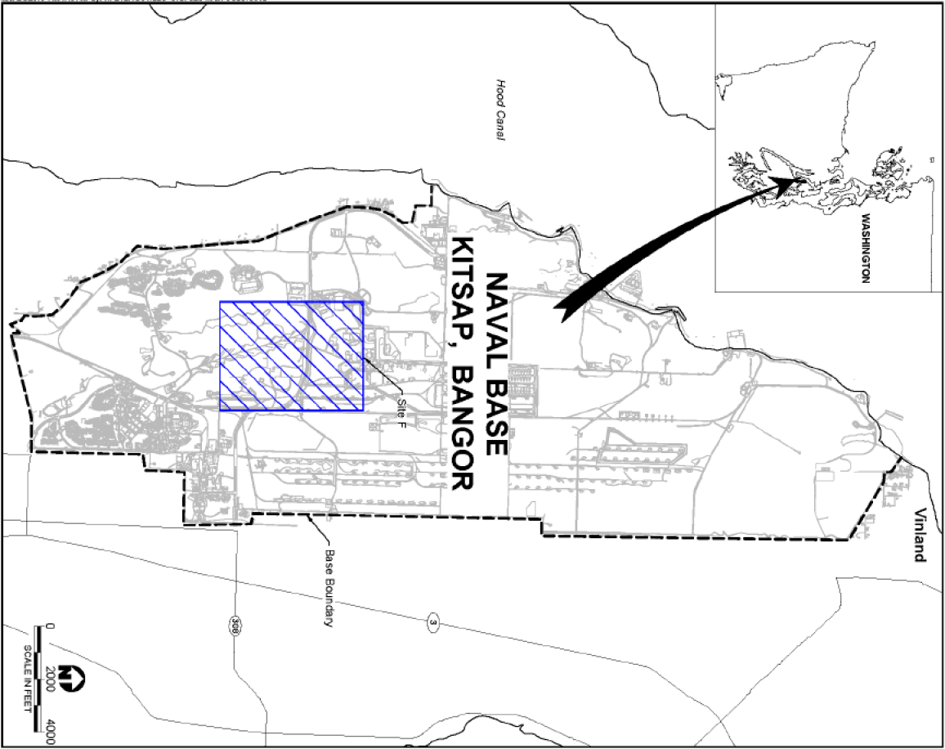

Figure 1. Bangor Site F Vicinity Map

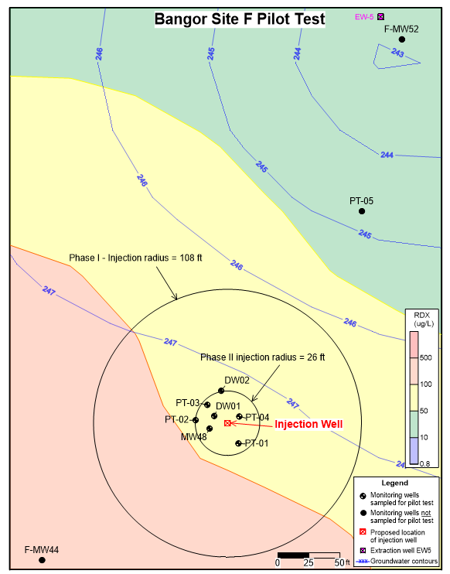

Figure 2. Pilot Test Wells and Anticipated Radius of Influence

# APPENDIX A: Field Forms

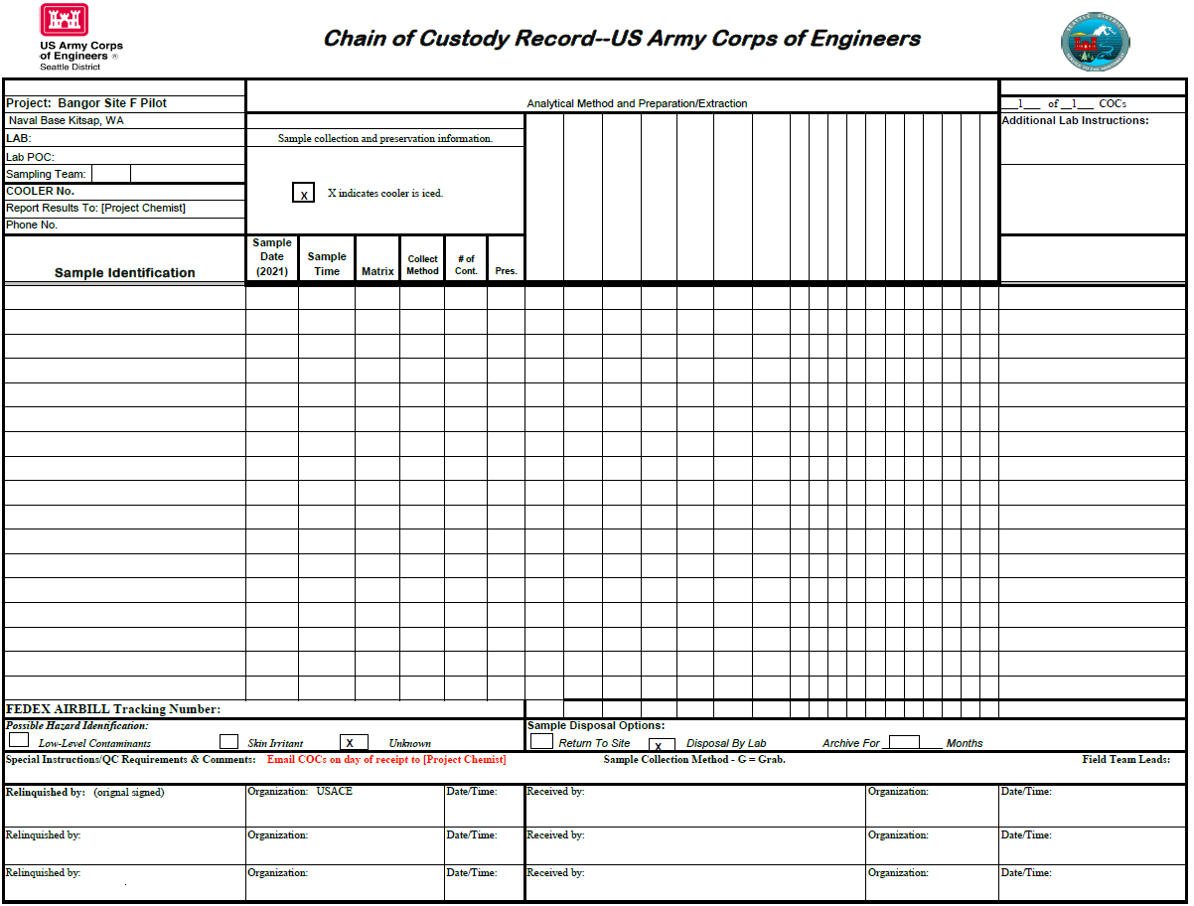

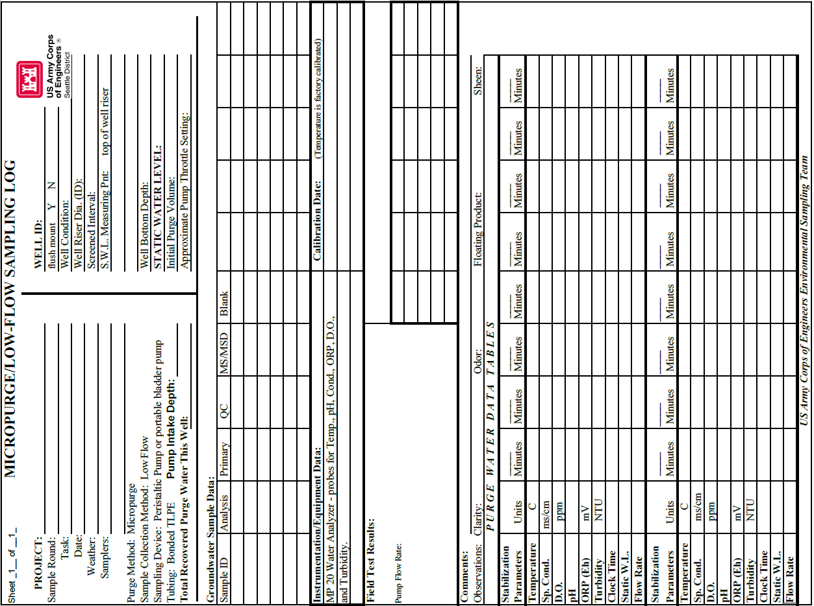

**APPENDIX B: PFAS Analytical Results**

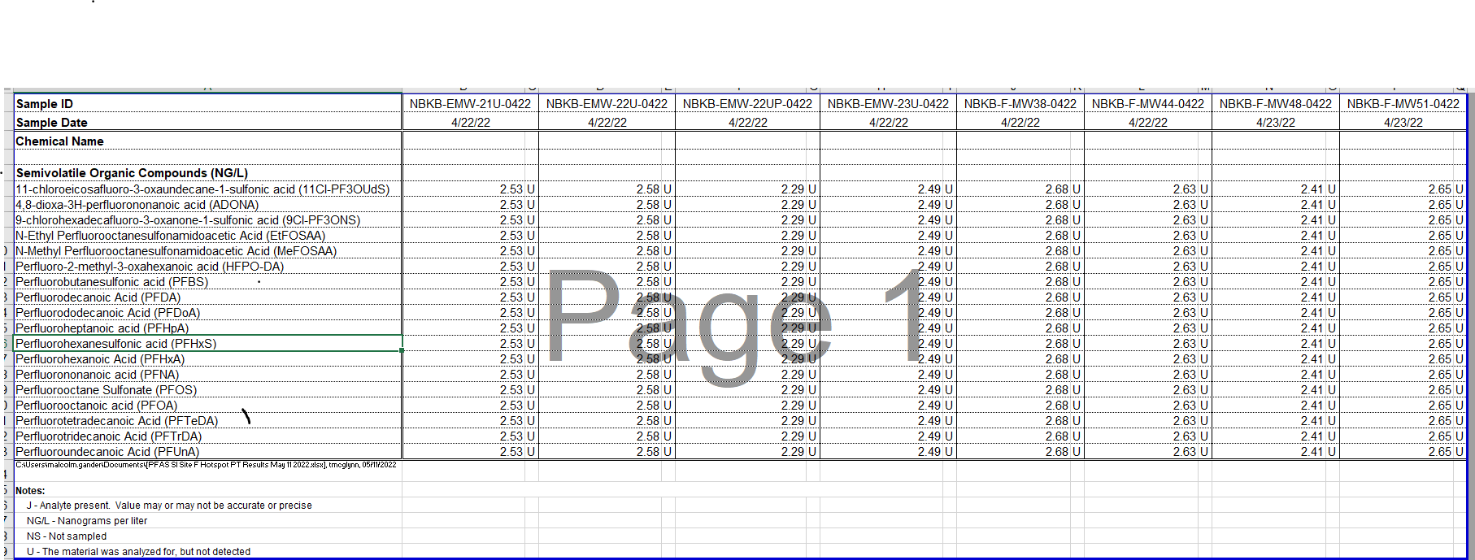

# APPENDIX C: Location Map for PFAS Sampling Locations

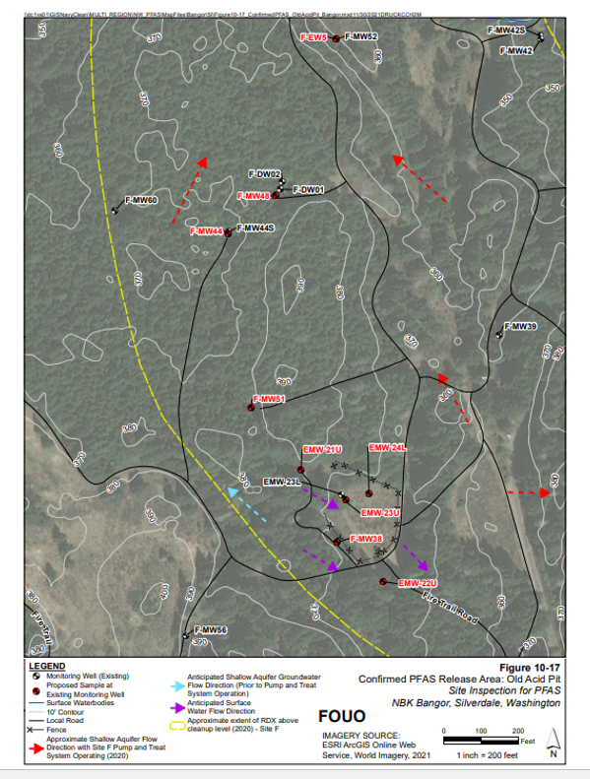

1. The MDL is equivalent to the limit of detection and the RL is equivalent to the limit of quantification.