Weyerhaeuser DuPont 1 a.k.a. Former DuPont Works
2301 Center Drive, DuPont, Pierce County
Agreed Order and Public Participation Plan Available for Public Comment
Facility Site ID: 1269 Cleanup Site ID: 3555

Comment accepted
October 6 — November 4, 2022

Submit comments online
https://tcp.ecology.commentinput.com/?id=HZNVj

Or by mail or email
Andrew Smith, Site Manager
WA State Department of Ecology
PO Box 47775
Olympia, WA 98504-7775
Andrew.Smith@ecy.wa.gov

Printed document review
DuPont Pierce County Library
1540 Wilmington Drive
DuPont, WA 98327
Ecology Lacey Office by appointment
300 Desmond Drive SE
Lacey, WA 98503
PublicDisclosureSWRO@ecy.wa.gov
or 360-407-6365

Site information
https://apps.ecology.wa.gov/
cleanupsearch/site/3555
Documents available for public comment
The Washington Department of Ecology (Ecology) has entered into a legal agreement called Agreed Order (AO) DE 21135 with Albatross Estates, LLC. Albatross Estates, LLC, is the potentially liable person (PLP) responsible for additional cleanup at the Site.
The agreement requires a plan for cleanup of contamination in some areas of the Weyerhaeuser DuPont 1 a.k.a. Former DuPont Works (Site). By removing more contamination, areas of restricted land use will be made suitable for unrestricted (residential) land use.
The AO has been signed and notice is provided here in keeping with WAC 173-340-600(11)(c). Two documents are available for your review and comment.
- Agreed Order No. DE 21135 (AO) (http://ecyaptcp/dsars/docViewer.ashx?did=116377)
The AO requires preparation of documents required for planning cleanup of the Site. These include a Data Summary Report, Remedial Investigation/Feasibility Study (RI/FS) and a preliminary draft Cleanup Action Plan (dCAP). The RI report identifies types of contamination and where it is located. The FS compares cleanup methods, and the preliminary dCAP describes the method used in clean up.
- Public Participation Plan
(http://ecyaptcp/dsars/docViewer.ashx?did=116381)
The plan describes how Ecology informs the community about cleanup at the Site. The plan encourages community involvement in cleanup decisions.

Documents are available electronically to view and/or download at Ecology’s Site information webpage. To review print documents, options are listed in the blue box on the left. Comments can be submitted online, by email, or by US Mail during the comment period from October 6 to November 4, 2022.

Site description
The Weyerhaeuser DuPont 1 a.k.a. Former DuPont Works cleanup site is located at 2301 Center Drive. The Site extends from Center Drive west to the Puget Sound. DuPont Works built an explosives factory at the Site, which operated from 1906 to 1976. Production, transportation, storage, and disposal of materials on the Site resulted in soil, groundwater, and surface water contamination. These contaminants included petroleum hydrocarbons, volatile organic compounds, metals, and solvents.
After the factory closed, it was dismantled. The area is currently used for commercial and recreational purposes.

Previous cleanup actions
In 1996 and 2003, Ecology approved cleanup action plans (CAPs) for the Site. Soil contamination was cleaned up in a series of interim actions, excavation, and capping. Institutional controls to maintain certain land uses were put in place. Groundwater contamination was addressed through a monitoring program. Cleanup actions were completed around 2007.
A series of environmental covenants were placed on the Site because some contamination remains. Among the covenant’s restrictions, they limit areas to non-residential land use. With environmental covenants in place, the condition of the Site is reviewed about every 5 years by Ecology.
In 2016, Ecology removed the Site from the Hazardous Sites List because the Site has been cleaned up and meets state cleanup standards.

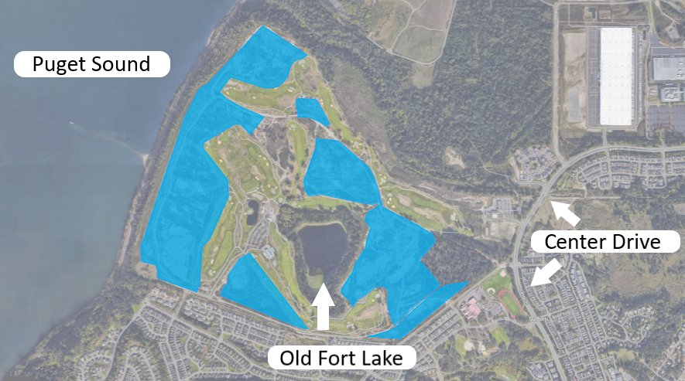
Figure 1. The shaded blue indicates the remedial action area.

Why a new Agreed Order?
More cleanup is needed to reduce contamination to levels required for unrestricted land use.
Agreed Order DE 21135 pertains to the Remedial Action Area portion of the Site (see Figure 1).
The purpose of the work under AO DE 21135 is to provide sufficient data, analysis, and evaluations to enable Ecology to select a method to further cleanup the Remedial Action Area.
The AO requires:
- Data Summary Report.
- Focused Remedial Investigation Feasibility Study (RI/FS).
- Interim actions if required or agreed to by Ecology.
- Preliminary Draft Cleanup Action Plan (DCAP)

When completed, the RI/FS, and dCAP will be available for a 30-day public comment period (see Figure 2). The Cleanup Action Plan (CAP) will be implemented under a separate legal agreement, which will also be available for public review and comment.

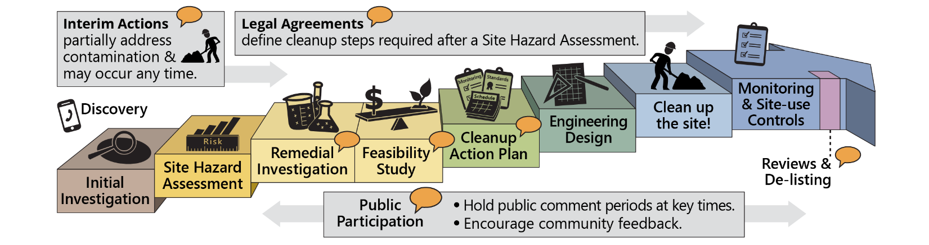
Figure 2. The Site will be cleaned up under the state’s cleanup law, the Model Toxics Control Act (MTCA). The RI/FS, CAP, and public comment periods are critical steps in the cleanup process.

Tips for commenting
Please review the AO and Public Participation Plan and submit your comments, questions, and concerns to Ecology. Your comment is valuable and helpful in the work we do. A comment can express support, disagreement, or give general information related to a project.
It is particularly helpful when a comment:
• Refers to the section or specific text of the document relevant to the comment.
• Explains why you agree or disagree and suggests alternatives.
• Gives an example to help us understand your comment.
Visit our website for more commenting tips (https://ecology.wa.gov/About-us/Get-involved/Public-input-events/Commenting-tips).
Submit your comment by the deadline of November 4, 2022.
Toxics Cleanup Program
PO Box 47775
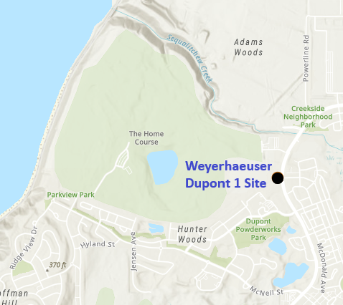
Olympia, WA 98504-7775

Weyerhaeuser DuPont 1 a.k.a. Former DuPont Works Site

2301 Center Drive, DuPont, WA 98327
Public comment period October 6 – November 4, 2022.
Why did I receive this mailing? You live near this cleanup site or have expressed interest in the cleanup. This fact sheet informs you about the proposed work and the opportunity for public comment.
What can I do? Please review the Site documents and submit your comment, question, and concerns.
¿Habla Español? Unáse al diálogo sobre Weyerhaeuser DuPont 1 Site. Cuando el período de comentarios termine, revisaremos los comentarios y haremos cambios antes de finalizar los documentos. Para más información en espanol llame al y solicite un intérprete.

ADA accessibility. To request an ADA accommodation, contact Ecology by phone at 360-485-5340 or email at matt.fuller@ecy.wa.gov, or visit ecology.wa.gov/Accessibility. For Relay Service or TTY call 711 or 877-833-6341.

