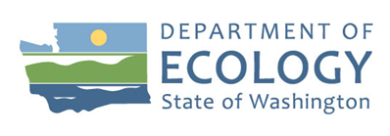
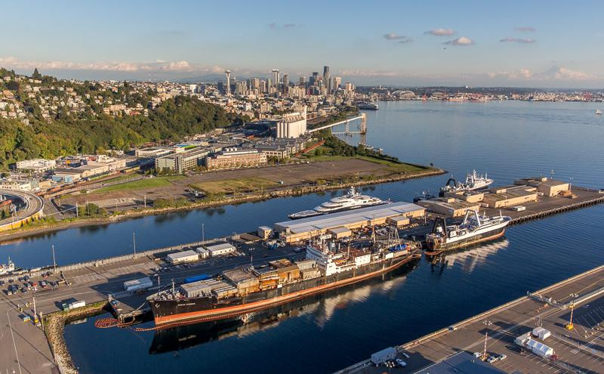

Public Participation Plan
Terminal 91
2001 W. Garfield St.
Seattle, WA, 98119
Hazardous Waste and Toxics Reduction Program
Washington State Department of Ecology
Northwest Regional Office
Shoreline, Washington
March 2023, Publication 23-04-019

Publication Information
This plan is available on Ecology’s website:
- https://ecology.wa.gov/Terminal91
- https://apps.ecology.wa.gov/publications/SummaryPages/2304019.html

Cover photo
Photo by the Port of Seattle 2022.

Related Information
- Facility site ID: 24768
- Cleanup site ID: 2674

Contact Information

Washington State
Department of Ecology
Hazardous Waste and Toxics Reduction Program
Northwest Regional Office
P.O. Box 330316
Shoreline, WA 98133
Janelle Anderson
Community Outreach Specialist
Pronouns: she/her
Phone: 425-301-6454
Email: janelle.anderson@ecy.wa.gov
Christa Colouzis
Site Manager
Pronouns: she/her
Phone: 425-324-1850
Email: christa.colouzis@ecy.wa.gov
Website: Washington State Department of Ecology

Port of Seattle
Joanna Florer
Pronouns: she/her
Port of Seattle, Pier 69
2711 Alaskan Way
Phone: 206-787-7739
Email: florer.j@portseattle.org

Español
El Departamento de Ecología está anunciando el período de comentarios públicos relacionado a la limpieza ambiental del sitio Terminal 91. Para obtener este documento, o más información sobre este sitio en español, favor de comunicarse con Janelle Anderson al 360-301-6454 o janelle.anderson@ecy.wa.gov.

한국어
주 환경부는 보잉 켄트 스페이스센터 환경정화와 관련된 공개논평 기간을 공지합니다. 한국어로 된 문서나, 이 현장에 대한 한국어 정보를 원하시면 담당자 (Jintae Lee: 360-890-5596, jintae.lee@ecy.way.gov)에게 연락하십시오.

Tiếng Việt
Bộ Môi Sinh (Ecology) đang công bố thời gian lấy ý kiến công chúng liên quan đến việc tẩy nhiễm môi trường tại địa điểm Terminal 91. Để truy cập tài liệu này bằng tiếng Việt, hoặc để biết thêm thông tin về địa điểm này bằng tiếng Việt, vui lòng liên lạc Liêm Nguyễn tại 360-790-4730 hoặc email liem.nguyen@ecy.wa.gov.

中文
華盛頓州生態管理署宣布與Terminal 91的環境清理工作有關的公眾意見徵詢期。如要本文檔的中文版，或了解更多關於本網站的中文版信息，請聯繫 Sunny Becker 撥打 425-457-3842 或發送電子郵件至 sunny.becker@ecy.wa.gov.

ADA Accessibility
The Department of Ecology is committed to providing people with disabilities access to information and services by meeting or exceeding the requirements of the Americans with Disabilities Act (ADA), Section 504 and 508 of the Rehabilitation Act, and Washington State Policy #188.
To request an ADA accommodation, contact Ecology by phone at 360-407-6700 or email at hwtrpubs@ecy.wa.gov. For Washington Relay Service or TTY call 711 or 877-833-6341. Visit Ecology's website for more information.

Department of Ecology’s Region Offices

Map of Counties Served
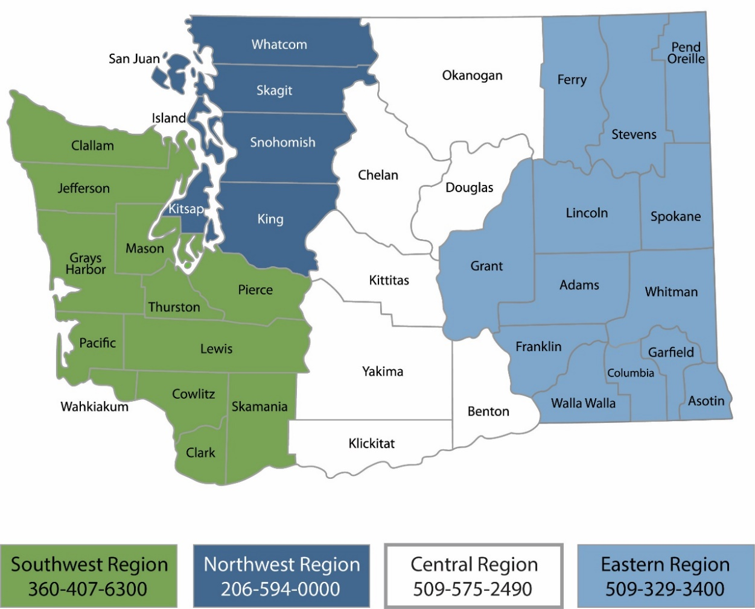
Region | Counties served | Mailing Address | Phone
Southwest | Clallam, Clark, Cowlitz, Grays Harbor, Jefferson, Mason, Lewis, Pacific, Pierce, Skamania, Thurston, Wahkiakum | PO Box 47775  Olympia, WA 98504 | 360-407-6300
Northwest | Island, King, Kitsap, San Juan, Skagit, Snohomish, Whatcom | PO Box 330316 Shoreline, WA 98133 | 206-594-0000
Central | Benton, Chelan, Douglas, Kittitas, Klickitat, Okanogan, Yakima | 1250 W Alder St  Union Gap, WA 98903 | 509-575-2490
Eastern | Adams, Asotin, Columbia, Ferry, Franklin, Garfield, Grant, Lincoln, Pend Oreille, Spokane, Stevens, Walla Walla, Whitman | 4601 N Monroe  Spokane, WA 99205 | 509-329-3400
Headquarters | Across Washington | PO Box 46700  Olympia, WA 98504 | 360-407-6000

Public Participation Plan
Terminal 91
2001 W. Garfield St.
Seattle, WA 98119
Hazardous Waste & Toxics Reduction Program
Washington State Department of Ecology
Northwest Region Office
Shoreline, WA
March 2023 | Publication 23-04-019
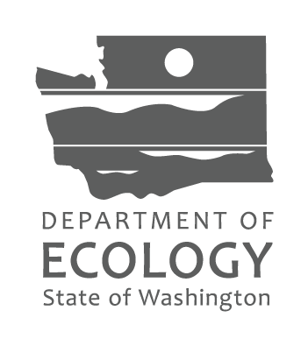

Table of Contents
List of Figures 5
List of Tables 5
Public Involvement in Contamination Cleanup 6
Site contacts 6
Public Participation Grants 7
State and Federal Cleanup Laws 7
Model Toxics Control Act 7
Resource Conservation and Recovery Act 7
State Environmental Policy Act 8
Site Information 10
Site background and land use 10
Contamination 12
Cleanup process 13
Area Community 15
Environmental Justice and Title VI 16
Public Participation Activities 19
How we share information with the community 19
How to share information with us 20
Americans with Disabilities Act 21
PPP Amendments 21
List of Abbreviations and Acronyms 22

List of Figures
Figure 1: Washington's formal cleanup process infographic. 9
Figure 2: Timeline of T91 ownership and operations. 10
Figure 3: Terminal 91 site map. 12
Figure 4: Formal cleanup process infographic (English). 14
Figure 5: Formal cleanup process infographic (Spanish). 14
Figure 6. Formal cleanup process infographic (Vietnamese). 14
Figure 7. Formal cleanup process infographic (Chinese). 14
Figure 8: Google map showing location of Terminal 91. 15
Figure 9: Environmental justice (EJ) demographic screening boundaries around Terminal 91, from EPA's EJSCREEN mapping tool. 17

List of Tables
Table 1. Study of the people living within 3.14 square miles around the site. 16
Table 2. List of abbreviations and acronyms. 22

Public Involvement in Contamination Cleanup
Ecology (we) developed this Public Participation Plan (PPP) in cooperation with the Port of Seattle. This plan is for the property located at 2001 W. Garfield St. in Seattle, Washington.
The PPP describes how we involve the public in investigating contamination and selecting cleanup activities during the corrective action process.
We encourage the public to:
- Learn about and get involved in decision-making opportunities.
- Provide input during the investigation and cleanup of contamination.
This plan is for corrective action (cleanup). Public participation activities are coordinated between the Port and Ecology. We must make sure the cleanup and the outreach comply with Washington State’s Dangerous Waste Regulations and Model Toxics Control Act (MTCA) requirements. We will hold public comment periods and other public outreach during the cleanup process.

Site contacts
To be included in the site record, comments about the cleanup process must be submitted during comment periods. Questions and informal comments or information about the site’s history are welcome anytime.

Ecology
Washington State Department of Ecology
Northwest Region Office
P.O. Box 330316
Shoreline, WA 98133
Christa Colouzis
Site Manager
christa.colouzis@ecy.wa.gov
425-324-1850
Janelle Anderson
Community Outreach Specialist
janelle.anderson@ecy.wa.gov
425-301-6454
Potentially Liable Party (PLP)
Port of Seattle
Joanna Florer
Port of Seattle, Pier 69
2711 Alaskan Way
florer.j@portseattle.org
206-787-7739

Public Participation Grants
Grants may be available to neighborhood committees, nonprofits, and other groups. For contaminated sites, these funds can be used to:
- Hire an expert to help interpret technical information.
- Conduct activities to increase understanding and participation in the cleanup process.
For more information about public participation grants, please contact Faith Wimberley at 425-275-7285 or faith.wimberley@ecy.wa.gov. You may also visit the Public Participation Grant webpage.

State and Federal Cleanup Laws
In Washington State, we use MTCA and other regulations for cleanup activities on properties that treated, stored, or disposed of hazardous wastes. These cleanups, called corrective actions, are required under the federal Resource Conservation and Recovery Act (RCRA). The U.S. Environmental Protection Agency (EPA) sets and enforces environmental standards in the United States. EPA allows Ecology to use MTCA, not RCRA, for cleanups in Washington State.
This PPP is required under MTCA. MTCA sets standards to ensure contaminated site cleanups in our state protect human health and the environment.

Model Toxics Control Act
MTCA began as a grassroots citizens’ initiative in 1988. We started using it in our state to clean up contaminated sites in 1989. Under MTCA, a current or past property owner or operator may need to pay to clean up contamination, until levels are safe for human health and the environment. The contamination may be on their property or coming from their property.
Under MTCA, we oversee cleanups and issue regulations and guidance for them. We investigate reports of property contamination. If the contamination is a threat to human health or the environment, the property is put on the Hazardous Sites List and the cleanup process begins.
Public participation is an important part of the MTCA process. Participation needs are determined for each cleanup site by the level of public interest and the risk posed by the contamination. People who live near the site, community groups, businesses, government entities, and other interested parties can comment on the cleanup process.
Under MTCA, the cleanup process happens in phases. Many of the phases have time for the public to review and comment on cleanup documents. See Figure 1, Washington’s Formal Cleanup Process, for more information.

Resource Conservation and Recovery Act
There are federal and state rules about hazardous wastes. Congress passed RCRA in 1976 to ensure safe management and disposal of hazardous waste. RCRA was updated several times to expand its scope and requirements.
RCRA’s goals are to:
- Protect human health and the environment.
- Reduce waste and conserve energy and natural resources.
- Reduce or stop hazardous waste generation.
Treatment, storage, and disposal (TSD) facilities must have a permit to design, operate, maintain, or close their site. RCRA also requires facilities to clean up contamination from past and present practices. These cleanup activities are called corrective actions.
Federal RCRA and state dangerous waste regulations require opportunities for public participation during the stages of facility permitting and cleanup.
Terminal 91 is currently under a RCRA permit for corrective action only.

State Environmental Policy Act
Ecology and the potentially liable party (PLP) follow the State Environmental Policy Act (SEPA) during review and development of cleanup plans. Ecology uses SEPA during site cleanups to find and evaluate negative environmental impacts that could result from a proposed action.
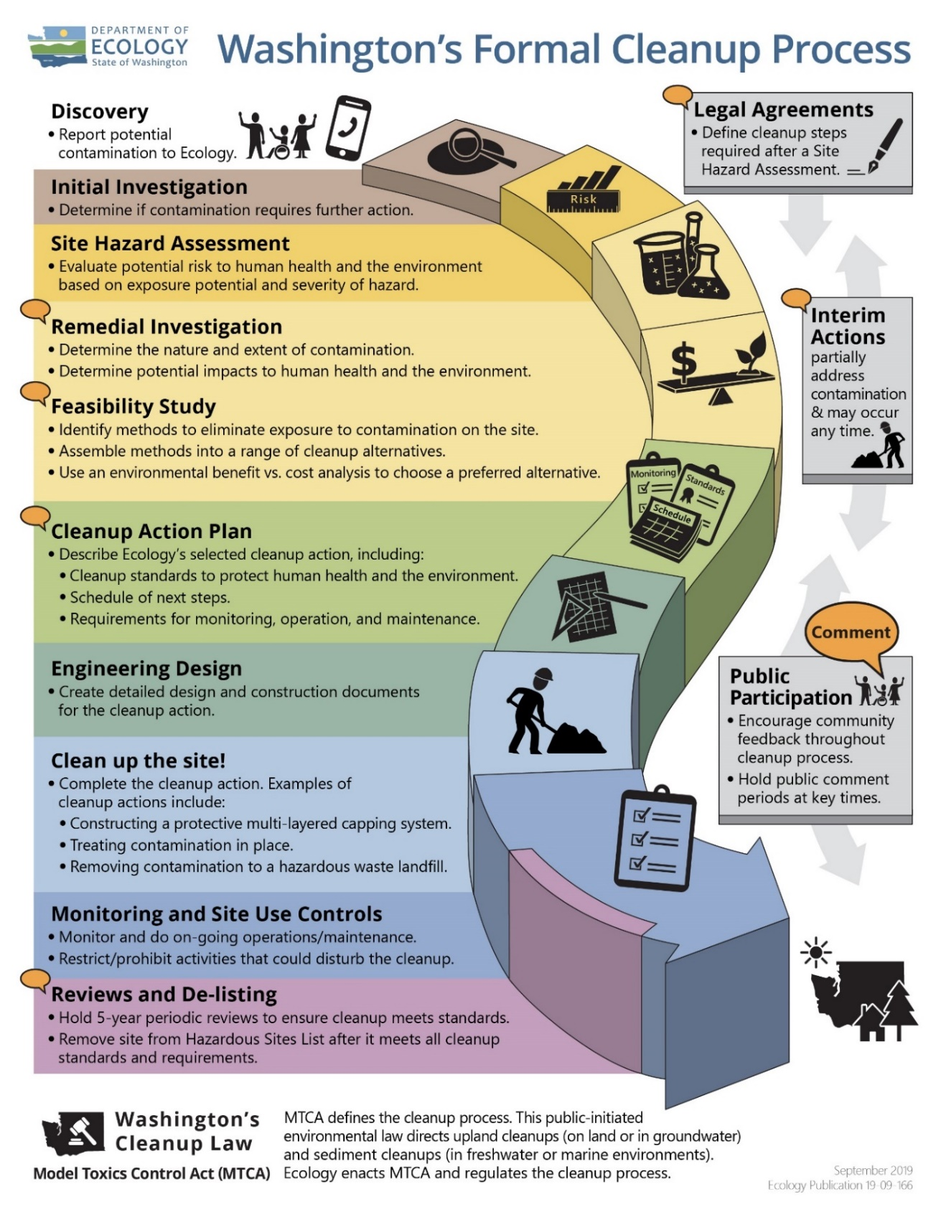
Figure 1: Washington's formal cleanup process infographic.
Read a plain text version of Figure 1.

Site Information

Site background and land use
Terminal 91 (T91) is in an industrial area of Seattle’s Interbay neighborhood. Interbay is in the valley between Queen Anne Hill and Magnolia. The Great Northern Railroad filled parts of Interbay with dirt and debris in the early 1900s. Filling continued through the 1940s. The four-acre tank farm operated from the 1920s until the tanks were removed in 2005.
Terminal 91 Owner and Operator Timeline:
- 1800s–1941: Various companies, the Port of Seattle, and individuals owned the property (see Figure 2).
- 1926–1941: Oil companies operated on part of the property.
- 1941: The U.S. Navy took possession, renamed it Terminal 91, and continued using the existing aboveground fuel tanks (tank farm) for fuel and lubricating oil.
- 1970s: The Port bought Terminal 91 and leased the tank farm to Burlington Environmental Inc. (BEI).
- 1971–1995: BEI recovered waste oil and treated wastewater under a RCRA treatment, storage, and disposal (TSD) permit.
- 1995: BEI terminated their lease.
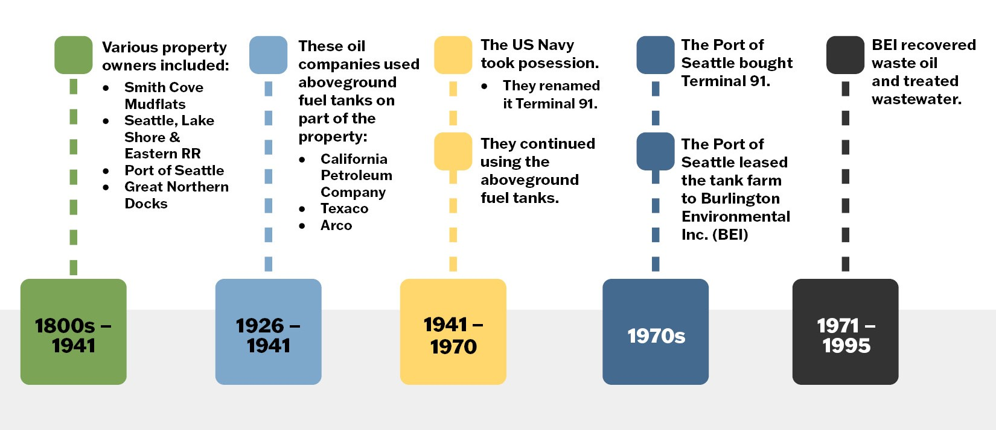
Figure 2: Timeline of T91 ownership and operations.

Past cleanups

Uplands
The Port began cleaning up the upland areas in 1999, except for the Tank Farm Area. Soil in the uplands areas was contaminated mostly with petroleum products.

Tank Farm
After the dangerous waste activities stopped, Ecology required BEI to remove contaminants from the tanks so that they no longer threatened human health or the environment. This process, known as RCRA closure, is done when a facility no longer treats, stores, or disposes of hazardous waste. BEI did above-ground closures following an Ecology-approved closure plan. After the closure, some of the tanks were used to store bunker and fuel oil until early 2003. The Port later removed those above ground tanks and structures in 2005. The Port conducted the final closure in 2013–2015 under Ecology oversight. The Port can only use the land in ways that prevent people from coming into contact with any remaining hazardous substances.

Submerged lands (sediments)
While the Navy owned the facility (1941–1970), it sometimes disposed of munitions overboard without documentation. Port of Seattle divers still occasionally find discarded military munitions and have them removed by the Army Corps of Engineers (Corps). They began cleaning up the sediment (mud) under Elliot Bay at this site in 2010 when discarded military munitions were first found near Pier 91.
The Corps located the discarded munitions and removed them under a federal program called the Defense Environmental Restoration Program for Formerly Used Defense Sites. Work was completed in March 2012.

Contamination

Tank farm and uplands

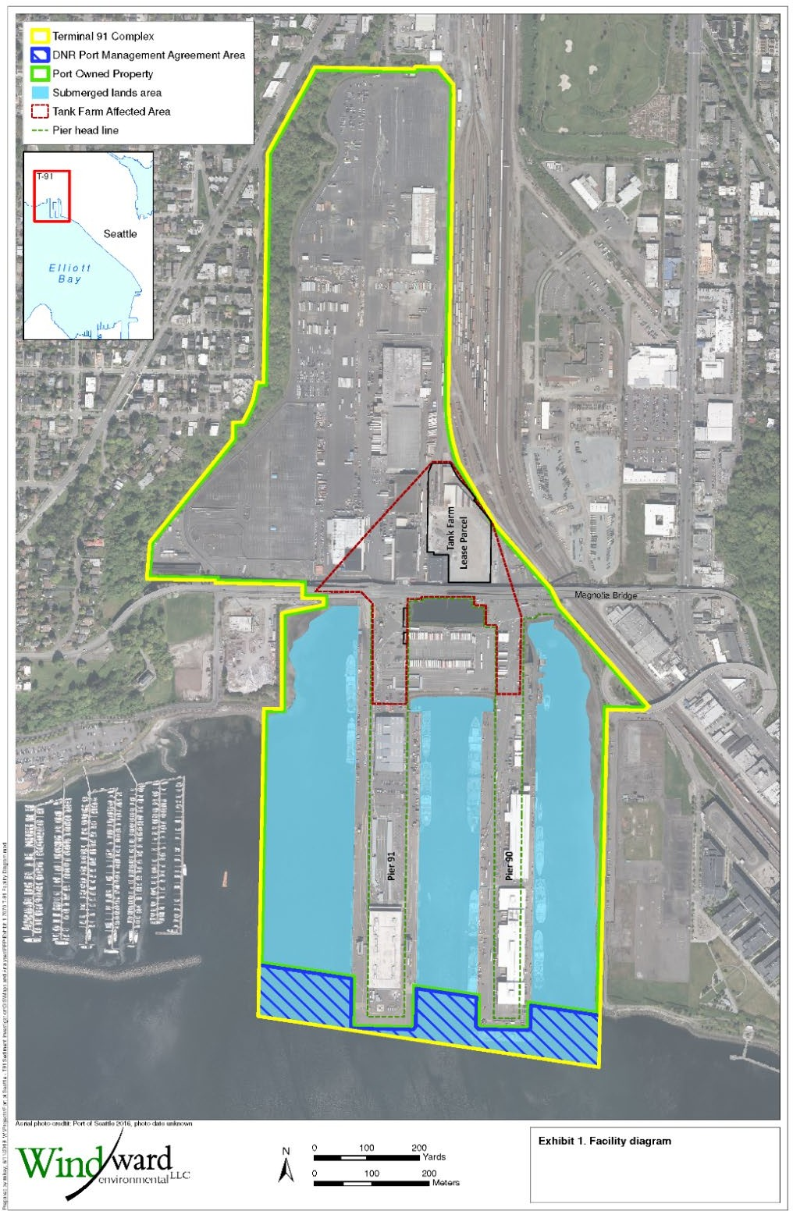
Figure 3: Terminal 91 site map.

The tank farm and uplands cleanup part of this site is complete. The remedy involved excavation, building and tank demolition, repaving, and installing an underground slurry wall to keep remaining groundwater contamination from entering Elliott Bay.
In the uplands, contaminants exceeding cleanup levels included:
- Metals: arsenic, copper, lead, mercury, and zinc—these are toxic.
- Polycyclic aromatic hydrocarbons (PAHs)—can cause cancer.
- Phthalates—these disrupt hormone production and can cause birth defects.
- Semi-volatile organic compounds (SVOCs)—can cause cancer.
- Polychlorinated biphenyls (PCBs)—some of these can cause cancer.
- Total petroleum hydrocarbons—some of these can cause cancer.

Submerged lands
Historic land use and industrial practices contaminated the sediment (mud) under Elliot Bay at this site. Our initial investigation found the following contaminants at levels of concern:
- Metals: arsenic, copper, lead, mercury, and zinc—these are toxic.
- Tributyltin—disrupts hormone production, can cause birth defects.
- PAHs—can cause cancer.
- Phthalates—these disrupt hormone production and can cause birth defects.
- SVOCs—can cause cancer.
- PCBs—some of these can cause cancer.
- Discarded military munitions (DMMs)—can explode and cause harm.

Cleanup process
The Port of Seattle must clean up the contamination at the site. There are six phases in the cleanup process: remedial investigation, feasibility study, cleanup plan, cleanup design, cleanup implementation, and monitoring and site use controls.
Interim actions or partial cleanups can occur at any time. There will be opportunities for public comment at each stage, except for cleanup implementation.
We apply both the Resource Conservation and Recovery Act (RCRA) and the Model Toxics Control Act (MTCA) regulations to clean up hazardous waste sites. The cleanup protects human health and the environment from dangerous wastes and chemicals.
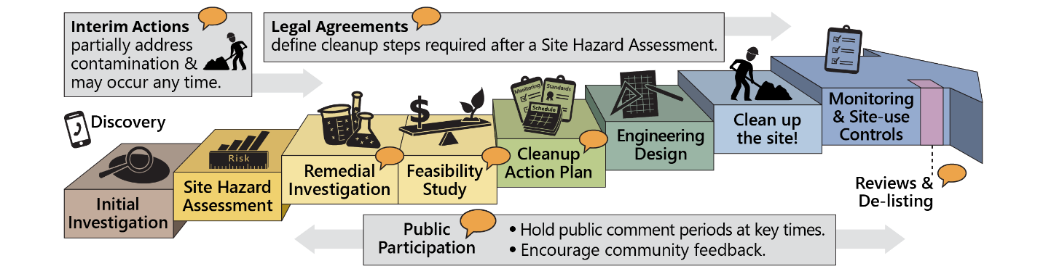

Figure 4: Formal cleanup process infographic (English).
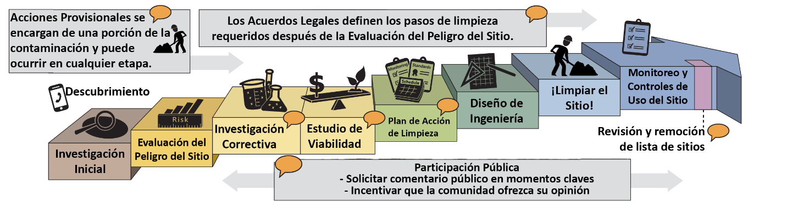
Figure 5: Formal cleanup process infographic (Spanish).
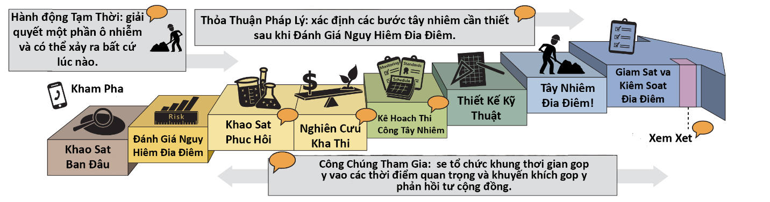
Figure 6. Formal cleanup process infographic (Vietnamese).
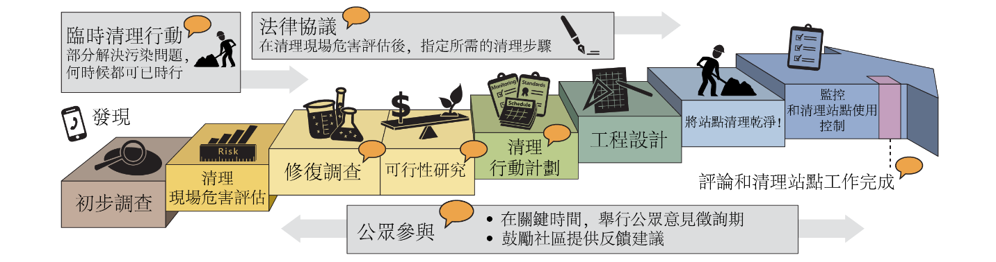
Figure 7. Formal cleanup process infographic (Chinese).

Area Community
The site is located on Elliot Bay, north of downtown Seattle and below the communities of Magnolia and Queen Anne. Queen Anne is the hill just east of the site. Magnolia is a neighborhood on a peninsula. Both neighborhoods are mostly residential.
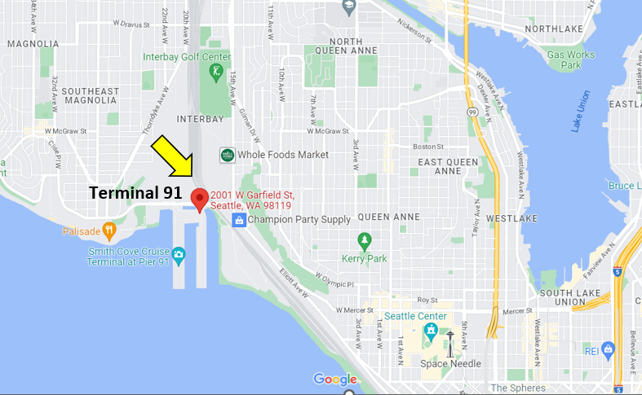
Figure 8: Google map showing location of Terminal 91.

Magnolia neighborhood
Magnolia is on a peninsula connected to the city by bridges. Much of the peninsula is occupied by Discovery Park, home to the Daybreak Star Indian Cultural Center. Daybreak Star is a conference center, a location for powwows, home for United Indians’ Sacred Circle Gallery, and headquarters for the United Indians.

Environmental Justice and Title VI
Environmental justice (EJ) promotes fair treatment of all people under environmental laws and policies, regardless of their race, color, national origin, or income.
In Washington (and across the United States), more people of color and/or low-income people live and work near industrial facilities, contaminated sites, and in neighborhoods without easy access to fresh food, green spaces, or clean air and water. These conditions negatively and unfairly affect their health and safety.
EJ strategies and compliance with Title VI of the Civil Rights Act are key to addressing these inequities—especially through public involvement. We make every effort to inform and involve all people. To do this, we use demographic information to design our messaging to fit the community.

Demographics
Below are the demographic indicators for the area around Terminal 91, including the people of color, low-income, and limited English-speaking populations.
Table 1. Study of the people living within 3.14 square miles around the site (population 17,396).
Socioeconomic Indicators | Value | State Average | Percentile in State
Demographic Index | 19% | 28% | 32
People of Color Population | 26% | 33% | 48
Low-Income Population | 12% | 24% | 27
Unemployment Rate | 3% | 5% | 46
Limited English Speaking | 2% | 4% | 63
Population with Less Than High School Education | 1% | 8% | 17
Population Under 5 Years of Age | 6% | 6% | 59
Population Over 64 Years of Age | 13% | 15% | 41

People of color population
The EJSCREEN for Terminal 91 did not have any socioeconomic indicators above the state’s 80th percentile for people of color populations.
Census data from the 2016–2020 American Community Survey indicates that the largest people of color populations near the Site are Asian (1,940 people), making up 11 percent of the population and Hispanic (1,024 people), making up 6 percent of the total population.

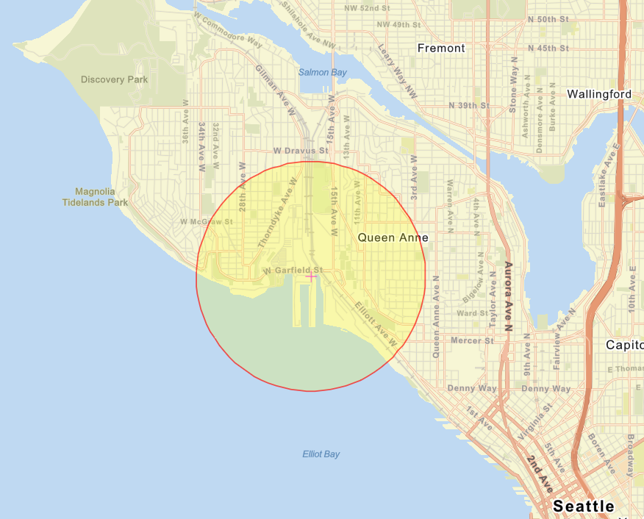
Figure 9: Environmental justice (EJ) demographic screening boundaries around Terminal 91, from EPA's EJSCREEN mapping tool.

English language proficiency
According to EJSCREEN census data, the households that speak English “less than very well” make up 3 percent of the area population. Spoken languages include Spanish, German, other West Germanic languages, Russian, Polish or other Slavic languages, other Indo-European languages, Chinese (including Mandarin and Cantonese), and other Asian and Pacific Island languages.
The population near the site includes non-English speaking households. The “linguistically isolated” households according to census data from 2016–2020 include the following non-English spoken languages:
- Asian-Pacific Islander Languages (63%)
- Other Indo-European Languages (28%)
- Spanish (8%)

Outreach activities and language access
Based on this analysis, we will conduct the following outreach activities for this site:
- Contact cultural organizations and leaders in these communities.
- Provide information about requesting language services in all public materials.
- Provide information for this site by request only for all basic outreach materials.
- Translate all documents that are vital or critical to well-being for language groups that are either 5% of the population or more than 1,000 people.
To request translation services, please contact:
Janelle Anderson, Community Outreach & Environmental Education Specialist
Washington Department of Ecology
Northwest Regional Office
P.O. Box 330316
Shoreline, WA 98133
Phone: 425-301-6454
Email: Janelle.anderson@ecy.wa.gov
Ecology will contact cultural community organizations as part of our outreach and provide information in other languages following federal guidance. The non-English languages most widely spoken in this area are Chinese and Spanish. When appropriate, we will provide outreach materials in these languages. We strive to make our public participation efforts as inclusive as possible and welcome your input about how to reach the nearby community.

Tribal involvement
Ecology invites the federally recognized Suquamish Tribe to engage in decision-making during the process on a government-to-government basis.

Public Participation Activities
Members of the public may ask questions, submit informal comments, or share site information at any time. Interested parties don’t need to wait for a formal public comment period to contact Ecology.
However, to be included in the formal site record, comments about the site investigation, cleanup alternatives, or cleanups must be submitted during formal comment periods. In addition, the public is invited to review site documents before they become final. This is the most direct way to learn more about the site and be involved in the cleanup’s decision-making.

How we share information with the community
During specific stages of the cleanup, Ecology will mail notices about public comment periods to addresses around the site. The mailing list area varies depending on the type of contamination and its location, but the list will at least include addresses within a quarter-mile radius of the site and other interested organizations and individuals. These notices will provide general information about the site, contact information for submitting comments, and times and locations of public meetings or hearings—or how to request one if a meeting is not yet scheduled.
Ecology may also develop documents outside of comment periods to keep the community updated on the site’s status. These informational documents will be available online and at document repositories. Print copies may be mailed to the nearby community if we feel the message warrants the extra costs.
Comment period notices and other site announcements may also be posted in the community (for example, in local businesses, schools, and libraries).

Postal mailing list
Ecology maintains a mailing list that includes addresses near the site. This mailing list also includes local, state, Tribal and federal government contacts.
Everyone will receive public comment notices when draft documents are available.
We’ll add additional individuals, organizations, and other interested parties to the mailing list as requested. If you would like to be added to the mailing list for this site, please contact Janelle Anderson at 425-301-6454 or janelle.anderson@ecy.wa.gov.

Site Register
Public comment periods, events, and other cleanup notices are published in Ecology’s Site Register. To receive the Site Register by email, please subscribe online, or contact Sarah Kellington at sarah.kellington@ecy.wa.gov or 360-280-3167.

Newspaper display ads or legal notices
We will announce public comment periods and events for this site in ads or notices published in the Seattle Times, elSieteDias, and Northwest Asian Weekly.

Ecology’s website and social media platforms
We have a website for Terminal 91 with more information and related documents. Information may also be shared about cleanup sites through social media sites, news releases, and Ecology’s blog.

Document repositories
You may review documents in person at this location by appointment:
Washington State Department of Ecology
Northwest Region Office
15700 Dayton Ave N.
Shoreline, WA 98133-9716
Reception (24-hour): 206-594-0000
To schedule an appointment, please contact:
Michael Hart
michael.hart@ecy.wa.gov
Public Disclosure Coordinator

Signs around the cleanup site
We may also display signs with information about project status, traffic impacts, and health risks around the cleanup site.

How to share information with us
You may ask questions, submit informal comments, or share site information with us at any time. Please contact Janelle Anderson at 425-301-6454 or janelle.anderson@ecy.wa.gov.
To be included in the formal site record, comments must be submitted during formal public comment periods. At minimum, MTCA requires 30-day public comment periods for draft cleanup documents and 14-day comment periods for SEPA documents. SEPA documents are often made available for public review with other cleanup documents. In that case, we combine the comment periods, and they will last at least 30 days. We may hold comment periods longer than 30 days.
We may also identify public concerns and cleanup goals by meeting with and soliciting information from interested community members and organizations. To collaborate with us about this site, please contact Janelle Anderson at 425-301-6454 or janelle.anderson@ecy.wa.gov.

Public comment periods
Formal 30-day comment periods allow members of the public to comment on draft documents, legal agreements, and proposed cleanup actions. If there is enough interest, Ecology may extend the public comment period. When Ecology oversees SEPA determinations, we hold comment periods for at least two weeks and comment periods may last 30 days or more when other cleanup documents are available for review at the same time.
Following a comment period, we publish all the input we received and respond to comments and questions. If the comments result in significant changes to the cleanup documents, then the documents will be revised and re-issued for public review. If the comments don’t result in significant changes, they become final.

Public events
We hold public meetings, workshops, open houses, and public hearings based on community interest. If we haven’t scheduled a meeting, we will hold one if 10 people request it—we may extend the public comment period so the meeting occurs during it.
Events are held at near the site at venues that meet Americans with Disabilities Act standards. Public meetings, workshops, open houses, and hearings are announced in advance using a variety of methods.

Americans with Disabilities Act
The Department of Ecology is committed to providing people with disabilities access to information and services by meeting or exceeding the requirements of the Americans with Disabilities Act (ADA), Section 504 and 508 of the Rehabilitation Act, and Washington State Policy #188.
To request an ADA accommodation, contact the Ecology by phone at 360-407-6700 or email at hwtrpubs@ecy.wa.gov. For Washington Relay Service or TTY call 711 or 877-833-6341. Visit Ecology's ADA website for more information.

PPP Amendments
Ecology developed this PPP following MTCA regulations (WAC 173-340-600). We review it as the cleanup progresses and amend it as necessary. You may suggest amendments to Janelle Anderson by phone at 425-301-6454 or email janelle.anderson@ecy.wa.gov.
This PPP includes information for the public regarding opportunities for public involvement and comment. The planned outreach activities will keep the public informed and provide ways for people to communicate their concerns and questions.
If you feel the planned outreach activities are insufficient or need changes, we welcome your feedback. Different outreach activities or outreach tools can be used right away, with or without updating this plan.

List of Abbreviations and Acronyms
Table 2. List of abbreviations and acronyms.
Abbreviation or Acronym | Definition
ADA | Americans with Disabilities Act
BEI | Burlington Environmental Inc.
Cleanup | Corrective action
Corps | The Army Corps of Engineers
DMM | Discarded military munitions
Ecology | Washington State Department of Ecology
EJ | Environmental Justice
EJScreen | EPA’s Environmental Justice Screening and Mapping Tool
EPA | US Environmental Protection Agency
Mud | Sediment
MTCA | Model Toxics Control Act
PAHs | Polycyclic aromatic hydrocarbons
PCBs | Polychlorinated biphenyls
PLP | Potentially liable party
PPP, Plan | Public participation plan
RCRA | Resource Conservation and Recovery Act
Sediments | Submerged lands
SEPA | State Environmental Policy Act
Site | Area where hazardous substances at the facility are currently located
SVOCs | Semi-volatile organic compounds
T91 | Terminal 91
Tank farm | Existing aboveground fuel tanks
TSD | Treatment, storage, and disposal facility
WAC | Washington Administrative Code

https://www.portseattle.org/page/terminal-91-information
www.ecology.wa.gov/contact
www.ecology.wa.gov/accessibility
Ecology currently does not have a citizen technical advisor for providing technical assistance to citizens on issues related to the investigation and cleanup of the site.
www.ecology.wa.gov/ppgrants
https://apps.ecology.wa.gov/publications/publications/9406.pdf
https://apps.ecology.wa.gov/publications/SummaryPages/1909166.html
https://apps.ecology.wa.gov/publications/parts/1909166part2.pdf
https://ejscreen.epa.gov/mapper/
https://ejscreen.epa.gov/mapper/
Guidance to Environmental Protection Agency Financial Assistance Recipients Regarding Title VI Prohibition Against National Origin Discrimination Affecting Limited English Proficient Persons, 69 Fed. Reg. § 35602 (June 15, 2004).
ecology.wa.gov/Regulations-Permits/Guidance-technical-assistance/Site-Register-lists-and-data
https://public.govdelivery.com/accounts/WAECY/subscriber/new?topic_id=WAECY_118
https://www.seattletimes.com/
https://elsietedias.com/
https://nwasianweekly.com/
https://apps.ecology.wa.gov/cleanupsearch/site/2674#site-documents
https://ecology.wa.gov/About-us/Get-to-know-us/News
https://ecology.wa.gov/blog
https://ecology.wa.gov/accessibility

