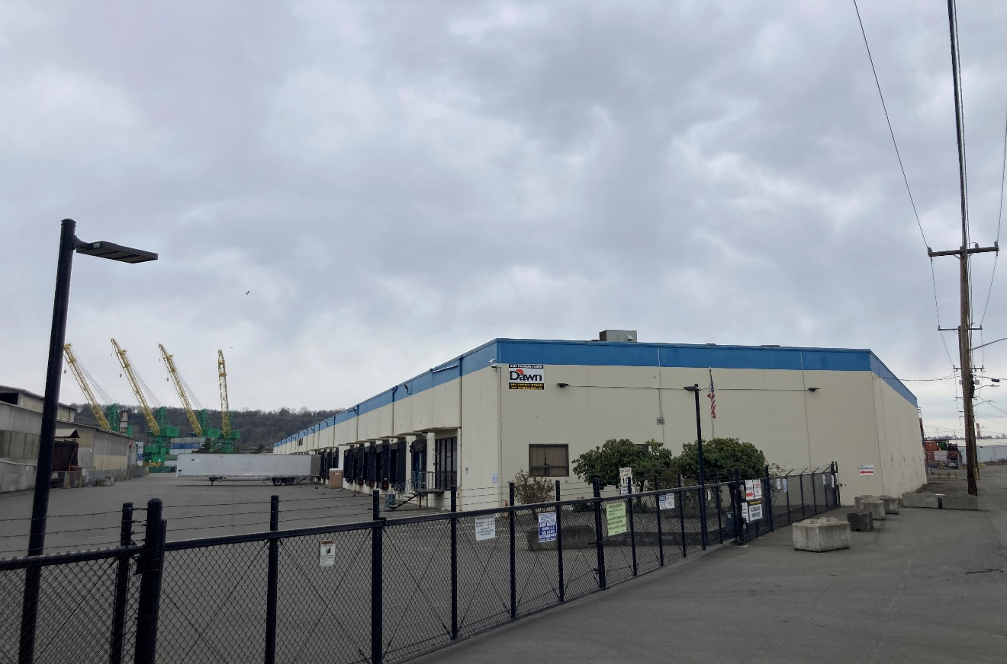



Public Participation Plan

Dawn Food Products Cleanup Site  
6901 Fox Avenue South  
Seattle, WA

**Toxics Cleanup Program**

Washington State Department of Ecology

Northwest Regional Office

Shoreline, Washington

July 2023

Publication Information

This document is available on the Department of Ecology’s website at:

<https://apps.ecology.wa.gov/cleanupsearch/site/16678>

Cover photo credit

* Ecology, March 2023

Related Information

* Cleanup site ID: 16678
* Facility site ID: 3505

Contact Information

**Toxics Cleanup Program**

**Northwest Regional Office**

Lower Duwamish Waterway email: [LDW@ecy.wa.gov](mailto:LDW@ecy.wa.gov)

Augie Nuszer

Outreach Specialist

(425) 533-5537, [Augie.Nuszer@ecy.wa.gov](mailto:Augie.Nuszer@ecy.wa.gov)

David Butler

Site Manager

(206) 518-3513, [David.Butler@ecy.wa.gov](mailto:David.Butler@ecy.wa.gov)

15700 Dayton Ave N.

Shoreline, WA 98133

Phone: (206) 594-0000

**Website[1]:** [Washington State Department of Ecology](https://ecology.wa.gov/contact)

ADA Accessibility

The Department of Ecology is committed to providing people with disabilities access to information and services by meeting or exceeding the requirements of the Americans with Disabilities Act (ADA), Section 504 and 508 of the Rehabilitation Act, and Washington State Policy #188. **To request an ADA accommodation, contact Ecology by phone at 360-407-6831 or email at** [ecyadacoordinator@ecy.wa.gov](mailto:ecyadacoordinator@ecy.wa.gov)**. For Washington Relay Service or TTY call 711 or 877-833-6341. Visit** [**Ecology's website**](https://ecology.wa.gov/About-us/Accountability-transparency/Our-website/Accessibility) **for more information.**

Department of Ecology’s Regional Offices

Map of Counties Served

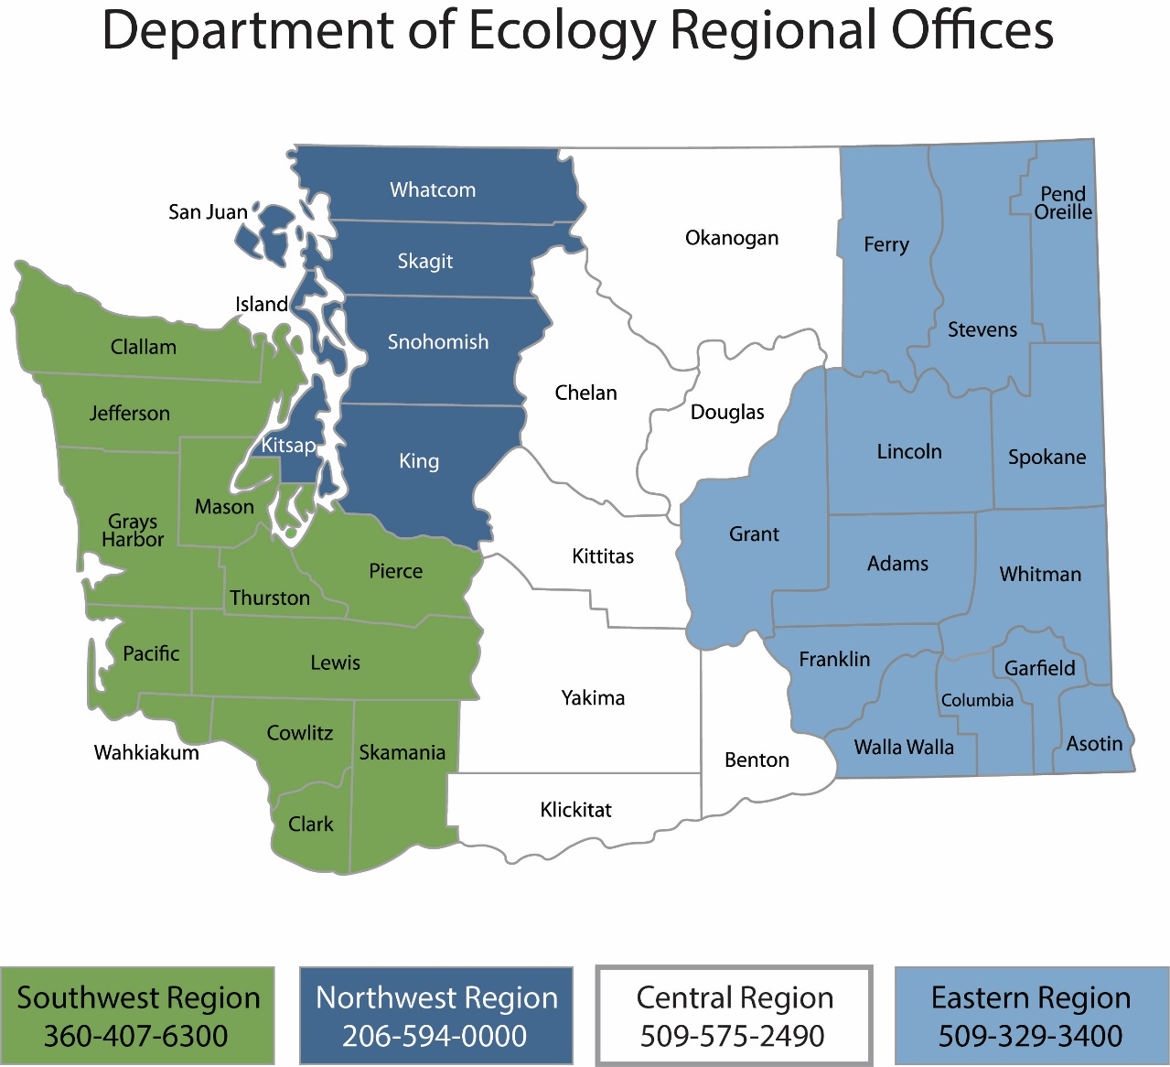

| Region | Counties served | Mailing Address | Phone |
| --- | --- | --- | --- |
| Southwest | Clallam, Clark, Cowlitz, Grays Harbor, Jefferson, Mason, Lewis, Pacific, Pierce, Skamania, Thurston, Wahkiakum | PO Box 47775  Olympia, WA 98504 | 360-407-6300 |
| Northwest | Island, King, Kitsap, San Juan, Skagit, Snohomish, Whatcom | PO Box 330316 Shoreline, WA 98133 | 206-594-0000 |
| Central | Benton, Chelan, Douglas, Kittitas, Klickitat, Okanogan, Yakima | 1250 W Alder St  Union Gap, WA 98903 | 509-575-2490 |
| Eastern | Adams, Asotin, Columbia, Ferry, Franklin, Garfield, Grant, Lincoln, Pend Oreille, Spokane, Stevens, Walla Walla, Whitman | 4601 N Monroe  Spokane, WA 99205 | 509-329-3400 |
| Headquarters | Across Washington | PO Box 46700  Olympia, WA 98504 | 360-407-6000 |

Public Participation Plan

Dawn Food Products Cleanup Site  
6901 Fox Ave S, Seattle WA

Toxics Cleanup Program

Washington State Department of Ecology

Northwest Regional Office

Shoreline, WA

**July 2023**

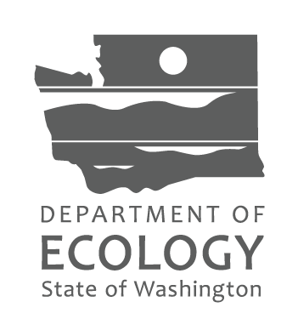

Table of Contents

List of Figures 5

Figures 5

Public Involvement in Contamination Cleanup 6

Site contacts 6

Public Participation Grants 6

Washington’s Cleanup Laws 7

Model Toxics Control Act 7

State Environmental Policy Act 7

Site Information 9

Land use 9

How the site became contaminated 10

Contamination 10

Cleanup plans 10

Area community 10

Public Participation Activities 13

How we share information with the community 13

How to share information with us 15

Americans with Disabilities Act 16

Plan Amendments 16

## List of Figures

### Figures

Figure 1: Steps in Washington's Cleanup Process……………………………………………………………………….8

Figure 2: Aerial view of Dawn Food Products Parcel…………………………………………………………………..9

Figure 3: Map of Dawn Food Products Location……………………………………………………………………….10

Figure 4: Washington Environmental Health Disparities Map for South Park and Georgetown…………….11

Figure 5: EPA EJScreen generated maps of the outreach impact area for this project……………..…12

## Public Involvement in Contamination Cleanup

The Washington State Department of Ecology (Ecology) developed this public participation plan (plan) in cooperation with Bridge Point Seattle 130 LLC (Bridge Point), the party responsible for cleanup costs. The purpose of the plan is to promote meaningful community involvement during cleanup.

The plan describes ways Ecology will inform the public about contamination investigations and cleanup options throughout the cleanup process. Ecology encourages the public to learn about and get involved in decision-making opportunities. This plan identifies how and when the public can get involved during different stages of the investigation and cleanup of contamination.

### Site contacts

To be included in the site record, comments about the cleanup process must be submitted during comment periods. Questions and informal comments or information about the site’s history are welcome anytime.

#### Toxics Cleanup Program

Northwest Regional Office

15700 Dayton Ave N

Shoreline, WA 98133

David Butler, Site Manager

[David.Butler@ecy.wa.gov](mailto:David.Butler@ecy.wa.gov)

(206) 518-3513

Augie Nuszer, Outreach Specialist

[Augie.Nuszer@ecy.wa.gov](mailto:Augie.Nuszer@ecy.wa.gov)

(425) 533-5537Potentially Liable Persons

Bridge Point Seattle 130 LLC

9525 Bryn Mawr Ave

Suite 700

Rosemont, IL 60018

### Public Participation Grants

Grants may be available to neighborhood committees, non-profits, and other groups interested in the site. For contaminated sites, these funds can be used to:

* Hire an expert to help interpret technical information[2]
* Conduct activities that enhance the public’s understanding of, and participation in, the cleanup process

For more information about public participation grants, please contact Faith Wimberley at 425‑275-7285 or [faith.wimberley@ecy.wa.gov](mailto:faith.wimberley@ecy.wa.gov). You may also visit the [Public Participation Grant website](http://www.ecology.wa.gov/About-us/How-we-operate/Grants-loans/Find-a-grant-or-loan/Public-participation-grants).[3]

## Washington’s Cleanup Laws

Ecology uses the Model Toxics Control Act (MTCA) and accompanying regulations for cleanup activities.

This plan is required under MTCA, a law that passed in 1989. MTCA provides guidelines for contaminated site cleanup in Washington State and sets standards to ensure the cleanup protects human health and the environment.

### Model Toxics Control Act

MTCA began as a grassroots citizen’s initiative in 1988 and started the process of systematically cleaning up contaminated sites in Washington. Under MTCA, a current or past property owner or operator may be held responsible for cleaning up contamination on, or coming from, their property to standards that are safe for human health and the environment.

Ecology enacts MTCA and oversees cleanups in the state and issues regulations and guidance governing those cleanups. The regulations are found in [Chapter 173-340 Washington Administrative Code (WAC)](https://apps.ecology.wa.gov/publications/publications/9406.pdf).[4] Ecology investigates reports of property contamination, and if the contamination is seen as a significant threat to human health or the environment, the contaminated property is placed on the Confirmed and Suspected Contaminated Sites List, and the cleanup process begins.

Public participation is an important part of cleanup under the MTCA process. Participation needs are assessed at each cleanup site according to the level of public interest and the degree of risk posed by the contamination. Individuals who live near the site, community groups, businesses, government, other organizations, and interested parties have the opportunity to get involved by commenting on the cleanup process.

Under the MTCA, the cleanup process generally includes multiple steps (see Figure 1 on page 8), with opportunities for the public to review and comment on cleanup documents. In addition, a partial cleanup (called an interim action) can occur at any time during the cleanup process. The public is provided an opportunity to review and comment on planned interim action work as well.

### State Environmental Policy Act

MTCA cleanups also require evaluation under the State Environmental Policy Act (SEPA; [Chapter 197-11 WAC](https://apps.leg.wa.gov/wac/default.aspx?cite=197-11)[5]). Under SEPA, the potential for significant adverse environmental impacts from a project or action must be evaluated by state and local agencies when making decisions. This evaluation is subject to public review and comment in parallel with cleanup documents.

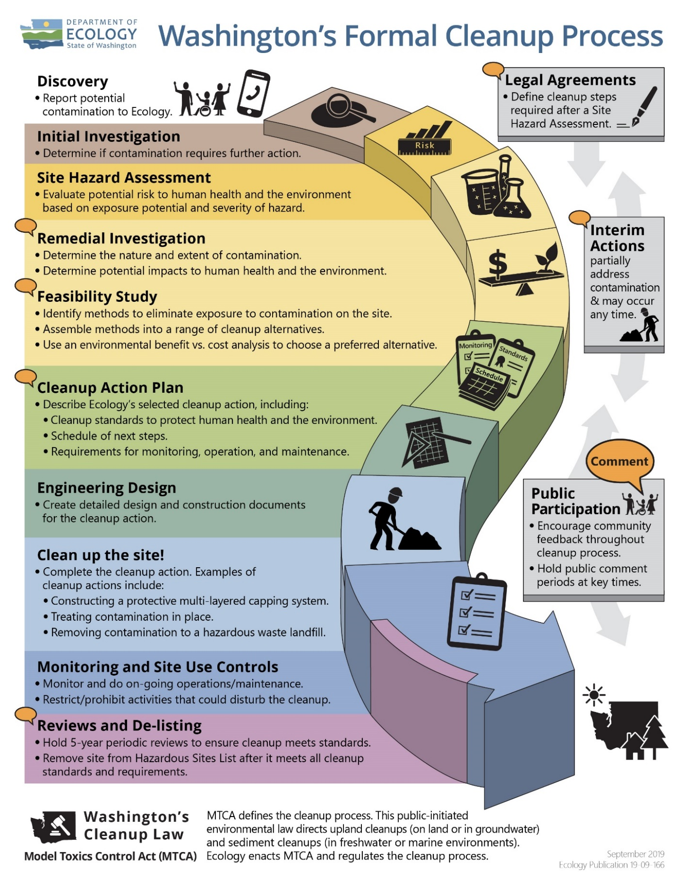

Figure 1: Steps in Washington's Cleanup Process[6]

## Aerial view of Dawn Food Products Cleanup SiteSite Information

Figure 2: Aerial view of Dawn Food Products Parcel

### Land use

Dawn Food Products is located at 6901 Fox Avenue South in Seattle, WA. The approximately 5.4-acre property is in an industrial area near Seattle’s Georgetown neighborhood. This property is located adjacent to the Lower Duwamish Waterway (LDW) Superfund Site.

Historical evidence indicates that the property has been used since at least 1917 for various commercial and industrial uses including ship building, sheet metal fabrication and generator manufacturing, electric thermostat manufacturing, paint spraying, general storage, and offices. Ship building operations occurred primarily in the southwestern portion of the property. Roughly seven structures were removed and replaced with the existing warehouse in 1977. The existing structure is approximately 128,800 square feet (2.96 acres), in which dry foods and cooking oils are currently stored. The warehouse has been used by multiple food companies over the decades.

### How the site became contaminated

Ship building activities occurred between 1917 and 1966. This, along with other industrial uses contributed to the presence of contamination at this site. In 1996, soil and groundwater contamination were found following a limited subsurface investigation for the property. Subsequent investigations were conducted in 2020 to confirm the previous data and to find any new contamination.

### Contamination

Due to historic land use and industrial practices, soil and groundwater at the site are contaminated with:

* Metals
* Total petroleum hydrocarbons (TPH) from gasoline
* Carcinogenic Polycyclic Aromatic Hydrocarbons (cPAHs)
* Halogenated solvents

### Cleanup plans

In 2023, Ecology is issuing a legal agreement (Agreed Order) for public review that requires Bridge Point to investigate environmental conditions, complete a Remedial Investigation (RI), Feasibility Study (FS), and a draft Cleanup Action Plan (dCAP). Each of these steps will require a public comment period.

### Figure showing Dawn Food Products location in relation to the Georgetown and South Park neighborhoodsArea community

Georgetown Neighborhood

#### Neighborhood

The Site is in the Georgetown neighborhood of the City of Seattle and across the waterway from South Park. The Lower Duwamish Waterway (LDW) borders the Site to the West. The blocks surrounding the site have a mixture of residential, commercial, and industrial uses.

Dawn Food Products

Georgetown is within Washington’s 7th Congressional District, 34th Legislative District, King County Council’s 8th District, and Seattle’s City Council District 2. The Site is adjacent to the Lower Duwamish Waterway Superfund Site and inside Ecology’s Lower Duwamish Waterway Source Control Area. The cleanup and development of sites in the area generate significant community, regional, and statewide interest. Exposure to contaminants in the LDW (through harvesting of fish and shellfish or other cultural practices) is of concern.

Figure 3: Map of Dawn Food Products Location

South Park Neighborhood

The South Park and Georgetown neighborhoods include industrial areas that are part of the Seattle’s manufacturing and industrial center, providing thousands of jobs. The neighborhoods’ median household income is below citywide average while the percentage of the population living below the poverty level is above the citywide average. The industrial portion of the area is vulnerable to sea level rise, and flood risk is high in many parts of the neighborhood. Exposure from particulate matter from industrial practices and car exhaust is a public health concern as it is linked to a range of illnesses.

The Muckleshoot and SuquamishTribes are federally recognized tribes that use the river for fishing and cultural practices. Ecology will ensure that the Tribes will be engaged with any decision-making process for this site and have ample opportunity to be involved throughout the process on a government-to-government basis. We will also engage with the Duwamish Tribe.

#### Sensitive populations

The [Washington Environmental Health Disparity Map](https://fortress.wa.gov/doh/wtnibl/WTNIBL/)[7] shows environmental risk based on threat and vulnerability (See Figure 7). Environmental risk is ranked on a scale of 1-10 (low to high). The census tract the site is within and the closest one next to it rank 10 for environmental risk. While there are some differences between the South Park and Georgetown neighborhoods, both rank high in overall Environmental Health Disparities, with South Park and Georgetown ranked at 10.

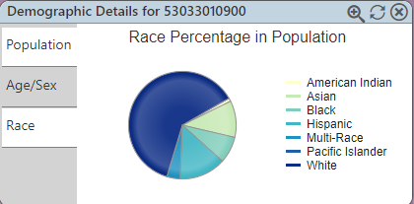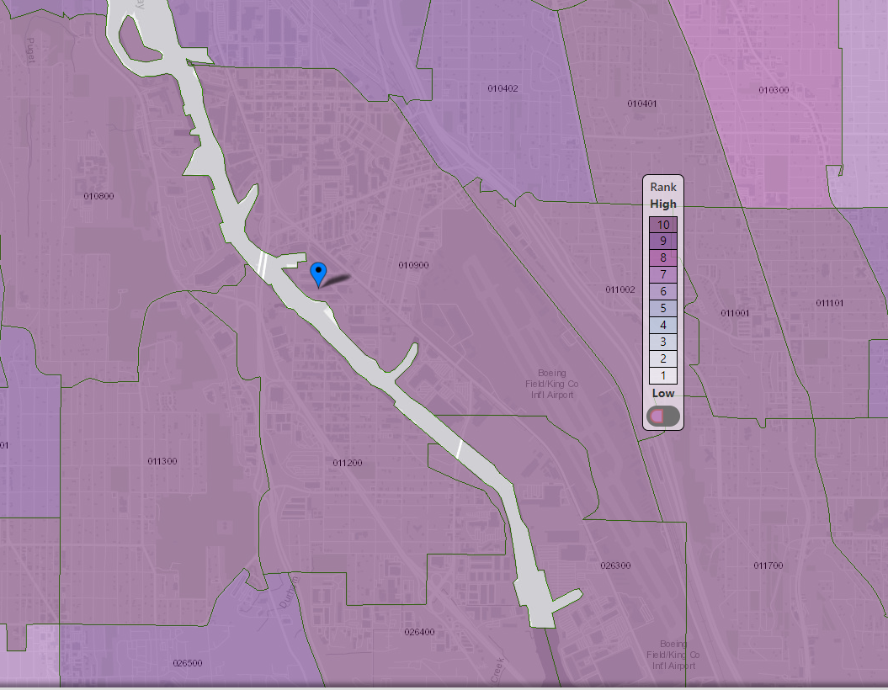

Figure 4: Washington Environmental Health Disparities Map for South Park and Georgetown

**Dawn Food Products**

#### Environmental Justice

The data below was generated for a one-mile area around the site using the Environmental Protection Agency’s [Environmental Justice Screening and Mapping Tool](https://ejscreen.epa.gov/mapper/index.html) (EJScreen)[8]. The data reveals a diverse and linguistically isolated population. Reaching underserved populations within the project area is a priority.

**Demographic Indicators nearing the EPA 80th percentile threshold:**

* People of Color – 76th percentile
* Limited English Speaking – 78th percentile

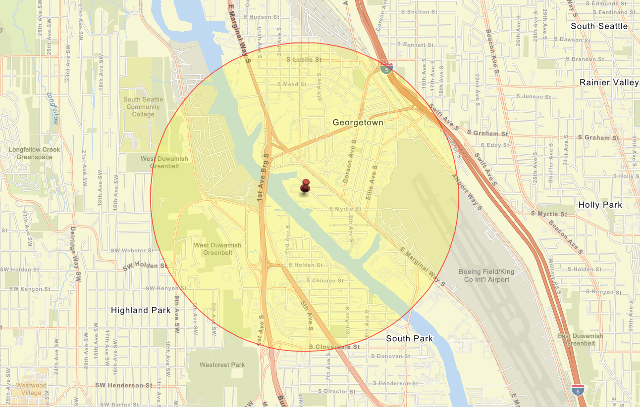 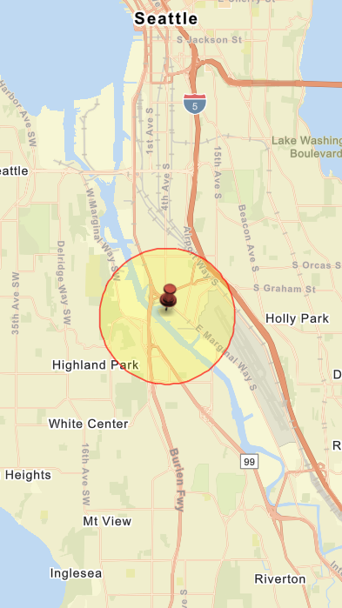

Figure 5: EPA EJScreen generated maps of the outreach impact area for this project

Ecology will plan our public outreach to consider this population’s needs. Ecology will reach out to cultural and community organizations as part of our outreach and provide information in other languages as appropriate following federal guidance. The non-English language(s) most widely spoken in the area Spanish (12%) and Vietnamese (4%). When appropriate, Ecology will provide outreach in these languages. Ecology has also identified Chinese and Khmer as other widely spoken languages for Ecology’s Lower Duwamish Waterway area outreach. We strive to make our public participation efforts as inclusive as possible and welcome your input about how to best reach the nearby community.

Outreach in the LDW Source Control and EPA Superfund impact area has a long history, generates significant community interest, and must be conducted in that context. These historic neighborhoods, where people live side-by-side with industry, require extra attention and a delicate touch when it comes to outreach. Georgetown and South Park are two of the most diverse communities in the city and have large immigrant populations. Reaching traditionally underserved populations within the project area is a priority, so we will tailor our outreach to meet this goal.

## Public Participation Activities

Members of the public may ask questions, submit informal comments, or share site information at any time. Interested parties do not need to wait for a formal public comment period to contact Ecology.

However, to be included in the formal site record, comments about the site investigation, cleanup alternatives, or cleanups must be submitted during formal comment periods. In addition, the public is invited to review site documents before they become final. This is the most direct and influential way to learn more about the site and be involved in the cleanup’s decision-making.

### How we share information with the community

During specific stages of the cleanup, Ecology will mail notices about public comment periods to addresses surrounding the site. The mailing list area will include addresses within a 1-mile radius of the site and other interested organizations and individuals. These notices will provide general information about the site, contact information for submitting comments, and times and locations of public meetings or hearings or how to request one if not yet scheduled.

Ecology may also develop documents outside of comment periods to keep the community updated on the site’s status. These informational documents will be available online and at document repositories. Print copies may be mailed to the nearby community if we feel the message warrants the associated cost and resources.

Comment period notices and other site announcements may also be posted in various locations throughout the community (for example, local businesses, schools, libraries).

#### Postal mailing list

Ecology maintains a mailing list that includes addresses within a 1-mile radius of the site and relevant local, state, and federal government contacts.

These people receive public comment notices when draft documents are available.

We will add additional individuals, organizations, and other interested parties to the mailing list as requested. If you would like to be added to the mailing list for this site, please contact Augie Nuszer at 425-533-5537 or [Augie.Nuszer@ecy.wa.gov](mailto:Augie.Nuszer@ecy.wa.gov).

#### Site Register

Public comment periods, events, and other cleanup notices are published in Ecology’s [*Site Register*](https://ecology.wa.gov/Regulations-Permits/Guidance-technical-assistance/Site-Register-lists-and-data).[9] To receive the *Site Register* by email, please [subscribe online](https://public.govdelivery.com/accounts/WAECY/subscriber/new?topic_id=WAECY_118),[10] or contact Sarah Kellington at [sarah.kellington@ecy.wa.gov](mailto:sarah.kellington@ecy.wa.gov) or 360-280-3167.

#### Newspaper display ads or legal notices

We announce public comment periods and events in ads or notices published in *The Seattle Times.* We will also publish notice on our [Public Input & Events Listing](https://ecology.wa.gov/Events/Search/Listing).[11]

#### Email lists

Ecology maintains an email list to update interested persons about this site. If you would like to be added to the email list for this site, please contact Augie Nuszer at 425-533-5537 or [Augie.Nuszer@ecy.wa.gov](mailto:Augie.Nuszer@ecy.wa.gov).

#### Ecology’s website and social media platforms

We maintain a website for the [Dawn Food Products](https://apps.ecology.wa.gov/cleanupsearch/site/16678) site.[12] The website provides site information, and you may download cleanup documents.

We may also share information about cleanup sites through [news releases, our ECOconnect blog, and social media](https://ecology.wa.gov/About-us/Get-to-know-us/News).[13]

#### Places to see print documents

During public comment periods when review locations are accessible, you can find print documents at the following locations:

Seattle Library – South Park Branch

8604 8th Ave S

Seattle, WA 98108

(206) 615-1688

Washington Department of Ecology

Northwest Regional Office

15700 Dayton Ave N

Shoreline, WA 98133

To schedule an appointment, please contact the Northwest Region Office Central Records staff

at 425-649-7239 or [nwro_public_request@ecy.wa.gov](mailto:nwro_public_request@ecy.wa.gov).

#### Signs around the cleanup site

We may also install signs displaying information about project status, traffic impacts, and health risks around the cleanup site.

### How to share information with us

At minimum, MTCA requires 30-day public comment periods for draft cleanup documents and 14-day comment periods SEPA documents. SEPA documents are often made available for public review with other cleanup documents. In that case, we combine the comment periods, and they last at least 30 days. We may hold comment periods longer than 30 days.

We may also identify public concerns and cleanup goals by meeting with and soliciting information from interested community members and organizations. To collaborate with us about this site, please contact Augie Nuszer at 425-533-5537 or [Augie.Nuszer@ecy.wa.gov](mailto:Augie.Nuszer@ecy.wa.gov).

#### Public comment periods

Formal 30-day comment periods allow interested members of the public to comment on draft documents, legal agreements, and proposed cleanup actions. If there is significant interest, Ecology may extend the public comment period. When Ecology oversees SEPA determinations, we hold comment periods for at least two weeks and may extend to 30 days or more when other cleanup documents are concurrently available for review.

Following the comment period, we publish all the input we received and respond to significant comments and questions, as appropriate. If the comments result in significant changes to the cleanup documents, then the documents will be revised and re-issued for public review. If the comments do not result in significant changes, then they become final.

#### Public events

We hold in-person and online public meetings, workshops, open houses, and public hearings based on community interest. If we have not scheduled a meeting, we will hold one if 10 people request it, and this may cause us to extend a public comment period so the meeting occurs during it.

Events are held at locations close to the site that meet Americans with Disabilities Act standards. Public meetings, workshops, open houses, and hearings are always announced in advance using a variety of methods.

### Americans with Disabilities Act

To request ADA accommodation for disabilities, or printed materials in a format for the visually impaired, contact the Ecology ADA Coordinator at 360-407-6831 or ecyadacoordinator@ecy.wa.gov, or visit our [ADA website](https://ecology.wa.gov/About-us/Accessibility-equity/Accessibility).[14] People with impaired hearing may call Washington Relay Service at 711. People with speech disability may call TTY at 877-833-6341.

## Plan Amendments

Ecology developed this plan following MTCA regulations (WAC 173-340-600). We review it as the cleanup progresses and amend it as necessary. You may suggest amendments to Augie Nuszer at 425-533-5537 or [Augie.Nuszer@ecy.wa.gov](mailto:Augie.Nuszer@ecy.wa.gov).This plan includes information for the public regarding opportunities for public involvement and comment. The outreach activities discussed in this section reflect Ecology’s current plans for keeping the public informed and providing ways for those interested in the site to communicate their concerns and questions to us.

If you feel the planned outreach activities and mechanisms described in this plan are insufficient, or should otherwise be modified, we will work to find solutions. New outreach activities or outreach tools established as a result can be implemented right away, with or without amending this plan.

1. www.ecology.wa.gov/contact
2. Ecology currently does not have a citizen technical advisor for providing technical assistance to citizens on issues related to the investigation and cleanup of the site.
3. ecology.wa.gov/About-us/How-we-operate/Grants-loans/Find-a-grant-or-loan/Public-participation-grants
4. https://apps.ecology.wa.gov/publications/publications/9406.pdf
5. https://apps.leg.wa.gov/wac/default.aspx?cite=197-11
6. https://apps.ecology.wa.gov/publications/SummaryPages/1909166.html
7. https://fortress.wa.gov/doh/wtnibl/WTNIBL/
8. https://ejscreen.epa.gov/mapper/index.html
9. ecology.wa.gov/Regulations-Permits/Guidance-technical-assistance/Site-Register-lists-and-data
10. https://public.govdelivery.com/accounts/WAECY/subscriber/new?topic_id=WAECY_118
11. ecology.wa.gov/Events/Search/Listing
12. <https://apps.ecology.wa.gov/cleanupsearch/site/16678>
13. ecology.wa.gov/About-us/Get-to-know-us/News
14. https://ecology.wa.gov/About-us/Accessibility-equity/Accessibility