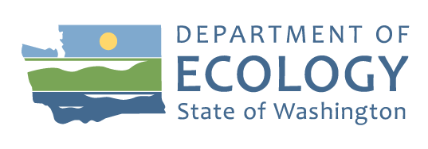
Toxics Cleanup Program

Unocal Bulk Plant 0766
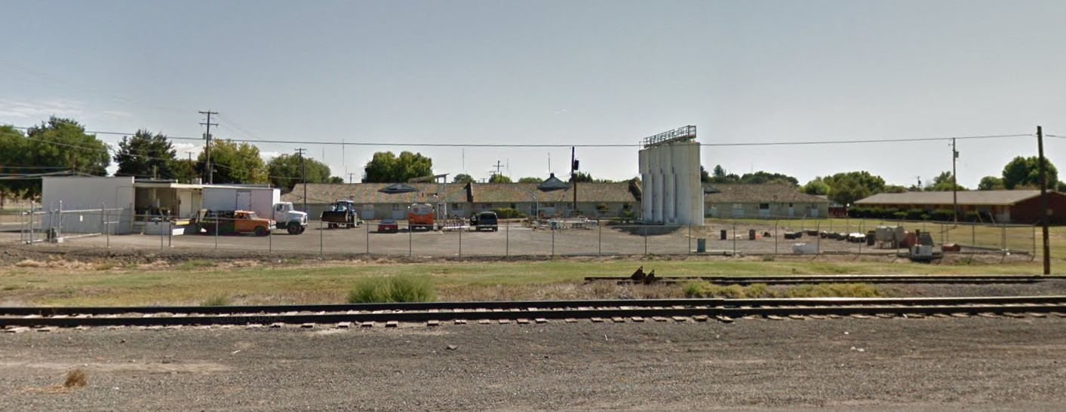

Comments accepted
March 7, 2024-April 6th, 2024

Submit comments
Online at:
https://tcp.ecology.commentinput.com?id=7GA5fPBCa
Or by mail to:
Kyle Parker, Site Manager
1250 West Alder Street
Union Gap, WA 98903-0009 509-406-6959
Kyle.Parker@ecy.wa.gov

Document review
https://apps.ecology.wa.gov/cleanupsearch/site/1907

Yakima Library
102 N 3rd Street
Yakima, WA 98901

Site info
Facility Site ID: 539
Site Cleanup ID: 1907
Unocal Bulk Plant 0766 – Photo courtesy of Google Street View

Proposed Removal from the Hazardous Sites List Available for Review and Comment
The Department of Ecology is proposing to remove Unocal Bulk Plant 0766, 511 Lincoln Ave, Sunnyside, WA 98944 from its Hazardous Sites List. The Hazardous Sites List is a list of sites Ecology reviewed for their potential threat to human health and the environment. This review is based on how much contamination is present, how toxic it is, and how easily it can come in contact with people and the environment. Sites must go through cleanup and meet state standards before Ecology can remove them from the list.
You are invited to:
- Review our letter saying the cleanup is complete, dated January 19, 2024.

Site Background

The Site operated as a bulk fuel facility which included aboveground storage tanks (ASTs), a heating oil underground storage tank (UST), an oil/water separator UST, and a waste oil AST. Gasoline and diesel were released to the soil and groundwater due to Site operations. The property currently operates as a fertilizer storage facility.

Toxics Cleanup Program

Why This Matters

Petroleum contains many chemicals that are harmful to human health and the environment, including the carcinogen benzene. Cleanup actions are taken to reduce the amount of contamination and restore conditions that are protective of human health and the environment.

What Was Done?

Several investigations and interim cleanup actions occurred between 1989 and 2020. The investigations identified areas of soil and groundwater contamination. Contaminated soil was removed during interim cleanup actions. A fluid was injected to aid the remediation of the remaining soil and groundwater contamination in 2020. Groundwater now meets the Site cleanup levels.

What Happens Next?
Ecology will respond to all the comments we receive by April 6th, 2024, and publish responses. We will hold an online public meeting if 10 or more people request it. After we consider public comments and no changes are necessary, Ecology will remove the site from the Hazardous Sites List.

The Cleanup Process
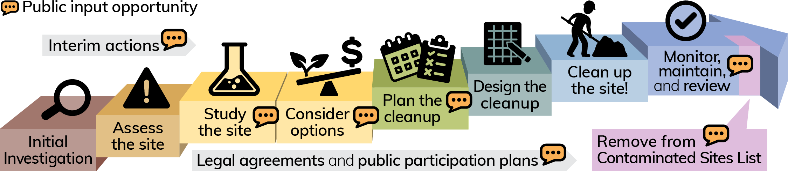

Public involvement opportunities, such as meetings, hearings, open houses, and workshops, can be found on
Ecology’s Public Involvement Calendar at https://ecology.wa.gov/Events/Search/Listing.

Kyle Parker Kyle.Parker@ecy.wa.gov
509-406-6959
To request an ADA accommodation, contact Ecology by phone at 509-406-6931 or email at Rhonda.Luke@ecy.wa.gov, or visit https://ecology.wa.gov/accessibility. For Relay Service or TTY call 711 or 877-833-6341

