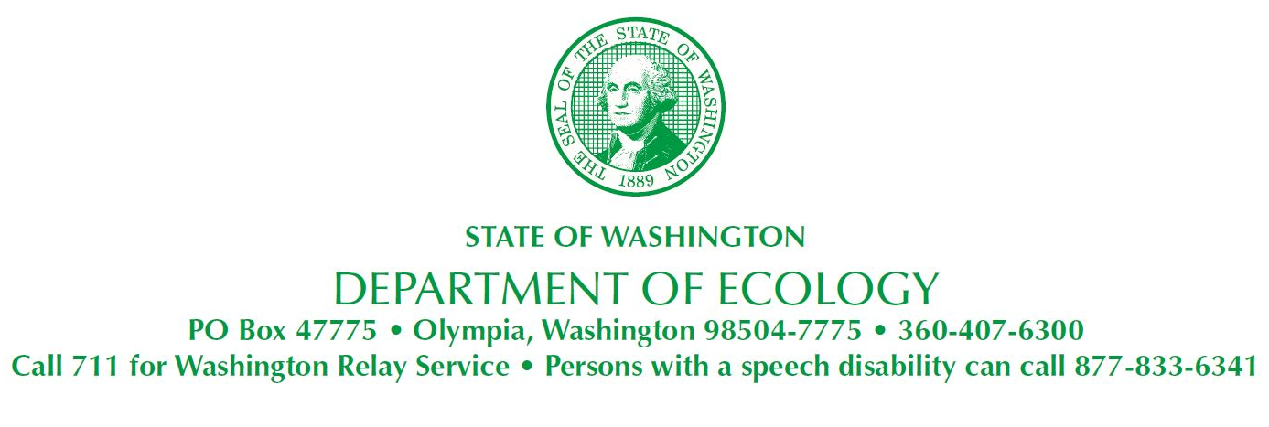
February 21, 2024
Justin Brown
Recreation Manager at City of Longview
P.O. Box 128
1525 Broadway
Longview, WA 98632
parks@mylongview.com

Re: Ecology Request for Access at Parks Maintenance Department, located 2920 Douglas St, Longview, WA 98632-1731 for Investigation Activities

- Site Name: Parks Maintenance Department
- Site Address: 2920 Douglas St, Longview, WA 98632-1731
- Facility Site ID: 99775267
- Cleanup/Site ID: 11368

Dear Justin Brown:

The Washington State Department of Ecology (Ecology) is hereby requesting access to the Evergreen Transportation Center to conduct a site reconnaissance visit and resulting field sampling activities, as part of the cleanup efforts supported by LUST Site Closure Funding. Dependent on the site reconnaissance visits, the field sampling activities that may occur onsite include ground penetrating radar of the properties, soil sampling, groundwater sampling, and soil-gas sampling, where applicable. This access agreement will extend to the contractors and subcontractors hired to carry out the necessary fieldwork as listed above.

Background Information
The purpose of this request is to determine if this site is eligible for funding to further clean up the active LUSTs located on the Site. If the Site appears to be a good candidate for the funding, the appropriate confirmation sampling will be performed on the sites by subcontractors; whom will be selected subsequent to the site reconnaissance visits.
Our records show this site had two LUSTs discovered and removed. Some remediation activities were executed on-site, however, the site characterization was not complete. Based on the information on file, this site requires additional characterization of the nature and extent of soil contamination present on the site. If groundwater is encountered during sampling events, groundwater will also be investigated.
If another person in your organization should be the recipient of this letter, please provide Ecology, as soon as possible, with the contact information for that person. We will then address the letter to the individual you identify.
Please notify Ecology within 30 days in writing (at Ecology’s address and/or via email) of your willingness to accede to the request for access.
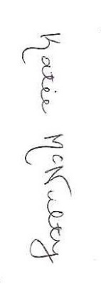
If you have any questions about this letter, please feel free to contact me at (360) 407-6221 or Katie.McNulty@ecy.wa.gov
Sincerely,
Katie McNulty, MS
LUST Site Manager/Hydrogeologist
Toxics Cleanup Program
Southwest Regional Office

By certified mail:

Department of Ecology
Southwest Regional Office
300 Desmond Dr SE, Lacey, WA
PO Box 47775
Olympia, WA 98504-7775

