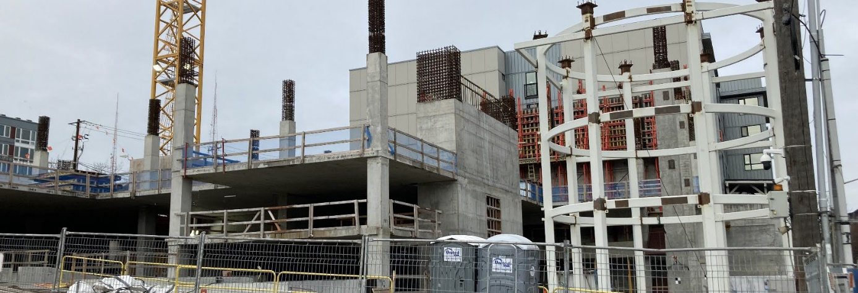

Response to Comments
Remedial Investigation and Amended Agreed Order
701 Dexter Cleanup Site
Seattle, WA
Toxics Cleanup Program
Washington State Department of Ecology
Northwest Regional Office
Shoreline, Washington
April 2024

Publication Information
This document is available on the Department of Ecology’s website at:
701 Dexter - (15112) (wa.gov)

Cover photo credit
- Department of Ecology

Related Information
- Clean-up site ID: 15112
- Facility site ID: 78082

Contact Information
Toxics Cleanup Program
Northwest Regional Office
Augie Nuszer
Public Involvement Coordinator
425-533-5537, Augie.Nuszer@ecy.wa.gov
Tanner Bushnell
Site Manager
425-691-0571, Tanner.Bushnell@ecy.wa.gov

Physical: 15700 Dayton Ave N
Mailing: PO Box 330316
Shoreline, WA 98133
Phone: 206-594-0000
Website: Washington State Department of Ecology

ADA Accessibility
The Department of Ecology is committed to providing people with disabilities access to information and services by meeting or exceeding the requirements of the Americans with Disabilities Act (ADA), Section 504 and 508 of the Rehabilitation Act, and Washington State Policy #188.
To request an ADA accommodation, contact Ecology by phone at 360-407-6831 or email at ecyadacoordinator@ecy.wa.gov. For Washington Relay Service or TTY call 711 or 877-833-6341. Visit Ecology's website for more information.

Department of Ecology’s Regional Offices

Map of Counties Served
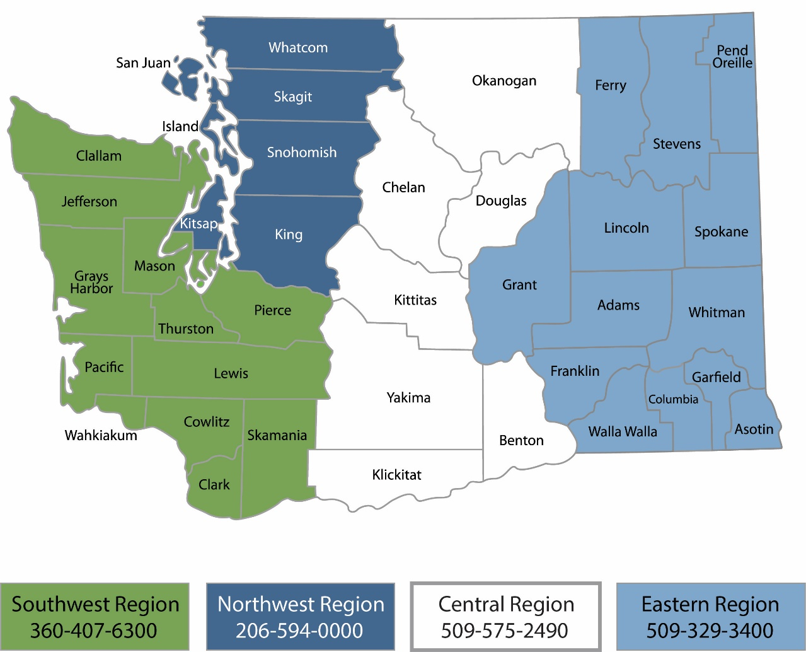
Region | Counties served | Mailing Address | Phone
Southwest | Clallam, Clark, Cowlitz, Grays Harbor, Jefferson, Mason, Lewis, Pacific, Pierce, Skamania, Thurston, Wahkiakum | PO Box 47775  Olympia, WA 98504 | 360-407-6300
Northwest | Island, King, Kitsap, San Juan, Skagit, Snohomish, Whatcom | PO Box 330316 Shoreline, WA 98133 | 206-594-0000
Central | Benton, Chelan, Douglas, Kittitas, Klickitat, Okanogan, Yakima | 1250 W Alder St  Union Gap, WA 98903 | 509-575-2490
Eastern | Adams, Asotin, Columbia, Ferry, Franklin, Garfield, Grant, Lincoln, Pend Oreille, Spokane, Stevens, Walla Walla, Whitman | 4601 N Monroe  Spokane, WA 99205 | 509-329-3400
Headquarters | Across Washington | PO Box 46700  Olympia, WA 98504 | 360-407-6000

Response to Comments
Remedial Investigation and Amended Agreed Order
701 Dexter Cleanup Site
Seattle, WA
Toxics Cleanup Program
Washington State Department of Ecology
Northwest Regional Office
Shoreline, WA
April 2024

Table of Contents
List of Figures and Tables 5
Figures 5
Tables 5
Public Outreach Summary 6
Comment Summary 7
Next Steps 7
Comments and Responses 8
Comment from: Chapman Anonymous 8
Appendices 9

List of Figures and Tables

Figures
Figure 1: Washington's formal cleanup process 7

Tables
Table 1: List of Commenters 7

Public Outreach Summary
The 701 Dexter cleanup site (Site), located in Seattle is continuing Washington State’s formal cleanup process as directed under the Model Toxics Control Act (MTCA). ARE-Seattle 33 LLC is addressing contamination at the Site under a legal agreement with Ecology.
The Department of Ecology’s public involvement activities related to this Site’s 30-day comment period (March 25 – April 23, 2024) included:
- Postcard and Fact Sheet:
  - US mail distribution of a postcard providing information about the cleanup documents and the public comment period, to approximately 6240 addresses including neighboring businesses and other interested parties.
  - Email distribution of the postcard and a fact sheet to 31 people, including interested individuals, local/county/state/federal agencies, neighborhood associations, and interested community groups.
  - The postcard and fact sheet were available digitally through Ecology’s cleanup site webpage.
- Legal Notices:
  - Publication of one paid display ad in The Seattle Times, dated March 22, 2024
- Site Register:
  - Publication of 4 notices in Ecology’s Toxics Cleanup Site Register:
    - Comment Period Notice:
      - April 4, 2024
      - April 18, 2024
    - Response Summary Notice:
      - May 2, 2024
    - Visit Ecology’s Site Register website to download PDFs.
- Websites:
  - Ecology announced the public comment period, posted the fact sheet and postcard, and made the review documents available on Ecology’s 701 Dexter webpage and Ecology’s Public Inputs & Events webpage.
- Document Repositories:
  - Ecology made the documents at the Central Branch of the Seattle Public Library at 1000 4th Ave, Seattle, WA 98104. Documents were also available at the Northwest Regional Office in Shoreline, WA.

Comment Summary
From March 25 – April 23, 2024, Ecology solicited public comments on a Remedial Investigation and Amended Agreed Order for the 701 Dexter cleanup site.
Ecology received 1 comment during the 30-day comment period.
Table 1: List of Commenters
 | First Name | Last Name | Agency/Organization/Business | Submitted By
1 | Chapman | Anonymous |  | Individual

Next Steps
Ecology has reviewed and considered the public comment received on the Remedial Investigation and Amended Agreed Order. Based on Ecology’s evaluation of the comment, no changes were necessary in the documents, and they are being finalized.
Ecology will finalize the documents and remove this site from the Contaminated Sites List. See graphic below and visit Ecology’s cleanup process webpage to learn more about Washington’s formal cleanup process.
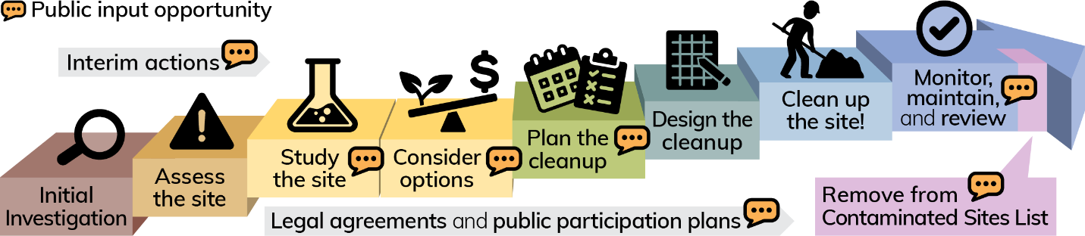
Figure 1: Washington's formal cleanup process

Comments and Responses
The public comment is presented below, along with Ecology’s response. Appendix A, page 9 contains the comment in its original format.

Comment from: Chapman Anonymous

I'd like ecology to conduct another remedial investigation due to the fact that the heating oil tank wasn't discovered until after the RI had completed

Response:

Remedial investigation data was collected before and after the heating oil tank was removed. Six soil samples were collected from the soil surrounding the heating oil tank following tank removal. An additional 15 soil samples were collected at the bottom of the excavation. None of the soil samples contained contamination above cleanup levels. Additionally, while TMW-5 was installed and sampled prior to tank discovery, it was located approximately 15 feet from the former tank. Groundwater from TMW-5 did not contain any detectable contaminants.
The remedial investigation included sampling focused on the removed heating oil tank, and property-wide sampling. Ecology considers the sample coverage sufficient to conclude that no more contamination cleanup is needed at the site.

Appendices
Appendix A. Public comments in original format

www.ecology.wa.gov/contact
https://ecology.wa.gov/Spills-Cleanup/Contamination-cleanup/Cleanup-process
https://ecology.wa.gov/mtca
https://apps.ecology.wa.gov/cleanupsearch/site/15112
https://apps.ecology.wa.gov/publications/UIPages/PublicationList.aspx?IndexTypeName=Program&NameValue=Toxics+Cleanup&DocumentTypeName=Newsletter
https://apps.ecology.wa.gov/cleanupsearch/site/15112
https://10ecology.wa.gov/Events/Search/Listing
https://ecology.wa.gov/regulations-permits/guidance-technical-assistance/site-register-lists-and-data
https://ecology.wa.gov/Spills-Cleanup/Contamination-cleanup/Cleanup-process ¹⁵ https://apps.ecology.wa.gov/publications/SummaryPages/1909166.html

