|  |  |
| --- | --- |
| **Explanation of Significant Differences  Commencement Bay Nearshore/Tideflats Superfund Site  Superfund Site** | |
| Site Name:  CERCLA ID #:  Site Location:  Support Agency:  Lead Agency: | Commencement Bay Nearshore/Tideflats Superfund Site Superfund Site - Operable Unit 02 Asarco Tacoma Smelter Facility and Slag Peninsula  WAD980726368  Ruston and Tacoma, Washington  State of Washington Department of Ecology  EPA, Region 10 |

## I. Introduction

This decision document presents an Explanation of Significant Differences (ESD) for Operable Unit (OU) 02 of the Commencement Bay Nearshore/Tideflats Superfund Site (Site), located in Ruston and Tacoma, Washington (Figure 1). The Record of Decision (ROD) for this OU was issued on March 24, 1995. This OU includes the former Asarco Smelter Facility and the adjacent Breakwater Peninsula, which is also referred to as the Tacoma Yacht Club (TYC) breakwater (slag peninsula) in the ROD.

This ESD is issued in accordance with § 117(c) of the Comprehensive Environmental Response, Compensation, and Liability Act of 1980 (CERCLA), 42 U.S.C. § 9601 et seq., as amended by the Superfund Amendments and Reauthorization Act of 1986 (SARA), and the National Oil and Hazardous Substances Pollution Contingency Plan (NCP), § 300.435(c)(2)(i). The Director of the Superfund Division has been delegated the authority to sign this ESD. As described herein, the changes affect shoreline stabilization and disposal requirements established in the ROD. The remedial action objectives remain the same.

This ESD will become part of the Administrative Record for the Commencement Bay Nearshore/Tideflats Superfund Site – Asarco Tacoma Smelter Facility and Slag Peninsula OU 02 (NCP 300.825(a)(2)), which has been developed in accordance with § 113 (k) of CERCLA, 42 U.S.C. § 9613 (k).

The Administrative Record is available for review at the U.S. EPA Region 10, 1200 6th Avenue, Seattle, WA 98101, Monday - Friday, 9:00 a.m. to 4:30 p.m., or [www.epa.gov/superfund/commencement-bay](https://cumulis.epa.gov/supercpad/cursites/csitinfo.cfm?id=1000981).

## II. Statement of Purpose

This ESD documents the following changes at OU 02:

1. Additional remedial measures implemented at the Breakwater Peninsula in the interior portion of the TYC Basin to 1) Stabilize the shoreline to minimize the release of slag particles into Commencement Bay and 2) Prevent humans, benthic organisms, and fish from being exposed to contaminants released from broken or fractured slag.
2. The transport and off-site disposal of contaminated soils and/or slag at undeveloped parcels within OU 02, which could have further development.

These additional measures represent a significant, but not fundamental, change to the remedy described in the ROD. EPA prepares an ESD when it is determined by the Agency that changes to the original selected remedy are significant, but do not fundamentally alter the remedy selected in the ROD with respect to scope, performance, or cost.

## III. Site History and Contamination

### Site History

The Tacoma Smelter Company began operation as a lead smelter in 1890. Copper production began in 1902. In 1905, ASARCO Incorporated purchased the smelter. In February 2005, ASARCO Incorporated merged into a newly formed Delaware limited liability company, ASARCO LLC (“Asarco”). During the active industrial life of the Asarco Tacoma Smelter, the primary product was refined copper. By-products of the copper smelting process included sulfuric acid, liquid sulfur dioxide, arsenic trioxide, arsenic metal, and copper reverbatory slag. Copper smelting operations were discontinued in 1985, and in 1986 the facility was taken completely out of production. Much of the smelter facility was built over fill material, including slag, which was placed by Asarco as part of the smelter operations. The adjacent Breakwater Peninsula was created from an estimated 15 million tons of slag generated from the smelting process which was poured or placed between 1930 and 1970. Since 1971, a portion of the Breakwater Peninsula has been occupied by the TYC and includes a club house, boat lift, security building, paved access road and parking lot, docks and boat houses located within the Yacht Club basin, and supporting infrastructure (sanitary sewer, wet and dry utilities).

By January 1987, Asarco completed two phases of demolition activities at OU 02. Facilities in the stack area associated with copper smelting and the production of both arsenic trioxide and metallic arsenic were demolished in 1987-1988. The majority of the remaining building and structures, including the smelter stack, were demolished in 1992-1994. In 1995, EPA selected a remedy for the Site, and Asarco subsequently undertook performance of that cleanup. However, before remedial action could be completed, Asarco entered into bankruptcy proceedings.

On December 8, 2005, Asarco entered into an agreement with MC Construction Consultants, Inc. (“MC Construction”), to sell the company approximately 97 acres of the Site, which included parts of the former Asarco Smelter Site, Operable Unit 02. MC Construction subsequently assigned to Point Ruston, LLC (“Point Ruston”) its rights under the Tacoma Purchase Agreement. Point Ruston has been performing the remediation of the site in conjunction with development of a residential and mixed-use development project that includes condominiums, apartments and other residential units along with commercial, retail, recreation, entertainment and public use facilities.

The 23-acre Breakwater Peninsula, now known as Dune Peninsula at Point Defiance Park, is owned by Metro Parks Tacoma (MPT). Due to Asarco’s bankruptcy, remedial design and remedial action (RD/RA) at the Breakwater Peninsula was not completed. In 2015, EPA entered into a cooperative agreement with MPT to complete the Breakwater Peninsula cleanup. Asarco bankruptcy settlement funds were used for the RA construction, and MPT funding was used to complete other non-RA activities at the Breakwater Peninsula. The project began in 2016 and was completed in 2020.

### Site Contamination

The following contaminants at the Site were identified as contaminants of concern based on risks to human health and the environment from exposure to contaminated soils:

* Metals: Antimony, Arsenic, Cadmium, Copper, Lead, Mercury, Silver, Thallium, Zinc
* Organic Chemicals: Polyaromatic Hydrocarbons and Polychlorinated Biphenyls

Slag contains high concentrations of metals, including arsenic and lead, in a rock-like form. Concentrations of arsenic found in slag ranged from 100 to 24,950 ppm; copper ranged from 1,924 ppm to 3,040 ppm; chromium ranged from 22 ppm to 124 ppm; lead ranged from 1,916 ppm to 7161 ppm; and zinc ranged from 6,725 ppm to 37,500 ppm.

Some or all of the contaminants identified in soils are hazardous substances or pollutant or contaminant as defined in § 104(14) and (33) of CERCLA, 42, U.S.C. § 9601(14) and (33), and 40 C.F.R. § 302.4 depending on the characteristics, concentrations and leachability. Slag is a pollutant or contaminant as defined by CERCLA but is also a dangerous waste as defined by the State of Washington[1].

## IV. Selected Remedy

The ROD for the Site was signed on March 24, 1995. An ESD which addressed the on-site containment facility located at the former Asarco Tacoma Smelter Facility portion of OU 02 was signed on September 27, 2018. These documents are available in the Superfund Enterprise Management System (SEMS) under Record Numbers 1029344 and 100114419, respectively.

The remedy for the Site involves the cleanup of metal (e.g., arsenic, copper, lead) and organic contaminated soil, slag, surface water, and groundwater. The remedy includes the following elements:

* Excavate source area soils and slag (approximately 160,000 cubic yards).
* Demolish the remaining buildings and structures.
* Dispose of source area soils and demolition debris designated as hazardous waste (approximately 240,000 cubic yards total) in an on-site containment facility (OCF) that meets or exceeds regulatory standards for hazardous waste landfills.
* Cap the entire site (plant site soils and slag, and the Slag Peninsula). The low permeability cap will be composed of layers of clean soils, gravel, and clay. The contaminated residential soils excavated from the Ruston/North Tacoma Study Area will be used as a sub-base for the cap.
* Replace the entire surface water drainage system.
* Armor portions of the plant site and slag peninsula shoreline.
* Continue to monitor the surface water and groundwater.
* Sample marine sediments.
* Develop and implement an enforceable program of restrictions and guidelines to supplement the actual cleanup activities to ensure that the cleanup remains protective of human health and the environment and that development activities do not impact the long-term effectiveness of the remedy.

The ROD also noted that if it is determined that source control activities do not result in ground water that meets federal and state standards, additional cleanup actions, if practicable, would be identified in a subsequent ROD.

## V. Description of Significant Differences and Basis for the ESD

Breakwater Peninsula

The ROD required shoreline armoring along portions of the Breakwater Peninsula to prevent erosion of the slag shoreline into Commencement Bay due to currents, waves, and tidal action. As identified in the ROD, the interior portion of the Yacht Basin would not require armoring because minimal slag erosion occurs in the interior portion of the peninsula (ROD Section 7.1, and Section 9.4.a).

The ROD recognizes the remedy will be refined and states that, “…before the design of the shoreline armoring begins additional data should be collected to determine (1) the extent of shoreline erosion; (2) how and where armoring should be placed; and (3) the impact of armoring to the existing marine biota versus the impact of not armoring slag to the marine biota over time.” (ROD Section 7.2.3)

The changes this ESD makes to the ROD are shown in Figure 2 and include:

1. The installation of shoreline armoring in the interior portion of the TYC basin. EPA determined this was necessary to further protect the shoreline and upland cap from erosion due to waves and thereby minimize the release of slag into Commencement Bay and to prevent humans, benthic organisms, and fish from being exposed to contaminants.[2] Shoreline armoring of the Breakwater Peninsula by MPT and EPA began in 2016 and was completed in 2017.
2. The installation of six pilings located at the entrance to the TYC.
   1. Three of the pilings installed are marker piles to demarcate the edge of the shoreline armoring. After the installation of the shoreline armoring, a boat ran aground on the shoreline cap while exiting the Yacht Basin. While no damage was caused to the cap, it was determined that marker piles were needed (1) to protect the shoreline armoring remedy from vessels, (2) improve navigation safety, and (3) to prevent boat grounding damage to the remedy (CH2M 2020b; Jacobs 2019).[3]
   2. The other three pilings have been installed for the purpose of creating a wave dissipation wall. This wall is designed to prevent a storm system causing 3-to-5-foot waves from entering the basin The wave dissipation wall is needed to reduce the amount of wind and wave energy entering the TYC, especially during storm events and higher tides to further protect the shoreline armoring remedy.2

Off-Site Waste Disposal

The ROD called for soils excavated from the Ruston/North Tacoma Study Area (OU 04) to be temporarily stored and then used as a sub-grade for the cap at the former Asarco facility (OU 02) (ROD Section 9.1.3.b). Contaminated soils from over 2,000 yards and 450 rights-of-way in OU 04 were removed by Asarco and EPA between 1994 and 2011 and transported to the material management zone (MMZ or Lot 15), which is located within OU 02. In total, approximately 170,000 cubic yards of contaminated soils from yards in Ruston and North Tacoma were stockpiled in this location. Additionally, approximately 8,300 cubic yards of soils were contaminated with slag during the cleanup and development of the park on the Breakwater Peninsula, which were transported to the MMZ for temporary storage to be and used as cap subgrade. Point Ruston has been remediating and developing the site since 2006. However, the development schedule was not keeping pace with the RA schedule. EPA required the developer to cap the remaining parcels until development could proceed. Capping construction was completed in December 2022, which included capping of the stockpiled contaminated soil. During this time, the approximately 8,300 cubic yards of contaminated soils at the MMZ were taken to another part of the Site, specifically to the former cooling pond area (Lot 10C) and capped there. Several parcels remain undeveloped, and the remaining stockpiles of contaminated soil exceed the volumes necessary for cap sub-grade.

This ESD will allow for the transport and off-site disposal of the excess contaminated soils and/or slag located in OU 02. The properties which could have further development in OU 02 include Lot 9/11, Lot 10A, Lot 10C, Lot 12, Lot 14, Lot 15, and Lot 16 (Figure 3).

The caps on these undeveloped parcels may be breached under EPA oversight in the future for development of these lots. Developing a previously capped lot in the future may require the transport and off-site disposal of the contaminated soils. EPA works closely with the Tacoma Pierce County Health Department which is charged with issuing the waste disposal authorizations for contaminated soils. Any offsite disposal shall be in compliance with CERCLA Off-Site Rule. 42 U.S.C. § 9621(d)(3).

It is expected that the majority of contaminated soils that would need to be disposed of off-site are located in Lot 15 and Lot 10C; however, a smaller quantity of contaminated soils may be removed from the developed properties. The quantity of contaminated soils at Lot 15 and Lot 10C that may require off-site disposal is estimated below in footnote 4. These estimates are conservative and will depend on the nature of the future development at Lot 15 and Lot 10C and the other properties. [4] In the alternative, future developers could elect to use the currently capped contaminated soils for site grading and may not need to transport and dispose of the entire estimated volume of contaminated soils off-site.

Additional volumes may be removed from other undeveloped parcels but would be within +30/-50 of these estimates.

### Change in Cost

The change in cost for implementing the remedial actions outlined in this ESD are provided in Table 1.

**Table 1.** Cost estimates for the 2024 ESD

| **Remedy Component** | **Cost Estimate** | **Cost Factors** |
| --- | --- | --- |
| Breakwater Peninsula | $1.2 million | The change in cost for the remedy includes the cost for additional materials and labor at the interior portion of the Yacht basin to perform excavation and sloping activities and place geotextile fabric, bedding stone, and armoring stone. The change in cost also includes the materials and labor needed to install the pilings for the marker piles and wave dissipation wall. |
| Off-Site Waste Disposal | Lot 15: $30 million  Lot 10C: $1.6 million | The change in cost for the remedy would be costs associated with the off-site transportation and disposal of contaminated soils from Lot 15 and Lot 10C. The cost estimate assumes that future developers would remove the full volume of contaminated soils capped under the undeveloped lots for development.  Transportation and disposal assumption costs are provided below:  *Transportation via truck[5]*  10 cubic yards of soil per truck  $500 per truck  *Disposal*  2 tons per cubic yards at $75 per ton |

## VII. Support Agency Comments

EPA consulted with Ecology and provided it the opportunity to comment on this ESD in accordance with NCP § 300.435 (c)(2) and § 300.435 (c)(2)(i) and CERCLA § 121(f). Ecology concurred with this ESD in a letter dated [date].

## VIII. Statutory Determinations

EPA has determined that these significant changes comply with the statutory requirements of CERCLA § 121, 42 U.S.C. § 9621, are protective of human health and the environment, comply with Federal and State requirements that are applicable or relevant and appropriate to the remedial action, are cost-effective, and utilize permanent solutions and alternative treatment technologies to the maximum extent practicable.

Because this remedy will result in hazardous substances, pollutants, or contaminants remaining on site above levels that allow for unlimited use and unrestricted exposure, a statutory review will be conducted no less often than each five years after the initiation of the remedial action to ensure that the remedy is, or will be, protective of human health and the environment.

## IX. Public Participation

The public participation requirements set out in the NCP § 300.435(c)(2) have been met by publishing this ESD and making it available to the public in the Administrative Record.

## X. Authorizing Signature

I have determined the remedy for the Site, as modified by this ESD, is protective of human health and the environment, and will remain so provided the actions presented in this report are implemented as described above.

This ESD documents the significant changes related to the remedy at the Site. U.S. EPA selected these changes with the concurrence of Ecology.

U.S. Environmental Protection Agency

By: ________________________________________

Calvin J. Terada

Director

Superfund and Emergency Management Division

Date: ______________________________________

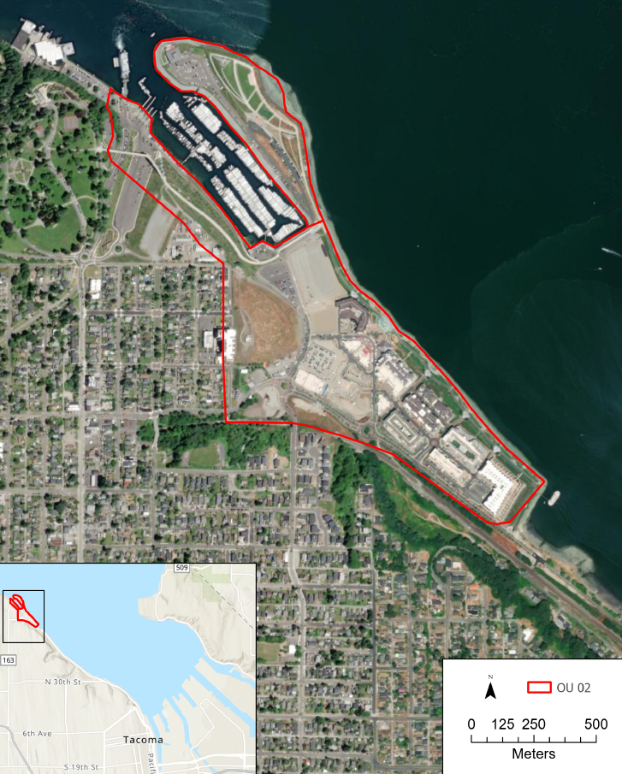

Figure 1: Location Map Commencement Bay Nearshore/Tideflats Superfund Site Superfund Site - Operable Unit 02.

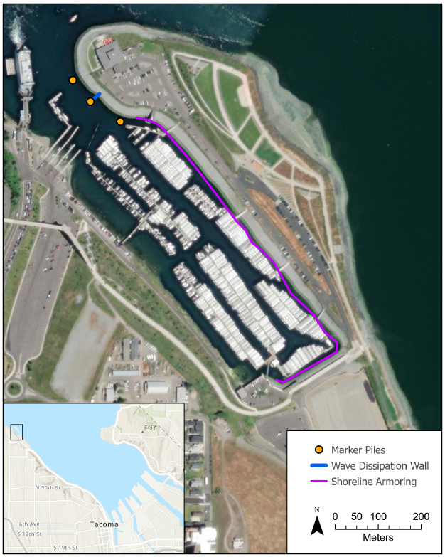

Figure 2: Additional remedial features implemented at the Breakwater Peninsula at Operable Unit 02.

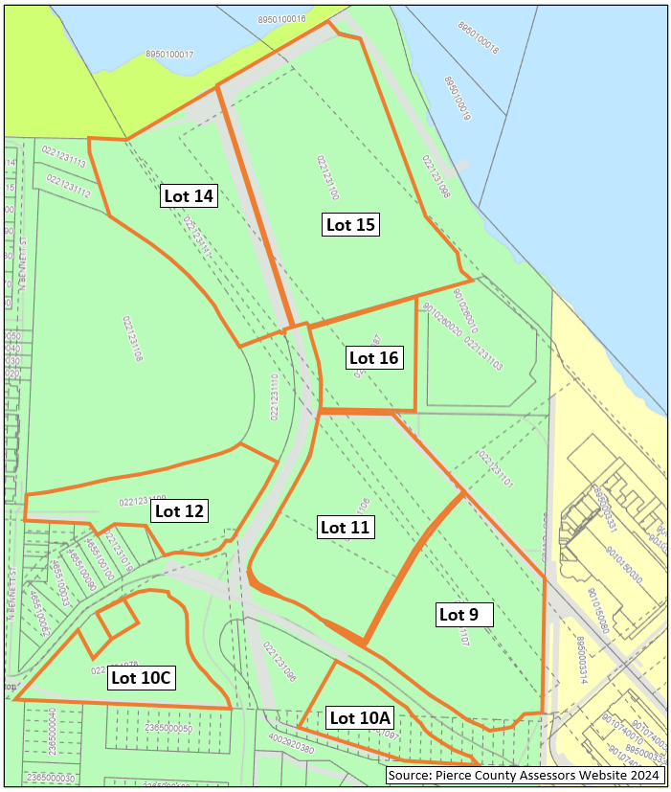

Figure 3: Undeveloped lots in Operable Unit 02.

1. Ecology 1994. Letter transmitting Final Decisions on Demolition Debris and Slag at the Asarco Tacoma Smelter Facility (June 10, 1994) with enclosure Asarco Petition for Exemption of Demolition Debris from the Asarco Tacoma Smelter from Washington State's Dangerous Waste Regulations Chapter 173-303 WAC and Asarco Petition for Exemption of Slag that exists as a Result of Smelting Operations at the Asarco Tacoma Smelter from Washington State's Dangerous Waste Regulations Chapter 173-303 WAC. May 23, 1994. 1029341.
2. Jacobs 2019. Addendum to 2013 Sediment Cap Biological Assessment Summary for Wave Wall and Marker Piles at Former Asarco Slag Peninsula (Dune Peninsula). Prepared by Jacobs Engineering, Inc., October 10, 2019. 100446997.; CH2M 2020. Remedial Action Completion Report – Asarco Tacoma Smelter Facility, Breakwater Peninsula Tacoma, Washington. Prepared by CH2M, September 2020. 100436974.
3. Jacobs 2019. Addendum to 2013 Sediment Cap Biological Assessment Summary for Wave Wall and Marker Piles at Former Asarco Slag Peninsula (Dune Peninsula). Prepared by Jacobs Engineering, Inc., October 10, 2019. 100446997.; CH2M 2020. Remedial Action Construction Completion Report – Wave Wall and Marker Piles (Tacoma Yacht Club Basin), Asarco Tacoma Smelter Facility – Slag Peninsula Tacoma, Washington. Prepared by CH2M, March 2020. 100464129.
4. Soil volume assumptions are based on the following:

   Lot 15: Assumes 150,000 cubic yards of contaminated soil will need to be transported and disposed of off-site to develop the property into an underground parking garage. The volume soil to be excavated is estimated based on removal of soil to excavate out two full floors, and one half of a floor.

   Lot 10C: Assumes 8,200 cubic yards of contaminated soil would be removed and disposed of off-site to bring portions of the property to grade with the adjacent roadways.
5. Estimates are based on transportation via truck; however, other means of transportation such as barge or rail may be used.