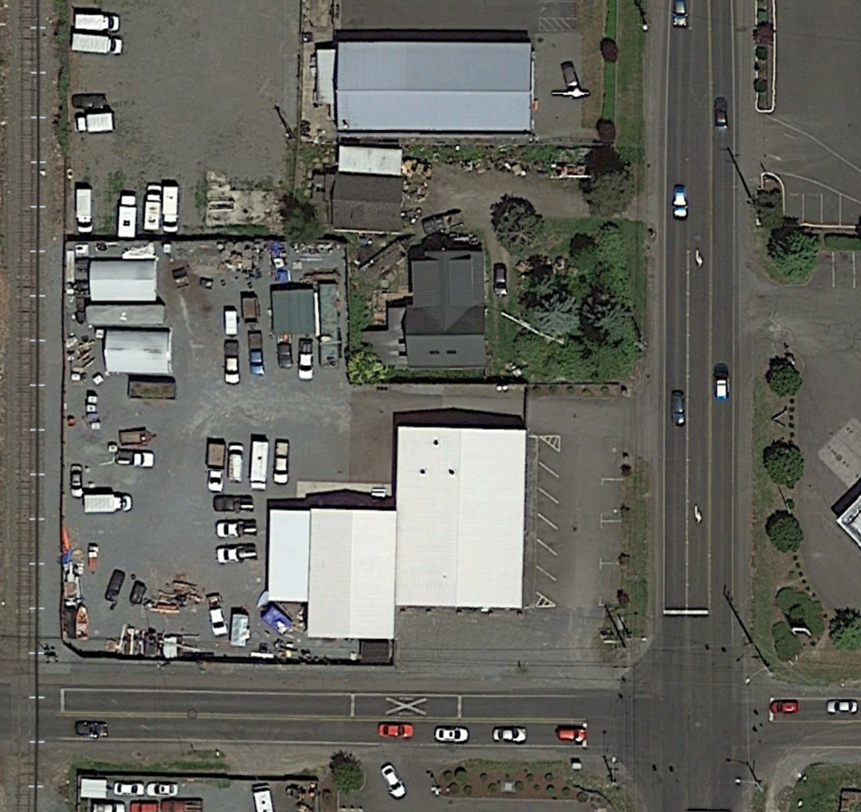
CONTAMINATED MEDIA MANAGEMENT PLAN
Former Midland Auto Wrecking Yard
10324 Portland Avenue East, Tacoma, Washington
VCP Identification: SW1295

January 7, 2025

Prepared by:
Josh Owen

Reviewed by:
Martin S. Burck, LG

Prepared for:
The Estate of Edwin Levesque

TABLE OF CONTENTS

1.0 INTRODUCTION 1
1.1 Site Background 1
1.2 Plan Objectives 2
2.0 EXAMPLE SITE HEALTH AND SAFETY PLAN 2
3.0 SOIL AND GROUNDWATER MANAGEMENT PLAN 3
3.1 Pre-Work Checklist 3
3.2 Project Organization 4
3.3 Soil Management Protocol 4
3.3.1 Dust and Odor Control 6
3.3.2 Decontamination Procedures 7
3.3.3 Contingency Plan for Unknown or Suspect Contamination 7
3.4 Groundwater Management Protocol 8
4.0 POST-CONSTRUCTION MANAGEMENT 9
5.0 REPORTING AND DOCUMENTATION 10
6.0 REMARKS AND SIGNATURES 11

FIGURES

Figure 1 Site Location Map

Figure 2 Remaining COCs Map
Figure 3 Remaining COCs Survey Map

APPENDICES

Appendix A Example Health and Safety Plan
Appendix B Guidance Excerpts

CONTAMINATED MEDIA MANAGEMENT PLAN

Former Midland Auto Wrecking Yard
10324 Portland Avenue East, Tacoma, Washington
VCP Identification: SW1295

1.0 INTRODUCTION

Martin S. Burck Associates, Inc. (MSBA) has prepared this Contaminated Media Management Plan (CMMP) to serve as general guidance for owners, operators, contractors, city, county, and state agencies, and/or individuals (Responsible Entities) who may perform actions that penetrate the surface including but not limited to investigations, excavations, or miscellaneous subsurface disturbances, etc... (Subsurface Work) at or in proximity to the property located at 10324 Portland Avenue East, Tacoma, Washington (site). A small area on the northern property boundary, extending onto the property at 1708 103rd Street East, and an area beneath the railroad crossing sign southwest of the site on the railroad right-of-way (ROW) are also included. This CMMP is not intended to replace independent investigation and due diligence by any Responsible Entity overseeing or performing Subsurface Work at the site. The general site location is illustrated on Figure 1.

1.1 Site Background

The site was reportedly operated as an auto salvage yard from 1949 to 2010 by several different entities, including most recently, the former owner Mr. Edwin Levesque. The property is currently owned by International Funding Group, LLC (IFG) and extensive cleanup activities have been performed. The main building at the site is currently used as an office building by IFG and the garage area and gravel yard are used by a property maintenance and management company.

Previous soil and groundwater sampling activities documented elevated concentrations of constituents of concern (COCs) including metals, petroleum hydrocarbons (PHCs), and petroleum constituents. In January 2017, the main excavation cleanup activities were initiated to remove COCs in soil at the site. Additional off-site excavation cleanup activities were also performed on the residential property to the northeast, the railroad right-of-way (ROW) to the west, and the Pierce County ROW to the south (Figures 2 and 3). Following the excavation cleanup, soil and groundwater sampling activities have been conducted.

The Washington Department of Ecology (Ecology) determined that the site is in compliance with the applicable Model Toxics Control Act (MTCA) regulations and no further action (NFA) is required. However, three limited areas of diesel/oil, cadmium, and lead remain in the soil at concentrations exceeding MTCA Method A cleanup levels (CULs). Diesel/oil beneath a concrete floor slab of the garage building represents the only COC remaining in on-site soil (Cap 1 of 3). The only remaining off-site COCs are cadmium and lead on the auto repair property north of the site (Cap 2 of 3) and in the railroad ROW west of the site (Cap 3 of 3) (Figures 2 and 3). Groundwater monitoring and sampling have demonstrated that COCs in groundwater are present at concentrations below the CULs following the cleanup activities. Although unlikely, it is possible that elevated concentrations of COCs could be encountered during Subsurface Work.

If at any time, COCs or any other unidentified materials or substances are encountered during Subsurface Work at the site, the assistance of an Environmental Professional or Ecology should be sought. Any Subsurface Work must be performed in accordance with all federal, state, and local regulations, permits, and requirements. Any Responsible Entity performing Subsurface Work at the site must have all required federal, state, and local licenses, training, and qualifications.

A more detailed summary of the site history, investigations, and assessment activities, corrective actions, and conceptual site model is presented in the Conceptual Site Model and Closure Report (MSBA, dated June 10, 2022). This report and additional soil and groundwater reports can be accessed from the Ecology website via the following link.
https://apps.ecology.wa.gov/cleanupsearch/site/11888#site-documents

1.2 Plan Objectives

This plan is intended to provide general guidance for managing soil and/or groundwater containing COCs that could be encountered during Subsurface Work, including but not limited to installing underground utilities, repairing or demolishing the existing building and concrete slab, building additions, grading, and other general construction activities.

2.0 EXAMPLE SITE HEALTH AND SAFETY PLAN

A site-specific and work-specific health and safety plan (HASP) will be required for any Subsurface Work that may encounter soil containing COCs at off-site locations 1 and 3 and on-site location 2, as shown on Figures 2 and 3. In accordance with the Washington State Department of Labor and Industries (L&I) under Washington Administrative Code 296-843-12005, a Health and Safety Plan (HASP) should identify potential site hazards, monitoring and compliance protocol, and present procedures for addressing hazards. MSBA prepared an Example Health and Safety Plan (EHASP) for work performed at the site, presented in Appendix A. The EHASP does not represent a work-specific HASP or preclude its preparation. The EHASP should not be used by any Responsible Entity in place of a current site-specific and work-specific Health and Safety Plan or HASP. A current work-specific HASP should be prepared for any Subsurface Work at the site. Due to possible regulatory changes, all health and safety-related data and information in the ESHASP may not be current or valid and cannot under any circumstance be relied on. All relevant health and safety information must be independently confirmed and verified immediately before performing Subsurface Work.

3.0 SOIL AND GROUNDWATER MANAGEMENT PLAN

The following section is intended to provide general guidance for possible future Subsurface Work at the site that may encounter soil and/or groundwater containing COCs. The inferred regulatory extent of COCs in soil is illustrated on Figures 2 and 3. The Management Plan includes tasks that present suggested options for the handling, management, and disposal of soil and groundwater containing COCs that may be encountered.

3.1 Pre-Work Tasks

Prior to beginning Subsurface Work at the site, the Responsible Entity should review/complete the following steps.

Review Conceptual Site Model and Closure Report (MSBA, dated June 10, 2022)

Review Guidance for Remediation of Petroleum Contaminated Sites (GRPCS) (Ecology, revised June 2016, or later version, if available).

Review How to Meet Ecology’s Construction Stormwater General Permit Requirements (Ecology, revised August 2017, or later version, if available).

Review Methods for Dust Control (Ecology, revised in July 2016)

Contact Ecology to determine if the regulatory information included in this document (CMMP) is still current and applicable.

Consult with MSBA or another qualified Environmental Professional familiar with the criteria and requirements of the applicable Ecology and site-specific documents listed above.

Obtain any/all necessary federal, state, and/or local permits.

Prepare a work plan and work-specific HASP consistent with the site conditions and the work to be performed. The attached EHASP does not represent a work-specific HASP.

Independently confirm the location of all utilities within the work area and adhere to the required utility notification protocols. Any/all Subsurface Work requires proper notification to the Utility Notification Center (UNC). The UNC can accept notifications 24 hours a day and be reached online at www.callbeforeyoudig.org or by calling 811. Utility locations on site maps are approximate and cannot be relied on or used to determine if work areas are clear of utilities. In addition to the required UNC locate, consulting with a private underground utility locating company is recommended.

3.2 Project Organization

Prior to any construction activities at the site, the contractor, property owner, and Environmental Professional should coordinate to ensure that the site requirements are met. The contacts below are subject to change.

Name | Responsibility | Phone Number | Email
To Be Determined (TBD) | Contractor/Superintendent | TBD | TBD
Anthony Valenzuela | Property Owner | (253) 627-5116 | av.equitycapitalfunding@gmail.com
Josh Owen | Environmental Professional | (541) 387-4422 | JOwen@MSBAenvironmental.com

3.3 Soil Management Protocol

The following tasks should be completed in accordance with Ecology regulations and guidance to properly manage soil containing COCs that may be encountered at the site (see the inferred extent of COCs on Figures 2 and 3). Excavated soil should be field screened for COCs. If soil and/or groundwater is encountered within the inferred areas of COCs and/or if field observations indicate COCs may be present, samples should be collected for laboratory analysis. If the suspect soil or groundwater is removed prior to sampling or receiving lab results, it should be contained in accordance with Section 11.3.2 Containment and Storage of Contaminated Soils and Water of the GRPCS. An excerpt is included in Appendix B of this report (Excerpt 1). Depending on the location(s), field observations, and previous analytical results, soil and/or groundwater samples may require the following analyses.

- Diesel and Oil by Method NWTPH-Dx (With and Without Silica-Gel Cleanup)
- Gasoline by Method NWTPH-Gx
- VOCs by Method 8260
- PAHs by Method 8270
- Metals Arsenic, Cadmium, Chromium, Mercury, and Lead by Methods 6010 or 6020
- PCBs by Method 8082

The sample results should be compared to the current MTCA Method A CULs for unrestricted land uses and the soil or groundwater should be managed accordingly.

Soil Not Exceeding the CULs:

If confirmation results indicate the soil does not contain COCs, it may be used as clean fill. If confirmation results indicate the soil that was or will be removed does contain COCs at concentrations that are below the CULs, the affected soil will need to be managed in accordance with the GRPCS. Depending on the contaminants and concentrations, construction debris landfills may accept the soil. The re-use of the soil as fill at commercial sites or as a paving base may also be appropriate if it is placed above the seasonal high groundwater table. Guidelines and best management practices for re-use of soil are presented in Tables 12.1 and 12.2 of the GRPCS (Excerpt 2, Appendix B). The soil should not be re-used without consulting with Ecology and/or a qualified Environmental Professional and all requisite approvals/authorizations.

Soil Exceeding the CULs:

If confirmation results indicate the soil contains COCs at concentrations exceeding the CULs, it should be handled and disposed of as a solid waste or a dangerous (hazardous) waste.

Solid Waste: a special waste permit will be required before disposal at an approved landfill.

Dangerous Waste: high concentrations of COCs may require disposal as dangerous (hazardous) waste in accordance with Chapter 173-303 WAC. Dangerous waste will require treatment, storage, and disposal at specifically permitted facilities. Additional information regarding Ecology’s hazardous waste regulations can be accessed from the following website. http://www.ecy.wa.gov/programs/hwtr/index.html

The following presents three common management and disposal or treatment remedies for soil containing COCs including: 1) Direct Off-site Disposal, 2) Stockpiling and Treatment, and 3) Stockpiling and Disposal. The selected option(s) should be based on site-specific conditions and circumstances which are not known in advance. All excavated soil should be field-screened for possible COCs using a photoionization detector. Soil containing COCs based on field screening should be handled, segregated, and managed in accordance with Ecology regulations and guidance.

Collect samples for laboratory analysis as required by Ecology and the selected remedy. Different landfills may have different analytical requirements that should be verified in advance.

Select one of the following three primary remedies or an additional Ecology approved alternative.

Direct Off-site Disposal: This option consists of excavating and loading soil containing COCs directly into a truck or container for immediate transport and disposal at a landfill (see list of potential landfills below). This option requires advance landfill disposal authorization.

Stockpiling and Treatment: This option consists of excavating and stockpiling soil containing COCs pending the implementation of the selected remedy. Soil stockpiles must adhere to specific Ecology protocols (see Soil Stockpiling below). Long-term storage and treatment options may require a solid waste permit and advance Ecology approval. When the logistical criteria are favorable, the soil stockpile would be managed, treated, and dispersed in accordance with the approved treatment plan.

Stockpiling and Off-site Disposal: This option consists of excavating and stockpiling soil containing COCs pending the implementation of the selected remedy. Soil stockpiles must adhere to specific Ecology protocols (see Soil Stockpiling below). This option also requires landfill disposal authorization. The soil would be loaded into a truck or container for transport and disposal at a landfill (see list of potential landfills below).

Potential Landfills:
- LRI Landfill, Puyallup, WA (Solid Waste)
- Eastmont Transfer Station, Seattle, WA (Solid Waste)
- Chemical Waste Management of the Northwest (CWM) facility in Arlington, Oregon (Solid Waste and Dangerous Waste)
- Other approved landfill or disposal options

Soil Stockpiling: Stockpiles of soil containing COCs must adhere to specific Ecology criteria and protocols. In general, soil should be stockpiled on plastic sheeting (a minimum of 6 mm thick), bermed, and covered with plastic as warranted to prevent contact with precipitation and/or surface water. The stockpiles should ideally be located in a relatively secure area, preferably fenced and inaccessible to the general public. A short-term on-site stockpile is generally limited to a maximum period of 90 days. A long-term stockpile on-site for more than 90 days will require additional precautions to prevent further releases to the environment. The stockpile may also be subject to local health department regulations. Additional information regarding short-term and long-term stockpile management is presented in the GRPCS (Section 11.3) (Excerpt 3, Appendix B). Smaller volumes of soil containing COCs may be more cost-effectively managed within containers such as 55-gallon drums, roll-off bins, etc.

3.3.1 Dust and Odor Control

Excavating, soil treatment, and/or storage could potentially result in nuisance dust and/or odors. To ensure that dust from the excavation activities does not affect nearby properties or on-site workers, water (or an alternative dust suppressant) should be applied as needed during dry conditions. Petroleum odors can be monitored using a photoionization detector. The site falls within the jurisdiction of the Puget Sound Clean Air Agency (PSCAA). The PSCAA should be contacted before initiating site work. The main phone number for the PSCAA is (206) 343-8800 and their website is https://www.pscleanair.gov/. BMPs for dust control can be found in the Ecology publication Methods for Dust Control, revised in July 2016, which can be downloaded from the following link https://apps.ecology.wa.gov/publications/documents/96433.pdf.

3.3.2 Decontamination Procedures

Decontamination procedures for personnel, equipment, and vehicles should be implemented to avoid tracking COCs off-site. If COCs are encountered or suspected, a decontamination area should be constructed at the site. Personnel may use disposable Tyvek boot coverings or manually clean boots at a designated decontamination area before leaving the site. Excavation, hauling, and sampling equipment should be decontaminated before leaving the site.

3.3.3 Contingency Plan for Unknown or Suspected Contamination

If unknown or suspected contamination is encountered, the following contingency plan should be implemented. An Environmental Professional should be consulted as soon as possible.

Containment Caps: if the containment caps have been damaged, require maintenance, or construction activities are planned, Ecology should be notified as soon as possible. An Environmental Professional can develop a plan to repair the cap and collect soil samples. A representative soil sample will be collected from the area and submitted for analysis based on the documented residual COCs in each area as shown below.

Containment Cap 1: Diesel and Oil (NWTPH-Dx) (With and Without Silica-Gel Cleanup)
Containment Cap 2: Cadmium and Lead (6020)
Containment Cap 3: cadmium and Lead (6020)

If the COCs are detected at concentrations above the previously determined levels, a work plan will be prepared to further evaluate conditions in the area and submitted to Ecology within 90 days of receiving the initial lab results if no detections exceed the CULs and 30 days if there are exceedances.

Unknown or Suspected Contamination: if soil containing COCs is encountered at locations not previously identified, Ecology should be notified within 24 hours and an Environmental Professional should be consulted as soon as possible. Indications of potential suspect contamination may include but are not limited to, stained or discolored soil; a sheen; odors; and metal piping, tank(s), or debris. Soil samples should be collected and analyzed for the COCs listed in Section 3.3. If the COCs are detected at concentrations above the MTCA Method A CULs, a work plan will be required to further evaluate conditions in the area and submitted to Ecology within 60 days of receiving the initial lab results.

3.4 Groundwater Management Protocol

Shallow groundwater has been encountered at the site at depths ranging from approximately 0.5 to 9 feet bsg. An Environmental Professional should be consulted immediately if groundwater is encountered at the site. Subsurface Work that could result in the need for collecting groundwater samples, including but not limited to, dewatering to backfill and compact an excavation, the installation of a sump pump, and installing footings. The following tasks should be completed in accordance with Ecology regulations and guidance to properly manage groundwater containing COCs that may be encountered at the site. Groundwater samples should be collected for laboratory analysis as needed for characterization and disposal authorization. The analytical requirements may vary between disposal facilities and should be verified in advance. The appropriate laboratory analyses for COCs are consistent with those discussed in Section 3.3.

The following presents three common management, disposal, and treatment remedies for groundwater containing COCs including 1) On-site 55 Gallon Drum Storage and Disposal, 2) Vacuum Truck Dewatering and Off-site Disposal, and 3) On-site Bulk Storage, Treatment, and Disposal. The selected option(s) should be based on site-specific conditions and circumstances.

Prepare and consult the work-specific HASP.

Collect samples for laboratory analysis for characterization and disposal authorization. Different disposal facilities may have different analytical requirements that should be verified in advance.

Select one of the following three common remedies or an additional Ecology-approved alternative.

On-Site 55-Gallon Drum Storage and Disposal: This option consists of storing small volumes of water containing COCs on-site in 55-gallon DOT-approved drums pending authorization and disposal (see below).

Vacuum Truck Dewatering and Off-site Disposal: This option is generally best suited for relatively small to medium volumes of water and limited frequency or one-time removals. Contact a qualified vacuum truck company to arrange for removal and disposal.

On-site Bulk Storage, Treatment, and Disposal: When repeated de-watering and/or large volumes are generated, on-site storage, treatment, and disposal might be more cost-effective. The water containing COCs is generally stored on-site in tanks designed for this purpose which are available for rent or purchase. Take all necessary precautions to prevent rain or surface water from entering the excavation if dewatering and treatment will be required. Once contained on-site, one of the following treatment/disposal options should be considered:

On-site treatment and batch discharge to the storm sewer system. This option requires an approved National Pollutant Discharge Elimination System (NPDES) permit criteria are generally the most cost-effective for large volumes of water. Effective water treatment options for dissolved PHCs include aeration and/or filtration with activated carbon.
On-site treatment and batch discharge to sanitary sewer system. This option requires advance approval by the local sanitary sewer municipality.

One-time vacuum or tanker truck removal and disposal at an authorized facility. No advanced regulatory authorization is required for this disposal option.

If groundwater containing COCs is present but removal is not required, consult the work-specific HASP (not attached EHASP).

4.0 POST-CONSTRUCTION MANAGEMENT

During and following any construction activities at the site, the groundwater monitoring wells and containment caps should be inspected and maintained. The wells and caps should also be inspected by an Environmental Professional no less than every fifteen months.

The containment caps shown on Figures 2 and 3 should not be compromised or altered without prior written approval by Ecology. Any damage to the caps must be reported to Ecology within 48 hours. The damage should be repaired promptly and a report documenting the work should be submitted to Ecology within 30 days of completing the repair.

Monitoring wells MW-2, MW-3, MW-4, MW-5, MW-8, MW-9, MW-10, and MW-11 are located within areas with a gravel surface. Monitoring wells MW-1, MW-6, and MW-7 are within paved or concrete areas. All monitoring wells should remain unobstructed and should not be covered with gravel or paved over. Vehicle and equipment washing and other activities resulting in runoff should only be done on paved areas with drainage to on-site storm sewer catch basins. The runoff should not be allowed to run onto the surrounding gravel and/or pond near the monitoring wells. The monitoring well monument gaskets and well plugs should be inspected, cleaned, and replaced as needed. Any damage to the monitoring wells or monuments should be reported to Ecology within 48 hours. The damage should be repaired promptly and a report documenting the work should be submitted to Ecology within 30 days of completing the repair.

5.0 REPORTING AND DOCUMENTATION

Laboratory reports, field notes, disposal documentation, photographs, and permits should be maintained throughout the project for future reporting. A narrative report summarizing the site activities including data tables and maps must be prepared and submitted to Ecology. The report should include recommendations for additional sampling and/or remediation if warranted. In accordance with the Voluntary Cleanup Program (VCP) requirements, all sample data must be entered into the Electronic Data Management (EIM) database.

6.0 REMARKS AND SIGNATURES

The information/conclusions contained in this plan were arrived at in accordance with currently accepted professional geologic and environmental practices at this time and location. No warranties are intended or implied. This plan was prepared solely for the Estate of Edwin Levesque. Martin S. Burck Associates, Inc. is not responsible for the independent interpretations, conclusions, or actions of others derived from or based on the information presented herein.

Information and opinions presented in this plan are based on the collection and review of data from limited portions of the site, subsurface, and surroundings. Martin S. Burck Associates, Inc. is not responsible for conditions or specific portions of the site that are not investigated, for conditions that are not reported or properly presented, and for future activities or investigations that may alter the current condition or understanding of the site.

Please contact me at (541) 387-4422 if you have any questions regarding this report.

Sincerely,
Martin S. Burck Associates, Inc.

Josh Owen Date
Senior Project Manager

Reviewed by:

Martin S. Burck, LG/RG Date
Licensed/Registered Geologist OR, WA, CA

S:\Project Files\Farmers - Midland\MSBA Docs\(2024 05 15) Mar-Apr 2024 GWMR\Text.docx

