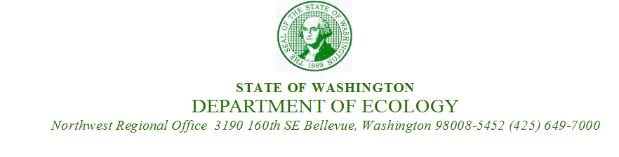

March 18, 2019

Eran Fields
FH Brooklyn, LLC
2251 Linda Flora Drive
Los Angeles, CA 90777

Re: Agreed Order DE 13815, Successful Completion of Interim Action:

- Name: Chevron 90129
- Address: 4700 Brooklyn Ave NE Seattle WA 98105
- County Assessor’s Parcel Number: 8816400985
- Facility/Site No.: 81966648
- Cleanup Site No.: 10632

Dear Mr. Fields

On February 13, 2019 the Washington State Department of Ecology (Ecology) received your request that Ecology acknowledge the successful completion of the Interim Action performed at the former Chevron 90129 facility (Site). Ecology is responding to your request under the authority of the Model Toxics Control Act (MTCA), Chapter 70.105D RCW, and Task 2 Interim Action, Exhibit B Scope of Work of Agreed Order DE 13815.

Ecology notes the following:

- The Interim Action was approved on March 18, 2018, after the completion of the Public Comment Period held from December 22, 2017, to January 22, 2018 for the Interim Action Work Plan, the State Environmental Policy Act Checklist and Determination of Non-Significance.
- The Interim Action remedial excavation activities commenced on June 9, 2018 and were completed on September 13, 2018. The Interim Action Report was submitted to Ecology on January 4, 2019. All environmental data was submitted to Ecology’s Environmental Information Management (EIM) on February 4, 2019 which completed the Interim Action.
- A total of 6,837 tons (4,558 cubic yards) of petroleum-contaminated soil exceeding MTCA Method A cleanup levels and a total of 1,259 tons (839 cubic yards) of impacted soil (detections below Method A cleanup levels) were excavated, and properly disposed of.
- A total of 1,842,284 gallons of groundwater were treated and discharged to surface water in compliance with all conditions required by Construction Stormwater General Permit (CSWGP) WAR No. 306191 and Administrative Order No. 15705 issued by Ecology’s Water Quality Program.
- The estimated average depth of the remedial excavation was 21 feet below ground surface (bgs). Focused areas of cleanup were necessary beyond 24 feet to excavate all contaminated soils above cleanup levels – with a maximum cleanup depth of 34 feet bgs.

After reviewing the Interim Action Report and EIM data, Ecology acknowledges that all soil and groundwater contamination exceeding MTCA Method A Cleanup levels have been removed from within the footprint of the Property.

Ecology further acknowledges that the Interim Action was completed in accordance with the Final Interim Action Work Plan and satisfies all Agreed Order requirements for the Interim Action.

This decision is only for the Property portion of the Site. Agreed Order DE 13815 requires the cleanup of the entire Site that includes off-property contamination. Off-property Remedial Investigations to characterize the full nature and extent of the Site are on-going. Off-property Remedial Investigations are scheduled to be completed no later than August 2019 (Ecology Formal Notice of Schedule Extension, July 31, 2018) and are a Deliverable. Remediation of the off-property contamination of the Site has not commenced.

Ecology is pleased that the cleanup at the Site has progressed to this timely completion of the Interim Action.

If you have any questions regarding this letter, please contact me at (425) 649-4446, or email at damy461@ecy.wa.gov.

Sincerely,
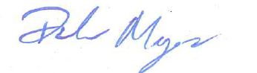
Dale Myers
Project Manager
Department of Ecology
Northwest Regional Office
Toxics Cleanup Program

cc Eric G. Hetrick (Chevron Environmental Management Company)
Robert Goodman (Rogers Joseph O’Donnell)
William Joyce (Joyce Ziker Parkinson)
Adam Griffin (Aspect Consulting LLC)
Allyson Bazan (WA AAG)

