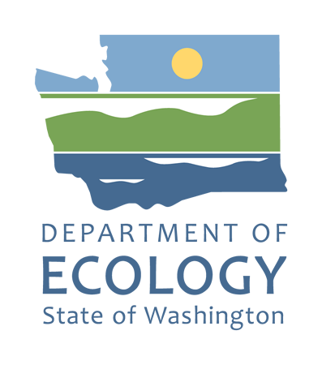

Tribal Engagement Plan
Boeing Development Center
9725 E. Marginal Way S., Tukwila, WA, King County
Facility Site ID: 2101, Cleanup Site ID: 5059
Hazardous Waste & Toxics Reduction Program, Northwest Region
Washington State Department of Ecology
Shoreline, Washington
September 2026

Document Information
This document is available on the Department of Ecology’s Boeing Developmental Center cleanup site page.

Related Information
- Facility Site ID: 2101
- Cleanup Site ID: 5059

Contact Information

Hazardous Waste & Toxics Reduction Program
Washington State Department of Ecology, Northwest Region Office
P.O. Box 330316
Shoreline, WA 98133
Phone: 206-594-0000
Website: Washington State Department of Ecology

ADA Accessibility
The Department of Ecology is committed to providing people with disabilities access to information and services by meeting or exceeding the requirements of the Americans with Disabilities Act (ADA), Section 504 and 508 of the Rehabilitation Act, and Washington State Policy #188.
To request an ADA accommodation, contact the Ecology ADA Coordinator by phone at 360-407-6831 or email at ecyadacoordinator@ecy.wa.gov. For Washington Relay Service or TTY call 711 or 877-833-6341. Visit Ecology's website for more information.

Tribal engagement in contamination cleanup
The purpose of this Tribal Engagement Plan is for the Washington Department of Ecology (Ecology) to invite affected Tribes as sovereign nations to learn about and consider their rights and interests for Ecology-conducted and Ecology-supervised cleanup sites.
Ecology’s goal is to provide timely information, effective communication, continuous opportunities for collaboration, and when necessary, government-to-government consultation, as appropriate for each cleanup site.

Site information
Boeing Developmental Center
Address 9725 E. Marginal Way S.
Tukwila, WA, 98108
Facility Site ID: 2101 Cleanup Site ID: 5059
Ecology’s Boeing Developmental Center cleanup site page

Tribes
Ecology identified the following Tribes as potentially affected by site contamination and cleanup: Stillaguamish Tribe, the Tulalip Tribes, the Suquamish Tribe, the Snoqualmie Tribe, the Squaxin Tribe, and the Muckleshoot Tribe.

Tribe

Stillaguamish Tribe of Indians
Preferred Communication
Stillaguamish Tribe of Indians would prefer communication through email. These are the preferred contacts:
Jody Brown, Water Resources Program Manager jbrown@stillaguamish.com
Rainer Luhrs, Natural Resources Technician Specialist 2 rluhrs@stillaguamish.com
And CC’ed to: Sara Thitipraserth, Natural Resources Director sthitipra@stillaguamish.com

Stillaguamish Tribe of Indians Engagement Framework
This is a living document. Information may be modified by the Tribe at any time. Last updated December 26, 2025.
Tribe’s Areas of Interest Stillaguamish Tribe of Indians would like to be informed regarding sites within the area on this map.
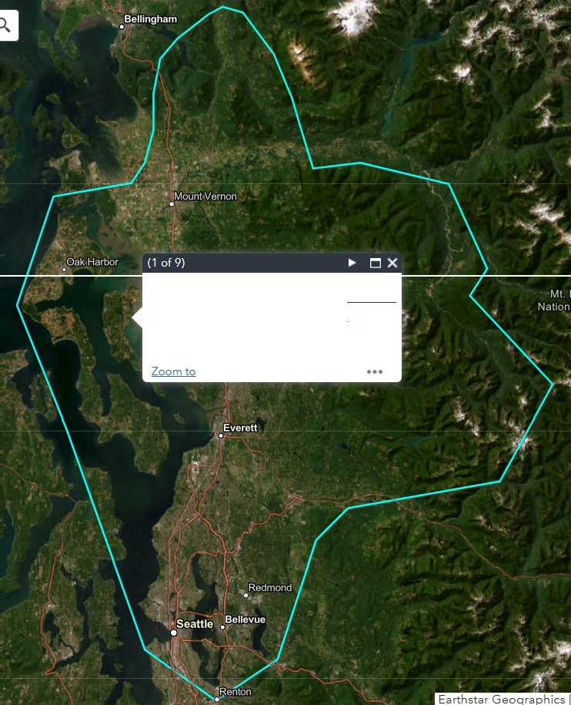

Stillaguamish Tribe of Indians

DAHPTribal Consultation Information Tribal Website
Current Engagement Actions:
•Invite Stillaguamish Tribe of Indians as early as possible in the cleanup process to share and discuss information about the site and to understand the Tribes’ concerns.
•Provide a copy of the Tribal Engagement Plan to Stillaguamish Tribe of Indians for review and comment.
•Stillaguamish Tribe of Indians, at any time, may propose any changes to this Tribal Engagement Plan.
•Notify Stillaguamish Tribe of Indians when Ecology identifies a potentially liable person under WAC 173-340-500.
•Provide early notifications and opportunities for collaboration and input at specific points in the cleanup process, including Remedial Investigation Work Plans, see Table 1.
•Provide Stillaguamish Tribe of Indians at least as much time to submit input asoffered to the public in each stage in the process, when possible, more time will be provided (30 extra days).
•Keep effective communication open throughout the cleanup process including communicating project timelines, reviewing timeframes, and comment period deadlines.
•Meet with the Stillaguamish Tribe of Indians to assess and make adjustments to the engagement process when needed.
•If long-term monitoring is required for the cleanup, learn from Stillaguamish Tribe of Indians what level of engagement is preferred during monitoring.
•If Stillaguamish Tribe of Indians requests government-to-government consultation, engage Ecology leadership and facilitate that process.

Tulalip Tribes
Preferred Communication
Tulalip Tribes would prefer communication through email. The Tulalip Tribes would like all emails sent to:
Kurt Nelson, Environmental Department Director knelson@tulaliptribes-nsn.gov
Todd Gray, Environmental Protection Ecologist toddgray@tulaliptribes-nsn.gov
Todd Zackey, Nearshore Program Manager tzackey@tulaliptribes-nsn.gov
And CC’ed to:
Jason Gobin, Executive Director of NCR jasongobin@tulaliptribes-nsn.gov
Aaron Jones, NCR Director aaronjones@tulaliptribes-nsn.gov
Tulalip Tribes Engagement Framework
This is a living document. Information may be modified by the Tribe at any time. Last updated December 26, 2025.Tribe’s Focus Areas for Toxic Cleanup Program Purposes1 Tulalip Tribes would like to be informed regarding sites within Snohomish County, Skagit County, San Juan County, Island County, and King County.
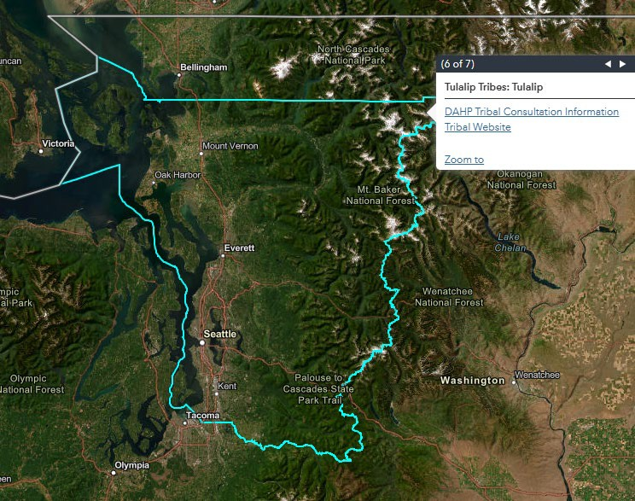

Suquamish Tribe
Preferred Communication:
Suquamish Tribe would prefer communication through email. These are the preferred contacts:
Alison O'Sullivan, Ecosystem Recovery Program Manager
aosullivan@suquamish.nsn.us
Denice Taylor, Senior Biologist dtaylor@suquamish.nsn.us
Shawn Blocker, Superfund Sites Project Manager sblocker@suquamish.nsn.us

Suquamish Tribe Engagement Framework
This is a living document. Information may be modified by the Tribe at any time. Last updated May 4, 2026.
Tribe’s Areas of Interest: Suquamish Tribe would like to be informed regarding sites within the area on this map, which includes the western half of Snohomish County, the western half of King County, Island County, Kitsap County, Jefferson County, Clallam County, Mason County (only the area that includes the Union River), and Pierce County (only for information on the Tacoma Smelter Plume). This area of interest is smaller than what is shown in the DAHP map.
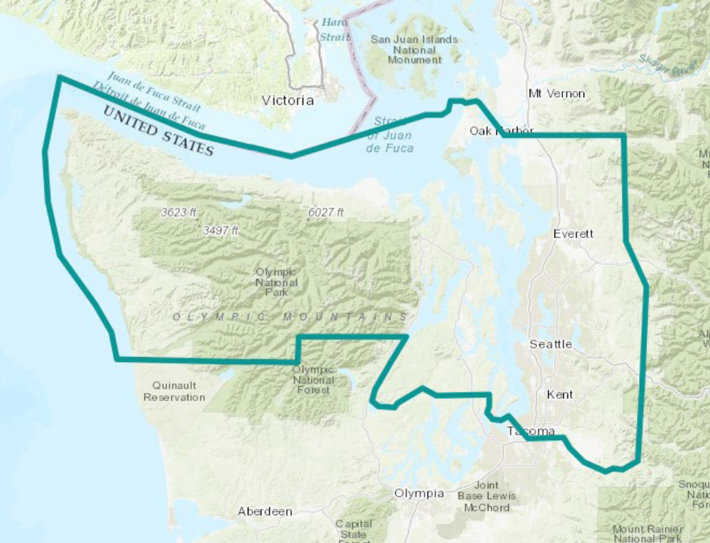
Current Engagement Actions:
•Invite Suquamish Tribe as early as possible in the cleanup process to share and discuss information about the site and to understand the Tribes’ concerns.
•Provide a copy of the Tribal Engagement Plan to Suquamish Tribe for review and comment.
•Suquamish Tribe, at any time, may propose any changes to this Tribal Engagement Plan.
•Notify Suquamish Tribe when Ecology identifies a potentially liable person under WAC 173-340-500.
•Provide early notifications and opportunities for collaboration and input at specific points in the cleanup process, including Remedial Investigation Work Plans, see Table 1.
•Provide Suquamish Tribe at least as much time to submit input as offered to the public in each stage in the process, when possible, more time will be provided (30 extra days prior to public comment period).
•Keep effective communication open throughout the cleanup process including communicating project timelines, reviewing timeframes, and comment period deadlines.
•Email the Suquamish Tribe to assess and make adjustments to the engagement process on an annual basis and offer a meeting if needed.
•If long-term monitoring is required for the cleanup, learn from Suquamish Tribe what level of engagement is preferred during monitoring.
•If Suquamish Tribe requests government-to-government consultation, engage Ecology leadership and facilitate that process.

Snoqualmie Indian Tribe
Preferred Communication
Snoqualmie Indian Tribe would prefer communication through email. All initial contact and formal engagement should be sent to:
Matthew Baerwalde, Senior Environmental Policy Analyst: Mattb@snoqualmietribe.us
Environmental Review Team: enrreview@snoqualmietribe.us
Contacts for the Snoqualmie Mill Site and Issaquah PFAS sites are:
Matthew Baerwalde, Senior Environmental Policy Analyst: Mattb@snoqualmietribe.us
Environmental Review Team: enrreview@snoqualmietribe.us
Snoqualmie Tribe Department of Archaeology and Historic Preservation: dahp@snoqualmetribe.us
Snoqualmie Indian Tribe Engagement Framework
This is a living document. Information may be modified by the Tribe at any time. Last updated December 26, 2025.Tribe’s Areas of Interest For environmental review, Snoqualmie Indian Tribe would like to be informed regarding sites within the Water Resource Inventory Areas (WRIA) 7 and 8. DOE’s interactive map provides a detailed boundary for these areas. This area of interest is smaller than what is shown on the DAHP map.
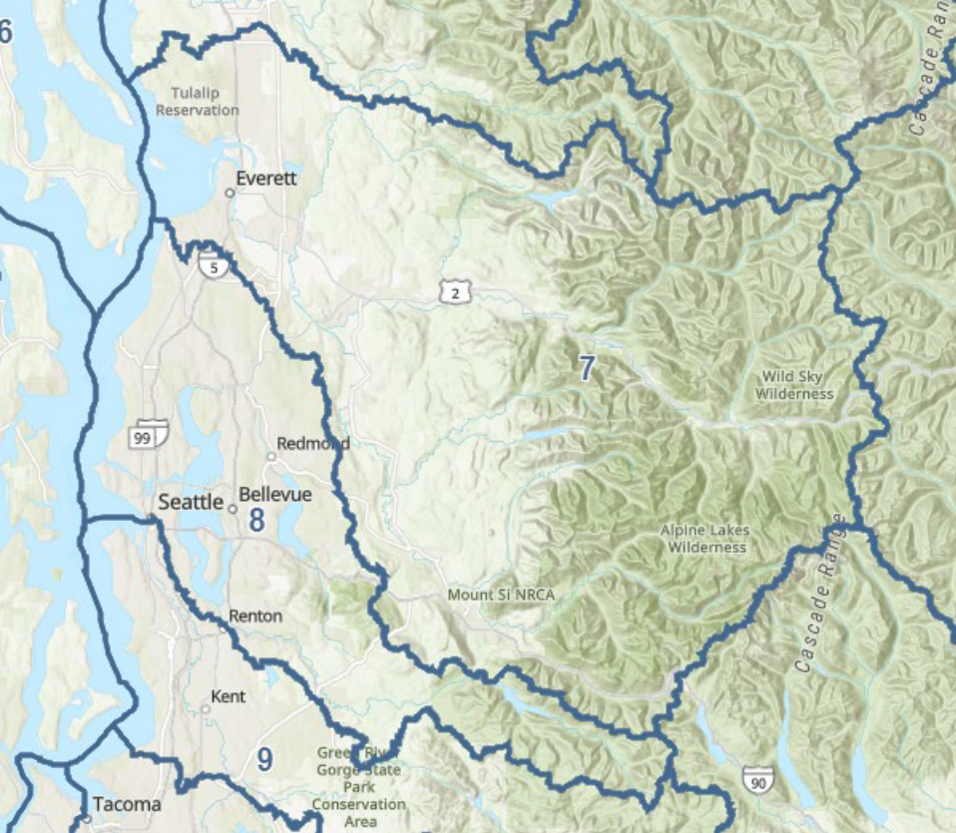
Current Engagement Actions:
•Invite Snoqualmie Indian Tribe as early as possible in the cleanup process to share and discuss information about the site and to understand the Tribes’ concerns.
•Provide a copy of the Tribal Engagement Plan to Snoqualmie Indian Tribe for review and comment.
•Snoqualmie Indian Tribe, at any time, may propose any changes to this Tribal Engagement Plan.
•Notify Snoqualmie Indian Tribe when Ecology identifies a potentially liable person under WAC 173-340-500.
•Provide early notifications and opportunities for collaboration and input at specific points in the cleanup process, including Remedial Investigation Work Plans, see Table 1.
•Provide Snoqualmie Indian Tribe at least as much time to submit input as offered to the public in each stage in the process, when possible, more time will be provided (30 extra days).
•Keep effective communication open throughout the cleanup process including communicating project timelines, reviewing timeframes, and comment period deadlines.

•Meet with Snoqualmie Indian Tribe upon request.
•Adjustments to the engagement process will be made as needed, when Snoqualmie Indian Tribe or Ecology identifies a need.
•If long-term monitoring is required for the cleanup, learn from Snoqualmie Indian Tribe what level of engagement is preferred during monitoring.
•If Snoqualmie Indian Tribe requests government-to-government consultation, engage Ecology leadership and facilitate that process.

Squaxin Island Tribe
Preferred Communication:
Squaxin Island Tribe would prefer communication through email. These are the preferred contacts:
Leila Whitener, Brownsfield Coordinator: lwhitener@squaxin.us
And CC’ed to:
Scott Steltzner, Environmental Manager: ssteltzner@squaxin.us
Squaxin Island Tribe Engagement Framework
This is a living document. Information may be modified by the Tribe at any time. Last updated February 23, 2026.
Tribe’s Areas of Interest: Squaxin Island Tribe would like to be informed regarding sites within the area on this map.
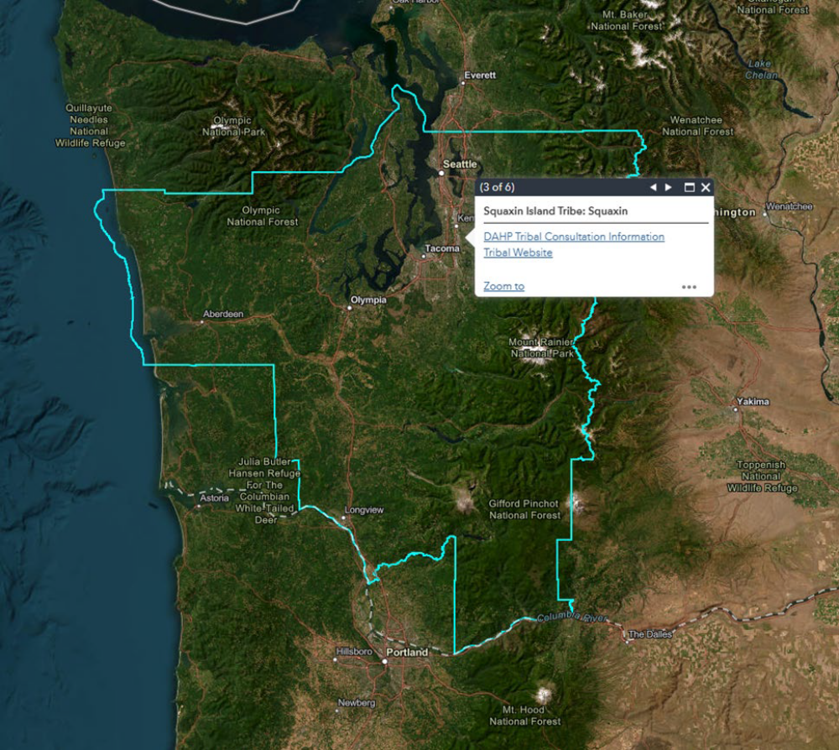
Current Engagement Actions:
•Invite Squaxin Island Tribe as early as possible in the cleanup process to share and discuss information about the site and to understand the Tribes’ concerns.
•Provide a copy of the Tribal Engagement Plan to Squaxin Island Tribe for review and comment.
•Squaxin Island Tribe, at any time, may propose any changes to this Tribal Engagement Plan.
•Notify Squaxin Island Tribe when Ecology identifies a potentially liable person under WAC 173-340-500.
•Provide early notifications and opportunities for collaboration and input at specific points in the cleanup process, including Remedial Investigation Work Plans, see Table 1.
•Provide Squaxin Island Tribe at least as much time to submit input as offered to the public in each stage in the process, when possible, more time will be provided (30 extra days).
•Keep effective communication open throughout the cleanup process including communicating project timelines, reviewing timeframes, and comment period deadlines.
•Meet with the Squaxin Island Tribe to assess and make adjustments to the engagement process on an annual basis.
•If long-term monitoring is required for the cleanup, learn from Squaxin Island Tribe what level of engagement is preferred during monitoring.
•If Squaxin Island Tribe requests government-to-government consultation, engage Ecology leadership and facilitate that process.

Muckleshoot Indian Tribe
Preferred Communication:
Muckleshoot Indian Tribe would prefer communication through email. All initial contact should be sent to:
Talise Rey, Habitat Program Assistant Director: talise.rey@muckleshoot.nsn.us
Kelsey van der Elst, Fisheries Division: kelsey.vanderelst@muckleshoot.nsn.us
Formal engagement should be sent to:
Jason Schaffler, Fisheries Director: jason.schaffler@muckleshoot.nsn.us
Kelsey van der Elst, Fisheries Division: kelsey.vanderelst@muckleshoot.nsn.us
Lower Duwamish Waterway engagement should be sent to:
Talise Rey, Habitat Program Assistant Director: talise.rey@muckleshoot.nsn.us
Kelsey van der Elst, Fisheries Division: kelsey.vanderelst@muckleshoot.nsn.us
Eric Warner: eric.warner@muckleshoot.nsn.us
Policy topics:
Kelsey van der Elst, Fisheries Division: kelsey.vanderelst@muckleshoot.nsn.us

Muckleshoot Indian Tribe Engagement Information
This is a living document. Information may be modified by the Tribe at any time. Last updated February 23, 2026.Tribe’s Areas of Interest: For environmental review, Muckleshoot Indian Tribe would like to be informed regarding sites within Snohomish County, King County, and Pierce County.

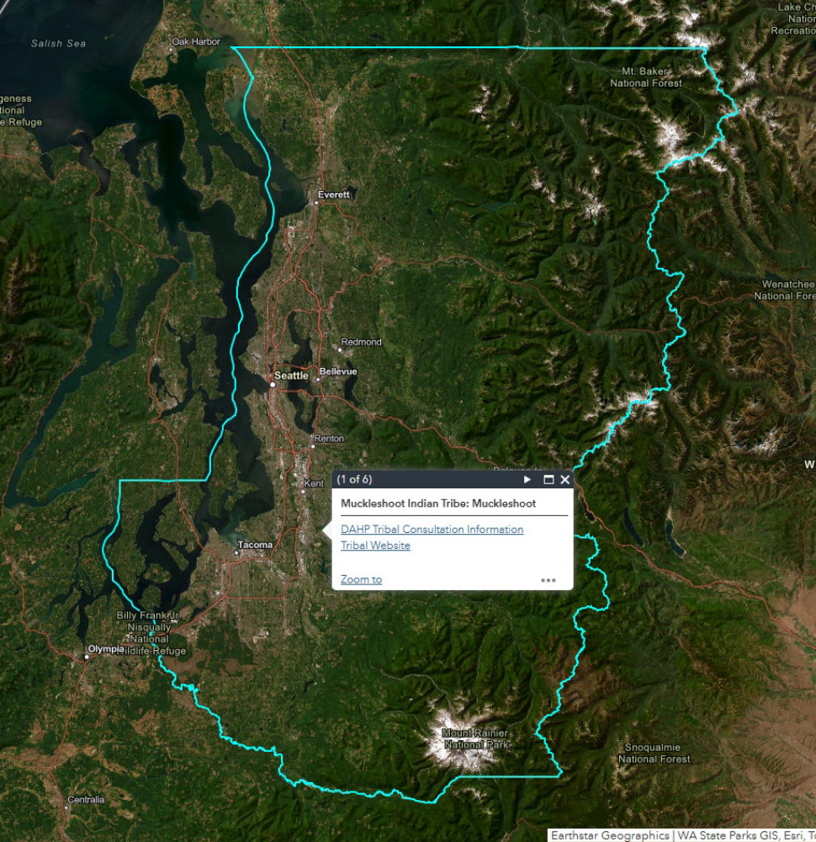
Current Engagement Actions:
•Invite Muckleshoot Indian Tribe as early as possible in the cleanup process to share and discuss information about the site and to understand the Tribes’ concerns.
•Provide a copy of the Tribal Engagement Plan to Muckleshoot Indian Tribe for review and comment.

•Muckleshoot Indian Tribe, at any time, may propose any changes to this Tribal Engagement Framework.
•Notify Muckleshoot Indian Tribe when Ecology identifies a potentially liable person under WAC 173-340-500.
•Provide early notifications and opportunities for collaboration and input at specific points in the cleanup process, including Remedial Investigation Work Plans (see Table 1).
•Communicate project timelines, review timeframes, and comment period deadlines.
•Provide Muckleshoot Indian Tribe at least as much time to offer input as provided to the public in each stage in the process, when possible, more time will be provided (30 extra days).
•Meet with Muckleshoot Indian Tribe quarterly for updates on sites in the Lower Duwamish Waterway, and other sites that may be of interest to the Tribe.
•Keep effective communication open throughout the cleanup process.
•If long-term monitoring is required for the cleanup, learn from Muckleshoot Indian Tribe what level of engagement is preferred during monitoring.
•Ecology will meet with the Muckleshoot Indian Tribe annually to assess and make adjustments as needed to the engagement process.
•If Muckleshoot Indian Tribe requests government-to-government consultation, engage Ecology leadership and facilitate that process.

Tribal Engagement Process
This Tribal Engagement Plan proposes actions Ecology will take to provide timely and relevant information and offer meaningful engagement opportunities to Tribes during investigation and cleanup of Ecology-conducted and Ecology-supervised contaminated sites.
Tribal Engagement for this site is separate from and in addition to public involvement. Tribes and indigenous peoples are welcome to also participate in Ecology’s public involvement process. Ecology’s Public Participation Plan for the site has more information about that process.
Ecology invites each Tribe to share their perspective on what constitutes meaningful engagement for this site, enabling Ecology to develop a more effective process.

Ecology’s Tribal Engagement Responsibilities under the Model Toxics Control Act (MTCA)
Ecology will initiate engagement with affected Tribes before a remedial investigation or an interim action at a site, or as early in the investigation and cleanup process as possible.
Ecology will seek to maintain meaningful engagement with Tribes throughout the cleanup process.
This Tribal Engagement Plan is publicly available on the cleanup site page.

Figure 1. Washington’s Cleanup Process under the Model Toxics Control Act (MTCA)
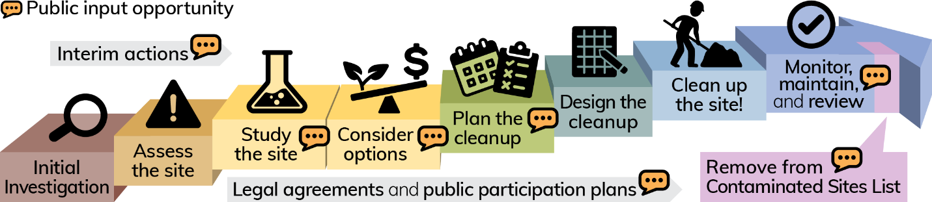

Ecology’s Tribal Engagement Plan actions:
- Invite Tribes as early as possible in the cleanup process to share and discuss information about the site and to understand the Tribes’ concerns.
- Provide a copy of the Tribal Engagement Plan to Tribes for review and comment.
- Tribes, at any time, may propose any changes to this Tribal Engagement Plan.
- Notify Tribes when Ecology identifies a potentially liable person under WAC 173-340-500.
- Provide early notifications and opportunities for collaboration and input at specific points in the cleanup process, including Remedial Investigation Work Plans, see Table 1.
- Provide Tribes at least as much time to submit input as offered to the public at each stage in the process, when possible, more time will be provided (30 extra days).
- Keep effective communication open throughout the cleanup process including communicating project timelines, reviewing timeframes, and comment period deadlines.
- Assess and make adjustments as needed to the engagement process in collaboration with each Tribe as follows:
- Muckleshoot Indian Tribe via annual meeting
- Snoqualmie Indian Tribe whenever a need is identified by the tribe or Ecology
- Squaxin Island Tribe via annual meeting
- Stillaguamish Tribe of Indians when needed
- Suquamish Tribe via annual email with offer for a meeting if needed
- Tulalip Tribes via annual meeting

- If long-term monitoring is required for the cleanup, learn from Tribe what level of engagement is preferred during monitoring.
- If Tribe requests government-to-government consultation, engage Ecology leadership and facilitate that process.
- If your site has site-specific engagement actions with a Tribe, please include them here.
Table 1: Ecology documents and cleanup actions where Tribes will be invited to review and comment.
 | Document or Action
 | Interim action plans
Legal Orders or Agreements
- Consent decrees & amendments
- Agreed orders & amendments
- Enforcement orders & amendments
 | Remedial investigation work plans
 | Remedial investigation reports
 | Feasibility study reports
 | Cleanup action plans (CAPs)  (which may or may not include institutional controls)
 | Engineering design reports
 | Implementation plans substantially changing cleanup action plans
 | Periodic review reports
 | Amendment of institutional controls
 | Removal of institutional controls
 | Removal of sites from contaminated sites list

Other Tribal engagement opportunities
In addition to engagement through MTCA, Ecology will also contact Tribes for the following purposes when relevant to the cleanup.
- Cleanup activities, especially those that disturb the ground, can affect or reveal cultural resources that may need to be assessed for protection or preservation, called a Cultural Resource Review.
- Identifying and analyzing environmental impacts associated with governmental decisions as required by the State Environmental Policy Act (SEPA) and associated SEPA rules.
- Implementing Washington’s Environmental Justice Law (HEAL Act).

Boeing Developmental Center - (5059)
Hazardous Waste & Toxics Reduction - Washington State Department of Ecology
Hazardous Waste & Toxics Reduction - Washington State Department of Ecology
Accessibility & ADA - Washington State Department of Ecology
Boeing Developmental Center - (5059)
Neither these areas nor this document, or work produced here from, is intended to identify or define the extent of the legal entitlement or authority of the Tulalip Tribes under the 1855 Treaty of Point Elliott or any other source of law. The Tulalip Tribes reserves all such rights and claims and nothing herein or work stemming here from shall limit, prejudice, or otherwise affect the assertion of such rights or claims, or defenses against the same, or create a precedent regarding such rights or claims. Any use or construction of this instrument or any work product stemming here from to limit, prejudice, or otherwise affect such rights or claims, or defenses against the same, or to use such as precedent, is unauthorized and improper.
If a public participation plan exists for this site, then it can be found in the ‘Documents’ section of the site webpage. If there is no Public Participation Plan listed on the site’s webpage, then it has not yet been prepared.
Boeing Developmental Center - (5059)
https://ecology.wa.gov/spills-cleanup/contamination-cleanup/cleanup-process
Institutional controls are legal and administrative tools that help protect people from exposure to contaminants. Examples include prohibiting use of groundwater for drinking, requiring maintenance of a barrier to prevent exposure, and zoning and property use restrictions among others.
https://ecology.wa.gov/about-us/payments-contracts-grants/grants-loans/find-a-grant-or-loan/area-wide-groundwater-investigation-grants/cultural-resources-review
https://ecology.wa.gov/Regulations-Permits/SEPA/Environmental-review
https://apps.leg.wa.gov/wac/default.aspx?cite=197-11
https://ecology.wa.gov/about-us/who-we-are/environmental-justice/heal

