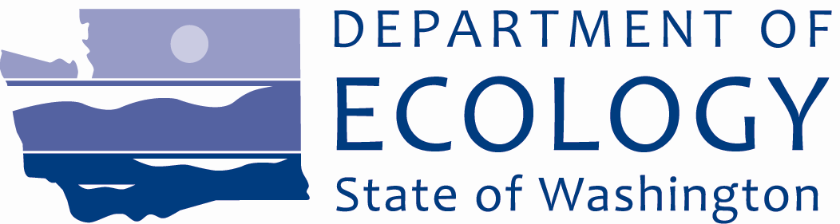

February 2011

Site Investigation and Cleanup Documents Available for Public Review and Comment
Comments Invited
February 10 to March 14, 2011

Submit Comments and
Technical Questions to:
Hun Seak Park - Site Manager
WA Department of Ecology
Toxics Cleanup Program
PO Box 47600
Olympia, WA 98504-7600
Phone: (360) 407-7189
E-mail: Hpar461@ecy.wa.gov
Andy Kallus - Baywide Manager
E-mail: Andy.Kallus@ecy.wa.gov

Document Review Locations
Everett Public Library
2702 Hoyt Avenue
Everett, WA 98201
Phone: (425) 257-8000
Hours: Mon – Wed 10 am - 9 pm
Thurs – Sat 10 am - 6 pm
Sun 1 - 5 pm

WA Department of Ecology
Headquarters
300 Desmond Drive SE
Lacey, WA 98503
By appointment only:
Contact Carol Dorn
Carol.Dorn@ecy.wa.gov or
(360) 407-7224

Ecology’s Toxics Cleanup Website
http://www.ecy.wa.gov/programs/tcp/ sites/everett_shipyard/ev_ship_hp. htm
Facility Site ID #: 2794
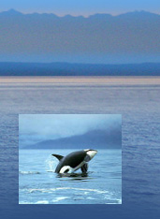
A PUGET SOUND INITIATIVE Site
Reaching the goal of a healthy, sustainable
Puget Sound.

Ecology Wants Your Input!
The Department of Ecology is asking for your comments on plans to clean up a site on Puget Sound. The Everett Shipyard, Inc. Site is one of several properties located on the waterfront that have been studied for cleanup under the state’s Puget Sound Initiative.
The Everett Shipyard, Inc. Site is located at 1016 14th Street next to the Port of Everett’s (port) North Marina, in Everett, Snohomish County, WA.
You are invited to:
- Review the Draft Remedial Investigation/Feasibility Study (RI/FS)
- Send your comments to Ecology. Comments will be accepted February 10 to March 14, 2011
- Attend an open house on February 16 to learn more about this cleanup and other Puget Sound Initiative sites
See the box on the right for details about where to review documents and submit comments. More information on the open house can be found on page 5.

Site Background
The Site is owned by the port and includes approximately five acres of upland area, west of West Marine View Drive, and adjacent in-water areas where the port and ESY, Inc. (previously Everett Shipyard, Inc.) historically operated. ESY, Inc. and its predecessors (Everett Shipyard Inc. and Fishermen’s Boat Shop) leased most of the upland portion of the Site from the port and

since 1947, operated a boat building, maintenance and repair facility. The shipyard historically conducted marine vessel repairs that included tank evacuations, equipment disassembly, sandblasting, woodwork and metalwork, painting/coating and mechanical repairs. Operations at the Site ceased in September 2009.

Investigations at the Site have included the collection of soil, groundwater, and marine sediment samples. Primary contaminants identified in the uplands include metals, polycyclic aromatic hydrocarbons (PAHs), petroleum, and polychlorinated biphenyls (PCBs). Contaminants found in marine sediment include various semi-volatile organic compounds (SVOCs) including PAHs, the antifouling metallic compound tributyltin (TBT), other metals, PCBs, and petroleum.

To address this contamination, Ecology, ESY, Inc. and the port entered into a legal agreement, called an Agreed Order, to conduct an RI/FS and develop a draft Cleanup Action Plan addressing upland and in-water contamination related to discharges from the Site.

Overview of the Draft Remedial Investigation/Feasibility Study
The Draft RI and FS, prepared by ESY, Inc. and the port, were combined into one report for the Everett Shipyard, Inc. Site. The report describes exposure pathways, or how contaminants move through upland soil, groundwater, and sediment, and how human health and the environment may be affected. Information about the amount and location of contaminants along with exposure pathways were used to identify cleanup alternatives for the Site.

Overview of the Remedial Investigation
The purpose of the RI is to determine which contaminants are on the Site, where they are located, and whether there is a significant threat to human health or the environment. RI results are discussed below.

Soil – Results indicate that soil in the upland portion of the Site has the following contaminants of concern (COCs): antimony, arsenic, lead, copper, cancer-causing PAHs, PCBs, and petroleum. These substances were found throughout the Site at depths generally less than 3 feet below ground surface. Deeper petroleum contamination was found in soil just east of the port’s travel lift bulkhead at a maximum depth of 14 feet. Contaminants in upland soil are a risk to people through direct contact and inhalation (e.g., windblown dust), and also may be transported to the adjacent Puget Sound via stormwater runoff and as windblown dust. Potential migration of petroleum contaminants in subsurface soil near the Port’s travel lift to groundwater and then to the marine environment is a concern.

Groundwater – Results indicate that groundwater in the upland portion has the following COCs: arsenic, nickel, zinc, and petroleum. Primary concerns in groundwater include an area of petroleum contamination just east of the port’s travel lift bulkhead and dissolved arsenic along the western portion of the Site. Contaminants in groundwater are a risk to people that may come in direct contact with it (e.g., shallow groundwater during construction), and it also may flow to the adjacent Puget Sound posing a risk to marine life. The groundwater at the Site is not used for drinking water and is not considered potable due to the proximity of marine waters and high level of salinity. Therefore, groundwater cleanup levels were based on protecting marine surface water quality.

Sediment – Results indicate that marine sediments at the Site have elevated (i.e., exceeds Ecology’s Sediment Management Standards) concentrations of SVOCs, cancer-causing PAHs, TBT, other metals (i.e., arsenic, copper, lead, mercury, silver, and zinc), PCBs, and petroleum. These contaminants are at concentrations that pose a risk to marine life. One sediment sample collected during the investigation exhibited biological toxicity.

Overview of the Feasibility Study
The purpose of the FS is to evaluate potential cleanup action alternatives and recommend a preferred cleanup action. This Draft FS addresses cleanup options for both upland and in-water portions of the Everett Shipyard, Inc. Site.

Cleanup action alternatives are the options that will successfully achieve cleanup of the Site. Alternatives may contain contamination, remove contamination, or include institutional controls to reduce exposure, and they may be used in different combinations.

Based on the results of the RI, four cleanup action alternatives were identified and evaluated (based on regulatory criteria) to address risk on the upland portion of the Site. Two cleanup action alternatives were identified and evaluated to address risk on the in-water portion of the Site.

Upland Cleanup Alternative 4 – Alternative 4 was selected as the preferred alternative for the upland portion of the Site, addressing both soil and groundwater. It would permanently remove most of the contaminated soil and focuses on removing the areas with the highest concentration of contamination. Alternative 4 would include the following measures:
- Excavate approximately 14,800 cubic yards of soil, including all impacted soil close to Puget Sound and in areas with the highest contaminant concentrations
- Remove two buildings under which high levels of PCBs and petroleum impacted soil were found
- Dispose of contaminated soil offsite
- Install an engineered cap on remaining soils containing concentrations of hazardous substances above cleanup levels subject to the requirements of a Soil/Groundwater Management Plan
- Clean out the stormwater system and modify, as needed
- Conduct groundwater monitoring and institutional controls
A Soil/Groundwater Management Plan will be part of the upland cleanup alternative. This plan describes procedures to be taken in the event that the integrity of the engineered cap is compromised and contaminated soil becomes exposed. Under the Soil/Groundwater Management Plan, contaminated soil that becomes exposed will be delineated and disposed of at an approved off-site disposal facility.

In addition to the two buildings that are required for removal as part of Alternative 4, the remaining structures at the Site are anticipated to be demolished in 2012 or prior to the beginning of major upland remedial construction. Under this scenario, the Soil/Groundwater Management Plan would be implemented concurrent with other upland cleanup activities.

In-Water Cleanup Alternative 2 – Two alternatives were considered for the in-water portion of the Site: targeted dredging and containment, or mass dredging. Alternative 2, mass dredging, was selected as the preferred alternative because it is the most permanent and would remove all of the impacted sediments.

These preferred alternatives are protective of human health and the environment, make up a permanent solution that can be completed in a reasonable timeframe, address public concerns, and are compatible with future land uses at the Site.

Why This Cleanup Matters

Protecting and restoring Puget Sound
Governor Chris Gregoire and the Washington State Legislature established the Puget Sound Initiative to protect and restore Puget Sound. Several baywide areas in the Sound have been identified as high priority cleanup areas as part of this Initiative, including Port Gamble, Dumas Bay, Padilla and Fidalgo Bays, Port Angeles, Budd Inlet, and Port Gardner Bay. This work includes cleaning up 50-60 sites within one-half mile of the Sound. One of these is the Everett Shipyard, Inc. Site. These cleanup actions will help to reduce pollution and restore habitat and shorelines in Puget Sound.
For more information about other cleanup sites, go to: http://www.ecy.wa.gov/programs/tcp/ sites/sites_information.html#S.

What Happens Next?
Once the public comment period ends on March 14, Ecology will review and consider all comments received on the Draft Remedial Investigation/Feasibility Study (RI/FS). This cleanup document may be modified based on your comments. The Public Participation Plan for this Site is updated and has more information about the cleanup process and how you can get involved. As future documents on the Site are developed, you will be notified of additional public comment periods.
For information about other Ecology public comment periods, meetings, and other events, please visit Ecology’s public events calendar at: http://apps.ecy.wa.gov/pubcalendar/ calendar.asp.

Come to the Open House Feb. 16
A community open house and meeting will be held from 6:00-8:00 pm on Wednesday, February 16, 2011.
Come learn about the plan to clean up the Everett Shipyard, Inc. Site and hear an update on each of the Puget Sound Initiative sites.
There will be a presentation at 6:30 pm followed by a Q &A period at 7:00 pm
Open House & Meeting Location:
Snohomish Public Utility District No. 1
2320 California Street
Everett, WA 98201
We hope you can join us
and welcome your comments

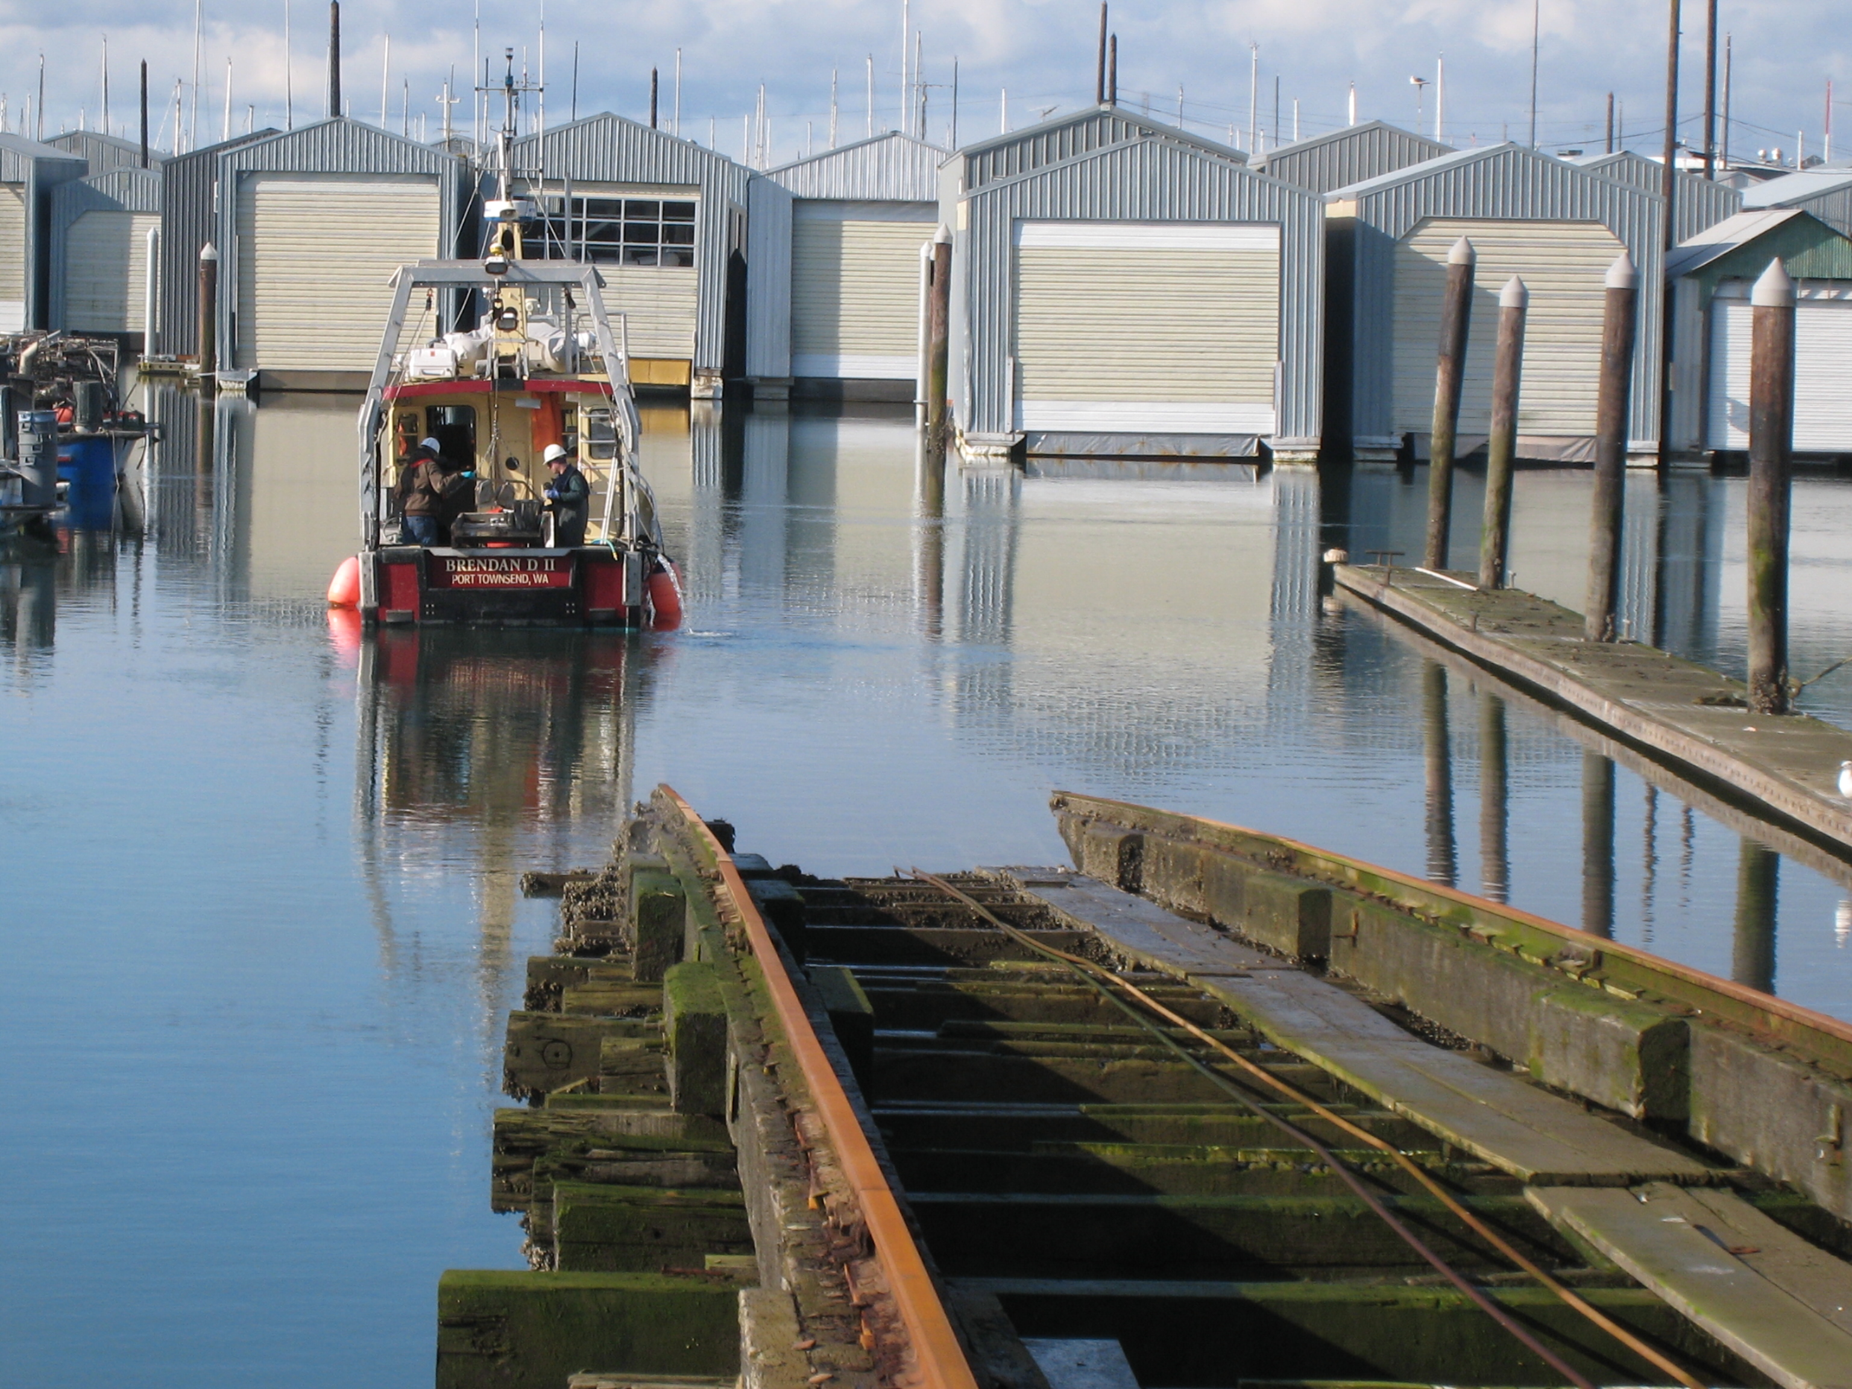

Sediment sampling is conducted just beyond the Marine Railway, which was used to move boats from the water to the Everett Shipyard, Inc. Site.

Read about the cleanup in this handout.
To get more detailed information, review the supporting documents at the locations listed on page one.
Write down your comments and questions. Send them to the Department of Ecology at the address shown on page one.
Come to the public meeting from 6 – 8 pm on February 16 at the Snohomish Public Utility District.
What can you do?

We appreciate your comments and concerns. Thank you.

1.…....11
2.…....11
3.…....11
4.…....11
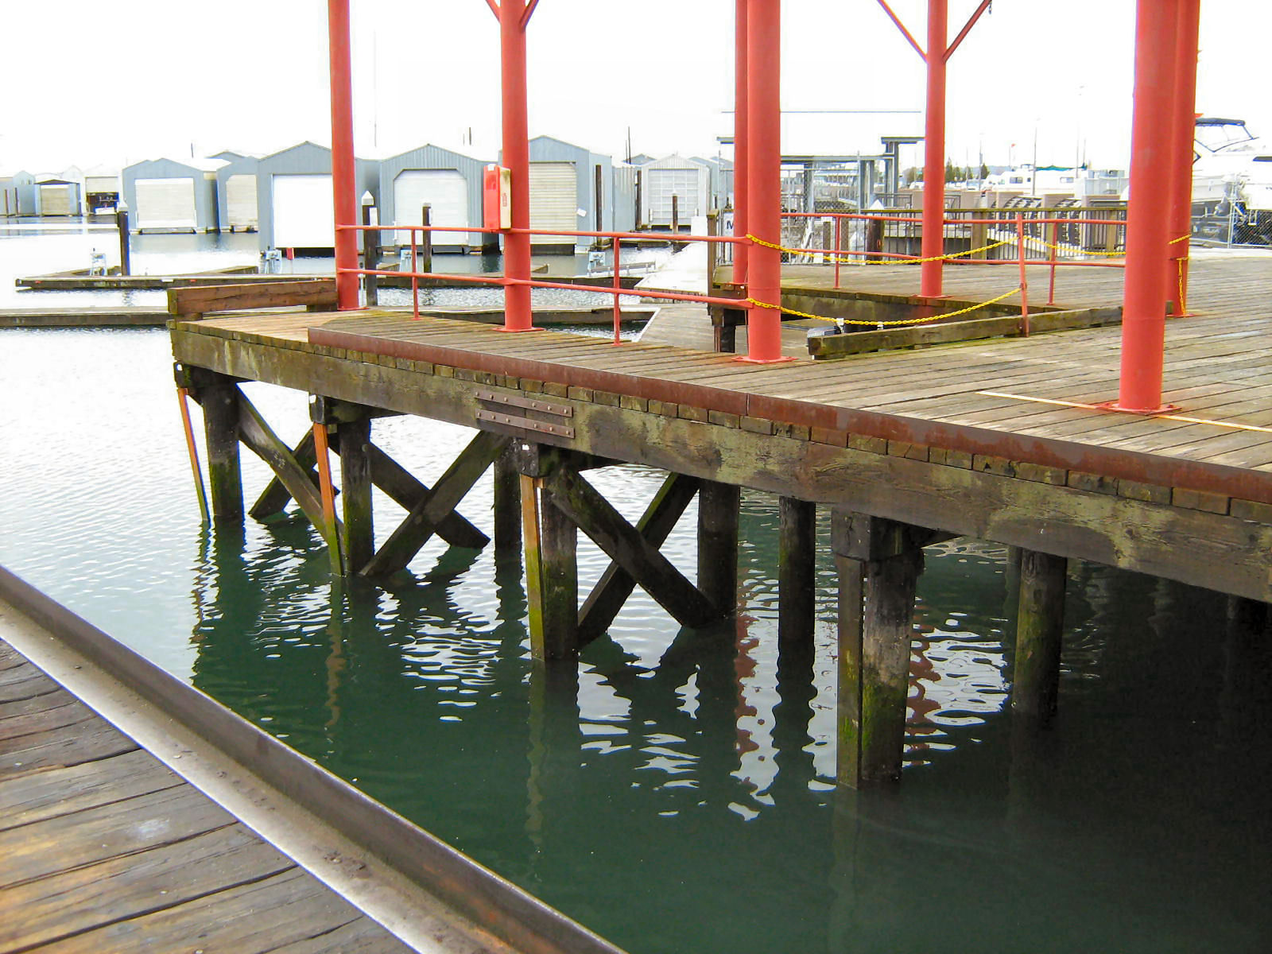

Picture of the port’s travel lift which is used by port customers to move boats into and out of the water.
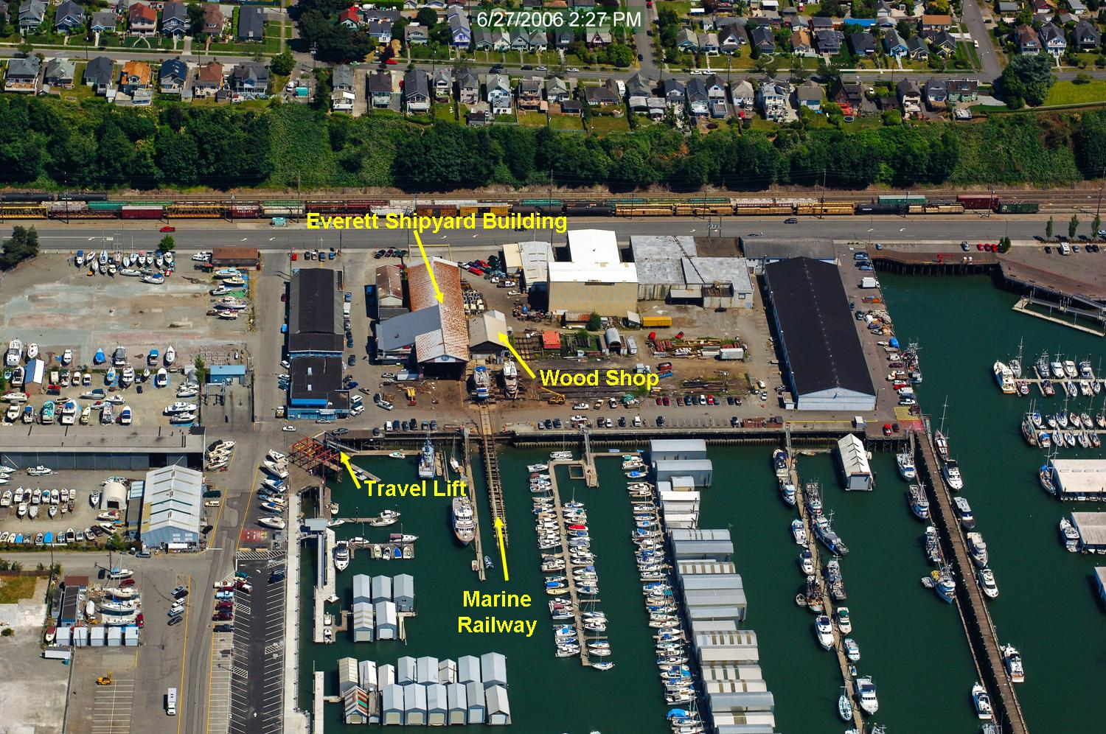
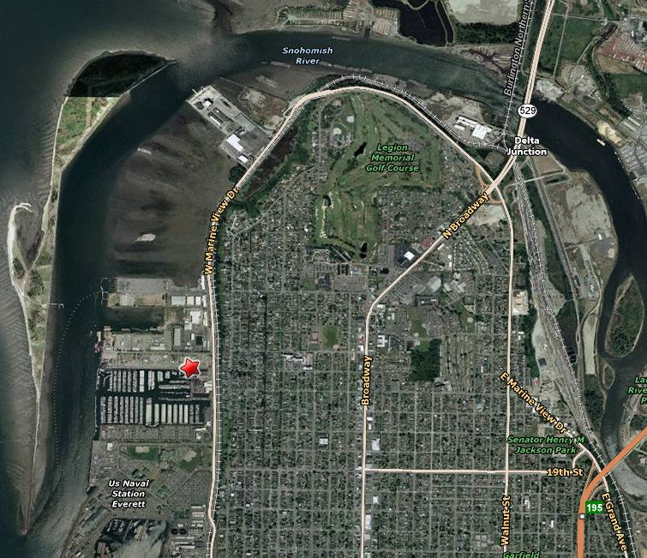
Aerial view of the Everett Shipyard, Inc. Site from 2006.
The Everett Shipyard, Inc. Site is located at 1016 14th Street in Everett, WA.

Site
Location
Toxics Cleanup Program
PO Box 47600
Olympia, WA 98504-7600

Help with other languages and formats?
If you need this publication in an alternate format, please call the Toxics Cleanup Program at (360) 407-7170. Persons with hearing loss can call 711 for Washington Relay Service. Persons with a speech disability can call (877) 833-6341.

Everett Shipyard, Inc. Site, Everett
Snohomish County, WA

Ecology Seeks Public Comment on Draft Site Investigation Document

Public Comment Period:
February 10 to March 14, 2011

Open House:
February 16, 2011
Snohomish Public Utility District
6:00-8:00 pm

Facility Site ID #: 2794

