November 21, 2014

Mr. Michael Marchetti

C/o John Spencer

Spencer Law Firm

1326 Tacoma Ave. S.

Tacoma, WA 98402

Re: **UST Removal Work Plan**

Breakwater Marina

5603 North Waterfront Drive

Tacoma, Washington

Mr. Spencer:

EcoCon, Inc. (ECI) appreciates the opportunity to provide this proposal scope of work for environmental consulting services. This underground storage tank (UST) removal and site assessment work plan has been completed to review and outline the required services necessary to decommission by removal a total of five (5) USTs. These USTs are located at the Breakwater Marina, 5603 North Waterfront Drive, Tacoma, Washington (Subject Site). ECI understand that the Subject Site currently houses five USTs, three 3,000 gallon formerly containing diesel and gasoline fuels (Tanks 3, 4 & 5) and two 8,000 gallon (Tanks 1 & 2).

**REGULATORY COMPLIANCE/PERMITTING**

Regulatory compliance for this project is based on the Washington Administrative Code (WAC) 173-340 – Model Toxic Control Act (MTCA) - RCW Chapter 70.105D, implemented by the Washington State Department of Ecology (Ecology), Tacoma Pierce County Health Department Underground Storage Tank regulations as defined by Board of Health Resolution 2010-4225, and Tacoma Fire Department regulations per Tacoma Municipal Code 13.09. Pursuant to Chapter 70.105D RCW, Ecology has established cleanup standards and requirements for the cleanup actions (MTCA).

The rules establishing these standards and requirements were developed by Ecology in consultation with the Science Advisory Board (established under the Act) and with representatives from local government, citizen, environmental, and business groups. The rules were first published in February 1991, with amendments in January 1996, February 2001, and October 2007.

Permitting and coordination with the applicable agencies will be completed prior to construction activities. Due to the Subject Site location, the permitting process is expected to take up to 30 - 60 days. Notification and a Preliminary Scope of Work for this project will be submitted to the following agencies.

**Agency and Permitting Notifications:**

Washington State Department of Ecology

* 30 Day Notice
* UST Closure & Site Assessment Notice

Tacoma Pierce County Health Department

* Underground Storage Tank Closure Permit

City of Tacoma Fire Department

* UST Closure Permit

**SCOPE OF SERVICES**

**Underground Utilities Survey**

Prior to any subsurface work an effort will be made in locating all underground utilities in the area. This will include calling the “call before you dig” public utility locating service (811) at a minimum two days prior to sampling activities. Also a private utility locating service will be utilized to locate any “private” underground utilities that may not have been marked by the public locating service.

**UST Closure**

Upon receipt of the proper permitting (as noted above), decommissioning activities will be implemented Piping & backflow devises will be dismantled to allow residual fuel to be drained back into the USTs. The UST and ancillary piping will be pumped of all existing residual contents. The UST’s contents will be disposed at a local, properly permitted recycling/disposal facility. Each UST will be inerted using carbon dioxide (CO2) gas following the pumping and cleaning process. The CO2 inertion will be supervised by a properly certified UST Decommissioner as required in WAC 173-360.

The asphalt and concrete overtopping the UST will be cut and removed. The soils on top the USTs will be excavated exposing the top of the USTs and associated piping. Excavated soil will stockpiled adjacent to the north of the UST’s on a lined soil containment area and covered with six millimeter plastic. All associated product piping will be exposed by excavation and inspected by the UST Site Assessor prior to removal. Additional spill prevention will be placed along the Breakwater Marine bulkhead, located approximately fifteen feet east of the USTs. Vent lines will be erected on each UST extending a minimum of thirty-six inches out of the excavation to allow for venting during the inertion process.

Prior to removing the UST from the site, each UST will be measured for oxygen content. Removal from the site will occur once the O2 level has been reported below ten percent. Once the USTs have been measured for oxygen content and labeled “INERT” with the date and time, each UST will be hauled off by flatbed trailer to be properly disposed of by cleaning and recycling of the scrap steel. Five samples shall be obtained from each tank excavation (floor and four sidewalls) and any soil found to be contaminated above MTCA cleanup levels shall be excavated and hauled off to a properly permitted disposal facility. Each area excavated will be backfilled as required (City of Tacoma / Metro Parks) with suitable backfill material following the UST removal and site assessment activities. The excavation area will be capped with 5/8” minus gravel backfill and the area paved with asphalt at the property owner’s request.

**Project Reporting**

An interim report will be provided ten days following the completion site activities outlined in this work plan. A final report will be provided fifteen days following any additional investigation or UST related activities. These reports will detail site activities completed for the UST removal.

**Closing**

As multiple regulatory agencies will be participating in this project, modification and better clarification to this work plan may be required. ECI is qualifying this work plan as Interim. As the project moves forward ECI will issue a final work plan which will incorporate any and all changes necessary to meet the regulatory agencies requirements.

ECI appreciates the opportunity to provide environmental consulting services on this project. Should you have any questions, please contact our office at (253) 238-9270.

Respectfully submitted,

Brad Reilly

Licensed UST Supervisor

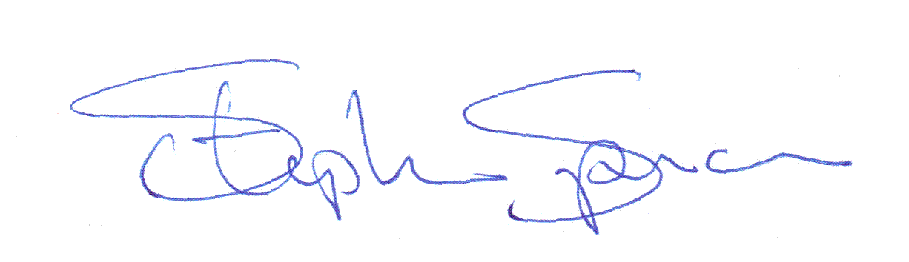

Stephen Spencer

Principal Environmental Scientist

Enclosures:

• Project Figures