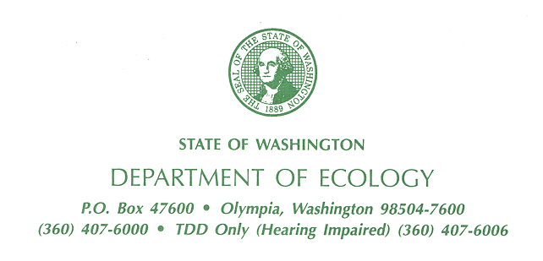

October 20, 2015

Ms. Carrie Pederson
PLIA
330 Desmond Drive
Lacey, WA 98504

Re: Acceptance of VCP Application for the following Site:

- Name: Acme Fuel Bulk Plant 305
- Property Address: 305 Thurston Ave NE Olympia WA 98501
- Facility/Site No.: 37135969
- VCP Project No.: SW1382
- Cleanup Site ID No.: 11769

Dear Ms. Pederson:

The Department of Ecology (Ecology) has accepted your Voluntary Cleanup Program (VCP) application for the Acme Fuel Bulk Plant 305, facility (Site). We applaud your initiative and welcome your interest in the VCP. This letter confirms your entry into the VCP and provides important information on how we will manage the Project.

Agreement

Ecology has completed and signed the VCP Agreement governing the Project. The effective date of the Agreement is October 20, 2015. A copy of the Agreement is enclosed. Please review it carefully.

Identification

Ecology has assigned a unique name and number to the Site. We have also assigned a unique number to your Project at the Site. You can find this information in the box at the bottom of the first page of the Agreement. When contacting us, please use this information to identify your Project.

Designated Managers

Communications between Ecology and Acme Fuel Bulk Plant 305 should be directed through their designated managers to the maximum extent possible.

Ecology

We have designated the following site manager to respond to your requests:

Mr. Nnamdi Madakor
Department of Ecology
Toxic Cleanup Program, Headquarters
300 Desmond Drive SE Lacey, WA 98503
Phone: (360) 407-7244
E-mail: nmad461@ecy.wa.gov

Acme Fuel Bulk Plant 305

The application designated you as the project manager for the site. We will therefore respond only to your requests. If someone replaces you as the project manager or your contact information changes, please submit a Change of Contact Form. You may download the Form from our VCP website: http://www.ecy.wa.gov/programs/tcp/vcp/vcp2008/vcpForms.html

Requests for Written Opinions

In your application, you requested a written opinion on the sufficiency of your cleanup. Ecology will review the documents you submitted and provide you a written opinion within 90-days.

Reporting Requirements

When requesting written opinions on planned or completed remedial actions, please comply with the following reporting requirements:

- Licensing. Documents submitted containing geologic, hydrologic, or engineering work must be under the seal of an appropriately licensed professional, as required by Chapters 18.43 and 18.220 RCW.

- Data Submittal. Environmental sampling data must be submitted in both a printed form and an electronic form capable of being transferred into our data management systems. For instructions on how to submit data, please refer to the following website:
www.ecy.wa.gov/programs/tcp/data submittal/data reguirements.html

Failure to comply with these requirements may result in unnecessary delays.

Payment

Ecology will send monthly invoices to you, the billing contact designated in the Application Form. If someone replaces you as billing contact or your contact information changes, please submit a Change of Contact Form. The Form is available on the VCP website.

The invoice will include a summary of the costs incurred, payments received, identity of staff involved, and the amount of time spent on the Project during the previous month. Payment is due within 30-days of the invoice date. For more information on the billing system, please refer to the VCP website.

Contact Information

We are committed to working with you to accomplish the prompt and effective cleanup of the Site. Again, if you have any questions about the VCP or your Project, please contact me at (360) 407-7244.

Sincerely,

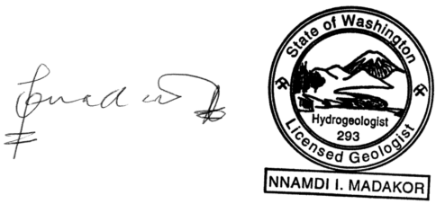

Nnamdi Madakor P.HG, P.G., VCP Statewide Coordinator
HQ – VCP Policy & Technical Manager
Toxic Cleanup Program

NM:nm

Enclosure: Copy of VCP Agreement

cc: Scott Rose, AEG (e-mail)
Dolores Mitchell, VCP Financial Manager HQ
Lisa Sweitzer, VCP Data Coordinator HQ
Kelly Fox, VCP Data Coordinator SWRO (email only)

