Tacoma Smelter Plume

ECOLOGO_W-C.wmf

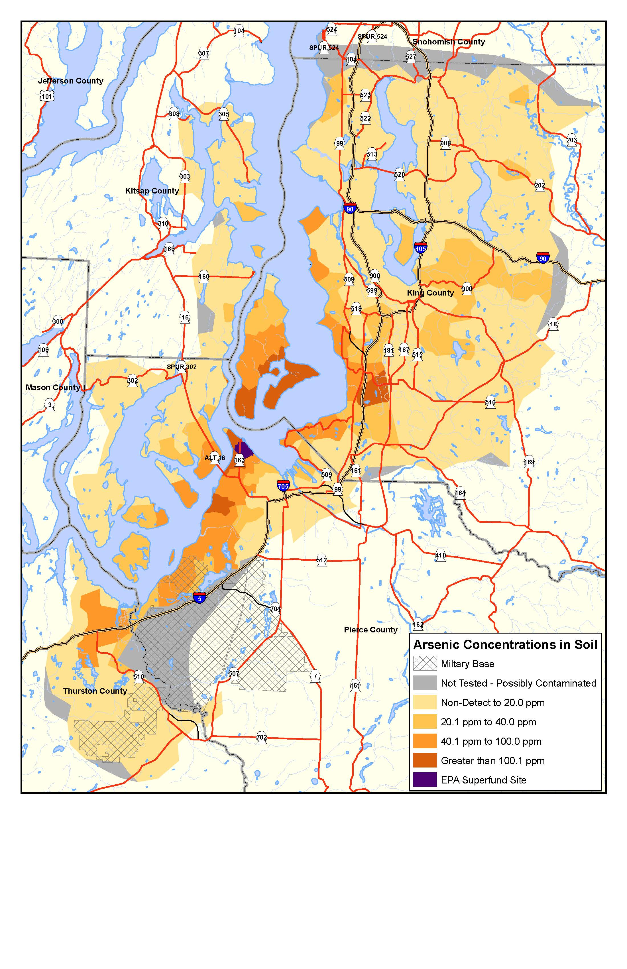This map shows estimated concentrations of arsenic in the top six inches of soil. It is based on a relatively small number of soil samples, given the large area that is affected. Property-specific sampling is needed to determine the actual amount of arsenic on a given property.