Tacoma Smelter Plume High Zone

ECOLOGO_W-C.wmf

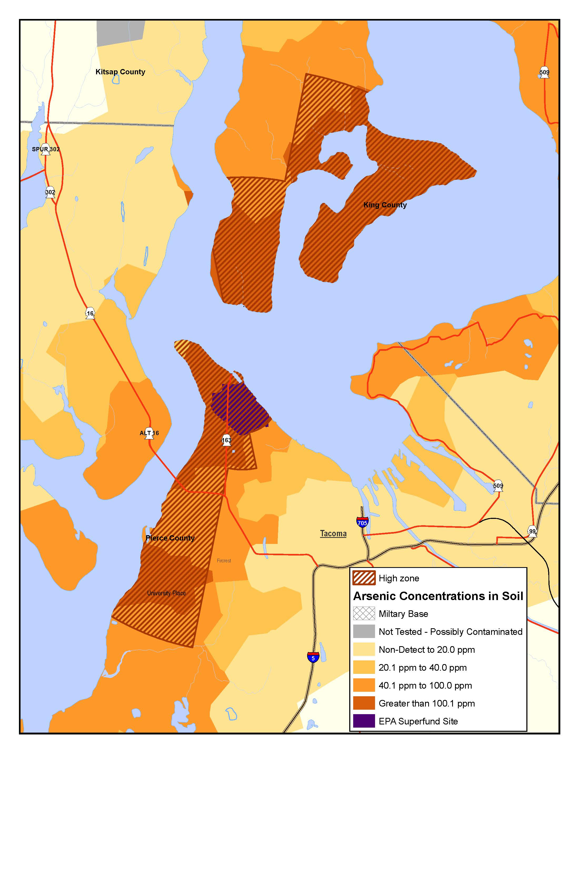

This map shows the areas Ecology estimates are more likely to have high contamination—over 100 parts per million (ppm)—of arsenic in the soil. This is there area where Ecology will focus a yard sampling and cleanup program, beginning in late 2012.