Soil Safety Program Service Area

ECOLOGO_W-C.wmf

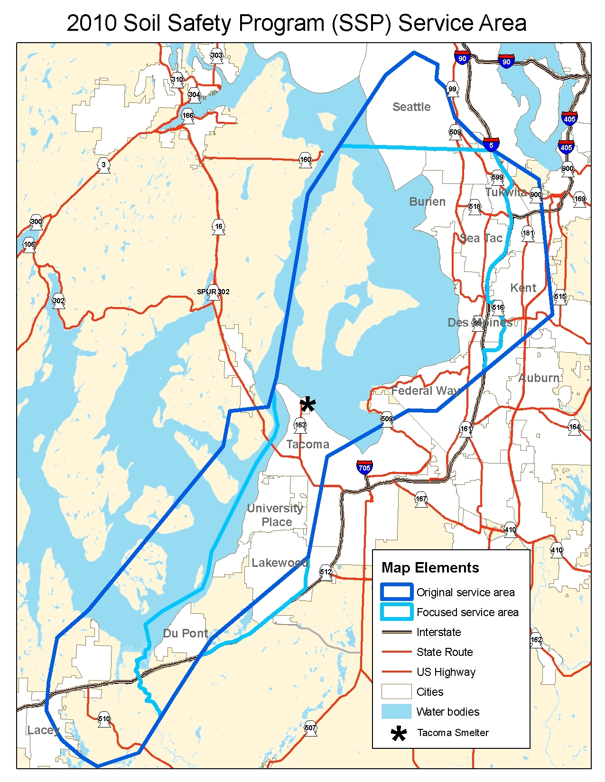

Ecology is sampling and cleaning up play areas at schools, childcares, parks, campus, and multi-family public housing within this service area. The lighter blue line is the current service area. Ecology updated it using recent soil sampling data. The darker blue line is the old service area, but Ecology may clean up play areas within those areas, too.