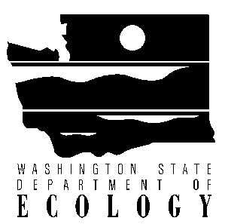

PUBLIC PARTICIPATION PLAN

Shelton C Street Landfill
Shelton, Washington

DRAFT

Prepared by
Washington State Department of Ecology
Southwest Regional Office
Toxics Cleanup Program
300 Desmond Drive
Olympia, Washington 98504-7775

January 2016
Table of Contents
INTRODUCTION 3
SITE LOCATION 3
SITE BACKGROUND 4
CURRENT STATUS 4
SITE CLEANUP PROCESS 5
PUBLIC PARTICIPATION ACTIVITIES AND RESPONSIBILITIES 6
Formal Public Comment Periods 6
Public Meetings and Hearings 7
Information Repositories 7
Site Register 7
Mailing List 7
Fact Sheets 7
Newspaper Display Ads 7
Plan Update 8
Contacts 8
GLOSSARY 9

INTRODUCTION

Public participation plans promote meaningful involvement during cleanups. This plan describes the tools the Washington State Department of Ecology (Ecology) will use to inform the public about and gather input on the Shelton C Street Landfill cleanup.

SITE LOCATION

The C Street Landfill cleanup site is located just west of downtown Shelton and Highway 101. The site boundaries will be established when the full extent of contamination is known following site investigations.
Figure 1: Site Location

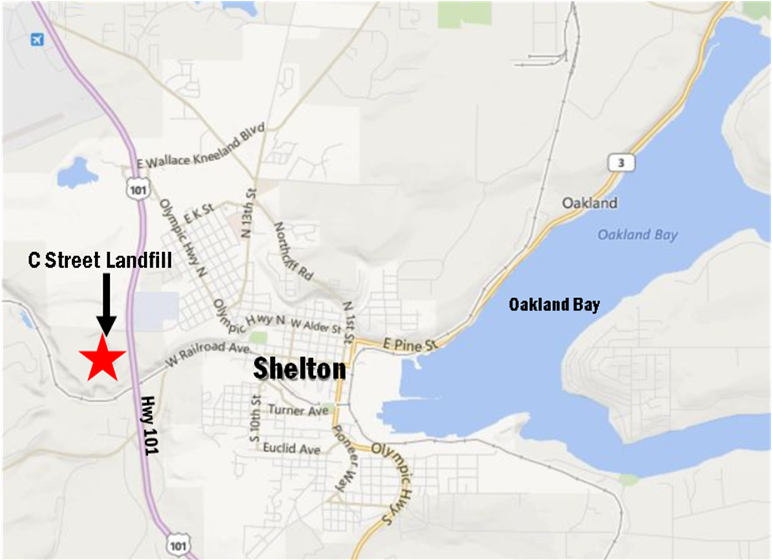

SITE BACKGROUND

The C Street Landfill was the city’s landfill in the 1950s and 1960s. In the 1970s, the city stopped using it for municipal disposal and began sending waste to a new Mason County facility northwest of Shelton.

From 1976-1981, wastewater treatment sludge containing ash from the Simpson Shelton mill was dumped on the site. The ash was sampled by the US Environmental Protection Agency in the 1980s. Based on standards in place at the time, a 1986 report concluding the EPA’s work determined dioxin exposure risk was low.

The site is currently vacant and adjacent to a proposed development, called Shelton Hills. We do not fully know the nature of the waste placed there, so it is a priority to collect thorough, fact-based information about the site. The site will be studied and cleaned up under the state’s Model Toxics Control Act.

CURRENT STATUS

MTCA defines the process and steps of cleaning up a contaminated site. A key step in the cleanup process is called a Site Hazard Assessment (SHA). The SHA is a preliminary evaluation of a site. Its purpose is to look into potential risk and assign priority for site cleanup.

After an SHA, Ecology ranks the site with a score of 1 to 5, with 1 representing the highest level of potential risk. In 2014, Ecology completed the SHA for the C Street Landfill and ranked it as a 3 on the Hazardous Sites List.
Some factors that enter into the SHA ranking method are:
- The amount and type of contaminants present.
- Site characteristics.
- How easily contaminants come into contact with people and the environment.

Ecology named the City of Shelton the potentially liable person (PLP) responsible for cleaning up the site.

Under the proposed agreed order, the City of Shelton is required to:
- Conduct a remedial investigation, which looks at the nature and extent of contamination.
- Conduct a feasibility study, which weighs cleanup options.
- Submit a cleanup action plan, which will outline proposed cleanup actions for the site.

The public will be able to review and comment on future agreements and draft cleanup plans.

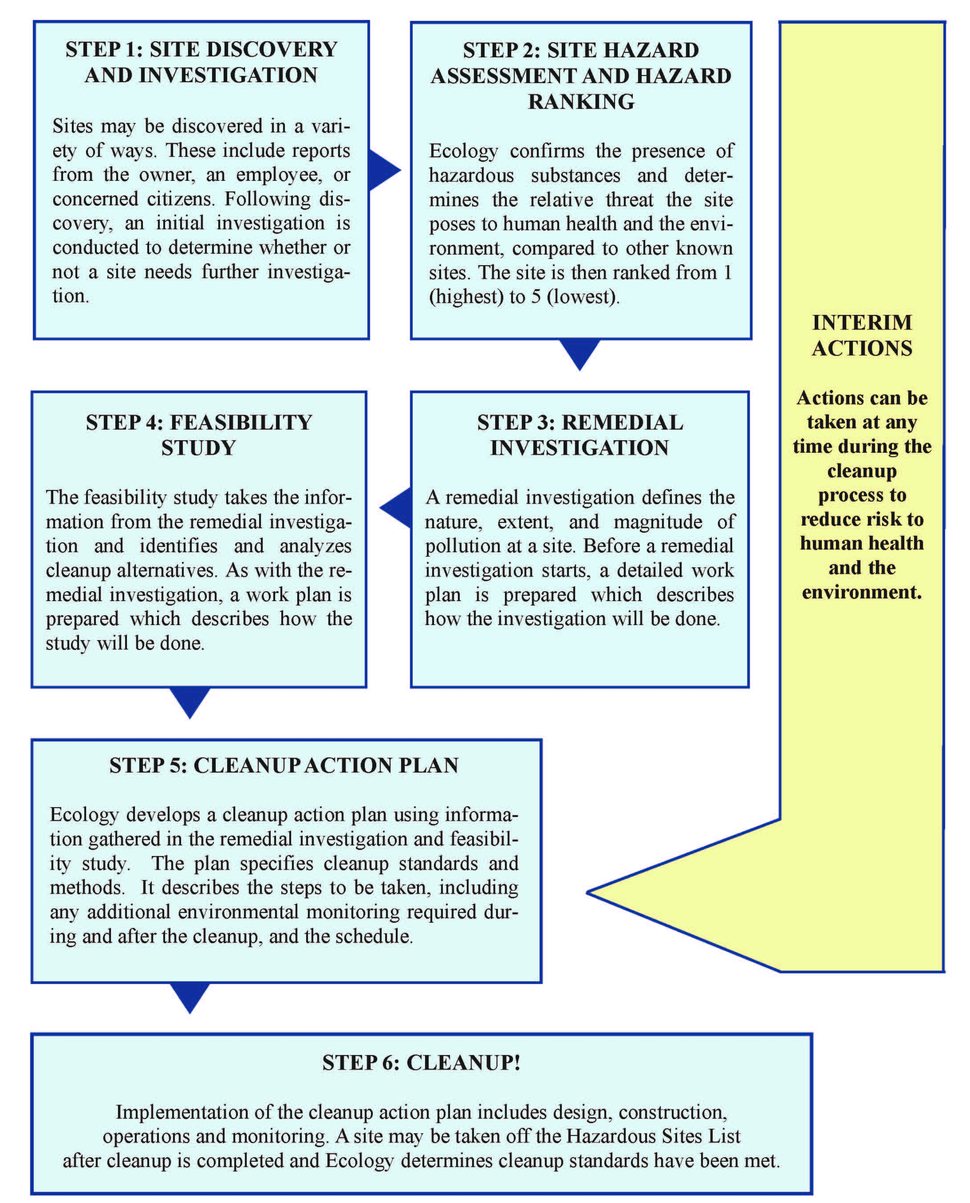
SITE CLEANUP PROCESS

Cleanup activities at the C Street Landfill site fall under Washington’s Model Toxics Control Act (MTCA) and accompanying regulations (Revised Code of Washington (RCW) 70.105D and Washington Administrative Code (WAC) 173-340). MTCA has procedures for cleaning up contaminated sites to standards that are safe for both human health and the environment.

Toxic sites are cleaned up in stages, described below. Each stage has a related report or plan that the public is welcome to review and comment on.

Remedial Investigation & Feasibility Study (RI/FS)
The RI looks at the extent and type of pollution on the site. It also looks at possible human health and environmental impacts. The FS identifies and evaluates different cleanup options.

Interim Actions
Ecology may allow Interim Actions to partly clean up a site before the final cleanup plan is complete.

Cleanup Action Plan (CAP)
The CAP describes the cleanup methods and how they will meet Ecology’s cleanup standards.

Cleanup
Cleanup removes contaminants from the site, contains them on the site, or treats them to make them less toxic. Based on the information in the RI/FS, Ecology selects a cleanup action and develops a new legal agreement for cleanup. CAPs require a public comment period.

Delisting
Ecology keeps track of toxic cleanup sites on the Hazardous Sites List. Once cleanup is complete, the public will have a chance to comment before Ecology takes a site off the list.

You can find more information about toxic cleanups on Ecology’s website: http://www.ecy.wa.gov/programs/tcp/cu_support/cu_process__steps_defns.htm.

PUBLIC PARTICIPATION ACTIVITIES AND RESPONSIBILITIES

The purpose of this Public Participation Plan is to promote public understanding and participation in the cleanup. This section of the plan describes how Ecology will share information and receive public comments on cleanup activities. Ecology will use the following public involvement activities during the C Street Landfill site cleanup:

Formal Public Comment Periods
Comment periods are the primary method Ecology uses to get feedback from the public on proposed cleanup decisions. Comment periods usually last 30 days. WAC 173-340-600 requires them at key points during the investigation and cleanup process, before final decisions are made. During a comment period, the public can comment in writing. Ecology can only take verbal comments during a public hearing.

After comment periods, Ecology reviews all comments and may respond in a document called a responsiveness summary. Ecology considers whether a document or decision needs to be changed or revised based on public input. If there are major changes, Ecology may hold a second comment period. If there are no major changes, Ecology finalizes the draft document(s).

Public Meetings and Hearings
Ecology may hold public meetings at key points during the investigation and cleanup. Ecology also may offer public meetings for actions expected to be of particular interest to the community. Ecology will also hold a public meeting if ten or more people request one. These meetings will be at places and times convenient to the public.

Information Repositories

These are places where the public can read and review site information, including public comment period documents. Ecology has three repositories for this site:

- Shelton Civic Center Kiosk Customer Service, 525 W Cota Street, Shelton WA 98584 (360) 426-4441
- Shelton Timberland Library, 710 W. Alder St., Shelton, WA 98584 (360) 426-1362
- Washington State Department of Ecology, 300 Desmond Drive, Lacey 98503. Please call (360) 407-6365 for an appointment.

See also Ecology’s website: https://fortress.wa.gov/ecy/gsp/Sitepage.aspx?csid=2295.

Site Register

Ecology’s Toxics Cleanup Program uses its bimonthly Site Register to announce public meetings and comment periods, and many other activities. To receive the Site Register by email, contact Seth Preston at (360) 407-6848 or Seth.Preston@ecy.wa.gov. You can also read it on Ecology’s website at http://www.ecy.wa.gov/programs/tcp/pub_inv/pub_inv2.html.

Mailing List
Ecology’s mailing list for this site includes neighboring landowners and businesses, public agencies, and other known interested parties. Ecology’s Southwest Regional Office maintains the list and will update it as needed. Please contact Megan MacClellan at (360) 407-0067 or Megan.MacClellan@ecy.wa.gov if you would like to have your address added to or deleted from this mailing list.

Fact Sheets
Ecology will mail fact sheets to people and groups interested in this cleanup, as well as nearby residents. Fact sheets will announce comment periods and public meetings. Ecology also may mail fact sheets with updates on cleanup progress.

Newspaper Display Ads
Ecology will place ads in Shelton Mason County Journal and KMAS News Radio to announce public comment periods and public meetings for the site.

Plan Update
Ecology may update this Public Participation Plan as the project moves forward. The public will have a chance to comment on any major changes to the plan.

Contacts
If you have questions or need more information about this plan or the C Street Landfill cleanup site, please contact:

Jason Landskron, Project Manager
WA Department of Ecology
PO Box 47775
Olympia, WA 98504-7775
Tel: (360) 407-6388
Email: Jason.Landskron@ecy.wa.gov

Megan MacClellan, Public Involvement Coordinator
WA Department of Ecology
PO Box 47775
Olympia, WA 98504-7775
Tel: (360) 407-0067
Email: Megan.MacClellan@ecy.wa.gov

GLOSSARY

Agreed Order: A legal agreement between Ecology and a Potentially Liable Person (see below) to conduct work toward a cleanup.

Cleanup: Actions that deal with a release or threatened release of hazardous substances that could affect public health or the environment. Ecology often uses the term "cleanup" broadly to describe response actions or phases of cleanup, such as the Remedial Investigation/Feasibility Study.

Cleanup Action Plan (CAP): A plan that explains which cleanup option(s) will be used at a site. The Remedial Investigation and Feasibility Study provide the data and analysis to write a CAP. It also takes into account public comments and public concerns.

Comment Period: A time period during which the public can review and comment on various documents and proposed actions. For example, a comment period may be provided to allow community members to review and comment on proposed cleanup action alternatives and proposed plans.

Contaminant: Any hazardous substance that does not occur naturally or occurs at greater than natural background levels

Feasibility Study: This study develops and evaluates cleanup options for a given site.

Groundwater: Water found beneath the earth's surface that fills spaces between materials such as sand, soil, or gravel. In some aquifers, ground water occurs in large enough amounts to be used for drinking water, irrigation and other purposes.

Information Repository: A file containing site information and reports for public review. It is usually located in a public building convenient for local residents, such as a public school, city hall, or library.

Model Toxics Control Act (MTCA): A law passed by Washington voter initiative in 1988. Its purpose is to find, investigate, and clean up places where hazardous substances have been released. It defines Ecology’s role and encourages public involvement in cleanup decisions.

Potentially Liable Person: Any individual(s) or company(s) potentially responsible for, or contributing to, the contamination problems at a site. Whenever possible, Ecology requires PLPs to clean up sites.

Public Notice: At a minimum, adequate notice mailed to all persons who have made a timely request of Ecology and to persons residing in the potentially affected vicinity of the proposed action; mailed to appropriate news media; published in the local (city and county) newspaper of largest circulation; and the opportunity for the interested persons to comment.

Public Participation Plan: A plan prepared to encourage coordinated and effective public involvement designed to the public's needs at a particular site.

Remedial Investigation: This study characterizes the site and defines the extent of contamination.

Remedial Investigation/Feasibility Study: Two distinct but related studies. They are usually performed at the same time, and together referred to as the "RI/FS." They are intended to:

-Gather the data necessary to determine the type and extent of contamination;
-Establish criteria for cleaning up the site;
-Identify and screen cleanup alternatives for remedial action; and
-Analyze in detail the technology and costs of the alternatives.

Responsiveness Summary: A summary of oral and/or written public comments received by Ecology during a comment period on key documents, and Ecology's responses to those comments. The responsiveness summary is especially valuable during the Cleanup Action Plan phase at a site when it highlights community concerns.

Risk: The probability that a hazardous substance, when released into the environment, will cause an adverse effect in the exposed humans or living organisms.

Sediments: Settled particles located at the bottom of a lake, river or in wetlands. Sediment(s) also includes settled particulate matter exposed by human activity (e.g., dredging) to the biologically active aquatic zone or to the water column.

Site: Any area where a hazardous substance, other than a consumer product in consumer use, has come to be located.

Toxicity: How much harm a substance causes to living organisms, including people, plants and animals, at a certain concentration.

