PERIODIC REVIEW
FINAL

Former Totem Pole Restaurant
Facility Site ID#: 21515785

7720 NE Highway 99
Vancouver, Washington 98665

Southwest Region Office

TOXICS CLEANUP PROGRAM

February 2012
TABLE OF CONTENTS

1.0 INTRODUCTION 1

2.0 SUMMARY OF SITE CONDITIONS 2

2.1 Site History 2
2.2 Site Investigation 2
2.3 Remediation 2
2.4 Soil to Vapor Pathway………………………………………………………………..…3
2.5 Points of Compliance 4
2.6 Groundwater Monitoring 4
2.7 Restrictive Covenant 5

3.0 PERIODIC REVIEW 7

3.1 Effectiveness of completed cleanup actions 7
3.2 New scientific information for individual hazardous substances for mixtures present at the Site 7
3.3 New applicable state and federal laws for hazardous substances present at the Site 7
3.3.1 Modified Cleanup Levels…………………………………………………………..7
3.3.2 Residual Saturation…………………………………………………………………8
3.4 Current and projected Site use 8
3.5 Availability and practicability of higher preference technologies 8
3.6 Availability of improved analytical techniques to evaluate compliance with cleanup levels 8

4.0 CONCLUSIONS 9

4.1 Next Review……………………………………………………………………………...9

5.0 REFERENCES 10

6.0 APPENDICIES 11
6.1 Vicinity Map 12
6.2 Current Site Plan……………………………………………………………………….13
6.3 Old Site Plan…………………………………………………………………………...14
6.4 Environmental Covenant 15
6.5 Photo log 22

INTRODUCTION

This document is a review by the Washington State Department of Ecology (Ecology) of post-cleanup site conditions and monitoring data to ensure that human health and the environment are being protected at the former Totem Pole Restaurant site (Site). Cleanup at this Site was implemented under the Model Toxics Control Act (MTCA) regulations, Chapter 173-340 Washington Administrative Code (WAC).

Cleanup activities at this Site were completed under the Voluntary Cleanup Program. The cleanup actions resulted in concentrations of gasoline-range petroleum hydrocarbons (TPH-G) exceeding MTCA Method A cleanup levels remaining at the Site. The MTCA Method A cleanup levels for soil are established under WAC 173-340-740(2). The MTCA Method A cleanup levels for groundwater are established under WAC 173-340-720(3). WAC 173-340-420 (2) requires that Ecology conduct a periodic review of a site every five years under the following conditions:

- Whenever the department conducts a cleanup action.
- Whenever the department approves a cleanup action under an order, agreed order or consent decree.
- Or, as resources permit, whenever the department issues a no further action opinion
- And one of the following conditions exists:

  - Institutional controls or financial assurance are required as part of the cleanup.
  - Where the cleanup level is based on a practical quantitation limit.
  - Where, in the department’s judgment, modifications to the default equations or assumptions using site-specific information would significantly increase the concentration of hazardous substances remaining at the site after cleanup or the uncertainty in the ecological evaluation or the reliability of the cleanup action is such that additional review is necessary to assure long-term protection of human health and the environment.

When evaluating whether human health and the environment are being protected, the factors the department shall consider include [WAC 173-340-420(4)]:

- The effectiveness of ongoing or completed cleanup actions, including the effectiveness of engineered controls and institutional controls in limiting exposure to hazardous substances remaining at the Site.
- New scientific information for individual hazardous substances of mixtures present at the Site.
- New applicable state and federal laws for hazardous substances present at the Site.
- Current and projected site use.
- Availability and practicability of higher preference technologies.
- The availability of improved analytical techniques to evaluate compliance with cleanup levels.

The department shall publish a notice of all periodic reviews in the site register and provide an opportunity for public comment.

SUMMARY OF SITE CONDITIONS

Site History

The Former Totem Pole Restaurant (Site) is located in the City of Vancouver in Clark County, Washington (Vicinity Map - Appendix 6.1). Following remedial activities, a Restrictive Covenant was recorded for the property in 2000 and the Site received a No Further Action determination on June 27, 2006.

The area surrounding the Site is predominantly commercial. The Site is occupied by a commercial building that contains a framing store, a cellular phone store, a coffee shop, and a tanning salon. The Site is bounded to the east by Highway 99, to the north by NE 78th Street, to the west by Interstate 5, and to the south by a Fred Meyer store. A current Site map is available as Appendix 6.2.

Some time prior to 1960, the Site was occupied by an automotive service station. A geophysical survey of the Site in 1999 indicated the presence of several possible underground structures. Test pits did not locate underground storage tanks (USTs), however, a former dispenser island and product piping were located. It appeared that the USTs had already been removed.

Site Investigation

In April 1999, soil samples were collected from a test pit at the former fuel dispenser island and product piping location. Analysis indicated the presence of TPH-G and heavy oil-range petroleum hydrocarbons (TPH-O) at maximum concentrations of 4,880 milligrams per kilogram (mg/kg) and 202 mg/kg, respectively. Between 1999 and 2000, several soil borings and monitoring wells were advanced at the Site. Additional soil contamination was confirmed including, benzene, toluene, ethylbenzene and xylenes (BTEX) at concentrations exceeding MTCA Method A cleanup levels. TPH-G, BTEX, volatile organic compounds, methyl tertiary butyl ether, 1,2-dichloroethane, ethyl dibromide, and lead were also detected in groundwater at concentrations exceeding MTCA Method A cleanup levels.

Remediation

In June 2000, approximately 2,020 tons of petroleum-contaminated soils (PCS) were excavated from the Site and disposed of at Hawks Prairie Waste and Recovery in Olympia, Washington and at Rabanco Regional Disposal Company in Roosevelt, Washington. Confirmation soil samples collected during and after excavation indicated residual concentrations of TPH-G and BTEX compounds exceeding MTCA Method A cleanup levels. Residual concentrations of TPH-G were present up to 2,960 mg/kg, and residual concentrations of BTEX were present up to 2.04

mg/kg benzene, 16.6 mg/kg ethylbenzene and 24.4 mg/kg xylenes. A figure showing the approximate area of excavation and locations of groundwater monitoring wells is available in Appendix 6.3.

Table-1: Maximum Residual Soil Concentrations

Contaminant | TPH-G | Benzene | Ethylbenzene | Xylenes
Concentration (mg/kg) | 1,460 | 2.04 | 16.6 | 24.4
Site Cleanup Levels | 100 | 0.5 | 20 | 20
Current MTCA Method-A Cleanup Levels | 30 | 0.03 | 6 | 9

A passive bioventing system was installed during backfilling activities along the north and east sidewalls of the excavation. The system included slotted horizontal 2-inch diameter, slotted polyvinyl chloride piping. The piping was installed approximately 4.5 feet below ground surface and was connected to two 2-inch risers that extend above the ground surface.

Soil to Vapor Pathway

Evaluation of the soil to vapor pathway is required at Sites contaminated with VOCs to determine the potential for adverse impacts on the indoor air quality that may pose a threat to human health and the environment. Examples of when this pathway should be evaluated include at Sites where soil gasoline range organics and/or other VOC concentrations are significantly higher than the cleanup levels derived for protection of groundwater for drinking water beneficial use, or where soil diesel range organic concentrations are higher than 10,000 mg/kg; WAC 173-340-740(3)(B)(iii)(C). As a part of this investigation, procedures outlined in the Department of Ecology draft “Guidance for Evaluating Soil Vapor Intrusion in Washington State: Investigation and Remedial Action” should be used.

Though the Former Totem Pole Restaurant Site is contaminated with VOCs and some contaminated soils were left on the Site exceeding the cleanup levels (Table 1), no investigations were conducted at this Site to evaluate the soil to vapor pathway and whether potential vapor concentrations are protective of human health or the environment. However, it is Ecology’s opinion that the exposure through the soil to vapor pathway does not pose a significant risk based on the following reasons:

- The service station operated on the Site sometime between 1930 and 1960. As such, any release that occurred at the Site would have happened 50 years ago. During that time, many of the VOCs present in the gasoline would have likely volatized. Based on the results of the confirmation soil samples collected in 2000 from the excavation sidewalls,

the ratio of VOCs to gasoline was indicative of weathered gasoline, which does not produce many vapors. Also it has been over 11 years these samples were collected and it is likely that VOCs present in the samples have volatized even further and the current gasoline concentrations on the Site are likely much lower.

- In 2000, the majority of contaminated soils beneath the Site (about 2,020 tons) was excavated and disposed of leaving only a small quantity of VOC contaminated soils behind.

- Groundwater beneath the Site is no longer impacted.

- The results of 2000 confirmation soil samples show very low benzene concentrations.

Based on the above reasons, though there is lack of soil vapor and indoor air data, Ecology believes that it is highly unlikely that there is any adverse impact on the human health and the environment through the soil to vapor pathway.

2.5 Point of Compliance

The point of compliance for soil is defined as the area throughout the Site affected by concentrations of petroleum hydrocarbons in soil above MTCA Method A cleanup levels, regardless of depth, to protect groundwater. The standard point of compliance for groundwater is throughout the Site from the uppermost level of the saturated zone to the lowest depth that could possibly be affected by the Site.

Groundwater Monitoring

Monitoring wells MW-1, MW-2, and MW-3 were removed during the remedial excavation and replaced following the completion of remedial activities. These wells were sampled quarterly from March 2001 until March 2002. A steady decrease in contaminants was observed until all contaminants except TPH-G were not detectable by March 2002. In July 2002, Ecology agreed that final Site compliance for groundwater would be achieved when four consecutive quarters of groundwater monitoring indicated TPH-G concentrations below the MTCA Method A cleanup level of 800 micrograms per liter (µg/l). Sampling continued until January 2006, when the fourth consecutive quarter of TPH-G in groundwater at concentrations below 800 µg/L was achieved.

Table-2: Groundwater Monitoring Results-Last Five Quarters

Monitoring Well | Date | TPH-G (µg/l) | Benzene (µg/l) | Ethylbenzene (µg/l) | Toluene (µg/l) | Xylene (µg/l) | Naphthalene (µg/l)
MW-1 | 04/25/05 | <80.0 | <0.200 | <0.500 | <0.500 | <1.00 | <2.00
 | 07/19/05 | <80.0 | <0.200 | <0.500 | <0.500 | <1.00 | <2.00
 | 10/13/05 | …… | <0.200 | <0.500 | <0.500 | <1.00 | <2.00
 | 11/01/05 | 110 | …… | …… | …… | …… | ……
 | 01/05/06 | 94.30 | <0.200 | <0.500 | <0.500 | <1.00 | <2.00
MW-2 | 04/25/05 | <80.0 | <0.200 | <0.500 | <0.500 | <1.00 | <2.00
 | 07/19/05 | <80.0 | <0.200 | <0.500 | <0.500 | <1.00 | <2.00
 | 10/13/05 | …… | <0.200 | <0.0500 | <0.500 | <1.00 | <2.00
 | 11/01/05 | <80.0 | …… | …… | …… | …… | ……
 | 01/05/06 | <80.0 | <0.200 | <0.500 | <0.500 | <1.00 | <2.00
MW-3A | 04/25/05 | <80.0 | <0.200 | <0.500 | <0.500 | <1.00 | <2.00
 | 07/19/05 | <80.0 | <0.200 | <0.500 | <0.500 | <1.00 | <2.00
 | 10/13/05 | …… | <0.200 | <0.500 | <0.500 | <1.00 | <2.00
 | 11/01/05 | 223 | …… | …… | …… | …… | ……
 | 01/05/06 | <80.0 | <0.200 | <0.500 | <0.500 | <1.00 | <2.00
MW-4 | 04/25/05 | <80.0 | <0.200 | <0.500 | <0.500 | <1.00 | <2.00
 | 07/19/05 | <80.0 | <0.200 | <0.500 | <0.500 | <1.00 | <2.00
 | 10/13/05 | ….. | <0.200 | <0.500 | <0.500 | <1.00 | <2.00
 | 11/01/05 | <80.0 | …… | …… | …… | …… | ……
 | 01/05/06 | <80.0 | <0.200 | <0.500 | <0.500 | <1.00 | <2.00
MTCA Method-A Cleanup Levels |  | 800 | 5 | 700 | 1000 | 1000 | 160

Note: All the contaminant concentrations are below cleanup level
…… Contaminant not analyzed

Restrictive Covenant

On October 10, 2000, a Restrictive Covenant was recorded for the Site. The following restrictions were imposed on the Site as a result of the residual contamination exceeding MTCA Method A cleanup levels:

- No soil or groundwater may be taken from the Site for any use from the Site, except as needed for sample collection.
- Any activity on the Site that may release or expose contaminated soil or groundwater is prohibited without prior written approval from Ecology.
- The owner must restrict leases to uses and activities consistent with the Restrictive Covenant and notify all lessees of the restrictions on the property.
- The owner shall allow Ecology on the Site to inspect and collect samples.
- The owner of the property reserves the right to remove the Covenant with Ecology’s approval.

The Restrictive Covenant is available as Appendix 6.4.

PERIODIC REVIEW

Effectiveness of completed cleanup actions

Based upon the Site visit conducted on October 24, 2011, the building and asphalt cover at the Site continue to eliminate exposure pathways (ingestion, contact) to contaminated soils. The asphalt appears in satisfactory condition and no repair, maintenance or contingency actions have been required. The Site is still occupied by commercial businesses. A photo log is available as Appendix 6.5.

The Restrictive Covenant for the Site was recorded and is in place. This Restrictive Covenant prohibits activities that will result in the release of contaminants contained as part of the cleanup without Ecology’s approval, and prohibits any use of the property that is inconsistent with the Covenant. This Restrictive Covenant serves to assure the long term integrity of the Site’s impermeable surfaces.

New scientific information for individual hazardous substances for mixtures present at the Site

There is no new relevant scientific information for the petroleum contaminants related to the Site.

New applicable state and federal laws for hazardous substances present at the Site

Modified Cleanup Levels

The cleanup at the Site was governed by Chapter 173-340 WAC (1996 ed.). WAC 173-340-702(12) (c) [2001 ed.] provides that,

“A release cleaned up under the cleanup levels determined in (a) or (b) of this subsection shall not be subject to further cleanup action due solely to subsequent amendments to the provision in this chapter on cleanup levels, unless the department determines, on a case-by-case basis, that the previous cleanup action is no longer sufficiently protective of human health and the environment.”

Although cleanup levels changed for gasoline and volatile organic compounds as a result of modifications to MTCA in 2001, contamination remains at the Site above MTCA Method A cleanup levels and the cleanup action is still protective of human health and the environment. In addition, though there is lack of soil vapor and indoor air data, as discussed in section 2.4, risk to the human health and the environment is low through the soil to vapor pathway.

Residual Saturation

Initial cleanup at the Site was governed by Chapter 173-340 WAC (1996 ed.). Current WAC 173-340-747(10) provides that,

“To ensure the soil concentrations established under one of the methods specified in subsections (4) through (9) of this section will not cause an exceedance of the ground water cleanup level established under WAC 173-340-720, the soil concentrations must not result in the accumulation of nonaqueous phase liquid in groundwater. To determine if this criterion is met....residual saturation screening levels must be established and compared with the soil concentrations.”

Model Toxics Control Act Method –A Unrestricted land use soil cleanup levels (30 mg/kg) were established for gasoline-range petroleum hydrocarbons. Soil concentrations (297 mg/kg – 1460 mg/kg) at the Site exceed this cleanup level and also the residual saturation screening level of 1000 mg/kg for weathered gasoline (Table 747-5 of MTCA). However, results of ground water monitoring at the Site indicates that these soil concentrations do not pose a threat to ground water quality.

Current and projected Site use

The Site is currently used for commercial purposes. There have been no changes in current or projected future Site or resource uses.

Availability and practicability of higher preference technologies

The remedy implemented included containment of hazardous substances and it continues to be protective of human health and the environment. While higher preference cleanup technologies may be available, they are still not practicable at this Site.

Availability of improved analytical techniques to evaluate compliance with cleanup levels

The analytical methods used at the time of the remedial action were capable of detection below MTCA Method A cleanup levels. The presence of improved analytical techniques would not effect decisions or recommendations made for the Site.

CONCLUSIONS

- The cleanup actions completed at the Site appear to be protective of human health and the environment.

- Soil cleanup levels have not been met at the Site; however, under WAC 173-340-740(6)(f), the cleanup action is determined to comply with cleanup standards, since the long-term integrity of the containment system is ensured and the requirements for containment technologies have been met.

- Soil concentrations of TPH-G exceed the cleanup level and the saturation concentration for the weathered gasoline; groundwater monitoring indicates that these concentrations do not pose a threat to ground water.

- No soil vapor or indoor air investigations were conducted to determine any potential risk through soil to vapor pathway. However, as discussed in section 2.4, Ecology considers the risk posed by the soil to vapor pathway to be low.

- The Restrictive Covenant for the property is in place and will be effective in protecting public health and the environment from exposure to hazardous substances and protecting the integrity of the cleanup action.

Based on this review, the Department of Ecology has determined that the requirements of the Restrictive Covenant have been satisfactorily completed. No additional actions are required by the property owner. It is the property owner’s responsibility to continue to inspect the Site to assure that the integrity of the cap is maintained.

  - NEXT REVIEW

The next review for the Site will be scheduled five years from the date of this periodic review. In the event that additional cleanup actions or institutional controls are required, the next periodic review will be scheduled five years from the completion of those activities.

REFERENCES

Hahn and Associates. 1999, Site Investigation and Method B Evaluation

Hahn and Associates. 1999, Data Gap Investigation Report

GeoEngineers. 2000, Voluntary Cleanup Program Remedial Action Summary Report

Ecology. 2000, Restrictive Covenant

Ecology. 2006, No Further Action Letter

Ecology. October 2009. Guidance for Evaluating Soil Vapor Intrusion in Washington State:
Investigation and Remedial Action.

Ecology. October 24, 2011 Site Visit

APPENDICIES

Vicinity Map
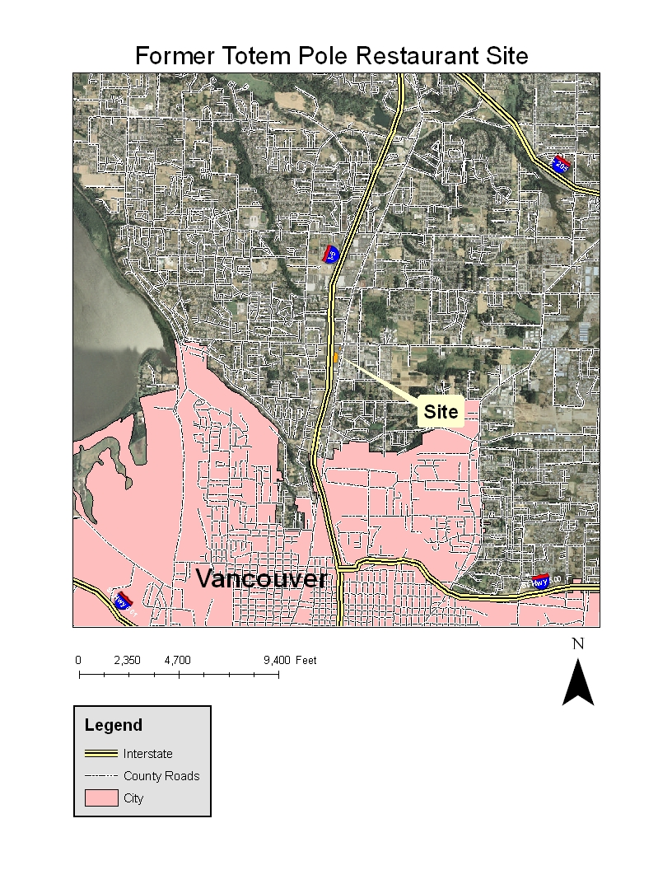

Current Site Plan
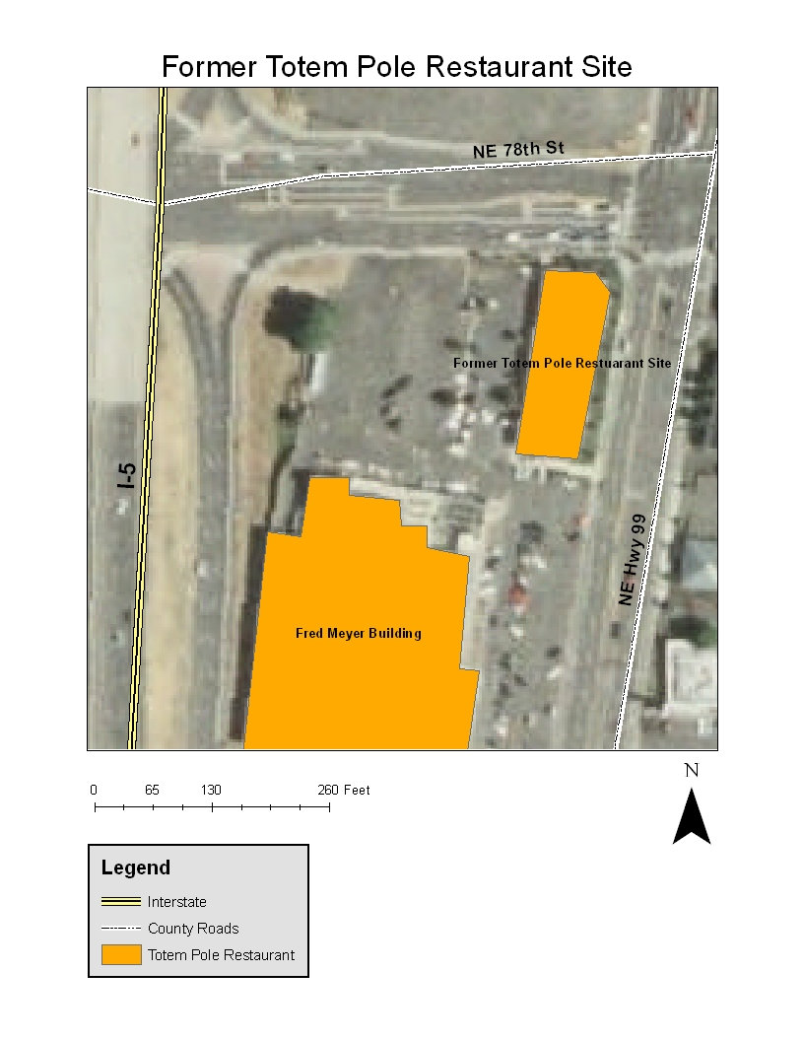

Old Site Plan

6.4 Environmental Covenant

Photo log

Photo 1: Southwest Corner of building - from the southwest
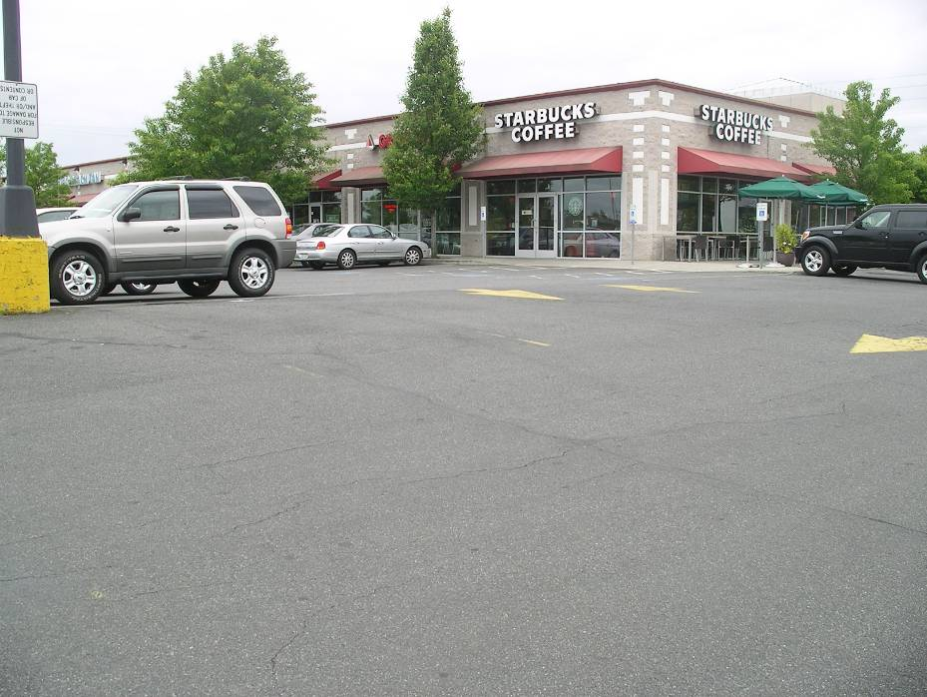

Photo 2: Southeast Corner of Building - from the southeast
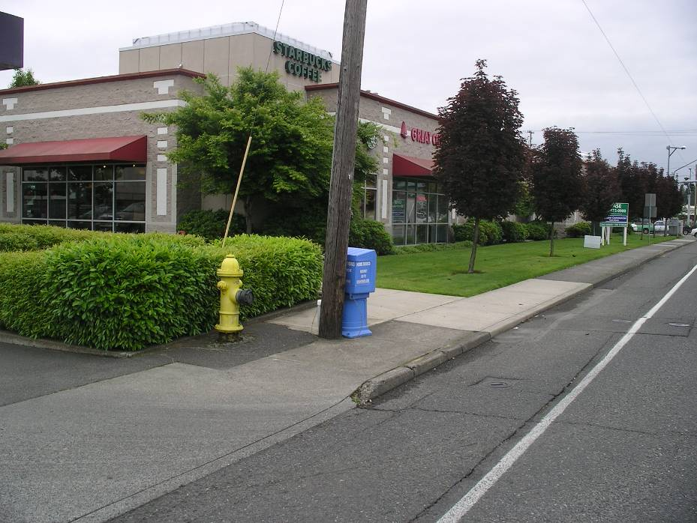

Photo 3: West Side of Building - from the northwest
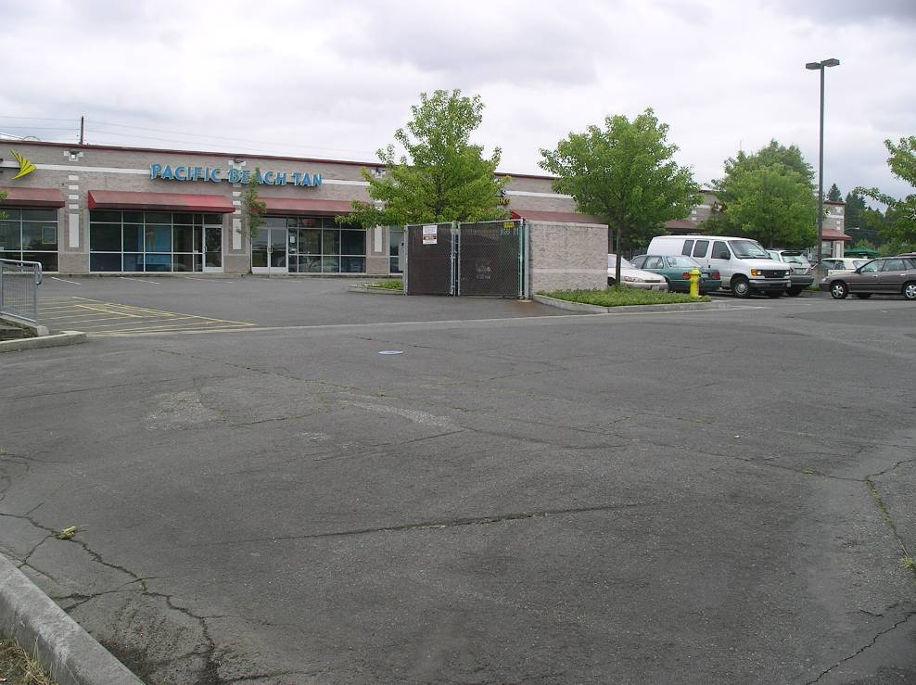

Photo 4: Abandoned Well Location West of the Building – from the northwest
