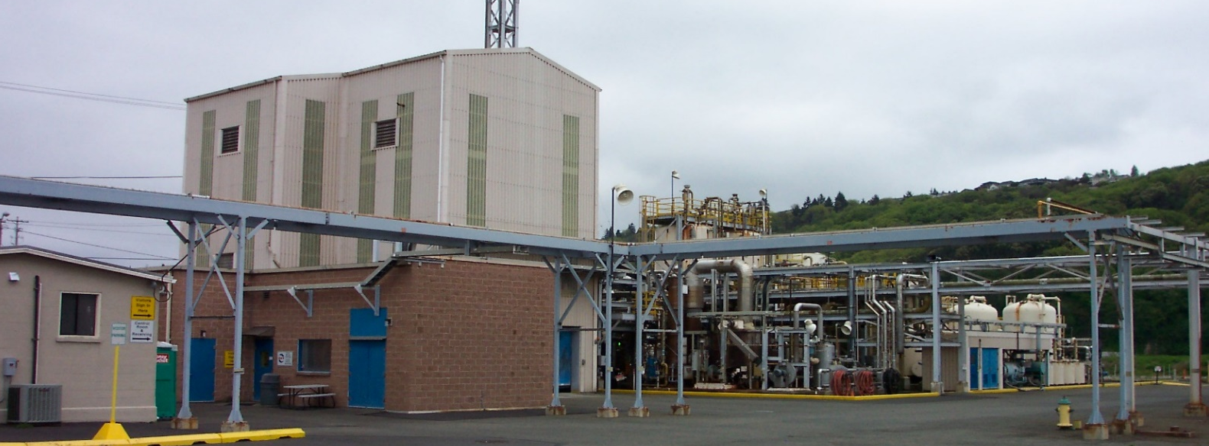
Occidental Chemical Corporation

Occidental Tacoma Site

Recent Sediment and Porewater Characterization at Occidental Chemical Corporation Tacoma Site
Occidental Chemical Corporation (OCC) recently studied surface sediment, porewater, and near-surface groundwater quality in areas of the Hylebos Waterway and Commencement Bay. These areas are potentially affected by the OCC Tacoma Groundwater Site (Site). This study adds to earlier data collection efforts and provides an evaluation of current conditions. The study also provides a baseline for long-term monitoring of future remedial actions planned for the Site. Sampling and analysis was overseen by the Washington Department of Ecology (Ecology) and the U.S. Environmental Protection Agency (EPA). A draft Data Summary Report is available for public review online at: https://fortress.wa.gov/ecy/gsp/DocViewer.ashx?did=61620.

Why conduct this study?
Previous investigations showed chlorinated volatile organic compounds (cVOCs) in groundwater below and near the Site. Based on the Conceptual Site Model (CSM), there are potential pathways to the Hylebos Waterway and Commencement Bay, including potential upwelling of groundwater into surface sediments, porewater, and surface water.

Previous sampling indicated that cVOC concentrations decline as groundwater moves to surface water. However, more data were needed to determine if current conditions are protective of human health and the environment.

How did OCC conduct their study?
In July and August 2016, OCC’s contractor, Anchor QEA, collected samples at 33 locations in the Hylebos Waterway and Commencement Bay. The samples were taken from near-surface groundwater at depths of 4 inches, 1 foot, and 3 feet below the top of the sediment. They took samples from:

- Surface sediment
- Near-surface groundwater
- Surface sediment porewater
- Near-bottom surface water

Sample locations were based on where potential upwelling of Site groundwater could occur. The samples were analyzed for a wide range of chemicals including cVOCs, metals, and pH.
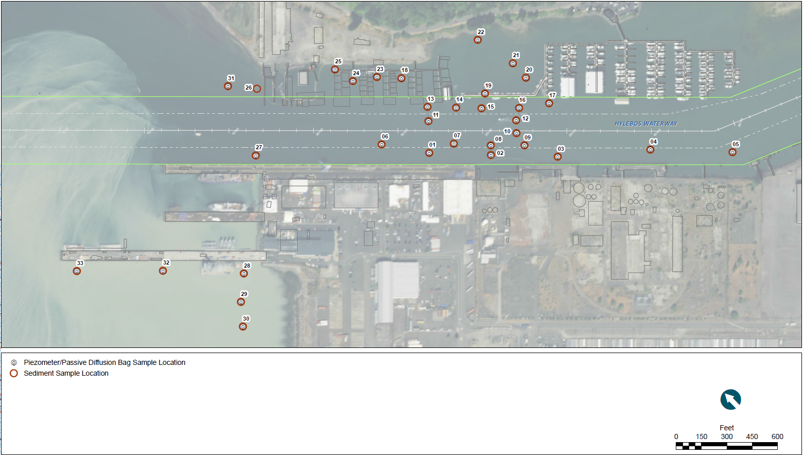

Samples were collected using two methods:
- Divers inserted piezometers into sediment, which extracted groundwater from a temporary well point.
- Divers deployed and retrieved sampling devices that equilibrated with surrounding groundwater, porewater, or surface water over four weeks. This sampling method also gathered samples about 1 inch above and below the top of the sediment.

These samples help compare surface water quality with regulatory cleanup standards. cVOC concentrations were often higher in method #2 than in the paired piezometer. Method 2 can effectively sample porewater in locations with little or no groundwater flow.

What did OCC find?
All surface sediment concentrations in the Site area were below regulatory cleanup standards, as were all metal and pH results.
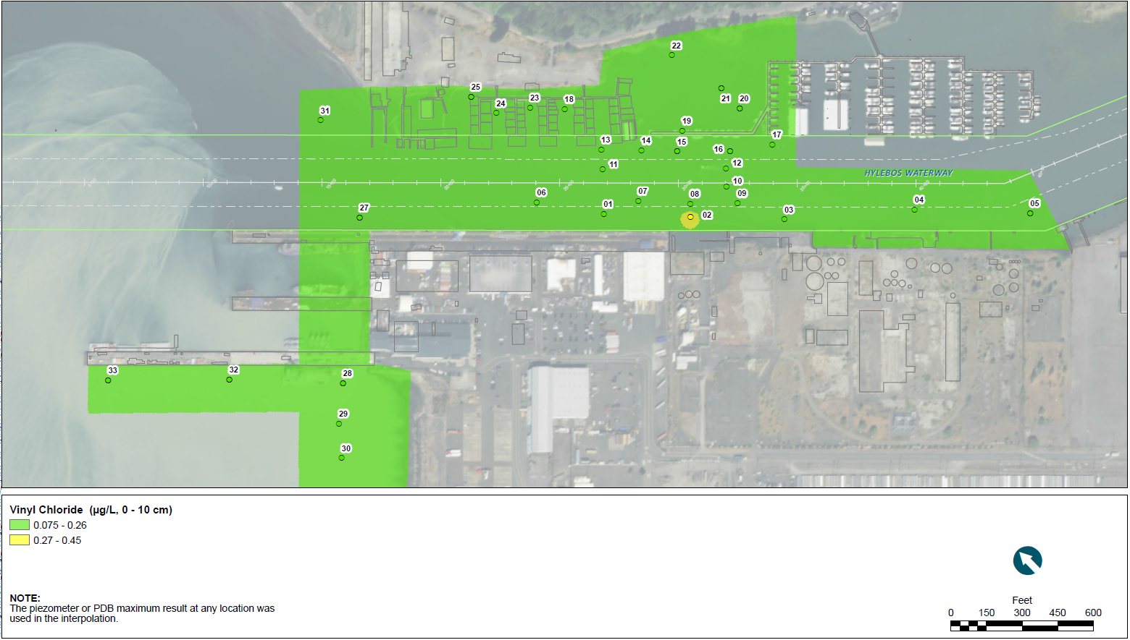

Elevated cVOC concentrations were detected at several locations below the top of the sediment. However, groundwater and porewater concentrations declined 1,000- and 10,000-fold over the last three feet of the pathway to surface water.

Surface water cVOC concentrations were below cleanup standards at all but one location. One localized area of the Hylebos Waterway adjacent to the Site has the potential to exceed standards, but did not exceed these criteria at the point of compliance measured at the top of the sediment. This area will be addressed as part of remediation of the OCC Site. The 2016 sampling data will provide a baseline for long-term monitoring following completion of further remedial actions planned for the Site.

The data show that current conditions in the Hylebos Waterway and Commencement Bay adjacent to the Site are protective of human health and the environment.

Accommodation Requests: To request ADA accommodation for disabilities, or printed materials in a format for the visually impaired, call Ecology at 360-407-6700 or visit http://www.ecy.wa.gov/accessibility.html. Persons with impaired hearing may call Washington Relay Service at 711. Persons with speech disability may call TTY at 877-833-6341.

