Occidental Chemical Corporation
What is Vapor Intrusion?
Vapor intrusion occurs when gaseous (vapor) phase movement of chemicals from the subsurface to land surface. Vapor phase movement into buildings and other structures may impact human health.

Historical production of chlorinated solvents resulted in releases from past Occidental Chemical Corporation (OCC) chemical manufacturing operations. These releases have significantly impacted both soil and groundwater. When released to soil and groundwater, chlorinated solvents such as trichloroethylene (TCE) and tetrachloroethylene (PCE) will break down. This breakdown results in four separate phases:
1. Solid phase when the chemical adsorbs to soil.
2. Water phase when the substance mixes with water.
3. Air or vapor phase.
4. Pure chemical phase such as a dense non-aqueous phase liquid (DNAPL).

Substances like TCE and PCE are volatile organic compounds (VOCs) and are cancer causing. These substances have a tendency to turn into vapor and go into the air. This becomes an issue when subsurface vapors seep into or buildings.

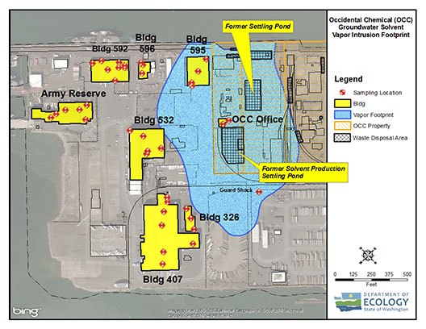
Occidental Vapor Intrusion Study
Between 2013 and 2015, Occidental collected indoor air and sub-slab soil gas samples from 8 buildings both on and off their property. Most of the buildings are operated by Port of Tacoma tenants. At each building, a hole was drilled through the concrete floor and soil gas (sub-slab) samples were collected. Indoor air samples were also collected. Indoor air samples were also collected from 40 locations and sub-slab from 24 locations.

Results from the Vapor Intrusion Study
The results of the vapor intrusion study indicate that there are high levels of TCE and PCE soil gas near the former Occidental solvent production settling ponds. A soil gas sample beneath the OCC office had 30,000 ug/m3 PCE. For reference, the Ecology PCE indoor air cleanup level (non-carcinogen, industrial land use) is 40 ug/m3. Thus, within the center of the vapor footprint, soil gas levels are roughly 1,000 times standards.

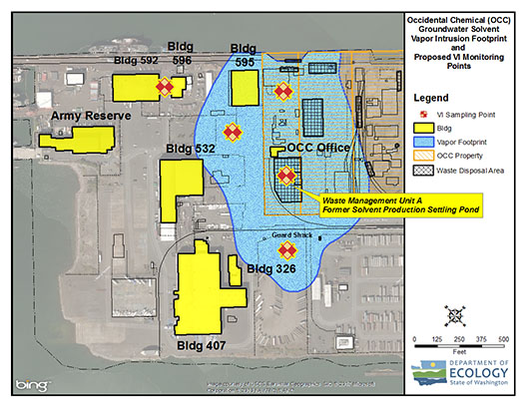
This vapor footprint is roughly 21 acres in size and extends north-northeast (and slightly southwest) from the former Occidental solvent production settling ponds. Outside of the vapor footprint, soil gas levels are significantly lower. Vapor levels decrease significantly west-northwest of the former Occidental solvent production settling ponds. However, high levels of indoor air TCE and PCE were detected in several of the buildings. For these same buildings, high levels of PCE and TCE were not detected in the sub-slab soil gas. This suggests is that the indoor air PCE and TCE levels are the result of indoor air chemical use, e.g. paints, solvents, etc.

Based on the data, Occidental (GHD, 2016) has concluded that only 2 of 8 buildings may be potentially impacted by vapor phase migration. Specifically, Occidental has proposed continued monitoring for one structure, Trident Seafoods Warehouse 595. Occidental has also proposed some limited mitigation such as opening doors and windows for the OCC office, which is rarely used.

Ecology’s Findings and Recommendations
Ecology conducted a detailed review of the vapor intrusion study. Ecology’s findings are in part consistent with Occidental. Specifically, there is a significant vapor footprint associated with the former Occidental solvent production settling ponds. Ecology also concurs that the high levels of indoor air PCE and TCE, for several of the buildings, are likely influenced by or are in part the result of indoor air sources (as opposed to subsurface vapor intrusion). However, Ecology believes the residual chlorinated solvent mass associated with the former production settling ponds poses a vapor intrusion risk. Specifically, there is a significant mass of residual solvents (PCE, TCE, etc.) roughly 10 feet below land surface.

Ecology will direct Occidental to conduct additional vapor phase monitoring. Specifically, probes will be drilled into the ground to measure vapors over time. These probes will be drilled in areas impacted by historical Occidental operations. Ecology will also be working with Occidental on cleanup of the former spent solvent production ponds. These particular areas are significantly impacted with residual chlorinated solvents and they therefore pose a vapor intrusion risk.

To request ADA accommodation for disabilities, call the Hazardous Waste and Toxics Reduction Program, 360-407-6700. Persons with impaired hearing may call Washington Relay Service at 711. Persons with speech disability may call TTY at 877-833-6341.

