Bothell Former Hertz Site
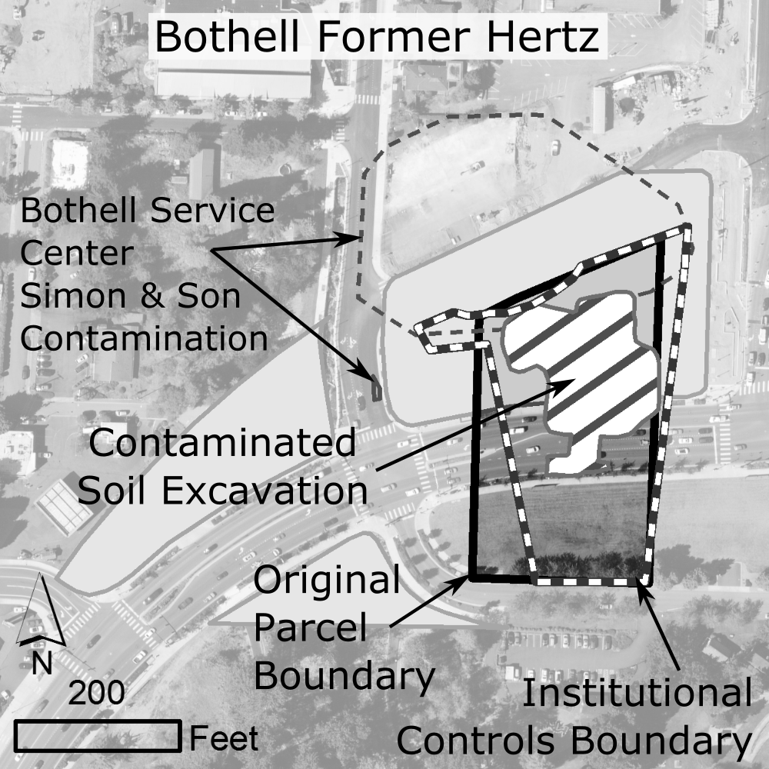
Public Participation Plan 2018

Northwest Regional Office – Toxics Cleanup Program
3190 160th Ave SE
Bellevue, WA 98008

Table of Contents
1.0 INTRODUCTION 3
2.0 SITE BACKGROUND 4
3.0 CLEANUP ACTIONS AND SCHEDULE 4
4.0 CHEMICALS OF CONCERN 4
5.0 PUBLIC PARTICIPATION ACTIVITIES AND RESPONSIBILITIES 4
Site Contact Information 5
Espanol 5
Americans with Disabilities Act (ADA) 5
Public Involvement Activities 5
Formal Public Comment Periods 6
Public Meetings and Hearings 6
Information Repositories 6
Site Webpage 7
Site Register and Public Events Calendar 7
Fact Sheet 7
Mailing List 7
Newspaper Display Ads 7
6.0 PARTICIPATION GRANTS AND TECHNICAL ASSISTANCE 7
7.0 PUBLIC PARTICIPATION PLAN AMENDMENTS 8
APPENDIX – GLOSSARY 8

1.0 INTRODUCTION
The Washington State Department of Ecology (Ecology) has developed this Public Participation Plan pursuant to the Model Toxics Control Act (MTCA), to promote meaningful community involvement prior to implementation of remedial action at the Bothell Former Hertz site. The site is generally located on both sides of the newly constructed SR 522 roadway, between Bothell Way NE and 98th Avenue NE/ NE 180th Street, in Bothell, Washington. This site is listed in Ecology’s Confirmed and Suspected Contaminated Sites List under Facility Site number 11687976.
This plan outlines and describes the tools and approaches that Ecology uses to inform the public about site activities and identifies opportunities for the community to become involved. This plan aims at addressing potential community concerns regarding the remedial action and defines the types of public participation activities that will take place as a part of the cleanup process. It is based on Ecology’s Model Toxic’s Control Act (MCTA) regulations (WAC 173-340-600 Public Participation).
Ecology is committed to an open dialogue with the community to ensure that interested parties receive information as well as provide input during the decision-making process.
Ecology and the City of Bothell have negotiated a legal agreement called an Agreed Order that formally describes their working relationship and outlines the scope of work for the final remedial action at the site. The city will complete the remedial action outlined in the Order. The remedial action tasks at this site are to implement the preferred remedial alternative for the site under a Final Cleanup Action Plan.
Following the completion of the draft Remedial Investigation/Feasibility Study (RI/FS) and draft Cleanup Action Plan (DCAP), additional public involvement activities may be scheduled. The public involvement activities will be tailored based on public comments received for this site and MTCA requirements. This will include public notification and a public comment period when appropriate.

2.0 SITE BACKGROUND
A Hertz Rentals facility with an office, warehouse and shop building, smaller buildings, and asphalt-paved parking and storage formerly occupied the site. There were multiple underground storage tanks (USTs) containing gasoline and diesel fuel.
During removal of USTs in 1993, petroleum contaminated soils were found to extend underneath the former buildings. Chlorinated solvents (chemicals commonly associated with dry cleaners) were found in groundwater. These came from the Bothell Service Center Simon & Son Cleanup site, which is being cleaned up separately.
The city acquired the property in 2009, and entered into an Agreed Order with Ecology in 2011 to investigate the site. All buildings were demolished in May 2010, before soil cleanup work and construction of the newly realigned SR 522.
Interim action soil cleanups were conducted in 2010, 2012, and 2013. These included removal of USTs, hydraulic hoists and associated reservoirs, and petroleum-contaminated soil.

3.0 CLEANUP ACTIONS AND SCHEDULE
The proposed remedy for the site is a combination of
- excavation of contaminated soils (already completed as interim actions),
- institutional controls (including property environmental covenants) restricting access to soil and groundwater, and
- monitoring the natural attenuation (decay) of contaminants in groundwater.
Remediation of halogenated volatile organic compounds (HVOCs), the technical name for the identified solvent chemicals, will be addressed by cleanup the Bothell Service Center Simon & Son site under the Ecology a separate consent decree.
Timeline for Remediation
A schedule for the remediation will be developed in the agreed order for cleanup. It will be presented as an exhibit to the agreed order.

4.0 CHEMICALS OF CONCERN
Chemicals of concern remaining in groundwater after the interim action cleanups are:
- Total petroleum hydrocarbons (gasoline-, diesel- and motor oil-range)
- Arsenic
- Halogenated volatile organic compounds (HVOCs) from the Bothell Service Center Simon & Son site.

5.0 PUBLIC PARTICIPATION ACTIVITIES AND RESPONSIBILITIES
The purpose of this Public Participation Plan is to promote public understanding and participation in the Model Toxics Control Act (MTCA) cleanup activities planned for this site. This section of the plan addresses how Ecology will share information and receive public comments and community input on the site activities.
Ecology urges the public to become involved in the cleanup process. Information will be provided regularly for opportunities to review material and provide comments. This plan is intended to be a flexible working document that will be updated as community concerns emerge and/or more information becomes available during the cleanup process.
To arrange for a briefing with project staff, ask questions, or provide comments on the plan or other aspects of the cleanup, please contact one of the persons listed below.

Site Contact Information
Technical questions, contact:
Jerome Cruz, Site Manager
Washington State Department of Ecology
3190 160th Ave S.E.
Phone: (425) 649-7094
Email: jerome.cruz@ecy.wa.gov
Community Outreach questions, contact:
Nancy Lui, Community Outreach Coordinator
Washington State Department of Ecology
3190 160th Ave S.E.
Phone: (425) 649-7117
Email:nancy.lui@ecy.wa.gov
For questions regarding redevelopment of the cleanup sites in Downtown Bothell, please contact:
Erin Leonhart
18415 101st Ave N.E.
Bothell, WA 98011
Phone: (425) 806-6810
Email:erin.leonhart@bothellwa.gov
To obtain more information in Spanish regarding this cleanup project, please see below and reference Bothell Former Hertz Site.

Espanol
Para obtener más información en español o traducciones de otros materiales, por favor comunicarse con Gretchen Newman en 360-407-6097, o por correo electrónico a preguntas@ecy.wa.gov. Usted debe referirse al Sitio de Bothell Former Hertz.

Americans with Disabilities Act (ADA)
To request ADA accommodation for disabilities, or printed materials in a format for the visually impaired, call Ecology at (425) 649-7117 or visit http://www.ecy.wa.gov/accessibility.html
Persons with impaired hearing may call Washington Relay Service at 711. Persons with speech disability may call TTY at 877-833-6341.

Public Involvement Activities
Ecology uses a variety of activities to facilitate public participation in the investigation and cleanup of contaminated sites. Ecology will take into consideration input provided by the community.
This follow sections describe the Ecology public involvement activities, their purposes, and descriptions of when and how they will be used during this site cleanup.

Formal Public Comment Periods
Comment periods are the primary method Ecology uses to obtain feedback from the public on proposed cleanup actions or decisions. Comment periods usually last 30 days and are required at key points during the investigation and evaluation of a proposed cleanup process and before a final decision is made.
During a comment period, the public is encouraged to comment in writing. At the conclusion of the comment period, Ecology reviews all comments and may respond in a document called a Responsiveness Summary. Ecology will consider the need for changes or revisions based on public input. If significant changes are made, then a second comment period may be held. If no significant changes are made, then the draft document(s) will be finalized.

Public Meetings and Hearings
Public Meetings and Hearings may be held at key points during the cleanup process, to obtain comments on draft documents. Ecology may also offer public meetings or hearing for actions expected to be of particular interest to the community and if requested by ten or more people during the 30-day comment period.

Information Repositories
Information repositories are convenient places where the public can go to read and review site information. The information repositories are often at libraries or community sites, which provide public access. During the comment period, the site documents will be available for review at each repository listed below. For special accommodation or translation assistance, please call (425) 649-7117. Please indicate you would like assistance with the Bothell Former Hertz Cleanup Site.
Ecology has established the following repositories:
Bothell City Hall
18415, 101st Ave NE
Bothell, WA 98011
Phone (425) 806-6100
Bothell Public Library
18215 98th Ave NE
Bothell, WA 98011
Phone: (425) 486-7811
Washington State Department of Ecology
3190 160th Ave. S.E.
Bellevue, WA 98008
Please contact Sally Perkins to schedule an appointment at (425) 649-7190 or send an email to nwro_public_request@ecy.wa.gov and reference Bothell Former Hertz.
Hours: Tuesday – Thursday, 8 a.m.–Noon and 1–4:30 p.m.
Fax Number: (425) 649-4450

Site Webpage
Ecology has a webpage for the Bothell Former Hertz Cleanup Site. This website will be updated when new information becomes available. Documents will be available on the website.
Bothell Former Hertz Cleanup Site website address: https://fortress.wa.gov/ecy/gsp/Sitepage.aspx?csid=7906
For more information about City of Bothell Downtown area: http://www.bothellwa.gov/toxicscleanup

Site Register and Public Events Calendar
Ecology’s Toxics Cleanup Program uses the Site Register and web-based Public Involvement Calendar to announce all of its public meetings and comment periods as well as additional site activities.
To receive the Site Register in electronic or hard copy format, please contact Cheryl Ann Bishop at (360) 407-6848 or via email cherylann.bishop@ecy.wa.gov. The Site Register is available on Ecology’s website at: http://www.ecy.wa.gov/programs/tcp/pub_inv/pub_inv2.html
The Public Involvement Calendar is available on Ecology’s website at:
https://www.ecology.wa.gov/Regulations-Permits/Guidance-technical-assistance/Site-lists-and-data-(Site-Register-HSL-WEB-Rep

Fact Sheets
Ecology will prepare and mail fact sheets to persons and organizations interested in the Bothell Former Hertz Site to inform them of public meetings and comment opportunities and important site activities. Ecology may mail a fact sheet about the progress of site activities.
The fact sheet will be posted on Ecology’s website: https://fortress.wa.gov/ecy/gsp/Sitepage.aspx?csid=7906

Mailing List
Ecology has compiled and maintained a list of interested parties, organizations and residents living near the cleanup site. The mailing list will be used to provide information regarding this project. If you are not on the mailing list for this site and wish to be added or taken off the mailing list, please call (425) 649-7117 and reference Bothell Former Hertz.

Newspaper Display Ads
Ecology will place ads in the local newspaper to announce public comment periods, public meetings or hearings for this site.

6.0 PARTICIPATION GRANTS AND TECHNICAL ASSISTANCE
Additionally, citizen groups living near known or suspected contaminated sites may apply for public participation grants during open application periods. These grants may be used to provide assistance to citizens through a citizen technical advisor who helps them understand the cleanup process and creates additional avenues for public participation.
For more information about the public participation grant, please go to Ecology’s website at:
https://www.ecology.wa.gov/About-us/How-we-operate/Grants-loans/Find-a-grant-or-loan/Public-participation-grants
Ecology currently does not have a citizen technical advisor for the site.

7.0 PUBLIC PARTICIPATION PLAN AMENDMENTS
This Public Participation Plan update was developed by Ecology and complies with the Model Toxics Control Act regulations (Chapter 173-340 WAC). It will be reviewed as cleanup progresses and may be amended if necessary. Amendments may be submitted to Ecology’s Site Manager Jerome Cruz for review and consideration at jerome.cruz@ecy.wa.gov or mail your request to Department of Ecology, 3190 160th Ave SE, Bellevue, WA 98008.

APPENDIX – GLOSSARY
Cleanup: The implementation of a cleanup action, or interim action.
Cleanup Action: Any remedial action, except interim actions, taken at a site to eliminate, render less toxic, stabilize, contain, immobilize, isolate, treat, destroy, or remove a hazardous substance that complies with WAC 173-340-350 through 173-340- 390.
Chemicals of Concern (COCs): Hazardous substances that are of particular concern at this site.
Comment Period: A time period during which the public can review and comment on various documents and proposed actions. For example, a comment period may be provided to allow community members to review and comment on proposed cleanup action alternatives and proposed plans.
Consent Decree: A legal document approved and issued by a court which formalizes an agreement reached between the state and potentially liable persons (PLPs) on the actions needed at a site. A decree is subject to public comment. If a decree is substantially changed, an additional comment period is provided.
Contaminant: Any hazardous substance that does not occur naturally or occurs at greater than natural background levels.
Environment: Any plant, animal, natural resource, surface water (including underlying sediments), ground water, drinking water supply, land surface (including tidelands and shorelands) or subsurface strata, or ambient air within the state of Washington.
Facility: Any building, structure, installation, equipment, pipe or pipeline (including any pipe into a sewer or publicly-owned treatment works), well, pit, pond, lagoon, impoundment, ditch, landfill, storage container, motor vehicle, rolling stock, vessel, or aircraft; or any site or area where a hazardous substance, other than a consumer product in consumer use, has been deposited, stored, disposed or, placed, or otherwise come to be located.
Facility Site ID #: Site specific number assigned by Ecology for the Ecology known and suspected contaminated sites database.
Feasibility Study: The Feasibility Study takes the information from the Remedial Investigation and identifies and analyzes the cleanup alternatives available. As with the Remedial Investigation, a workplan will be prepared which describes how the study will be done.
Interim Action: Any remedial action that partially addresses the cleanup of a site. It is an action that is technically necessary to reduce a threat to human health or the environment by eliminating or substantially reducing one or more pathways for exposure to a hazardous substance at a facility; an action that corrects a problem that may become substantially worse or cost substantially more to address if the action is delayed; an action needed to provide for completion of a site hazard assessment, state remedial investigation/feasibility study, or design of a cleanup action.
Model Toxics Control Act (MTCA): Refers to RCW 70.105D approved by voters in the state of Washington in November 1988. The implementing regulation is WAC 173- 340 and was amended in 2001.
Public Participation Plan: A plan prepared under the authority of WAC 173-340-600 to encourage coordinated and effective public involvement tailored to the public's needs at a particular site.
Remedial Investigation: A Remedial Investigation is a study to define the nature, extent, and magnitude of contamination at a site. Before a remedial investigation can be conducted, a detailed workplan must be prepared which describes how the investigation work will be done.
Responsiveness Summary: A compilation of all questions and comments into a document open for public comment and their respective answers/replies by Ecology. The responsiveness summary is mailed, at a minimum, to those who provided comments, and its availability is published in the Site Register.
Site Register: Publication issued every two weeks of major activities conducted statewide related to the study and cleanup of hazardous waste sites under the Model Toxics Control Act. To receive this publication, please call (360) 407-7200.

