RESPONSIVENESS SUMMARY

Shelton Harbor Sediment Cleanup Unit
February 15 to March 19, 2018 Public Comment Period

Interim Action Plan

Prepared by
Washington State Department of Ecology
Southwest Regional Office
Toxics Cleanup Program
300 Desmond Drive
Olympia, Washington 98504-7775

July 2018

Document and Contact Information
This document is available on the Department of Ecology’s website at: https://fortress.wa.gov/ecy/gsp/Sitepage.aspx?csid=13007

For more information contact:
Toxics Cleanup Program
P.O. Box 47600
Olympia, WA 98504-7600
Phone: 360-407-6255

Site Manager: Joyce Mercuri
Public Involvement Coordinator: Sheila Coughlan

Washington State Department of Ecology — www.ecology.wa.gov
- Headquarters, Olympia 360-407-6000
- Northwest Regional Office, Bellevue 425-649-7000
- Southwest Regional Office, Olympia 360-407-6300
- Central Regional Office, Union Gap 509-575-2490
- Eastern Regional Office, Spokane 509-329-3400

To request ADA accommodation including materials in a format for the visually impaired, call Ecology at 360-407-7668 or visit https://ecology.wa.gov/accessibility. People with impaired hearing may call Washington Relay Service at 711. People with speech disability may call TTY at 877-833-6341.
Table of Contents
Document and Contact Information 2
List of Commenters 4
Project Summary 4
Comments – Patricia Vandehey 5
Comments–Brandon Palmer 11
Attachment A – Comment Letter from Patricia Vandehey 12
Attachment A – Comment Letter from Patricia Vandehey (continued) 13
Attachment B – Comment Letter from Brandon Palmer 14

List of Commenters

Name | Affiliation | Comment Date
Patricia Vandehey | Individual | 3/07/2018
Brandon Palmer | Port of Shelton | 3/07/2018

Project Summary
The Washington Department of Ecology is working with Simpson Timber Company to clean up contamination from historic industrial activities in Shelton Harbor. A plan to clean up part of the site, called an Interim Action Plan, was available for public comment. The Interim Action Plan:
- Describes the nature and extent of contamination at the Shelton Harbor sediment cleanup unit - the area addressed by the interim action.
- Evaluates different cleanup options for portions of the site.
- Proposes cleanup actions to protect people and the environment from contamination in the interim action areas.
We also reviewed information about the cleanup activities to see if they will have negative impacts on people or the environment. State Environmental Policy Act (SEPA) documents explain this review and were also available for public comment. The cleanup documents are available online at https://fortress.wa.gov/ecy/gsp/Sitepage.aspx?csid=13007.
The comment period ran from February 15 to March 19, 2018. We received two comments that did not suggest substantive changes.

Comments – Patricia Vandehey
Thank you for your comments and questions. For organization and clarity, we have responded comment by comment by separating the letter you submitted. All text in the letter is reproduced verbatim, although we have made some formatting changes. The letter as it was originally submitted is included as Attachment A.

Comment 1 How can a partial cleanup plan be acceptable when the history of this site has been one of the worst polluted areas with extremely toxic chemicals and contaminants for decades? This so called 'cleanup' is more like a cover-up than a cleanup.

Response 1 The interim actions (partial cleanup) are a key part of a longer-term process that is required under Agreed Order DE 14091, for the Simpson Timber Company (Simpson) to complete a remedial investigation and feasibility study and develop a cleanup action plan for Shelton Harbor. The cleanup must meet the requirements of the Model Toxics Control Act (MTCA) regulation WAC 173-340. The interim actions are the subject of this comment period. Ecology allowed Simpson to begin with a partial cleanup of the sediments in the north harbor before the habitat restoration is built.
Simpson considered different cleanup action alternatives in the interim action plan, including allowing the area to recover naturally, dredging, and capping. Natural recovery would take a very long time and would allow for continued exposure to contamination. Removing all contamination from Shelton Harbor by dredging would be protective and permanent but there would be little additional environmental benefit and a large degree of additional costs and risks. Risks include the potential to redistribute the contamination to cleaner areas, potential harm to the environment from releases to marine waters, the potential to fail to remove all contaminated sediment, and the logistics and risks of dewatering and transporting the sediments for disposal. Capping was identified as the most feasible alternative that would be permanent and protect human health and the environment. Modeling confirmed that the cap would stand up to erosion and effectively contain contamination permanently. Also, the long-term use of the north harbor area is for a habitat restoration area that will require many cubic yards of additional clean fill on top of the cap..

Comment 2 On page 6 of (Agreed Order NO DE 14091) it states; K." In 2008, Ecology characterized sediments in Oakland Bay and Shelton Harbor. The study concluded that dioxins are present at levels that may present a threat to human the health and the environment." Then in the conclusion comments were made that Washington Department of Health tested shellfish collected from Oakland Bay and found low levels of dioxin." and stated' 'that eating shellfish that contains dioxin is not expected to harm health the general population." This does not make any sense. All this contamination has not just gone away.
Response 2 We understand how the statements about effects on human health from Ecology and Washington Department of Health (WDOH) statements seem to be conflicting. This is because Ecology and WDOH have different benchmarks for what is considered acceptable risk to human health, although both benchmarks are protective. Under the Model Toxics Control Act (MTCA) regulation (WAC 173-340-700(5) (b)), Ecology's benchmark for acceptable excess cancer risk from a single chemical is one in one million. That value represents one additional cancer above the average chance of cancer from all sources, for every million people exposed. One in one million is an extremely low level of risk, and represents the goal of bringing contaminated sites back to essentially completely uncontaminated conditions. WDOH compared potential cancer risk from eating shellfish from Oakland Bay to the maximum risk level that the U.S. Environmental Protection Agency (EPA) considers acceptable,; which is one in ten thousand. The risks calculated by WDOH were actually many times lower than one in ten thousand. As stated in Section K (a) of the Agreed Order for the Shelton Harbor Cleanup, WDOH found the potential cancer risk to be 1.8 in one million, for people who would consume large amounts of Oakland Bay Shellfish every day. This is still a very low level of risk, and is many times lower than what EPA considers acceptable. WDOH also evaluated potential non-cancer effects from eating shellfish, as well as potential cancer and non-cancer effects from touching or accidentally ingesting small amounts of sediment. The WDOH evaluations and results are explained in detail in the Responsiveness Summary for the 2017 Agreed Order between Simpson and Ecology (Order No. DE 14091).. That document is available at the Oakland Bay and Shelton Harbor Sediments web site. The web site can be found at https://fortress.wa.gov/ecy/gsp/Sitepage.aspx?csid=13007, or by an internet search for "Oakland Bay + Ecology".

Comment 3 This does not make any sense. All this contamination has not just gone away. Rather it suggests that some of the testing has been 'adjusted' to make it more in line to be acceptable.
Response 3 None of the testing or results for the Ecology Sediment Investigation Study or the WDOH shellfish study were adjusted or modified other than the calculation of the toxicity equivalence for dioxin (explained under the next question below). It is not uncommon at cleanup sites for present-day concentrations in the environment to be much lower than the historic, undiluted source of the contaminant. The dioxin results in the Ecology and WDOH reports are based on the actual chemical concentrations found in lab analysis. The calculations of site risk done by WDOH followed scientifically accepted methods for calculating human health risk and were peer-reviewed internally. The data lab sheets, chemical analysis instrument outputs, and validation reports are available for review at Ecology by request.

Comment 4 The 2,3,7,8 TCDD dioxin in particular is of special concern. The amounts of ash containing some of the highest amounts of this the most toxic form of dioxin needs the best and most comprehensive type of cleanup.
Response 4 You are correct that 2,3,7,8 TCDD is considered the most toxic dioxin chemical within the dioxin mixture. The dioxin results you see in the reports already incorporate the high toxicity of 2,3,7,8 TCDD. There are 17 dioxin and furan chemicals (called congeners). Current scientific protocol is for all the dioxin congener results to be added together and represented in terms of a toxicity 'equivalent' to 2,3,7,8 TCDD. This is called the dioxin TEQ. When adding the congeners for the TEQ, 2,3,7,8 TCDD is counted at the full lab result value because it has the highest toxicity. Scaling factors are applied to the other dioxin congeners to account for their reduced toxicity in relationship to 2,3,7,8 TCDD. Each congener is multiplied by its scaling factor, then added together for a value that represents the whole mixture as if it were all 2,3,7,8 TCDD. For example, several of the other congeners are 1/10th as toxic as 2,3,7,8 TCDD, so their result values are multiplied by 0.1 before adding into the TEQ. Data interpretation and cleanup decisions are based on the 2,3,7,8 TCDD TEQ. Refer to the answer to Comments #1 and #7 regarding the quality of the interim action cleanups.

Comment 5 The 2003 Herrera Report that samples of the ash from the Simpson Plant boiler showed readings of 2,400 ppt. The MCL for this dioxin (2,3,7,8TCDD) the most toxic form ofdioxin, 3-11 ppt is the MCL for soil. The June 1986 CH2M Hill Study states, Chlorinated dioxins and furans were found in samples of residue in the low p&#230;ssure boiler. Concentrations of 2,3,7,8 TCDD averaged one part per billion (equals I ppt). From 1926 to March 1976 the STC boilers were operated without emission controls. two banks of bag houses produced about 3,000 pounds per day of residue.' It was known that bag house residues had been sent to two municipal wastewater treatment plants. Effluent from the two wastewater treatment plants had been discharged to Oakland Bay. Page 23. "Potential points of exposure are as follows.: "Sediment in Oakland Bay near the two municipal sewage treatment plants. Potential exposure be via consumption of fish and shellfish . " Page 38. Sampling May 1986 ;"Residue from the bag-house for low pressure boiler contained 4.2 parts per billion (4,200 parts per trillion) of 2.3.7.8TCDD were found". "Burning salt -laden hog fuel(wood waste from logs rafted on saltwater) has been implicated in the production of dioxins (Ecology 1998) Because PCP is typically contaminated with concentrations of dioxins, PCP wood treatment wood facilities are a concern;Ecology 1998). In the May 13, 2013 Ecology Study, "Dioxin in Surface Water Sources to Oakland Bay" Page 17, " Shelton Creek sediments had the highest dioxin "IFQs of the studied streams Dioxin TEQs increased from 2.46 to 5.77 ng/Kg TEQ."
Response 5 You are correct that concentrations of dioxin in the pure ash during the 1980's were very high, and that quite a bit of contaminated ash was generated during the history of the old wood burners. But the only information we can use for making cleanup decisions is the current-day data from samples of sediment and shellfish that were collected in Shelton Harbor and Oakland Bay. Many sediment samples were taken in Shelton Harbor, and Ecology believes these represent the current situation accurately. It is not uncommon at cleanup sites for the historic, undiluted source of the contaminant to be much higher than what is found in the environment many years later. The highest concentration of dioxin found in the surface sediments of Oakland Bay was 175 parts per trillion. There are higher concentrations in deeper sediments, which makes sense because the more polluted discharges were from historic sources.. The concentration of dioxin found in Shelton Creek sediments near its outflow into Shelton Harbor, (5.77 parts per trillion), is slightly above the Puget Sound background concentration of 4 parts per trillion (from uncontaminated areas). Other creek samples were all below Puget Sound background. The concentration at the mouth of Shelton Creek is not unexpected, considering that this is near where the landfill of boiler clinker (see below) was deposited. Also, there are contaminated sediments in the harbor which could be carried upstream into the creek with tides.

Comment 6 On page 19 Ash Mound, "The ash mound is about 25 meters wide by 125 meters long. "Two terrestrial soil samples collected form the ash mound and had the highest dioxin concentrations reported for the study (21.3 and 41.1 ng/kg, TEQ Dioxin results from the ash mound show TEQs more aligned with mean TEQs From Shelton Harbor and Oakland Bay surface sediments than TEQs from Shelton Goldsborough, or John's Creek. Results exceeded Washington State background levels for dioxin TEQs in forested and open land-use soil (5.21ng/Kg, TEQ) by about 4 and 8 eight times respectively. These results also exceed a benchmark value proposed for Puget Sound-wide background levels of4.ng.'Kg, TEQ (IJSACE, 2009)." what happened to this ASH PILE? Wouldn't it have to go through a regulated process under Ecology's supervision? Was something done to it when Sierra Pacific bought the property? Where could it have been moved?
Response 6 The landfill that was called the "ash mound" in the Dioxin in Surface Water Sources to Oakland Bay report (May 2013) is still present in the same location next to Shelton Creek. It is shown in Figure 1-2 of the Interim Action Plan. After the 2013 creek study was done, Ecology determined that this landfill does not actually consist of loose ash generated from boilers. Instead, it appears to consist of solidified wastes that form in the bottom of boilers, called "clinker". Historically, this landfill might have contained loose ash that may be one of the historical sources to Shelton Harbor, but currently it appears to be a consolidated rock and gravel-like material. We are now referring to the landfill more accurately as the clinker deposit. The clinker deposit is not included in the interim actions that were the subject of the public comment period. The Agreed Order requires Simpson to complete a remedial investigation, which will include an evaluation of the potential risks to human health and the environment from the clinker deposit. The remedial investigation will be completed in 2019, after the interim actions.

Comment 7 The area marked for remedial cleanup, is much smaller than what is marked as the contaminated area. Why is that?
Response 7 The three areas shown on the fact sheet and in Figure 1-2 of the Interim Action Plan are sediment management areas (SMAs) to be capped under the interim action. These were selected because they have the highest levels of contaminants. Most of Shelton Harbor contains elevated dioxin (Figure 2-3 from Interim Action Plan), and it is not feasible or necessary to remove or cap all of the sediments in the entire harbor. The dioxin levels are not high enough to pose a health risk through accidental ingestion or skin contact. The levels of dioxin are of concern because of the potential to affect human health through consuming fish. (Consumption of shellfish is addressed in Shelton Harbor because shellfish harvest is prohibited due to the wastewater treatment plant). Fish are mobile and continually swim throughout an area over their lifetimes, so the compliance with the cleanup standard is evaluated by averaging the dioxin concentration over the area of concern (in this case, Shelton Harbor Cleanup Unit). Capping SMA 1 and 2 (the zones with the highest contamination in the north harbor) would result in meeting the dioxin cleanup standard as an average across the north harbor. For more information about the averaging approach, refer to the Sediment Cleanup User's Manual (Ecology Publication Number 12-09-57). In the south harbor, SMA-3 is proposed for an interim action because it contains the highest levels of contamination in the south harbor. Under the Agreed Order, after the interim actions are complete, Simpson will still need to complete the remedial investigation and feasibility study (RI/FS) and develop a cleanup action plan (CAP) to make sure the entire harbor can ultimately meet cleanup standards. This could involve additional capping, sediment removal from key areas, or allowing sediments to naturally recover. The RI/FS and the draft CAP will be subject to public review and comment when they are available in late 2019.

Comment 8 Simpson owned a facility in the Tacoma harbor. In that cleanup, what method was used to clean it up? How much did Simpson pay for the cleanup? Why is the information for that cleanup site not available from a computer site?
Response 8 Simpson cleaned up sediments at their former Tacoma paper mill site in the late 1980's. The cleanup involved capping contaminated sediments and creating habitat restoration areas. Ecology does not have information about the cost of the cleanup. There is some information about that cleanup available online at Ecology's Cleanup Sites directory. Click on the Documents link on the right-hand side of this web site: https://fortress.wa.gov/ecy/gsp/Sitepage.aspx?csid=2870.

Comment 9 In Initial Investigation field Report", Date Submitted 2/18/16, investigator Joyce Mercuri, Lists Site Owners, Rayonier is not listed but is listed "Alternate site Names" Rayonier Shelton Pulp Mill. Comments: Rayonier previously operated a pulp mill that discharged to this bay." Why isn't Rayonier not included in as owner operator that is responsible for cleanup costs? If Rayonier was included, what would be the contaminants they would be responsible for in the clean up?
Response 9 Rayonier was not listed as a site owner on the initial investigation form because that company no longer owns any of the property where their former pulp mill was located. Ecology believes Rayonier's operations were a source of contamination to sediments and we are currently in the process of identifying Rayonier as a Potentially Liable Party under the Model Toxics Control Act (RCW 70.105D.040).

Comment 10 It seems that when the evaluation is made concerning the seriousness of health issues, in connection with these very toxic chemicals, it is always down played as 'not to worry'. But I would argue that because of the very, very toxicity of those chemicals and the extremely high amounts that have been dumped everywhere, in the Bay, Harbor, through the City Water Treatment Plant, dumped all over Shelton Hills (and never covered), does pose a serious condition in Mason County and that the public should be aware of it.
Response 10 Ecology depends on current data to evaluate risks and make cleanup decisions. There have been a lot of samples in Oakland Bay and Shelton Harbor, which reflect conditions resulting from discharges of chemicals directly to the marine waters as well as through the wastewater treatment plant. The results of the sampling show that the levels of dioxin are above the state's protective cleanup standards, which means they do pose some risk. However, the concentrations that are currently present do not represent extremely high levels of toxicity, nor do they pose an urgent health threat. Also, see response to Comment 2. We are not aware of wastes being dumped all over the planned Shelton Hills development. The Goose Lake cleanup site is addressing pulp mill wastes that were deposited in Goose Lake and nearby ravines, and the C Street Landfill cleanup site is addressing ash wastes that were deposited in the old city landfill.

Comment 11 Why is Simpson collecting data TO REFINE the engineering design for the "Interim action"? They are being investigated and should not have any control as to what information is used.
Response 11 Simpson is required to collect the additional data to refine the engineering design. Under MTCA, the liable parties must pay for all of the investigations and cleanup. Ecology has regulatory oversight of their work to make sure that samples are collected correctly, lab analysis is done correctly, and that there are no mistakes or misrepresentations in the results. Ecology also has to review and approve the specific designs for the caps.

Comments–Brandon Palmer
Thank you for your comments. The letter as it was originally submitted is included as Attachment B.
Comment 1 This letter is to inform you that the Port of Shelton supports the Interim Action Plan for the Shelton Harbor partial cleanup.
Response 1 Ecology acknowledges the Port of Shelton letter of support for the Interim Action Plan.

Attachment A – Comment Letter from Patricia Vandehey
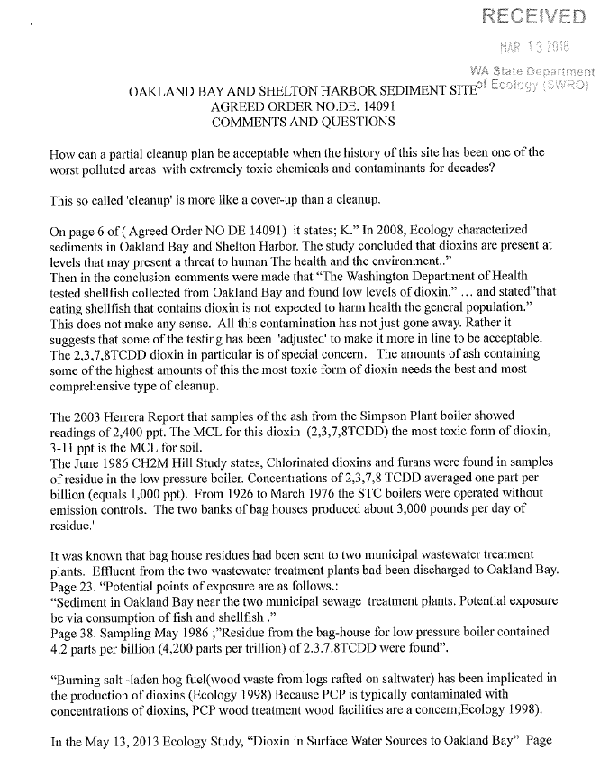

Attachment A – Comment Letter from Patricia Vandehey (continued)

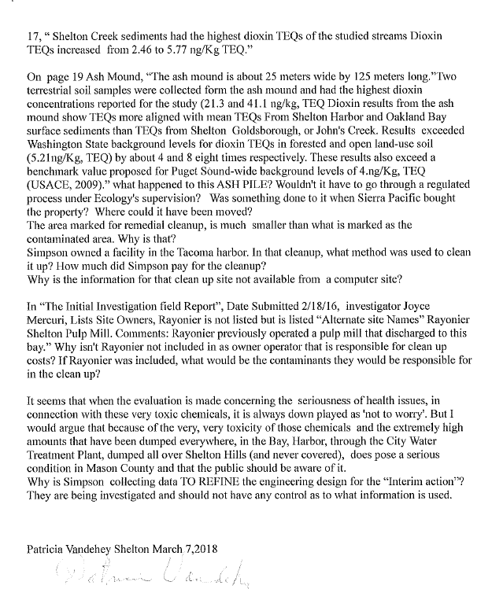

Attachment B – Comment Letter from Brandon Palmer

