Public Participation Plan

Tacoma Coal Gas

22nd Street and A Street, Tacoma, WA
Facility Site ID: 1249
Cleanup Site ID: 3675
July 2018
Publication 18-09-120

Publication and Contact Information
This plan is available on the Department of Ecology’s website at:
https://fortress.wa.gov/ecy/publications/publications/1809120.html

For more information contact:

Southwest Regional Office
Toxics Cleanup Program
P.O. Box 47600
Olympia, WA 98504-7600
Phone: 360-407-6300
Washington State Department of Ecology — www.ecology.wa.gov
- Headquarters, Olympia 360-407-6000
- Northwest Regional Office, Bellevue 425-649-7000
- Southwest Regional Office, Olympia 360-407-6300
- Central Regional Office, Union Gap 509-575-2490
- Eastern Regional Office, Spokane 509-329-3400
To request ADA accommodation including materials in a format for the visually impaired, call Ecology at 360-407-6300 or visit https://ecology.wa.gov/accessibility. People with impaired hearing may call Washington Relay Service at 711. People with speech disability may call TTY at 877-833-6341.

Public Participation Plan

Tacoma Coal Gas
Toxics Cleanup Program
Southwest Region
Washington State Department of Ecology
Olympia, Washington
This page is purposely left blank

Table of Contents
Public Involvement in Contamination Cleanup 1
Site contacts 1
Ecology 1
PLP 1
Public Participation Grants 2
Washington’s Cleanup Laws 2
Model Toxics Control Act (MTCA) 2
State Environmental Policy Act 4
Site History 5
Land use 5
How the site became contaminated 5
Contamination 5
Cleanup plans 6
Area community 6
Public Participation Activities 7
How we share information with the community 7
Postal mailing list 8
Site Register 8
Newspaper display ads or legal notices 8
Email lists 8
Ecology’s website and social media platforms 9
Document repositories 9
Signs around the cleanup site 9
How to share information with us 10
Public comment periods 10
Public events 10
Plan Amendments 10

Public Involvement in Contamination Cleanup
The Washington State Department of Ecology (Ecology) developed this public participation plan (plan) in cooperation with the City of Tacoma, Washington Department of Transportation, Puget Sound Energy, and Pacific Corp, the parties responsible for cleanup costs. The purpose of the plan is to promote meaningful community involvement during cleanup.
The plan describes ways Ecology will inform the public about contamination investigations and cleanup options throughout the cleanup process. Ecology encourages the public to learn about and get involved in decision-making opportunities. This plan identifies how and when the public can get involved during different stages of the investigation and cleanup of contamination.
This plan is for the Agreed Order #DE-13972 for the Tacoma Coal Gas site.

Site contacts
To be included in the site record, comments about the cleanup process must be submitted during comment periods. Questions and informal comments or information about the site’s history are welcome anytime.
Ecology | PLP
Southwest Regional Office  PO Box 47775  Olympia, WA 98504-7775  Marv Coleman, site manager  Marv.Coleman@ecy.wa.gov  360-407-6259  Sheila Coughlan, public involvement coordinator  Sheila.Coughlan@ecy.wa.gov  360-407-6255 | City of Tacoma  mhenley@ci.tacoma.wa.us  253-502-2113  Washington Department of Transportation – Olympic Region  sawyerj@wsdot.wa.gov  360-570-6701  Puget Sound Energy  Libby.Goldstein@pse.com  425-457-5339  PacifiCorp  Jackie.Wetzsteon@pacificorp.com  503-813-5036

Public Participation Grants
Grants may be available to neighborhood committees, non-profits, and other groups interested in the site. For contaminated sites, these funds can be used to:
- Hire an expert to help interpret technical information
- Conduct activities that enhance the public’s understanding of, and participation in, the cleanup process
For more information about public participation grants, please contact Lynn Gooding at 360-407-6062 or lynn.gooding@ecy.wa.gov. You may also visit the Public Participation Grant website.

Washington’s Cleanup Laws
Ecology uses the Model Toxics Control Act (MTCA) and accompanying regulations for cleanup activities.
This plan is required under MTCA, a law that passed in 1989. MTCA provides guidelines for contaminated site cleanup in Washington State and sets standards to ensure the cleanup protects human health and the environment.

Model Toxics Control Act (MTCA)
MTCA began as a grassroots citizen’s initiative in 1988, and started the process of systematically cleaning up contaminated sites in Washington. Under MTCA, a current or past property owner or operator may be held responsible for cleaning up contamination on, or coming from, their property to standards that are safe for human health and the environment.
Ecology enacts MTCA and oversees cleanups in the state and issues regulations and guidance governing those cleanups. The regulations are found in Chapter 173-340 Washington Administrative Code (WAC). Ecology investigates reports of property contamination, and if the contamination is seen as a significant threat to human health or the environment, the contaminated property is placed on the Hazardous Sites List, and the cleanup process begins.
Public participation is an important part of cleanup under the MTCA process. Participation needs are assessed at each cleanup site according to the level of public interest and the degree of risk posed by the contamination. Individuals who live near the site, community groups, businesses, government, other organizations, and interested parties have the opportunity to get involved by commenting on the cleanup process.
Under MTCA, the cleanup process generally includes five phases. Each phase includes an opportunity for the public to review and comment on cleanup documents.

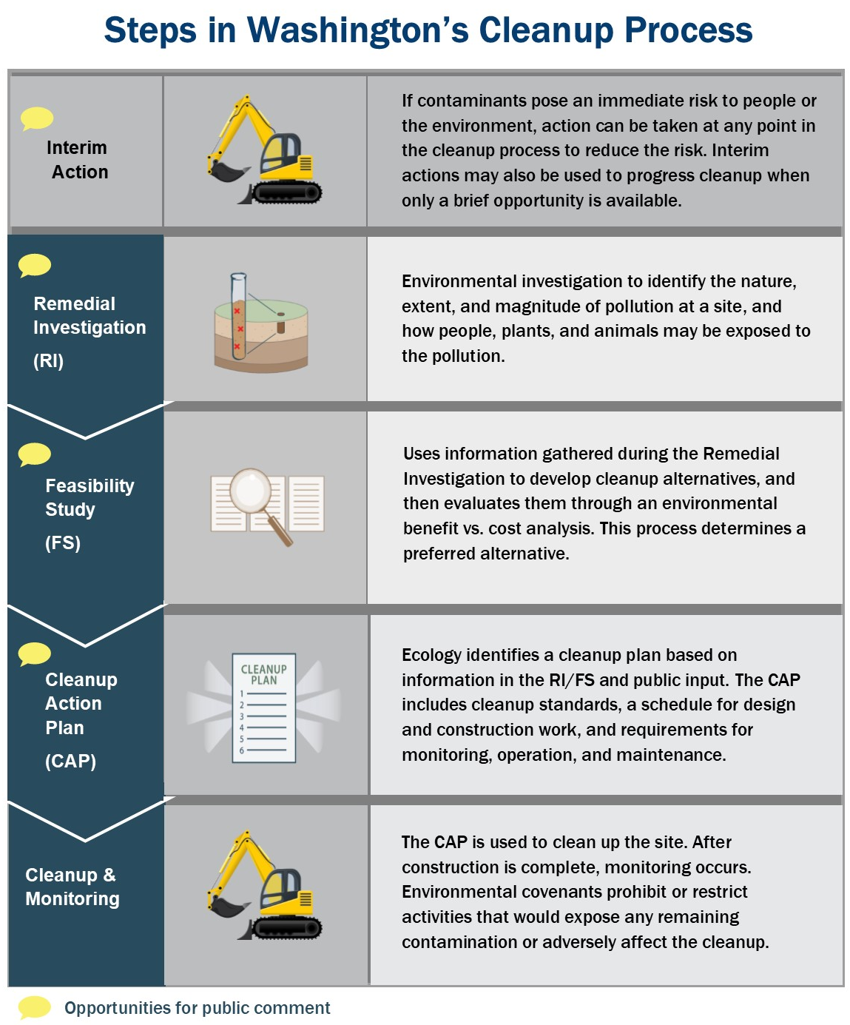
Figure 1. Steps in Washington's Cleanup Process

State Environmental Policy Act
The State Environmental Policy Act (SEPA) is followed during review and development of cleanup plans.

Site History

Land use
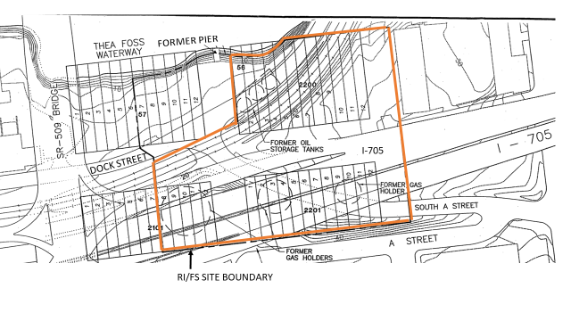
The Tacoma Coal Gas plant was in active operation from 1884 to 1924. The plant manufactured natural gas from coal that lit the city streets and provided energy for industrial manufacturing. The site is generally located at South 21st to South 24th Streets and South A Street to Thea Foss Waterway, Tacoma, WA. The legal description is: Blocks 57, 2200, 2300, 2101, 2201, and 2301 of Tacoma Land Company’s Second Addition to Tacoma, W.T.

How the site became contaminated
As a result of manufacturing operations, contaminants were released into soil and groundwater. These contaminants were discovered on the site in 1984 during roadway construction and excavation activities for the I-705 freeway. Some of the contaminated soils were removed from within the right-of-way. Contaminants outside of the right-of-way were identified but not removed. The site is now covered by elevated portions of I-705 freeway

Contamination
Due to historic land use and industrial practices, soil and groundwater on the site are contaminated with:
- Polynuclear Aromatic Hydrocarbons (PAHs)
- BTEX (benzene, toluene, ethylbenzene and xylene)

Cleanup plans
The following Potentially Liable Persons (PLPs) are current or past facility owners or operators of the Site and under MTCA are jointly and severally responsible for the cleanup:
- The City of Tacoma, which owns public property and maintains public rights-of-way within limited portions of the site.
- The Washington State Department of Transportation, which owns portions of the site and exposed and created migration pathways for the contamination during roadway construction.
- Puget Sound Energy (formerly Washington Natural gas), which was an owner and operator of the site.
- PacifiCorp, which was an owner and operator of the site as a successor corporation to Mountain States Power.
The current Agreed Order requires the PLPs to complete a Remedial Investigation and Feasibility Study (RI/FS) and develop a draft Cleanup Action Plan (dCAP) to determine the nature and extent of remaining contamination on the site and the cleanup actions needed to address it.
The reports will describe:
- The full nature and extent of the pollution on the site.
- The risk to human health and the environment.
- Cleanup method alternatives.
- The cleanup action plan.

Area community
The site is located at the head of the Thea Foss waterway in a predominately industrial and commercial part of Tacoma, locally referred to as the Port of Tacoma Tideflats or just “Tideflats.” The city of Tacoma’s population is ethnically and economically diverse. In the district surrounding the site (WA Legislative District 27), there are large African-American, Latino/Hispanic, Asian American, and Native American populations. It is important to consider cultural and linguistic needs of this diverse community when we conduct our public outreach and participation activities.

Ecology will reach out to cultural community organizations as part of our outreach and provide information in other languages as appropriate following federal guidance. The non-English language most widely spoken in the area of the site is Spanish. In this case, Ecology will provide outreach in Spanish. We strive to make our public participation efforts as inclusive as possible and welcome your input about how to best reach the nearby community.
The Puyallup Tribe is a federally recognized tribe that owns land that could be affected by the contamination. Ecology will ensure that the Tribe will be engaged with any decision-making process for this site and has ample opportunity to be involved throughout the process on a government-to-government basis.

Public Participation Activities
Members of the public may ask questions, submit informal comments, or share site information at any time. Interested parties do not need to wait for a formal public comment period to contact Ecology.
However, to be included in the formal site record, comments about the site investigation, cleanup alternatives, or cleanups must be submitted during formal comment periods. In addition, the public is invited to review site documents before they become final. This is the most direct and influential way to learn more about the site and be involved in the cleanup’s decision-making.

How we share information with the community
During specific stages of the cleanup, Ecology will mail notices about public comment periods to addresses surrounding the site. The mailing list area will vary depending on the type of contamination and where it’s located, but the list will at least include addresses within a 1/4-mile radius of the site and other interested organizations and individuals. These notices will provide general information about the site, contact information for submitting comments, and times and locations of public meetings or hearings or how to request one if not yet scheduled.
Ecology may also develop documents outside of comment periods to keep the community updated on the site’s status. These informational documents will be available online and at document repositories. Print copies may be mailed to the nearby community if we feel the message warrants the associated cost and resources.
Comment period notices and other site announcements may also be posted in various locations throughout the community (for example, local businesses, schools, libraries).

Postal mailing list
Ecology maintains a mailing list that includes addresses within a 1/4-mile radius of the site and relevant local, state, and federal government contacts.
These people receive public comment notices when draft documents are available.
We will add additional individuals, organizations, and other interested parties to the mailing list as requested. If you would like to be added to the mailing list for this site, please contact Sheila Coughlan at 360-407-6255 or Sheila.Coughlan@ecy.wa.gov.

Site Register
Public comment periods, events, and other cleanup notices are published in Ecology’s Site Register. To receive the Site Register by email, please contact Cheryl Ann Bishop at 360-407-6848 or cherylann.bishop@ecy.wa.gov, or subscribe online.

Newspaper display ads or legal notices
We announce public comment periods and events in ads or notices published in the Tacoma News Tribune. We will also publish notice on our Public Input & Events Listing.

Email lists
Ecology maintains an email list to update interested persons about this site. If you would like to be added to the email list, please contact Sheila Coughlan at 360-407-6255 or Sheila.Coughlan@ecy.wa.gov. You can also join our Listserv to stay informed about Ecology's environmental cleanup work in and around Tacoma's Commencement Bay. We will share news about public comment periods, public meetings, and other cleanup-related information for the cleanup sites we manage in the area.

Ecology’s website and social media platforms
We maintain a website for the Tacoma Coal Gas site. The website provides site information, and you may download cleanup documents.
We may also share information about cleanup sites through news releases, our ECOconnect blog, and social media.

Document repositories
During public comment periods, you can find print documents at the following locations:
Tacoma Public Library
1102 Tacoma Avenue S.
Tacoma, WA 98402
(253) 292-2001

Citizens for a Healthy Bay
535 Dock Street Suite 213
Tacoma, WA 98402
(253) 383-2429
Washington Department of Ecology
Southwest Regional Office
300 Desmond Drive SW
Lacey, WA 98503
360-407-6300
To schedule an appointment, please Susie Baxter at 360-407-6365 or Susie.Baxter@ecy.wa.gov.

Signs around the cleanup site
We may also install signs displaying information about project status, traffic impacts, and health risks around the cleanup site.

How to share information with us
At minimum, MTCA requires 30-day public comment periods for draft cleanup documents and 14-day comment periods SEPA documents. SEPA documents are often made available for review with other cleanup documents. We may hold comment periods longer than 30 days.
We may also identify public concerns and cleanup goals by meeting with and soliciting information from interested community members and organizations. To collaborate with us about this site, please contact Sheila Coughlan at 360-407-6255 or Sheila.Coughlan@ecy.wa.gov.

Public comment periods
Formal 30-day comment periods allow interested members of the public to comment on draft documents, legal agreements, and proposed cleanup actions. If there is significant interest, Ecology may extend the public comment period. When Ecology oversees SEPA determinations, we hold comment periods for at least two weeks.
Following a comment period, we publish all the input we received and respond to significant comments and questions. If the comments result in significant changes to the cleanup documents, then the documents will be revised and re-issued for public review. If the comments do not result in significant changes, then they become final.

Public events
We hold public meetings, workshops, open houses, and public hearings based on community interest. If we have not scheduled a meeting, we will hold one if 10 people request it, and this may cause us to extend a public comment period so the meeting occurs during it.
Events are held at locations close to the site that meet Americans with Disabilities Act standards. Public meetings, workshops, open houses, and hearings are always announced in advance using a variety of methods.

Plan Amendments
Ecology developed this plan following MTCA regulations (WAC 173-340-600). We review it as the cleanup progresses and amend it as necessary. You may suggest amendments to Sheila Coughlan at 360-407-6255 or Sheila.Coughlan@ecy.wa.gov.
This plan includes information for the public regarding opportunities for public involvement and comment. The outreach activities discussed in this section reflect Ecology’s current plans for keeping the public informed and providing ways for those interested in the site to communicate their concerns and questions to us.
If you feel the planned outreach activities and mechanisms described in this plan are insufficient, or should otherwise be modified, we will work to find solutions. New outreach activities or outreach tools established as a result can be implemented right away, with or without amending this plan.

Ecology currently does not have a citizen technical advisor for providing technical assistance to citizens on issues related to the investigation and cleanup of the site.
ecology.wa.gov/About-us/How-we-operate/Grants-loans/Find-a-grant-or-loan/Public-participation-grants
https://fortress.wa.gov/ecy/publications/publications/9406.pdf
Guidance to Environmental Protection Agency Financial Assistance Recipients Regarding Title VI Prohibition Against National Origin Discrimination Affecting Limited English Proficient Persons, 69 Fed. Reg. § 35602 (June 15, 2004).
ecology.wa.gov/Regulations-Permits/Guidance-technical-assistance/Site-Register-lists-and-data
http://listserv.wa.gov/cgi-bin/wa?SUBED1=siteregister&A=1
ecology.wa.gov/Events/Search/Listing
https://fortress.wa.gov/ecy/gsp/Sitepage.aspx?csid=3675
ecology.wa.gov/About-us/Get-to-know-us/News

