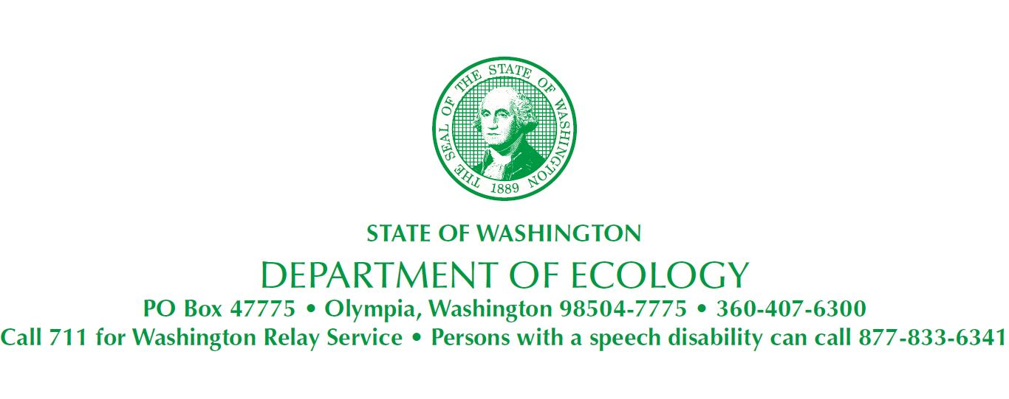
October 18, 2018

Estate of Sophie Sussman
Portland Avenue Associates, LLC
Attn: Mr. Loren R. Dunn
Beveridge & Diamond PC
600 University Street, Suite 1601
Seattle, WA 98101-3109

Re: Notification of Project Coordinator Designation
- Site Name: Tacoma Metals
- Site Address: 1919 Portland Ave, Tacoma, Pierce County, WA 98421
- Facility/Site No.: 1257
Dear Loren Dunn:

Section V (4) of Agreed Order No. DE 97-5435 for Estate of Sophie Sussman/Portland Avenue Associates, LLC (Sussman Estate)—Tacoma Metals Site requires both the Washington State Department of Ecology (Ecology) and Sussman Estate to notify the other party if a new Project Coordinator is designated. Ecology hereby notifies Sussman Estate that Andrew Smith, Cleanup Project Manager, is now the agency’s Project Coordinator. Contact information follows:

Andrew Smith, Cleanup Project Manager
Toxics Cleanup Program – Washington Dept. of Ecology
PO Box 47775
Olympia, WA 98504-7775
(360) 407-6316
(360) 407-6305 Fax
andrew.smith@ecy.wa.gov

Please contact me if you have questions or comments.
Sincerely,

Andrew Smith, P.E., LHG
UST/Technical Services Unit Supervisor
Toxics Cleanup Program
Southwest Regional Office

By certified mail: 9489 0090 0027 6066 6789 44

cc: (Via electronic mail)
Peter Bannister, Aspect Consulting
Mary Henley, City of Tacoma Environmental Services Department
Philip J. Slowiak, IP, Senior Project Manager
Bill Hengemihle, Managing Director, LECG, LLC
Brenda Anderson, CHMM, Schnitzer Steel Industries
Paul Kalina, P.E., URS Corporation
Mark Meyers, Attorney for General Metals
John Cermak, Jr., Attorney for IP
Clark Davis, Attorney for Tacoma Metals
Rod Rennie, Dept. of Natural Resources
Rich Scrivner, Dept. of Natural Resources
John Level, Office of the Attorney General
Nick Acklam, Ecology
Ecology Site File

