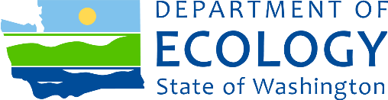

Chevron Bulk Camas Responsiveness Summary

Cleanup Site ID: 3783
Facility ID: 1043
Address: 612 SE Union Street in Camas, Washington
County: Clark

Document for review and comment
Remedial Investigation Report

Comments
The Washington Department of Ecology (Ecology) held a public comment period between December 23, 2018, and January 23, 2019. No comments were received. Ecology will finalize the Remedial Investigation (RI) and Cleanup Action Plan (CAP) reports and remove the site from the Hazardous Sites List.

Background
Practices associated with the handling of petroleum and leaks from storage tanks and pipelines contaminated soil and groundwater.
Chevron conducted site cleanup work prior to entering into an Agreed Order with Ecology in 2003. To ensure that cleanup met state standards, the Agreed Order required Chevron to conduct an RI and feasibility study (FS) and implement the recommendations of the FS in a CAP. Chevron wrote the draft RI report in 2015. Data in the report showed that TPH levels were below the Model Toxics Control Act (MTCA) Method B soil cleanup levels and no other TPH contamination remained at the site.
Chevron sampled groundwater between 1990 and 1995 and again between 2004 and 2015. Groundwater sampling stopped in 2015 after more than eight quarters showed TPH contamination was below MTCA Method A groundwater cleanup levels.
Since the cleanup meets state standards, a FS which is typically written as part of the cleanup process is not required to evaluate cleanup alternatives. Therefore, the preferred cleanup alternative of the site of the CAP is no further action.

Prepared by
Craig Rankine Sheila Coughlan
Cleanup Project Manager Public Involvement Coordinator

