To: | Linda Berry-Maraist, Pope Resources/Olympic Property Group
From: | Kathy Ketteridge, PhD, PE, and John Laplante, PE, Anchor QEA, LLC
cc: | Clay Patmont, Anchor QEA, LLC
Re: | Port Gamble Bay Cleanup Project – Coastal Engineering Evaluation of Shoreline Erosion

The purpose of this memorandum is to summarize observations and evaluations of the movement of armor rock along the shoreline at the Port Gamble Bay Cleanup Project (Site) resulting from a series of significant storm events that occurred from approximately November 2018 through April 2019. This memorandum also presents design solutions to address armor rock movement where necessary. As part of this evaluation, wind statistics at the Site were revised using updated wind data, which include wind information through April 2019. This memorandum is divided into the following two sections: 1) recent storm wind conditions and wind/wave statistics review; and 2) observed armor movement, shoreline erosion, and mitigation recommendations.

Review of Recent Storm Wind and Water Level Conditions
The winter storm season of 2018 to 2019 had many high wind and water level events, many for extended time periods, as summarized in this section. Wind data from the Seattle-Tacoma International Airport weather station (KSEA) were used because this was the closest station with available data for the winter season. The National Oceanic and Atmospheric Administration (NOAA) West Point weather station (WPOW1) in West Point, Washington, is closer to the Site but did not have data available for this current time period.
Three main wind directions produce waves and higher tides along the shorelines at Port Gamble: north, southeast, and south. Wind events observed from November 2018 to April 2019 ranged in intensity from a typical annual event to an approximate 10-year storm event, with high winds lasting for long periods of time. These large storm durations resulted in storm surges and elevated tides along the shoreline for long periods of time. The end of November (November 27 to 30) experienced tides 1 to 1.5 feet higher than predicted. Mid-December (December 12 through 24) experienced tides 1 to 2 feet higher than predicted. The highest tides of January (January 14 through 21) were 1 to 1.5 feet higher than predicted. The highest tides of February (February 11 through 15) were 1 foot higher than predicted. Tide and wind data from significant storm events over the winter season are provided in Table 1.
Table 1
Summary of Winds During 2018 to 2019 Winter Storm Events
Dates | Predicted/Actual High Tide Elevations at Port Townsend¹  (feet MLLW) | Sustained Winds² |  |  | Maximum Winds²
Dates |  | Wind Speed (mph) | Wind Duration  (hours) | Average Wind Direction | Wind Speed  (mph)
November 2–3, 2018 | 6.4/6.9 | 18–25 | 24 | from south | 35
November 17, 2018 | 8.5/8.0 | 18–20 | 12 | from north | 25
December 3–5, 2018 | 9.0/8.5 | 10–15 | 72 | from north | 15
December 15, 2018 | 8.5/10 | 30 | 12 | from south | 45
December 20–21, 2018 | 8.9/11.1 | 20–35 | 24 | from south | 47
December 29–30, 2018 | 9.5/9.9 | 20–25 | 48 | from south | 37
January 3–4, 2019 | 9.0/9.4 | 18–30 | 24 | from south | 37
January 6, 2019 | 9.4/10.2 | 30–40 | 12 | from south | 60
January 17–18, 2019 | 8.8/9.9 | 15–22 | 36 | from southeast | 35
January 22 to 23, 2019 | 8.6/9.2 | 20 | 24 | from south/  southeast | 40
January 25–30, 2019 | 9.2/9.3 | 8–16 | 96 | from north | --
February 3–4, 2019 | 7.7/8.7 | 15–25 | 48 | from north | 40
February 10–11, 2019 | 5.8/6.4 | 15–25 | 48 | from north | 35
February 22, 2019 | 7.6/7.6 | 20 | 12 | from south | 35
February 26–27, 2019 | 7.9/7.9 | 20 | 12 | from southeast | 32
March 18–20, 2019 | 8.8/8.8 | 15–25 | 72 | from southeast | 35
Notes:
- Measured tide data from Port Townsend Station No. 9444900. Multiple high tides occurred over the duration of the storm event.
- Wind speeds from the Seattle-Tacoma International Airport station.
-- : no data
MLLW: mean lower low water
mph: miles per hour

Extreme Wind Comparison
To support the Engineering Design Report for the project (Anchor QEA 2015), a coastal engineering evaluation was completed to evaluate extreme wind speeds and associated wave heights at the Site for use in cap armor design. Long-term wind data used for this evaluation were taken from NOAA West Point station, and included hourly sustained wind speeds (2-minute averages) for the years from 1984 to 2009 (Table 2). The West Point station was used for Port Gamble because it is the closest station location that has a long-term hourly sustained wind speed record (32 years at 10 meters above sea level). In addition, the West Point station better matches the Site conditions being on the shoreline with large north and south fetches compared to the Seattle-Tacoma International Airport station, which is over two miles inland. Because of its inland location, the Seattle-Tacoma International Airport station generally experiences lower wind speeds than the West Point station. A more in-depth comparison of wind data from the West Point station and the Seattle-Tacoma International Airport station (used in Table 1 to evaluate potential storm winds at the Site this past winter) is provided in the Engineering Design Report (Anchor QEA 2015).
Table 2
Design (Sustained) Storm Wind Speeds
Wind Data | Direction  (degrees) | 2-year (mph) | 10-year (mph) | 20-year (mph) | 50-year (mph) | 100-year (mph)
West Point¹ (1984 to 2009) | 0–30 | 34 | 42 | 44 | 47 | 49
West Point¹ (1984 to 2009) | 121–150 | 33 | 41 | 44 | 47 | 49
West Point¹ (1984 to 2009) | 151–180 | 52 | 66 | 71 | 76 | 80
Note:
- Return period wind speeds are from Table D1-2 from the Engineering Design Report (Anchor QEA 2015) (NOAA West Point station, 1984 to 2009).

Based on the information in Table 2, the Site experienced one 10-year storm event, several 2-year storm events, and several typical annual storm events over a 5-month period. Many of these storms were also characterized by higher-than-normal tides (storm surge) and unexpectedly long durations (i.e. 72 to 96 hours).

Armor Rock Sizing

Original Cap Armor
Armor rock size specified for the original cap armor (9 inches) was calculated using the Automated Coastal Engineering System (ACES) (USACE, 1992) using a damage control level of “2,” which allows for some movement of armor rock under storm events. This calculation results in a smaller armor rock size than using a damage control level that allows for no movement of armor rock. The expected armor rock movement at Port Gamble was likely exacerbated by the large number of storms that occurred over a relatively short time frame, as well as by long storm durations resulting in unusually high water levels (storm surge) coupled with large waves.

Import Armor Rock for Shoreline Repair
The import armor rock size range for the slope repair described in this memorandum was calculated using the ACES for non-uniform armor rock gradation using a damage level of “0,” which corresponds to no movement of armor rock under storm events. Import armor rock size calculated for zero movement, is from 1 to 2 feet in diameter with a median diameter of approximately 1.5 feet.

Salvage Armor Rock on Site
From visual inspection, the salvage armor rock is expected to generally range from 1 to 3 feet in diameter, with an approximate median diameter (D50) of 2 feet and some discreet smaller and larger sized rocks. The calculated stable import armor rock size range for the slope, based on predicted storm waves and USACE guidance (USACE, 1992, USACE, 2006) for zero movement for non-uniform armor rock size, is from 1 to 2 feet in diameter with a median diameter of approximately 1.5 feet. Therefore, the salvage armor rock is large enough to be used for this repair.

Observed Armor Movement, Shoreline Erosion, and Mitigation Recommendations
On March 27, 2019, Anchor QEA, LLC, staff conducted a site visit at Port Gamble to observe shoreline conditions and discuss armor movement and shoreline erosion with Pope Resources and Washington State Department of Ecology (Ecology) staff. Three areas of interest were identified along the Port Gamble shoreline, as shown in Figure 1. Area 1 is in SMA-1, and Areas 2 and 3 are in SMA-2. These areas were capped with Type 2 armor rock material (D50 of 9 inches) in accordance with the Ecology-approved cleanup design. Observations in these areas during the March 27, 2019 site visit noted movement of Type 2 armor rock at the top of the slope as a result of numerous storm events occurring at higher-than-predicted tides, as discussed previously. The Type 2 material placed in these areas was sized to balance requirements for protection of the underlying isolation layer and habitat concerns. Therefore, material was sized to allow for some localized movement under the design storm event.
Anchor QEA suggests that the repairs include the following (see Figure 1 for area locations):
- Area 1A GPS Spot Repair: Place filter rock and two layers of salvage armor rock from the top of the slope to approximately 15 feet waterward of the top of the slope.
- Area 1B Shoreline Repair: Place two layers of salvage and import armor rock from the top of the slope to approximately 15 feet waterward of the top of the slope.
- Area 2A GPS Spot Repair: Place filter rock and two layers of import armor rock from the top of the slope to approximately 15 feet waterward of the top of the slope.
- Area 2B Corner Repair: Place one layer of import armor rock to provide additional stability to the corner of the embayment; blend with Area 2A Repair.
- Areas 3A and 3B GPS Spot Repair: Place filter rock and two layers of import armor rock from the top of the slope to approximately 15 feet waterward of the top of the slope.
- Area 3C Shoreline Repair: Place a “triangle” of import armor rock from the top of the slope to approximately 10 feet waterward of the top of the slope.
- Areas 2C and 3D Shoreline Areas: No action.
Discussion of each of these areas and proposed measures are provided in the following sections. Estimated lengths of shoreline impacted and volumes of rock to be added to each area are provided in Table 3 at the end of this section. Additional design assumptions used to develop rock volumes are summarized in Table 4 at the end of this section.
Figure 1
Proposed Repair Areas Based on March 27, 2019 Site Visit
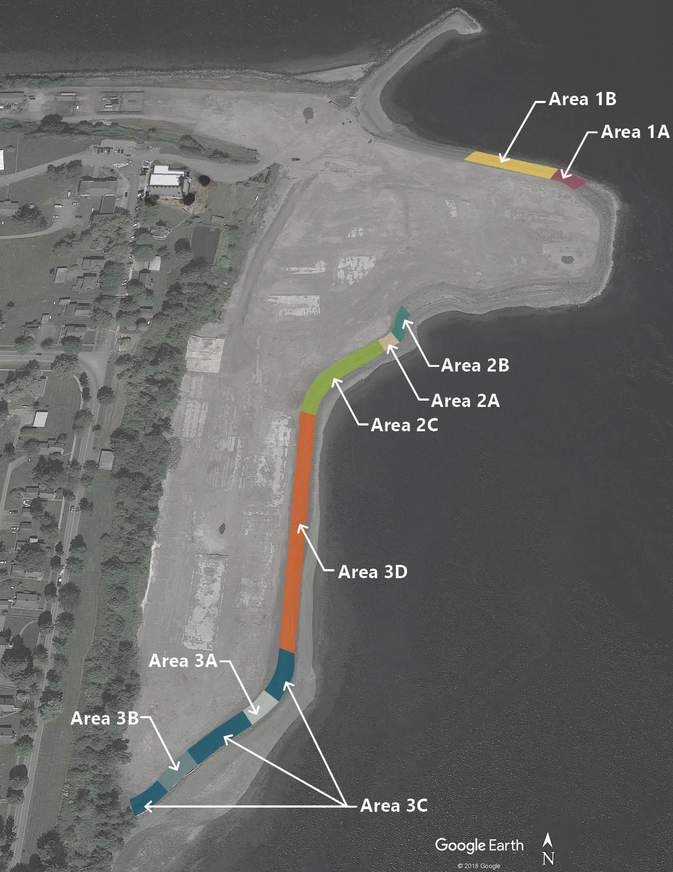

Area 1

Observations
The shoreline erosion in this area occurred due to repeated wave attack from the north and northeast at higher-than-predicted tides (i.e., storm surge) from approximately November 2018 to April 2019. The shoreline approximately above mean high water (MHW) has eroded in this area, resulting in a near-vertical scarp at the top of the slope, as shown in Photographs 1 and 2 and Attachment 1. Erosion in the Area 1A GPS Spot Repair location, as shown in Figure 1, is more significant than the remainder of the shoreline in Area 1.
Photographs 1 and 2
Shoreline Erosion in Area 1A
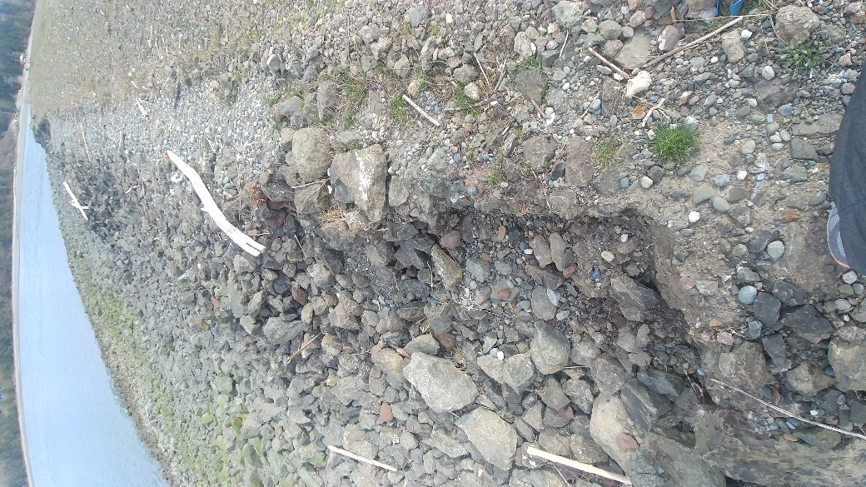 | 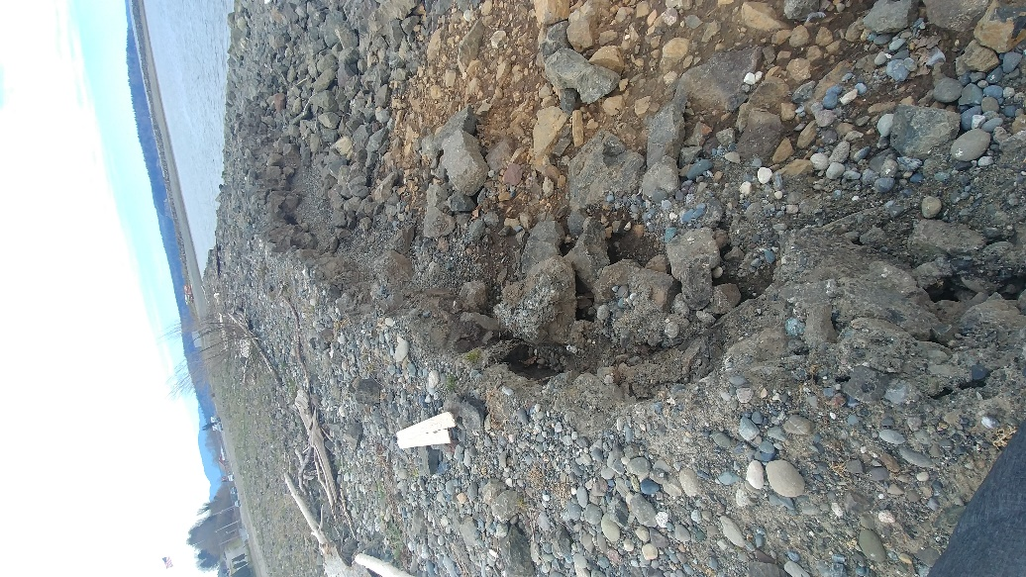
1. Looking East | 2. Looking West

Recommendations
Design recommendations to address shoreline erosion in this area are as follows (see Figure 1 for locations):
- Area 1A GPS Spot Repair: Place a 1-foot layer of filter rock (D50 of 1 to 4 inches) followed by two layers of salvage armor rock from approximately MHW (where the existing slope flattens out) to the top of the slope. The armor rock should be placed a distance along the slope of approximately 15 linear feet. Armor rock should be placed up and over the top of the slope and extend landward 2 to 3 rock diameters to provide protection for future wave events that occur during storm surge conditions.
- Area 1B Shoreline Repair: Place two layers of a combination of salvage and import armor rock from approximately MHW (where the existing slope flattens out) to the top of the slope. This is a distance along the slope of approximately 15 linear feet. Armor rock should be placed up and over the top of the slope and extend landward 2 to 3 rock diameters to provide protection for future wave events that occur during storm surge conditions.
Rock placement should be rounded off at the ends to match existing grade so there are no abrupt or steep transitions along the slope.

Area 2

Observations
The shoreline erosion in this area occurred due to repeated wave attack from the south and southeast at higher-than-predicted tides (i.e., storm surge) from approximately November 2018 to April 2019, similar to Area 1. Visible erosion in Area 2 is localized in the discrete area at the western corner of the Pier 4 cove (Area 2A GPS Repair in Figure 1) and does not extend along the entire length shown in Figure 1. The shoreline approximately above MHW has eroded in this area, resulting in a near-vertical scarp at the top of the slope, as shown in Photograph 3 and Attachment 1. In addition, the armor rock at the very top of the slope in Area 2C (see Figure 1) has slumped due to expected deformation of the slope by waves and high tides. This deformation of the slope was anticipated during design.

Recommendations
Design recommendations to address shoreline erosion in this area are similar to Area 1 and are summarized as follows (see Figure 1 for locations):
- Area 2A GPS Spot Repair: Place a 1-foot layer of filter rock (D50 of 1 to 4 inches) followed by two layers of import armor rock from approximately MHW (where the existing slope flattens out) to the top of the slope. This is a distance along the slope of approximately 15 linear feet.
- Area 2B Corner Repair: Place one layer of import armor rock along the top of the slope to provide additional stability to the corner. Placement should be from the top of the slope waterward approximately 10 linear feet.
- Area 2C Shoreline: No action. This area should be monitored for potential future erosion. If possible, large woody debris that collects along the shoreline in this area should be removed to reduce the risk of erosion due to abrasion.
Rock placement should be rounded off at the ends to match existing grade so there are no abrupt or steep transitions along the slope.
Photograph 3
Shoreline Erosion in Area 2A
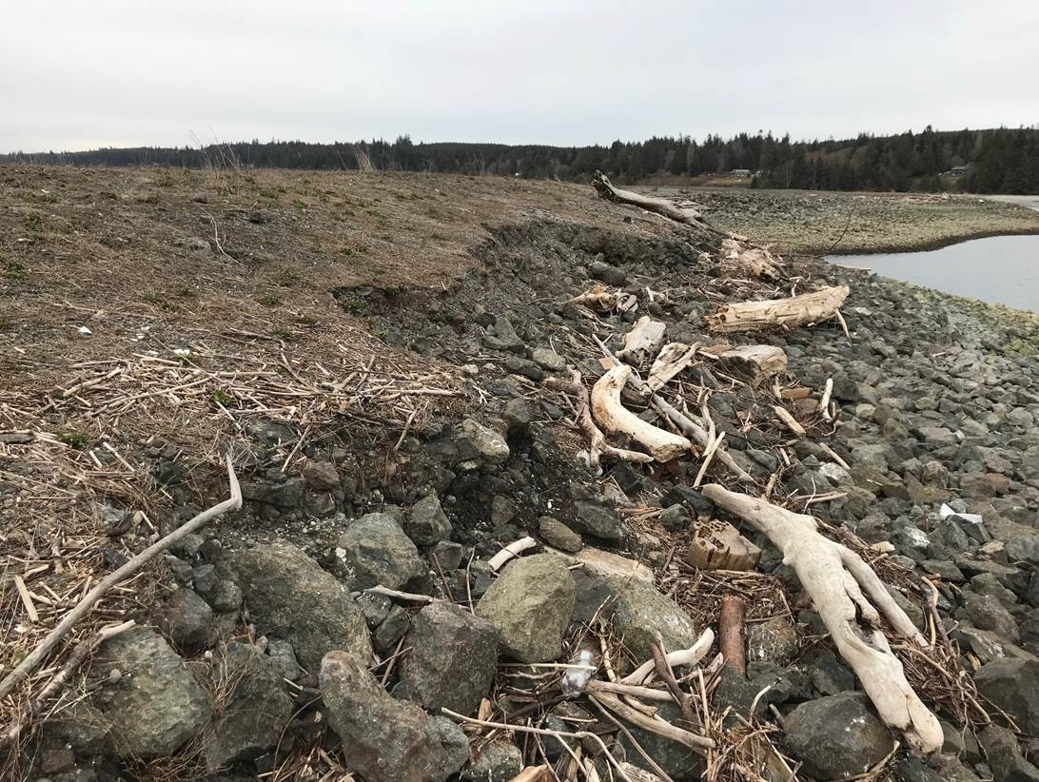

Area 3

Observations
Similar to Areas 1 and 2, the shoreline erosion in Area 3 occurred due to repeated wave attack from the south and southeast at higher-than-predicted tides (i.e., storm surge) from approximately November 2018 to April 2019. Visible erosion is Area 3 is localized in the discrete areas shown in Figure 1 as Areas 3A and 3B GPS Repair Areas and does not extend along the entire length shown in Figure 1. The shoreline area approximately above MHW has eroded in this area, resulting in a near-vertical scarp at the top of the slope and visible brick debris in the northern GPS Repair Area, as shown in Photograph 4 and in Attachment 1. In addition, the armor rock at the very top of the slope in Areas 3C and 3D have slumped due to expected deformation of the slope by waves and high tides, as shown in Photograph 5. This deformation of the slope was anticipated during design. Area 3C is of more concern than Area 3D due to the proximity of upland contamination under the cap to the shoreline along Area 3C.
Photograph 4
Shoreline Erosion in Area 3A
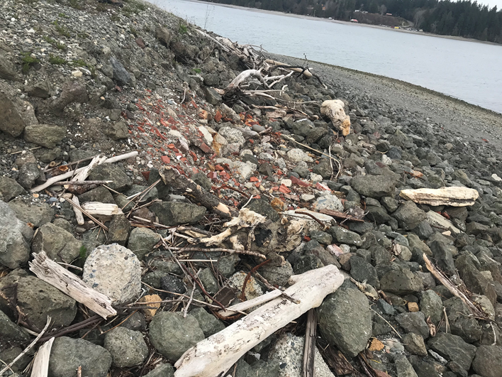

Photograph 5
Typical Shoreline Deformation in Area 3C
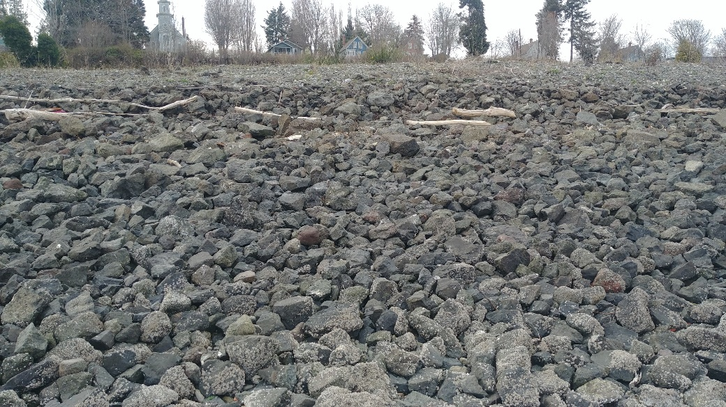

Additional erosion at the top of the slope in a few discrete locations in Area 3C appears to be caused by abrasion of large woody debris during high tide wave impacts, as shown in Photograph 6.
Photograph 6
Shoreline Erosion in Area 3C Likely Due to Abrasion from Debris (Southern Area 3 GPS Repair Area in Figure 1)

Recommendations
Design recommendations to address shoreline erosion in this area are similar to Areas 1 and 2, and are summarized as follows (see Figure 1 for locations):
- Areas 3A and 3B GPS Spot Repair: Place a 1-foot layer of filter rock (D50 of 1 to 4 inches) followed by two layers of import armor rock from approximately MHW (where the existing slope flattens out) to the top of the slope. This is a distance along the slope of approximately 15 linear feet. The repair will be extended north around the corner to provide additional stability to that area.
- Area 3C Shoreline Repair: Place a “triangle” of import armor rock from the top of the slope to approximately 10 feet waterward of the top of the slope. This repair will consist of a volume of armor rock (with no added filter) that would fill in the depression at the top of the “S”-shaped slope, as shown in Figure 2. The purpose of doing this type of repair is to return the shoreline to a constant slope, without the depression or “S” shape, which will be more stable under wave impact over the long term.
- Area 3D Shoreline: No action. This area should be monitored for potential future erosion. If possible, large woody debris that collects along the shoreline in this area should be removed to reduce the risk of erosion due to abrasion.
Rock placement should be rounded off at the ends to match existing grade so there are no abrupt or steep transitions along the slope.
Figure 2
Schematic of Armor Rock Repair (“triangle”) for Area 3C
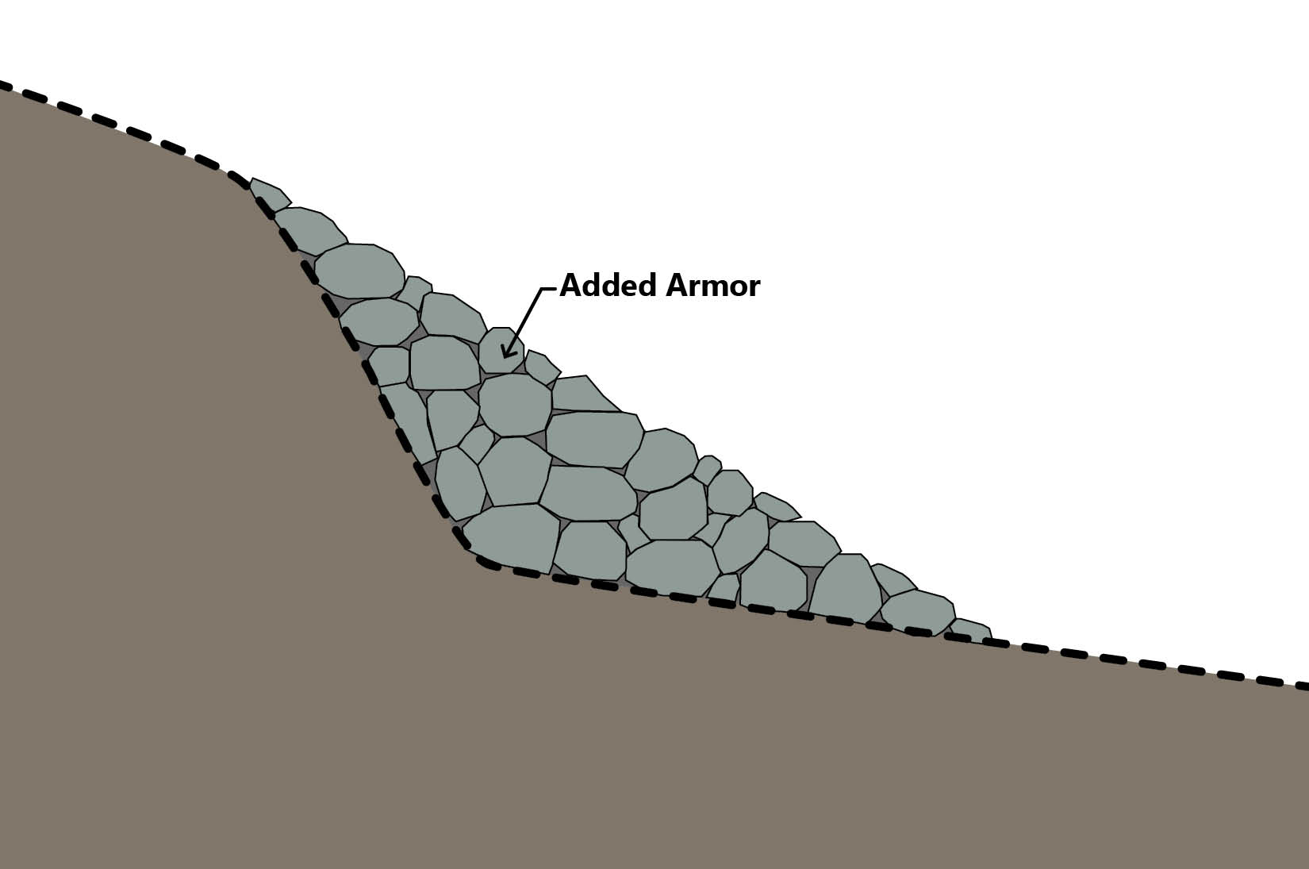

Summary of Rock Volumes
Estimated length for each repair type shown in Figure 1 and associated rock volumes for Areas 1, 2, and 3 are summarized in Table 3. Additional design assumptions, including armor rock diameter, layer thickness, etc., are provided in Table 4.
Table 3
Summary of Estimated Rock Volumes (See Figure 1 for Area Locations¹)
Area for Repair | Length of Shoreline  to Be Repaired (lf) | Armor Rock Volume (cy) | Filter Rock  Volume (cy)
Area 1A GPS Spot Repair | 150 | 292² | 83
Area 1B Shoreline Repair | 270 | 525³ | -
Area 2A GPS Spot Repair | 65 | 98 | 36
Area 2B Corner Repair | 80 | 44 | -
Area 3A North GPS Spot Repair and Corner | 40 | 60 | 22
Area 3B South GPS Spot Repair | 65 | 98 | 36
Area 3C Shoreline Repair | 315 | 292 | -
Notes:
- Areas 2C and 3D are no-action areas.
- Armor rock proposed in Area 1 repair work is salvage armor rock stockpiled at the Port Gamble Site. Approximately 490 cy of salvage rock are assumed to be available on site.
- Armor rock proposed is a combination of salvage armor rock (approximately 195 cy) and import armor rock (approximately 330 cy).
cy: cubic yard
lf: linear feet
Table 4
Design Recommendations and Assumptions for Rock Volume Estimates
(See Figure 1 for Area Locations)
Area for Repair | Design Recommendations and Assumptions for Volume Estimates
Area 1A GPS Spot Repair | 1-foot-thick layer of filter rock (D50 2–4 inches), two layers of salvage armor rock (D50 2 feet, layer thickness 3.5 feet). Width of repair along slope assumed to be 15 feet.
Area 1B Shoreline Repair | No filter needed; two layers of salvage (D50 2 feet, layer thickness 3.5 feet) or import armor rock (D50 1.5⁴ feet, layer thickness 3.5 feet). Width of repair along slope assumed to be 15 feet.
Area 2A GPS Spot Repair | 1-foot-thick layer of filter rock (D50 2–4 inches), two layers of import armor rock (D50 1.5⁴ feet, layer thickness 3.5 feet). Width of repair along slope assumed to be 15 feet.
Area 2B Corner Repair | No filter needed; one layer of armor rock (D50 1.5⁴ feet, layer thickness 1.5 feet). Width of repair along slope assumed to be 10 feet.
Area 2C Shoreline Repair | No action
Area 3A North GPS | 1-foot-thick layer of filter rock (D50 2–4 inches), two layers of import armor rock (D50 1.5 feet, layer thickness 3.5 feet). Width of repair along slope assumed to be 15 feet.
Area 3B South GPS Spot Repair | 1-foot-thick layer of filter rock (D50 2–4 inches), two layers of import armor rock (D50 1.5⁵ feet, layer thickness 3.5 feet). Width of repair along slope assumed to be 15 feet.
Area 3C Shoreline Repair | No filter needed; “triangle” of import armor rock (D50 2 feet) to fill in depression at top of slope. Width of repair along slope assumed to be 10 feet.
Area 3D Shoreline Area | No action

Reference
Anchor QEA (Anchor QEA, LLC), 2015. Engineering Design Report. Port Gamble Bay Cleanup Project. Prepared for Pope Resources, LP/OPG Properties, LLC. May 2015.
USACE, 1992. Automated Coastal Engineering System, Users Guide. Coastal Engineering Research Center, Department of the Army. September 1992.
USACE, 2006. Coastal Engineering Manual, USACE, 2006.

Attachment 1
Field Measurements – GPS Locations of Erosion Areas

NOAA West Point station wind data were not available for the 2018 to 2019 winter season and therefore were not used in the storm summary. Wind data from the Seattle-Tacoma International Airport station were available for the current winter season; this is the next closest station to the Site.
Median diameter of armor rock gradation, which consists of armor rock of variable sizes within a specified range.
Armor rock size range required for stability with no movement under waves is 1 to 2 feet in diameter, with a median diameter (D50) of approximately 1.5 feet. The salvage armor rock is slightly larger than this, and from visual inspection ranges from 1 to 3 feet with a median diameter of 2 feet.
Armor rock size range required for stability with no movement under waves is 1 to 2 feet in diameter, with a median diameter (D50) of approximately 1.5 feet. The salvage armor rock is slightly larger than this, and from visual inspection ranges from 1 to 3 feet with a median diameter of 2 feet.

