Photograph | Description
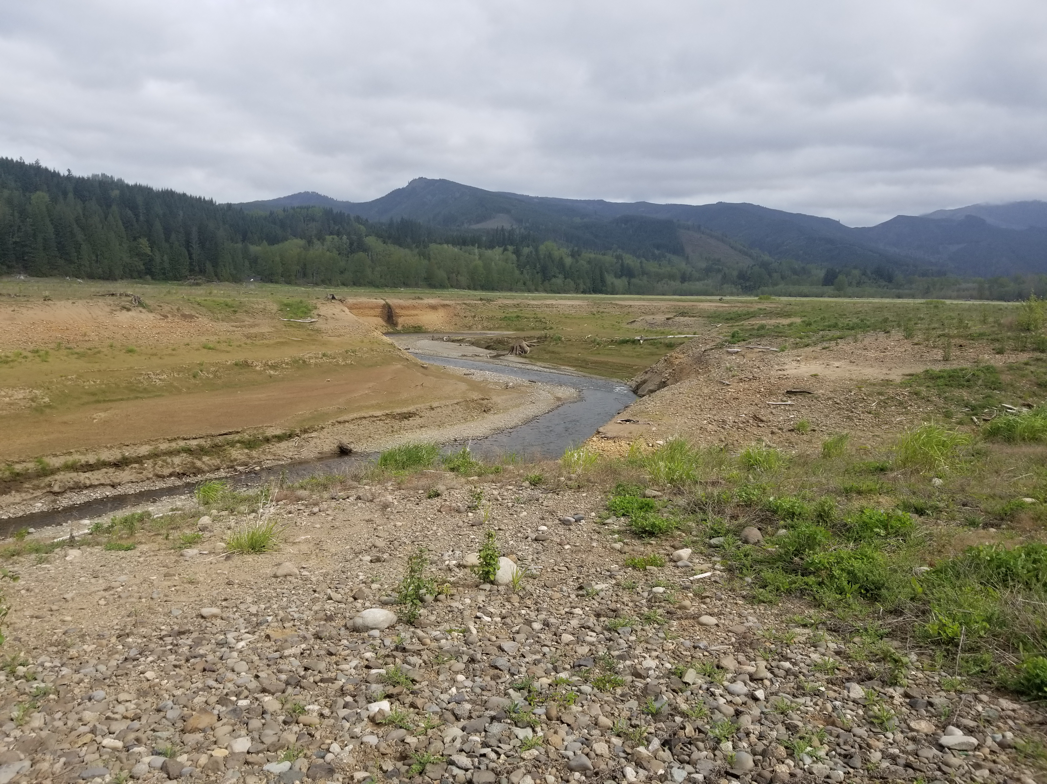 | Upper portion of impacted hillside (contamination underfoot) looking north
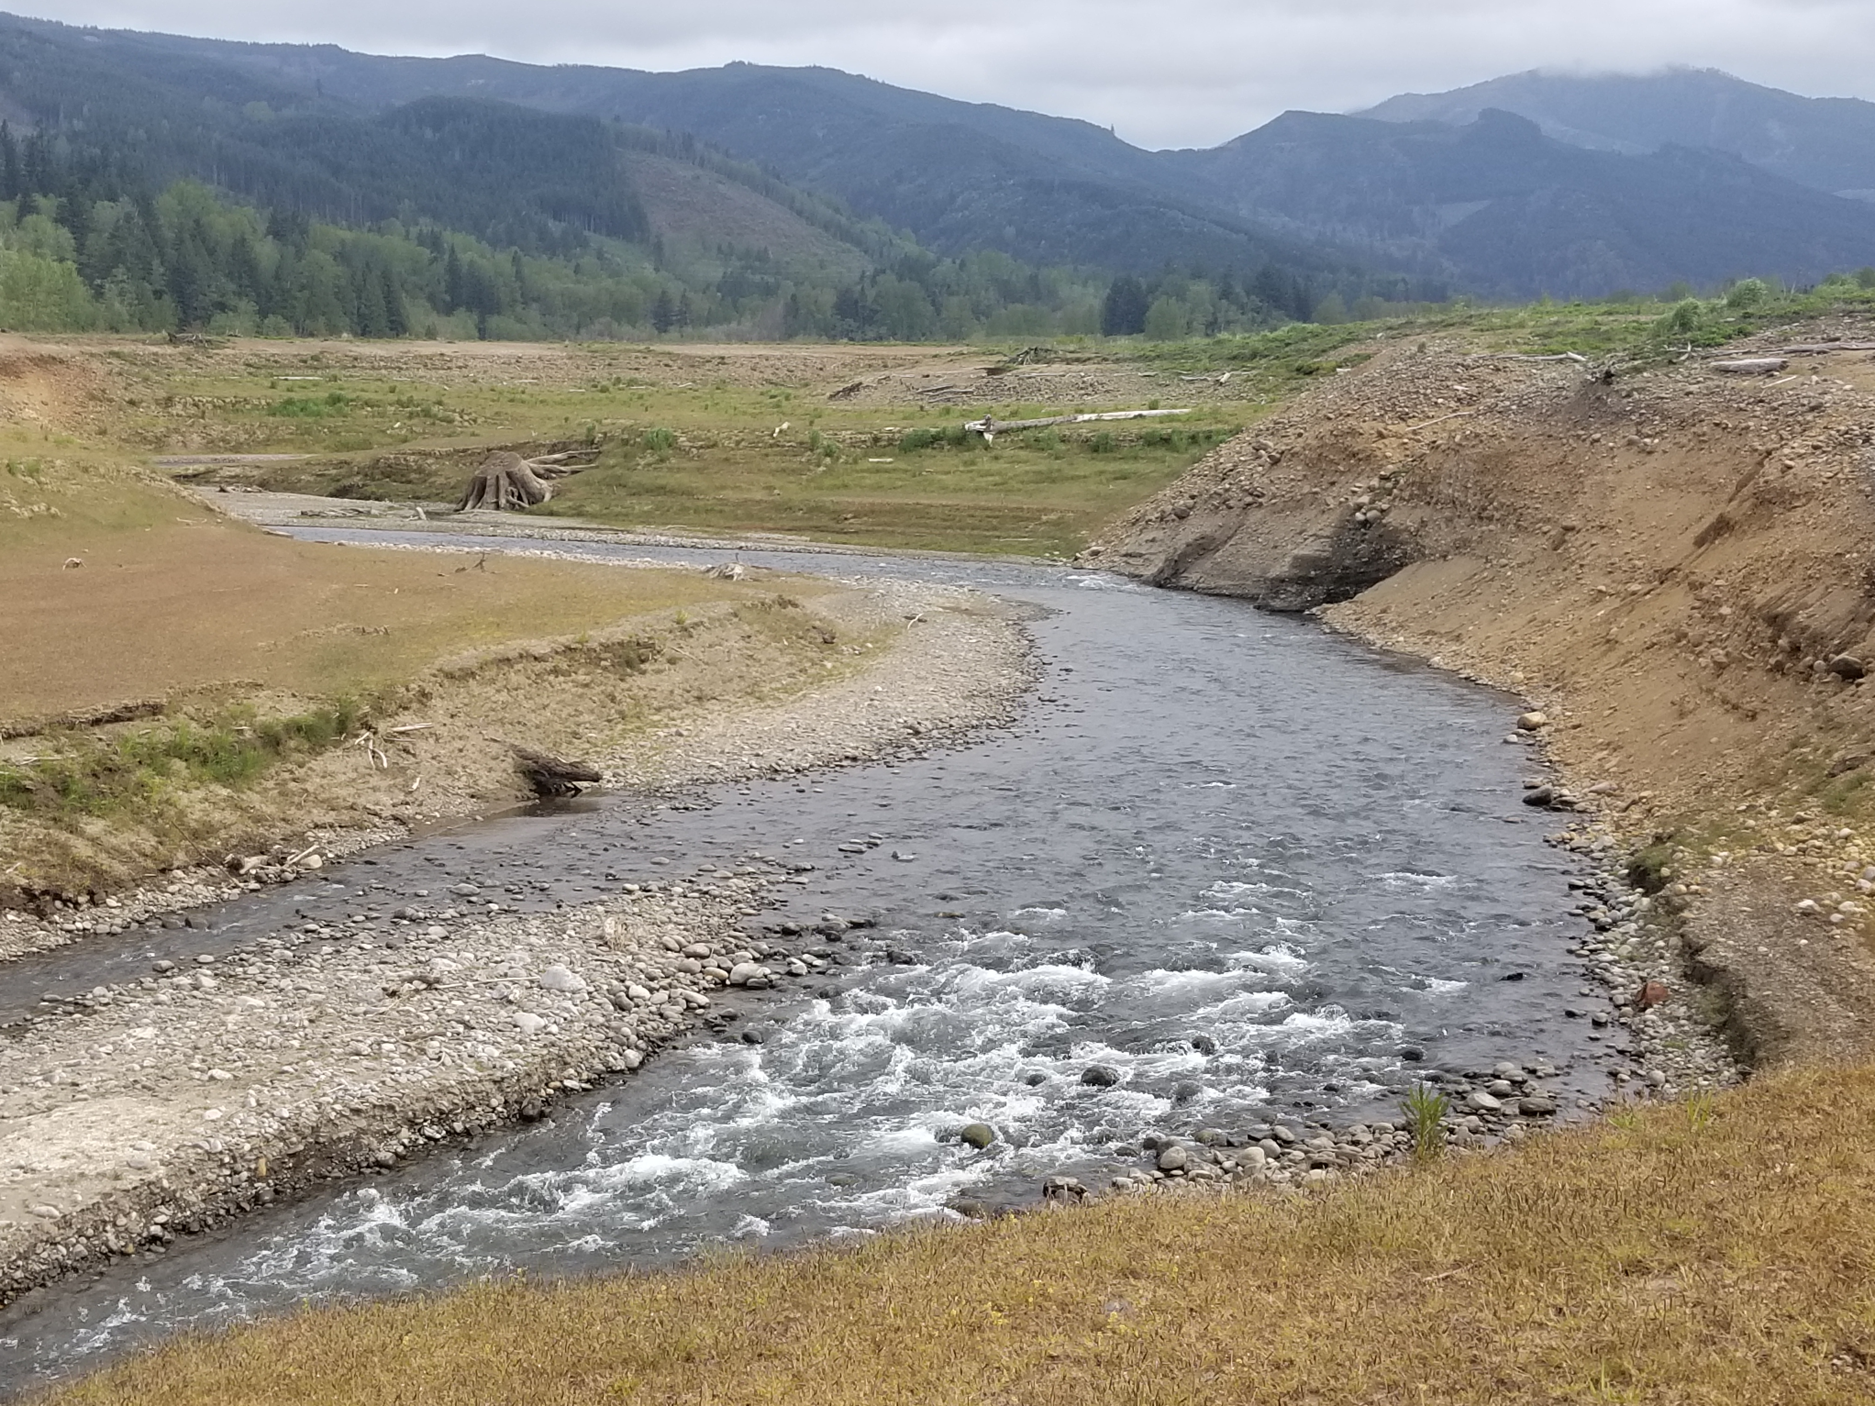 | Upper portion of impacted hillside (contamination underfoot) looking north
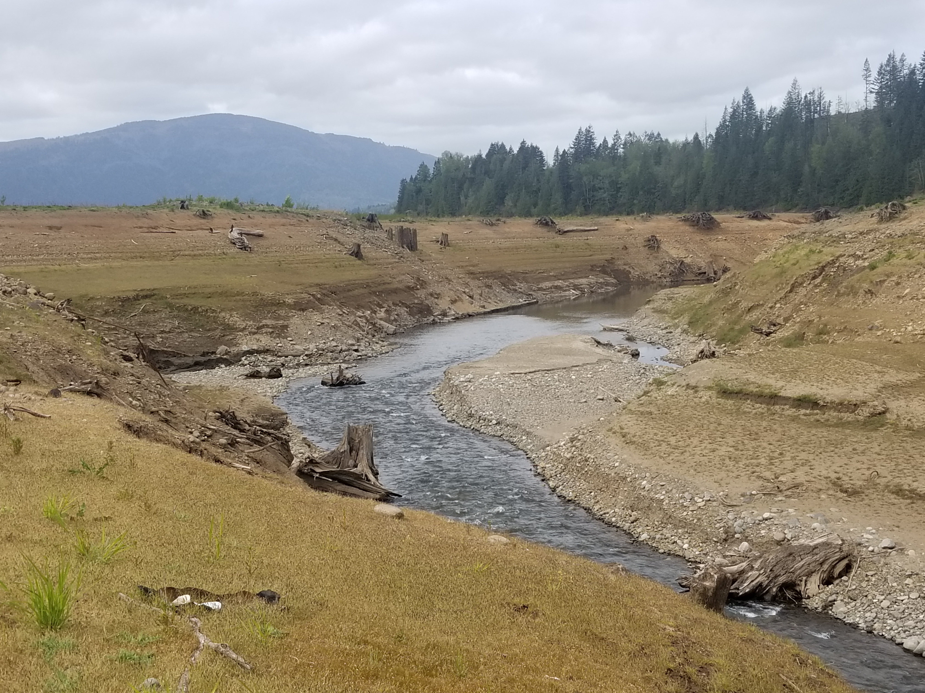 | Upper portion of impacted hillside (contamination underfoot), looking south
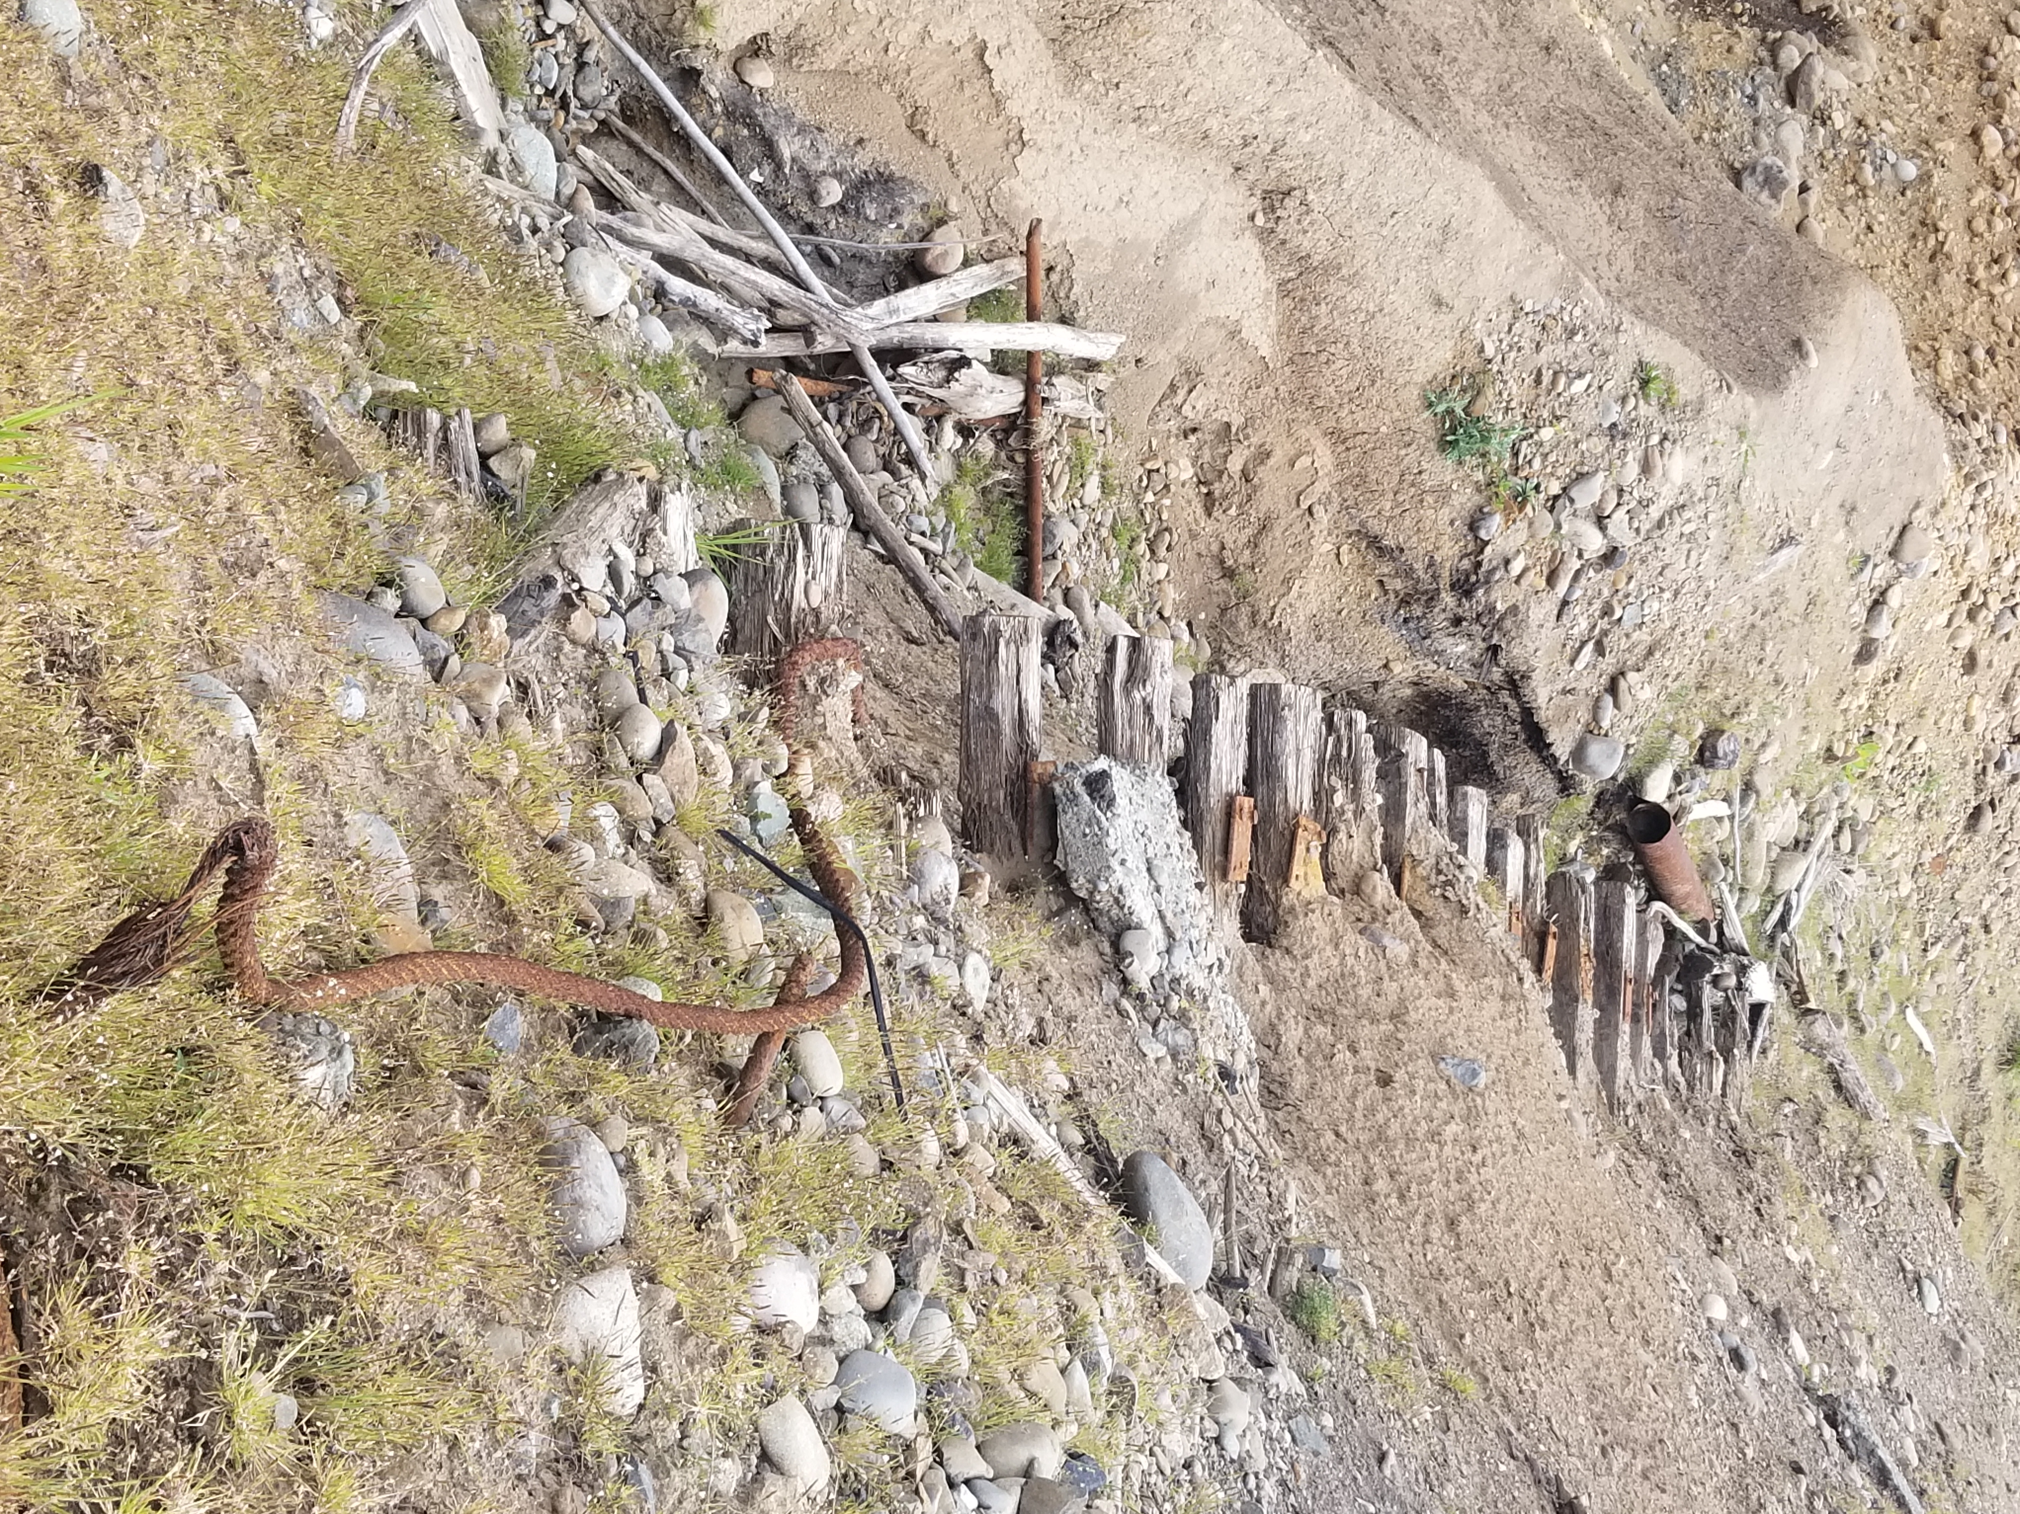 | Heading down the eroding hillside, exposed historical railroad ties, metal scrap, and rebar
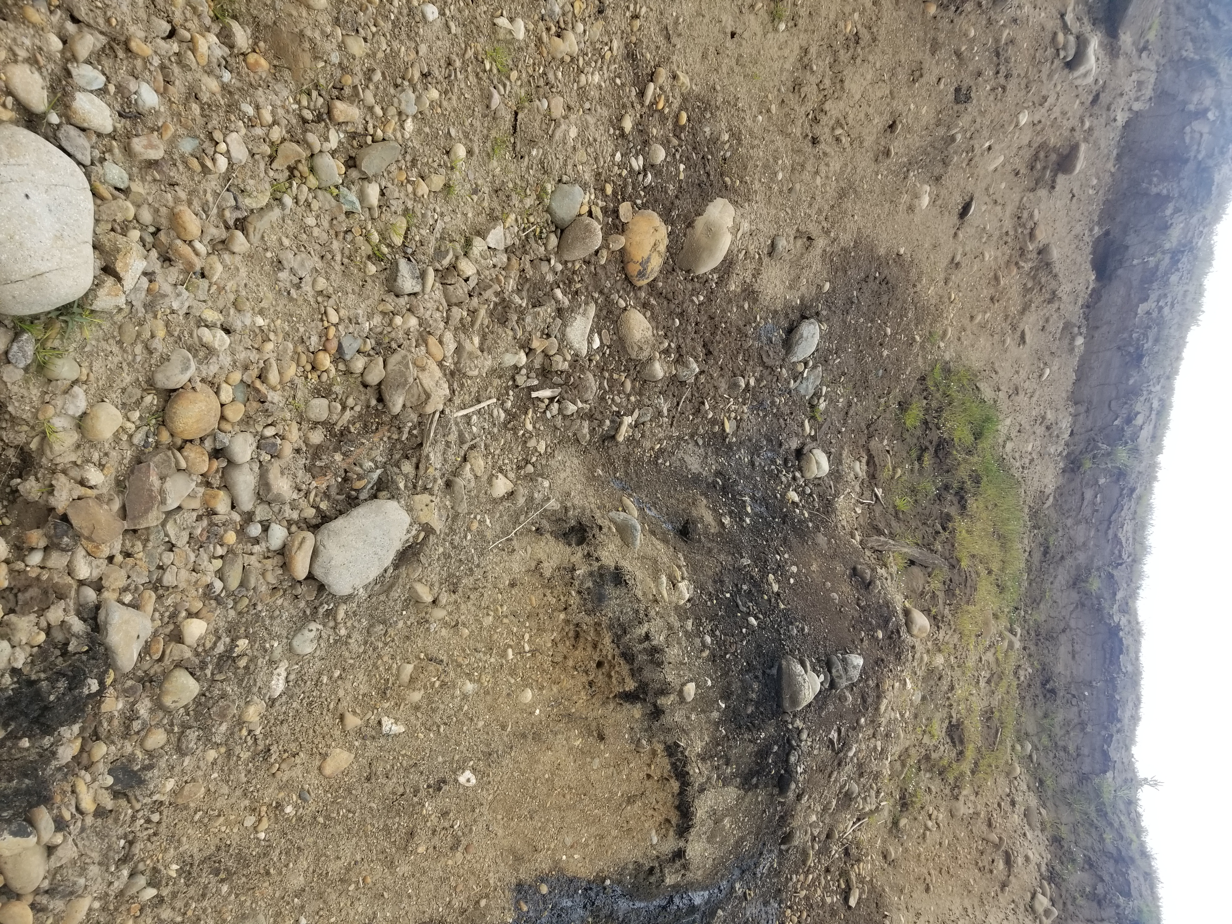 | Lower portion of impacted hillside, Looking up at location of photos from Page 1. Petroleum visible leaking from hillside
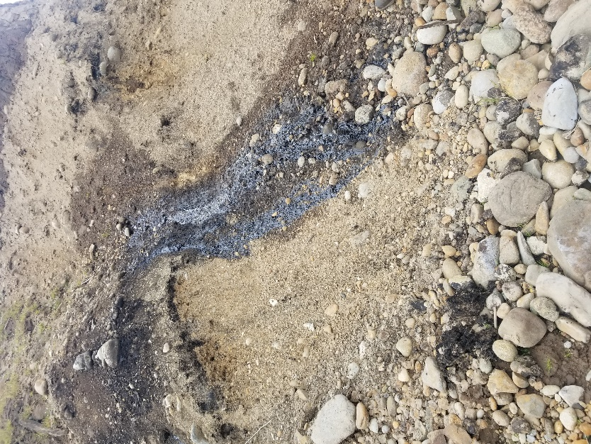 | Lower portion of impacted hillside, Looking up at location of photos from Page 1. Petroleum visible leaking from hillside
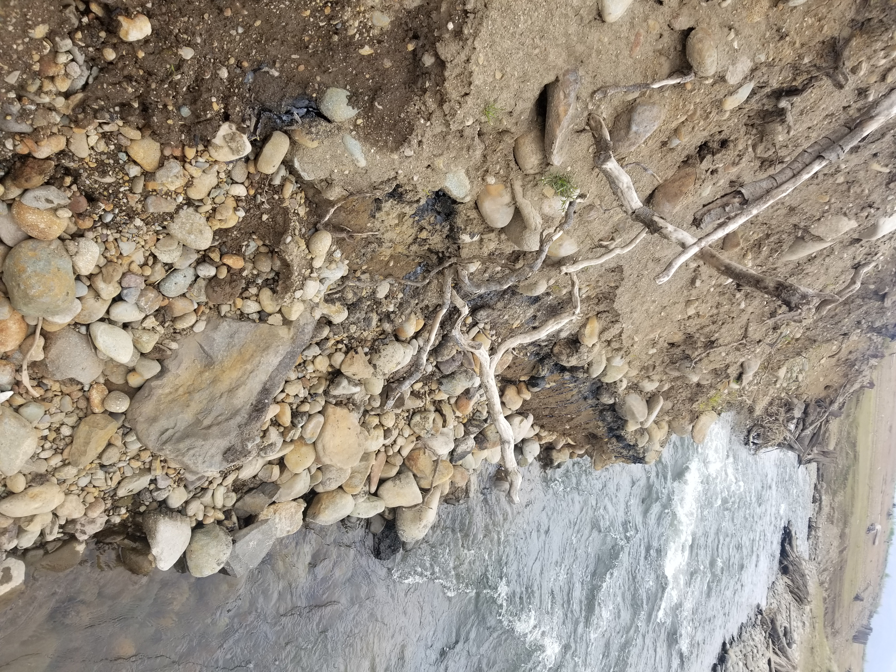 | Second seepage area, further south from that noted in photos from page 3. Approximately 2 feet from current water level
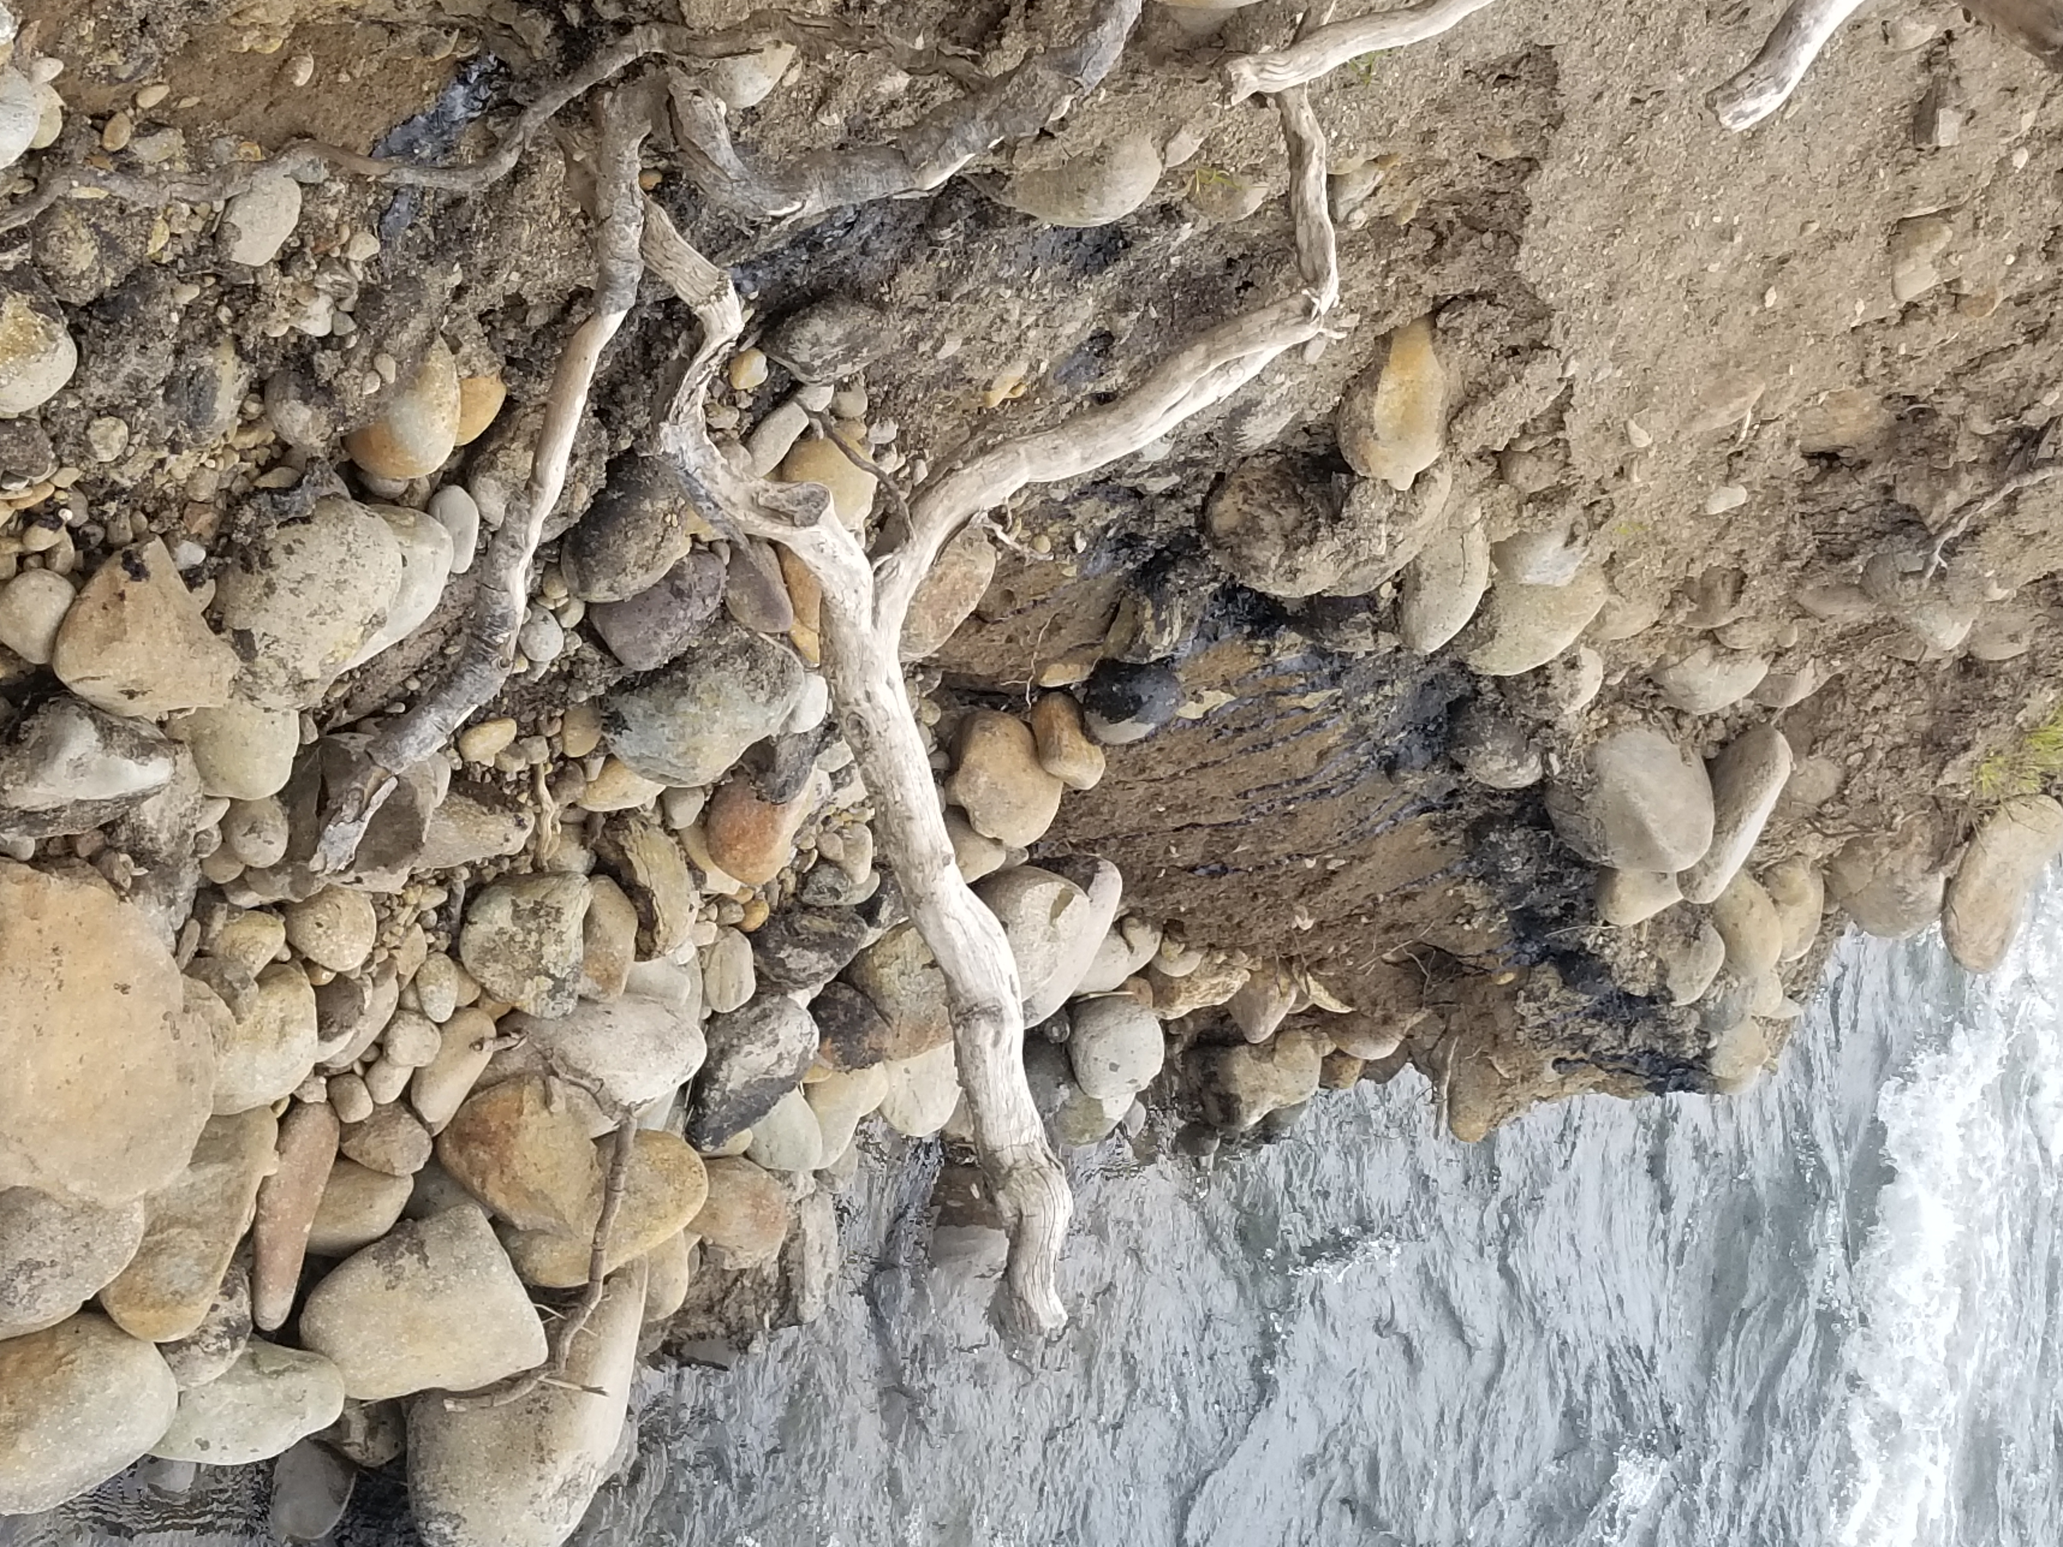 | Second seepage area, further south from that noted in photos from page 3. Approximately 2 feet from current water level
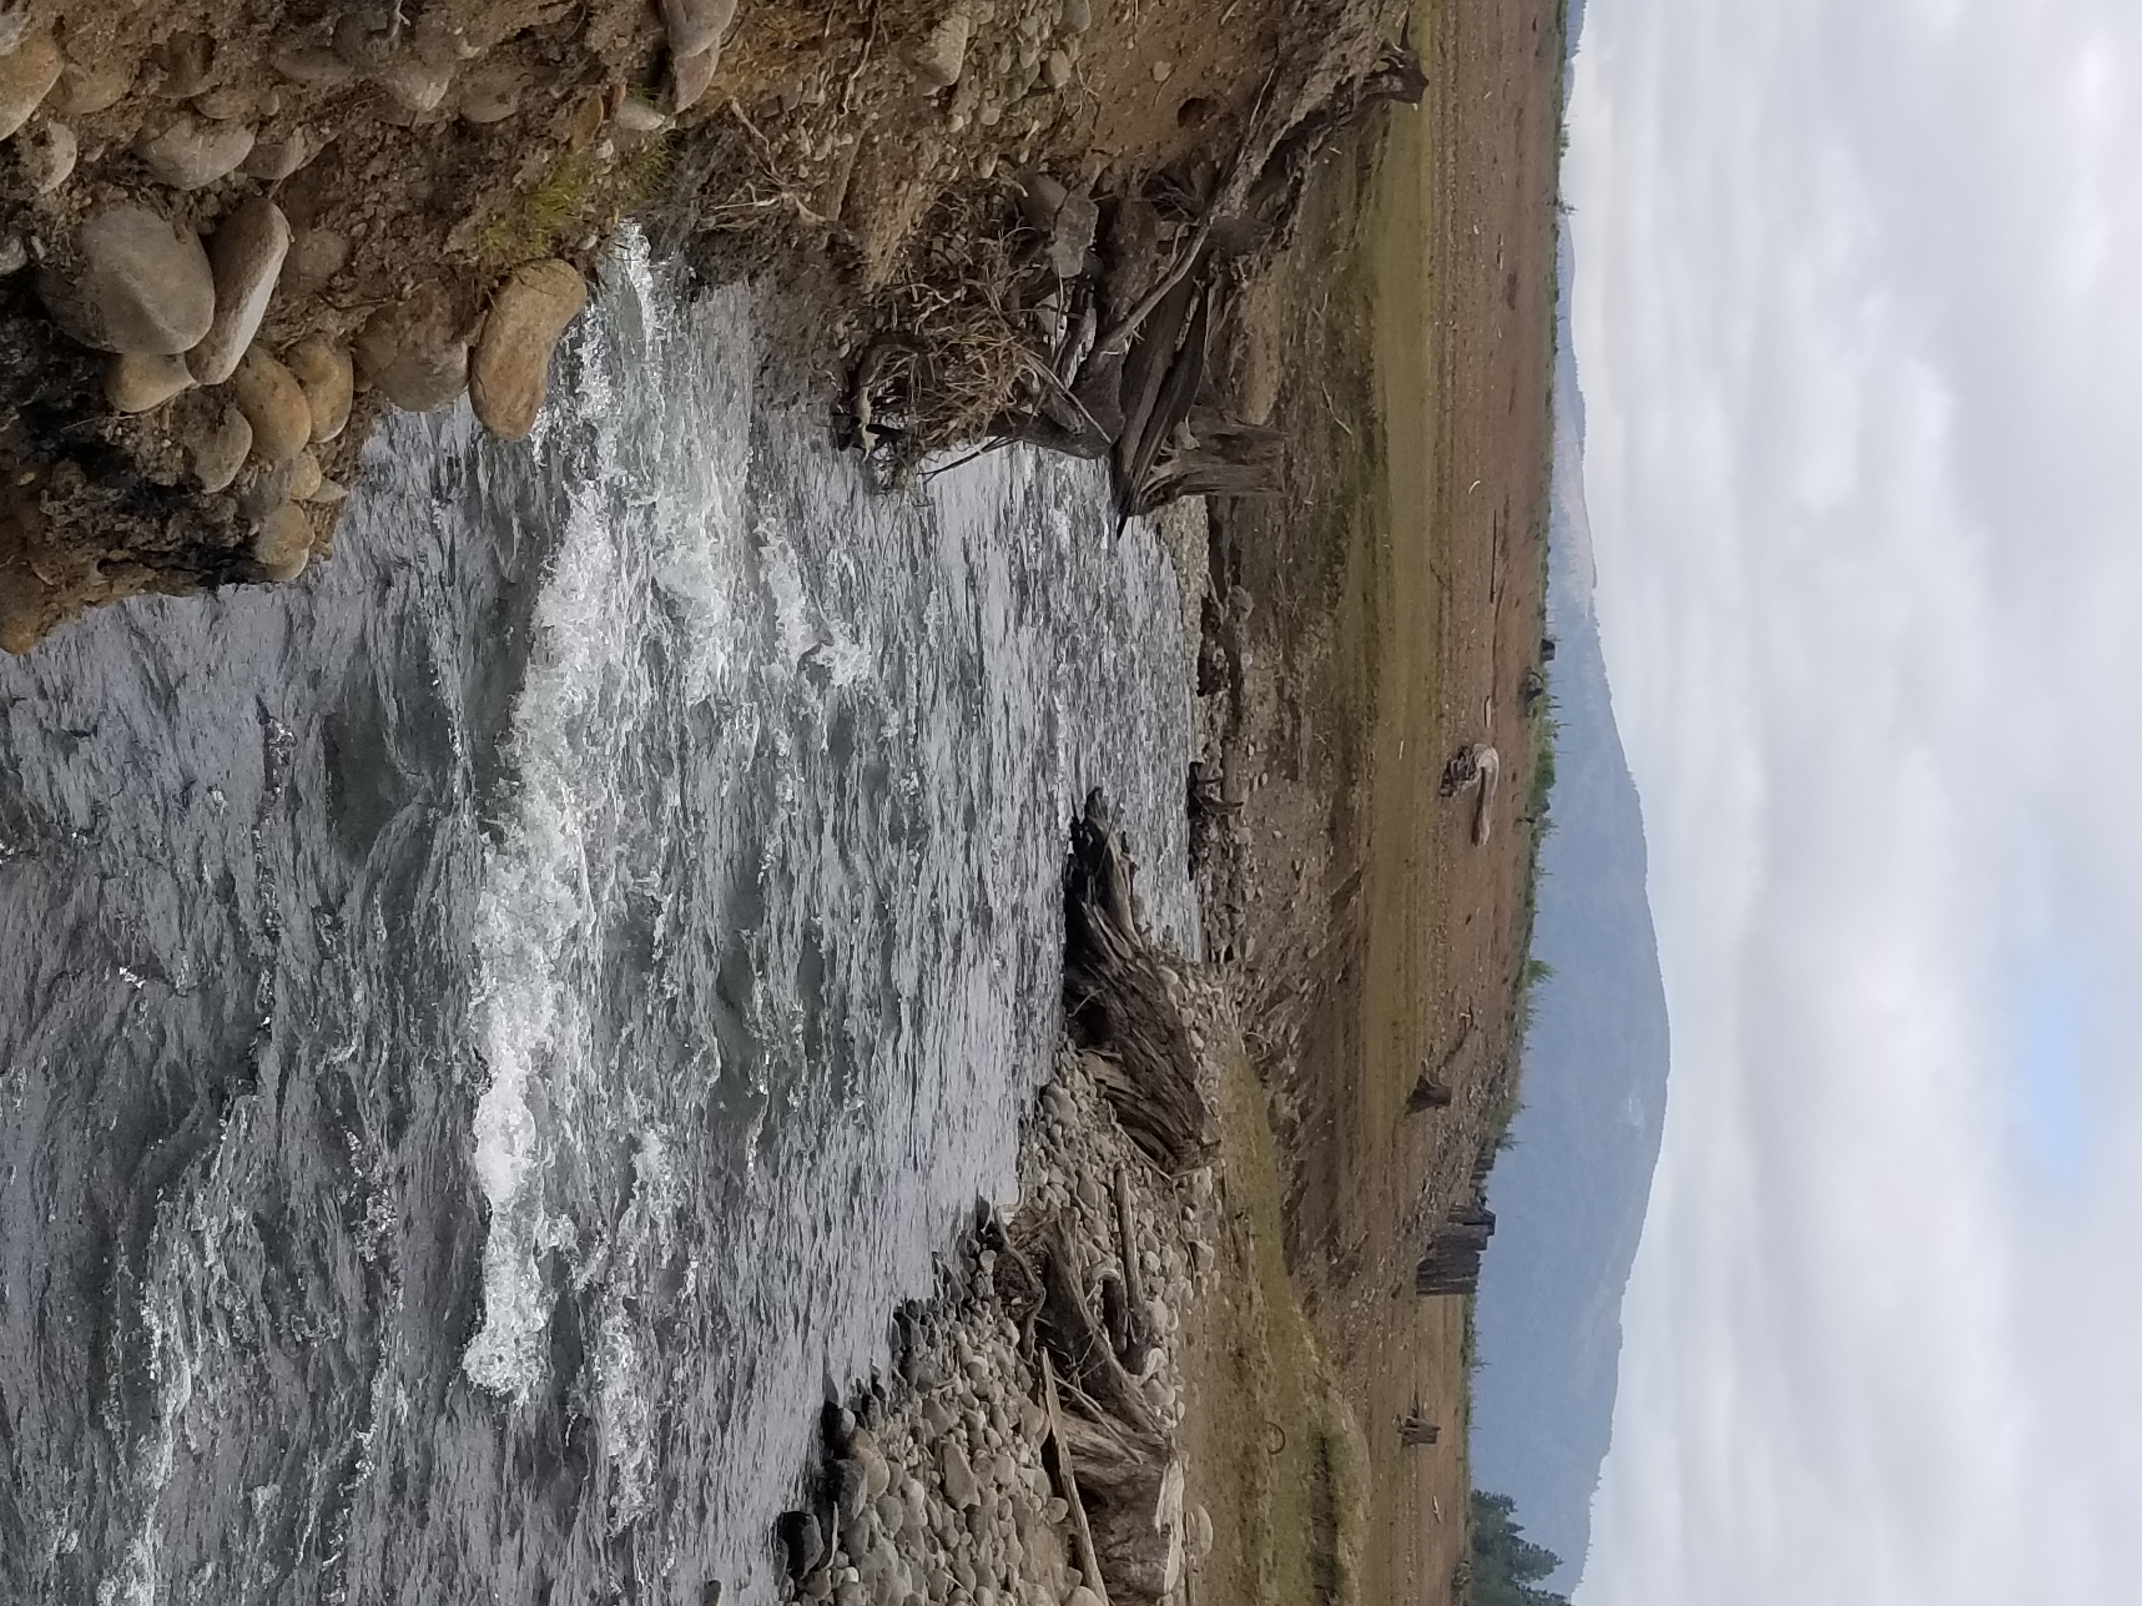 | Second seepage area noted in bottom left corner, looking south. Note the current of the water
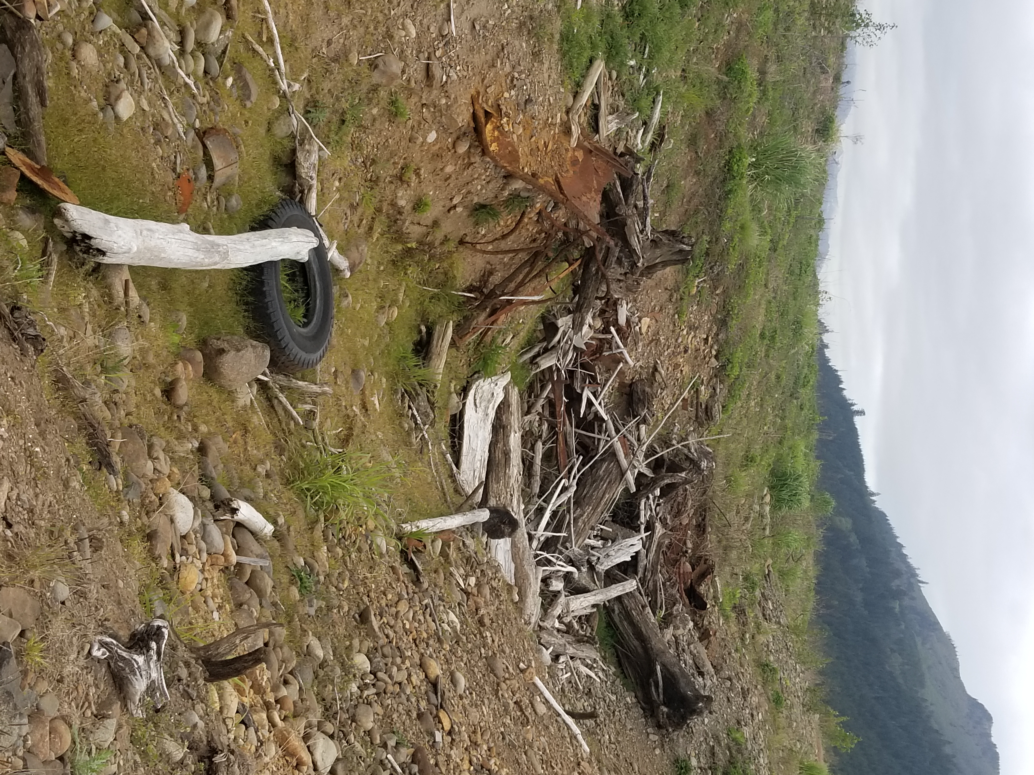 | Top of hillside from Page 1 photos, more scrap metal
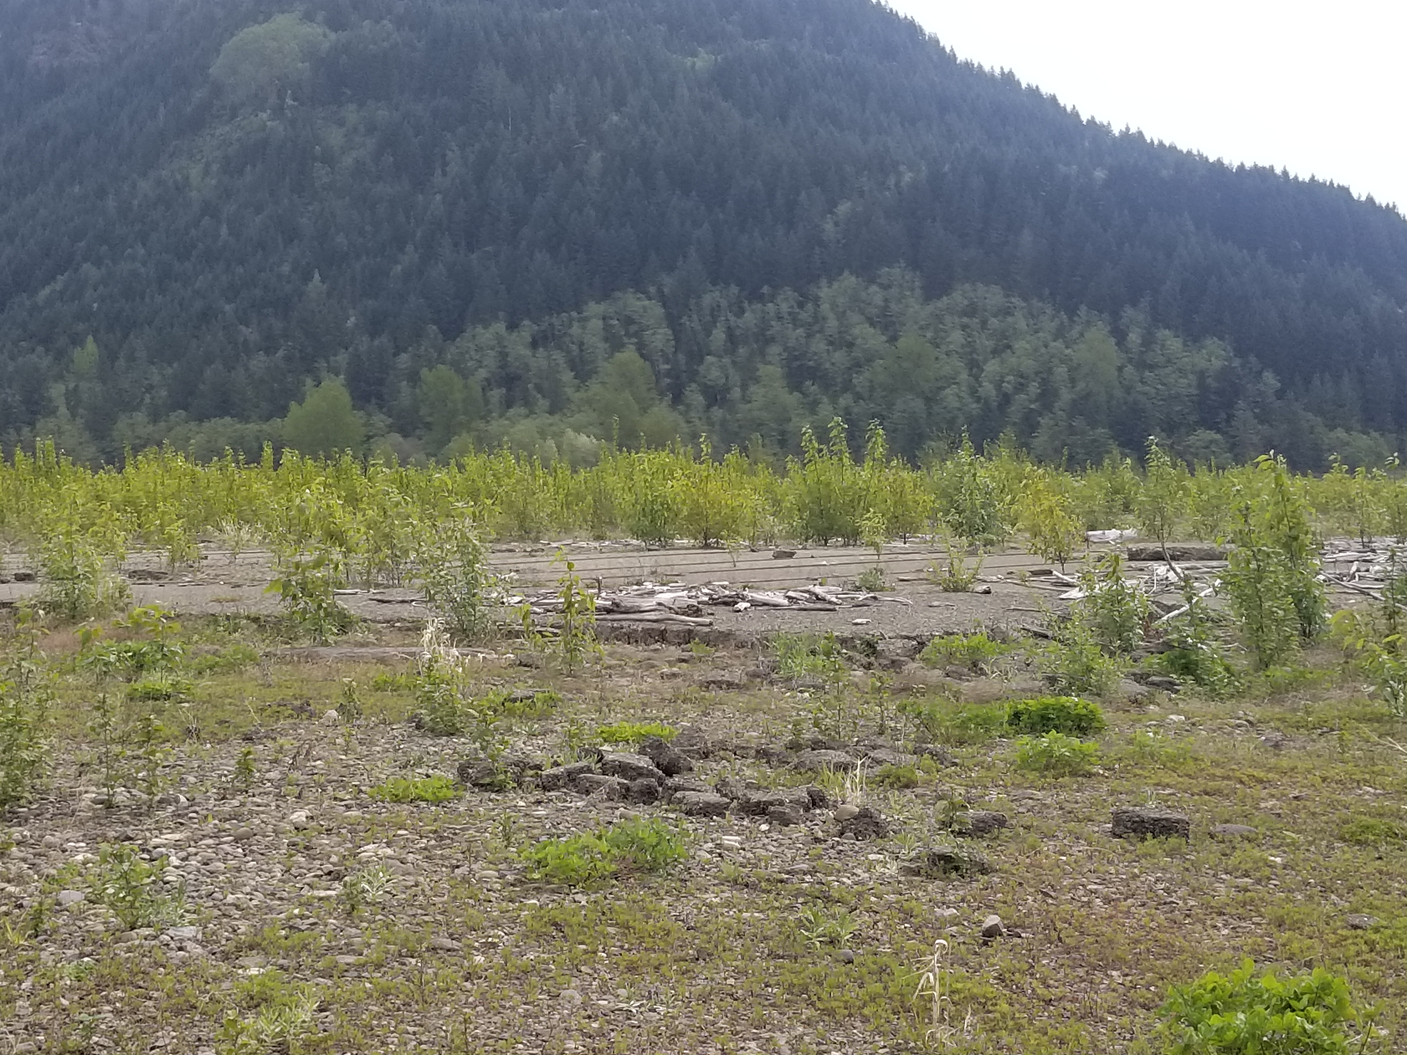 | Historical mill foundation location at the foot of “Dog Mountain” hang-gliders reportedly land in this area
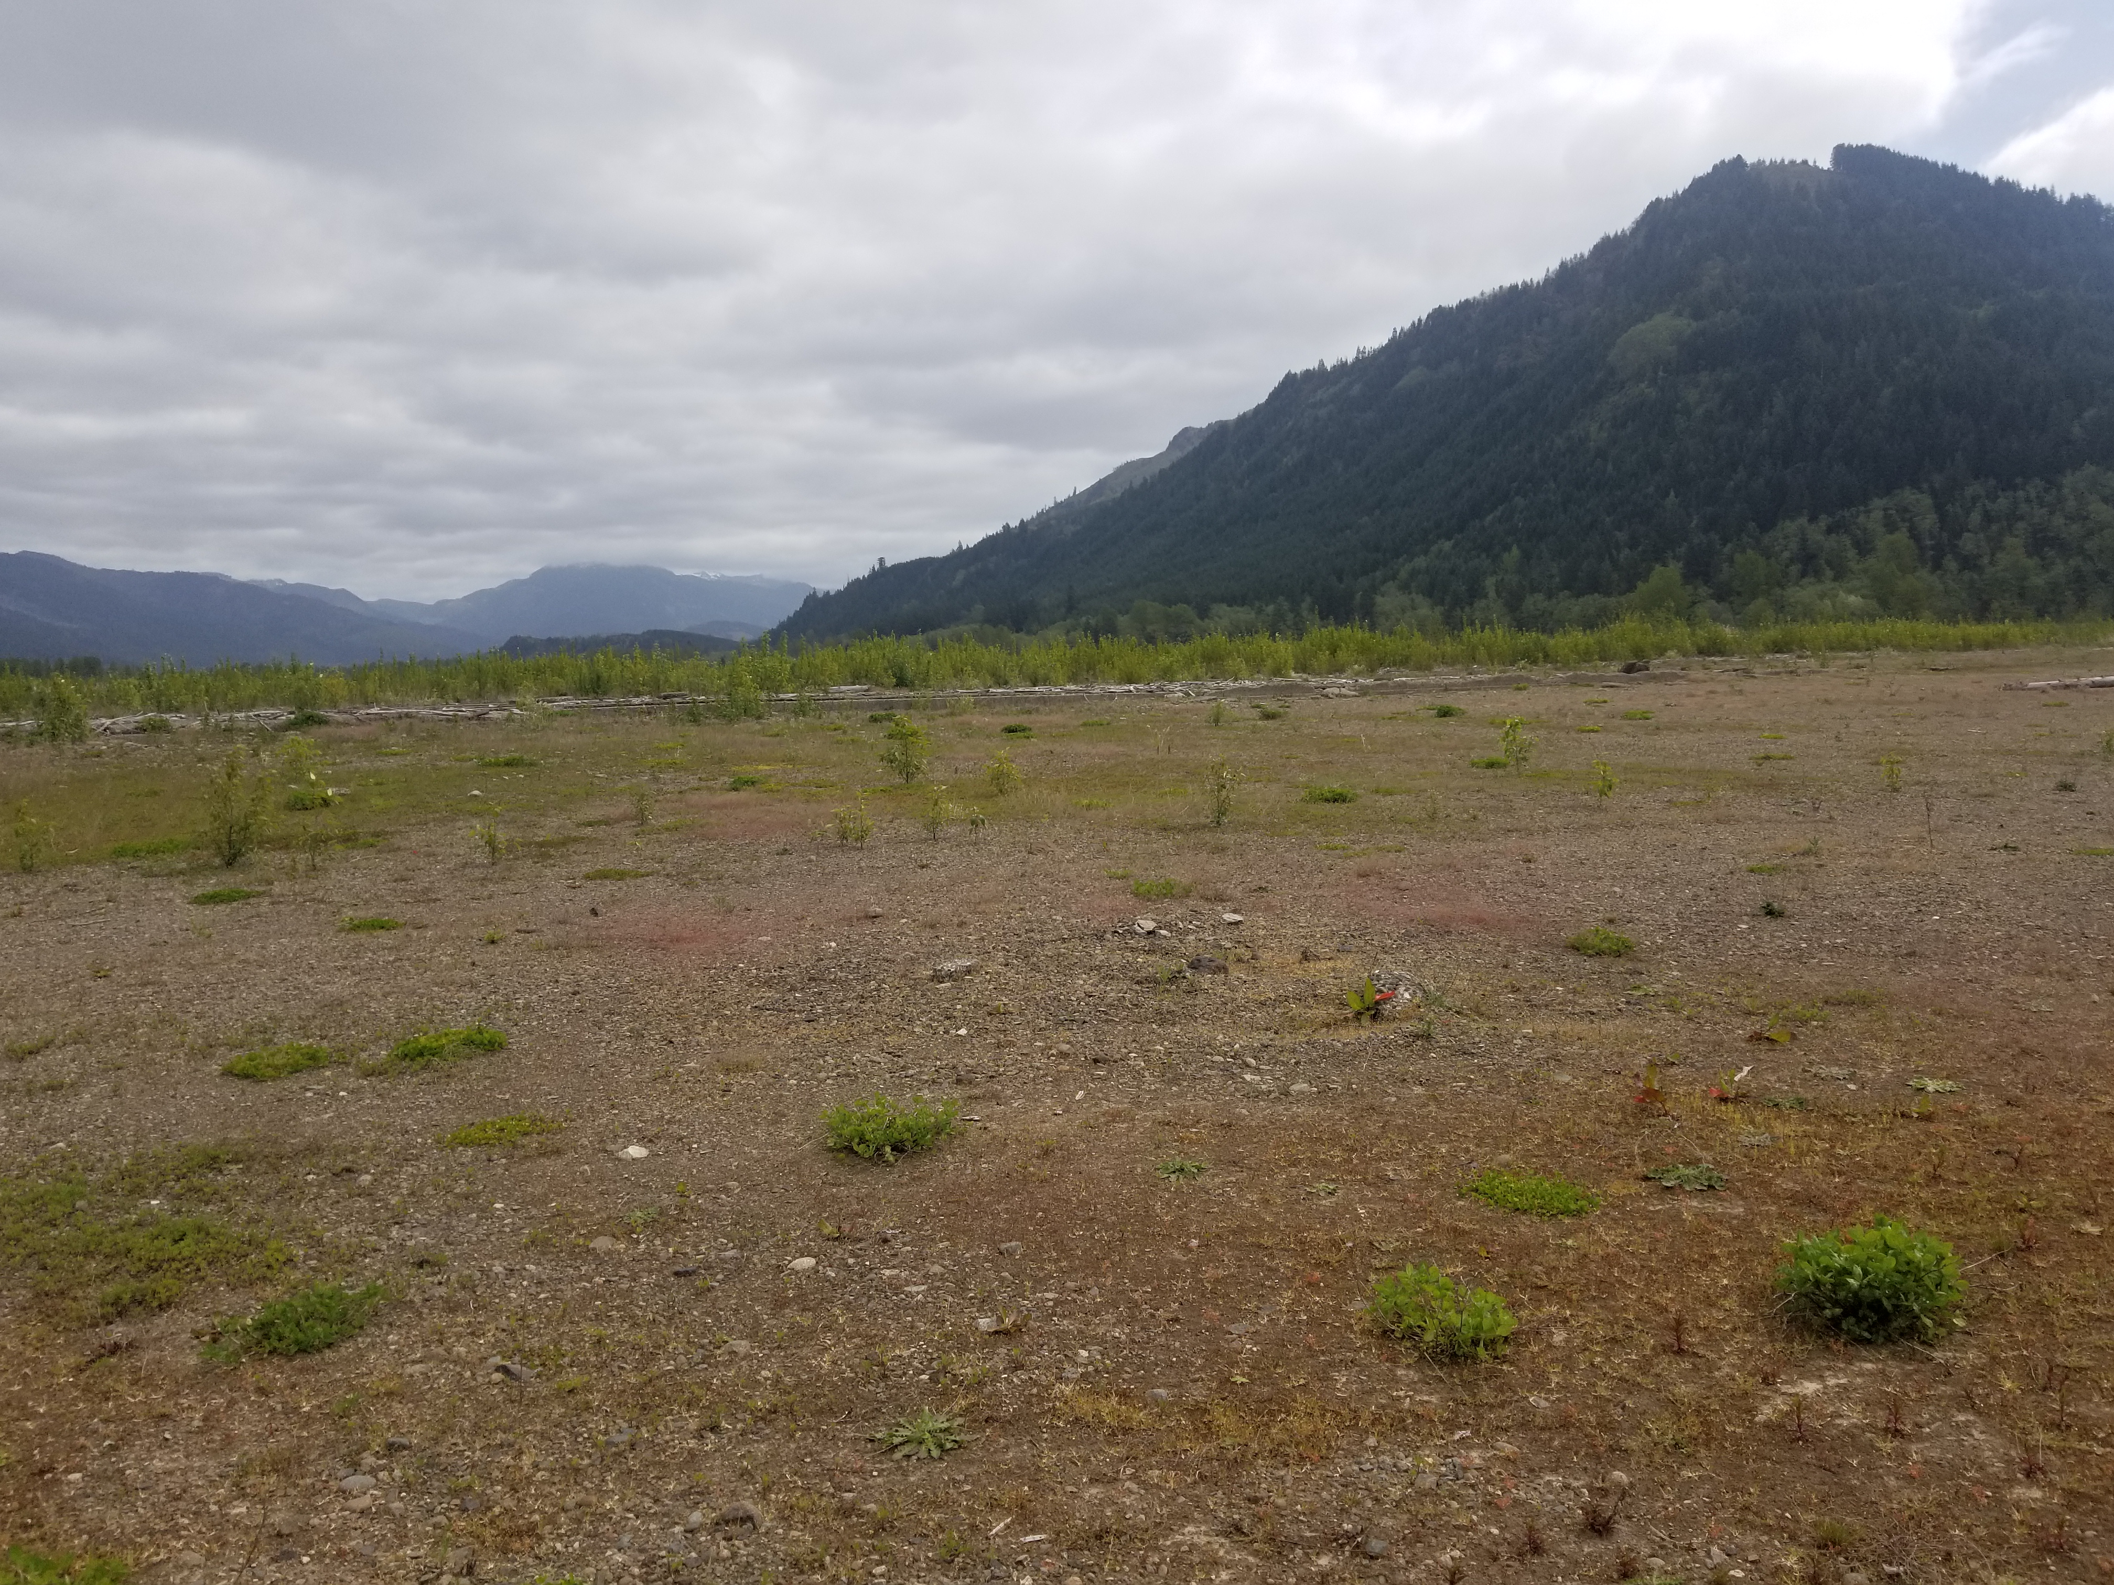 | Historical mill foundation location at the foot of “Dog Mountain” hang-gliders reportedly land in this area
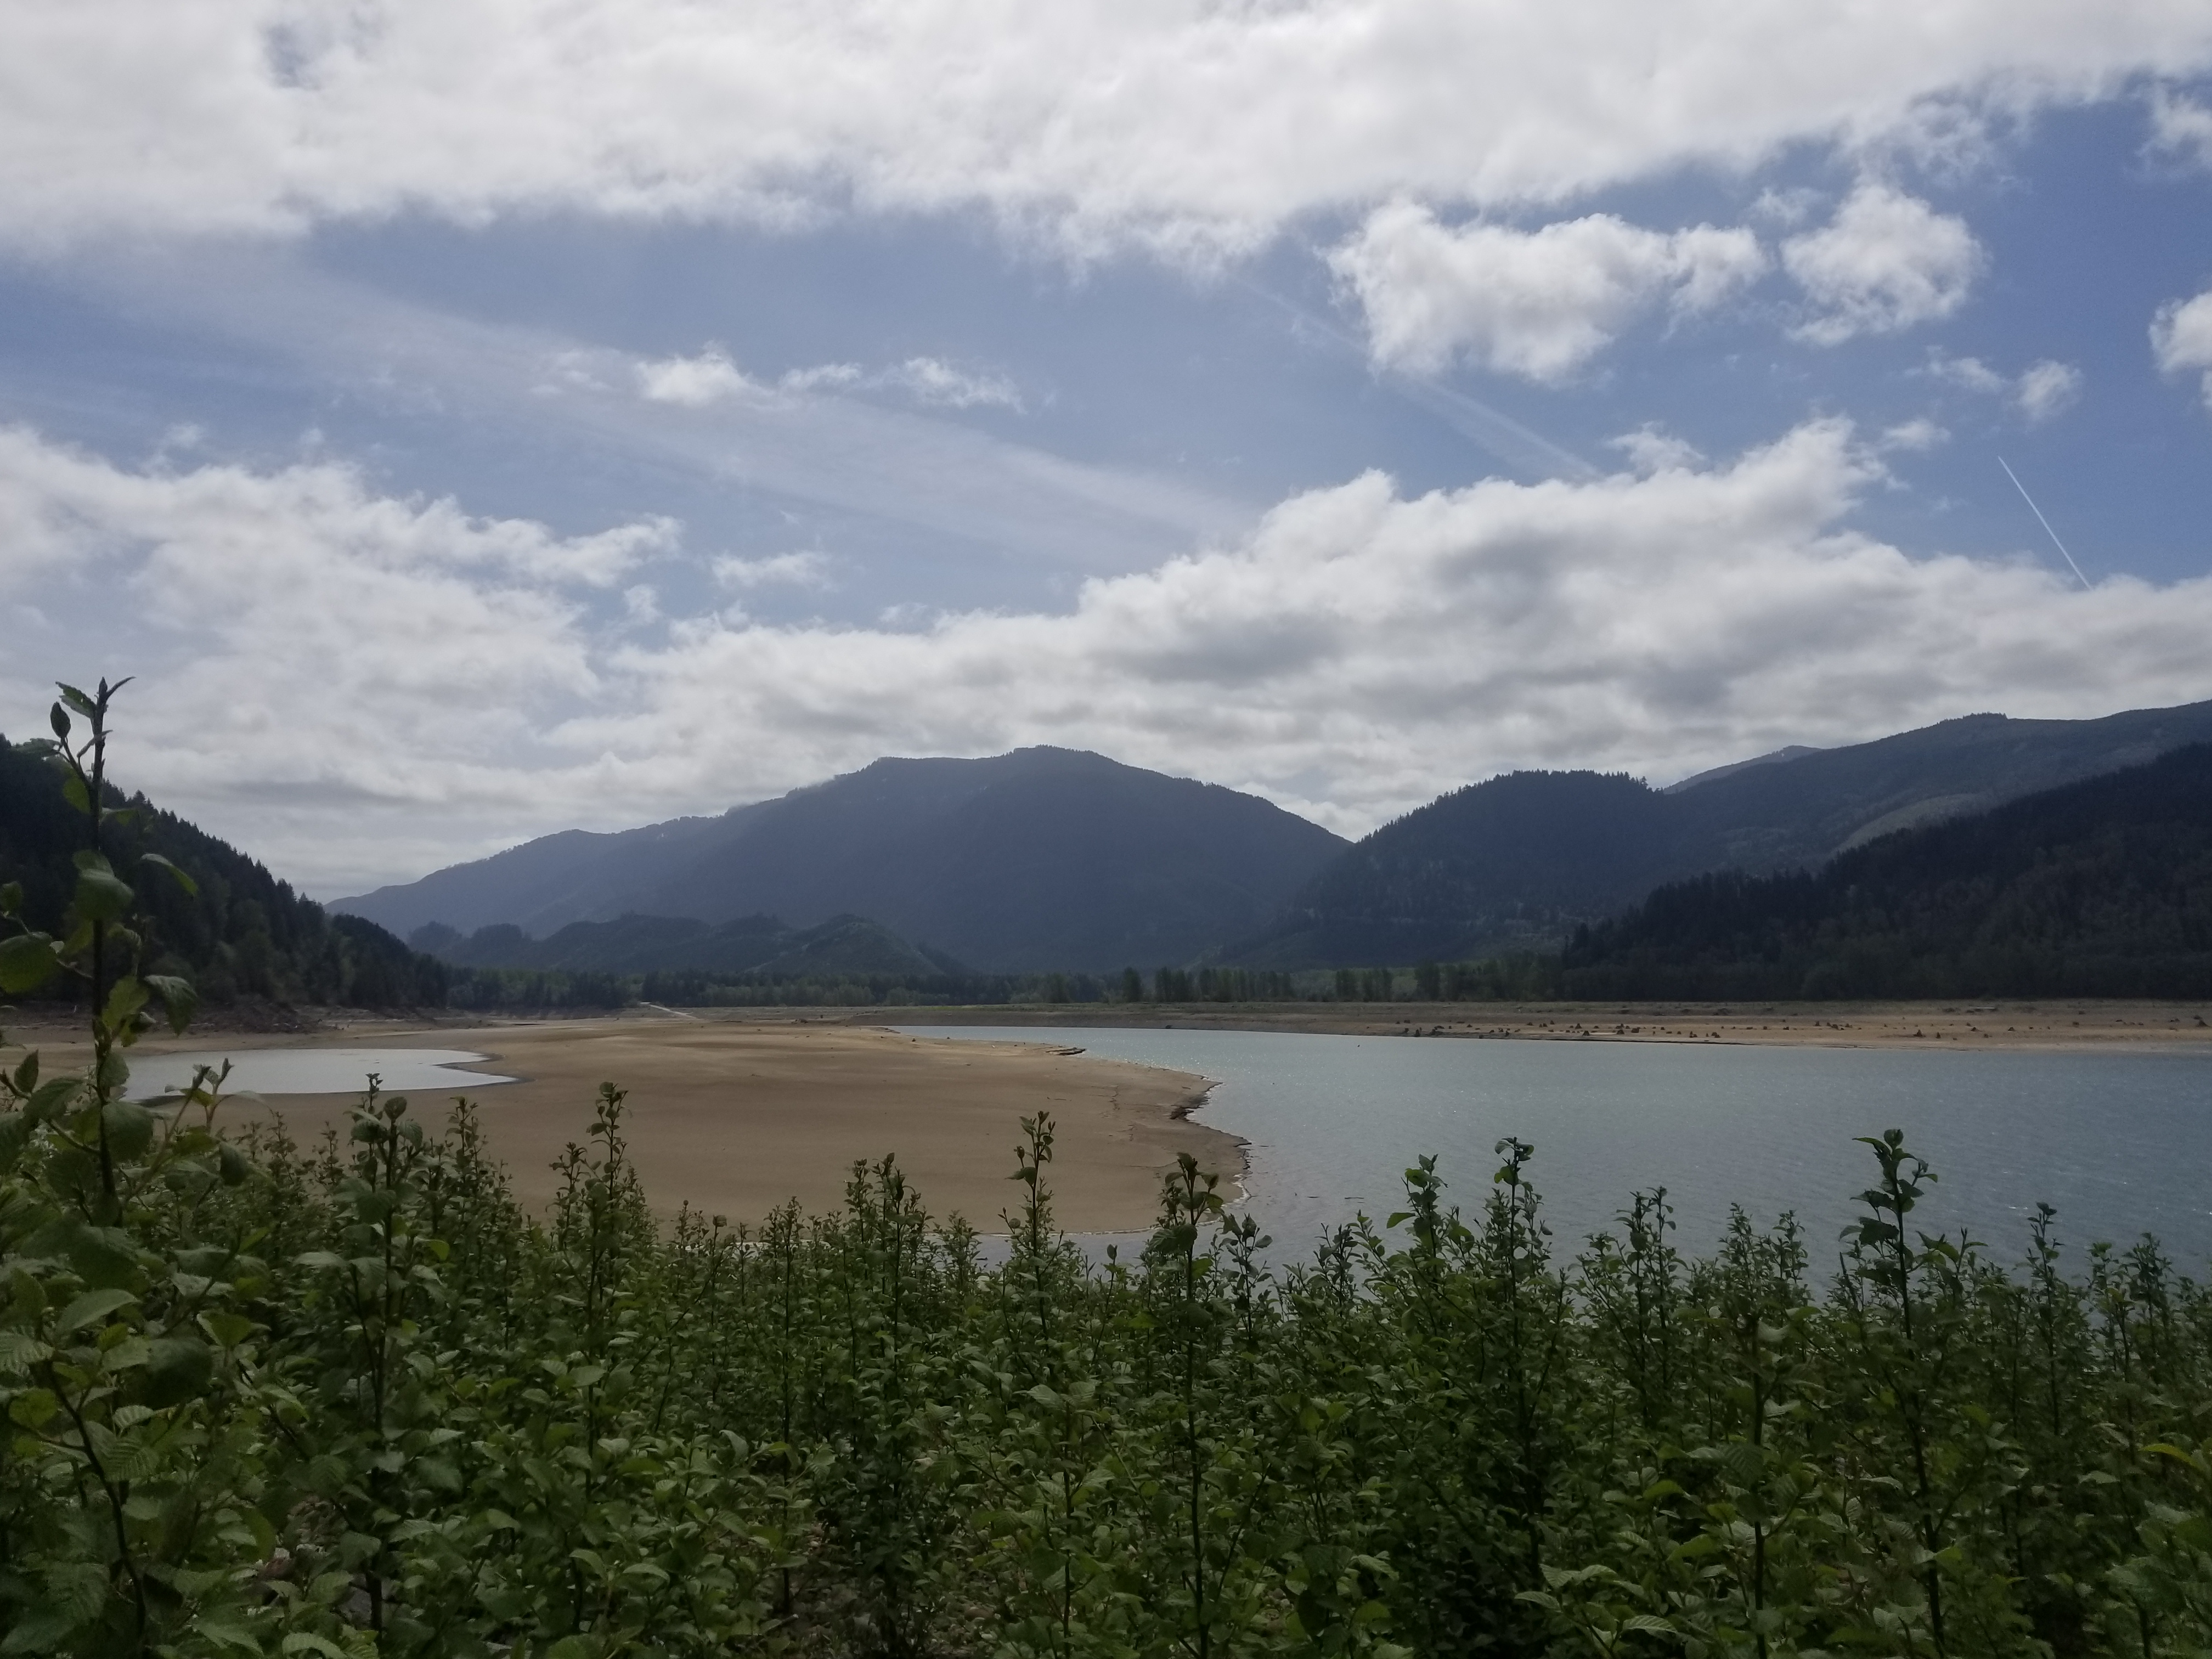 | Looking east at Riffe Lake towards dam
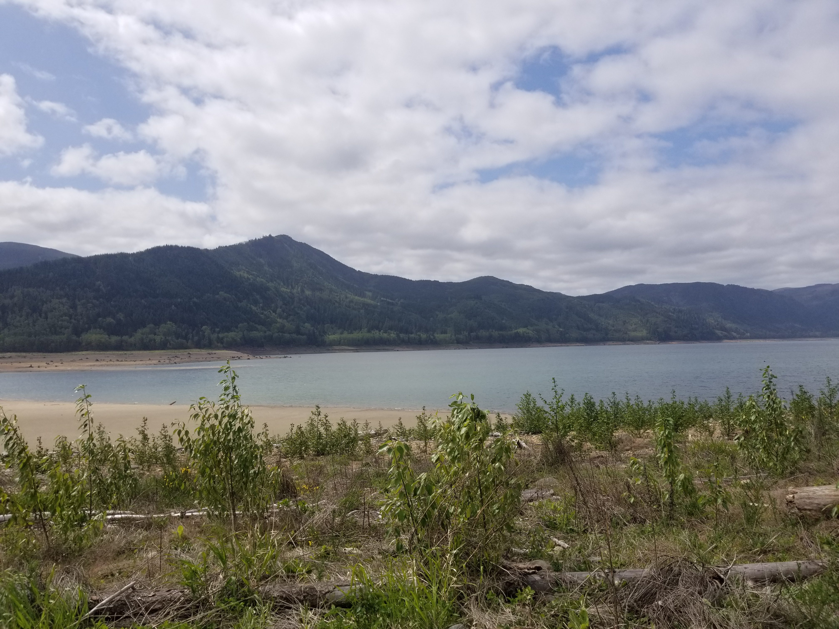 | Looking west at Riffe Lake away from dam

