Dangerous Waste Permit, Agreed Order & Public Participation Plan for the

U.S. Army Yakima Training Center
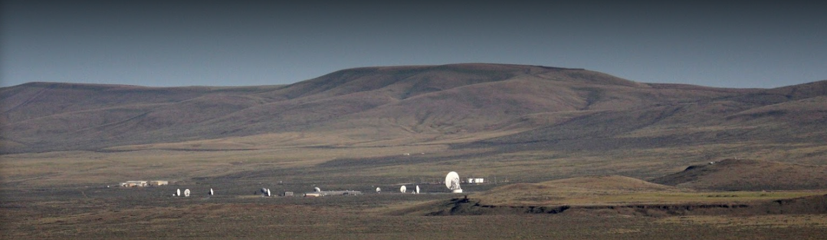
View of the U.S. Army Yakima Training Center

Comments accepted:
Aug. 3, 2020 – Sept. 16, 2020

Submit comments:
Online: https://bit.ly/ArmyYakimaEComments
By mail:
Tom Mackie, Site Manager
1250 W. Alder Street
Union Gap, WA 98903
509-575-2803
thomas.mackie@ecy.wa.gov

Site info:
Webpage: https://ecology.wa.gov/YTC
Facility Site ID: 105
Site Cleanup ID: 2301
See inside for document review locations.
A virtual public meeting will be held if at least 10 people request one.

We want to hear from you!
Washington State’s coronavirus response
Due to the coronavirus response, we are not hosting in-person public meetings or supporting physical document repositories. Documents for review are available online only. If a hearing is requested, we will determine the appropriate response under Washington’s Stay Home, Stay Healthy order. If you need access to a hard copy document, would like to request a hearing, or have other questions, please contact Janelle Anderson at 425-301-6454 or janelle.anderson@ecy.wa.gov.

Ecology invites you to review and comment on a draft Agreed Order, draft permit, and draft Public Participation Plan, for the U.S. Army Yakima Training Center (YTC) in Yakima, WA.
Agreed Order (AO)
Ecology has invited the Army to sign an AO for cleanup where releases of hazardous substances occurred. This AO requires the Army to improve polluted areas at 8 Solid Waste Management Units and 13 Areas of Concern at the YTC.
Draft Permit (Permit Lite)
For environmental cleanup at YTC to continue, the Army must have a Corrective Action Permit. The Resource Conservation and Recovery Act (RCRA) requires this permit and outlines how to manage hazardous waste at a facility by federal law.
Public Participation Plan (PPP)
The Public Participation Plan (PPP) encourages community involvement in the cleanup process. It outlines how people can comment on the cleanup process decisions.
When the public comment period ends, we will consider all public comments and may change the documents based on them. After considering all public comments, the documents will become final.

Public Meetings
At this time, there are no public meetings scheduled for this comment period. To request a virtual public meeting, please call 425-301-6454 or email janelle.anderson@ecy.wa.gov.

Documents Available for Public Comment:
- Draft Agreed Order (AO): The AO formalizes and legally documents the cleanup work that has been done and that remains. Read more at https://bit.ly/ArmyYakimaRCRADraft.
- Draft Permit (Permit Lite): Federal law requires facilities to have a hazardous waste permit until all waste-related activities, including cleanup, are done. This permit must be renewed every 10 years. Read more at https://bit.ly/ArmyYakimaPermitDraft.
- Draft Public Participation Plan (PPP): This plan informs and involves the community before the Corrective Action Permit and Agreed Order are fina. It is designed under the Model Toxics Control Act (MTCA) and you can see it at https://bit.ly/YTCPPP.

Site Background
YTC is a sub-installation of Joint Base Lewis-McChord (JBLM). It is located about 100 air miles east of JBLM and about 10 miles north of Yakima. YTC covers 327,231 acres in Yakima and Kittitas Counties.
YTC’s community is mostly visiting soldiers doing maneuvers and weapons training, and a few permanent residents and on-site workers.
Soldiers have been training at YTC since 1941. The center has military and federal government tenants, including the Washington State Army National Guard and Marine and Army Reserve Centers.

Past Contamination and Cleanup at the Site
Since 1980, the Army has owned and operated YTC as a Dangerous Waste Management Facility. Although it has been in use since the early 1940s, there are few records of waste management practices before 1984.
Activities that use chemical products and can generate hazardous wastes occur at the YTC. The pollution to be addressed on site includes releases (spills and leaks) of chemical products and toxic waste from past military and maintenance operations involving:
- Petroleum-based fuels (gasoline, diesel, and Jet-A)
- Solvents (TCE, MEK, or other top contaminates of concern at the site)
- Lead-acid batteries (better known as “car batteries”)
- Ordnance, explosives, and other pyrotechnics (unneeded or outdated ammunition and weapons)
A 1995 Facility Assessment report identified 115 known or potentially polluted areas within the YTC. These contaminated areas are mostly near the residential section (i.e. barracks). The residential area at the YTC is near East Selah.
Since 1995, about a dozen more areas have been discovered. By 2013, all the areas had been investigated and more than 80 percent of them had been cleaned up. All of those cleanups happened under our oversight, but not under a legal order. The investigation and cleanup of those areas is summarized in a Draft RCRA Corrective Action Completion Report.
There are still 21 more areas to clean up at YTC. They either do not meet soil or groundwater cleanup standards or have yet to be investigated. This public comment period covers cleanup documents about these areas including the U.S. Army Yakima Training Center RCRA Agreed Order DRAFT, U.S. Army Yakima Training Center Permit Lite 2020 DRAFT, and U.S. Army Yakima Training Center Public Participation Plan DRAFT.

Document Review Locations
In-person document review is not currently available: You may review documents online at Ecology’s U.S. Army Yakima Training Center website: https://ecology.wa.gov/YTC.

Once the Stay Home, Stay Healthy executive order ends and these locations open to the public, you can see the documents in person at:

Yakima Central Library
102 N 3rd St.
Yakima, WA 98901
509-452-8541

Washington State Department of Ecology
Central Regional Office
1250 West Alder Street
509-575-2490
Union Gap, WA 98903-0009

Questions about accessing information?
Contact Janelle Anderson:
425-301-6454
janelle.anderson@ecy.wa.gov

To submit your comments, questions, or concerns about any of these documents, visit the Ecology eComments page: https://bit.ly/ArmyYakimaEComments.

What Happens Next?
Once the public comment period ends, we will review and consider all received comments. The draft permit, AO, and PPP may be changed based on your comments. When new documents about the site are developed, you will be notified of any additional public comment periods.

Borrador del Plan de Acción para la Limpieza
Una limpieza ambiental se está llevando a cabo en el U.S. Army Yakima Training Center en Yakima, WA. El borrador del Plan de Acción para la Limpieza está disponible para comentario público. Este plan describe como la limpieza protegerá a las personas y el medio ambiente de la contaminación en el sitio.

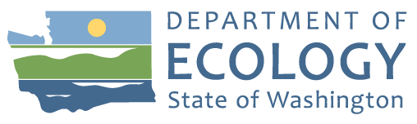
Hazardous Waste & Toxics Reduction Program
3190 160th Ave. SE
Bellevue, WA 98008
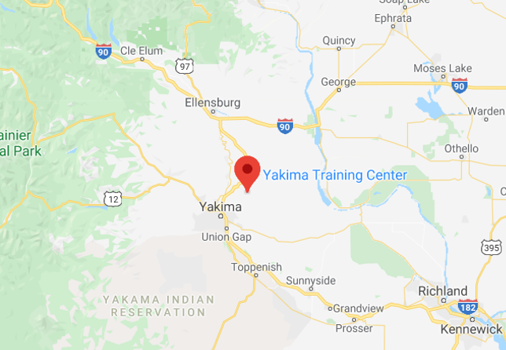

Join the Discussion!

Draft Permit, Agreed Order & Public Participation Plan
Figure 1: YTC Google Map Location
Ecology seeks public comment on a draft permit, draft Agreed Order, and draft public participation plan for the U.S. Army Training Center in Yakima, WA.

Public comment period
Aug. 3, 2020 – Sept. 16, 2020
https://bit.ly/ArmyYakimaEComments

Public meeting and hearing
No public meetings are scheduled for this comment period at this time. To request a virtual public meeting, please call 425-301-6454 or email janelle.anderson@ecy.wa.gov.
Información en español incluida: El Departamento de Ecología está anunciando el periodo de comentario público relacionado a la limpieza ambiental del sitio U.S. Army Yakima Training Center. Para obtener este documento, o más información sobre este sitio, en español, favor de comunicarse con Gretchen Newman al 360-407-6097 o preguntas@ecy.wa.gov.
ADA Accessibility: To request an ADA accommodation, contact Ecology by phone at 360-407-6700, email hwtrpubs@ecy.wa.gov, or visit https://ecology.wa.gov/accessibility. For Relay Service or TTY call 711 or 877-833-6341.

