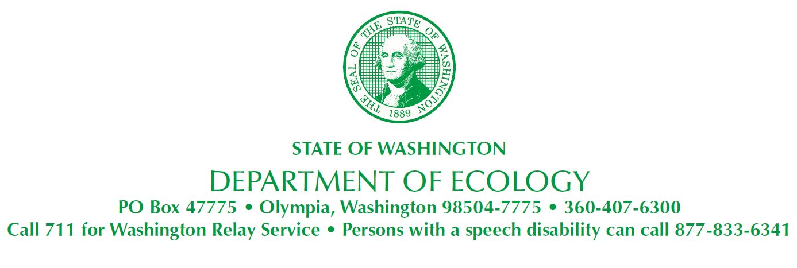
November 18, 2020
Allison Geiselbrecht, Ph.D. Floyd│Snider
601 Union Street, Suite 600
Seattle, WA 98101
Allison.Geiselbrecht@floydsnider.com

Re: Approval of Western Port Angeles Harbor Sediment Cleanup Unit Remedial Investigation/Feasibility Study

• Site Name: Western Port Angeles Harbor
• Site Address: Western Port Angeles Harbor, Port Angeles, 98363
• Cleanup Site ID: 11907
• Facility/Site ID: 18898

Dear Allison Geiselbrecht:

The Washington State Department of Ecology (Ecology) has completed a review of the revised Western Port Angeles Harbor Sediment Cleanup Unit Remedial Investigation/Feasibility Study, October 2020, Final (RI/FS), submitted November 10, 2020. Ecology accepts this RI/FS as providing sufficient information for Ecology to select a remedial action alternative and approves it.

Please submit four hard copies of the RI/FS for the repositories and files. The next step is to sign the Agreed Order amendment requiring preparation of the preliminary draft cleanup action plan. The signed amendment is due no later than 14 days after receipt of this approval. The preliminary draft cleanup action plan is due 120 days from the effective date of the amendment.

If you have any questions, you can reach me at connie.groven@ecy.wa.gov or (360) 407-6254 office or (360) 584-7037 mobile.

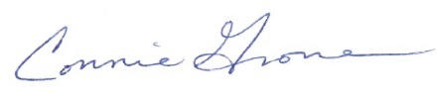
Sincerely,
Connie G. Groven, PE
Cleanup Project Manager
Toxics Cleanup Program
Southwest Regional Office

cc (by email): Karen F. Goschen, Port of Port Angeles kareng@portofpa.com
Nicole Kimzey, Merrill & Ring kareng@portofpa.com
David Massengill, Georgia-Pacific LLC dgmassen@gapac.com
Yoshifumi Nagaura, Nippon Paper Industries USA Co., Ltd. Chris.nagaura@npiusa.com
Nathan West, City of Port Angeles nwest@cityofpa.us
Jon Thompson, Attorney General Office
Marian Abbett, P.E, marian.abbett@ecy.wa.gov
Rebecca S. Lawson, P.E., LHG, Ecology rebecca.lawson@ecy.wa.gov
Ecology Site file

