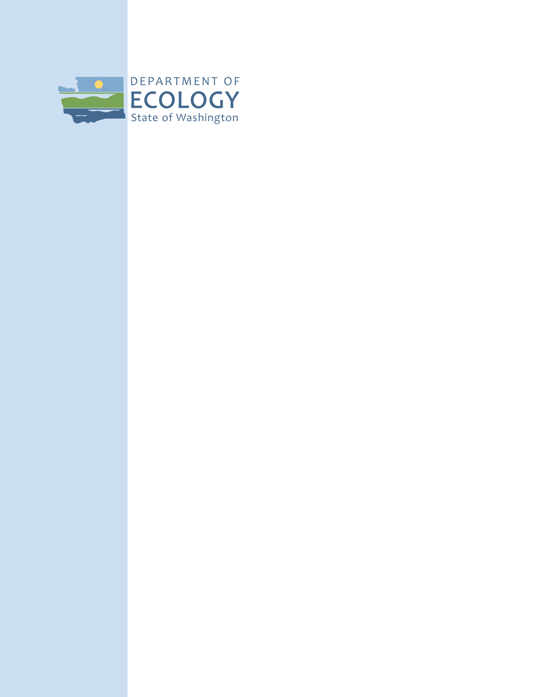

Public Participation Plan

International Paper/Port of Longview

10 International Way

Longview, Washington 98362

Facility Site ID: 1080

Cleanup Site ID: 3685

January 2021

Publication 20-04-054

## Publication and Contact Information

This plan is available on Ecology’s [International Paper Longview website](https://apps.ecology.wa.gov/gsp/Sitepage.aspx?csid=3685).[1]

For more information contact:

Washington State Department of Ecology  
Southwest Regional Office  
Hazardous Waste and Toxics Reduction Program  
P.O. Box 47600   
Olympia, WA 98504-7600   
Phone: 360-407-6300

Washington State Department of Ecology — [www.ecology.wa.gov](http://www.ecology.wa.gov)

Additional Ecology Locations:

* Headquarters, Olympia:   
  360-407-6000
* Northwest Regional Office, Bellevue: 425-649-7000
* Central Regional Office, Union Gap: 509-575-2490
* Eastern Regional Office, Spokane: 509-329-3400

### Español

El Departamento de Ecología está anunciando el período de comentarios públicos relacionado a la limpieza ambiental del sitio International Paper. Para obtener este documento, o más información sobre este sitio en español, favor de comunicarse con Gretchen Newman al 360-407-6097 o [preguntas@ecy.wa.gov](mailto:preguntas@ecy.wa.gov).

### ADA Accessibility

The Department of Ecology is committed to providing people with disabilities access to information and services by meeting or exceeding the requirements of the Americans with Disabilities Act (ADA), Section 504 and 508 of the Rehabilitation Act, and Washington State Policy #188.

To request an ADA accommodation, contact Ecology by phone at 360-407-6700 or email at [hwtrpubs@ecy.wa.gov](mailto:hwtrpubs@ecy.wa.gov). For Washington Relay Service or TTY call 711 or 877-833-6341. Visit [Ecology’s website](https://ecology.wa.gov/About-us/Accountability-transparency/Our-website/Accessibility)[2] for more information.

*This page is purposely left blank*

Table of Contents

Publication and Contact Information ii

Español ii

ADA Accessibility ii

Site Contacts 2

Department of Ecology 2

International Paper 2

Public Involvement in Contamination Cleanup 2

Public participation grants 2

State and Federal Cleanup Laws 2

Model Toxics Control Act (MTCA) 2

Resource Conservation and Recovery Act (RCRA) 3

State Environmental Policy Act 5

Site Information 5

Basic information 5

Site history 6

Site contamination 6

The cleanup process 7

Area Community 9

Geography 9

Demographics 10

People of color and minority population 10

English language proficiency 12

Outreach activities and language access 12

Public Participation Activities 12

How we share information with the community 12

Non-English speakers 13

Tribal communication 13

Postal mailing list 13

Site register 13

Newspaper display ads or legal notices 14

Email lists 14

Ecology and Longview news websites 14

Document repositories 14

How to Share Information with Us 18

Public comment periods 18

Public events 18

Plan Amendments 19

List of Abbreviations and Acronyms 19

## Site Contacts

To be included in the site record, comments must be submitted during comment periods. Questions and informal comments or information about the site’s history are welcome anytime.

### Department of Ecology

Kaia Petersen, *Ecology Site Manager*

Hazardous Waste and Toxics Reduction Program

Southwest Regional Office

PO Box 47775

Olympia, WA 98504

Phone: 360-407-6359

Email: [kaia.petersen@ecy.wa.gov](mailto:kaia.petersen@ecy.wa.gov)

Janelle Anderson, *Community Outreach & Environmental Education Specialist*Hazardous Waste and Toxics Reduction Program  
Northwest Regional Office  
3190 160th Ave. SEBellevue, WA 98008425-301-6454Email: [janelle.anderson@ecy.wa.gov](mailto:janelle.anderson@ecy.wa.gov)

### International Paper

Tom Richardson, *Program Manager*  
International Paper  
6400 Poplar Ave.   
Memphis, TN 38197  
Phone: 901-419-3878  
Email: [tom.richardson@ipaper.com](mailto:tom.richardson@ipaper.com)

## Public Involvement in Contamination Cleanup

Ecology (we) developed this public participation plan (plan) in cooperation with the International Paper Company (International Paper) and the Port of Longview (Port). This plan is for the Maintenance Facility Area (MFA), located on a portion of parcels 6161401 and 10171 at the Port of Longview, WA 98632.

This plan describes how we involve the public in contamination investigations and select cleanup activities during the corrective action process. We encourage the public to:

* Learn about and get involved in decision-making opportunities at this site.
* Provide input during the investigation and cleanup of contamination at the site.

This plan is for corrective action, or cleanup, at the MFA. Public participation activities are coordinated between Ecology, International Paper, and the Port. We must make sure the cleanup and the outreach comply with the Washington State Dangerous Waste Regulations and Model Toxics Control Act (MTCA) requirements. With input from International Paper and the Port, we will conduct formal public comment periods and other forms of public involvement throughout the cleanup process.

### Public participation grants

Grants to neighborhood committees, non-profits, and other groups interested in the site are available. For contaminated sites, these funds can be used to:

* Hire an expert to help explain technical information.[3]
* Conduct activities that increase understanding of, and participation in, the cleanup process.

For more information about public participation grants, please contact Lynn Gooding by phone at 360-407-6062 or email at [lynn.gooding@ecy.wa.gov](mailto:lynn.gooding@ecy.wa.gov). You may also visit the [Public Participation Grant website](http://www.ecology.wa.gov/About-us/How-we-operate/Grants-loans/Find-a-grant-or-loan/Public-participation-grants).[4]

## State and Federal Cleanup Laws

In Washington state, we use the Model Toxics Control Act (MTCA) and other regulations for cleanup activities on properties that treated, stored, or disposed of hazardous chemicals. These cleanups, called **corrective actions**, are required under the federal Resource Conservation and Recovery Act (RCRA). The Environmental Protection Agency (EPA) is responsible for maintaining and enforcing environmental standards across the United States. EPA allows us to follow MTCA, not RCRA, for cleanup activities in Washington state.

This public participation plan is required under MTCA. MTCA provides guidelines for contaminated site cleanup in Washington state and sets standards to ensure the cleanup protects human health and the environment.

### Model Toxics Control Act (MTCA)

MTCA began as a grassroots citizen’s initiative in 1988. We started using it to clean up contaminated sites in Washington in 1989. Under MTCA, a current or past property owner or operator may need to pay to clean up contamination on or coming from their property, until levels are safe for human health and the environment.

Under MTCA, we oversee cleanups in the state and issue [regulations and guidance](https://apps.ecology.wa.gov/publications/SummaryPages/9406.html)[5] for them. We investigate reports of property contamination. If the contamination is a threat to human health or the environment, the property goes on the Hazardous Sites List and the cleanup process begins.

Public participation is an important part of the MTCA process. Participation needs are determined for each cleanup site by the level of public interest and the risk posed by the contamination. People who live near the site, community groups, businesses, government entities, and other interested parties can comment on the cleanup process.

Under MTCA, the cleanup process happens in phases. Many of the phases have time for the public to review and comment on cleanup documents. See Figure 1, Washington’s Formal Cleanup Process, for more information.

### Resource Conservation and Recovery Act (RCRA)

There are federal and state rules about hazardous wastes. Congress passed the Resource Conservation and Recovery Act (RCRA) in 1976 to ensure hazardous waste is managed and disposed of safely. RCRA has been updated several times to expand the scope and requirements.

RCRA’s goals are to:

* Protect human health and the environment.
* Reduce waste.
* Conserve energy and natural resources.
* Reduce or stop hazardous waste generation.

Treatment, storage, and disposal (TSD) facilities must have a permit to design, operate, maintain, or close their site. RCRA also requires facilities to clean up contamination from past and present practices. These cleanup activities are known as **corrective action**.

Federal RCRA and state dangerous waste regulations require opportunities for public participation during the stages of facility permitting and cleanup.

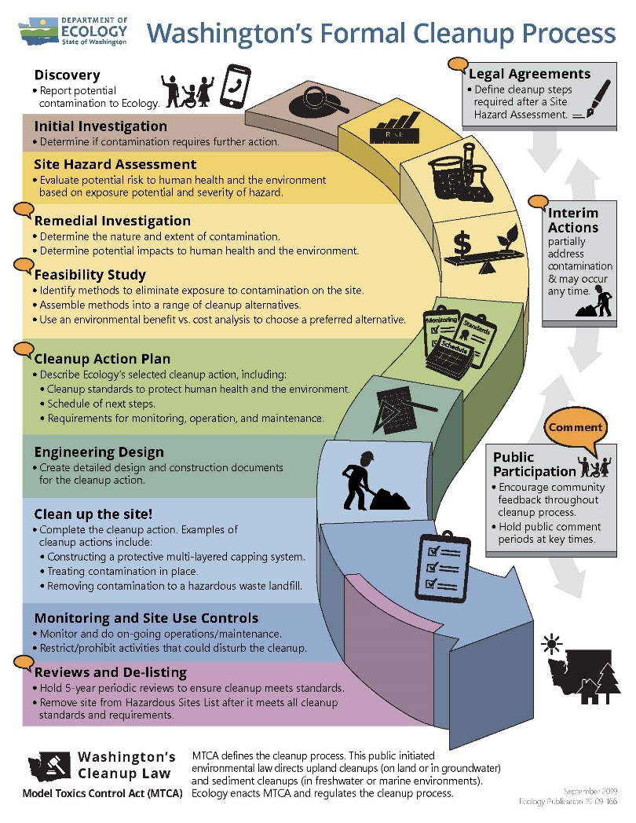

Figure 1: [Washington's Formal Cleanup Process Infographic](https://apps.ecology.wa.gov/publications/SummaryPages/1909166.html)[6]

[**Read a Plain Text version of Figure 1**](https://apps.ecology.wa.gov/publications/parts/1909166part2.pdf)**[7]**

### State Environmental Policy Act

We follow the State Environmental Policy Act (SEPA) while cleanup plans are conducted. SEPA’s purpose is to identify and evaluate large, negative environmental impacts likely to result from a proposed action. For permit renewals, there is no SEPA determination because permit renewals are administrative processes.

## Site Information

### Basic information

International Paper is one of the world’s leading producers of fiber-based packaging, pulp, and paper. The International Paper facility in Longview has a Maintenance Facility Area and Former Treated Wood Products Area. Other commercial and industrial properties surround the facility.

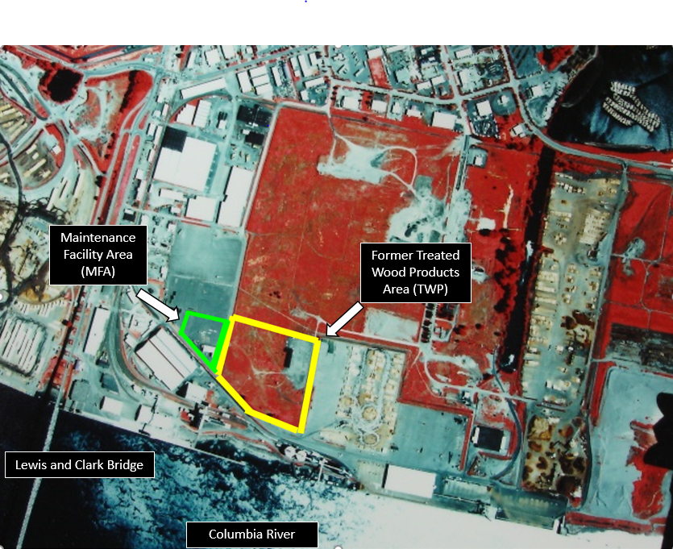

Figure 2: Aerial Photo of the facility taken in 2001.

### Site history

International Paper treated wood at the site from 1937 to 1982 in the Treated Wood Products (TWP) Area, adjacent to the Maintenance Facility Area (MFA). The wood treatment operations contaminated soils and groundwater with:

* Diesel—a petroleum product.
* Pentachlorophenol (PCP)—a chemical used to treat wood to reduce decay.
* Polycyclic aromatic hydrocarbons (PAHs) from creosote—petroleum-derived chemicals used to treat wood to reduce decay.

### Site contamination

There have been cleanup activities in the TWP Area to deal with contamination related to the facility beginning in 1985.

* In 1985, International Paper excavated contaminated soils from two surface impoundments and process areas in the TWP Area and capped remaining contaminated soils with a cover.
* In May 1991, EPA identified several solid waste management units (SWMUs) in a RCRA facility assessment dated May 1991 (1991 RFA).
* In 1997, we requested additional cleanup in the TWP Area to ensure long-term protection of human health and the environment.

In 1997 and 1998, International Paper:

* Constructed an underground barrier wall around the TWP Area to keep contaminated soil and groundwater in place.
* Capped the area with a cover to keep water out.
* Installed systems to remove contaminated groundwater from within the contained area.
* Installed wells so treatments that breakdown contaminants could be added within the contained area.
* Installed groundwater monitoring wells inside and outside the subsurface barrier wall.

During the construction of the subsurface barrier wall, contaminated soils were found along the alignment of the wall. This contamination occurred between 1947 and 1953, when wood treating wastewater was sent into an unlined ditch originating from within the TWP Area. The ditch extended from the TWP Area through the MFA. The MFA property is now owned by the Port. The MFA is about five acres and contains the Port of Longview’s Mechanics Shop and a paved storage yard. The Port purchased this land from International Paper in 1965.

International Paper investigated to find the extent of contamination in the MFA and installed a biosparging/bioventing treatment system that operated from 2002 until 2008. In 2012, International Paper tested soil in the MFA to see whether soil solidification methods could be used to treat soil in the MFA.

### The cleanup process

#### Remedial Investigation and Feasibility Study (RI/FS)

In 2017, public comments were accepted on the draft Remedial Investigation and Feasibility Study (RI/FS) and related documents. Our 45-day comment period ended on October 2, 2017. We hosted an open house and public hearing at the Cowlitz County Event Center in Longview. There were approximately 30 people in attendance and 10 gave oral comments. In total, we received 24 comments regarding the RI/FS study.

Our responses to those public comments are available in our [Responsiveness Summary](https://apps.ecology.wa.gov/gsp/DocViewer.ashx?did=76349).[8]

A combined, revised [Remedial Investigation (RI) and Focused Feasibility Study (FFS) report with addendum](https://apps.ecology.wa.gov/gsp/DocViewer.ashx?did=75442)[9] was developed in 2018 and outlines all of the cleanup options for this site. This final [International Paper RI/FFS](https://apps.ecology.wa.gov/gsp/DocViewer.ashx?did=75442)[10] and [Fact Sheet for International Paper RI/FSS](https://apps.ecology.wa.gov/gsp/DocViewer.ashx?did=67578)[11] are in the [International Paper Electronic Repository](https://apps.ecology.wa.gov/gsp/CleanupSiteDocuments.aspx?csid=3685)[12]on our website.

#### Cleanup Action Plan (CAP)

The [draft Cleanup Action Plan (dCAP)](https://apps.ecology.wa.gov/gsp/DocViewer.ashx?did=95466)[13] is the next step in the cleanup process. This dCAP describes how the site will be cleaned up. The dCAP will focus mainly on the area at the site called the Maintenance Facility Area (MFA).

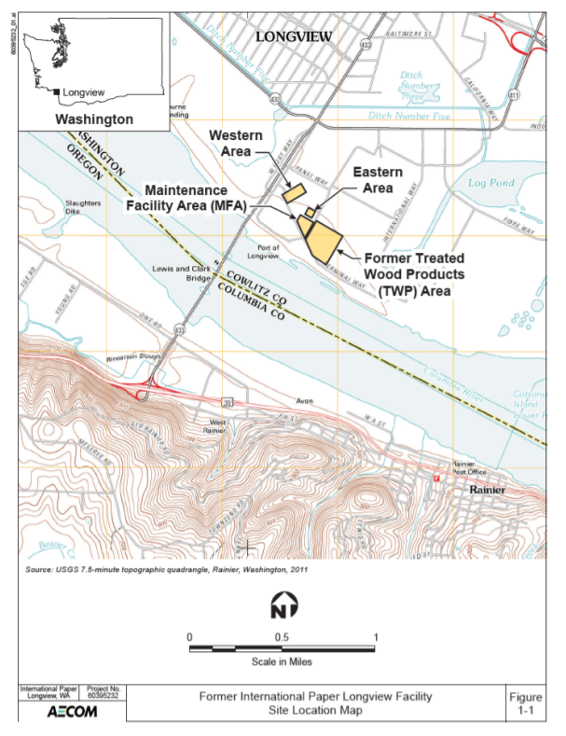

Figure : Former International Paper Longview facility site location map.

## Area Community

### Geography

The City of Longview is located in southwest Washington in [Cowlitz County](https://en.wikipedia.org/wiki/King_County,_Washington). It has a total area of 14.8 square miles and a population of about 38,000 people. The [Lewis and Clark Bridge](https://en.wikipedia.org/wiki/Lewis_and_Clark_Bridge_(Columbia_River)) spans the Columbia River, linking Longview to [Rainier, Oregon](https://en.wikipedia.org/wiki/Rainier,_Oregon). It is the only bridge across the river between [Portland](https://en.wikipedia.org/wiki/Portland,_Oregon) and [Astoria, Oregon](https://en.wikipedia.org/wiki/Astoria,_Oregon).

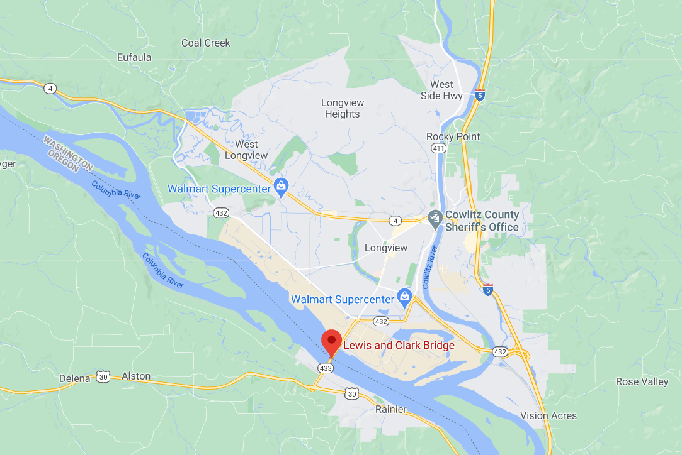

Figure 4: Google map showing location of Longview, WA and the Lewis and Clark Bridge.

The International Paper site is located at the Port of Longview in Longview, Washington on the north side of the Columbia River, approximately 66 miles upstream (east) from the Pacific Ocean and less than 2 miles downstream (west) from where the Cowlitz River joins the Columbia. It is east of the Lewis and Clark Bridge and about three miles away from the nearest school.

### Demographics

Table : Longview study area: One-mile ring (radius) around the site (population 2,704).

| Demographic Indicators | Value | State Average | Percentile in State |
| --- | --- | --- | --- |
| Demographic index | 52% | 29% | 89 |
| Minority population | 31% | 30% | 59 |
| Low-income population | 73% | 28% | 97 |
| Linguistically isolated population | 2% | 4% | 58 |
| Population with less-than-high school education | 21% | 9% | 89 |
| Population under 5 years of age | 10% | 6% | 87 |
| Population over 64 years of age | 8% | 14% | 22 |

Figure 5: EPA’s Environmental Justice Screen standard report.[14]

### People of color and minority population

We ran a demographic analysis using EPA’s Environmental Justice Screen (EJSCREEN) tool for a one-mile radius around the site at the Port of Longview. The standard report indicates some environmental justice considerations, including:

* Minority population
* Low-income population

Census data from the 2013–2017 American Community Survey (ACS) indicates the largest racial and ethnic population around the site is Hispanic with 690 residents.

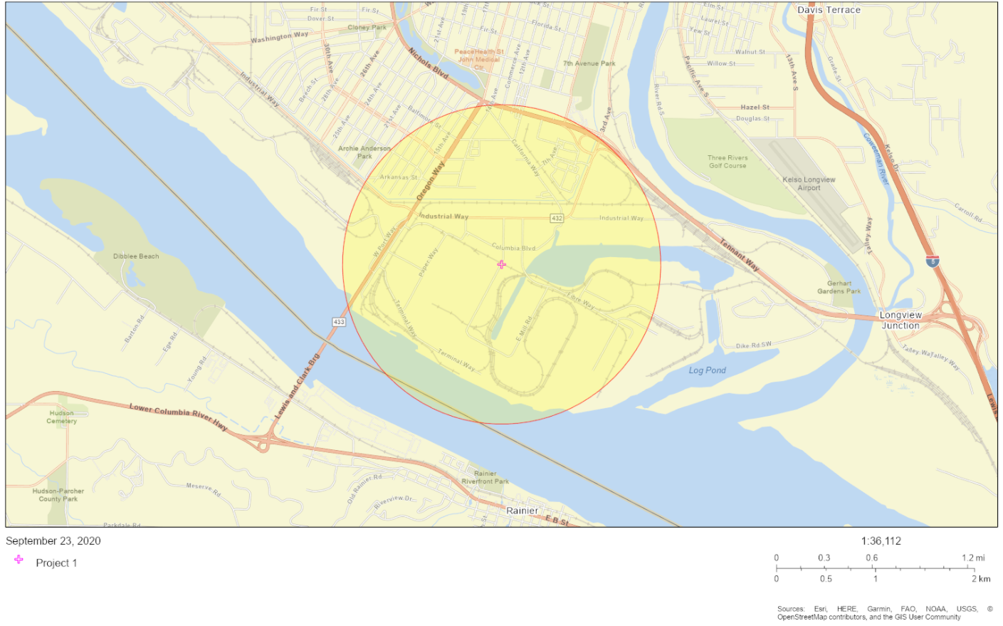

Figure : Map showing one-mile radius for EJ indicators (taken from EPA’s EJSCREEN mapping tool).[15]

### English language proficiency

According to the [Language Data (Census 2015)](http://teams/sites/EXEC/mitt/LanguageMap/Shared%20Documents/ACS_LanguageData_2015.aspx)[16] for Longview, the Hispanic population is the primary non-English language group that speaks English less than “very well” and makes up 2.21 percent of the population.

### Outreach activities and language access

Based on the demographic analysis, we will include the following outreach activities for this site:

* Reach out to Hispanic cultural organizations and community leaders in the area.
* Provide information about requesting language services in all public materials.
* Provide basic information about this site in Spanish in all outreach materials.

To request translation services, please contact:

Janelle Anderson, *Community Outreach & Environmental Education Specialist*Washington Department of Ecology, Northwest Regional Office  
3190 160th Ave. SE  
Bellevue, WA 98008  
425-301-6454  
[janelle.anderson@ecy.wa.gov](mailto:janelle.anderson@ecy.wa.gov)

## Public Participation Activities

The public may ask questions, submit informal comments, or share site information at any time. You don’t have to wait for a formal public comment period to contact us. However, to be included in the formal site record, comments about the site investigation, cleanup alternatives, or cleanup must be submitted during formal comment periods. Additionally, we invite the public to review and comment on site documents before they become final. This is a direct and influential way to learn more about the site and be involved in the cleanup’s decision-making process.

### How we share information with the community

During the cleanup, we mail notices about public comment periods to addresses surrounding the site. The mailing list area will vary depending on the type of contamination and where it is located, but the list will at least include addresses within a quarter-mile of the site and other interested organizations and individuals. These notices provide information about the site such as contact information, how to submit comments, times and locations of public meetings or hearings, or how to request a public meeting or hearing if one is not scheduled.

We may also develop documents outside of comment periods to keep the community updated about the site. These documents will be available online. Printed copies may be mailed to the community if we think the message warrants the extra costs.

Comment period notices and other site announcements may also be posted in the community (for example, at local businesses, schools, or libraries).

### Non-English speakers

We will reach out to cultural community organizations as part of the project and provide information in other languages following federal guidance. We strive to make our public participation efforts as inclusive as possible. We welcome your input about how to best reach your community.

### Tribal communication

The federally recognized Yakama Tribe, Grand Ronde Confederated Tribes, and Cowlitz Tribe rely on potentially contaminated resources near this site. We will invite these tribes to engage in decision-making during the process on a government-to-government basis.

### Postal mailing list

We maintain a mailing list that includes addresses near the site and relevant local, state, tribal, and federal government contacts. These addresses receive public notices when draft documents are available for comment.

We will add you or your organization to the mailing list when asked. If you would like to be added to the mailing list for this site, please contact Janelle Anderson at 425-301-6454 or [janelle.anderson@ecy.wa.gov](mailto:janelle.anderson@ecy.wa.gov).

### Site register

Public comment periods, events, and other cleanup notices are published in our [Site Register](https://ecology.wa.gov/Regulations-Permits/Guidance-technical-assistance/Site-Register-lists-and-data).[17] To receive the Site Register by email, please contact Sarah Kellington at 360-407-7466 or [sarah.kellington@ecy.wa.gov](mailto:sarah.kellington@ecy.wa.gov).

### Newspaper display ads or legal notices

We announce public comment periods and public events in newspaper display ads or legal notices. For this comment period, we will post an ad in [The Daily News](https://tdn.com/)*[18]* in Longview, Washington. We will also put a notice on our [Public Input & Events Listing](https://ecology.wa.gov/Events/Search/Listing).[19]

### Email lists

We have an email list to update interested people about TSD facilities in the state, including this site. If you would like to be added to that email list, please contact:

Janelle Anderson, *Community Outreach & Environmental Education Specialist*425-301-6454  
[janelle.anderson@ecy.wa.gov](mailto:janelle.anderson@ecy.wa.gov).

### Ecology and Longview news websites

We maintain a website for the [International Paper Longview site](https://apps.ecology.wa.gov/gsp/Sitepage.aspx?csid=3685).[20] This website provides site information and cleanup documents. Information may also be shared about cleanup sites through [news releases](https://ecology.wa.gov/About-us/Get-to-know-us/News),[21] and [Ecology’s blog](https://ecologywa.blogspot.com/).[22]

### Document repositories

**In response to Washington state’s coronavirus response and Governor Inslee’s Stay Home, Stay Healthy Order, in-person document review is not currently available.** You may review documents at these locations when they re-open to the public.

Washington State Department of Ecology  
Southwest Regional Office  
300 Desmond Drive SW

Lacey, WA 98503

360-407-6300

Longview Public Library  
1600 Louisiana Street

Longview, WA 98632

360-442-5300

The current public comment period covers the [International Paper Draft Cleanup Action Plan (CAP) for the Maintenance Facility Area (MFA)](https://apps.ecology.wa.gov/gsp/DocViewer.ashx?did=95466)[23] and this Draft Public Participation Plan.

## How to Share Information with Us

We may identify public concerns and cleanup goals by meeting with interested community members and organizations. To talk with us about this site, please contact Kaia Petersen, Site Manager, by phone at 360-407-6359 or email at [kaia.petersen@ecy.wa.gov](mailto:kaia.petersen@ecy.wa.gov).

**While the Stay Home, Stay Healthy order is in effect, we will not be hosting in-person public meetings or supporting physical document repositories. Documents for review will be available online only. If you need access to a hard copy document or have any other questions, please contact Janelle Anderson at 425-301-6454 or** [**janelle.anderson@ecy.wa.gov**](mailto:janelle.anderson@ecy.wa.gov)**.**

### Public comment periods

Formal 30-day comment periods allow the public to comment on draft documents, legal agreements, and proposed cleanup actions. If there is enough interest, we can extend the public comment period. When we oversee SEPA determinations, we hold comment periods for at least two weeks. We hold 45-day comment periods when we are issuing or renewing corrective action permits.

After a public comment period, we publish all the input we received and our responses to comments and questions. If the comments result in significant changes, the documents are revised and re-issued for public review. If the comments do not result in significant changes, they become final.

### Public events

We hold public meetings, workshops, open houses, and public hearings based on community interest. If we have not scheduled a meeting, we will if 10 or more people request it. We may extend a public comment period so that these meetings can occur during the comment period.

At this time there are no public meetings scheduled for this comment period. To request a public meeting, please contact Janelle Anderson at 425-301-6454 or [janelle.anderson@ecy.wa.gov](mailto:janelle.anderson@ecy.wa.gov).

**While the Stay Home, Stay Healthy order is in effect, we will not be hosting in-person public meetings.** Any online public meetings that are scheduled will meet Americans with Disabilities Act (ADA) standards. Public meetings, workshops, open houses, and hearings are announced in advance in several ways.

## Plan Amendments

We developed this plan following MTCA regulations (WAC 173-340-600). We will review it as the cleanup progresses and amend it as necessary.

This plan includes information about opportunities for public involvement and comment. The outreach activities in this section are our current plans for keeping the public informed and providing ways for the community to share their concerns and questions.

If you believe the planned outreach activities are insufficient or should be modified, we will work to find solutions. New outreach activities or tools may be used with or without amending this plan.

## List of Abbreviations and Acronyms

Table 2: List of abbreviations and acronyms

| **Abbreviation or Acronym** | **Definition** |
| --- | --- |
| ADA | Americans with Disabilities Act |
| ACS | American Community Survey |
| dCAP | Draft Cleanup Action Plan |
| Ecology | Washington State Department of Ecology |
| EJSCREEN | EPA’s Environmental Justice Screen |
| EPA | US Environmental Protection Agency |
| Facility | International Paper facility at 10 International Way, Longview, WA |
| FFS | Focused feasibility study |
| MFA | Maintenance Facility Area |
| MTCA | Model Toxics Control Act |
| Plan | Public Participation Plan |
| RCRA | Resource Conservation and Recovery Act |
| RFA | RCRA Facility Assessment |
| RI | Remedial investigation |
| RI/FS | Remedial Investigation/Feasibility Study |
| SEPA | State Environmental Policy Act |
| Site | Area where hazardous substances at the Facility are currently located |
| SWMUs | Solid waste management units |
| TSD | Treatment, Storage, and Disposal Facility |
| TWP | Treated Wood Products Area |
| WAC | Washington Administrative Code |

1. https://apps.ecology.wa.gov/gsp/Sitepage.aspx?csid=3685
2. https://ecology.wa.gov/accessibility
3. We currently do not have a citizen technical advisor to provide citizens with technical assistance on issues related to site investigation and cleanup.
4. https://ecology.wa.gov/ppgrants
5. https://apps.ecology.wa.gov/publications/SummaryPages/9406.html
6. https://apps.ecology.wa.gov/publications/SummaryPages/1909166.html
7. https://apps.ecology.wa.gov/publications/parts/1909166part2.pdf
8. https://apps.ecology.wa.gov/gsp/DocViewer.ashx?did=76349
9. https://apps.ecology.wa.gov/gsp/DocViewer.ashx?did=75442
10. https://apps.ecology.wa.gov/gsp/DocViewer.ashx?did=75442
11. https://apps.ecology.wa.gov/gsp/DocViewer.ashx?did=67578
12. https://apps.ecology.wa.gov/gsp/CleanupSiteDocuments.aspx?csid=3685
13. https://apps.ecology.wa.gov/gsp/DocViewer.ashx?did=95466
14. https://www.epa.gov/ejscreen
15. https://ejscreen.epa.gov/mapper/
16. http://teams/sites/EXEC/mitt/LanguageMap/Shared%20Documents/ACS_LanguageData_2015.aspx
17. https://ecology.wa.gov/Regulations-Permits/Guidance-technical-assistance/Site-Register-lists-and-data
18. https://tdn.com/
19. ecology.wa.gov/Events/Search/Listing
20. https://ecology.wa.gov/intlpaper
21. https://ecology.wa.gov/About-us/Get-to-know-us/News
22. https://ecology.wa.gov/blog
23. https://apps.ecology.wa.gov/gsp/DocViewer.ashx?did=95466