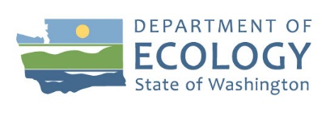
Stericycle - Georgetown

New Groundwater Pilot Studies Due to Begin

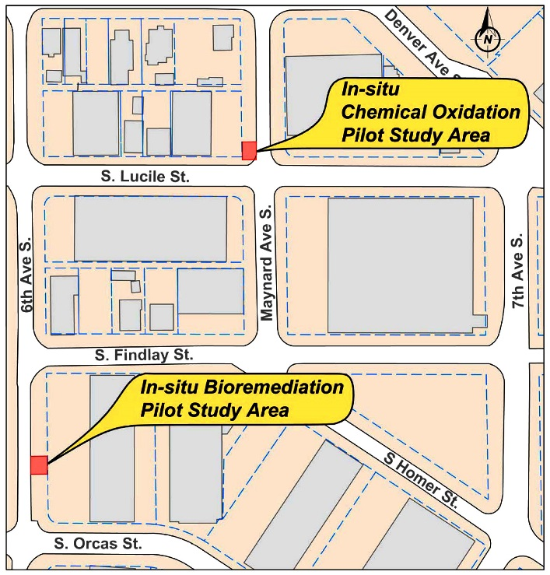
Beginning in early April, contractors working for Stericycle will study two methods designed to enhance the breakdown of groundwater contamination. The City of Seattle supplies tap water to the local area. It is not affected by the contamination or by the work we will do. The project poses no threats to human health or the environment.

In-Situ Chemical Oxidation Pilot Study
This project will be similar to the in situ chemical oxidation pilot project done in 2016. This time, however, the oxidant will be placed in groundwater using wax “candles.” Three new wells will be installed and the candles will be inserted at the depth of contamination (50 to 60 feet below ground surface). The candles will slowly release persulfate and permanganate into the contaminated groundwater. Monitoring of the groundwater will begin about a month later and continue every three months for about a year.
Location of studies.

In-Situ Bioremediation Study
There are two phases of this project.
Phase 1: About 2 ½ gallons of microorganisms known to degrade 1,4-dioxane will be put into one to two existing groundwater monitoring wells. Groundwater monitoring will begin about a week later and continue every three months for six months. Monitoring will help us know if the microorganisms thrive and reduce 1,4-dioxane concentrations.

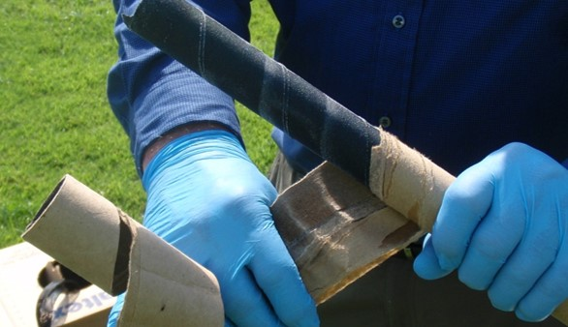
Phase 2: If Phase 1 is successful, the same type of microorganisms will be injected into groundwater about half a block farther north, just east of the 6th Avenue South and South Findlay Street intersection. Prior to initiating Phase 2, Ecology and Stericycle will provide specific information to businesses located in the vicinity of Findlay and 6th about what will be done and when.

Wax candles containing oxidants will be used to break down groundwater contamination.

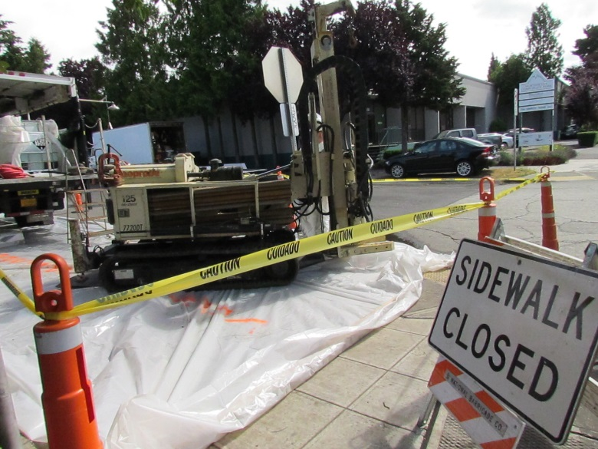
What about public safety?
The project is low risk to the public and the environment. Stericycle has worked with the Department of Ecology and the City of Seattle to create a plan to protect the public and the environment. An exclusion zone will be marked off with cones and tape to keep people away from the equipment and the chemicals used in the oxidant study.

The oxidant used is a mixture of permanganate and sodium persulfate. It is a corrosive hazardous chemical and can burn skin and eyes. It can also irritate respiratory systems with prolonged inhaled exposure. The oxidant will not be present aboveground except in the solid wax candles, transported to the area for placement.
Example of exclusion zone to be used.

A mobile drilling rig about the size of a large pickup truck will install new wells for the project. Once the wells are installed, no drill rig is required when groundwater samples are collected.

Will this work be disruptive?
Stericycle has designed the work so that traffic lanes can remain open. However, there will be some noise at the intersection of Lucile and Maynard while the contractors are drilling the wells. Hopefully, the disruption will be minor.

History
Groundwater contamination at the site is a result of hazardous substances leaking from former underground storage tanks (USTs) at the Stericycle facility at 734 South Lucile Street. The releases occurred before removal of the leaking tanks in the late 1980s and closure of the facility in 2003. 1,4-dioxane, one of the contaminants in the groundwater, is a toxic chemical that has been used to stabilize certain chlorinated solvents (such as 1,1,1-trichloroethane). When these solvents are released into the environment, as they were at the Stericycle facility, 1,4-dioxane can be released too.

Questions?
Contact Ed Jones, Ecology’s PSC-Georgetown site manager with questions about this notice, or other aspects of the cleanup. Email him at ejon461@ecy.wa.gov, or call 425-649-4449.

If you are interested in learning more about the cleanup, visit Ecology’s website at https://fortress.wa.gov/ecy/gsp/Sitepage.aspx?csid=2622.
To request materials in a format for the visually impaired, call the Hazardous Waste & Toxics Reduction Program
at 360-407-6700, Relay Service 711, or TTY 877-833-6341.

