Snopac Property Cleanup Site 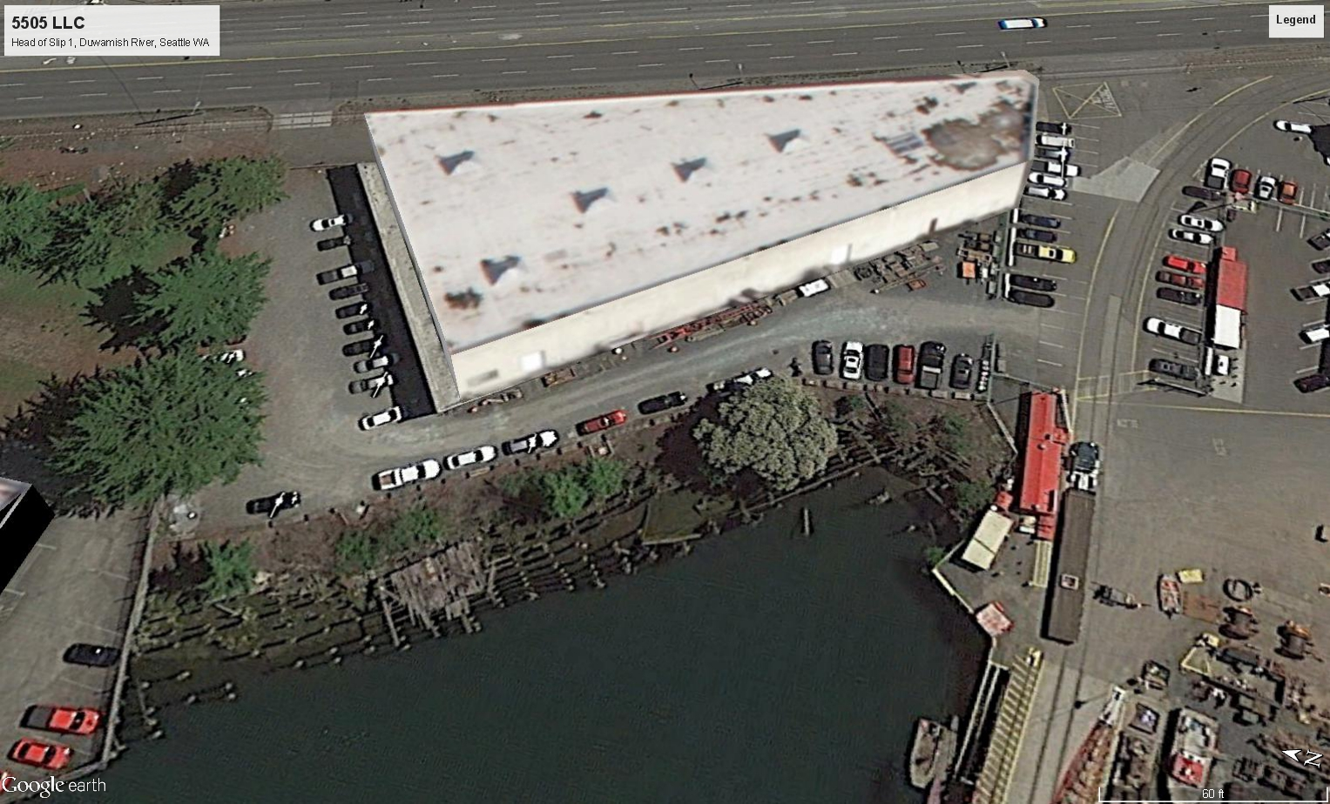
Snopac Property

Comments accepted:
June 10 – July 9, 2019

Submit comments:
Online at:
http://bit.ly/Snopac-Comments
Or:
Sandra Matthews - Site Manager
3190 160th Ave SE
Bellevue WA 98008
Phone: 425-649-7206
Email: Sandra. Matthews@ecy.wa.gov

Site information: http://bit.ly/Ecology-SnoPac
Facility Site ID: 1523145
Cleanup Site ID: 12463

Document review locations:
Seattle Public Library,
New Holly Branch
7058 32nd Ave. S.
Seattle, WA 98118
Phone 206-386-1905

Ecology NW Regional Office
3190 160th Ave SE
Bellevue, WA 98008
Please call for appointment.
Phone: 425-649-7190

Legal agreement ready for public review and comment
Ecology has negotiated a legal agreement called an Agreed Order with 5055 Properties LLC, the Potentially Liable Party (PLP) for the Snopac Property (Site). The order requires them to investigate environmental conditions, develop a cleanup plan, and conduct an interim cleanup.
We’d like your input on the following documents:
- Agreed Order – requires the PLP to investigate contamination, complete a Remedial Investigation (RI), Feasibility Study (FS) and draft Cleanup Action Plan (dCAP) for the Site.
- Interim Action Work Plan – describes how the PLP will conduct a partial cleanup of the contaminated soil present in the upland portion of the Site.
- Public Participation Plan – describes how Ecology will inform the community about Site activities and opportunities to be involved in the cleanup process.

Community Open House
Ecology and the Environmental Protection Agency (EPA) will host an open house for the community, which will include information about the Snopac Property Site, as well as other sites we are working on in and around the Lower Duwamish Waterway.
Tuesday, June 18, 2019
5:30 – 7:30 p.m.
South Seattle College - Georgetown Campus, Room C122
6737 Corson Avenue South
Seattle, WA 98108

Site History
The Snopac Property is located at 5055 East Marginal Way S. in Seattle. It is approximately 1.3 acres on the east bank of the Lower Duwamish Waterway (LDW), at the head of Slip 1. Olympic Lighterage Company, operated there from 1935 to 1940. Pioneer Towing Company occupied the buildings and utilized underground storage tanks (USTs) from 1940 through 1970. Marine Power & Equipment utilized the warehouse for marine equipment storage and disposed of spent sandblast grit (SBG) on the Site between 1973 and 1986. Snopac Products Inc. operated a fish packing facility in the building from 1992 to 2008. In 2008 they relocated the business, leaving the property and warehouse vacant. 5055 Properties LLC purchased the property in 2012.

Contamination
During the 1970’s and 1980’s portions of the Site were filled with SBG, which contributed to contamination in the LDW. Soil samples at the Site contained concentrations of arsenic, copper, lead, zinc, tributyl tin (TBT), carcinogenic polycyclic aromatic hydrocarbons (cPAHs), and polychlorinated biphenyls (PCBs). Groundwater samples contained metals (arsenic, chromium, copper, nickel) and PAHs. Sediment sampling conducted in the vicinity of the Snopac property found metals, PAHs, and PCBs. A sample from groundwater entering Slip 1 on the southwest corner of the property found arsenic, copper, lead, mercury, and zinc.
All of these contaminants were found at levels that exceed allowable standards under the state’s cleanup law, the Model Toxics Control Act (MTCA) and therefore must be addressed.

Interim Action Work Plan
As overall Site investigation and cleanup move forward, the owners of the property are planning to demolish the warehouse building and have proposed to excavate and remove contaminated soil with SBG from the property as an interim action. They will also build a shoring wall and conduct dewatering activities to facilitate soil removal.

Why this Site matters
The LDW Superfund Site includes a 5-mile stretch of the Duwamish River that flows north into Elliot Bay. The U.S. EPA added the LDW Superfund Site to the Superfund National Priorities List in 2001. EPA is leading efforts to clean up the river sediments. Ecology is leading efforts to stop or reduce sources of pollution to the LDW Superfund Site so that the sediment cleanup can proceed, a task commonly known as “source control”. The long-term goal for source control is to minimize recontamination of the river sediments above the limits established by EPA.
Due to its proximity to the river, understanding how much contamination the Site is contributing to the LDW is an important step for source control. Contaminants in the soil and groundwater near the river may pose a risk to human health and the environment. They can also find their way into the river through storm runoff and other pathways. The sediments in the river contain a wide range of contaminants due to decades of industrial activity and runoff from urban areas.
To contact the Community Advisory Group for the Lower Duwamish Superfund Site:
Call Duwamish River Cleanup Coalition/ Technical Advisory Group at (206) 954-0218, email contact@duwamishcleanup.org, or visit http://duwamishcleanup.org/
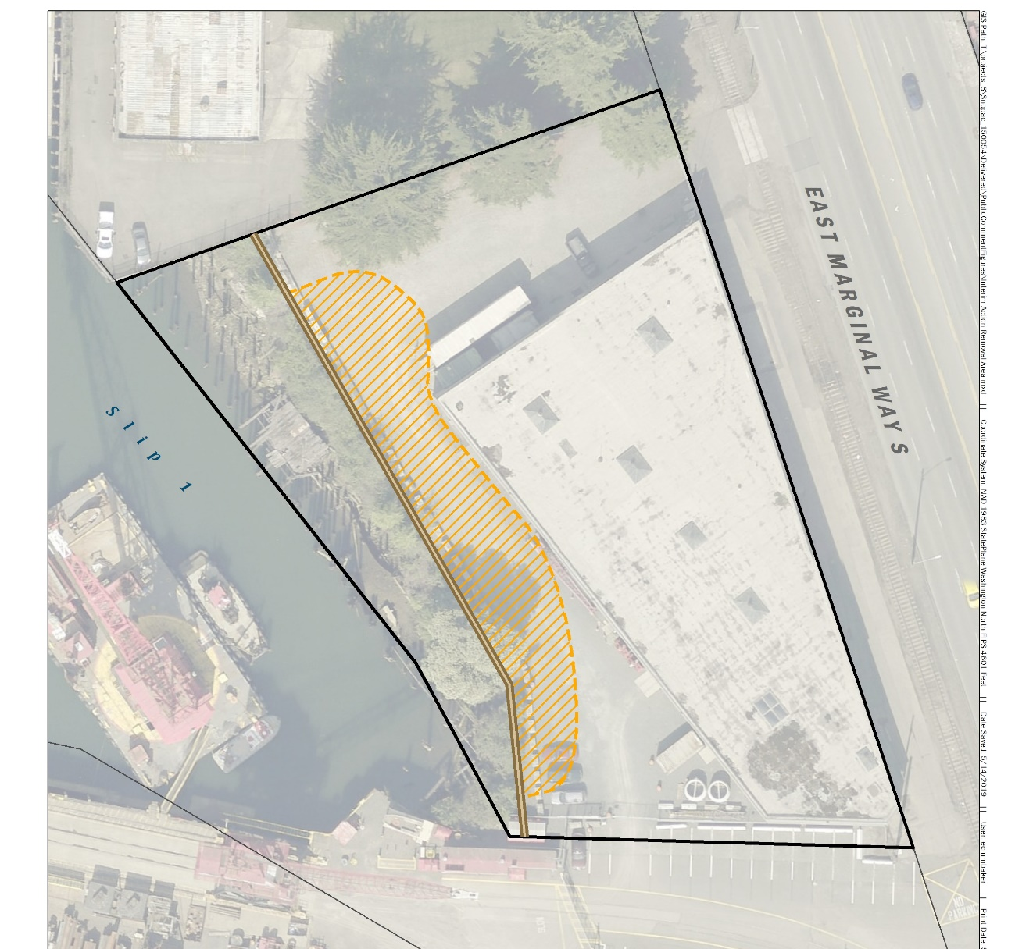

What happens next?
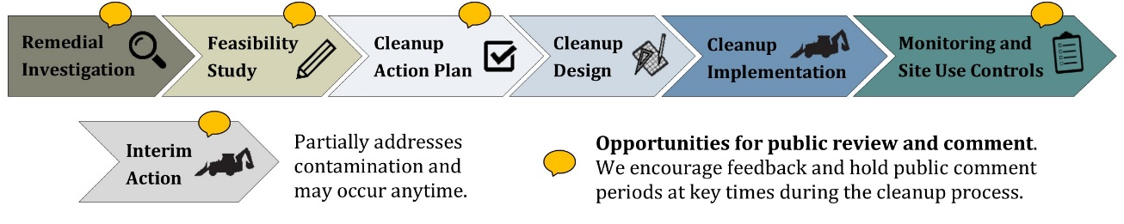
Ecology will consider all comments received and may amend the documents based on your comments. After that, the Agreed Order will be finalized, and the PLPs will proceed with the Interim Action, Remedial Investigation, and Feasibility Study. Results from this work will then lead to a Cleanup Action Plan.
Toxics Cleanup Program
3190 160th Avenue SE
Bellevue, WA 98008

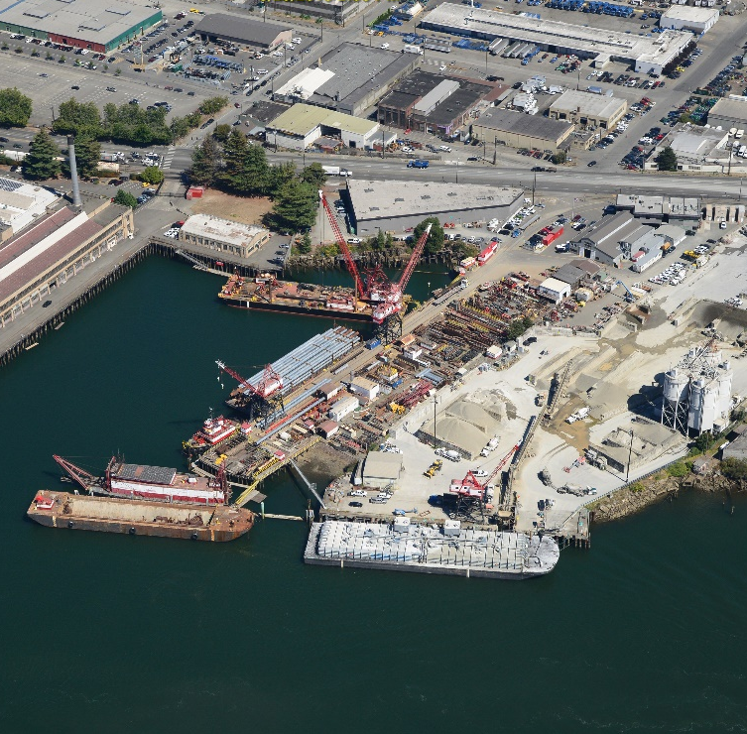
Comment Invited – Snopac Property Cleanup Site
View of Slip 1 to the Snopac Property

Public comment period
June 10 – July 9, 2019
http://bit.ly/Ecology-SnoPac
El Departamento de Ecología esta anunciando el periodo de comentario público relacionado a la limpieza ambiental del sitio Snopac Property. Para obtener este documento, o más información sobre este sitio, en español favor de comunicarse con Gretchen Newman al 360-407-6097 o preguntas@ecy.wa.gov

Bo Mo i Sinh tho ng ba o đe n co ng chu ng ve khung thờ i gian go p y cho co ng ta c la m sa ch mo i trườ ng khu vư c Snopac Property. Ne u quy vi muo n nha n ta i lie u na y ba ng tie ng Vie t hoa c ca n the m tho ng tin, xin lie n he o ng Lie m Nguye n 360-407-6955, đie n thư: Lngu461@ecy.wa.gov

Accommodation Requests: To request ADA accommodation including materials in a format for the visually impaired, call Ecology at 425-649-7000 or visit https://ecology.wa.gov/accessibility. People with impaired hearing may call Washington Relay Service at 711. People with speech disability may call TTY at 877-833-6341.

