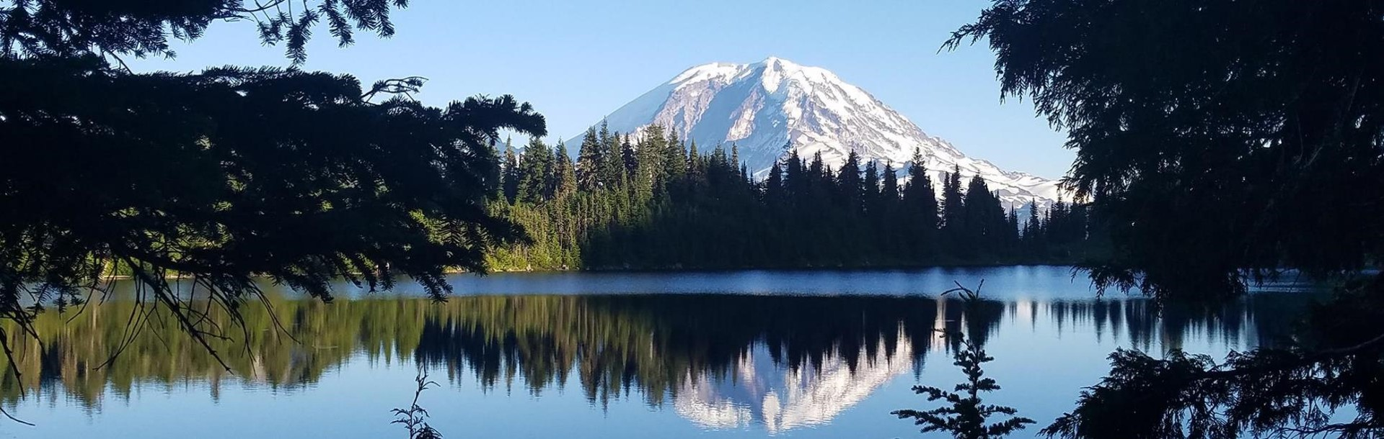
Focus on: Solid Waste Management

Funding Opportunities

Overview: Solid Waste Management Funding Opportunities
The Washington Department of Ecology’s Solid Waste Management program administers six state-wide funding opportunities. Funding is eligible to local governments, nonprofit organizations, and for-profit businesses for a variety of waste-related activities. These funds help Ecology support waste management, waste reduction, and recycling programs throughout Washington. For additional information, visit each funding opportunity’s individual webpage.

Community Litter Cleanup Program
Funds authorized from the waste reduction, recycling, and litter control account, chapter 70A.200 RCW, support local governments with litter pickup, illegal-dump cleanup, and litter-prevention education and public outreach. Ecology administers these funds through the Community Litter Cleanup Program (CLCP).
- Application period: 2/1/23 – 3/1/23
- Eligible applicants: Local governments
- Program Type: Non-competitive grant
- Per application: Formula funded
- Match requirements: 0%
For more information, visit: https://ecology.wa.gov/About-us/How-we- operate/Grants-loans/Find-a-grant-or-loan/Community-litter-cleanup- grants

Ramp Litter Cleanup Program
Funds authorized from the waste reduction, recycling and litter control account, chapter 70A.200 RCW are used to conduct a permanent and continuous program to control and remove litter from this state. In 2021, the Legislature established the Welcome to Washington Act for the Ramp Litter Cleanup Program (RLCP). Funding supports local governments with litter cleanup efforts on Interstate, State Route, or US highway ramps, interchanges, and intersections located in their jurisdiction.
- Application period: Late spring 2023
- Eligible applicants: Local governments
- Program Type: Competitive grant
- Per application: To be determined
- Match requirements: 0%
For more information, visit: https://ecology.wa.gov/About-us/Payments-contracts-grants/Grants-loans/Find-a-grant-or-loan/Community-litter-cleanup-program-Welcome-to-WA-Act

Local Solid Waste Financial Assistance
Funds authorized from the model toxics control operating account, chapter 70A.305 RCW, Local Solid Waste Financial Assistance (LSWFA) supports efforts in local solid and hazardous waste planning and plan implementation, and local enforcement of solid waste handling rules and regulations.
- Application period: 4/11/23 – 5/9/23
- Eligible applicants: Local governments
- Program Type: Non-competitive grant
- Per application: Formula funded
- Match requirements: 25%
For more information, visit: https://ecology.wa.gov/About-us/Payments-contracts-grants/Grants-loans/Find-a-grant-or-loan/Local-solid-waste-financial-assistance

Public Participation Grants
Funds authorized from the model toxics control operating account, chapter 70A.305 RCW, Public Participation Grants (PPG) support public outreach and education about contaminated site cleanups and waste management issues. PPG prioritizes contaminated site projects, outreach to highly impacted and low-income communities, and new applicants.
- Application period: 3/8/23 – 4/5/23
- Eligible applicants: Individuals and nonprofit organizations
- Program Type: Competitive grant
- Per application: $60,000 in year 1, $60,000 renewal in year 2
- Match requirements: 0%
For more information, visit: https://ecology.wa.gov/About-us/How-we- operate/Grants-loans/Find-a-grant-or-loan/Public-participation-grants

Waste Not Washington School Awards
Authorized under chapter 70A.214.100 RCW, school awards are given to K-12 staff of public, private, or tribal schools or school districts to help build and improve waste reduction, reuse, and recycling programs and curricula in Washington schools. Awards also fund ongoing efforts and program expansion, and the areas of green purchasing, food waste reduction, and composting.
- Application period: Late summer 2023
- Eligible applicants: K-12 staff, school districts
- Program Type: Competitive award
- Award amount per project: Up to $5,000 per school year
- Match requirements: 0%
For more information, visit: https://ecology.wa.gov/About-us/Who-we-are/Our-Programs/Solid-Waste-Management/Waste-Not-Washington-School-Awards

Waste Reduction and Recycling Education Grants
The Waste Reduction and Recycling Education (WRRED) grant supports local governments to develop and implement contamination reduction and outreach plans (CROPS) for inclusion in their local solid waste management plans. These funds also support local and statewide education programs designed to help the public with litter control, waste reduction, recycling, and composting.
- Application period: Late summer 2023
- Eligible applicants: Local governments and nonprofit organizations
- Program Type: Competitive grant
- Match requirements: 25%
For more information, visit: https://ecology.wa.gov/WRRED

Contact Information

CLCP, RLCP & LSWFA
Tami Ramsey
360-628-4261
Tami.Ramsey@ecy.wa.gov

PPG
Faith Wimberley
425-275-7285
Faith.Wimberley@ecy.wa.gov

School Awards
Lauren DiRe
509-202-6946
Lauren.DiRe@ecy.wa.gov

WRRED
Alaina Robertson
360-706-4048
Alaina.Robertson@ecy.wa.gov

