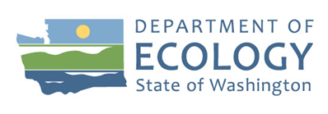
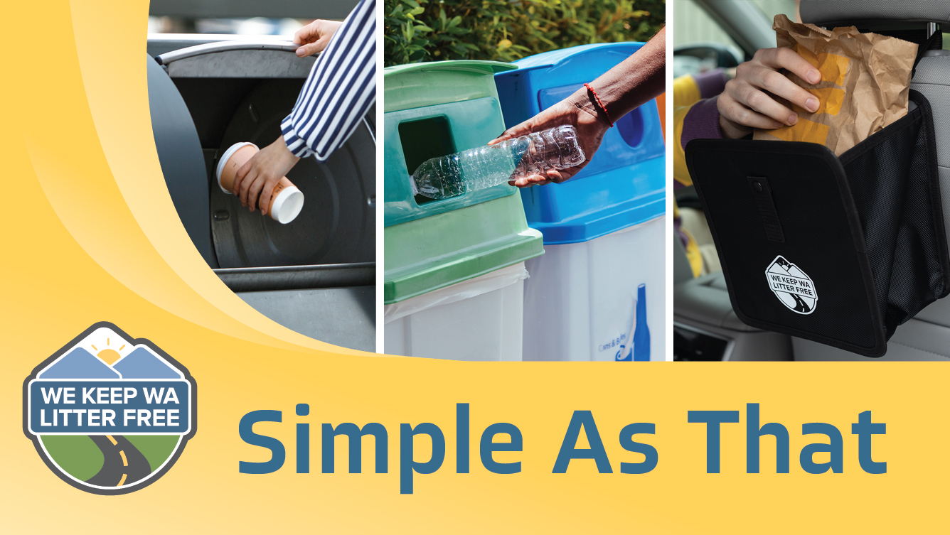

Social Marketing Plan for Littering on Roadways
By
C+C
For the
Solid Waste Management Program
Washington State Department of Ecology

Olympia, Washington
July 2022, Publication 22-07-017

Publication Information
This document is available on the Department of Ecology’s website at:
https://apps.ecology.wa.gov/publications/summarypages/2107022.html
Cover photo credit
- Getty image and Goathouse Production, 2022

Contact Information
Solid Waste Management Program
Amber Smith, Litter Prevention Coordinator
Headquarters
P.O. Box 47600
Olympia, WA 98504-7600
Phone: 360-407-6057
Website: Washington State Department of Ecology

ADA Accessibility
The Department of Ecology is committed to providing people with disabilities access to information and services by meeting or exceeding the requirements of the Americans with Disabilities Act (ADA), Section 504 and 508 of the Rehabilitation Act, and Washington State Policy #188.
To request an ADA accommodation, contact Ecology by phone at 360-407-6900 or email at SWMpublications@ecy.wa.gov, or visit https://ecology.wa.gov/accessibility. For Washington Relay Service or TTY call 711 or 877-833-6341. Visit Ecology's website for more information.

Department of Ecology’s Regional Offices

Map of Counties Served
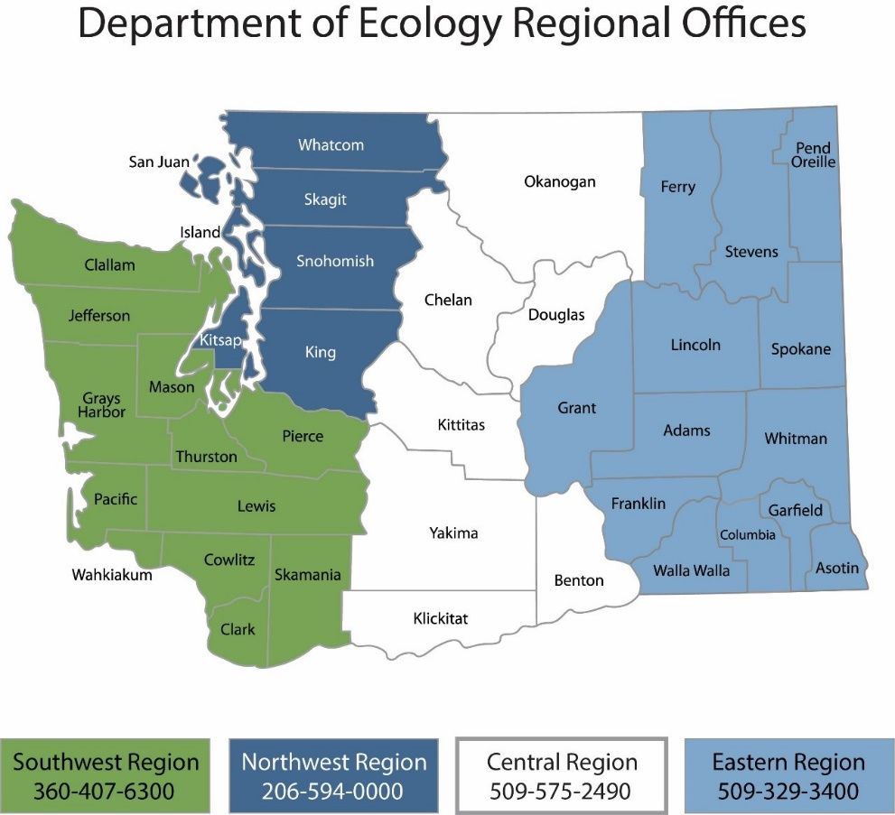
Region | Counties served | Mailing Address | Phone
Southwest | Clallam, Clark, Cowlitz, Grays Harbor, Jefferson, Mason, Lewis, Pacific, Pierce, Skamania, Thurston, Wahkiakum | PO Box 47775  Olympia, WA 98504 | 360-407-6300
Northwest | Island, King, Kitsap, San Juan, Skagit, Snohomish, Whatcom | 15700 Dayton Ave. N  Shoreline, WA 98133 | 206-594-0000
Central | Benton, Chelan, Douglas, Kittitas, Klickitat, Okanogan, Yakima | 1250 W Alder St  Union Gap, WA 98903 | 509-575-2490
Eastern | Adams, Asotin, Columbia, Ferry, Franklin, Garfield, Grant, Lincoln, Pend Oreille, Spokane, Stevens, Walla Walla, Whitman | 4601 N Monroe  Spokane, WA 99205 | 509-329-3400
Headquarters | Across Washington | PO Box 46700  Olympia, WA 98504 | 360-407-6000

Social Marketing Plan
for Litter Prevention
Solid Waste Management Program
Washington State Department of Ecology
Headquarters
Olympia, WA
July 2022 | Publication 22-07-017
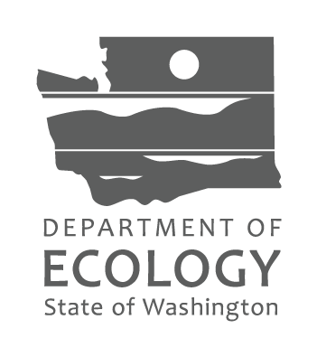

Table of Contents

List of Figures and Tables 6
Figures 6
Tables 6
Executive Summary 7
Introduction to Social Marketing 9
10-Step Process 9
Social Marketing Tools 11
Litter Prevention Social Marketing Plan 12
Introduction 12
Step 1: Identify project purpose, goals and objectives 13
Step 2: Identify desired behavior changes 14
Step 3: Research 14
Step 4: Define priority audiences 17
Step 5: Audience barriers, benefits, and motivators 18
Step 6: Create a messaging strategy 19
Step 7: Social marketing intervention 20
Step 8: Identify partners 21
Step 9: Develop a marketing plan 22
Step 10: Create an evaluation plan 24

List of Figures and Tables

Figures
Figure 1: This bell curve shows the spectrum of people and which tools are most effective in
driving behavior change. 9
Figure 2: Ecology's new litter prevention umbrella brand in English and Spanish. 12

Tables
Table 1: Budget table by task to develop, implement and evaluate the Simple As That campaign. 23
Table 2: Campaign development timeline by task. 23
Table 3: “Outputs” to report following the 2022 pilot and future campaign implementations. 24
Table 4: "Outcomes” to report following the 2022 pilot and future campaign implementations. 24
Table 5: Recommended long-term “outcomes” to measure in the future. 25

Executive Summary
In 2021, Ecology worked with C+C (a communications, marketing and public relations agency out of Seattle, WA) to create the We Keep WA Litter Free umbrella brand in English and Spanish (www.LitterFreeWA.org and www.PorUnWAImpecable.org) to help prevent litter in Washington state. Ecology is using this umbrella brand across a number of litter prevention campaigns focused on different behaviors.
The first litter prevention social marketing campaign developed by Ecology and C+C under the new brand was called Secure Your Load for Safer Roads (www.SecureLoadsWA.org and www.SujetaTuCargaWA.org). It focuses on unsecured loads, which cause 300 crashes in Washington every year and items blowing or falling from vehicles also contribute to nearly 40% of roadside litter. The Secure Load for Safer Roads social marketing plan and Litter Prevention Partner Toolkit is publicly available for those seeking to learn more about the campaign.
The second litter prevention social marketing campaign we developed under the umbrella brand, and the focus of this social marketing plan, is the Simple As That campaign. It focuses on commonly littered items on roadways (beverage containers, food packaging and PPE). The campaign’s purpose is to motivate people to use a litter bag in their vehicle or to wait to dispose of trash at their destination or another convenient place along their journey (gas station, rest stop, etc.). The priority audience for this campaign are those that litter while driving. Research shows these are primarily males, ages 18-44, with a skew towards urban and suburban areas of Western Washington due to population density. Major influencers for these individuals are their passionate non-littering peers, family, friends and coworkers.
To influence the audience to change their littering behavior, marketing interventions focus on removing major barriers identified through both quantitative and qualitative audience research conducted by Ecology and C+C in 2021. Major research findings include:
- The vast majority of Washington residents (more than 75%) do not litter.
- Almost all litterers do not have a litter bag in their vehicle. They dispose of litter on roadways to avoid spills, smells or trash piling up in their vehicle.
- Litterers know it’s wrong, so they tend to do it when they are alone and no one is looking.
- Those that litter rationalize their behavior since they see so much litter on roadways already. They believe their own litter makes a small impact by comparison, that it will biodegrade or that it will get picked up by litter pickup crews. The primary motivators for stopping littering are having access to a litter bag in their vehicle, self-satisfaction to be part of the solution and a good role model and to no longer have to hide their actions from others.
- The priority audience is also concerned about getting caught and fined, and they have a desire to help keep Washington beautiful and litter free.
To reduce barriers and provide desired benefits, we developed major intervention strategies to:
- Share messaging that taps into litterer’s desire to align their behavior with their beliefs and how they identify (as good people) so they can be part of the solution to keeping Washington litter free.
- Spread the facts about litter, how much is not picked up and the true environmental and aesthetic impact litter has when it remains on the ground.
- Increase access to reusable litter bags through special giveaway events at targeted locations.
- Increase awareness of social norms: more than 75% of Washingtonians never litter.
- Achieve a strong media presence through paid advertising, social media and news stories.

Introduction to Social Marketing
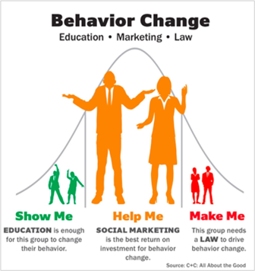
The practice of social marketing is built on a significant base of research that shows awareness and education alone rarely change behaviors. In order to create meaningful, sustainable behavior change, you must use strategies that aim to overcome barriers and provide people with personal, relevant motivators. This approach increases the efficiency and effectiveness of marketing efforts by:
- Identifying the specific behaviors that must change to achieve a program’s goals.
- Segmenting audiences based on who has the highest probability of changing the desired behavior (or who is not yet participating).
- Addressing the barriers to behavior change, while also ensuring that an audience is sufficiently motivated to act.
The following recommendations describe how community-based social marketing is used to overcome barriers and motivate people to act.
Figure 1: This bell curve shows the spectrum of people and which tools are most effective in driving behavior change.

10-Step Process
C+C and Ecology used this 10-step process to develop the social marketing campaign plan focused on unsecured loads.
Step 1: Identify project purpose, goals, and objectives.
Develop a roadmap for the project. Focus on defining what success looks like and include measurable objectives.
Step 2: Identify desired behavior changes.
Determine the specific desired behavior changes that are the most direct path to achieving the program’s goals. This is often done by mapping which behaviors have the highest impact on the goal and the highest probability of change.
Step 3: Research.
Good campaigns and materials are grounded in research. Research is used to understand priority audiences’ current actions and identify what they think and feel about the subject matter and behaviors.
Step 4: Define priority audiences.
Define the priority audiences that are likely to be most receptive to changing their behaviors.
Step 5: Identify barriers, benefits and motivators for the desired behavior changes.
Once you know what behaviors you want people to adopt, the next step is analyzing the barriers that prevent the priority audience from doing the desired behaviors. It’s important to identify the possible benefits and motivators that could overcome those barriers. Providing incentives and ensuring key messages align with what people find most beneficial about the desired behavior (e.g., protecting those we love, being a good citizen) increases their motivation to change. This is a key part of the process and one that often provides a reality check. If the motivators for a particular behavior change are not strong enough to overcome the barriers, it may be necessary to re-think that behavior change. The goal is to set the program up for success. Pick the achievable behaviors and focus efforts there.
Step 6: Create a messaging strategy.
A succinct and compelling message strategy is critical to help ensure the success of social marketing efforts. We live in a world where the average person is exposed to between 2,000 and 3,000 marketing messages daily. We have three-to-five seconds to catch someone’s attention so they continue reading or viewing to learn more. In this step, it's important to identify key value propositions and messaging to motivate the desired change.
Step 7: Social marketing intervention.
This step is the culmination of the process where we prioritize and choose what social marketing tools will work best to influence behaviors among the priority audience groups. Sample tools are listed and explained in the next section.
Step 8: Identify partners.
Partnerships help create demand for a program by providing access to a larger audience, incentives for program participants and adding credibility to the cause. Good potential partners have a complementary mission and audiences that overlap with the campaign’s priority audiences.
Step 9: Develop a marketing plan.
A fully developed marketing plan is crucial to the success of social marketing efforts. The plan identifies how to:
- Operationalize the social marketing tools.
- Deliver the program’s message to priority audiences.
- Define the outreach strategies and tactics that deliver on the program’s goals and objectives.
It is advised to launch a social marketing program with a pilot campaign so you can gather feedback on effectiveness prior to broad-scale implementation.
Step 10: Create an evaluation plan.
The evaluation plan is designed to track the program’s progress, celebrate successes and make necessary changes along the way. It includes measurements of campaign inputs, outputs, outcomes and overall campaign impact.
This process can be scaled to the scope of each program. No matter the scale or scope of the campaign, the essence of the planning process is to:
- Clarify objectives and how to measure success.
- Identify the priority audiences most likely to act.
- Create messaging that cuts through the clutter.
- Create a plan to deliver that messaging at the right time, in the right place.
These basic steps ensure that outreach and communications efforts have the maximum impact possible for the resources invested.

Social Marketing Tools
Based on research in psychology and other social sciences, community-based social marketing identified a set of tools to promote behavior change. These tools are most effective when they address barriers, benefits and motivators identified through audience research.
Social Marketing tools include:
- Commitments – Making a commitment to change a behavior makes it more likely that people will follow through.
- Social Norms – People will change their behaviors if they believe everyone else has done so.
- Social Diffusion – Peer and referent groups spread behavior change through conversations, interactions, and observation of each other.
- Prompts – Placing reminders to act as close to the location of behavior as possible.
- Communication – Seeks to capture attention, overcome barriers with motivators and highlight benefits. Disseminate through channels that reach priority audiences.
- Incentives – Providing a tool or discount that helps overcome a barrier to trying the behavior.
- Convenience – Making it easy to do the behavior (for example, providing free equipment or how-to instructions).
- Recognition/Feedback – People want to know that their behavior is making a difference. Report back with messages like, “XX% of people or groups have committed to do (or are doing) the behavior”.

Litter Prevention Social Marketing Plan

Introduction
Ecology worked with C+C in 2021 to create the We Keep WA Litter Free umbrella brand to prevent litter in Washington (www.LitterFreeWA.org and www.PorUnWAImpecable.org). Ecology will use this umbrella brand across prevention campaigns focused on different behaviors. These include unsecured loads as well as littering beverage containers, food packaging and personal protective equipment (PPE) on roadways while driving. A separate campaign focusing on cigarette butt litter may be developed in the future.
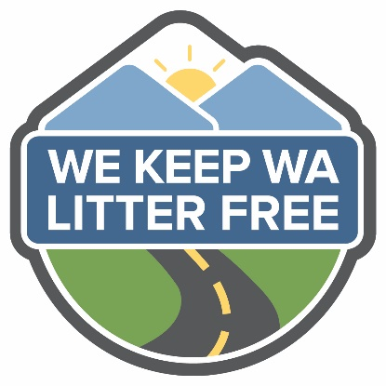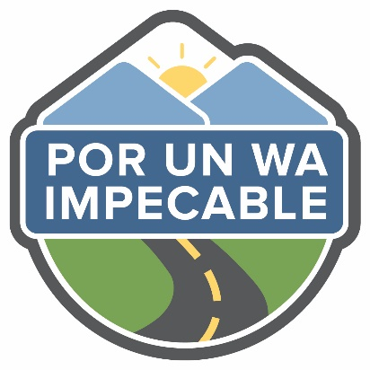
Figure 2: Ecology's new litter prevention umbrella brand in English and Spanish.
The We Keep WA Litter Free brand uses a positive culture framework and builds off the social norm that most people in Washington (more than 75%) don’t litter. The brand addresses a broad audience of litterers as well as those in their social circle who can influence and intervene in littering behavior.
The brand inspires litterers to:
- THINK: Safe, litter free roads and public spaces are important to our community and small actions can add up to make a big difference.
- FEEL: I am proud of my state and want to make sure it is safe and litter free.
- DO: I will stop my own behaviors that contribute to litter and/or talk to others in my social circle about their littering behavior.
We are developing campaigns for different littering behaviors using the 10-step social marketing process outlined in the introduction. To date, there are two bilingual campaigns informed by audience research and tested before going into the marketplace:
- Secure Your Load for Safer Roads (www.SecureLoadsWA.org and www.SujetaTuCargaWA.org).
- Simple as That (www.LitterFreeWA.org/simple and www.PorUnWAImpecable.org/simple).

Step 1: Identify project purpose, goals and objectives

Background information on litter
Past litter surveys conducted by Ecology indicate that every year 18 million pounds of waste accumulate on Washington roads, parks and recreation areas. Annually, Ecology-funded cleanup efforts pick up 4-5 million pounds of waste at a cost of $4.6 million. The Washington State Department of Transportation spends another $4-5 million annually. Even with these massive efforts, the majority of littered items remain on the ground. This litter can leach chemicals into the environment, endanger both wildlife and human health and often ends up in waterways. Additionally, studies show that littered areas attract more litter, creating a vicious cycle and that litter impacts economic opportunities, public safety and people’s overall mental health and community pride.
Keep America Beautiful’s 2020 National Litter Study cataloged 50 billion pieces of litter across the country (or 152 pieces of litter for every U.S. resident), including:
- 417.9 million food-packaging film, fast food packaging, other food packaging items.
- 207.1 million PPE items (masks and gloves).
- 147.1 million beer and soda containers.
Aside from cigarette butts, many of these highly visible items are among the top most commonly littered materials and several are trending up. For these reasons, beverage containers, food packaging and PPE have been prioritized for this social marketing campaign effort.
Washington law (RCW 70A.200.060) sets minimum fines for littering and illegal dumping, which range from $103 to $5,000. The largest fines are for items that can cause car crashes and “lit debris” — primarily cigarettes. Fine amounts by category are outlined below:
- Throwing or depositing litter on the highway = $231
- Littering less than 1 cubic foot = $103
- Litter more than 1 cubic foot, but less than 1 cubic yard = $500
- Littering more than 1 cubic yard = $1,000 - $5,000 and potential jail time
- Potentially dangerous litter (including cigarette butts) = $1,025
The Washington State Patrol, local police departments, sheriff's offices and health departments enforce litter laws. Many cities and counties have local ordinances that are stricter than state law. Data from Washington State Patrol indicates that:
- In 2021162 people were pulled over for littering violations with 115 warnings given and 47 tickets written.
- In 2020, 155 people were pulled over for littering violations with 101 warnings given and 52 tickets written.
- 2020-2021 numbers were lower than normal due to the COVID-19 pandemic. However, in 2019, still only 278 people were pulled over for littering with 180 warnings given and 98 tickets written.
This data demonstrates how difficult it is to catch litterers, enforce state laws and issue fines in a punitive manner. This is also why the We Keep WA Litter Free campaign focuses on reinforcing positive behavior and providing information, tools and strategies to help change negative behavior rather than punishing it.

Campaign purpose
To decrease littering on Washington roadways

Campaign focus
Beverage containers, food packaging and PPE (personal protective equipment such as masks and gloves) littered on Washington roadways.

Campaign goal and objective
To educate drivers about the impact of their littering and provide them with the information, tools and strategies to properly dispose of trash while on the road.

Step 2: Identify desired behavior changes
We want the audience to get and use a litter bag in their vehicle or wait to dispose of items in a waste receptacle at their destination or another convenient place on their journey (gas station, rest stop, etc.).

Step 3: Research

Overview
To inform the overall social marketing strategy for litter prevention efforts in Washington, Ecology and C+C conducted research in March-April 2021 with the primary goal of identifying the priority audience, behaviors, motivators and barriers to changing littering behaviors. This process included 14 subject matter expert interviews with solid waste/litter professionals and key stakeholders from the Washington Traffic Safety Commission, Washington State Patrol and Washington State Department of Transportation. We also completed a literature review to evaluate prior efforts and similar litter campaigns.
In April 2021, we conducted a statewide quantitative survey to develop priority audience demographic profiles, establish benchmarks for a broad range of littering behaviors and prioritize barriers and motivators. Later in September-October 2021, we conducted additional qualitative audience research to better understand why people litter and what would motivate them to stop. This information informed the overall strategy and creative approach for the Simple as That campaign. Lastly, we conducted message testing research in Jan 2022 to select the final campaign creative approach. Further information on all of these research efforts is detailed below.

Washington’s prior litter prevention campaign
From 2002-2009 Ecology developed and ran the Litter and It Will Hurt campaign to prevent litter on roadways. It had a heavy enforcement theme, focused on steep fines and included a litter reporting hotline to discourage litterers. The campaign was effective, but ultimately lost funding. The Legislature restored Ecology’s funding in 2019. That spring, Ecology partnered with the Washington State Patrol (WSP) on emphasis patrols targeting litter and unsecured vehicle loads. In 2020, Ecology worked closely with the WSP, Washington Traffic Safety Commission (WTSC), Washington State Department of Transportation (WSDOT) and local jurisdictions on the state’s Secure Your Load Day efforts and a successful Secure Your Load Week social media campaign.

Other similar litter prevention campaigns
There are many other campaigns across the country with similar efforts to reduce litter on roadways. Before developing We Keep WA Litter Free, we reviewed several of them including:
- The Don’t Mess with Texas campaign (1985-present), which is the most well-known. It has an emphasis on Texas pride and protecting the state’s beauty.
- The nationwide Keep America Beautiful campaign (1956-present) that intends to inspire and educate all Americans to understand the scope of the litter problem and to take action every day to improve and beautify their community.
- South Carolina’s Palmetto Pride campaign (2001-present) that emphasizes litter prevention through collaboration and partnership and includes a large number of tarp giveaway events.
- Tennessee’s Nobody Trashes Tennessee campaign (2016-present) that builds state pride and leverages celebrities to spread the message.

Quantitative research survey
Ecology and C+C conducted a quantitative research survey in April 2021 with 1,130 participants using the Ask Your Target Market (AYTM) platform. The survey gathered information on audience, behavior benchmarks, barriers and motivators for a range of littering behaviors including unsecured loads and littering cigarette butts, food packaging, beverage containers and PPE. There were recruitment quotas for smokers and pickup truck drivers to ensure participation by members of our priority audiences (people who litter cigarette butts and don’t secure their loads). In addition, we made significant efforts to recruit a diverse group of Washingtonians across demographics, especially by race and geography, with quotas for African American/Black, Asian/Asian American and Hispanic/Latinx participants. The data collected continue to inform Ecology’s litter prevention efforts.
The key findings related to littering beverage containers, food packaging and PPE were that approximately 16% of Washington residents litter these items and those who do are most likely to be males between the ages of 18-44. Additional findings related to audience, barriers and motivators are outlined in Step 4 and Step 5.

Qualitative research study
In September-October 2021, Ecology and C+C conducted additional qualitative audience research to better understand why our priority audience litters beverage containers, food packaging and PPE and what would influence them to stop. This exploratory research was used to inform the strategy and creative approach for the Simple as That campaign.
We recruited a total of 12 male Washingtonians aged 18-44 to participate, of which seven identified as BIPOC (Black, Indigenous, People of Color) and five identified as white males. Participants completed a total of three online sessions to answer detailed open-ended questions about themselves and the subject of litter. They also purchased a litter bag to use for one week and then provided feedback on their experience. In the final step of the research, participants joined 1-hour, Zoom-enabled interviews in groups of three (triads) with a moderator.
Key findings of the research were used to inform the creative strategy and included:
- Participants know their littering behavior is wrong so they do it when no one is watching
- The act of littering was not aligned with how participants see themselves, as ‘good people.’ All participants had some sort of connection with the outdoors, almost all were employed and several were dads who want to set a good example for their kids.
- Despite all this, participants still find themselves tossing trash out their vehicle window
for three key reasons 1) it’s wet 2) it smells, or 3) it’s small and will pile up in their car.
- Participants feel a little guilty or embarrassed about their behavior and worry about getting caught, but also feel a sense of relief to have the item out of the car.
- Participants primarily litter items such as paper straw wrappers, receipts, food packaging and disposable beverage containers.
- They rationalized their behavior since they see litter everywhere so don’t think theirs makes a big impact or believe it is biodegradable or will eventually get picked up by crews.
- Most participants don’t have a litter bag of any kind in their vehicle. Trialing a litter bag for one week encouraged them to not litter and increased their awareness of just how much they were tossing out their car window.
These findings pointed the team to two key messaging recommendations:
- The campaign materials needed to communicate the larger impact of littering behavior and why it is a problem.
- Motivate the audience to adopt the priority behaviors by tapping into positive emotions that allow them to "feel good about myself" and be part of the solution to ending litter. This also helps the campaign align within the positive cultural framework approach of the We Keep WA Litter Free umbrella brand.

Qualitative message testing study
To help select and gather feedback on the campaign’s creative concept, we conducted qualitative message testing with 10 male Washingtonians aged 18-44 who admitted to littering. Six identified as BIPOC (Black, Indigenous, People of Color) and four identified as white. Three concepts were tested through a series of three online sessions. All the concepts were generally well-received and rated as somewhat to very motivating. Humor, which was incorporated into all the concepts, proved an important aspect of participants’ positive reactions.
.We chose the Simple As That campaign concept because it was thought provoking, cut through the everyday clutter of messaging and did not shame the audience. Additionally, it provided more opportunities to build an extendable, ongoing campaign than the other concepts.

Step 4: Define priority audiences
As part of this social marketing plan, we developed strategies to influence Washington drivers. The priority audience within this group are those who litter beverage containers, food packaging and PPE.
Based on the quantitative survey (outlined in Step 3) we discovered:
- ~16% of Washington drivers litter beverage containers, food packaging and PPE.
- ~79% of drivers never litter these items.
The audience profile of those that litter beverage containers, food packaging and PPE is:
- 63% male
- 79% are ages 18-44
  - 26% ages 18-24
  - 26% ages 25-34
  - 27% ages 35-44
- Residence:
  - 53% urban
  - 36% suburban
  - 11% rural
  - Note: The skew towards urban/suburban areas is likely due to population density.
- Are of the State:
  - 63% Western counties
  - 32% Eastern counties
  - Note: A few participants selected “Rather not say” and the skew towards Western Washington is likely due to population density.
- Children:
  - 61% have one or more children
  - 39% have no children

Influencers
For this social marketing plan, we also identified who might influence our priority audience. Our research indicated that drivers who litter these items would be most influenced by peers, friends and family members who are passionate about preventing litter.
Our research indicated that:
- On average, 26% of litterers would be motivated to stop if “a friend, family member or passenger asked me to refrain.” Percentages by material type are noted below:
  - Food packaging (24%)
  - Beverage containers (28%)
  - PPEs (27%)
- About 36% of people are very likely to ask someone not to litter food packaging, beverage containers or PPE.
- Many people who litter have previously been ‘scolded’ by others for their behavior. They know it is wrong so they primarily litter when they are alone and no one is watching.

Step 5: Audience barriers, benefits, and motivators
Based on the findings in our research we developed campaign strategies to help overcome barriers for the priority audience to changing their littering behavior. The strategies offer top ranking motivators in exchange for properly disposing of frequently littered items, while ensuring their desired benefits are met.

Barriers
Barriers are reasons the priority audience hasn’t done the behavior in the past or is not likely to in the future. The campaign addresses the following top-ranking barriers:
- I don’t have a litter bag in my car.
- I don’t want to wait until I get to my destination to dispose of litter because it smells, it might spill or I will forget about it and it will pile up in my vehicle.
- Littering doesn’t matter because trash biodegrades or will get picked up by crews.
- I do it so infrequently it’s not a big deal and there is so much trash what difference will mine make.
- It takes too long to pull off the road to find a trash can or I have a hard time finding them when I need them.
Other barriers uncovered included:
- I don’t want to get caught with open containers that had alcohol in them.
- I don’t want a contaminated mask in my car.

Desired benefits
Desired benefits are what the priority audience says would make it “worth it” to put trash in a litter bag or other waste receptacle.
- Align my behavior and values.
- Not have to hide my littering behavior from others.
- Take pride in helping keep Washington litter free.

Motivators
Motivators are things someone could give, show or say to the priority audience to make it more likely they would properly dispose of litter.
- Having a litter bag in the car.
- Feeling self-satisfaction to be part of the solution and be a good role model.
- Aligning beliefs with behavior and not having to hide littering from others.
- Knowing how much litter doesn’t get picked up and the negative impact it has when it stays on the ground.
Other motivating factors uncovered included:
- A connection to the outdoors and helping keep Washington beautiful and litter free.
- Knowing how much it costs taxpayers to clean up litter.
- Avoiding a fine
  - Note: While fines came up as a high-ranking motivator in the quantitative survey, focusing on punitive measures for littering doesn’t align with the positive culture framework approach of our umbrella brand and social marketing plan. So this was not recommended as a primary focus.

Step 6: Create a messaging strategy
Our campaign messaging strategy and creative elements focus on what we want the audience to think, feel, and do.
- Think (What information will be motivating?)
  - Food packaging, beverage containers and PPE are not biodegradable, and when I litter these items it has a negative impact on Washington.
- Feel (What feelings will be motivating?)
  - When I take care of my trash the right way, I feel a sense of self-satisfaction that I’m part of the solution and that my beliefs and behavior are aligned.
- Do (What do we want the audience to do?)
  - I will properly dispose of food packaging, beverage containers, PPEs and other litter by getting and using a trash bag in my car or waiting to toss items in a waste receptacle at a gas station, rest area or at my destination.

Main message
Your actions have an impact. When you put your trash in a litter bag or waste receptacle instead of littering, it makes a real difference.

Supporting messages
- State-funded litter cleanup efforts can only pick up a fraction of what ends up on the ground each year. That means the majority of litter remains on the ground harming the environment, wildlife, human health and the economy.
- Getting and using a litter bag, or waiting to toss items in a waste receptacle, are easy and effective ways to protect Washington and keep it litter free.
- Be part of the solution and join the more than 75% of Washingtonians who never litter.
- Every year, Washington state spends more than $8.5M to pick up millions of pounds of litter along more than 20,000 miles of roads. When people do their part this taxpayer funding goes further or can be put towards better uses.

Creative elements
The campaign uses the We Keep WA Litter Free umbrella brand and a creative concept that emphasizes the simplicity of adopting behaviors that help prevent litter (e.g. using a litter bag or waiting and tossing items in a waste receptacle). This messaging carries through all the materials. The core video advertisement centers around a high-energy mock morning show format where a man who has recently stopped littering is interviewed on how he did it.
We selected the campaign creative concept through qualitative audience message testing, which considered the following factors:
  - Understanding – Did people interpret the main message the way we intended?
  - Believability – Does the concept seem to be believable and credible for someone like them?
  - Relevance – Does the concept seem to be relevant for someone like them?
  - Motivation – How likely are they to adopt the priority behaviors after seeing concept messaging?

More details on message testing are outlined in Step 3 (Research).

Step 7: Social marketing intervention

Convenience and incentives
Our research shows that of those who litter, 37% identified not having a litter bag in the car as a top barrier. To address this, along with encouraging people to get and use a litter bag, Ecology will provide free litter bags (incentives) distributed through Fred Meyer customer service counters as part of a pilot program in May 2022 at select store locations (Auburn, Renton, Sumner and Tacoma). This tactic will be expanded to additional stores with the statewide campaign in the fall of 2022. A chance to win a gift card is also being offered as an incentive for recipients to provide feedback on their use of, and satisfaction with, the free litter bag.

Social Norms
Our research shows that more than 75% of Washington drivers never litter. Including this statistic in our campaign messaging helps motivate residents who litter to change their behavior since people tend to follow social norms and ‘what everyone else is doing.’

Communications
The campaign uses a variety of communications channels to highlight motivators and benefits of adopting litter prevention behaviors, such as road signage, advertising, a website landing page (www.LitterFreeWA.org/Simple), social media content and other materials distributed through Ecology and its partners.

Prompts
Residents who received a litter bag are also offered a branded window cling for their vehicle both as a prompt and to build and strengthen a social norm of not littering.

Social diffusion
Social diffusion happens when a social norm is initially adopted by a group of people who later influence others to adopt the same behavior. We are encouraging friends, family and peers to spread behavior change through conversations, interactions and observation of each other.

Fines
No specific campaign messages focus on fines, but the Washington State Patrol and local law enforcement agencies will continue pulling over drivers violating littering laws. They will use the opportunity to educate or to give out a verbal warning or citation and fine. There will also be a link to Ecology’s litter laws webpage at the bottom of the Simple As That campaign page.

Step 8: Identify partners
Ecology was the major sponsor of this campaign, but several other organizations also acted as partners or messengers in the effort:
- Washington State Patrol
- Washington State Department of Transportation
- Washington Traffic Safety Commission
- Fred Meyer
- Washington State Parks
- Washington Dept. of Fish & Wildlife
- Washington Surfrider Foundation
- Washington Coast Savers
- Recreate Responsibly Coalition
- Sounders FC / RAVE Foundation TBD
- Local jurisdictions, law enforcement, nonprofits and other community-based organizations focused on litter prevention and cleanup (via toolkit)
In Step 9, we describe a cooperative advertising model we plan to pursue with the goal to expand future partnerships to include other auto-oriented businesses, such as gas stations, convenience stores, fast food chains, and car dealerships, etc.

Step 9: Develop a marketing plan

Communication channels
The major communication channels of this campaign include:
- Statewide advertising using the Simple as That video advertisement as well as radio, social media and gas station ads.
- Distribution of litter bags in convenient retail locations (Fred Meyer) and in the future other auto-oriented partner locations.
- News stories on TV, radio and print outlets generated by a press release.
- Targeted outreach to key regional publications and relevant reporters covering litter or environmental topics.
- Targeted social media advertising to drive local residents to partner locations to receive a free litter bag for their vehicle.
- Educational materials on Ecology and key partner websites, social media and other channels.
- Messages on WSDOT’s variable message highway signs and new Keep WA Litter Free highway signs.
- A Partner Toolkit emailed to local governments and made publicly available to other businesses, nonprofits and community-based organizations on Ecology’s website

Cooperative advertising model
As part of the statewide radio advertising media buy, Ecology plans to pursue a cooperative advertising model. This approach helps recruit partners to the campaign and incentivizes radio advertising vendors with the opportunity to receive additional advertising dollars. Radio advertising vendors will help persuade advertisers they have existing relationships with to support the campaign. Recruited advertisers will need to meet a certain business profile relevant to our campaign topic (for example, fast food, gas station, convenience store chains or other auto-oriented businesses such as auto repair centers, auto supply stores and car dealerships). Qualifying advertisers will receive a set discounted price on radio advertising placements through the radio ad vendor in exchange for incorporating campaign messaging at the end of their own radio commercial and/or distributing litter bags to their customers. Should the cooperative advertising model not be effective in recruiting additional partners, we will instead pursue partnerships directly with the radio advertisers to garner added-value promotions such as bonus ad placements, on-air chatter by station talent, interviews, social media posts, etc.

Budget
Funding for this campaign comes from Ecology and was deployed through a contract awarded to C+C. This work runs from July 2021 – June 30, 2023. The contract budget by task and implementation timeline is outlined below. Ecology intends to run the Simple as That campaign annually for 2-3 weeks during the summer/fall months when there are more drivers on the road. For more information on Ecology funding, see Ecology's Paying for litter programs webpage.
Table 1: Budget table by task to develop, implement and evaluate the Simple As That campaign.
Task | Description | Timing
1 | Project Management and Reporting | $39,170
2 | Conduct Audience Research & Message Testing | $47,360
3 | Promote We Keep WA Free Umbrella Campaign | $146,640*
4 | Develop and Pilot Simple as That Litter Prevention Campaign | $205,000
5 | Manage Sponsorship/Partnership Program | $20,000
6 | Launch & Implement Simple as That Litter Prevention Campaign Statewide | $411,000
 | Total | $869,170
*Includes ongoing social media content and promotion as well as campaign-specific materials

Implementation timeline
Table 2: Campaign development timeline by task.
Task | Description | Timing
1 | Project Management and Reporting | July 2021-Oct 2022
2 | Conduct Audience Research & Message Testing | Sept 2021-Jan 2022
3 | Promote We Keep WA Free Umbrella Campaign | July 2021-June 2022
4 | Develop and Pilot Simple As That Litter Prevention Campaign | Jan -June 2022
5 | Manage Sponsorship/Partnership Program | Nov 2021-Oct 2022
6 | Launch & Implement Simple As That Litter Prevention Campaign Statewide | July 2022-Oct 2022

Step 10: Create an evaluation plan
To evaluate the effectiveness of our campaign we will measure a number of outputs and outcomes.
Outputs are program activities that influence audiences to perform the desired behavior. Outcomes are changes in knowledge, attitudes, and behaviors that we can attribute to campaign outputs. In addition, we identified a number of recommended long-term impacts to measure as the campaign continues to develop and more year-over-year data are available. Impacts are indicators showing levels of impact on the social issue and/or behavior that the campaign focused on. These are outlined in the charts on the following pages.
Table 3: “Outputs” to report following the 2022 pilot and future campaign implementations.
Output | Reporting Owner
Total ad impressions | C+C / KW Media
Media stories | C+C
Social media engagement | C+C/Ecology
Website traffic | Ecology
Materials distributed | C+C / Partner jurisdictions

Table 4: "Outcomes” to report following the 2022 pilot and future campaign implementations.
Outcomes | Reporting Owner
Litter bags distributed | Partner jurisdictions
Partnerships created | C+C
Opt-in survey to understand use of and satisfaction with litter bags | C+C / Partner jurisdictions
Number of partners using toolkit (based on downloads) | C+C / Partner jurisdictions
Number of litter warnings/tickets from law enforcement | Washington State Patrol

Table 5: Recommended long-term “impacts” to measure in the future.
Impacts | Reporting Owner
Washington litter collection surveys measuring changes in amounts and types of litter on roadways over time | Ecology
Changes in litter warnings/tickets from law enforcement over time | Washington State Patrol

www.ecology.wa.gov/contact
http://www.litterfreewa.org/
http://www.porunwaimpecable.org/
http://www.secureloadswa.org/
http://www.sujetatucargawa.org/
https://apps.ecology.wa.gov/publications/summarypages/2107022.html
https://ecology.wa.gov/Waste-Toxics/Solid-waste-litter/Litter/litter-prevention/Keep-Washington-Litter-Free/Secure-Load-campaign/Outreach-materials-request-form
http://www.litterfreewa.org/
http://www.porunwaimpecable.org/
http://www.secureloadswa.org/
http://www.sujetatucargawa.org/
https://kab.org/wp-content/uploads/2021/05/Litter-Study-Summary-Report-May-2021_final_05172021.pdf
https://app.leg.wa.gov/RCW/default.aspx?cite=70A.200.060
https://www.dontmesswithtexas.org/
https://kab.org/
https://www.palmettopride.org/
https://nobodytrashestennessee.com/
http://www.litterfreewa.org/Simple
https://ecology.wa.gov/Waste-Toxics/Solid-waste-litter/Litter/Paying-for-litter

