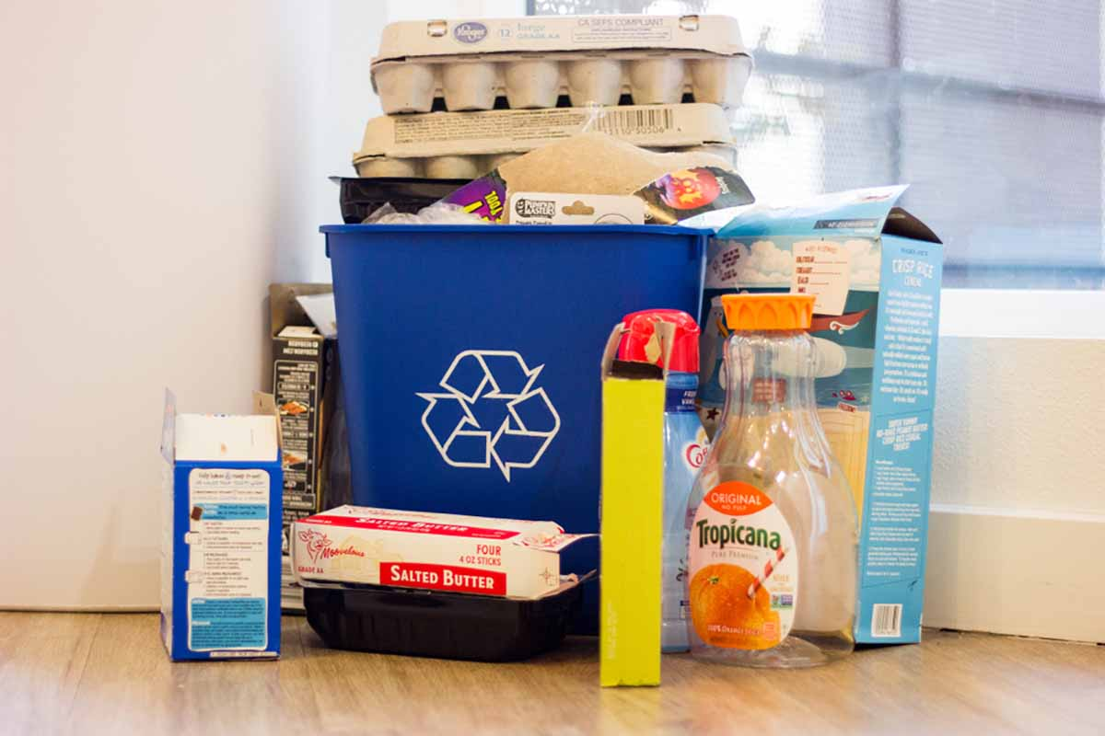

Washington Consumer Packaging and Paper Study: Recycling Rate Assessment and Recommendations
Publication 22-07-022
Original publication January 2023
Updated publication April 2023
Publication Information
This report is available on the Department of Ecology’s website at https://apps.ecology.wa.gov/ecy/publications/SummaryPages/2207022.html

Research Team
John Carhart
Raphaella Heath

Technical Leads
John Carhart
Sarah Edwards

Prepared By
John Carhart
Caitlin Harrington-Smith
Raphaella Heath

Quality Review
Sarah Edwards
Mark Cordle

Approved By

Sarah Edwards
(Project Director)

Eunomia Research & Consulting Inc
33 Nassau Avenue
New York NY 11222
USA
Tel +1 646 256-6792
Web www.eunomia-inc.com
ADA Accessibility
The Department of Ecology is committed to providing people with disabilities access to information and services by meeting or exceeding the requirements of the Americans with Disabilities Act (ADA), Section 504 and 508 of the Rehabilitation Act, and Washington State Policy #188.
To request an ADA accommodation, contact Ecology by phone at 360-407-6000 or email at mark.hayes@ecy.wa.gov. For Washington Relay Service or TTY call 711 or 877-833-6341. Visit Ecology's website for more information.

Executive
Summary

Overview
This report presents a detailed and comprehensive current baseline account of all consumer packaging and paper products within the state of Washington as well as estimated recycling rates for these materials. It also reviews problematic materials and proposed policy measures to address them. The report was prepared by Eunomia Research & Consulting (Eunomia) in response to a brief set by the Washington State Department of Ecology (Ecology).
Ecology was directed by the Washington State Legislature (Engrossed Substitute Senate Bill 5693, section 302 (59)) to contract for a study to:
- Assess the amount and types of consumer packaging and paper products (CPPP) sold or supplied into the state and the recycling rates achieved for these materials through existing recycling programs and activities in the state; and
- In accordance with the recommendations for managing plastic packaging waste submitted to the Washington state legislature in 2020, consider and make recommendations on legislative action to address the items included in the list of problematic and unnecessary materials identified for elimination by the US Plastics Pact.
Consumer packaging and paper products include a range of materials – plastic, paper, cardboard, glass bottles and jars, and metal packaging – collected through recycling programs from end-users in both households and commercial facilities. This differs from pre-consumer or post-industrial material, which is diverted during a manufacturing process.

Methods and Data
Engrossed Substitute Senate Bill 5693, section 302 (59) specifically requested the study to assess consumer packaging and paper products sold or supplied into Washington State and the recycling rates achieved for these materials through existing programs and activities. The primary sources of data used for this analysis were: 2020-2021 Washington Statewide Waste Characterization Study, 2021 Ecology Statewide Disposal Totals,the 2021 Ecology Recycling Recovery Data which is reported by facilities,and 2020-2021 King County Material Recovery Assessment.These sources provide the Washington-specific data used to estimate generation of these materials.
As producers are currently not required to report the quantity of products they sell into Washington, alternative approaches to gathering this data were considered and modelled to estimate the quantity of materials sold into Washington. Data from the following sources were used to estimate the quantity of consumer packaging and paper products, by material, sold into the state:
- Published industry datasets on annual sales nationally (National Association for PET Container Resources Glass Packaging Institute, Association of Plastic Recyclers, Can Manufacturers Institute).
- Third-party analyses of sales data from consultants and non-profit organizations ("2018 Beverage Market Data Analysis”, The Container Recycling Institute, 2020. Circular Ventures LLC.).
- Stewardship reports from Canadian jurisdictions where producers are required to submit their annual sales totals (Stewardship Ontario & The Beer Store data, RecycleBC and ReturnIt data). Additionally, data from the US Environmental Protection Agency (US EPA) were used as a comparison source.
For some materials, such as PET bottles, the Washington generation data were within a couple of pounds per capita of the data reported by industry associations NAPCOR and the Container Recycling Institute. This indicates that using the Washington-specific dataset to calculate the amount of material generated, disposed, and recycled is the best option to calculate current recycling rates and is a good proxy for the amount of material sold into Washington.
Recycling rates were calculated by taking the quantity of outbound material from a materials recovery facility (MRF) or collected through a drop-off program as the numerator and dividing it by the amount of material generated (collected for disposal and recycling), as shown below.
Recycling Rate $=\frac{Quantity of Outbound Material from MRFs or Drop Off Programs}{Quantity of Material Disposed and Recycled}$
To be clear, the recycling rates in this report do not reflect the amount of material that is recycled into new products, but instead the amount of material that is sorted and delivered to potential recyclers, such as pulp and paper mills and plastic processors.
For materials where we were able to compare Washington generation data with industry supply data (national data on a per capita basis), the Washington tonnage was greater in most cases. This is largely because material collected for disposal or recycling contains moisture, dirt, and residue, which increase the material’s weight. Thus, when calculating the recycling rate, the denominator in the equation is a “clean” weight (i.e., the weight provided by industry or producers as the quantity sold into a state) and the numerator is a “dirty” weight (i.e., the tons of material recycled, which contains dirt, moisture, and residue). The resulting recycling rate is higher than if the denominator used a “dirty” number (i.e., is the generated tons that include moisture, dirt, and residue). Additionally, for this study, contaminants (e.g., non-recyclable materials, organics waste, textiles) were accounted for (and excluded from tons counted as "recycled") in the calculations, as required by the Engrossed Substitute Senate Bill 5693, section 302 (59) that mandated it.

Consumer Packaging and Paper Products (CPPP) Supplied into Washington and Recycling Rates
Table 1 below shows the material data for all consumer packaging and paper products in Washington, including both the residential and commercial sectors. The table includes the total tons of each material generated as well as the tons disposed and recycled, based on data reported to Ecology. Note that beverage containers are a subset of other material categories (e.g., the beverage container category includes aluminum beverage cans which are also counted under the metals category). The 2021 statewide recycling rate for all Washington consumer packaging and paper products material is estimated to be 48%. These rates are calculated in a state where 89% of single-family households have access to curbside recycling and 86% of multi-family households have access to curbside recycling
Table 1: Statewide Material Flows in tons and Recycling Rates for CCCP (2021)
Material | Disposed - Garbage | Disposed -MRF Residue | Total Disposed | Recycled | Total Generated | Recycling Rate
Total Rigid Plastics | 222,100 | 24,500 | 246,600 | 68,100 | 314,700 | 22%
#1 PET Bottles | 39,800 | 7,500 | 47,300 | 30,600 | 77,900 | 39%
#1 PET Other Packaging | 21,600 | 1,400 | 23,000 | 7,300 | 30,300 | 24%
#2 HDPE Natural Bottles | 10,530 | 860 | 11,390 | 11,200 | 22,590 | 50%
#2 HDPE Colored Bottles | 13,600 | 1,400 | 15,000 | 8,700 | 23,700 | 37%
#2 HDPE Other Packaging | 14,100 | 280 | 14,380 | 2,200 | 16,580 | 13%
#3 PVC Packaging | 54 | 0 | 54 | 0 | 54 | 0%
#4 LDPE Packaging | 92 | 0 | 92 | 0 | 92 | 0%
#5 PP Packaging | 42,000 | 11,700 | 53,700 | 6,100 | 59,800 | 10%
#6 PS Packaging | 5,950 | 250 | 6,200 | 1,100 | 7,300 | 15%
#7 Other Packaging | 40,000 | 0 | 40,000 | 0 | 40,000 | 0%
Expanded Polystyrene Packaging | 32,600 | 1,100 | 33,700 | 900 | 34,600 | 3%
R/C Plastic Packaging | 340 | 0 | 340 | 0 | 340 | 0%
PLA/Compostable Packaging | 1,440 | 0 | 1,440 | 0 | 1,440 | 0%
Total Flexible Plastics | 203,000 | 21,700 | 224,700 | 8,000 | 232,700 | 3%
PE Plastic Bags & Film | 88,800 | 10,000 | 98,800 | 5,300 | 104,100 | 5%
Other Plastic Film & Flexible Packaging | 114,200 | 11,700 | 125,900 | 2,700 | 128,600 | 2%
Total Metals | 58,400 | 9,700 | 68,100 | 48,400 | 116,500 | 42%
Steel Cans | 26,000 | 1,900 | 27,900 | 15,800 | 43,700 | 36%
Aluminum Cans | 20,900 | 2,800 | 23,700 | 19,100 | 42,800 | 45%
Other Nonferrous Metal | 11,500 | 5,000 | 16,500 | 13,500 | 30,000 | 45%
Total Paper & Cardboard | 693,500 | 76,000 | 769,500 | 1,096,410 | 1,865,910 | 59%
Newspaper | 17,200 | 1,400 | 18,600 | 59,100 | 77,700 | 76%
Cardboard | 279,000 | 12,800 | 291,800 | 718,000 | 1,009,800 | 71%
Mixed Paper Products | 225,300 | 41,700 | 267,000 | 246,600 | 513,600 | 48%
Cartons | 26,600 | 0 | 26,600 | 210 | 26,810 | 1%
Paper Packaging | 145,400 | 20,100 | 165,500 | 72,500 | 238,000 | 30%
Total Container Glass | 98,000 | 8,300 | 106,300 | 71,500 | 177,800 | 40%
Total CPPP | 1,275,000 | 140,000 | 1,415,000 | 1,292,000 | 2,708,000 | 48%
Total Beverage Containers | 127,000 | 18,100 | 144,900 | 121,500 | 266,400 | 46%
Sources: Eunomia Modelling, 2021 Ecology Washington Recycling and Recovery Data, 2020-2021 Washington Statewide Waste Characterization Study, 2020 King County Material Recovery Assessment

Figure 1 shows the statewide recycling rate for each material, ranked from highest to lowest, across all sectors (residential and commercial). All percentages are expressed as the percentage of weight of material (rather than volume or units of material, for example).
Figure 1: CPPP Materials Organized by Generation with Recycling Rates (2021)
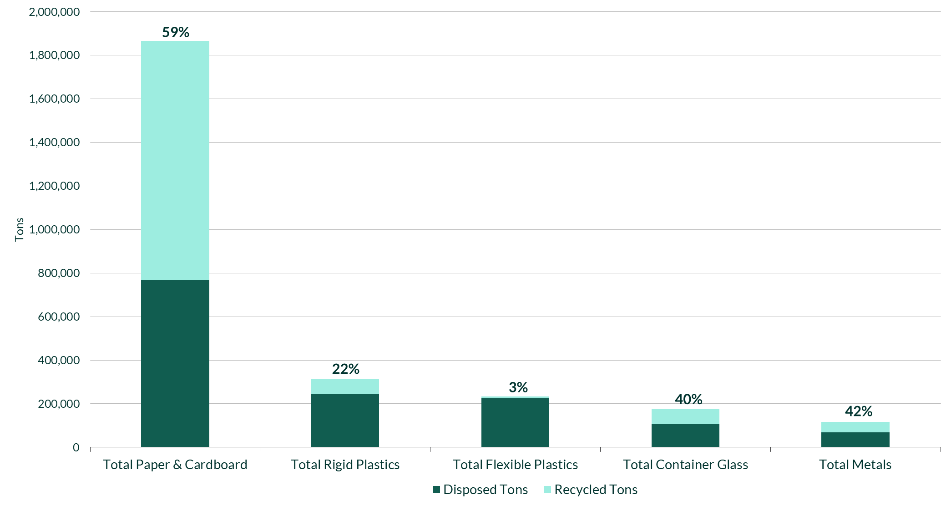
Source: Eunomia Modelling, 2021 Ecology Data, 2021 Washington Statewide Waste Characterization Study
Paper packaging and mixed paper products make up 54% of the paper and cardboard stream by weight. Paper and cardboard have the highest recycling rate, at 61%, and the highest generation; they account for 67% of the consumer packaging and paper products generated in Washington, by weight. Newspaper and cardboard have recycling rates of 77% and 76% respectively, while mixed paper products and paper packaging have lower rates of 51% and 30.
Metals have the next highest recycling rate, at 41%. Aluminum beverage cans comprise an estimated 33% of metal CPPP generated, by weight. Aluminum beverage cans have a recycling rate of 48%, while steel cans have a 36% recycling rate.
Overall, container glass has a recycling rate of 39%, while beverage container glass has a recycling rate of 49%. Beverage container glass makes up 75% of container glass generated.
Rigid and flexible plastics have recycling rates of 22% and 3%, respectively. Rigid plastic beverage containers, which include PET and HDPE items, have a recycling rate of 45%, 22 percentage points higher than the rigid plastic category.

Beverage Containers
Beverage containers represent a portion of materials within each material category. Overall, beverage containers represent 10% of all CPPP and have a recycling rate of 46%.
Table 2: Statewide Material Flows in tons and Recycling Rates for Beverage Containers (2021)
Material | Disposed - Garbage | Disposed -MRF Residue | Total Disposed | Recycled | Beverage Containers Generated | Beverage Container Recycling Rate (%) | Beverage Container Generation as % of Whole Material Category
All Plastic Beverage Containers | 38,000 | 7,700 | 45,500 | 37,300 | 82,800 | 45% | 67%
#1 PET Beverage Containers | 28,100 | 6,800 | 34,900 | 27,600 | 62,400 | 44% | 80%
#2 HDPE Natural Beverage Containers | 8,600 | 700 | 9,200 | 8,800 | 18,000 | 49% | 80%
#2 HDPE Colored Beverage Containers | 1,300 | 200 | 1,400 | 900 | 2,400 | 38% | 10%
Aluminum Beverage Cans | 17,500 | 2,700 | 20,200 | 18,400 | 38,600 | 48% | 90%
Carton Beverage Containers | 11,600 | 0 | 11,600 | 100 | 11,700 | 1% | 44%
Glass Beverage Containers | 59,900 | 7,700 | 67,600 | 65,700 | 133,300 | 49% | 75%
All Beverage Containers | 127,000 | 18,100 | 144,900 | 121,500 | 266,400 | 46% | 72%
Sources: Eunomia Modelling, Industry Data, City of Tacoma Solid Waste Management, Glass Packaging Institute Data, 2021 Ecology Data, 2021 Washington Statewide Waste Characterization Study
The beverage container category includes glass beverage containers (49% recycling rate), HDPE natural beverage containers (49%), aluminum beverage cans (48%), PET beverage bottles (44%), and beverage cartons (1%). Beverage cartons are recycled at a very low level compared to other beverage containers; this presents an opportunity for more than 11,000 tons in additional diversion. Figure 2 below graphically shows the information displayed in Table 2 above, describing the recycling rate of an entire material category and its beverage container only subset.
Figure 2: All Containers and Beverage Container Recycling Rates
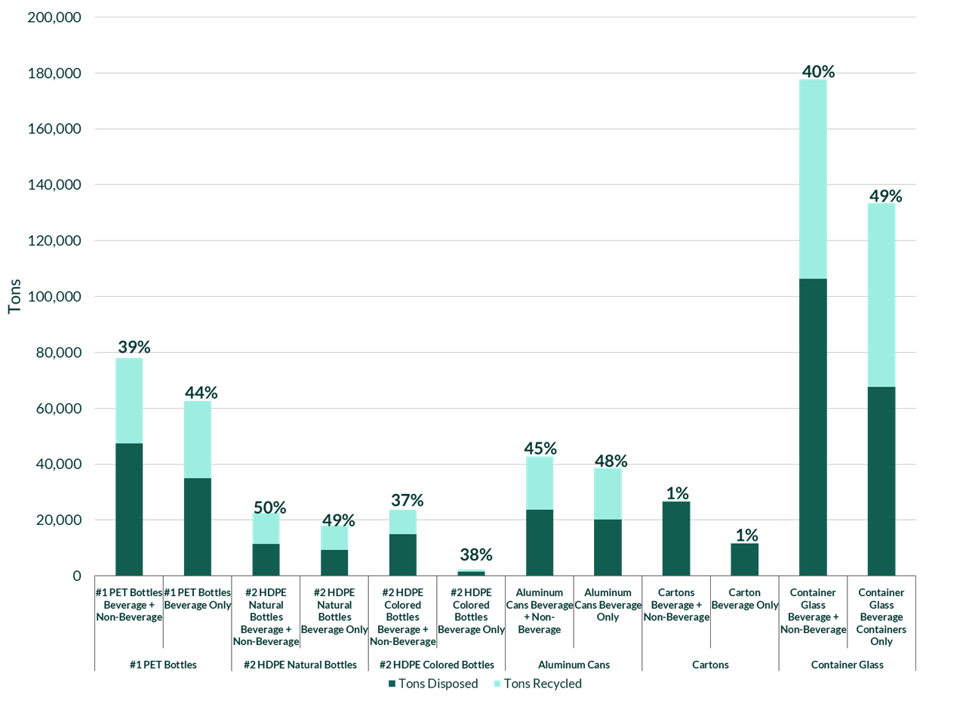
Source: Eunomia Modelling, proprietary data gathered by Eunomia, City of Tacoma Solid Waste Management
While high compared to other materials, the beverage containers recycling rate is below the average redemption rate for beverage containers in US states with Deposit Return System (DRS) programs (known as bottle bill states); that average redemption rate was approximately 70% prior to COVID-19 pandemic related disruptions. Furthermore, for US DRS programs with at least one type of container with a deposit of 10 cents or higher per container, the average redemption rate is 81%. Programs in Europe regularly achieve a 90%+ return rate. If DRS with a return rate of 90% were implemented in Washington, it would divert at least an additional 125,000 tons from landfill. This would increase the total statewide recycling rate for all consumer packaging and paper products from 48% to 53%.
Recycling Rate and Disposed Tons
Figure 3 below shows the recycling rate for the material categories on the y-axis versus their pounds per capita disposed on the x-axis.
Figure 3: Recycling Rate of Materials vs Disposed Weight
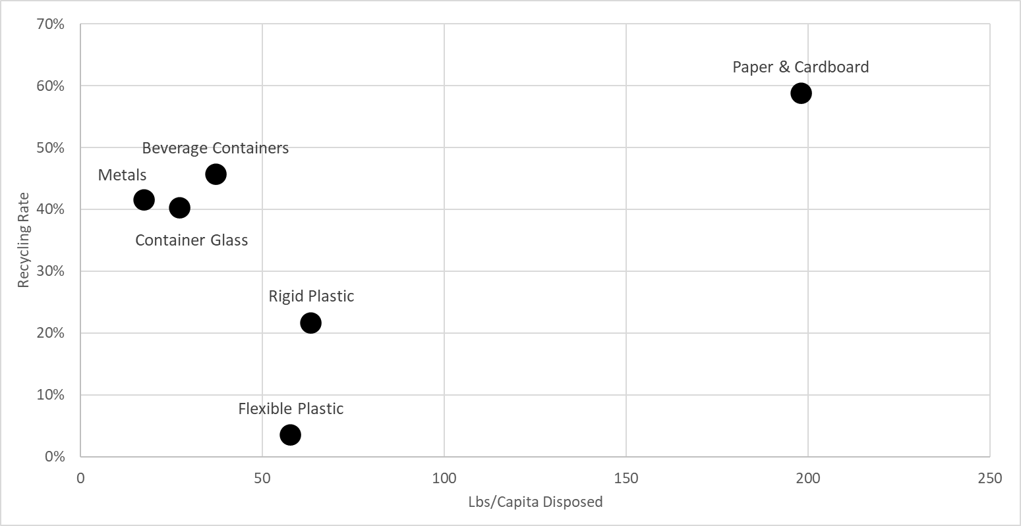
Source: Eunomia Calculations, 2021 Ecology Data, 2021 Washington Statewide Waste Characterization Study
In Figure 3, the paper and cardboard category has the highest recycling rate, but also the highest quantity per capita of material remaining in the disposed waste stream. As Table 1 shows, paper packaging and mixed paper products, which are subcategories of the paper and cardboard category, have recycling rates of only 30% and 48% respectively. These two paper streams account for over 54% of the total paper and cardboard streams, so low recycling rates for these categories bring down the overall recycling rate for paper and cardboard. However, almost six times more paper and cardboard are generated than the next largest category, rigid plastic packaging; given this, a relatively high recycling rate for paper and cardboard will still mean large quantities are disposed. This means that significant opportunity exists to reduce how much paper and cardboard material ends up in landfill and incineration.
For flexible plastic packaging and rigid plastic packaging, similar amounts of tons are disposed, but the recycling rate for rigid plastic is over 20 points higher than for flexibles. Flexible plastic packaging, which is not accepted in 99% of residential curbside programs, has the lowest recycling rate of the group of materials and the second highest amount disposed per capita. Flexibles present an opportunity for additional diversion that can begin with a relatively small increase in recycling rate. For example, a 10-point increase in flexibles diversion, which would bring the recycling rate to just above that of Ontario’s stewardship program, would result in an additional 24,000 tons diverted from landfill and increase the statewide recycling rate for all CPPP by one percentage point.

Policy Recommendations for Problematic Materials
Eunomia used the Problematic and Unnecessary Materials List, published in 2022 by the US Plastics Pact, as the primary source for determining the list of problematic CPPP considered in this study. Chemicals and additives from the list, such as carbon black, oxodegradables, and PFAS, are components of CPPP but not in themselves CCCP; as such, while they are recognized as problematic, they are not specifically considered in terms of policy intervention in this report. Additionally, the Washington State Department of Ecology requested that Eunomia expand the problematic list beyond the US Plastics Pact list. CPPP materials are considered problematic in this study if they are (1) often littered and/or a source of pollution that harms the environment; (2) disruptive to sorting and recycling infrastructure, and/or (3) not recyclable or compostable at scale. The final list of problematic consumer packaging and paper products for this study includes:
- single-use plastic cutlery, stirrers, and straws;
- opaque or pigmented PET;
- PETG;
- PS (including EPS);
- PVC;
- multimaterial multilayer film;
- monomaterial multilayer film;
- biodegradable plastics;
- aseptic/poly-coated cartons;
- laminated paper; and
- paper packaging with plastic windows and other components that cannot be separated.
Eunomia completed a landscape review of policies that could address these problematic materials. This report presents the findings, along with an assessment of the suitability of measures for each problematic item. Table 3 presents a summary of the problematic materials and relevant policies.
Table 3: Policy Recommendation by Problematic Material
Category | Problematic Material | Ban | EPR | DRS | Other Policies
Plastic | Single-use plastic cutlery and stirrers | X | X |  | Reuse
 | Single-use plastic straws |  | X
 | Opaque PET |  | X | X | Reuse, Label
 | Transparent pigmented PET |  | X | X | Reuse
 | PETG – Polyethylene Terephthalate Glycol in rigid packaging |  | X | X | Label
 | PS – Polystyrene, including EPS (Expanded Polystyrene) | X | X | X | Label, Reuse
 | PVC – Polyvinyl Chloride, including PVDC (Polyvinylidene Chloride) |  | X |  | Label
 | Multimaterial multilayer film |  | X |  | Label
 | Monomaterial multilayer film (PE,PP,PA nylon) |  | X |  | PCR
 | Biodegradable plastics |  | X |  | Reuse
Paper | Aseptic/poly-coated cartons |  | X | X | Reuse
 | Laminated paper |  | X
 | Paper packaging with plastic windows and other components that cannot be separated |  | X |  | Label

Ultimately, the report recommends a combination of policy approaches to comprehensively address the management of problematic materials. These approaches are summarized below.
Bans help to remove materials that are often littered, disruptive to sorting and recycling infrastructure, and not recyclable at scale. Before any ban is implemented, due diligence is required to consider the impact of potential substitutions. An analysis of alternative items must also be conducted to ensure substitutions do not have detrimental environmental impacts and undue costs nor disproportionately impact certain groups. This study recommends material bans on the following CPPP:
- Single-use plastic stirrers and cutlery, and
- EPS in food packaging.
Though not the focus of this study, it is relevant to note that bans can also be an appropriate policy response to problematic additives to packaging. Oxo-degradable and oxo-biodegradable additives accelerate the breakdown of plastic into microplastic and are not recyclable or compostable. These additives can disrupt sorting, harm recycling infrastructure, contaminate recyclable material, harm the environment, and/or harm human health. A ban could help prevent these issues by removing problematic additives from the market.
Extended Producer Responsibility (EPR) policy that provides incentives for manufacturers to incorporate environmental considerations into the design of their products and packaging, often called eco-modulation, would encourage the phasing out of materials that are disruptive to recycling infrastructure, harmful in the environment, and/or hard-to-recycle. EPR is a recommended policy response to address each of the problematic consumer packaging and paper products listed. EPR fees can be modulated in two main ways:
- Create a bonus/malus (i.e., reward/penalize) system that incentivizes materials that are recyclable, compostable, or reusable and disincentivizes/penalizes materials that cannot be effectively processed or that increase the cost of recycling.
- Create a list of covered materials (minimum recyclable list) and automatically apply a higher fee for products that use materials not included on this list.
EPR legislation also requires investments in collection, sorting, secondary sorting, and recycling infrastructure, education and outreach efforts, and developments in end markets. The purpose of these investments must be to ensure all households and businesses have recycling collection services that are convenient and collect a common set of materials for recycling. EPR also allows for investment in the system to enable the collection of materials that meet the quality and quantities necessary to market to recyclers. These investments enable producers to meet recycling targets whether set within the legislation or through producer plans.
Deposit Return System (DRS) policy that covers beverages — including carbonated, noncarbonated, alcoholic, and non-alcoholic beverages — would be useful to increase beverage container collection in the state. In terms of problematic materials, DRS can cover the collection of beverage containers made of problematic materials such as transparent pigmented PET, PETG, PS, and aseptic/poly-coated cartons. Beverage containers are also a major source of litter, and Washington’s recycling rate for beverage containers (46%) is low compared to jurisdictions with DRS, such as its neighbors Oregon and British Columbia. If a DRS with a return rate of 90% were implemented in Washington (like redemption rates in Oregon, Maine, and Michigan prior to COVID-19 related disruptions), it would increase the total statewide consumer packaging and paper products recycling rate from 48% to 53%. DRS infrastructure can also help develop reuse and refill programs, where deposit drop-off points can also be used to return certain reusable and refillable product containers.
A 2020 study by Eunomia outlined the design for a best-in-class deposit system in Washington: Container Deposit Study - Phase 2 - Responsible Recycling Task Force - King County Solid Waste Division. Mitigation of the impacts of deposits on material recovery facilities (MRFs) can be addressed through appropriate payment mechanisms.
Labeling provides information for consumers on the recyclability of a product and its packaging. A clear labeling system ensures transparent and consistent approaches to avoid misleading advertising on recyclability from producers and improve consumer awareness. Labeling can also improve recycling behavior and decrease contamination in the recycling stream. Labeling requirements can be implemented through standalone legislation or can be incorporated in EPR, either through requirements or incentivized through eco-modulation of fees. Consistent and clear labeling is recommended for all products and packaging, and especially for the problematic materials highlighted in this study, as they can disrupt processing infrastructure and contaminate recycled materials.
Postconsumer Recycled (PCR) content requirements are effective policies to stimulate market demand and drive the recovery and use of recycled feedstocks that are produced from materials collected for recycling. Since PCR targets apply to products and not resin types, placing PCR targets on consumer packaging and paper products can incentivize producers to design products with available recycled content, thereby phasing out problematic materials. Washington already has PCR targets for plastic beverage containers, plastic trash bags, and non-beverage rigid plastic containers for household cleaning and personal care products. This study recommends extending it to monomaterial multilayer film. This extension was considered by Washington’s PCR Recycled Content Mandate Study Group and ultimately rejected due to limited collection and the need to obtain approval from the Food and Drug Administration (FDA) for food contact applications.
Reuse refers to the set of policies and programs that require, support, incentivize, or encourage alternatives to single-use items that can be washed and reused or refilled. Reuse can help reduce the use of problematic consumer packaging and paper products with alternatives that can be washed and used again. This reuse helps reduce waste at source and remove single use items from the waste stream. Reuse can be applied to single-use cutlery and stirrers as well as food takeout containers or beverages made from opaque PET, transparent pigmented PET, PS, biodegradable plastics, and aseptic/poly-coated cartons. Many local jurisdictions are also creating both incentives and requirements for various reuse programs. Similar reuse-supportive policies could be adopted at the state level, such as requirements for restaurants to provide on-site dining using durable dishware and to offer reusable options for takeout and delivery where possible. Recent state laws on bag bans, EPS bans, and service ware on request aim to eliminate the disposal of these problematic single-use products and can encourage the adoption of reusable products. To succeed, reuse systems require investment and policy support from various stakeholders, ranging from collection infrastructure to industrial washing and updated regulations on food safety.
Overall, a combination of policy approaches, such as DRS and EPR, are recommended to comprehensively address the management of problematic consumer packaging and paper products.

Errata
Page number | Correction in the April 2023 publication
8 | Aluminum beverage can and beverage container glass recycling rate in text
9 | Beverage container recycling rates in text  Tonnages and recycling rates listed in Table 2
15 | Beverage container glass recycling rate in text
41 | Tonnages and recycling rates listed in Table 10
43 | PET data in text
60 | Beverage container data in Table 15
61 | Rigid plastic beverage container recycling rate in text
62 | Beverage container recycling rate in text

Table of Contents
Executive Summary 3
Errata 18
Glossary 20
Acronyms 23
1.0 Introduction 24
2.0 Analysis of Consumer Packaging and Paper Products in Washington State 26
2.1 Approach & Methods 27
2.2 Tons Generated, Disposed and Recycled 34
2.3 Conclusion 59
3.0 Policies to Address Problematic Consumer Packaging and Paper Products 63
3.1 Approach and Methods 64
3.2 Problematic Materials 65
3.3 Policy Overviews 66
3.4 Policy Recommendations by Material 83
3.5 Overall Policy Recommendations 89
3.6 Conclusion 91

Glossary
Term | Description
Biodegradable Plastics | Biodegradable plastics are those that can be decomposed by the action of living organisms, such as microbes into water, carbon dioxide, and biomass. Biodegradable plastics are commonly produced with renewable raw materials, micro-organisms, petrochemicals, or combinations of all three.
Bonus/Malus System | Policy system that alternately rewards or penalizes producers based on defined criteria. For example, a bonus/malus system might reward producers for placing packaging and products on the market that contain recycled content, that are easy to recycle, that are reusable or refillable, and that contribute to overall source reduction. Conversely, this system could extract higher fees from producers who place packaging and products on the market that are often littered, disrupt sorting and recycling infrastructure, or that are hard to recycle.
Consumer Packaging and Paper Products (CPPP) | Materials, including rigid and film plastic, paper, cardboard, glass bottles and jars, and metal cans, collected through recycling programs. This includes materials from both the residential and commercial sectors. The commercial sector is included because post-consumer generally refers to household generated waste, as well as commercial sources.
Curbside Disposal | Disposal stream collected by haulers that are franchises or municipalities.
Curbside/Depot Collected | Material that is separately collected from disposal for recycling, either through curbside programs or depot sites.
Deposit Return System (DRS) | A deposit return system (DRS), also called a container deposit system, or bottle bill, is a legislatively designated system that places a small monetary deposit on a product, paid by the consumer at the time of purchase, which is refunded when the consumer returns the product packaging to a designated return location for reuse and/or recycling. DRS is considered a form of EPR in that producers are required to financially contribute to the system’s operation.
Disposed Material | Material that is collected for landfill or incineration (i.e., not recycled or reused), or disposed after being sorted out at a MRF (i.e., MRF residues).
Expanded Polystyrene (EPS) | A rigid cellular plastic foam found in a multitude of shapes and applications, often referred to by the brand name “Styrofoam.”
Extended Producer Responsibility (EPR) | A mandatory type of product stewardship that includes, at a minimum, the requirement that the manufacturer’s responsibility for its product extends to post-consumer management of that product and its packaging. There are two related features of EPR policy: (1) shifting financial and management responsibility, with government oversight, upstream to the manufacturer and away from the public sector; and (2) providing incentives for manufacturers to incorporate environmental considerations into the design of their products and packaging, often called eco-modulation.
High-density Polyethylene (HDPE) (2) | A strong, durable, lightweight, and chemically resistant plastic material popular for a variety of applications, including milk jugs. Coded as plastic resin #2.
Low-density Polyethylene (LDPE) (4) | A soft, flexible, lightweight plastic material. It is often used for sandwich bags and cling wrap. Coded as plastic resin #4.
Material Recovery Facility (MRF) | An establishment primarily engaged in sorting mixed recyclable materials into distinct categories and preparing them for shipment.
MRF Residue | Material which ends up in the residue stream at an MRF and is subsequently disposed.
Placed-on-Market (POM) | Tonnage of material reported as being sold into a jurisdiction by producers in a given year.
Polyethylene Terephthalate (PET) (1) | A clear, strong, and lightweight plastic that is widely used for packaging foods and beverages, especially convenience-sized soft drinks, juices, and water. Coded as plastic resin #1.
Polypropylene (PP) (5) | A thermoplastic used in a variety of applications to include packaging for consumer products, like yogurt tubs, margarine containers, and many plastic bottle caps. Coded as plastic resin #5.
Polystyrene (PS) (6) | A transparent thermoplastic that is found as both a typical solid plastic as well as in the form of a rigid foam material. Often used for producing disposable cutlery and dinnerware and coded as plastic resin #6.
Polyvinyl Chloride (PVC) (3) | A common thermoplastic used in construction and generally known for its hardness. Coded as plastic resin #3.
Post-Consumer Recycled (PCR) Content | Refers to the content of a covered product made of recycled materials derived specifically from recycled material generated by households or by commercial, industrial, and institutional facilities in their role as end users of a product that can no longer be used for its intended purpose. "Postconsumer recycled content" includes returns of material from the distribution chain.
Producer Responsibility Organization (PRO) | The entity (usually a not-for-profit organization) designated by a producer or producers to act on their behalf to administer an EPR or product stewardship program.
Recycled | For the purposes of this report, a material is deemed recycled if it has left a MRF in a bale or is delivered directly to a recycling facility.
Recycling | Transforming or remanufacturing waste materials into usable or marketable materials for use other than landfill disposal or incineration. The term “recycling”, as commonly used, often also means the process of collecting and sorting material for reprocessing into feedstock. Where possible, we used precise language to indicate the process of collecting materials for recycling (e.g., curbside collection, depot collection) versus the actual transformation of used products and packaging into feedstock for new materials.
Recycling Rate | Calculated by taking the quantity of outbound material from an MRF or collected through a drop-off program as the numerator and dividing it by the amount of material generated (disposed and recycled). To be clear, the recycling rates modelled in this report do not reflect the amount of material that is recycled into new products and packaging, but instead the amount of material that is processed to be delivered to end markets. The recycling rates in EPR programs are calculated differently and are based on reported amounts supplied to a market.
Self-Haul Disposal | Disposal stream hauled by vehicles not operated by a franchise or municipality.
Sorted Material | Material that has been sorted separately from waste as a commodity, destined for recycling, either at an MRF or directly from depots.

Acronyms
Acronym | Description
CPPP | Consumer Packaging and Paper Products
DRS | Deposit Return System
EPR | Extended Producer Responsibility
EPS | Expanded Polystyrene
FDA | US Food and Drug Administration
HDPE | High-density Polyethylene
LDPE | Low-density Polyethylene
MRF | Material Recovery Facility
MSW | Municipal Solid Waste
PA | Polyamide nylon
PCR | Post-Consumer Recycled
PET | Polyethylene Terephthalate
PLA | Polylactic Acid
POM | Placed-on-Market
PP | Polypropylene
PRO | Producer Responsibility Organization
PS | Polystyrene
PVC | Polyvinyl Chloride
R/C | Remainder/composite

Introduction

The Washington State Department of Ecology (Ecology) was directed by the Washington State Legislature (Engrossed Substitute Senate Bill 5693, section 302 (59)) to contract for a study on consumer packaging and paper products sold or supplied into Washington State and the recycling rates achieved for these materials through existing programs and activities. Eunomia Research & Consulting Ltd (Eunomia) was commissioned to:
(i) Assess the amount and types of consumer packaging and paper products sold or supplied into the state and the recycling rates achieved for these materials through existing recycling programs and activities in the state. Recycling rate estimates must account for and exclude contamination, and must be presented by material category, including, at minimum, for paper, plastic, aluminum, steel, and glass, as well as for beverage containers, and by other factors as appropriate; and
(ii) In accordance with the recommendations for managing plastic packaging waste submitted to the Washington state legislature in 2020, consider and make recommendations on legislative action to address the items included in the list of problematic and unnecessary materials identified for elimination by the United States Plastic Pact.
This report provides a detailed and comprehensive baseline account of all consumer packaging and paper products (CPPP) within the state of Washington and the recycling rates for these materials, including not only plastic but also paper, aluminum, steel, glass, and beverage containers as a group. The recycling rates estimated here are calculated by taking the quantity of outbound material from a material recovery facility (MRF) or collected through a drop-off program as the numerator and dividing it by the amount of material generated (disposed and recycled). To be clear, the recycling rates in this report do not reflect the amount of material that is recycled into new products, but instead the amount of material that is processed to be delivered to end markets.
As required by the legislature, this report also reviews problematic materials and makes recommendations for different policy measures that could be used to manage them. Ecology requested that Eunomia expand the problematic material list beyond the consumer packaging materials on the US Plastics Pact Problematic and Unnecessary Materials List. Eunomia consulted multiple other sources and added more materials as appropriate. In this report, a material is considered problematic if it is (1) often littered and/or a source of pollution that harms the environment, (2) disruptive to sorting and recycling infrastructure, and/or (3) not recyclable or compostable at scale.
In summary, this report presents:
- An assessment of the generation of consumer packaging and paper products sold into Washington State;
- an estimate of material recycling rates, including beverages containers, in Washington; and
- recommendations on legislative action for problematic CPPP materials.

Analysis of Consumer Packaging and Paper Products in Washington State

Approach & Methods

Approach
As described in the Introduction, the goal of the modelling conducted for this study was to quantify the amount placed-on-market (POM) and the recycling rates for consumer packaging and paper products within Washington on a material-by-material basis. This analysis was carried out for consumer materials collected from both the residential and commercial sectors and managed as municipal solid waste (MSW) across the entire state. Additionally, a beverage container specific recycling rate was calculated for PET bottles, container glass, aluminum cans, and cartons.
The recycling rates estimated in this report are calculated by taking the quantity of outbound material from an MRF or collected through a drop-off program as the numerator and dividing it by the amount of material generated (disposed and recycled). This point of measurement, as depicted in yellow in Figure 4, is different to a recycling rate that reflects the percentage of used products and packaging transformed into feedstock for new materials.
Figure 4: Points of Measurement along Recycling Value Chain
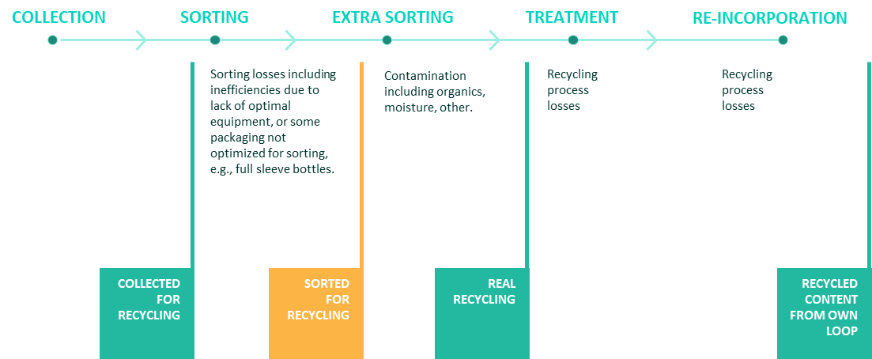
Source: 2021 The 50 States of Recycling: A State-by-State Assessment of Containers and Packaging Recycling Rates.
The primary data source for this study was Washington Ecology generation data, which is estimated using collection and disposal tonnage (i.e., from the “bottom up”). To inform programs in the future, this study also compares the estimated generation rates versus data on material supplied to market from other jurisdictions and sources.
The primary sources of data used for this analysis were:
- 2020-2021 Washington Statewide Waste Characterization Study – which differentiates by residential, commercial, and self-hauled sectors
- 2021 Ecology Statewide Disposal Totals
- 2021 Ecology Recycling Recovery Data – which differentiates by residential and commercial sectors and provides estimates of outbound tonnage
- 2020 King County Material Recovery Assessment – which differentiates by residential and commercial sectors

Tons Recycled
Recycling facilities can report data by material category (e.g., “PET”), or in a consolidated category (e.g., “comingled material”). To account for this difference, the data had to be standardized and broken down into the material categories agreed for this study, detailed in Table 4. The material categories also align with those used in the 2020-2021 Washington Statewide Waste Characterization Study.
Table 4: Material Categories
Material | Description
#1 PET Bottles | Any plastic bottles bearing the #1 symbol
#1 PET Other Packaging | Non-bottle plastic that bears a #1 symbol
#2 HDPE Natural Bottles | Any natural bottle including the #2 symbol (e.g., milk jugs, water jugs)
#2 HDPE Colored Bottles | Any opaque bottle including the #2 symbol (e.g., detergent bottles)
#2 HDPE Other Packaging | Jars or tubs bearing the #2 that are non-bottle, e.g., yogurt tubs.
#3 PVC Packaging | Plastic bottle or container with a #3 symbol
#4 LDPE Packaging | Plastic bottle or container with a #4 symbol
#5 PP Packaging | Plastic packaging with a #5 symbol, as well as plastic straws
#6 PS Packaging | Plastic packaging marked with a #6 symbol (e.g., plastic to go beverage cups)
#7 Other Packaging | Includes all non-numbered plastic packaging as well as plastic packaging marked with a #7
Expanded Polystyrene Packaging | Includes packing peanuts, coolers, egg cartons, take out containers and other EPS packaging
R/C Plastic Packaging | Remainder/composite rigid packaging
PLA/Compostable Packaging | Compostable plastic packaging
PE Plastic Bags & Film | Mono-material plastic PE film (e.g., retail bags, bread bags)
Other Plastic Film & Flexible Packaging | Non-PE and composite film
Steel Cans | Cans and containers made out of ferrous steel (e.g., pet food cans)
Aluminum Cans | Aluminum beverage and non-beverage cans
Other Nonferrous Metal | Metallic packaging that is not aluminum or derived from ferrous metals, such as food trays, pet food cases, non-scrap
Newspaper | Printed newsprint, including magazines delivered with newspaper
Cardboard | Unwaxed Kraft paper and corrugated products
Mixed Paper Products | All other paper products (e.g., high grade paper, magazines, journals, compostable paper packaging)
Cartons | Aseptic and gable-top containers
Paper Packaging | Non-cardboard fiber packaging material including paperboard, egg cartons, packing materials.
Container Glass | Food or beverage glass containers
The process carried out to standardize the data, so that the tons of material recycled could be calculated on a like-for-like basis for each material by generator, involved:
- Step 1: Tons reported to Ecology as recycled were totaled by county, material category and sector (commercial, residential, self-hauled).
- Step 2: Non-packaging categories (e.g., ferrous scrap metal) were subtracted from the dataset.
- Step 3: Where it was necessary to reconcile data because material was reported at a less granular material category level (e.g., “comingled material”), recycling tonnages were split into a common format using the compositional splits calculated in the 2020-2021 King County Material Recovery Facility Assessment.
- Step 4: The recycling data supplied by Ecology also included material designated as “recycling residuals” – material that is collected for recycling but not accepted at the facility (due to contamination) or material that is missorted into the residue stream at the sorting stage. This material is disposed after sorting and is not recycled. To calculate the composition of the residues, the 2020-2021 King County Material Recovery Facility Assessment residue compositional percentages were applied to tons reported in the recycling residuals category.
Recycling data was aggregated for each waste generation area (WGA) so that recycling tonnages by region could be calculated. As shown in Figure 5, the state is divided into six areas, which are used in Washington’s waste characterization studies. Having six sets of recycling tonnages allowed for comparison across areas to identify anomalies.
Figure 5: Map of Waste Generation Areas
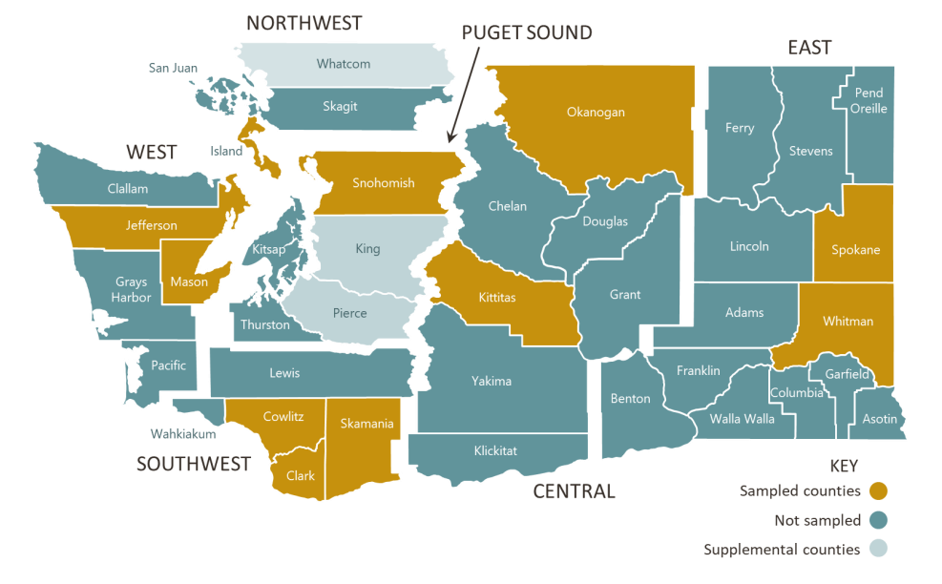
Source: 2020-2021 Washington Statewide Waste Characterization Study.

Tons Disposed by Material
Disposed MSW totals were provided for each of the six WGAs in Washington by Ecology for 2021. This data comes from required annual facility reports under landfill reporting requirements (Chapter 173-351, Washington Administrative Code), compiled by Ecology. The disposal totals do not distinguish between residential, commercial, or self-haul disposed tonnages. The disposal totals were broken into these three sectors using the Ecology 2020-2021 Washington Statewide Waste Characterization Study. The study calculates the split of residential, commercial, and self-hauled material in each WGA. Table 5 shows the percentage split by generator in each WGA:
Table 5: Sector Breakdown for Disposed Material
Sector | Central | East | Southwest | Puget Sound | Northwest | West | Statewide
Commercial (% of Disposed Material) | 42% | 44% | 55% | 13% | 48% | 47% | 29%
Residential (% of Disposed Material) | 36% | 40% | 28% | 54% | 29% | 31% | 45%
Self-Haul (% of Disposed Material) | 22% | 17% | 17% | 33% | 24% | 22% | 27%
Source: 2020-2021 Washington Statewide Waste Characterization Study
The splits in the table above were applied to the total waste disposed in each WGA as provided by Ecology. These sector disposal totals were then broken down into granular material categories using the disposal characterizations from the 2020-2021 Statewide Waste Characterization Study. Self-haul material was separated into residential and commercial sectors using an assumed proportion of 2/3 residential and 1/3 commercial.

Tons Generated
The recycling and disposal data were then combined to estimate the total generation of each material within Washington. Data for the disposal totals includes waste disposed by municipal or private haulers, as well as self-hauled (i.e., by residents themselves) municipal solid waste.

Recycling Rate based on Generation
The recycling rate was calculated by dividing the total tons sorted for recycling by the tons of material generated.

CCCP Sold/Supplied into Washington
Engrossed Substitute Senate Bill 5693, section 302 (59) specifically requested that the study assess consumer packaging and paper products sold or supplied into Washington State and the recycling rates achieved for these materials through existing programs and activities. As producers are currently not required to report on what they sell into Washington, alternative approaches were considered and modelled. Data from the following sources was used to estimate the quantity of consumer packaging and paper products by material sold into the state:
- Stewardship reports from jurisdictions where producers are required to submit their annual sales totals (Stewardship Ontario & The Beer Store data, RecycleBC and ReturnIt data)
- Published industry datasets on annual sales nationally (NAPCOR, Glass Packaging Institute, Association of Plastic Recyclers, Can Manufacturers Institute)
- Third-party analyses of sales data from consultants and non-profit organizations ("2018 Beverage Market Data Analysis”, The Container Recycling Institute, 2020. Circular Ventures LLC.)
Data from the US Environmental Protection Agency (US EPA) was also used as a comparison source, as the EPA uses industry-reported sales data in some of its material estimates.
Using the above data involved various challenges:
- Not all data sets included both commercial and residential material. For example, EPR data for Ontario, published by Stewardship Ontario, and for British Columbia, published by Recycle BC, does not include commercial tonnage.
- Some data sets did not include beverage containers. In Ontario, beer containers are collected through a deposit system managed by the Beer Store, and in British Columbia all beverages are included in the province’s deposit program, managed by ReturnIt.
- Industry data is often reported on the sales of units of materials, rather than the tonnage, forcing reliance on average weights; additionally, sales are not separated into the commercial versus the residential sector.
- Rarely does one source provide material-specific, sector-by-sector estimates for all consumer packaging and paper products packaging, and this requires that data sources be combined. Additionally, categories are not uniform, and must be broken down into more granular material categories using external material composition splits.
The comparison normalized each data source by population, so that a comparative pounds (lbs) per capita measure could be matched against the Washington per capita generation data.
The data were converted to a per capita figure and compared to the Ecology per capita generation data. Results of the analysis of supply data versus the Ecology generation data are discussed further in Section 2.2.

Tons Generated, Disposed and Recycled
Table 6 shows the material flows for all consumer packaging and paper products in Washington for calendar year 2021, including both the residential and commercial sectors. The table details the total tons of each material generated as well as the tons disposed and recycled, based on data from Ecology and the 2020-2021 Statewide Waste Characterization Study. A separate, in-depth analysis is discussed using industry and other jurisdictional and third-party sources following the presentation of results in this study.
Table 6: Statewide Commercial and Residential Material Flows (in tons) and Recycling Rates (2021)
Material | Disposed - Garbage | Disposed -MRF Residue | Total Disposed | Recycled | Total Generated | Recycling Rate
Total Rigid Plastics | 222,100 | 24,500 | 246,600 | 68,100 | 314,700 | 22%
#1 PET Bottles | 39,800 | 7,500 | 47,300 | 30,600 | 77,900 | 39%
#1 PET Other Packaging | 21,600 | 1,400 | 23,000 | 7,300 | 30,300 | 24%
#2 HDPE Natural Bottles | 10,530 | 860 | 11,390 | 11,200 | 22,590 | 50%
#2 HDPE Colored Bottles | 13,600 | 1,400 | 15,000 | 8,700 | 23,700 | 37%
#2 HDPE Other Packaging | 14,100 | 280 | 14,380 | 2,200 | 16,580 | 13%
#3 PVC Packaging | 54 | 0 | 54 | 0 | 54 | 0%
#4 LDPE Packaging | 92 | 0 | 92 | 0 | 92 | 0%
#5 PP Packaging | 42,000 | 11,700 | 53,700 | 6,100 | 59,800 | 10%
#6 PS Packaging | 5,950 | 250 | 6,200 | 1,100 | 7,300 | 15%
#7 Other Packaging | 40,000 | 0 | 40,000 | 0 | 40,000 | 0%
Expanded Polystyrene Packaging | 32,600 | 1,100 | 33,700 | 900 | 34,600 | 3%
R/C Plastic Packaging | 340 | 0 | 340 | 0 | 340 | 0%
PLA/Compostable Packaging | 1,440 | 0 | 1,440 | 0 | 1,440 | 0%
Total Flexible Plastics | 203,000 | 21,700 | 224,700 | 8,000 | 232,700 | 3%
PE Plastic Bags & Film | 88,800 | 10,000 | 98,800 | 5,300 | 104,100 | 5%
Other Plastic Film & Flexible Packaging | 114,200 | 11,700 | 125,900 | 2,700 | 128,600 | 2%
Total Metals | 58,400 | 9,700 | 68,100 | 48,400 | 116,500 | 42%
Steel Cans | 26,000 | 1,900 | 27,900 | 15,800 | 43,700 | 36%
Aluminum Cans | 20,900 | 2,800 | 23,700 | 19,100 | 42,800 | 45%
Other Nonferrous Metal | 11,500 | 5,000 | 16,500 | 13,500 | 30,000 | 45%
Total Paper & Cardboard | 693,500 | 76,000 | 769,500 | 1,096,410 | 1,865,910 | 59%
Newspaper | 17,200 | 1,400 | 18,600 | 59,100 | 77,700 | 76%
Cardboard | 279,000 | 12,800 | 291,800 | 718,000 | 1,009,800 | 71%
Mixed Paper Products | 225,300 | 41,700 | 267,000 | 246,600 | 513,600 | 48%
Cartons | 26,600 | 0 | 26,600 | 210 | 26,810 | 1%
Paper Packaging | 145,400 | 20,100 | 165,500 | 72,500 | 238,000 | 30%
Total Container Glass | 98,000 | 8,300 | 106,300 | 71,500 | 177,800 | 40%
Total CPPP | 1,275,000 | 140,000 | 1,415,000 | 1,292,000 | 2,708,000 | 48%
Total Beverage Containers | 127,000 | 18,100 | 144,900 | 121,500 | 266,400 | 46%
Source: Eunomia Modelling, 2021 Ecology Recycling Data, 2020-2021 Statewide Waste Characterization Study, Industry Data, City of Tacoma Solid Waste Management, "2018 Beverage Market Data Analysis," The Container Recycling Institute, 2020.
Table 7 shows the estimated statewide material flow for the residential sector, while Table 8 shows the estimated statewide material flow for the commercial sector.
Table 7: Statewide Residential Material Flow in tons and Recycling Rates (2021)
Material | Disposed - Garbage | Disposed -MRF Residue | Total Disposed | Recycled | Total Generated | Recycling Rate
Total Rigid Plastics | 134,500 | 5,000 | 139,400 | 36,600 | 176,000 | 21%
#1 PET Bottles | 29,800 | 1,500 | 31,300 | 16,600 | 47,900 | 35%
#1 PET Other Packaging | 15,400 | 280 | 15,680 | 3,700 | 19,380 | 19%
#2 HDPE Natural Bottles | 6,920 | 180 | 7,100 | 4,400 | 11,500 | 38%
#2 HDPE Colored Bottles | 9,700 | 280 | 9,980 | 5,400 | 15,380 | 35%
#2 HDPE Other Packaging | 4,590 | 57 | 4,647 | 1,600 | 6,247 | 26%
#3 PVC Packaging | 20 | 0 | 20 | 0 | 20 | 0%
#4 LDPE Packaging | 77 | 0 | 77 | 0 | 77 | 0%
#5 PP Packaging | 28,900 | 2,380 | 31,280 | 3,700 | 34,980 | 11%
#6 PS Packaging | 3,900 | 48 | 3,948 | 650 | 4,598 | 14%
#7 Other Packaging | 14,300 | 0 | 14,300 | 0 | 14,300 | 0%
Expanded Polystyrene Packaging | 19,500 | 230 | 19,730 | 570 | 20,300 | 3%
R/C Plastic Packaging | 340 | 0 | 340 | 0 | 340 | 0%
PLA/Compostable Packaging | 1,046 | 0 | 1,046 | 0 | 1,046 | 0%
Total Flexible Plastics | 112,300 | 4,400 | 116,700 | 3,590 | 120,290 | 3%
PE Plastic Bags & Film | 45,400 | 2,000 | 47,400 | 2,090 | 49,490 | 4%
Other Plastic Film & Flexible Packaging | 66,900 | 2,400 | 69,300 | 1,500 | 70,800 | 2%
Total Metals | 41,390 | 1,970 | 43,360 | 36,700 | 80,060 | 46%
Steel Cans | 17,400 | 400 | 17,800 | 11,900 | 29,700 | 40%
Aluminum Cans | 15,300 | 570 | 15,870 | 11,800 | 27,670 | 43%
Other Nonferrous Metal | 8,690 | 1,000 | 9,690 | 13,000 | 22,690 | 57%
Total Paper & Cardboard | 367,790 | 15,480 | 383,270 | 489,347 | 872,617 | 56%
Newspaper | 13,760 | 280 | 14,040 | 40,000 | 54,040 | 74%
Cardboard | 142,500 | 2,600 | 145,100 | 258,000 | 403,100 | 64%
Mixed Paper Products | 117,870 | 8,500 | 126,370 | 142,800 | 269,170 | 53%
Cartons | 9,060 | 0 | 9,060 | 47 | 9,107 | 1%
Paper Packaging | 84,600 | 4,100 | 88,700 | 48,500 | 137,200 | 35%
Total Container Glass | 78,000 | 1,700 | 79,700 | 56,300 | 136,000 | 41%
Total CPPP | 734,000 | 29,000 | 762,000 | 623,000 | 1,385,000 | 45%
Total Beverage Containers | 94,270 | 3,600 | 97,970 | 82,120 | 179,990 | 46%
Source: Eunomia Modelling, 2021 Ecology Recycling Data, 2020-2021 Statewide Waste Characterization Study, Industry Data, City of Tacoma Solid Waste Management, "2018 Beverage Market Data Analysis," The Container Recycling Institute, 2020.

Table 8: Statewide Commercial Material Flow in tons and Recycling Rates (2021)
Material | Disposed - Garbage | Disposed -MRF Residue | Total Disposed | Recycled | Total Generated | Recycling Rate
Total Rigid Plastics | 87,700 | 19,500 | 107,200 | 31,600 | 138,800 | 23%
#1 PET Bottles | 10,000 | 6,000 | 16,000 | 14,100 | 30,100 | 47%
#1 PET Other Packaging | 6,170 | 1,100 | 7,270 | 3,600 | 10,870 | 33%
#2 HDPE Natural Bottles | 3,610 | 680 | 4,290 | 6,700 | 10,990 | 61%
#2 HDPE Colored Bottles | 3,900 | 1,100 | 5,000 | 3,400 | 8,400 | 40%
#2 HDPE Other Packaging | 9,540 | 220 | 9,760 | 610 | 10,370 | 6%
#3 PVC Packaging | 35 | 0 | 35 | 0 | 35 | 0%
#4 LDPE Packaging | 15 | 0 | 15 | 0 | 15 | 0%
#5 PP Packaging | 13,090 | 9,300 | 22,390 | 2,400 | 24,790 | 10%
#6 PS Packaging | 2,050 | 200 | 2,250 | 490 | 2,740 | 18%
#7 Other Packaging | 25,770 | 0 | 25,770 | 0 | 25,770 | 0%
Expanded Polystyrene Packaging | 13,100 | 890 | 13,990 | 330 | 14,320 | 2%
R/C Plastic Packaging | 0 | 0 | 0 | 0 | 0 | 0%
PLA/Compostable Packaging | 400 | 0 | 400 | 0 | 400 | 0%
Total Flexible Plastics | 90,700 | 17,300 | 108,000 | 4,400 | 112,400 | 4%
PE Plastic Bags & Film | 43,300 | 8,000 | 51,300 | 3,200 | 54,500 | 6%
Other Plastic Film & Flexible Packaging | 47,400 | 9,300 | 56,700 | 1,200 | 57,900 | 2%
Total Metals | 16,960 | 7,800 | 24,760 | 11,670 | 36,430 | 32%
Steel Cans | 8,540 | 1,600 | 10,140 | 3,800 | 13,940 | 27%
Aluminum Cans | 5,600 | 2,200 | 7,800 | 7,400 | 15,200 | 49%
Other Nonferrous Metal | 2,820 | 4,000 | 6,820 | 470 | 7,290 | 6%
Total Paper & Cardboard | 330,690 | 60,500 | 391,190 | 601,870 | 993,060 | 61%
Newspaper | 3,440 | 1,100 | 4,540 | 19,200 | 23,740 | 81%
Cardboard | 136,370 | 10,200 | 146,570 | 460,000 | 606,570 | 76%
Mixed Paper Products | 112,180 | 33,200 | 145,380 | 98,500 | 243,880 | 40%
Cartons | 17,500 | 0 | 17,500 | 170 | 17,670 | 1%
Paper Packaging | 61,200 | 16,000 | 77,200 | 24,000 | 101,200 | 24%
Total Container Glass | 19,870 | 6,600 | 26,470 | 15,200 | 41,670 | 36%
Total CPPP | 546,000 | 112,000 | 658,000 | 665,000 | 1,322,000 | 50%
Total Beverage Containers | 32,600 | 14,200 | 46,900 | 39,600 | 86,300 | 46%
Source: Eunomia Modelling, 2021 Ecology Recycling Data, 2020-2021 Statewide Waste Characterization Study
Figure 6 shows the statewide recycling rate for each higher-level material grouping, organized from highest generation to lowest generation, across all sectors (residential and commercial). The chart shows the tons disposed and recycled, along with the recycling rate as a percentage above the bar for each material. The disposed tons and recycled tons put together equal the total number of tons generated for each material.
Figure 6: CPPP Materials Organized by Generation with Recycling Rates (2021)
Source: Eunomia Modelling, 2021 Ecology Data, 2021 Washington Statewide Waste Characterization Study
The statewide recycling rate for all consumer packaging and paper products material is estimated to be 48%. Material-specific findings are described below. All percentages are expressed as the percentage of weight of material (rather than volume or units of material, for example).
In addition to the CPPP mentioned in the graph above, 65,000 tons of plastic products were also disposed in Washington in 2021. This includes plastic utensils, hard plastic toys, and other unidentifiable plastic products.
This study examined the breakdown of material generation from the residential and commercial sectors. Table 9 shows the percentage of material tonnage estimated to be generated from the commercial versus the residential sectors. For example, 58% of rigid plastics are generated from the residential sector, while the other 42% is generated from the commercial sector.
Table 9: Generation of Material by Sector
Material | % of Material Generated from Residential sector | % of Material Generated from Commercial sector
Rigid Plastics | 56% | 44%
Flexible Plastics | 52% | 48%
Metals Packaging | 69% | 31%
Paper & Cardboard | 47% | 53%
Container Glass | 76% | 24%
All CPPP | 51% | 49%
Beverage Containers | 49% | 51%
CPPP generated is split nearly equally (within two percentage points) across the residential and commercial sectors. The commercial sector generates more of the paper and cardboard category, which has the highest generation of all the CPPP materials; therefore, the commercial paper and cardboard stream may present an opportunity for increased diversion through potential policies as universal recycling collection.
The section below goes into further detail into the specific material categories shown in Table 6, Table 7, and Table 8.
Paper and Cardboard
- Cardboard is the largest component of consumer packaging and paper products generated, and it represents the second largest category of consumer packaging and paper products material disposed statewide. This category includes secondary packaging from the commercial sectors as well as boxed packaging associated with e-commerce. Nearly 1 million tons are generated, which account for 37% of all consumer packaging and paper generated in the state, with 71% recycled (Table 6). However, cardboard is also the largest component of the CPPP stream that is disposed, representing 20% of all consumer packaging and paper CPPP disposed (Table 6). The commercial sector accounts for 60% of the cardboard generated, but only 50% of the cardboard disposed (Table 7 and Table 8). This disparity is because the commercial recycling rate for cardboard is higher (76%) than the residential sector cardboard recycling rate (64%) (Table 7 and Table 8).
- Mixed paper products comprise the second largest component of CPPP generated, accounting for 19% of the generation (Table 6) with a recycling rate of 48% (Table 6). This material category includes low-grade recyclable papers, including colored papers, notebook or other lined paper, envelopes with plastic windows, non-corrugated paperboard, carbonless copy paper, shredded paper, and junk mail.
- Paper packaging (e.g., cereal boxes) has a recycling rate of 25% and makes up 9% of the consumer packaging and paper products generated in the state (Table 6). Paper packaging is 12% of the CPPP disposed, three percentage points higher than its generation share of 9% (Table 6).
Rigid Plastics
- All rigid plastics make up 12% of CPPP generated, with 22% being recycled (Table 6). Rigid plastics are 17% of all CPPP disposed (Table 6). The commercial sector has higher recycling rates of rigid plastics overall – 24% compared to the residential sector’s rate of 20% (Table 7 and Table 8).
- PET bottles constitute the largest proportion of rigid plastics, accounting for 3% of consumer packaging and paper products generated and 25% of rigid plastics generated (Table 6). PET bottles are estimated to have a recycling rate of 39% in 2021 (Table 6). The residential sector accounts for 61% of PET bottles generated and 66% of PET bottles disposed (Table 7).
- Natural HDPE bottles (e.g., milk bottles) have a higher recycling rate at 50% compared to colored (e.g., detergent bottles) at 37% (Table 6). Natural HDPE bottles and colored HDPE bottles are each 1% of overall CPPP generation and 1% of CPPP disposed (Table 6).
Flexible Plastics
- Flexible plastic packaging has two categories in each of Table 6, Table 7, and Table 8 above. Those categories are PE plastic bags and film (e.g., plastic retail bags) and other plastic film and flexible packaging (e.g., composite packaging). The former film category, PE plastic bags and film, is primarily collected through retail takeback programs or reverse logistics from businesses. Retail collection programs ask for pure PE film to be returned, as opposed to multi-material composite packaging. The majority of reverse logistics PE film is returned through the commercial sector. Commercial sector film is clean film with a much higher value than curbside film. The density of the back of house film is different from the grocery bags and consumers films added to this stream from front of house. The commercial sector has a PE plastic bag and film recycling rate of 6%, while the residential sector has a rate of 4% (Table 7 and Table 8).
- Only 1% of single-family households in Washington have access to curbside film collection, as MRF operators often do not often accept plastic film. This refusal is because plastic films can clog the sorting infrastructure, leading to shutdowns that require manual removal of the film. Other plastic film and flexible packaging (e.g., multi-material film, any non-mono-material PE film) contains a higher proportion of harder to recycle plastic film, such as composite film, and as a result has a lower recycling rate compared to PE plastic bags and film. Combining these two film categories across sectors together yields a recycling rate of 5% and a disposal tonnage of 224,700. The disposed tonnage of plastic film is greater than the disposed tonnages of container glass (106,300) and paper packaging (165,500) respectively for the entire state. Although PE film has recycling end markets, it is not collected in high enough quantities or at high enough quality levels to reach these end markets, as curbside film is deemed too contaminated or dirty by mechanical recyclers.
Metal
- Aluminum cans, steel cans, and other non-ferrous metals (e.g., trays, pet food containers) account for 4% of consumer packaging and paper products generated, as well as 4% of the total tons recycled (Table 6). Metals have a combined recycling rate of 42% and account for 5% of CPPP disposed in total (Table 6).
- Steel cans account for the greatest proportion (38%) of all metal CPPP generated (Table 6). Steel cans have a recycling rate of 36% and comprise 2% of CPPP generated and disposed (Table 6).
- Other nonferrous metals (e.g., food trays, pet food) have the highest recycling rate of the metals group at 45%. Other nonferrous packaging is 1% of the CPPP generated and 1% of CPPP disposed in Washington (Table 6).
- The residential sector has a total metals recycling rate that is 14 percentage points higher than the commercial sectors (46% to 32%) (Table 7 and Table 8).
Container Glass
- The 2021 recycling rate for all container glass is estimated at 39%. In a previous study using 2017 data, container glass was estimated to have a 60% recycling rate in Washington. One of the primary reasons for this decrease is because of a refinement to the state-wide waste characterization methodology, which has allowed for a more accurate estimate of the container glass stream within the disposed streams. In addition to this, several municipalities have stopped collecting glass at the curb, which will also have been reflected in the 2021 numbers. Glass container recycling rates are similar across the residential and commercial sectors.
Beverage Containers
- A separate assessment of the beverage container recycling rate was also undertaken, which includes #1 PET bottles, plastic beverage bottles, aluminum cans, carton beverage containers, glass beverage bottles, and aluminum cans. An estimated 274,100 tons of beverage containers were generated in Washington in 2021, of which glass beverage containers were the greatest proportion at 58% of the waste stream. Estimates for the tonnage of beverage containers generated, disposed within the municipal waste stream, disposed within the MRF residues, and recycled are shown inTable Table 10 below.
Table 10: Statewide Material Flows in tons and Recycling Rates for Beverage Containers (2021)
Beverage Container | Disposed - Garbage | Disposed -MRF Residue | Total Disposed | Recycled | Beverage Containers Generated | Beverage Container Recycling Rate (%) | Beverage Container Generation as % of Whole Material Category
All Plastic Beverage Containers | 38,000 | 7,700 | 45,500 | 37,300 | 82,800 | 45% | 67%
#1 PET Beverage Containers | 28,100 | 6,800 | 34,900 | 27,600 | 62,400 | 44% | 80%
#2 HDPE Natural Beverage Containers | 8,600 | 700 | 9,200 | 8,800 | 18,000 | 49% | 80%
#2 HDPE Colored Beverage Containers | 1,300 | 200 | 1,400 | 900 | 2,400 | 38% | 10%
Aluminum Beverage Cans | 17,500 | 2,700 | 20,200 | 18,400 | 38,600 | 48% | 90%
Carton Beverage Containers | 11,600 | 0 | 11,600 | 100 | 11,700 | 1% | 44%
Glass Beverage Containers | 59,900 | 7,700 | 67,600 | 65,700 | 133,300 | 49% | 75%
All Beverage Containers | 127,000 | 18,100 | 144,900 | 121,500 | 266,400 | 46% | 72%
Sources: Eunomia Modelling, Industry Data, City of Tacoma Solid Waste Management, Glass Packaging Institute Data, 2021 Ecology Data, 2021 Washington Statewide Waste Characterization Study
Beverage containers are estimated to have higher recycling rates than non-beverage containers, as beverage containers make up a higher proportion of the recycling stream relative to the disposal of beverage versus non-beverage containers. Table 11 below shows the results of the City of Tacoma’s waste sort on beverage containers within the recycling and disposal stream.
Table 11: Beverage Containers as a Proportion of Recycling & Disposal Streams
Beverage Container | Proportion of Disposal that is Beverage Containers | Proportion of Recycling that is Beverage Containers
PET Bottles | 75% | 90%
HDPE Bottles | 5% | 5%
Glass Containers | 69% | 92%
Aluminum Cans | 96% | 96%
Cartons | 5% | 5%
Source: City of Tacoma Solid Waste Management
PET beverage bottles make up 90% of the PET bottles recycled but only 75% of the PET bottles disposed. This means that the beverage stream of PET bottles will have a higher recycling rate than the non-beverage stream will. This is true for glass containers as well. For the other beverage containers, the recycling and disposal rates are similar. Aluminum beverage cans make up 96% of aluminum cans disposed and 96% of aluminum cans recycled. Beverage HDPE bottles are 5% of HDPE bottles disposed and 5% of HDPE bottles recycled. Lastly, beverage cartons are 5% of cartons disposed and 5% of cartons recycled. However, for cartons, the Tacoma study only included milk cartons, whereas this analysis includes all beverage cartons. Conversely, the HDPE bottles in the Tacoma study did not include milk bottles, which have been included in this study. Therefore, the values from the Tacoma study were not directly used for HDPE bottles and beverage cartons.
Of PET beverage bottles collected, 20% end up in MRF residue; this figure is estimated as 10.5% for container glass beverage containers and 13% for aluminum beverage cans. In total, an estimated 13% of beverage containers collected are lost to the MRF residue stream. In total 54% of beverage containers are disposed in Washington, with 7 points coming from MRF residue and 48 points coming directly from the garbage/disposal streams.
Figure 7 shows the tons disposed, tons recycled and recycling rate for both beverage containers and the overall material category. For example, it shows that all PET bottles have a 39% recycling rate, but PET beverage bottles by themselves have a 44% recycling rate. The chart also shows the generation of the whole material category (beverage + non-beverage containers) next to the generation of only beverage containers of the same material. Combining the tons disposed and recycled for each bar reveals the total generation. Again, using PET bottles as an example, the chart shows that just 80,000 tons of PET bottles (beverage + non-beverage) were generated in Washington in 2021, while just over 60,000 tons of those PET bottles are only beverage containers.
Figure 7: Recycling Rate of Beverage Containers and Larger Material Category (2021)
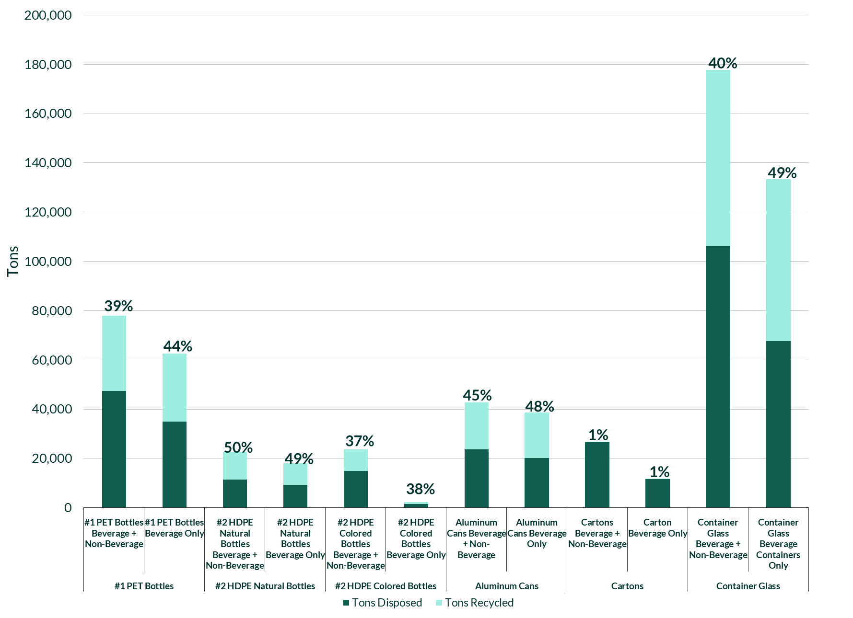
Source: Eunomia Modelling, proprietary data gathered by Eunomia, City of Tacoma Solid Waste Management
Across most material types, beverage containers have a higher recycling rate than non-beverage containers, the only exception being HDPE natural bottles (these are often milk jugs). Glass beverage containers have the highest recycling rate among beverage container categories at 49%. They also have the greatest tonnage generated among beverage containers at just under 140,000 tons. PET beverage bottles are second in terms of generation at just over 60,000 tons. Beverage containers comprise most of the generation of PET bottles, HDPE natural bottles, aluminum cans, and container glass.
Despite beverage containers frequently having higher recycling rates than non-beverage containers of the same material, their rates are still below the average redemption rate for beverage containers in DRS programs in the United States. The average redemption rate in the US for DRS programs was around 70% prior to the COVID-19 pandemic related disruptions. Furthermore, in US DRS programs with at least one type of container covered by a deposit of 10 cents or higher, the average redemption rate is 81%.
Greatest Materials Disposed
Figure Figure 8 below shows the top 10 materials disposed in 2021, based on pounds per capita, for commercial and residential combined. Figure 9 and Figure 10 show the top 10 disposed items by weight for the residential and commercial respectively. These categories are the individual material categories from Table 6, rather than the rolled-up material categories from the same table (e.g., rigid plastics, beverage containers, all paper and cardboard). The beverage container category has a pounds per capita disposed value of 37, which would place it in fourth position in the chart below.
Figure 8: Top Ten Materials Disposed (lbs/capita) –Total 2021
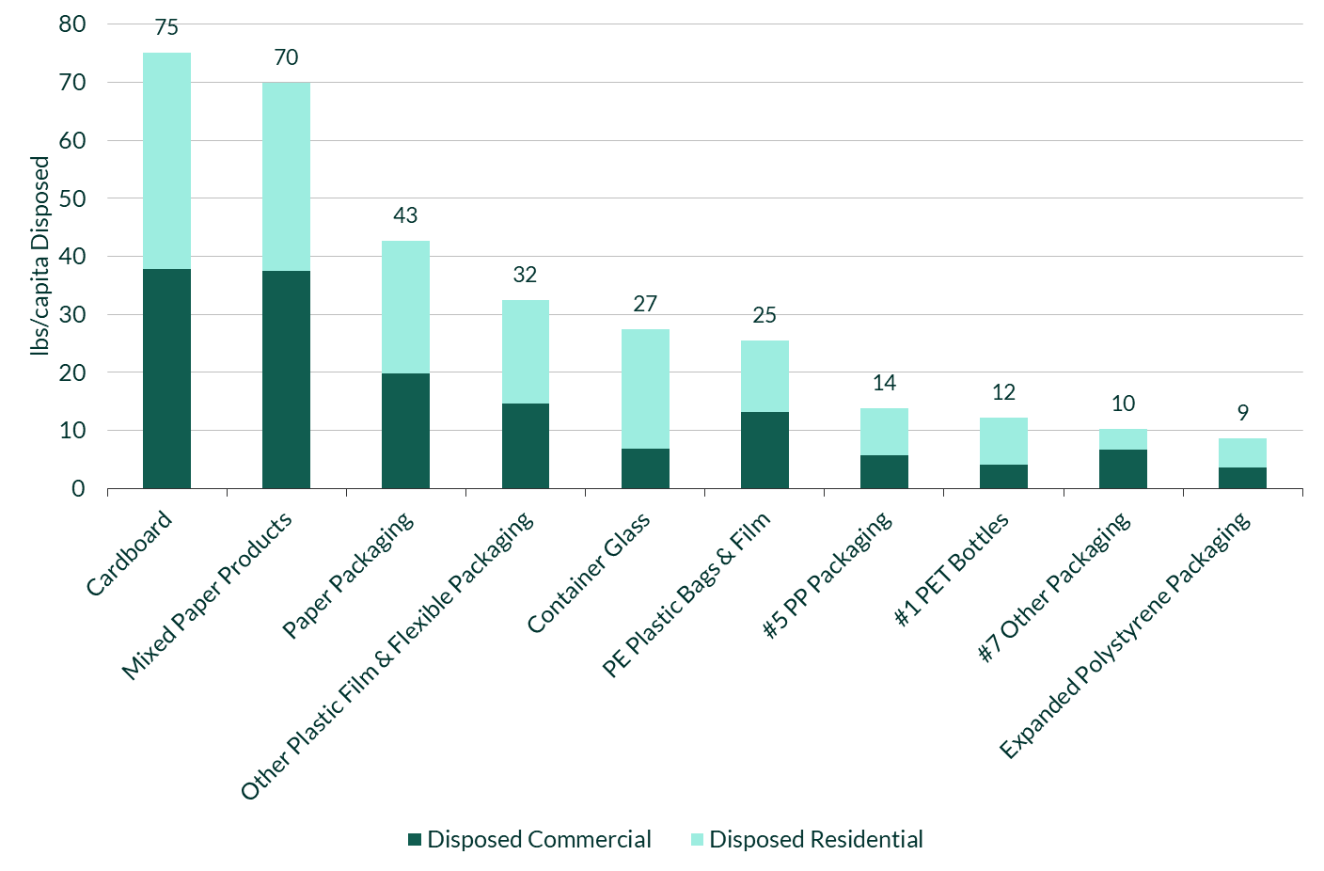Source: Source: Eunomia Calculations, 2021 Ecology Waste Generation and Recovery Data, 2020-2021 Washington Statewide Waste Characterization Study
Figure 9: Top Ten Materials Disposed (lbs/capita) - Residential Sector 2021
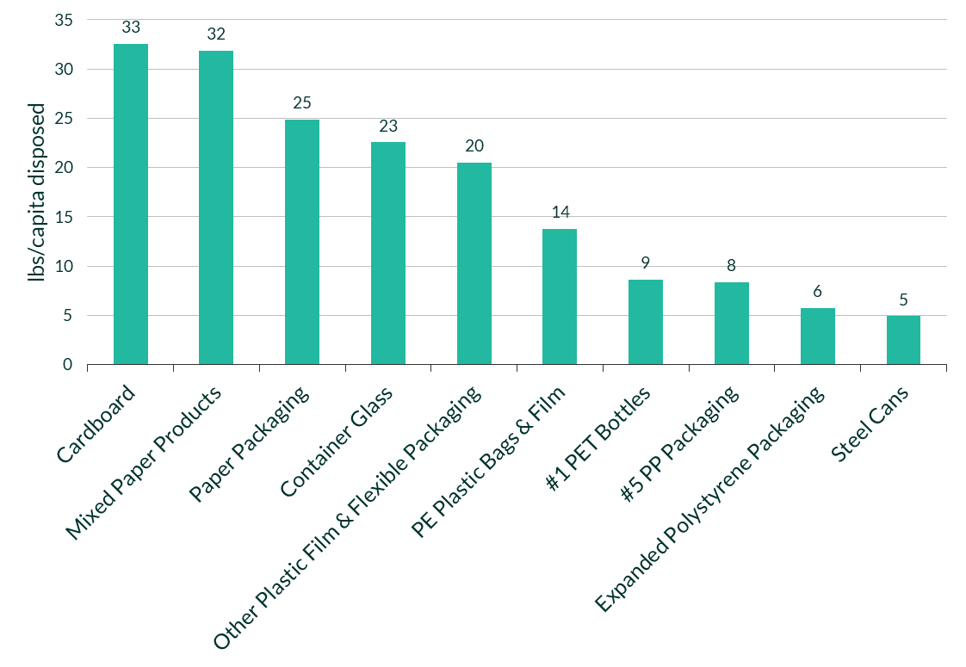
Source: Source: Eunomia Calculations, 2021 Ecology Data, 2021 Washington Statewide Waste Characterization Study
Figure 10: Top Ten Materials Disposed (lbs/capita) - Commercial Sector 2021
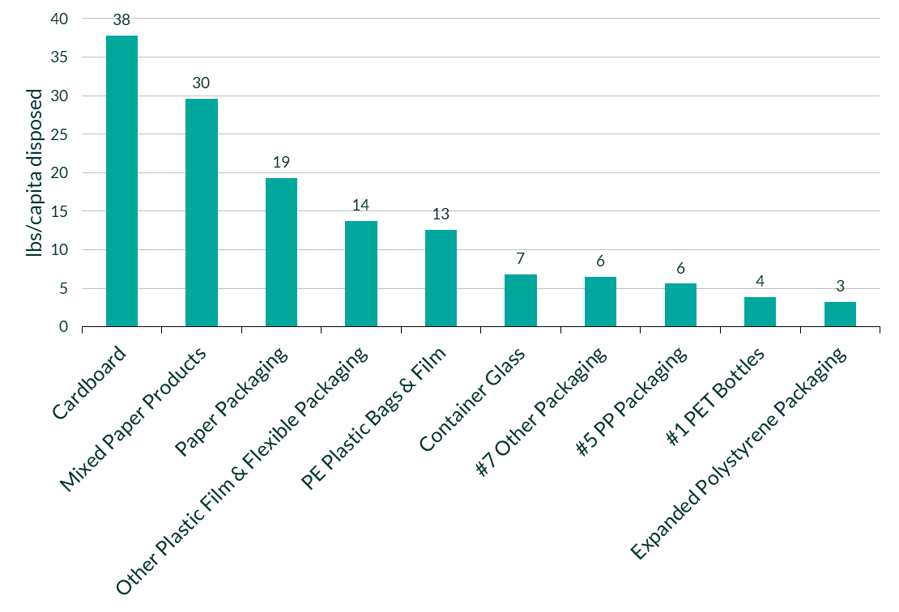
Source: Source: Eunomia Calculations, 2021 Ecology Data, 2020-2021 Washington Statewide Waste Characterization Study
The top 10 list of items by weight disposed per capita is similar across the commercial and residential sectors, with fibers filling the three highest spots in both sectors.
Cardboard, despite having the second highest recycling rate, is also present in the disposal stream in the highest quantities, with 70 pounds per capita of cardboard still being disposed across both sectors. Approximately two-thirds of the cardboard stream is generated from the commercial sector and 76% is recycled from this sector compared to 67% from the household residential sector. Cardboard may be cleaner and bundled into bales for collection in the commercial sector, resulting in a higher recycling rate. Two fiber categories – mixed paper products and paper packaging – are the next two categories present in the greatest quantities in the garbage stream, at 60 and 43 pounds per capita, respectively. In the residential sector, 25 pounds per capita of paper packaging is disposed annually; the commercial sector disposes of 19 pounds per capita annually. These two categories also have lower recycling rates compared to cardboard and newspaper.
Figure 11 below plots the recycling rate for every material on the y-axis against the lbs/capita disposed of that same material on the x-axis. This shows that newspaper has a high recycling rate as well as a low presence in the disposed stream. Cardboard has a high recycling rate but, due to its dominance by weight in the waste stream, still makes up a large percentage of the disposed waste, most of this coming from the commercial sector. Mixed paper products and paper packaging are the next largest material type in the disposed stream and also have a low recycling rate. While films are lightweight, there are significant quantities in the waste stream, and even the PE films for which there are markets (especially for clean commercial material) have a low recycling rate.

Figure 11: Recycling Rate of CPPP vs pounds per capita Disposed
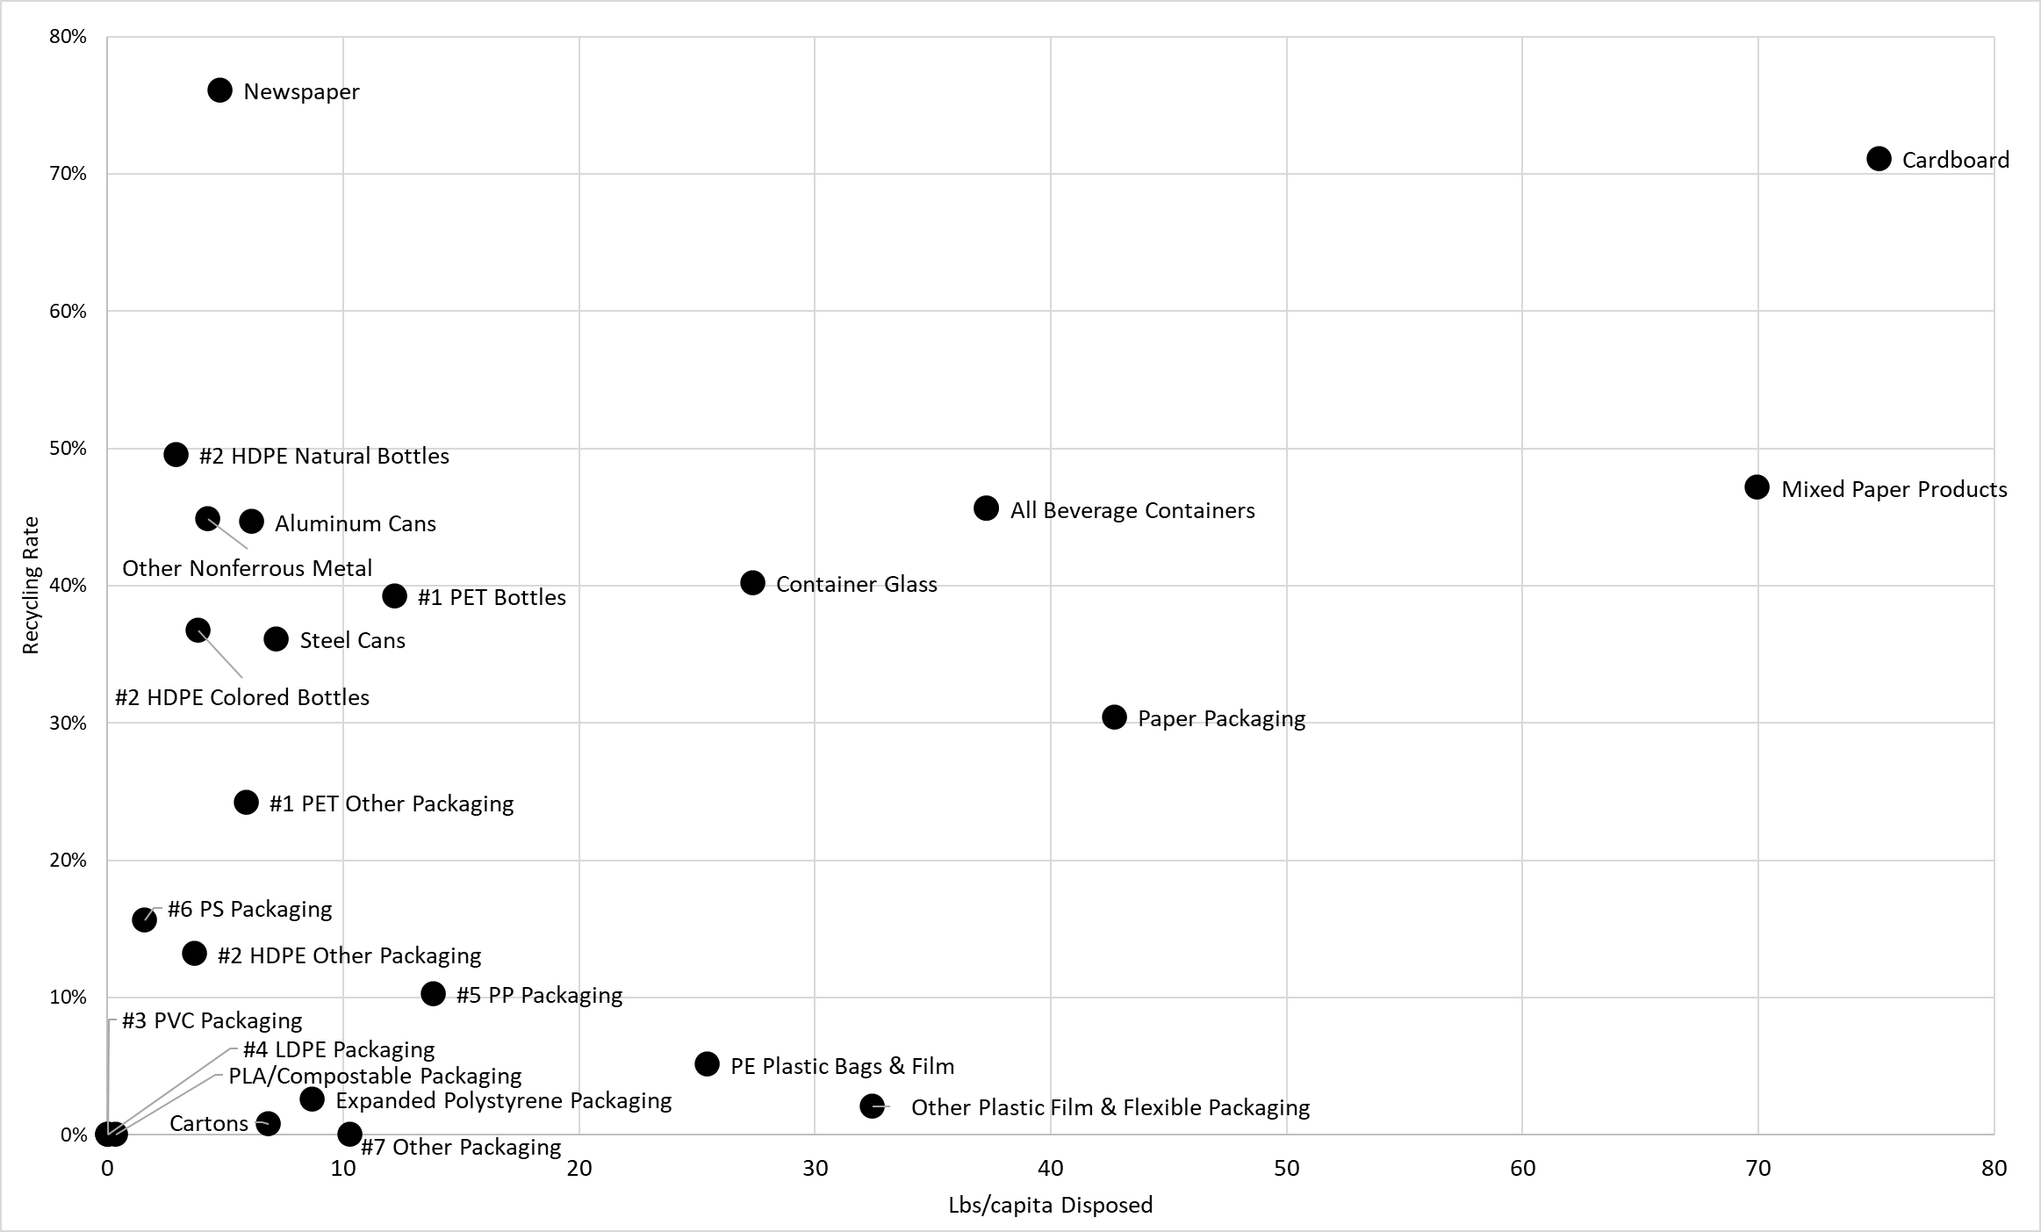
Source: Eunomia Calculations, 2021 Ecology Data, 2021 Washington Statewide Waste Characterization Study
Figure 11 shows which materials perform highly in terms of recycling rate but still have a large quantity disposed. Cardboard has a high recycling rate (73%), yet it has the most pounds per capita disposed as well (70 lbs). Plastic films have low recycling rates (each of the two categories is below 10% recycling), and they have high disposal quantities (25 lbs per capita for PE plastic bag and film, and 32 lbs/capita for other plastic film and flexible packaging). Increasing the recycling rates for cardboard, mixed paper, glass, and plastic film would divert the most material from disposal and increase overall recycling rates significantly.
The beverage container category is an aggregated category of a portion of some of the other materials in the same chart (e.g., it includes parts of container glass, PET bottles, HDPE bottles, and aluminum cans – shown in more detail in Table 2). Altogether, just under 40 pounds per capita of beverage containers are disposed each year. Beverage containers therefore represent an opportunity for increased diversion.

Generation Versus Supply
The recycling rate analysis presented up to this point has been done using generation data or “bottom-up” data, which relies on calculating the total disposal tonnage and total recycling tonnage independently and then adding them together to get overall generation. Another method is to use supply data, or the “top-down” method of deriving the estimated tonnage of material supplied or sold into the market and then comparing recycling tonnages to that figure. Supplied tonnages are often reported by the industries that sell material, as well as by stewardship organizations where they are required to report the supplied tonnages by law. There is no centralized data source for supplied tonnage in Washington state currently.
Producers are not required to report on the quantity of material they supply into Washington or any other state in the US. EPR programs require producers to report supply data, and thus in other jurisdictions such as Ontario and British Columbia there is some producer data on supply. However, this is currently only for the residential sector and it is available in different levels of detail, making direct comparisons with Washington data difficult. Under a mandated reporting system, producers would submit the tonnage of material they supply into the state, providing a more certain denominator to calculate recycling rates.
In addition to incomplete data from EPR programs, there is also material-specific data from industry associations, the EPA, and other research papers by Eunomia and other consultants.
The Washington generation data was accessed via Ecology from reports submitted by various waste management facilities, including transfer stations, landfills, material recovery facilities (MRFs), and secondary processing facilities. In the following sections we compare data from the above sources (EPR programs, industry associations, EPA, and third party organizations) with the generation data in Washington to establish whether some tonnage supplied into Washington is missed in the statewide reporting systems of recycled and disposed material. The true denominator for recycling rates may be higher or lower than what can be calculated using the current Ecology data. This analysis aims to examine how close the current reporting system might be to estimating the supplied tonnage in Washington.

Residential Generation vs Supply Using EPR Data from Canada
In this section, we compare Washington generation data with supply data from two of the larger residential programs in Canada: British Columbia and Ontario. To convert this data to a format that could be compared with Washington residential data, we combined the data reported under the EPR and DRS programs that cover all or some of the beverage containers. Because DRS data contains both commercial and residential tonnages, assumptions had to be made to separate the residential tonnages from the total. The material splits between residential and commercial from the Washington Ecology data for a given material (e.g., PET Bottles) were used to estimate residential versus commercial generation in other jurisdictions.
These steps demonstrate the complexity of trying to use supply data from other sources as a comparison to Washington generation data or as a proxy for the quantity of a material sold into Washington. This is on top of regional differences that may have an impact on consumption and generation.
Figure 12 below compares the residential generation from Washington to the supply rates of various consumer packaging and paper products materials in British Columbia and Ontario on a pounds per capita basis. Note that British Columbia reports its plastic and fiber data at a more consolidated level than Ontario or the Washington categories. For example, PET bottles are generated in British Columbia, but they would fall under the All-Rigid Plastic Packaging category, as this is how the stewardship report rolls up its plastic categories.
Figure 12: Washington Generation versus supply data from EPR Programs in Ontario and British Columbia (annual lbs/capita)
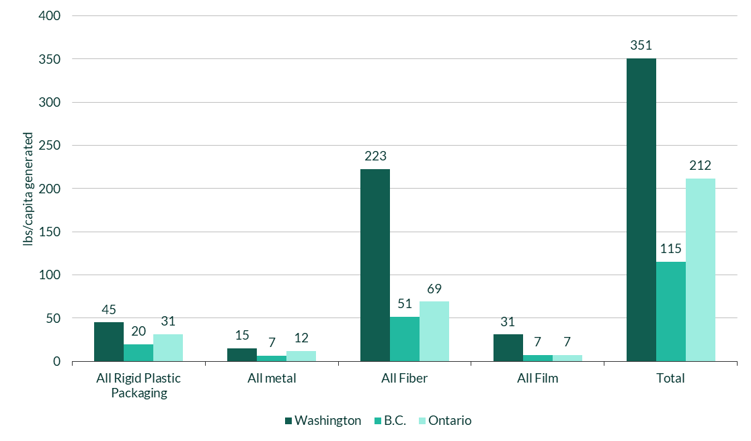
Sources: Eunomia Calculations, Ontario 2022 PIM data, The Beer Store 2020 Operating Report, RecycleBC 2021 Annual Report, ReturnIT 2021 Annual Report
Comparing materials like-for-like across jurisdictions can be difficult based on different reporting categories; however, a few comparisons can be made. It appears that Washington generates more plastic per capita from its residential sector than the stewardship programs report as sold into the two Canadian provinces. The value for all rigid plastic packaging in Washington is 47 pounds per capita, as opposed to 20 and 31 pounds per capita for BC and Ontario, respectively. There also appears to be an order of magnitude difference in the generation of plastic film between Washington and the other two jurisdictions. In most cases, the Washington generation data suggests higher generation per capita than the Canadian programs. There could be multiple reasons for this, including:
- the methodology by Department of Ecology for splitting commercial and residential data;
- the fact that supplied data is calculated with clean, dry material weights, or
- the split of material sold into the residential vs commercial sector in these provinces, and the complexity of using multiple data sources in these other jurisdictions to form a comparison.
Differences in consumption levels between countries could also explain part of the variation. Lastly, with the shift towards working from home in the past two years, it is possible that more material is ending up in the residential waste stream than producers may be calculating when they estimate at the point of sale. Looking at both the residential and commercial sectors together may be more accurate when comparing to other jurisdictions.

Generation versus Industry and EPA Reports
Next, Washington generation data was compared with data sourced from trade organizations and from the EPA, as EPA data relies in part on industry-reported supply data. Industry reports, for example for PET bottles, provide sales data based on the number of units sold each year. In these cases, it is necessary to assume a weight per unit to estimate the tonnage of material sold in order to compare industry data to the generation data. Industry data also often combines residential and commercial sectors; therefore, the comparison in this section has been made using the total Washington generation data that includes both sectors.
Figure 13: Washington Generation versus Industry Reports and EPA Data (annual lbs/capita)
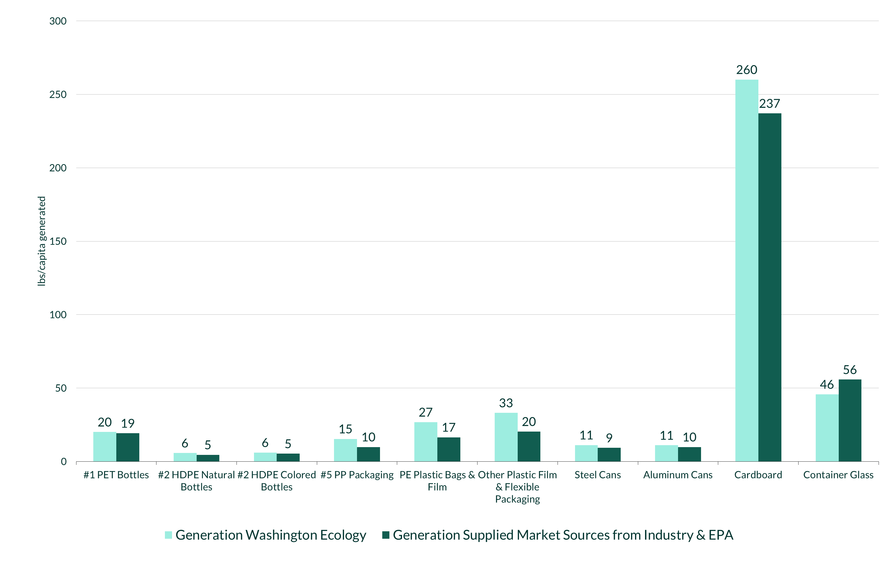
Sources: Eunomia Calculations, NAPCOR 2018, Can Manufacturers Institute 2020, Association of Plastics Recyclers 2020, Other Proprietary Industry Data., EPA 2018 Advancing Sustainable Materials Management: Facts and Figures Report
Compared with industry reports and EPA data, Washington Ecology generation data appears to be similar for most of the rigid plastics categories. PET bottles, HDPE bottles, HDPE other packaging, and aluminum cans are all within 1-2 pounds per capita between the generation and industry data. The quantity of these materials has been measured and monitored by industry for many years, so this alignment could be expected. A possible reason for the slight difference for these materials is explored below.
The quantity of plastic films generated in Washington is significantly higher than that reported by industry. The reason for this difference is likely to do with the difficulty in accurately collecting this data at a national level due to the complexity of the stream. Plastic film as a stream of material has also been far less analyzed and tracked compared to rigid plastics. Washington’s waste characterization data is sufficiently granular to estimate this stream.
Glass containers generated per capita are higher in the industry data than in the Washington waste generation data. This may be because the generation data is aggregated from waste characterizations, where glass is often broken and may be in a “fines” category, which could be missed in the final tally.
For all material, it is expected that the Washington Ecology generated data will be higher than the industry-supplied data. The reason for this is that the former includes residue substances such as liquids, moisture, and dirt. Eunomia has previously estimated the moisture/dirt/residue rate as being between 2-23% depending on the material, as shown in Table 12 below. This may explain some of the variation between supplied data sources and the Washington generation data. However, certain estimates, particularly for cardboard, in the “Generation vs Third Party Reports” section below are higher than the Washington generation data, suggesting dirt and moisture are not the sole reason for differences.
Table 12: Estimated Dirt and Moisture Residue as a Percentage of Sorted Material
Material | Dirt/Moisture/Residues Percentage
PET bottles | 11%
PET other rigid | 11%
HDPE bottles | 5%
PP Rigid | 9%
Rigid plastics #3-7 | 11%
Plastic films | 6%
Cardboard/boxboard | 5%
Other paper packaging | 18%
Cartons | 23%
Glass bottles and jars | 2%
Aluminum cans | 2%
Steel cans | 5%
Residue may explain some of the difference, but not all. For PET bottles, the Ecology data is 4% higher than the NAPCOR data and the moisture levels may account for 4% of the weight. Ecology data for HDPE Natural bottles are 26% greater than the industry sources and HDPE colored bottles are 16% greater; it is unlikely that this variance is a result of these factors alone. The cardboard moisture and dirt levels are low in the recycling stream, as a large percentage of the material is often collected after it has been compacted and baled, particularly in the commercial sector.
Other differences may lie in how facilities categorize their plastic input. The plastic categories given to Ecology are not uniform across reporters, and compositional assumptions had to be made to uniformly categorize the data.
This approach again demonstrates the difficulty in trying to estimate the supply of material into Washington using alternative data sources.

Generation versus Third Party Reports
The final comparison considered data in material- or category-specific third-party reports. These include:
- The Container Recycling Institute “2018 Beverage Market Data Analysis” for Washington, which covers all beverage containers
- Circular Ventures LLC., which published their own estimate of the tons of cardboard generated nationally.
This comparison is shown in Figure 14.
Figure 14: Washington Generation versus Third Party Publications (annual lbs/capita)
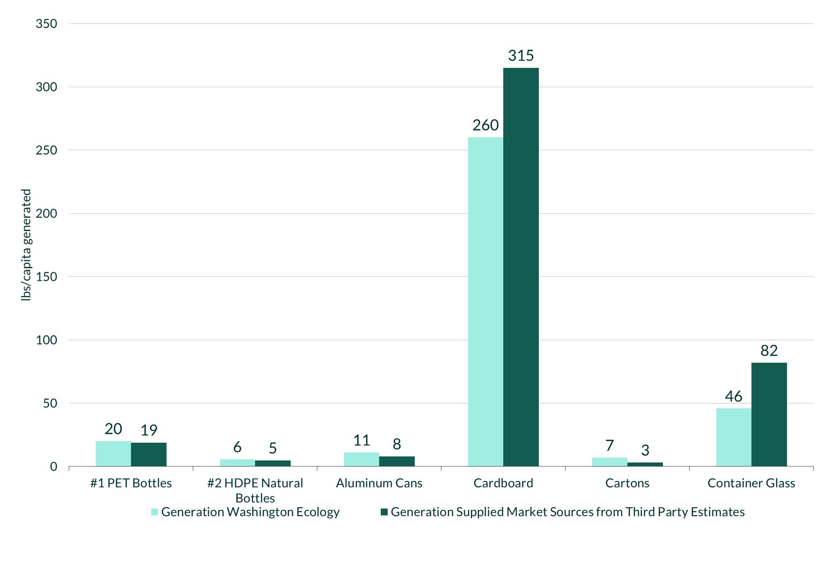
Source: Circular Ventures LLC, “A Fresh Look at OCC Recycling” (2022), "2018 Beverage Market Data Analysis," The Container Recycling Institute, 2020.
For the six materials that could be compared to third party publications, the Washington generation data has similar quantities for four of them: PET bottles, HDPE natural bottles, aluminum cans, and cartons. The small differences could be a result of moisture/dirt/residue in the Washington data.
Two materials show supplied data from third party sources as higher than Washington’s data: cardboard and glass.
Washington’s cardboard data had a higher generation per capita when compared to EPR data (in Canada) and industry reports. However, when the Washington data is compared per capita to the cardboard estimate from Circular Ventures, the latter value is 21% higher than the Washington data.
Circular Ventures believes that commercial generation data is undercounted in the official published generation totals.
Washington’s data on glass beverage containers are also 55% lower than the Beverage Market Data Analysis states. This suggests to some extent that there are still challenges with determining the amount of glass in the waste stream when using waste audits. These include allocating the glass tonnage between containers, jars, and other glass products, as well as separating out the glass container material in the fines category of waste audits.

Implications of Supplied Material Comparison
The sections above demonstrate the difficulty in trying to apply data from other jurisdictions or national data from industry and the EPA to Washington state. If we consider the impact of changing the denominator in the recycling rate equation from Ecology-generated data to one of these other sources for just one material, PET, we can see the impact this change has on the recycling rate. The recycling rate using Washington’s generated data is 39%; using the Container Recycling Institute BMDA data, it would be 41% and using NAPCOR national data 42%. The recycling rates are within a few percentage points of each other, but they will change based on the source used for supplied data. When using the generation data, it appears less likely that material will be missed than when using the supplied producer data. As stated above, the weight of outbound material from an MRF will include moisture and contaminants, and Eunomia has previously estimated that for PET bottles this could be around 11%; if this is deducted from the numerator when using the BMDA and NAPCOR data, then the recycling rates would be 37%.
In Figure 15 below, the two bars for each material represent the estimates of pounds per capita generated first by the Ecology waste generation data and then by the largest supplied material source. For example, the largest supplied material source for generation of PET bottles per capita was from NAPCOR, so this value is the orange bar for PET bottles, while the teal bar is the Washington generation data estimate. Second, the chart also shows the difference in the recycling rates based on the two generation estimates for each material. The circle represents the estimate based on the industry supply data, while the triangle represents the estimate for the Washington generation data estimate. Paper packaging has been omitted from the chart as no reliable, like-for-like comparison on supplied data was found.

Figure 15: Comparison of Supplied versus Waste Generation Data and each Respective Recycling Rate
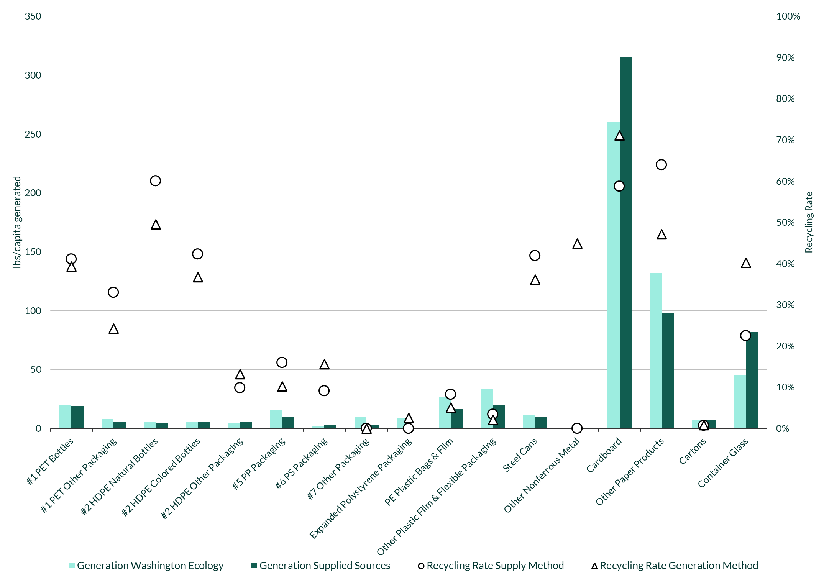

Of the 22 packaging materials estimated in the chart above, in 14 cases the Washington Ecology generation estimates are higher than the supplied data using industry and other estimated data. This figure shows how there can be a difference in the tonnage supplied versus generation for most materials, and that the direction of the difference (overestimate or underestimate) can vary by material.
As an example, Table 13 below illustrates the differences in supplied versus Washington generation data for three materials, and how the recycling rates vary based on the source.
Table 13: Differences in Recycling Rate of Select Materials Based on Generation
Material | Washington generation data lbs/capita generated | Supplied Estimate lbs/capita | Recycling Rate Washington Generation Data | Recycling Rate Supplied Data
Cardboard | 255 | 315 | 72% | 59%
Container Glass | 48 | 82 | 39% | 22%
PE Plastic Bags & Film | 28 | 16 | 5% | 8%
In the case of cardboard and container glass, the generation from supplied estimates is higher, resulting in a lower recycling rate. However, for PE plastic bags and film, the supplied estimate is lower than the Washington generation estimate, resulting in a higher recycling rate.

Conclusion
The analysis established that disposed and recycled data reported to Ecology by facilities operating in the state, along with relevant waste characterization studies, comprises the most appropriate data for assessing the amount and types of consumer packaging and paper products sold or supplied into the state and the recycling rates achieved for these materials through existing recycling programs and activities in the state. Data from other jurisdictions and industry data was explored as a potential source to estimate the total generation of material in Washington state as well; however, it was not used for the following reasons:
- Supplied tonnages from other jurisdictions do not cover the entire consumer packaging and paper products stream; they are either a subset of all sectors (e.g., residential stewardship data in Ontario, B.C) or they do not cover all material categories (e.g., stewardship data without deposit sales). Further modelling and assumptions must then be made to estimate the tonnage associated with the generators that are not included in the data.
- Supplied tonnages from industry sources are material-specific; this results in needing to combine sources of data which are likely to have been calculated using different methodologies to estimate generated streams.
- Supply sales data is provided as units of sales rather than by weight, requiring weight assumptions to be made to convert sales data to tonnage of material generated.
- Inconsistencies exist between data reported by industry or submitted to stewardship programs with data published by third party sources; this suggests that, in some cases, industry reports may not be accurately calculating imports and exports, for example.
The statewide recycling rates for consumer packaging and paper products are shown below:
Table 14: Statewide Material Flow in tons and Recycling Rates in Washington (2021)
CPPP Material | Disposed - Garbage | Disposed -MRF Residue | Total Disposed | Recycled | Total Generated | Recycling Rate (%)
Total Rigid Plastics | 222,100 | 24,500 | 246,600 | 68,100 | 314,700 | 22%
Total Flexible Plastics | 203,000 | 21,700 | 224,700 | 8,000 | 232,700 | 3%
Total Metals | 58,400 | 9,700 | 68,100 | 48,400 | 116,500 | 42%
Total Paper & Cardboard | 693,500 | 76,000 | 769,500 | 1,096,410 | 1,865,910 | 59%
Container Glass | 98,000 | 8,300 | 106,300 | 71,500 | 177,800 | 40%
Total CPPP | 1,275,000 | 140,200 | 1,415,200 | 1,292,410 | 2,707,610 | 48%
Total Beverage Containers | 127,000 | 18,100 | 144,900 | 121,500 | 266,400 | 46%
Source: Eunomia Modelling, 2021 Ecology Washington Recycling and Recovery Data, 2020-2021 Washington Statewide Waste Characterization Study, City of Tacoma Solid Waste Management, "2018 Beverage Market Data Analysis," The Container Recycling Institute, 2020.
Table 15: Beverage Container Recycling in Washington in Tons (2021)
Beverage Container | Disposed - Garbage | Disposed -MRF Residue | Total Disposed | Recycled | Total Generated | Recycling Rate (%)
All Plastic Beverage Containers | 38,000 | 7,700 | 45,500 | 37,300 | 82,800 | 45%
#1 PET Beverage Containers | 28,100 | 6,800 | 34,900 | 27,600 | 62,400 | 44%
#2 HDPE Natural Beverage Containers | 8,600 | 700 | 9,200 | 8,800 | 18,000 | 49%
#2 HDPE Colored Beverage Containers | 1,300 | 200 | 1,400 | 900 | 2,400 | 38%
Aluminum Beverage Cans | 17,500 | 2,700 | 20,200 | 18,400 | 38,600 | 48%
Carton Beverage Containers | 11,600 | 0 | 11,600 | 100 | 11,700 | 1%
Container Glass Beverage Containers | 59,900 | 7,700 | 67,600 | 65,700 | 133,300 | 49%
Total Beverage Containers | 127,000 | 18,100 | 144,900 | 121,500 | 266,400 | 46%
Source: Eunomia Modelling, City of Tacoma Waste Management, GPI Data
Paper and cardboard have the highest recycling rate at 61% and also the highest generation, as the sector accounts for 67% of the consumer packaging and paper products generated in Washington.
Metals have the next highest recycling rate at 41%, while metal beverage cans have a recycling rate of 47%. Metal beverage cans make up an estimated 33% of the metal consumer packaging and paper products generated.
Container glass has a recycling rate of 39%, while beverage container glass has a recycling rate of 48%. Beverage container glass comprises 75% of container glass generation.
Rigid and flexible plastics have a recycling rate of 22% and 6%, respectively. Rigid plastic beverage containers, including PET and HDPE beverage containers, have a recycling rate of 45%.
In total, the recycling rate for consumer packaging and paper products in Washington is 48%. This is two percentage points higher than the recycling rate for all beverage containers in the state (46%). However, beverage containers only represent 10% of CPPP generated. For comparison, the paper and cardboard category represents 69% of all CPPP generated, which means the paper and cardboard category has considerable influence on the overall CPPP rate.
Denser materials will show up in the consumer packaging and paper product stream in greater quantities by weight than less dense materials; however, assessing the shares of the stream by weight is still valuable. Describing the weight of material disposed is a useful measure to see to what extent different materials are responsible for the costs and impacts of waste disposal. For example, garbage collections are often weight-limited, suggesting that more tonnage disposed will result in additional collections. Landfill fees are also charged by the ton, so more weight disposed will result in higher costs for waste management.
The paper and cardboard stream has the most weight disposed of the material categories, presenting an opportunity for diversion. A nine-point recycling rate increase in the paper and cardboard recycling rate would result in an additional 170,000 tons diverted from landfill and incineration and increase the statewide recycling rate for all consumer packaging and paper products to 55%.
Flexible plastic packaging and rigid plastic packaging each have similar amounts disposed, but the recycling rate for rigid plastic is over 20 points higher than that for flexibles. With the lowest recycling rate of this group of materials and the second highest amount disposed per capita, flexibles present an opportunity for additional diversion. This could begin with a relatively small increase in recycling rate. A 10-point increase in flexibles diversion would result in an additional 24,000 tons diverted from landfill and increase the statewide recycling rate for all consumer packaging and paper products by one percentage point.
Beverage containers currently have a recycling rate of 46%; this is below what a deposit return system (DRS) would be able to deliver. If a DRS with a return rate of 90% were implemented in Washington, it would divert at least an additional 125,000 tons from landfill. This would increase the total statewide recycling rate for all consumer packaging and paper products from 48% to 53%.

Policies to Address Problematic Consumer Packaging and Paper Products

Approach and Methods
In addition to calculating recycling rates for consumer packaging and paper products, the legislature directed Ecology to contract for recommendations on legislative action to address the items included in the list of problematic and unnecessary materials identified for elimination by the US Plastics Pact. This requirement accords with recommendations in the 2020 Plastic Packaging Study: Evaluation, Assessment, and Recommendations for the Responsible Management of Plastic Packaging in Washington. The US Plastic Pact’s Problematic and Unnecessary Materials list is shown below:
- Cutlery, when non-reusable, non-recyclable, or non-compostable
- Intentionally added¹ Per- and Polyfluoroalkyl Substances (PFAS)
- Non-Detectable Pigments such as Carbon Black
- Opaque or Pigmented PET – Polyethylene Terephthalate bottles (any color other than transparent blue or green)
- Oxo-Degradable Additives, including oxo-biodegradable additives
- PETG – Polyethylene Terephthalate Glycol in rigid packaging
- Problematic Label Constructions – This includes adhesives, inks, materials (e.g., PETG, PVC, PLA, paper). Avoid formats/materials/features that render a package detrimental or non-recyclable per the APR Design® Guide. Labels should meet APR Preferred Guidance for coverage and compatibility and be tested in any areas where this is unclear.
- PS – Polystyrene, including EPS (Expanded Polystyrene)
- PVC – Polyvinyl Chloride, including PVDC (Polyvinylidene Chloride)
- Stirrers, when non-reusable, non-recyclable, or non-compostable
- Straws, when non-reusable, non-recyclable, or non-compostable
While all these materials are considered problematic and unnecessary, the policy analysis presented here focuses only on those that are consumer packaging or paper products: single-use plastic cutlery, stirrers, and straws, opaque PET, transparent pigmented PET, PETG, PS (including EPS), and PVC (including PVDC).
PFAS, carbon black, oxo-degradable additives, and problematic label constructions were not considered in this policy analysis, as they are additions to or subcomponents of the packaging material rather than packaging itself. Labels and additives are briefly addressed in Section 3.3 of the report on eco-modulation of fees in EPR, as their inclusion can impact the recyclability of consumer packaging and paper products.
As the US Plastics Pact list focuses only on plastics, Ecology requested that Eunomia identify additional problematic materials. Section 3.2 of this report details how additional consumer packaging and paper products were deemed problematic.
In order to identify and analyze policy mechanisms to address problematic consumer packaging and paper products, the following approach was taken:
- Step 1: Develop a long list of problematic consumer packaging and paper products, including:
  - CPPP items on the US Plastics Pact’s Problematic and Unnecessary Materials list: opaque PET, transparent pigmented PET, PETG, PS (including EPS), and PVC (including PVDC), and cutlery, stirrers, and straws.
  - Consumer packaging and paper product items that are (1) often littered and/or a source of pollution that harms the environment, (2) disruptive to sorting and recycling infrastructure, and/or (3) not recyclable or compostable at scale. More detail on these criteria is provided in the following section.
- Step 2: Consolidate data from Eunomia’s previous projects on potential policy recommendations.
- Step 3: Conduct a literature review to identify policies being considered in other jurisdictions in North America, Europe, and Asia.
- Step 4: Develop a long list of potential policy recommendations.
- Step 5: Conduct a workshop with Ecology and the Eunomia team to review the long list of policies and qualitatively assess each measure’s applicability to each material, and to discuss the intended and unintended impacts of such policies and the practicality of implementing them in Washington.
- Step 6: Compile the findings on policy impacts, suitability for each hard-to-recycle item, and potential effectiveness into the report format.
The following sections of the report present a summary of the problematic consumer packaging and paper products analyzed, an overview of applicable policies, and recommended policies by item and as a whole.

Problematic Materials
In this report, a CPPP material is considered problematic if it meets any one of the following criteria:
- it is often littered and/or a source of pollution that harms the environment, as determined in the 2022 Keep America Beautiful litter audit.
- it is disruptive to sorting and recycling infrastructure, meaning it may cause damage to collection, sorting, or processing equipment and may contaminate the recycling stream.
- it is not recyclable or compostable at scale. This includes limited recycling processors and markets for the material, linked to the composition of the material and the volume.
The final list of problematic CPPP items includes: single-use plastic cutlery, stirrers, and straws; opaque or pigmented PET, PETG, PS (including EPS), and PVC; both multimaterial and monomaterial multilayer film; laminated paper; paper packaging with plastic windows and other components that cannot be separated; aseptic/poly-coated cartons, and biodegradable plastics. Table 16 provides an overview of each material identified through the process (set out in Section 3.1) and indicates the criteria that make the material problematic.
Table 16: Problematic CPPP Materials
Category | Material | Criteria
 |  | Often littered and/or source of pollution | Disruptive to sorting/recycling infrastructure | Not recyclable/ compostable at scale
Plastic | Single-use plastic cutlery and stirrers | X
 | Single-use plastic straws | X
 | Opaque PET * | X | X | X
 | Transparent pigmented PET* | X
 | PETG – Polyethylene Terephthalate Glycol in rigid packaging* |  | X | X
 | PS – Polystyrene, including EPS (Expanded Polystyrene)* | X | X | X
 | PVC – Polyvinyl Chloride, including PVDC (Polyvinylidene Chloride)* |  | X | X
 | Multimaterial multilayer film | X | X | X
 | Monomaterial multilayer film (PE, PP) | X | X
 | Biodegradable plastics | X | X | X
Paper | Laminated paper |  |  | X
 | Paper packaging with plastic windows and other components that cannot be separated |  | X | X
 | Aseptic/poly-coated cartons | X |  | X
* These materials are from the US Plastics Pact’s problematic and unnecessary materials list. US Pact Activators committed to take measures to eliminate these items by 2025. The problematic items identified are not currently reusable, recyclable, or compostable with existing US infrastructure at scale and are not projected to be kept in a closed loop in practice and at scale by 2025. Note that some of these materials have been reworded slightly or broken into multiple categories to be more specific than the original US Plastic Pact phrasing.

Policy Overviews
The 2020 report Successful Plastic Packaging Management Programs and Innovations (wa.gov) for the Department of Ecology outlined the following policies:
- Landfill or Material Disposal Bans
- Fees or Taxes
- Extended Producer Responsibility (EPR)
- Deposit Return Systems (DRS)
- Post-Consumer Recycled Content Requirements
- Reuse Systems and Policies
- Multi-faceted measures (combination of policies)
This section provides an overview of the above policies, highlighting their potential to address problematic materials.

Bans
Bans can be approached in two ways: they can be used 1) to completely phase out the use of a material for a specific application or an item (material bans) or 2) to encourage a different approach to managing a material at the end of its life (disposal bans). Before implementing a ban, due diligence is required to consider the impact of potential substitutions. An analysis of alternative items must also be completed to ensure substitutions do not have a detrimental environmental impact and do not place undue cost on nor disproportionately impact certain groups. Due diligence in the form of an alternatives analysis and/or life cycle assessment can anticipate the types of substitutions that arise and determine the environmental effect and cost impact.
For a ban to be successful, suitable replacement materials must be available that perform the function of the banned material. Additionally, appropriate penalties need to be in place to deter non- compliance, along with sufficient resources to ensure that the ban is enforced. The risk of being caught for non-compliance must be greater than the reward for not complying. Additional resources may be required to enforce bans to ensure their success, and the legislative framework must be such that fines can be issued and prosecutions can be pursued. The cost of adequate education and enforcement should be factored into any consideration of a ban. It would be ineffectual to implement a policy that cannot be enforced or for which enforcement costs would prohibit the program’s success.

Disposal Bans
Disposal bans aim to keep recyclables out of trash and subsequently out of landfills and/or waste-to-energy facilities. Compliance with a disposal ban can fall on a variety of stakeholders, including residents, businesses, landfill operators, and waste haulers. Disposal bans encourage the use of end-of-life options that are higher in the waste management hierarchy, such as recycling and composting. They are intended to divert recyclable materials that are currently landfilled or converted into energy due to poor separation at source. Landfill bans are not designed for materials that are not recyclable or for which no recycling infrastructure exists. Furthermore, disposal bans do not address the need to phase out non-recyclable materials and single-use items.

Material Bans
Material bans on specific packaging products have also become a common policy response in the US. These bans are effective polices to eliminate problematic materials from the waste stream. For example, Washington banned EPS filling peanuts and will ban EPS for coolers and food service products starting in 2024.
However, some material bans suffer from lack of specificity, which creates loopholes that lead to substitutions with alternative materials that are less environmentally sound and/or have unintended negative consequences. The most common example of this are plastic bag bans that rely on thickness to differentiate single-use and reusable plastic bags. If this thickness is too low, retailers may provide bags that contain less plastic but that are unlikely to be reused. To address this, bag bans can increase the designated thickness or change the definition of reusable bag, relying on indicators such as material type (fabric bags instead of plastic), a minimum lifetime (must withstand a certain number of uses carrying a determined weight load), and/or ability to be washed.
Likewise, bans can unintentionally provide a loophole for substitutions using materials that are similar but not explicitly banned in legislation. For example, the EU Single-Use Plastic Directive targets the 10 most common single-use plastic items found as marine pollution, including through bans. The Directive excludes “natural polymers that have not been chemically modified”, which is necessary to avoid banning materials like cotton and paper that were not in the scope of the Directive. However, natural polymers encompass regenerated cellulose-based materials such as viscose and lyocell; these are often used in nonwoven fibers that occur in products such as wet wipes and cigarette filters, both of which are intended to be regulated through this legislation. Therefore, additional regulation may be required to ensure that bans do not allow for alternative materials that have the same or greater detrimental impact.
Moreover, bans can disproportionately impact and place undue burdens on certain communities, such as low-income communities and people with disabilities. For instance, bans on plastic straws can hinder people with disabilities from being able to consume food or beverages. Alternatives such as paper or biodegradable straws are poor substitutes because they disintegrate more easily. To prevent such impact, states including Washington have not entirely banned plastic straws, but require businesses to provide straws only when customers request them.
Bans are essential when materials are not only problematic but harmful to the environment and/or human health. This is the case for substances such as Per- and Polyfluoroalkyl Substances (PFAS), ‘forever chemicals’ that are harmful to human health, and bisphenol A, a component present in some food-contact packaging that may impact the health of babies and young children. Washington has already taken legislative action on these substances:
- Washington banned intentionally added PFAS from food packaging in Chapter 70A.222 of the Revised Codes of Washington (RCW). The US Plastic Pact recommends banning intentionally added PFAS; however, the lack of intention and/or awareness should not affect a ban, since any amount of PFAS can be harmful to the environment and human health.
- Washington banned BPA from use in bottles, cups, and other food and drink containers intended for children under the age of three, as well as sports bottles.
Bans can remove problematic materials from consumer packaging and paper products, but they are not a silver bullet for all problematic materials. Any ban must be accompanied by careful due diligence to avoid unintended impacts.

Combining Bans with Fees
Material bans are a common intervention to reduce the use of and pollution from materials that are not recycled. As outlined above, this can lead to substitutions with materials that have an equal or higher life cycle impact. Furthermore, there is no scope for governments to raise any revenue through bans, with the exception of financial penalties for offenders. Additionally, there could be significant costs from the ban arising through its implementation and enforcement, with direct costs such as policing and indirect costs such as the loss of jobs.
To mitigate this, bans can be coupled with a system of taxes, fees, or charges to encourage use of a preferred alternative. For instance, to prevent single-use plastic cutlery from being replaced on a one-for-one basis with single-use non-plastic cutlery, a charge can be implemented. Single-use non-plastic cutlery includes bamboo or bioplastic cutlery, which is often littered and seldom recycled or composted. Implementing a customer charge on these items will ensure that single-use cutlery is not available for free, thereby encouraging the use of reusable cutlery. Charges can be increased in phases to deliver incremental impact over time. This has been implemented in Washington; Chapter 70A.530 of the Revised Code of Washington bans single-use plastic carryout bags and places an increasing charge for large paper bags and thick, reusable plastic bags.

Fees and Taxes
Fees and taxes are widely used mechanisms for correcting market failures that do not properly account for environmental externalities. By placing a monetary charge, fees and taxes are designed to create appropriate incentives to change behavior patterns. This can considerably reduce undesirable behavior and achieve the same environmental outcome as a ban.
For instance, placing a charge on single-use coffee cups can nudge consumers to adapt their behavior and bring their own reusable and refillable cups. Implementing a charge on single-use items can align the interests of retailers and businesses, who do not have to give an item to a customer free of charge. If successfully implemented, it thereby becomes a cost-saving measure for businesses.
Fees and taxes can also raise much-needed revenue for government agencies or other entities. Despite this, monetary instruments like fees and taxes cannot guarantee a specific amount of pollution or waste reduction and may impose a great burden on those unable to comply. It can also be argued that poorly designed taxes lead to distortions in the market, or accentuate pre-existing distortions, with negative impacts on economic activity.
Fees and taxes are often politically unpopular and difficult to pass through legislatures. Any tax or fee should also be carefully designed to ensure that it does not place a disproportionate financial burden on certain groups of consumers. Some consumer protection groups argue that producers should bear greater responsibility for the products they place on the market. They claim that consumers often do not have the time, access to information, available choice, or financial ability to change their consumption behaviors to avoid fees or taxes on problematic materials.

Disposal Fees/ Tipping Fees
As opposed to an outright ban, some jurisdictions are turning to taxes or fees on landfilled material to discourage landfilling in favor of disposal options that are higher up the waste management hierarchy.
In addition to reducing the amount of waste going to landfill, landfill fees can be used as a mechanism to generate a revenue stream for governmental and potentially non-profit entities to make other waste management options, such as recycling, more financially viable.
While a landfill fee can generate revenue and provide funds to invest in recycling and other waste management programs, it is not a straightforward approach to manage problematic materials. Landfill fees place a financial burden on haulers and residents. They do not directly impact producers who design products with problematic materials, nor do they stimulate the market to invest in recycling such materials. In other words, there is little financial incentive to reduce the use of problematic materials and/or to improve recycling capacity through a landfill fee. While a landfill fee can presumably support expanding recycling capacity and improve infrastructure to manage problematic materials, this supposes sufficient resources would be allocated to allow for alternative treatment options to become viable in the long term.

Extended Producer Responsibility (EPR)
Extended producer responsibility (EPR) is an environmental policy tool that transfers the financial responsibility for end-of-life management of products and packaging to producers. EPR can be applied to many product categories, including packaging and paper products. If implemented correctly, EPR for packaging and paper products is an effective mechanism to improve recycling rates, reduce litter, incentivize system efficiencies, reduce costs for end-of-life management, and make collection and recycling more widespread and available. When well designed, EPR can also create incentives for producers to incorporate environmental considerations into the design of their products and packaging. EPR legislation must make clear, at a minimum:
- Products that are covered
- Requirements for producers of covered products
- Financing mechanism
- Performance targets
- Data monitoring, reporting, and oversight
- Enforcement and sanctions mechanism
Shifting the end-of-life management costs for targeted materials from municipalities and ratepayers to producers includes costs such as the creation of producer responsibility organizations (PROs), reporting and data management systems, education and outreach, compliance and enforcement costs, and new collection, sorting, and reprocessing infrastructure. Implementing EPR requires adjustments from all stakeholders involved in the recycling value chain. The design of the program will determine the degree of impacts on all stakeholders in terms of roles, responsibilities, costs, and savings.
EPR that focuses on achieving specified outcomes, such as specific recycling and reuse targets, without delineating how they should be achieved (e.g., the collection and sorting mechanisms) provides greater flexibility for producers to support in the design, implementation, and evolution of a system that will manage the packaging stream of the future. It also encourages technological innovation and infrastructure improvement. This can enable performance objectives to be delivered in the most cost-effective and efficient way.
EPR legislation should require producer fees to invest in the infrastructure to collect, process, and recycle packaging and products. EPR legislation should also require producer fees to invest in consumer education and outreach efforts and developments in end markets. The purpose of these investments must be to modernize collection, processing, and recycling infrastructure, standardize what can be collected and recycled across the state, ensure that all households and businesses have recycling collection services that are convenient, and improve consumer education. Investments in sorting and recycling infrastructure should ensure materials are of sufficient quality for use in producing items from equivalent primary materials.
Producer fees should be regularly adjusted to support necessary investments and enable performance targets to be met. The fees that producers pay can also be modulated for different materials placed on the market. This modulation can be based a bonus/malus system that rewards producers for placing packaging and products on the market that contain recycled content, that are easy to recycle, that are reusable or refillable, and that contribute to overall source reduction. Conversely, this system places higher fees on producers that place packaging and products on the market that are often littered, disrupt sorting and recycling infrastructure, or that are hard to recycle. Therefore, the eco-modulation of fees can accelerate the phasing out of problematic materials by supporting and rewarding producers that design their products and packaging for source reduction, reuse, recycling, and composting. It can also address packaging and products containing additives and labels that make the entire packaging problematic. Certain additives and labels render a recyclable product non-recyclable: oxo-degradable and oxo-biodegradable additives; additives affecting the density of plastic packaging; labels made of PLA and PVC; labels or sleeves covering over 50% of the surface areas of a product, and labels that use non-recyclable hot melt adhesives, mineral oil colors, heavy metal inks, and inks on the EuPIA list. These should be subject to a higher fee to reduce incentives for their use.
- Oxo-degradable and oxo-biodegradable additives accelerate the breakdown of plastic into microplastic and are not recyclable or compostable. Therefore, a higher EPR fee is appropriate to mitigate the environmental damage and incentivize producers to stop using these plastics in packaging.
- Plastic packaging with additives affecting density interfere with sink/float necessary to separate materials. These additives disrupt sorting, harm recycling infrastructure, and can contaminate recycled resins.
- PLA in labels is difficult to remove in the recycling process due to its similar density to PET. Even in small amounts, PLA can cause severe quality degradation of recycled PET. PVC in labels is similarly difficult to remove due to similar density to PET and PS. If PVC labels are not properly removed, they can contaminate the PET or PS recycling stream, causing severe quality degradation to recycled material and making large amounts of material unusable for recycling applications.
- Labels or sleeves covering over 50% of the surface area of a product may hinder sorting technology from correctly determining the material of the product.
- Labels that use non-recyclable hot melt adhesives, mineral oil colors, heavy metal inks, and inks on the EuPIA list contaminate recycled materials.
In the US, four states have passed EPR legislation for consumer packaging: Oregon, Maine, Colorado, and California. As these bills passed in 2021 and 2022, the EPR programs have not yet been implemented and cannot be evaluated on their impact. The table below summarizes the covered materials and program cost structures as they have been written in legislation.
Table 17: Packaging EPR Legislation Passed in the US
 | Maine  LD1541 | Oregon  SB582 | Colorado  HB22-1355 | California  SB54
Materials covered | Paper  Plastic packaging | Packaging (including paper, plastic, glass, metal, or mixture)  Paper  Food service ware | The Producer Responsibility Organization (PRO) will develop a minimum recyclable list based on the availability of recycling services, recycling collection and processing infrastructure, and recycling end markets | Single-use packaging  Single-use food service ware
Modulation of fees | The department will adopt rules establishing payment calculation. Designed to incentivize the use of materials that are readily recyclable | PRO fees are adjusted to be lower or higher based on PCR content, product-to-package ratio, material type, life cycle environmental impact, and recycling rate | PRO fees modulated to discourage the design and practices that increase costs of recycling or disrupt recycling of other materials and the use of covered materials that are not on the minimum recyclable list | PRO fees are modulated based on: PCR content, source reduction (right-sizing, optimization, bulking of packaging), standardization of packaging, the presence of hazardous materials and toxic additives, labeling instructions that improve consumer behavior to sort and dispose products, and acceleration of source reduction and investment in reuse/refill systems
Other jurisdictions outside the US have more established EPR programs for consumer packaging, such as those listed in Table 18. Given these longer implementation timelines, it is possible to learn from their experiences.
Table 18: Examples of EPR for Consumer Packaging and Eco-modulation
Region | Start Date | Detail
Germany | 1991 | Germany was one of the first countries to implement EPR and set mandatory targets. There was no eco-modulation of fees to encourage the use of recycled content until an amendment in 2019. This requires fee modulation to drive recyclability, therefore incentivizing the phasing out of problematic materials. However, it is too soon to assess the impact of this amendment on recyclability and recycling rates.
France | 1992 | France introduced eco-modulated fees in 2010 to encourage more sustainable packaging material design by producers. France’s eco-modulation is characterized by a bonus/penalty system, where products that are recyclable, have PCR content, and/or lead to source reduction have a lower fee, and the use of a problematic material is associated with a penalty. The French PRO CITEO documents that the fees have encouraged design for recyclability among producers, thereby reducing problematic materials. For example, since the introduction of eco-modulated fees, there has been a decline in PVC bottles from 0.9 kilotons in 2012 to 0.3 kilotons in 2015.
British Columbia, Canada | 2014 | The province-wide post-collection system developed by the PRO (Recycle BC) has made it possible to collect and recycle a much wider range and quantity of packaging compared to most other programs in North America. Fees are modulated by material and problematic materials are associated with higher fees. For instance, PS has a fee of 137 cents per kilogram, compared to 40 cent per kilogram for PET bottles.

Deposit Return System (DRS)
A deposit return system (DRS), also called a container deposit system, or bottle bill, is a legislatively designated system that places a small monetary deposit on a product, paid by the consumer at the time of purchase, which is refunded when the consumer returns the product to a designated return location for reuse and/or recycling. DRS can be considered a form of EPR in that producers are required to financially cover the operation of the system and in many cases meet specific return or recycling rates. A deposit on an item provides a financial incentive for the user to return the item. Unclaimed deposits as well as material revenues can partially cover the cost of the system; however, if high return rates are achieved, then producers are also likely to need to contribute through producer fees akin to EPR.
DRS has proven effective at maximizing the capture of beverage containers, minimizing litter, and collecting high quality material. However, DRS can take away valuable material from the curbside recycling stream, which represents a loss for MRFs due to reduced tipping fees and material revenues. The value of a deposit container passing through the MRF can be redeemed, making up for some of the loss. MRFs can also be given access to unclaimed deposits. There is also the option for MRFs to provide counting center function under contract to the PRO, providing an additional opportunity to increase revenue. Further analysis of the cost and benefits of DRS in Washington can be found in Container Deposit Study - Phase 3 - Responsible Recycling Task Force - King County Solid Waste Division. If EPR is also implemented alongside DRS, a greater quantity of material will be collected at the curbside; this will require sorting, thus increasing revenue from tipping fees.
DRS can cover beverage containers that are not recyclable at scale with current post-collection infrastructure, such as aseptic cartons. Aseptic cartons are complex, multi-layer packages made up of polymer-coated paperboards with a layer of aluminum foil. On average, aseptic cartons contain 75% of paper fibers, which can be recovered through hydrapulping. However, due to the composite nature of the packaging, the recycling process requires more time to separate the components and is more costly. There are also significant losses in reprocessing due to this need for specialized material separation and pulping infrastructure.
DRS can maximize collection and minimize sorting losses by separating the collection of aseptic cartons from curbside recycling. While DRS may not directly influence investment in end markets, they can help cover the cost of transporting collected material to end users. Cartons collected through DRS programs also have a high value and are desired by end users. Currently, aseptic cartons in Washington are not reaching end markets due to low levels of collection. Only 39% of single-family households have curbside access to milk and juice cartons. Due to low volumes and the greater complexity of sorting and recycling aseptic cartons, there is little incentive for sorting centers to accept cartons and for pulp mills to process them.
EPR can standardize what is accepted in curbside programs to include cartons and force investment into post-collection infrastructure to handle the increased volume. Additionally, EPR fees can be allocated to invest in the infrastructure for both sorting centers and pulp mills to recover paper fibers from cartons. Alternatively, producer fees can go towards transporting cartons collected through DRS to mills that accept cartons both inside and outside of Washington. With performance targets and investments, EPR can incentivize recycling while a DRS system can ensure high quality materials with minimal collection and sorting losses. In the US, 10 states have DRS for beverage containers. Table 19 outlines these states, including the return rates and materials covered by DRS.
Table 19: States with DRS in the US
DRS States | Return Rate  (2019) | Beverage Types Materials Covered
California | 67% | Plastic, aluminum and bi-metal, and glass beverage containers for soft drinks, water, juices, coffee, and tea, as well as beer, malt, wine coolers, wine, and distilled spirits  Excludes milk and infant formula, wine, spirits, 100% fruit juice over 46 ounces and 100% vegetable juice over 16 ounces
Connecticut | 50% | Containers under 3 liters / 0.79 gallons  Plastic (PET), aluminum, glass beverage containers under 3L including carbonated drinks, non-carbonated water, beer, and malt  Excludes other non-carbonated beverages, juices, wine, liquor
Hawaii | 63% | Containers under 2 liters / 0.53 gallons  Plastic (PET, HDPE), aluminum and bimetal (tin cans), and glass beverage containers under 2L including beer, malt beverages, and all non-alcoholic beverages except milk and dairy products  Excludes wine, milk and dairy products, hard liquor
Iowa | 64% | Plastic, glass, metal beverage containers including beer, wine, liquor, carbonated soft drinks and mineral water  Excludes non-carbonated, non-mineral water (bottled water), fruit and vegetable juices, fruit drinks, milk and milk products
Maine | 84% | Containers under 4 litres / 1.06 gallons  Beer, ale or other drink produced by fermenting malt, spirits (including 50 ml (0.01 gal) liquor known as ‘nips’), wine, hard cider, wine coolers, soda, non-carbonated water, non-alcohol carbonated or non-carbonated drinks in liquid form and intended for human consumption  Excludes unflavoured milk and milk substitutes, certain containers composed of a combination of aluminum and plastic/paper filled with non-alcohol beverages, Maine-produced juices and cider, infant formula, nutritional supplements, products frozen at sale or intended for consumption in a frozen state, paper, or cardboard container
Massachusetts | 50% | Plastic, metal (aluminum, bimetal), glass beverage containers including beer, malt, carbonated soft drinks, mineral water  Excludes non-carbonated beverages other than mineral water (e.g., non-carbonated, non-alcohol water), wine, dairy products, liquor, natural fruit juices, non-carbonated alcohol beverages other than beer and malt
Michigan | 89% | Containers under 3.78 liters / 1 gallon  Plastic, aluminum and tinplate, glass, and liquid paperboard beverage containers including beer and ale, carbonated and mineral water, wine coolers, malt drinks, canned cocktails  Excludes non-carbonated beverages other than mineral water: juice, coffee, milk, sport drinks, wine, liquor, drinks in foil pouches
New York | 64% | Containers under 3.78 liters / 1 gallon  Plastic, aluminum and tinplate, and glass beverage containers under 1 gallon including carbonated soft drinks, soda water, beer and other malt beverages, wine products and water that does not contain sugar  Excludes milk products, wine and liquor, tea, sports drinks, juice, drink boxes, water containing sugar
Oregon | 86% | Containers between 4 ounces and 1.5 liters  Plastic, aluminum and tinplate, and glass beverage containers for juices, coffee/tea, juice smoothies, protein shakes, coconut water, non-alcoholic wine, marijuana beverages, energy drinks, sports drinks, kombucha, cocktail mixers  Containers under 3 liters  Soda (carbonated/sparkling beverages), beer, water  Excludes distilled liquor, wine, dairy or plant-based milks and milk substitutes, infant formula, meal-replacement drinks, alcohol kombucha made with cane sugar, kefir, concentrates
Vermont | 75% | Plastic, aluminum and tinplate, and glass beverage containers including liquor and spirits, wine coolers, malt beverages, soft drinks, carbonated drinks  Excludes wine, hard cider, water, milk, juices, sports drinks, other non-carbonated beverages
In the states in Table 19, legislation introducing DRS for beverage containers was passed in the 1970s and 1980s; the only exception is Hawaii, which passed its DRS in 2005. In contrast, Europe’s DRS for beverage containers is a policy of the present and the future, with multiple countries set to adopt DRS in the next three years. As Figure 16 shows, 12 of 28 European countries have DRS with EPR systems already in place with start dates ranging from 1984 to 2022. Nine other countries have DRS planned to begin in 2023, and six have DRS planned for 2024 or later. Therefore, it is realistic to think DRS could expand to additional states, or even nationally in US as has been proposed by some proponents.
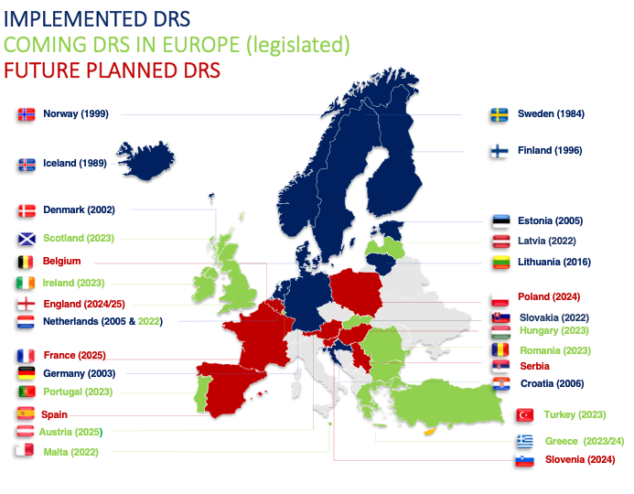
Figure 16: Current and Future DRS in Europe
Source: BOOK-Deposit-Global-24May2017-for-Website.pdf (reloopplatform.org)

Post-Consumer Recycled (PCR) Content Requirements
Establishing Post-Consumer Recycled (PCR) content requirements aims to reduce demand for virgin materials, thereby reducing the negative environmental and social impacts associated with the extraction and production of virgin materials. PCR content requirements have been adopted in legislation in three states, including Washington, and incorporated into many voluntary corporate targets.
In the absence of requirements, market demand for recycled content from a variety of material types is low; this is especially true for plastic packaging. Post-consumer resin (PCR) is uncompetitive because virgin plastic material is often cheaper due to structural issues and market failures that subsidize the extraction of natural resources and externalize the costs of virgin plastic production. PCR content requirements seek to grow market demand and use of recycled feedstocks. This in turn is intended to drive collection rates. However, a direct link between collection and recycled content cannot be established since recycled material is generally procured from global markets, and not from local collection programs.
The success of recycled content requirements depends on existing capacity to collect, process, and recycle material to be remanufactured into new products. PCR requirements will not be achieved without greater infrastructure to collect and recycle material, efficient processing and remanufacturing operations, and reliable end markets. In order for producers to incorporate recycled content into their packaging and meet PCR content requirements, recyclable material needs to be collected and sorted to a quality that meets market demand on a large scale. In short, there needs to be enough supply of PCR materials to meet demand, which can be supported by EPR and DRS policies as discussed later in this report. Moreover, improvements need to be made beyond the boundaries of Washington, to meet demand for recycled materials on global markets. Furthermore, the US Food and Drug Administration (FDA) sets safety standards for the use of recycled content in plastic and paper food-contact packaging. In order to be approved for recycling plastic for food-contact, producers must provide contaminant tests and a full description of their own recycling process, as well as proposed conditions of recycled plastic (temperature, type of food, duration of food-plastic contact, etc.). The FDA must approve the use of PCR plastic in food-contact products and has issued 278 approvals, 191 of which were for PET. In the context of food contact products, PCR targets for non-PET plastic are limited both by low collection and recycling rates as well as by the need for FDA approval.
PCR content requirements can be passed as standalone legislation or within EPR legislation that has PCR performance targets. PCR mandates are effective in combination with DRS and EPR, to improve collection, stimulate end markets, and increase the supply of recycled content available.
Table 20: States with PCR Content Requirements
State | Legislation | Description
Washington | PCR | Chapter 70A.245 RCW sets recycled content targets for plastic beverage containers, non-beverage rigid plastic containers for household cleaning and personal care products, and plastic trash bags.
New Jersey | PCR | New Jersey passed AB 4676, setting PCR content targets for rigid plastic containers, plastic beverage containers, glass containers, paper and plastic carryout bags, and plastic trash bags.
California | EPR with PCR content targets | California’s extended producer responsibility legislation (SB54) sets increasing target recycling rates for all covered plastic packaging.  EPR fees are also modulated to incentivize the use of PCR content in packaging.
PCR legislation is mostly resin-agnostic, applying to packaging types and products such as plastic beverage containers or plastic bags. The materials that are the focus of this study have been deemed problematic in part due to the lack of recycling at scale or the potential to disrupt sorting and processing infrastructure. As such, placing PCR mandates on materials that are not recyclable at scale or do not have end markets is setting up a target for failure. PCR mandates should be prioritized for materials that make up a larger share of the consumer packaging market and have existing recycling end markets, such as PET. However, since PCR targets apply to products and not resin types, placing PCR targets on consumer packaging and paper products can incentivize producers to design products with existing and available recycled content, thereby phasing out problematic materials. For instance, since PS and PVC are not recycled at scale, producers using these resins for packaging may switch to PET or HDPE to meet recycled content targets. In this way, PCR targets can incentivize producers to design for recyclability and eliminate problematic materials from packaging.

Reuse or Refill Programs
Reuse programs seek to support the overall reduction of resource consumption and waste generation through the reuse or refill of products that would otherwise be recycled or disposed, or to replace single-use items with durable items.
Reuse/refill programs can be required or encouraged through EPR modulation policies, by setting reuse targets, exempting reusables from regulation, or modulating fees so they are lower for producers who transition to reusable and refillable products. Reuse/refill programs can also be developed in tandem with DRS, whereby the DRS infrastructure can also be used to facilitate the return of reusable and refillable product packaging. Much reuse policy is being implemented at a local level, such as requirements for restaurants that provide on-site seating to use durable dishware and provide reusable options for takeout and delivery where possible. Similar reuse-supportive policies could be adopted at the state level to encourage:
- durable cutlery and stirrers instead of single-use cutlery and stirrers;
- washable beverage containers at entertainment venues to eliminate single-use plastic cups made of PS; and
- washable coffee cups to decrease the use of to-go laminated paper cups.
Reuse programs can also encourage customers to bring in their own containers. Updating food and health codes to allow reuse/refill is necessary to standardize practices for food-service businesses. Washington updated its food codes in March 2022, with section 03348 allowing for customer-provided containers to be reused and industry-provided containers to be refilled. The Covid-19 pandemic led to health and safety concerns regarding refilling and reusing containers, with some food service businesses suspending or no longer accepting customer containers. Greater education and training for food service businesses is beneficial to support safety and cleanliness when refilling and reusing containers as well as to ensure standard and convenient access for customers.
The Ellen MacArthur Foundation (EMF) details four reuse models that businesses can adopt to develop their own reuse or refill programs.
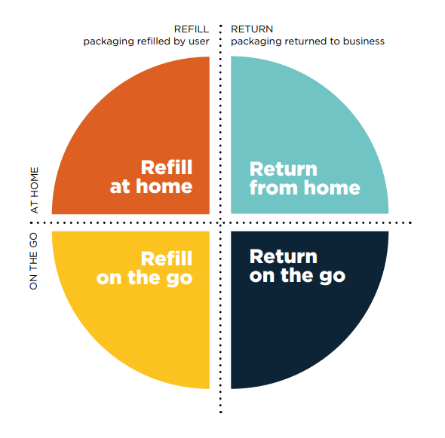
Figure 17: EMF Reuse Models
Refill at home: users can refill their containers at home, through refills that can be bought or delivered at home.
Refill on the go: users refill their containers at a store or in another location, through a dispensing system.
Return from home: packaging is picked up by a collection company.
Return on the go: users return the containers to a drop-off location (deposit return location, retail location, or through the mail).
The shift to reuse models requires investment in infrastructure and reverse logistics to collect, clean, and distribute the containers, as well as added costs for labor and space to store the containers. The upfront costs of developing reuse systems have significant economic benefits; EMF estimates that shifting 20% of single-use packaging to reuse globally is a $10 billion opportunity. Reuse policies and investment in reuse from the private sector can contribute to the development of infrastructure and circular economy jobs, such as collection from drop-off locations, dishwashing services, and distribution businesses.

Labeling requirements
Labeling provides information to consumers on the recyclability of a product and/or its packaging and aims to provide transparent and consistent approaches to producers’ claims about the recyclability of a product.
Labeling can add clarity around how a problematic material should be collected to decrease contamination rates in the recycling stream. This can help address the problem of “wish cycling”, where consumers place non-recyclable products in recycling bins, unaware of actual recyclability and/or convinced that they are acting sustainably because the item will be recycled. Labeling requirements can also prevent greenwashing, whereby producers make misleading or deceptive marketing claims about the sustainability or recyclability of a product.

Voluntary Approaches
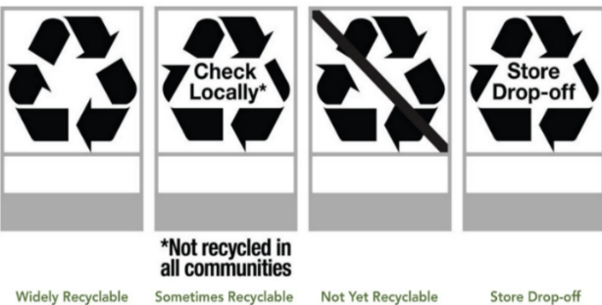
How2Recycle developed a labeling system to communicate recycling instructions to consumers. This system has been adopted by 225 brands. The labels inform consumers on the recyclability of a product, the recyclability of different parts of the packaging, and the best way to prepare a material to ensure it is ready for recycling. The “widely recyclable” label can only be placed on packaging and products that can be recycled by at least 60% of Americans through curbside or drop-off recycling systems.
Figure 18: How2Recycle Labels

Labeling in Policy
Labeling requirements can be passed as standalone legislation or incorporated into EPR:
State | Legislation | Description
California | Truth in Labeling | California’s Truth in Labeling law (SB343) was passed in May 2021. The law prohibits the use of the chasing arrows symbol or any other suggestion that a product is recyclable unless it is collected for recycling by at least 60% of the population of the state or it is sorted for recycling by processing facilities that serve at least 60% of recycling services statewide.
 | Resin Code Identification | AB 906 states that all rigid plastic bottles and cans sold in California must include a code indicating the type of resin used to produce it. It excludes PETG from the definition of PET and from being labeled with the resin identification code 1. This ensures that PETG, which does not have a consistent melting point, does not contaminate PET recycling.
 | EPR | California’s EPR law (SB54) incorporates labeling in the eco-modulation of fees for producers. EPR fees for a covered product are adjusted following a bonus/malus system. A product with clear and accurate instructions for disposal, recycling, composting, or reuse that improve consumer behavior are incentivized by lowering fees, and vice versa.
Oregon | EPR | Oregon’s EPR law has a truth in labeling section requiring a task force to evaluate misleading or confusing claims regarding the recyclability of products and packaging and provide legislative recommendations. This work must include consideration of accessibility for diverse audiences.
Washington | Proposed EPR law | A proposed EPR law in Washington (SB5697) in 2022 included a truth in labeling section that would prohibit a product from displaying a symbol or indication that it is recyclable unless it is designated for collection in a PRO plan.
Labeling policies prohibit producers from labeling non-recyclable packaging as recyclable; however, these policies do not directly prevent producers from continuing to use the non-recyclable packaging. While labeling requirements can help consumers recycle better, it is difficult to have state-specific labeling requirements, as most producers will supply products into many states. Ideally labeling may be better addressed at a federal level, but some states are taking action in the absence of this. Labeling requirements also need to include provisions for robust consumer education to effectively impact consumer behavior. Thus, they are not an ideal policy response for problematic materials alone. They are most effective to reduce problematic products in concert with policies like EPR and bans that directly require or incentivize the phasing out of such materials.

Policy Recommendations by Material
Material bans, extended producer responsibility (EPR), and deposit return systems (DRS) have been identified as the most effective policy tools to address the management of problematic materials covered in this assessment. Table 21 outlines the recommended policies for problematic materials, including a rationale for each one.
PCR content requirements are effective policies to stimulate market demand and drive the use of recycled feedstocks produced from materials collected for recycling. Since PCR targets apply on products and not resin types, placing them on consumer packaging and paper products can incentivize producers to design products with existing and available recycled content materials, thereby phasing out problematic materials. PCR targets can incentivize producers to design for recyclability and eliminate problematic materials from packaging. Washington has already passed legislation setting recycled content targets for plastic beverage containers, plastic trash bags, and non-beverage rigid plastic containers for household cleaning and personal care products sold in rigid plastic containers.
Fees and taxes are not included in the recommendations as standalone policies due to their potential to disproportionally impact low-income communities. Policies that ban problematic items in conjunction with fees to avoid direct substitutions are best suited for small, single-use items such as plastic bags; Washington has a ban on single-use plastic bags coupled with an increasing charge placed on large paper bags and thick, reusable plastic bags.
Labeling and reuse/refill programs can be standalone policies or complementary to bans, DRS, and EPR. They are included in the recommendations to further decrease contamination of the recycling stream and reduce the total amount of consumer packaging and paper products in the waste stream.

Table 21: Policy Options by Problematic Material
Category | Problematic Material | Ban | EPR | DRS | Other Policies | Rationale
Plastic | Single-use plastic cutlery and stirrers | X | X |  | Reuse | Single-use plastic cutlery and stirrers are litter-prone items generally used “on the go”, which are not recyclable due to their small format.  Washington already requires food services to only provide single-use service ware to customers who request them. Single-use plastic cutlery and stirrers should eventually be banned. Fess should be placed on single-use biodegradable or compostable alternatives to incentivize reusable alternatives that are durable and washable.
 | Single-use plastic straws |  | X |  |  | Plastic straws are litter-prone items used “on the go” and not recyclable due to their small format.  Plastic straws should not be banned due to the adverse impact it would have on people with disabilities, who may need straws to consume food and beverages. Straws can be covered by EPR to invest in collection and recycling infrastructure.
 | Opaque PET |  | X | X | Reuse, Label | Opaque pigments cannot be separated from the resin and mix with clear and pigmented PET. This causes undesirable colors in recycled PET, which then has low market value.  Opaque PET in EPR can be subject to targets or higher fees to require/incentivize to switch to transparent PET.  Cover opaque PET beverages through DRS to (1) implement higher fees for this material compared to transparent PET and (2) reach economies of scale to encourage separate recycling from transparent PET.  Labeling requirement to inform consumers that these items should not be placed in curbside recycling bins.  Encourage transition to a reusable/refillable model to reduce use of opaque PET in packaging.
 | Transparent pigmented PET |  | X | X | Reuse | Transparent blue or green PET is recyclable but requires separation from clear PET. Pigmented recycled PET has lower value.  Can be covered by EPR and subject to targets or higher fees to require/incentivize switch to non-pigmented/clear and transparent PET.  Cover transparent pigmented PET beverages through DRS to (1) implement higher fees for this material compared to transparent PET and (2) reach economies of scale to encourage separate recycling from transparent PET.  Encourage transition to a reusable/refillable model to reduce use of transparent pigmented PET in packaging.
 | PETG – Polyethylene Terephthalate Glycol in rigid packaging |  | X | X | Label | PETG is not currently recyclable at scale. If it is not separated properly, PETG contaminates PET recycling.  Can be covered by EPR and be subject to targets or higher fees to require/incentivize a switch from PETG products to a recyclable alternative and/or a reusable/refillable model.  Labeling requirement to inform consumers PETG items are not recyclable. Consider excluding PETG from the PET resin identification code.
 | PS – Polystyrene, including EPS (Expanded Polystyrene) | X | X | X | Label, Reuse | PS and EPS are not recyclable at scale with existing infrastructure. Due to its light weight and fragility, EPS easily breaks down and pollutes the environment.  EPS is banned in Washington for coolers and food service packaging, starting in 2024.  Cover PS through EPR and subject it to targets or higher fees to require/incentivize packaging with recycled content, transition to a different resin and/or switch to reuse/refill packaging.  Limited number of curbside programs cover PS and EPS; labeling requirement can inform consumers that PS and EPS packaging should not be placed in recycling bins.
 | PVC – Polyvinyl Chloride, including PVDC (Polyvinylidene Chloride) |  | X |  | Label | PVC is difficult to remove in the recycling process due to similar density to PET and PS. Even in small amounts, PVC causes severe quality degradation to recycled material and make it unusable for recycling applications.  PVC/PVDC in food packaging should be banned.  PVC/PVDC in non-food packaging should be covered by EPR and subject to targets or higher fees to require/incentivize elimination of this material.  Labeling requirement to inform consumers that PVC should not be placed in recycling bins.
 | Multimaterial multilayer film |  | X |  | Label | Multimaterial multilayer film is costly to separate and contains low value resin that will likely be disposed.  Can be covered by EPR and subject to targets or higher fees to require/incentivize a switch from multimaterial to monomaterial film, which is recyclable.  Labeling requirement to inform consumers that these films should not be placed in recycling bins.
 | Monomaterial multilayer film (PE,PP,PA nylon) |  | X |  | PCR | Monomaterial multilayer film is recyclable, but not at scale with existing infrastructure.  Can be covered by EPR and subject to targets or fees to increase collection and recycling of monomaterial multilayer film.  Can require PCR content to improve collection by stimulating market demand for recycled monomaterial multilayer film.
 | Biodegradable plastics |  | X |  | Reuse | Generally, biodegradable plastics are a contaminant to conventional recycling infrastructure if included in normal plastic recycling streams. These plastics generally biodegrade only under industrial composting conditions and must be processed in organic waste streams where the receiving facilities (in-vessel composting or anaerobic digestion plant) can deal with them effectively.  Can be covered by EPR and subject to targets or higher fees to require/incentivize a switch to recyclable resins.  Encourage alternative reusable containers.
Paper | Aseptic/poly-coated cartons |  | X | X | Reuse | Aseptic/poly-coated cartons are multilayer polymer-coated paperboards with a layer of aluminum foil. Separation takes time and is costly, with significant losses in reprocessing and the need for specialized material separation and pulping equipment. These products are not recyclable at scale.  Can be covered by EPR and subject to targets or higher fees to require/incentivize these items to be recycled and invest in recycling infrastructure.  Can be covered by DRS for beverages.  Encourage alternative reusable containers.
 | Laminated paper |  | X |  |  | Laminated paper is a composite of paper and plastic polymers bound by adhesives, which are difficult and costly to separate. Can be covered by EPR and subject to targets or higher fees to require/incentivize items to use recyclable materials.
 | Paper packaging with plastic windows and other components that cannot be separated |  | X |  | Label | Paper packaging with plastic windows can disrupt the sorting and recycling process. Can be covered by EPR and subject to targets or fees to require/incentivize items to remove plastic windows and make packaging recyclable.  Labeling requirement to inform consumers that plastic window and other components should not be placed in recycling bins.

Overall Policy Recommendations
A combination of policy approaches could comprehensively address the management of problematic materials.
Bans would help to remove materials that are often littered, disruptive to sorting and recycling infrastructure, and difficult to recycle.
- Single-use plastic stirrers and cutlery should be banned. Placing a fee on single-use, non- plastic cutlery and stirrers is recommended to avoid a one-for-one substitution. Durable and washable cutlery and stirrers should be free to incentivize reuse.
- EPS in food packaging has already been banned by the state of Washington; the ban will take effect in 2024.
EPR systems for consumer packaging and paper products enable investment in infrastructure to improve collection, processing, and recycling of CPPP. The 2020 study Successful Plastic Packaging Management Programs and Innovations also recommended EPR to address plastic packaging in Washington state. Eco-modulated fees incentivize producers to encourage the phasing out of materials that are disruptive to recycling infrastructure and hard to recycle. EPR fees can be modulated in two main ways:
- Create a bonus/malus (i.e., reward/penalize) system that incentivizes the use of materials that are recyclable, compostable, or reusable and disincentivizes the use of materials that cannot be processed or that increase the cost of recycling.
  - The problematic materials featured in this report could be subject to a higher fee, with the exception of multilayer monomaterial film, which is preferable since it is more recyclable than multilayer multimaterial film. While few collection and sorting options exist for monomaterial films, investment (funded by EPR fees or voluntary commitments) could make these materials more easily recyclable both mechanically and chemically.
- Create a minimum recyclable list and automatically apply a higher fee for products that use materials not included on the list.
  - A minimum recyclable list should include materials that can be recycled. The exact definition of recyclability can vary, from broader qualitative requirements (materials are recyclable if they have end markets), to more specific quantitative requirements (materials are recyclable if recycling facilities are available to 60% of consumers, per the FTC Green Guides). A set definition of recyclable and additional analysis is necessary to determine which materials should be included on this list.
Washington would benefit from a DRS for beverage containers. These are a major source of litter, and Washington’s recycling rate for beverage containers is low compared to jurisdictions with DRS. A 2020 study by Eunomia outlined the design for a best-in-class deposit system in Washington: Container Deposit Study - Phase 2 - Responsible Recycling Task Force - King County Solid Waste Division. Another 2020 study for the Washington Department of Ecology also recommended a DRS to increase the quantity and quality of beverage containers collected in Washington.
When DRS is implemented with EPR, DRS infrastructure (such as depots and drop-and-go infrastructure locations) can also be used to collect other materials that are not allowed in curbside collection. The combination of DRS and EPR can provide convenient access to return points as well as mitigate the impacts of deposits on MRFs through appropriate payment mechanisms.
Labeling requirements would help consumers recycle better and can be incorporated in EPR, either through requirements or incentivized through eco-modulation of fees. They can also be put in place outside of EPR as standalone policy.
PCR content requirements are effective policies to stimulate market demand and drive the use of recycled feedstocks produced from materials collected for recycling. Washington has already passed legislation setting recycled content targets for plastic beverage containers, plastic trash bags, and non-beverage rigid plastic containers for household cleaning and personal care products sold in rigid plastic containers. These PCR targets apply to products and packaging types, not resins or specific materials. These recycled content targets can incentivize producers to design products with recycled resins available at a large enough scale, thereby phasing out problematic materials such as PVC, and PS with low to no recycled resins. Monomaterial multilayer film could be added to PCR content targets once investments in infrastructure and end markets enable the use of larger amounts of recycled resin. However, the use of PCR monomaterial multilayer film for food contact packaging will need to receive FDA approval.
Reuse/refill programs should be required, supported, or incentivized through EPR, DRS, or bans on single-use food service ware. In EPR legislation, products that are reusable/refillable can be subject to low fees for producers and achieve goals for all covered products to be recyclable or reusable by a target date. Many local jurisdictions are also creating both incentives and requirements for various reuse programs. Similar reuse-supportive policies could be adopted at the state level, such as requirements that restaurants provide on-site dining using durable dishware and offer reusable options for takeout and delivery where possible. Recent state laws on bag bans, EPS bans, and service ware on request can also encourage more reuse, especially if there is buy-in from producers or the government (local, state, or federal) provides support.

Conclusion
A review of the potential for different policies to address problematic materials has demonstrated that there are a number of policies that could improve the management of various materials. Bans, EPR, DRS, PCR content requirements, reuse and refill programs, and labeling requirements have the potential to work in tandem to address the following 13 problematic consumer packaging and paper products: single-use plastic cutlery, stirrers, and straws, opaque or pigmented PET, PETG, PS (including EPS), PVC, problematic label constructions, multimaterial multilayer film, monomaterial multilayer film, biodegradable plastics, aseptic/poly-coated cartons laminated paper, and paper packaging with plastic windows and other components that cannot be separated.
Bans result in a complete and absolute shift in the market and are best applied to remove materials or substances within items that are harmful to the environment and human and animal health. EPR with eco-modulated fees can encourage the phasing out of materials that are disruptive to recycling infrastructure and/or are hard to recycle. A policy such as DRS has the potential to drive up collection and recycling rates for beverage containers. In the case of Washington, as well as driving up recycling rates for all beverages containers, DRS would be an effective measure to manage waste glass specifically, as a large proportion of the glass stream is beverage containers. While labeling requirements can help consumers recycle better, it is difficult to have state-specific labeling requirements, as most producers will supply products into many states. Ideally labeling is better addressed at a federal level, but states are taking action in the absence of this. Reuse and refill programs can be incentivized through EPR and deposits. A combination of policy approaches would best comprehensively address the management of problematic consumer packaging and paper products.

eunomia-inc.com
eunomia-inc.com

Washington State Department of Ecology (2021) 2020-2021 Washington Statewide Waste Characterization Study.
Data provided by Department of Ecology.
Ibid.
King County Solid Waste Division (2020) Materials Recovery Facility Assessment: Recyclables Characterization.
Acronyms are defined on page 20 of the report.
Press release on redemption rates for 2021 with chart final.pdf (container-recycling.org).
Ibid.
Reloop (2020) GLOBAL DEPOSIT BOOK 2020 https://www.reloopplatform.org/wp-content/uploads/2020/12/2020-Global-Deposit-Book-WEB-version-1DEC2020.pdf
Washington Department of Ecology Recycling Access Survey
https://usplasticspact.org/wp-content/uploads/dlm_uploads/2022/01/US-Plastics-Pact-Problematic-Unnecessary-Materials-Report-1.25.2022.pdf
A glossary and list of acronyms are included on page 18 of the report.
EPS has already been banned by the State of Washington and will take effect in 2024.
King County Solid Waste Division (2020) Container Deposit Study: Phase II: A Beverage Container Deposit Return System for Washington - Qualitative Research and Recommendations.
US Plastics Pact (2022) Problematic and Unnecessary Materials Report.
As per Washington State Department of Ecology’s definition of post-consumer material, this includes material generated by the end-users of packaging and paper products. End users include households, as well as commercial, industrial, and institutional facilities. This differs from pre-consumer material which is defined as material diverted during a manufacturing process.
Washington State Department of Ecology (2021) 2020-2021 Washington Statewide Waste Characterization Study.
Data provided by Department of Ecology.
Ibid.
King County Solid Waste Division (2020) Materials Recovery Facility Assessment: Recyclables Characterization.
Responsible Recycling Task Force 2021. Improving Recycling in Washington through Producer Responsibility Policy: Costs and Benefits - Responsible Recycling Task Force - King County Solid Waste Division.
Ecology Statewide Recycling Survey
Responsible Recycling Task Force 2020, Improving Recycling in Washington through Producer Responsibility Policy: Costs and Benefits. Improving Recycling in Washington through Producer Responsibility Policy: Costs and Benefits - Responsible Recycling Task Force - King County Solid Waste Division
City of Tacoma Solid Waste Management. Economic & Environmental Benefits of a Deposit System for Beverage Containers in the State Of Washington.
Press release on redemption rates for 2021 with chart final.pdf (container-recycling.org)
Ibid.
Values from Eunomia, The 50 States of Recycling: A State-by-State Assessment of Containers and Packaging Recycling Rates (2021). The 50 States of Recycling: A State-by-State Assessment of Containers and Packaging Recycling Rates - Eunomia
US Plastics Pact (2022) Problematic and Unnecessary Materials Report.
Washington State Department of Ecology (2020) Evaluation, Assessment, and Recommendations for the Responsible Management of Plastic Packaging in Washington.
Keep America Beautiful (2021) 2020 National Litter Study.
RCW 70A.245.070: Expanded polystyrene prohibitions—Penalty. (wa.gov)
https://legiscan.com/ME/text/LD1541/id/2424320
https://legiscan.com/OR/bill/SB582/2021
https://leg.colorado.gov/sites/default/files/documents/2022A/bills/2022a_1355_rer.pdf
https://leginfo.legislature.ca.gov/faces/billTextClient.xhtml?bill_id=202120220SB54
Further information on these policies can be found in the following reports: Washington State Department of Ecology (2020) Successful Plastic Packaging Management Programs and Innovations and National Waste and Recycling Association (2021) Extended Producer Responsibility for Packaging.
CITEO (2019) Incentives for Eco-Design in the French EPR Scheme for Household Packaging, paper given at Ecomodulation workshop - Brussels, February 2019
King County Solid Waste Division (2020) Container Deposit Study: Phase III: Costs and Benefits of Residential Packaging and Paper Product Recycling in Washington State.
Robertson, G.L. Recycling of Aseptic Beverage Cartons: A Review. Recycling 2021, 6, 20. https://doi.org/10.3390/ recycling6010020
Recycling of multilayer composite packaging: the beverage carton (2020) zero_waste_europe_report_-beverage-carton_en.pdf (zerowasteeurope.eu)
Submissions on Post-Consumer Recycled (PCR) Plastics for Food-Contact Articles (fda.gov)
Washington State Department of Health (2022) Washington State Retail Food Code
Reuse – rethinking packaging | Shared by New Plastics Economy (thirdlight.com)
California SB-343 Environmental advertising: recycling symbol: recyclability: products and packaging.
Chapter 70A.530 RCW: CARRYOUT BAGS (wa.gov)
RCW 70A.245.070: Expanded polystyrene prohibitions—Penalty. (wa.gov)
Washington State Department of Ecology (2020) Successful Plastic Packaging Management Programs and Innovations.
Federal Trade Commission, Environmental Claims Summary of the Green Guides
King County Solid Waste Division (2020) Container Deposit Study: Phase II: A Beverage Container Deposit Return System for Washington - Qualitative Research and Recommendations.
Washington State Department of Ecology (2020) Plastic Packaging in Washington Assessing Use, Disposal, and Management.

