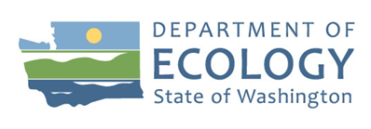
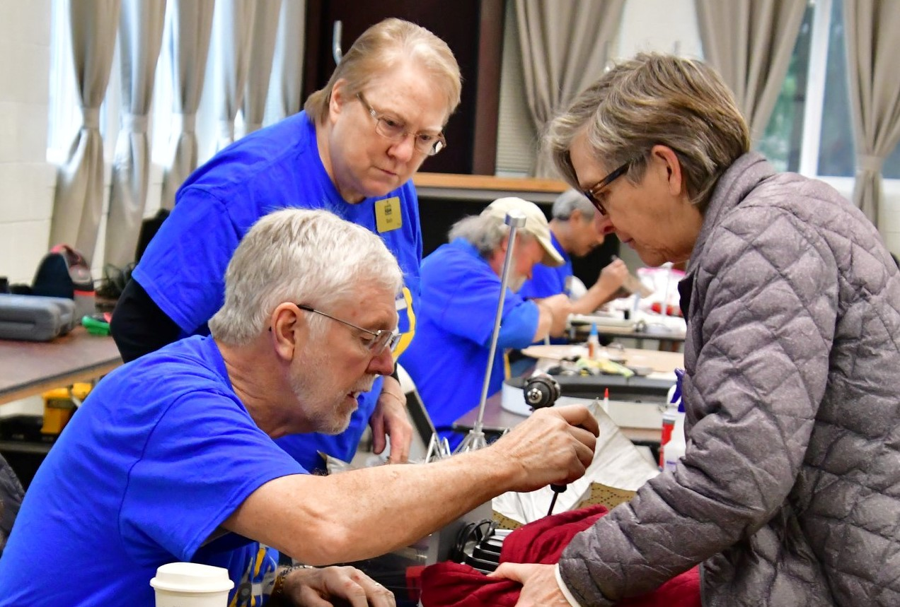

2019 – 2021 Biennium Report

Public Participation Grant Program

Solid Waste Management Division
Washington State Department of Ecology

Solid Waste Management Division
Washington State Department of Ecology
Olympia, Washington
October 2022, Publication 22-07-024

Publication Information
This document is available on the Department of Ecology’s website at: https://apps.ecology.wa.gov/publications/summarypages/2207025.html

Cover photo credit
- Photo courtesy of South King Tool Library, 2021

Related Information
- Chapter 70A.305 RCW, Hazardous Waste Cleanup-Model Toxic Control Act
- WAC 173-321
- Public Participation Grant Program Guidelines, publication 14-07-027

Contact Information
Solid Waste Management Program
Headquarters
P.O. Box 46700
Olympia, WA 98504-7600
Phone: 360-407-6000
Website: Washington State Department of Ecology

ADA Accessibility
The Department of Ecology is committed to providing people with disabilities access to information and services by meeting or exceeding the requirements of the Americans with Disabilities Act (ADA), Section 504 and 508 of the Rehabilitation Act, and Washington State Policy #188.
To request an ADA accommodation, contact Ecology by phone at 360-407-6000 or email at mark.hayes@ecy.wa.gov. For Washington Relay Service or TTY call 711 or 877-833-6341. Visit Ecology's website for more information.

Department of Ecology’s Regional Offices

Map of Counties Served
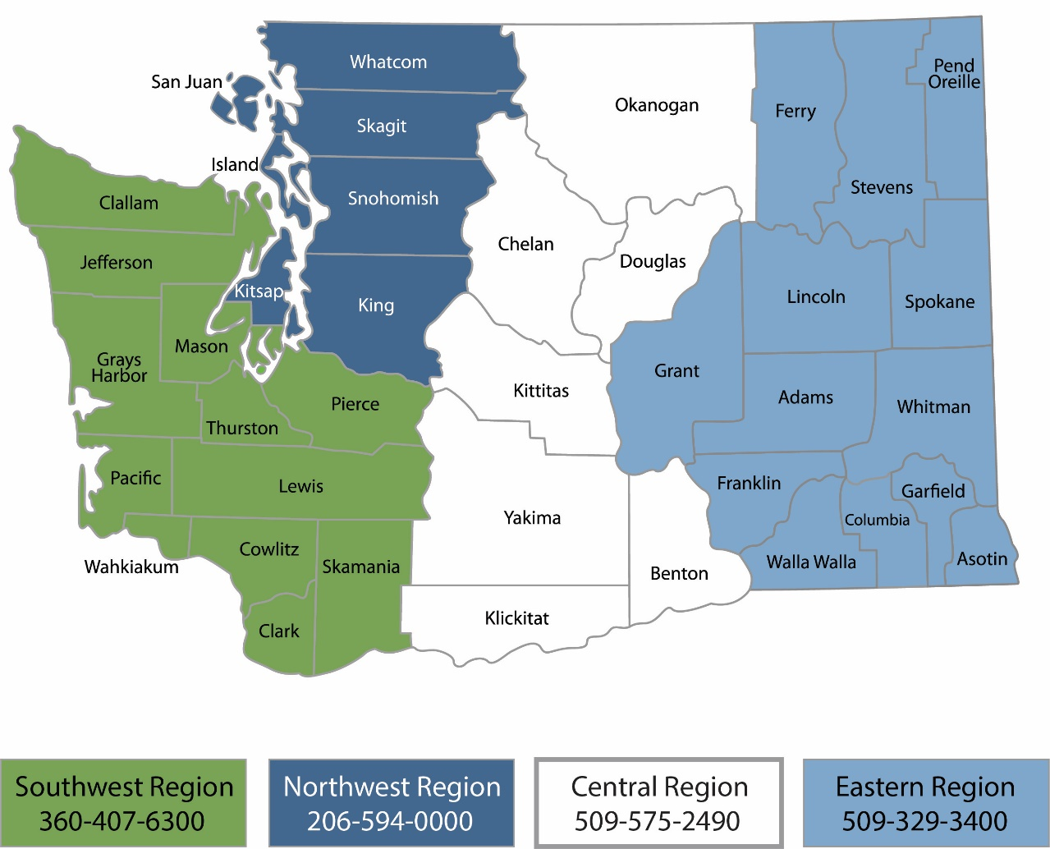
Region | Counties served | Mailing Address | Phone
Southwest | Clallam, Clark, Cowlitz, Grays Harbor, Jefferson, Mason, Lewis, Pacific, Pierce, Skamania, Thurston, Wahkiakum | PO Box 47775  Olympia, WA 98504 | 360-407-6300
Northwest | Island, King, Kitsap, San Juan, Skagit, Snohomish, Whatcom | PO Box 330316 Shoreline, WA 98133 | 206-594-0000
Central | Benton, Chelan, Douglas, Kittitas, Klickitat, Okanogan, Yakima | 1250 W Alder St  Union Gap, WA 98903 | 509-575-2490
Eastern | Adams, Asotin, Columbia, Ferry, Franklin, Garfield, Grant, Lincoln, Pend Oreille, Spokane, Stevens, Walla Walla, Whitman | 4601 N Monroe  Spokane, WA 99205 | 509-329-3400
Headquarters | Across Washington | PO Box 46700  Olympia, WA 98504 | 360-407-6000

2019 – 2021 BienniUM Report
Public Participation Grant Program
Solid Waste Management Program
Washington State Department of Ecology

October 2022 | Publication 22-07-024
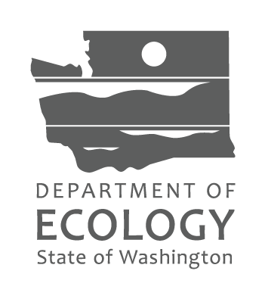

Table of Contents
Introduction 7
Governance – Program Changes 7
Application process 8
Project Categories and their impact on evaluation results 8
Public Participation Grant funds are awarded for two project categories: 8
Funding Analysis 8
Allocation spent by region and category 9
Allocation spent by region and category 9
Spending by task 10
Funding Analysis over time 10
Project Descriptions 11
Project Categories 11
Agreement Activities 11
COVID impact on project activities 11
Project Outcomes 12
Task 1 Outcomes 12
Task 2 Outcomes 12
Community Health Workers Coalition of Migrants and Refugees 13
Citizens for a Healthy Bay 13
Columbia Riverkeeper, Hanford Journey 13
Columbia Riverkeeper, Education 13
Columbia Springs 14
Duwamish River Cleanup Coalition 14
Friends of Grays Harbor 14
Futurewise 14
Hanford Challenge 15
Heart of America Northwest 15
Just Health Action 15
The Lands Council 15
Lake Roosevelt Forum 16
Methow Recycles 16
Mother Africa 16
Nourish Pierce County 17
Pacific Shellfish Institute 17
Re Sources for Sustainable Communities 17
ReUse Works (doing business as Ragfinery) 17
Refugee Federation Service Center 17
Seattle Tilth (doing business as Tilth Alliance) 18
South King Tool Library 18
Sustainable Connections 18
Zero Waste Washington 18
Appendix A - COmplete list of funded projects with short descriptions. 19

Introduction
The following report outlines the application process and performance of the 2019-2021 Public Participation Grant (PPG) program and a funding analysis of the program to date. The Department of Ecology (Ecology) is required to produce a report at the close of each biennium per WAC 173-321-070(6). This report is to include, at a minimum, the type and location of grant projects and the outcomes achieved.
The Washington State Department of Ecology’s (Ecology) Public Participation Grant (PPG) program provides up to $60,000 per year to qualified individuals and nonprofit organizations through a competitive application process. The purpose of this program is to facilitate public participation in the investigation and remediation of contaminated sites, and to facilitate implementation of the state’s solid and hazardous waste management priorities.
The program funds a growing number of community-based organizations that engage people who have historically been adversely impacted by environmental decisions, policies, and degradation including people experiencing social barriers such as low-incomes and limited English proficiency.
Ecology awarded $2,391,587 funds to twenty-two recipients. Of those awards, recipients spent $2,257,798 funds, leaving $133,789 unspent.
Governance – Program Changes
There are no new updates for the 2019-21 cycle. The 2019 – 2021 Program Guidelines were updated with only nominal revisions to clarify wording and revise dates.
Ecology adopted changes to Chapter 173-321 WAC, Public Participation Grants on June 28, 2017. The updated rule resulted in the following changes:
- Individuals can apply for a grant. Previously only three or more unrelated individuals could apply.
- Priority considerations for grants. Facilitating public participation in highly impacted or low-income communities is now a priority consideration.
- Tribal nonprofit organizations can apply for grants.
- Application evaluation criteria were revised and clarified.
- Purchases of tools up to $5,000 are allowed if Ecology determines them necessary to implement the project.
- An annual grant renewal process based on performance was incorporated.

Application process
A committee of four Ecology employees reviewed application submittals to determine the score for the project’s Scope of Work. These four evaluators worked independently to score applications against standardized criteria. After individual scoring was complete, the four scores were combined, and averages across scoring criteria and ranked from highest to lowest. Of the 38 applications initiated, three were cancelled before submission leaving 36 to be evaluated. Of these, 12 were unfunded, one was awarded and declined, and 22 were awarded and initiated. Two organizations submitted two applications each. Ecology chose to fund only one application for each of these two organizations so that funds would be distribute as broadly as possible across the State and organizational missions.

Project Categories and their impact on evaluation results

Public Participation Grant funds are awarded for two project categories:
- Contaminated site projects – Projects that facilitate public participation in a hazardous substance release site can receive up to ten evaluation points depending on the sites State Washington Ranking Method (WARM) or the National Priority List (Superfund) site ranking.
- Waste management projects – Projects that implement the number one state priority of waste reduction receive five evaluation points.
Projects cannot receive evaluation points for both the Waste management and Contaminated site criteria. Applications that do not fit either of these two project categories are ineligible for funding in the program.

Funding Analysis

The total legislative allocation for the 2019-21 Biennium was $2,676,583. This is based on the requirement in the Model Toxics Control Act (RCW 70A.305.180) for one percent of moneys collected under RCW 82.21.030 Pollution Tax (HST) to be allocated for Public Participation Grants.

Total amount requested by the public in the competitive application process was $3,813,523

Total amount funded by Ecology was $2,391,587

Total approved expenses (Total spent) $2,257,798

Total amount of funds left unspent at the end of the biennium was $133,789

Allocation by region and category
The number of awards and total award amount by region and program category is dependent on the characteristics of the applications submitted and their scoring in the evaluation process.

Table 1. Total dollars awarded by region and funding category
Awarded | CRO | ERO | NWRO | SWRO | Total
Contaminated Site Involvement | 358,000 | 142,900 | 506,600 | 66,091 | 1,073,591
Solid Waste Management Priorities | 196,000 | 0 | 881,996 | 240,000 | 1,317,996
Total | 554,000 | 142,900 | 1,388,596 | 306,091 | 2,391,587

Allocation spent by region and category
The total amount spent by region and program category is dependent on the recipient’s project performance and completion rate over the grant period and the recipients’ requests for eligible project costs.
The total amount of the budgeted $ 2,391,587 spent was $2,257,798, leaving $133,789, or five-percent, unspent in the 2019-21 biennium. Only two recipients failed to spend more than $25,000 of their award amount.

Table 2. Total dollars spent by region and funding category
Spent | CRO | ERO | NWRO | SWRO | Total
Contaminated Site Involvement | 358,000 | 142,889 | 448,562 | 64,331 | 1,013,782
Solid Waste Management Priorities | 195,987 | 0 | 856,557 | 191,472 | 1,244,051
Total | 553,987 | 142,889 | 1,305,119 | 255,803 | 2,257,798

Spending by task
Standard task titles were created for each category of work. Budgets and outcomes were tracked at the task level throughout the biennium.
Actual amounts spent by Task come from payment history forms associated with each PPG agreement in Ecology’s electronic tracking system, Ecology’s Administration of Grants and Loans (EAGL).
- Task 1 included project administration, which includes only the management of grant terms and conditions such as quarterly reporting, requesting payments, and negotiating the agreement.
- Task 2 included project work under each of the two funding categories. This included activities required to carry out the goals of the project such as outreach to community members, hosting workshops, and providing public comment on issues of concern.

Funding Analysis over time
The amount of funds awarded to grant recipients has fluctuated over time. Grant recipients have spent approximately 92 – 94% of their awards over the last 10 years.

Table 3. Spending by biennium in dollars
Biennium | Amount Awarded | Amount disbursed to Grant Recipients | % Spent
2011-13 | 1,229,210 | 1,127,945 | 92%
2013-15 |  | 3,525,492
2015-17 | 0 | 0
2017-19 | 2,420,876 | 2,230,767 | 92%
2019-21 | 2,391,587 | 2,257,798 | 94%
The 2016 Supplemental Budget cut $3.8 Million from the PPG Allocation, leaving no funding for grants. The allocation was restored in the 2017-19 biennium.

Project Descriptions

Project Categories
Contaminated site projects - These projects encourage public involvement in the investigation and cleanup of contaminated sites designated on the State WARM and National Priority List ranking.
Waste management projects - These projects facilitate implementation of the state’s solid and hazardous waste priorities.

Agreement Activities
The twenty-three implemented projects each negotiated distinct scopes of work within the two categories. For a full list of projects and a brief description of each, see Appendix A.
Most projects prioritized education and outreach to the public in a variety of settings including classrooms and public events. Several agreements launched pilots to innovate for waste diversion strategies through repair cafes/fix-it events, community composting, and privatized recycling. Table 4: Projects grouped by like activities associates the projects according to the general activities conducted under each grant.
Table 4. Projects grouped by like activities
Project Category | General Project Activities | Number of Agreements
Contaminated site projects | Public Outreach for Contaminated Sites | 6 agreements
 | Public Outreach for Hanford Nuclear Waste Cleanup | 3 agreements
 | Public Education for Hazardous Waste and Toxic Reduction | 4 agreements
Solid Waste Management Priorities | Recycling Promotion | 1 agreement
 | Organics Waste Reduction | 3 agreements
 | Product Reuse Initiatives and Promotion | 4 agreements

COVID impact on project activities
The international public health crisis of the COVID-19 pandemic brought a halt to many Public Particiaption Grant activities that had begun in February and March of 2019 and spanned the duration of the biennium. Grant recipients proved their determiniation and fortitude by pivoting project activities to reach community members through electronic and remote strategies.
The South King Tool Library and Columbia Springs provide illustrations of this fortitude and ingenuity. Due to the pandemic, South King Tool Library (SKTL) shifted from in-person educational classes to virtual educational classes. The PPG agreement called for eight classes total, SKTL held 18 classes in seven quarters attracting 797 participants. Topics covered gardening, food preservation, sewing repairs, green cleaning, and clutter clearing, which were all topics the public was keenly aware of during the economic shutdown and isolation. Three classes were offered in Spanish.
At Columbia Springs, typical repair events include many people in close contact. During the pandemic, repair went remote by turning librarys into drop-off locations for damaged items in need of repair. Fixers would collect the items and repair them from home or in smaller, distanced groups. The project served 2,127 clients and fixed 2,027 items with a repair rate of 90% over the grant period.

Project Outcomes
Public Participation Grant projects must include measurable project outcomes as described in the following:
WAC 173-321-050 (8)(d)
The evaluation criteria will include at a minimum… (d) The extent to which the applicant has demonstrated the ability to measure the project's outcomes.
Project Guidelines
Projects may include both outputs and outcomes… Outcomes refer to the result, effect, or consequence that will occur from carrying out the activities or outputs of the project. Outcomes may be environmental, behavioral, health-related, or programmatic, should be quantitative, and may not necessarily be achievable during the project period.
Each project achieved at least the minimum required single outcome per project task.

Task 1 Outcomes
All projects achieved Task 1 Outcomes, including completion of the quarterly progress reports, grant payment requests as needed, and grant closeout (final) reports.

Task 2 Outcomes
Project outcomes included primarily some number of people educated or trained. Grant recipients set, monitored, and analyzed unique Outcomes specific to their projects. A complete list of projects and their reported outcomes is included below.

Community Health Workers Coalition of Migrants and Refugees
- Twenty-two Latina Community Health Workers became trainers on Pesticide use and safety.
- One hundred fifty-three (153) people attended pesticide use and safety workshops in Spanish in 27 cities across Washington State.
- An additional 1,568 people downloaded a pesticide educational mobile application that CHWCMR developed with the grant between September 2019 and June 30, 2021. Application downloads serves here as a proxy for review of Pesticide educational materials.

Citizens for a Healthy Bay
- Girls participated in an environmental justice camp where they learned about the importance of clean air and water, functioning wetlands and riparian zones, and healthy salmon habitat. Campers left connected to their local environmental and knowing that they can and should have a voice in environmental decision making.
- Engagement with Puyallup Tribe of Indians to increase mutual understanding of the technical issues facing Commencement Bay.
- Increased public participation from Tacoma’s diverse communities in environmental decision-making, as well as the submission of more technical, substantive comments from this community during the public participation process.

Columbia Riverkeeper, Hanford Journey
- Completion of one short film based on the 2019 Hanford Journey. The film promotion resulted in a variety of community responses including:
- Social media: 20,000 views on Facebook; 4,058 impressions on Twitter; 372 views on Instagram; and 113 views on YouTube.
- Five hundred thirty-four people signed on to a linked Hanford petition.
- At least 2,000 page views on Riverkeeper’s web pages and blog posts about Hanford.
- One earned media news article.
- Completion of two strong communications plans designed to reach at least 10,000 Washington residents and Yakama Nation citizens to inspire Hanford participation. This first plan was implemented from January to June 2020 and the second was drafted to reflect the challenges of outreach during the COVID-19 pandemic.

Columbia Riverkeeper, Education
- Students in five classrooms learned about Hanford Nuclear site cleanup plans and progress.
- Community members learned about a variety of Hanford Nuclear site issues through virtual online education presentations, including
  - A Groundwater Webinar which had 48 attendees and 58 post-engagement views;
  - An interview with 14-year-old Hanford Art Contest winner Jazmine Cabaluna, which reached over 150 people;
  - A Waste Encapsulation and Storage Facility (WESF) Webinar, which had 148 attendees, with 218 additional views of the recorded webinar;
  - An online poetry reading with a Wyampum Nez Perce poet, Tyrone Ross Thompson, whose poem, “Gift with Meaning,” explores the stories of Indigenous people after the introduction of Hanford on the Columbia River. The online reading reached 747 views across social media platforms.
- Distributed four produced fact sheets to the public on Hanford 100-BC area; aging infrastructure; groundwater; and M-091.

Columbia Springs
- Participation from 2,127 people in fix-it fairs where 2,027 items were repaired.
- Textile waste diverted to create 1,683 reusable fabric gift-wrapping bags, 1,841 facemasks, and 3D printed 4,301 mask straps.

Duwamish River Cleanup Coalition
- Facilitated four Duwamish Alive! events and one Duwamish River Festival.
- Hosted three contaminated site boat tours and an additional three kayak tours.
- Produced online Duwamish River tours, at least five informational flyers, a monthly newsletter.

Friends of Grays Harbor
- Three hundred five (305) people attended virtual toxic site education events.
- One-hundred forty-two (142) people attended 19 outreach presentations about Toxic Cleanup Sites.
- One hundred thirty (130) viewers watched two educational videos produced.
- Students in 12 classrooms learned about microplastics’ ocean impacts through virtual classroom presentations and at beach cleanup events.
- Volunteers collected 87,000 littered yellow ropes off beaches that were then recycled into crab keys and useful items.

Futurewise
- Door to door canvasing resulted in 52 residents engaged about Algona site cleanup.
- Two presentations kept the Algona City Council informed on the cleanup.
- Project communications compelled two people to submit public comment in response to the draft Feasibility Study.
- Project activities kept the Algona community informed about the groundwater contamination and its cleanup plan.

Hanford Challenge
- Through community-events, educational workshops, classroom lectures, and virtual presentations, 47,702 people learned about cleanup activities at the Hanford Nuclear Site.
- Twenty-six educators participated in the Teaching Hanford initiative with regular monthly meetings and regular support.
- Three students received project guidance and mentorship on two intensive academic projects.
- Through newsletters, distributed materials, and web-based content, almost 370,000 people were introduced to cleanup activities at the Hanford Nuclear Site.

Heart of America Northwest
- Project activities kept the people across Washington informed about Hanford Nuclear Site contamination and its cleanup plan.
- Fifty percent of Hanford Live participants attended after receiving an invitation via HoANW phone banking.
- Twenty-three people attended workshops learned how to submit public comments on Hanford Nuclear Site cleanup issues, “very well.”
- Earned and published review of key Hanford Cleanup issues and public notice for Hanford Live in The Inlander, Spokane’s weekly newspaper.
- In-service-and-lecture-based education for students at various levels interested in the Hanford Nuclear Site’s intersections with environmental justice.

Just Health Action
- Successful development of source control videos for English and Spanish speaking community.
- Engaged and launched an inter-disciplinary team to represent the Duwamish Valley communities in addressing regional source control issues.
- Youth education on source control, green cleaning, and community-building.
- Conducted a source control materials review and provided feedback to agency authors to make the materials more relevant, engaging, and culturally relevant to communities in the Duwamish Valley.

The Lands Council
- Outreach activities to the public resulted in their increased knowledge and awareness of the health risks of Spokane River toxics. Of members of the public interviewed, 46% said that information they received affected or will affect their use of the river.
- Educational programming to youth resulted in their increased knowledge and awareness of Spokane River toxic contamination, the watershed, and the importance of preventing further pollution.
- Planting of 35 street trees resulted in the uptake of contaminated stormwater runoff and prompted public access to free Ponderosa pine seedlings to plant on private lands.
- Two Spokane River clean-up events resulted in the removal of six tons of garbage along the river.

Lake Roosevelt Forum
- One thousand nine hundred (1,900) households received print newsletters about the Lake Roosevelt region’s environmental management and topics. An additional equivalent received an electronic newsletter, which was an increase of 15-percent in two years.
- Two hundred ninety-nine (299) people attended a Spokane River focused conference hosted by Lake Roosevelt Forum.
- One thousand nine hundred (1,900) households received a 2020 Human Health Risk Assessment Public Guide.
- Three hundred seventy (370) students from nine schools attended a Lake Roosevelt Water Festival.
- One hundred citizens (100), stakeholders, elected, and opinion leaders, participated in one or more meetings about Lake Roosevelt’s environmental issues and management.
- Two-hundred ninety-seven (297) people attended two webinars on Lake Roosevelt’s environmental issues and management.

Methow Recycles
- Four hundred sixty-nine (469) items that would otherwise have been trash were repaired, an 89-percent success rate.
- Social media posted educational stories on reuse and repair earned 900 views each.
- Earned and published Plastic-free challenge in Methow Newspaper.
- Forty volunteers engaged, learned, and implemented waste repair and reuse strategies.
- Sixteen hundred (1,600) people at Farmers markets engaged on waste diversion issues.
- Waste Prevention and recycling priorities were integrated into Methow Valley’s Climate Action Plan.

Mother Africa
- Fifty people attended three project launch events
- Twenty families enrolled in project activities including compost workshops and community gardening
- Compost station built at the project partner’s farm site
- Participants diverted approximately 50 pounds of food waste to compost each month, resulting in a total 600 pounds of waste transformed into 100 pounds of compost by the end of the program.

Nourish Pierce County
- Two hundred seventeen thousand forty-three (217,043) pounds of food were diverted from the waste stream to people at risk of hunger.
- Partner education fostered increased commitment to food waste diversion such as this testimony from a grocery store manager, "Now that I know how many we are helping, I want to make sure we are giving you good, usable product."
- The COVID-19 Pandemic’s restriction on volunteer service resulted in hundreds of National Guard members’ participation in the project, learning about organic waste reduction and management.

Pacific Shellfish Institute
- Motivated by project activities, 531 people committed to practice watershed healthy habits through completing Salish Sea Watersheds Challenge commitments.

Re Sources for Sustainable Communities
- This project facilitated development of digital media tools for educating the public on contamination, cleanup plans, and environmental health strategies with a legacy that will outlive live, in-person events. The reach of these tools was in the hundreds per piece as more people have viewed the instructional pollution videos, the MTCA 101 workshops, and the site-specific videos tours than would have been able to attend a synchronous workshop or tour offering.
- Survey finding suggest an increased understanding of the process and timeline for cleanup along the bay, as well as the adoption of the Water Reporter app by 80+ people for use as a pollution reporting tool.
- Recipient’s dedicated staffing under this grant has fostered improved relationship with local Cities and the Port of Bellingham, resulting in more responsiveness to reported pollution and collaborative work that is beyond the original grant intent.

ReUse Works (doing business as Ragfinery)
- Five thousand five hundred forty (5,540) of textiles were diverted from the landfill through Community Closet, Artist ReUse, and ReUse Kits projects.
- An additional 61,900 of textiles were diverted from the landfill and put to good use via donation to a non-profit program.
- Dozens of community members received mending kids, useful textiles, textile artist supplies, and coaching on how to extend the useful life of imperfect textiles.

Refugee Federation Service Center
- One hundred twenty-four (124) people from six ethnic communities completed at least one workshop on residential waste management strategies, helping raise awareness with their families and friends in the community.
- Three grass roots community organizations in the Khmer, Cham, and Laotian communities and two community leaders in the Latinx and Burmese/Karen communities received subcontracts to provide environmental education in-language on source control and disposal of household hazardous items.
- In year two, four community workshops were conducted virtually and two were conducted in person and sessions were split into smaller groups due to necessary safety precautions during the COVID19 pandemic.

Seattle Tilth (doing business as Tilth Alliance)
- Program participants received food waste prevention education and resources in up to nine different languages.

South King Tool Library
- Three hundred seventy-eight (378) people brought 581 damaged items for repair at eight Repair Cafes. Two cafes were remote through video during the pandemic.
- Seven hundred eighty-eight (788) people brought 18,480 pounds of material to recycle or be repurposed at events including clothing swaps, Christmas Tree recycling, shredding events and electronics recycling events.
- Seven hundred ninety-seven (797) people attended 18 classes on food preservation and other sustainability topics. Three classes were offered in Spanish.

Sustainable Connections
- Sustainable Connections achieved their goal in reducing food waste generated by businesses and redistributing food to community members experiencing hunger.
- Sustainable Connections diverted 410,365 pounds of food from the landfill. Of this, 350,094 pounds were fit for human consumption, creating nearly 300,000 meals for the hungry.
- Sixty thousand two hundred seventy-one (60,271) pounds of food waste were diverted for animal feed.

Zero Waste Washington
- Two hundred and six (206) people chose to repair and reuse damaged items, diverting 1,307 pounds of goods from the waste stream in Tacoma, Kitsap, and Seattle.
- Twenty-three “fixers” volunteered to repair items in Seattle, 93 volunteered in Kitsap County, and 46 volunteered in Tacoma.
- Zero Waste Washington established a strong online promotion network of partners to inform the public about upcoming events. This includes news coverage (Kitsap Sun Bremerton Beat Blast video that was watched 29K+ times). Fix-it Fair programming reached an estimated 40K people through various channels.
- Fifty-two people received e-news to advance Washington’s repair economy, 41 and 38 people attended two repair-focused symposiums.

Appendix A.

Complete list of funded projects with short descriptions.

Citizens for a Healthy Bay facilitated public participation among highly impacted, low-income communities in Tacoma in the investigation and cleanup of contaminated sites, and in the prevention of industrial pollution.
Columbia Riverkeeper collaborated with Yakama Nation and the Yakama Nation Tribal School to educate and encourage people on the Yakama Reservation and Treaty territory to engage in Hanford cleanup decisions.
Community Health Worker Coalition for Migrants and Refugees trained community leaders to deliver workshops to community members on ways to avoid pesticide exposure.
Duwamish River Cleanup Coalition conducted community education and engagement programs to involve residents, fishers, tribal members, waterfront workers, recreational users, small businesses, and youth in efforts to clean, restore and prevent recontamination of the Duwamish River Superfund/MTCA site.
Friends of Grays Harbor contracted with Twin Harbors Waterkeeper to provide a series of workshops to educate the public about Washington State’s Model Toxics Control Act (MTCA) and Environmental Protection Agency (EPA) National Priority List (NPL) cleanup sites in the Chehalis River watershed and microplastics in water and food waste composting.
Futurewise planned to increase public education and participation related to the Boeing Auburn Fabrication groundwater site through outreach and activities in the cities of Algona and Auburn. Due to delays in the cleanup process, the project was not able to achieve the anticipated deliverables.
Hanford Challenge supports and inspires a broad and diverse public, with a focus on underserved communities, to effectively participate in the Hanford Nuclear Reservation National Priority List site cleanup.
Heart of America Northwest Research Center involved the public statewide in Hanford Nuclear Site cleanup decisions with focused work with Native American and Latinx populations.
Just Health Action provided community education and outreach in the Duwamish Valley on controlling the source of pollutants to the Lower Duwamish Waterway Superfund site.
Lake Roosevelt Forum increased public awareness of the remedial activities on the Upper Columbia River and their informed feedback to the Environmental Protection Agency (EPA) through conferences, tours, workshops, education, and outreach materials.
Methow Recycles increased waste reduction in the Methow Valley by continuing to host household item repair events, operated a tool lending library and materials exchange program, and conducted waste reduction education at area schools and community events.
Mother Africa engaged members in the African and Middle Eastern immigrant and refugee communities in South King County to compost food and yard waste at the Living Well Kent greenhouse. Nourish Pierce County provided safe, reliable, and consistent transport of perishable, edible food from grocery stores to 24 food banks. The project raised public awareness about food waste among store managers and volunteers while supporting food security.
Pacific Shellfish Institute, the fiscal sponsor for the Garden of the Salish Sea Curriculum (GSSC), delivered K-12 education and community outreach using a Salish Sea Challenge tool to gain student, family, and community commitments for watershed healthy habits.
RE Sources for Sustainable Communities utilized audience-specific approaches and neighborhood-based education to facilitate public understanding of the role they play in reducing stormwater impacts and influencing the regulatory cleanup process occurring in Bellingham Bay and Blaine Harbor.
Refugee Federation Service Center developed and conducted multilingual environmental education workshops for the immigrant and refugee fishing communities in South Seattle, West Seattle, and South King County. Community members provided input on the State of Washington's Toxics in Fish strategies and learned about what actions they can take to reduce toxics affecting the environment and the health of their community.
ReUse Works, through their program Ragfinery, reduced textile waste and increased creative reuse in Whatcom County through community projects that distributed textiles to those who need them and will use them.
Repair Clark County provided free community events where skilled volunteer fixers repaired broken household items such as clothing, bikes, walkers, appliances, electronics, and jewelry for the public to reduce solid waste going to landfills and conserve resources.
South King Tool Library expanded their tool library operations to reach low-income and non-English speaking populations to encourage waste reduction through tool checkout, waste reduction classes, and fix-it events.
Sustainable Connections reduced food waste generated by restaurants and events in Whatcom County by redistributing food to those in need. Hanford Challenge supported and inspired a broad and diverse public, with a focus on underserved communities, to effectively participate in the Hanford Nuclear Reservation National Priority List site cleanup.
The Lands Council increased the knowledge and awareness of the health risks of toxins in the Spokane River, increased awareness and acceptance of green infrastructure, promoted environmental stewardship in primary and secondary schools, and identified an online clearinghouse of PCB product-testing information through public outreach and education.
Tilth Alliance achieved waste reduction by increasing knowledge and skills related to preventing food waste at home, focusing in South Seattle and the Rainier Beach Neighborhood.
Zero Waste Washington collaborated with local housing authorities to create and hold Fix-It Fairs and conduct waste prevention education. Fix-It Fairs provided residents with skilled community members ("fixers") to repair household items such as small appliances and apparel free of charge.

www.ecology.wa.gov/contact
https://app.leg.wa.gov/WAC/default.aspx?cite=173-321
The actual amounts awarded statewide and by region were derived from an Ecology’s Administration of Grants and Loans (EAGL) report called DocumentListwithMap.
The actual amounts spent were derived from an Ecology’s Administration of Grants and Loans (EAGL) report called Agreement Balance Summary.
Since 2017, amounts awarded and disbursed are derived from data in Ecology’s Administration of Grants and Loans, Funding Distribution Report.
Grant recipients reported project Outcomes on quarterly progress reports and in conclusion of their project on a Recipient Closeout Report in EAGL. Outcomes submitted were collected for this report using EAGL Reporting System report, “Task Outcome.”

