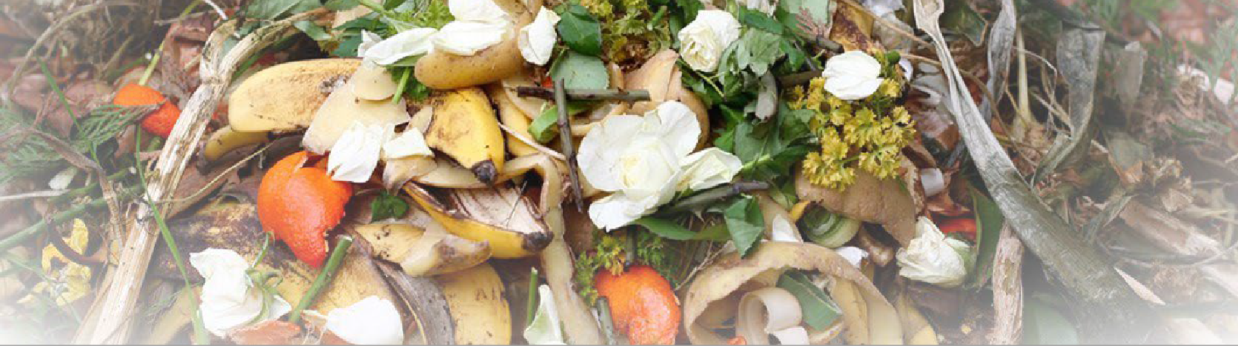
2022 Organics Management Law
Focus on Business Management Requirements

Overview
Methane is a greenhouse gas that is, over 20 years, at least 75 times more potent than carbon dioxide. The primary goal of the 2022 Organics Management Law¹ is to reduce the emissions of methane created when organic materials, like food and yard waste, decompose in a landfill. To achieve this reduction, the bill established milestones based on 2015 disposal levels:
- Rescue 20% of previously disposed edible food for human consumption by 2025
- Divert 75% of previously disposed organic materials from landfills by 2030
To help meet the state’s organic management goals, the new law added to and amended many different RCWs.

State requirements
This focus sheet examines a portion of the new law, RCW 70A.205.545^{[2]}, which has near-term requirements for Ecology and businesses. By July 1, 2023, and each following year, Ecology must post a determination of where the following apply:
- Curbside collection of food waste and organic materials is provided to businesses, and these materials are delivered to an organics management facility such as a compost facility or anaerobic digester.
- Adequate capacity exists at these facilities to accept increased volumes of organic materials from businesses.

¹https://ecology.wa.gov/Waste-Toxics/Reducing-recycling-
waste/Waste-reduction-programs/Organic-materials/2022- organics-management-law

Businesses requirements
Based on available service and volumes of organic material and solid waste produced, businesses must arrange for organic materials management services following the schedule below:
- Jan. 1, 2024 -Businesses generating at least eight cubic yards of organic material waste per week must arrange for organic materials management service.
- Jan. 1, 2025 -Businesses generating at least four cubic yards of organic material waste per week must arrange for organic materials management service.
- Jan. 1, 2026 - Businesses generating at least four cubic yards of solid waste per week must arrange for organic materials management service.
These requirements also apply to businesses arranging for gardening and landscape work. Following the schedule above, they must ensure that an organics management facility will process the organic materials taken off site.
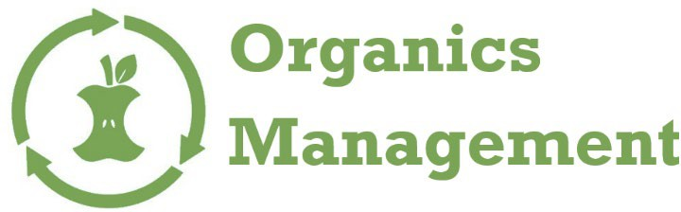
More details on these requirements can be found at Organics management for businesses - Washington State Department of Ecology.
(continued)
^{[2]}https://app.leg.wa.gov/RCW/default.aspx?cite=70A.205.545

Publication 22-07-025 | October 2022 | Revised August 2023 Solid Waste Management

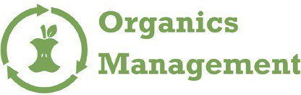

Business exemptions may apply
Ecology and local jurisdictions will work together to determine primary exemptions for businesses from the organic material management requirements

- Businesses will not be required to arrange for organics management services if there are no haulers in a jurisdiction to collect and deliver organic materials to a management facility, or the existing organic management facilities have no capacity for additional deliveries, or it is not economically feasible to collect and deliver organic materials to them.
- A jurisdiction may provide written notice to Ecology that, based on the criteria above, the organic material management requirements do not apply to businesses in their jurisdiction. Guidance on how to request an exemption can be found here.
Businesses may also be exempt from arranging for organic material management services if one of the following conditions apply:
- Organic materials are managed onsite.
- Organic materials from growing or harvesting food or fiber are used offsite by a business for growing food or fiber.
- Organic materials are sold or donated to another business for offsite use.
- Organic materials are generated from a natural disaster.
- Organic materials are self-hauled to an organic materials management facility.

How to learn more
Subscribe to the Organics Management email news to stay up to date. To sign up, follow the email news² link:
- Submit your email address
- Choose the Solid Waste Management Program
- Choose Organic Materials
Additional information about the 2022 Organics Management Law and related resources can be on our BOX platform.

²https://public.govdelivery.com/accounts/WAECY/subscriber/new?topic_id=WAECY_244%22%3eClick%20to%20subscribe%3c/a
³https://ecology.wa.gov/Waste-Toxics/Reducing-recycling-waste/Strategic-policy-and-planning/Enacting-legislation
DEFINITIONS
“Business” means a commercial or public entity including, but not limited to, a firm, partnership, proprietorship, joint stock company, corporation, or association that is organized as a for-profit or nonprofit entity. [Note: This definition includes public and nonprofit entities such as schools, churches, and hospitals.]
“Business” does not include a multifamily residential entity.
“Food waste” means waste from fruits, vegetables, meats, dairy products, fish, shellfish, nuts, seeds, grains, and similar materials that results from the storage, preparation, cooking, handling, selling, or serving of food for human consumption.

Organics Management Team
Organics@ecy.wa.gov
(509) 960-1290
To request ADA accommodation including materials in a format for the visually impaired, call Ecology at 360-407-6381 or visit https://ecology.wa.gov/accessibility. People with impaired hearing may call Washington Relay Service at 711. People with speech disability may call TTY at 877- 833-634

