Overview
Methane is a greenhouse gas that is, over 20 years, at least 75 times more potent than carbon dioxide. The primary goal of the 2022 Organics Management Law¹ is to reduce the emissions of methane created when organic materials, like food and yard waste, decompose in a landfill. To achieve this goal, the bill established goals based on 2015 disposal levels, which require actions by state and local agencies, residents, and businesses to:

- Rescue 20% of previously disposed edible food for human consumption by 2025.

- Divert 75% of previously disposed organic materials from landfills by 2030.

The purpose of the compost procurement provisions now codified in RCW 43.19A.150² is to strengthen markets for the anticipated large amounts of additional compost that will be produced as organics collection programs expand. Other statutes established or amended for this purpose include RCW 43.19A.160 and RCW 39.30.040.

Specifically, these statutes require cities and counties that meet certain criteria to adopt compost procurement ordinances (CPO) and to report their compost purchases to Ecology.

1 https://ecology.wa.gov/Waste-Toxics/Reducing-recycling- waste/Waste-reduction-programs/Organic-materials/2022-organics- management-law
What follows are answers to key questions about how these new provisions affect local governments:

Which local governments are required to adopt a CPO and submit compost procurement activity reports to Ecology?
- Counties and incorporated cities with a population of more than 25,000, based on the latest Office of Financial Management data, are required to adopt a CPO and submit compost procurement activity reports to Ecology.

- Counties with a population of 25,000 or fewer that contract to provide or require the UTC-franchised hauler(s) in their county to provide residential curbside organic material collection services.

- Cities and towns with a population of 25,000 or fewer that directly provide, contract to provide, or require the UTC-franchised hauler(s) in their jurisdiction to provide residential curbside organic material collection services.

What was the deadline for adopting a CPO?

The deadline for adopting compost procurement ordinances was January 1, 2023.
2 https://app.leg.wa.gov/RCW/default.aspx?cite=43.19A.150
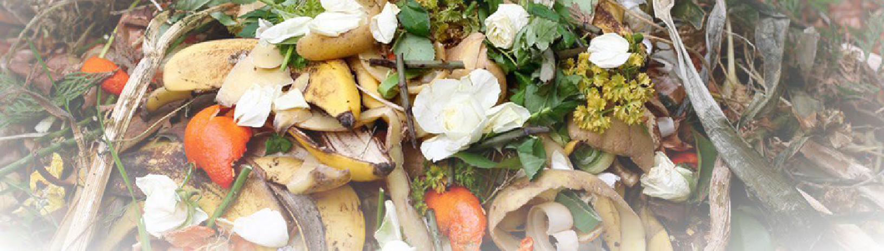
2022 Organics Management Law
Focus on Compost Procurement Ordinances and Reporting

Publication 22-07-026 | Revised February 2023 Solid Waste Management

What options do jurisdictions have for meeting the CPO adoption and reporting requirements?
Each county, city, or town required to adopt a CPO must adopt their own CPO or amend an existing recycled product procurement ordinance to include compost. To facilitate this process, jurisdictions can work together to draft identical or similar CPOs for separate adoption.
Counties, cities, and towns may coordinate purchasing compost with other jurisdictions through the use of collective purchasing agreements under RCW 43.19A.150(7). For more information, consult Intergovernmental Procurement and “Piggybacking” on the Municipal Research Service Center website.

What should a CPO address?
A CPO is intended to implement RCW 43.19A.120: Use of compost products in projects. This statute states that when “planning government-funded projects or soliciting and reviewing bids for such projects, all state agencies and local governments shall consider whether compost products can be utilized in the project.” If it is determined that compost products can be used, then they must be used unless certain exceptions related to cost, availability, and quality apply.
Other relevant statues to review in preparing a CPO include:
  - RCW 43.19A.110, which requires counties and cities to adopt specifications for compost products to be used in road projects.
  - RCW 43.19A.130, which encourages local governments to purchase compost from the compost facility that serves its residents.
When are compost procurement activity reports due?
The first report is due by Dec. 31, 2024, and by December 31 in every subsequent even-numbered year – 2024, 2026, 2028, 2030 and so on.

What is included in a compost procurement activity report?
Organics Management Team
Organics@ecy.wa.gov
(509) 960-1290
To request ADA accommodation including materials in a format for the visually impaired, call Ecology at 360-407-6381 or visit https://ecology.wa.gov/accessibility. People with impaired hearing may call Washington Relay Service at 711. People with speech disability may call TTY at 877- 833-6341.
Compost procurement activity reports need to include the following:
- The total tons of organic material diverted from disposal each year.
- The volume and cost of compost purchased each year.
- The source(s) of the compost.
Details on what to include in these reports can be found in this guide.

How are these reports submitted and tracked?
Ecology is developing an online system for local governments to submit their compost procurement activity reports. The first reports, due in December 2024 will cover 2023 procurement activity; we expect the reporting portal to be open by July 1, 2024.

Are there other related requirements in the new law?
Yes. Any county or city that adopts a CPO must “develop strategies to inform residents about the value of compost and how the jurisdiction uses compost in its operations.” These strategies will need to be included in the local solid waste management plan the jurisdiction participates in when that plan is amended or updated. Information on the value of compost and making and using compost are on Ecology’s compost page.

How can I get help drafting my CPO?
Expert help to draft a CPO is offered to all Washington towns, cities, and counties free of charge by the Municipal Research Service Center through their Ask MRSC inquiry service. Additional resources, including sample ordinances, can be found on Ecology’s Box platform. These materials include environmentally preferred purchasing materials prepared by Ecology and the Department of Enterprise Services.

For more information
Subscribe to our Organics Management email. Set up your account, choose Solid Waste Management, then Organics Management.

https://mrsc.org/Home/Explore-Topics/Public-Works/Purchasing-and-Bidding/Purchasing-and-Bidding-for-Washington-State-Local/Piggybacking.aspx
https://app.leg.wa.gov/RCW/default.aspx?cite=43.19A.120
https://app.box.com/s/5ifwsyu30x7uk0xlapz6t6g4a7j5gofp
https://ecology.wa.gov/Waste-Toxics/Reducing-recycling-waste/Waste-reduction-programs/Organic-materials/Managing-organics-compost
https://mrsc.org/Home/Research-Tools/Ask-MRSC.aspx
https://app.box.com/s/r7shmywl2t798nu43f1udkp1481bcx6y
https://public.govdelivery.com/accounts/WAECY/subscriber/new

