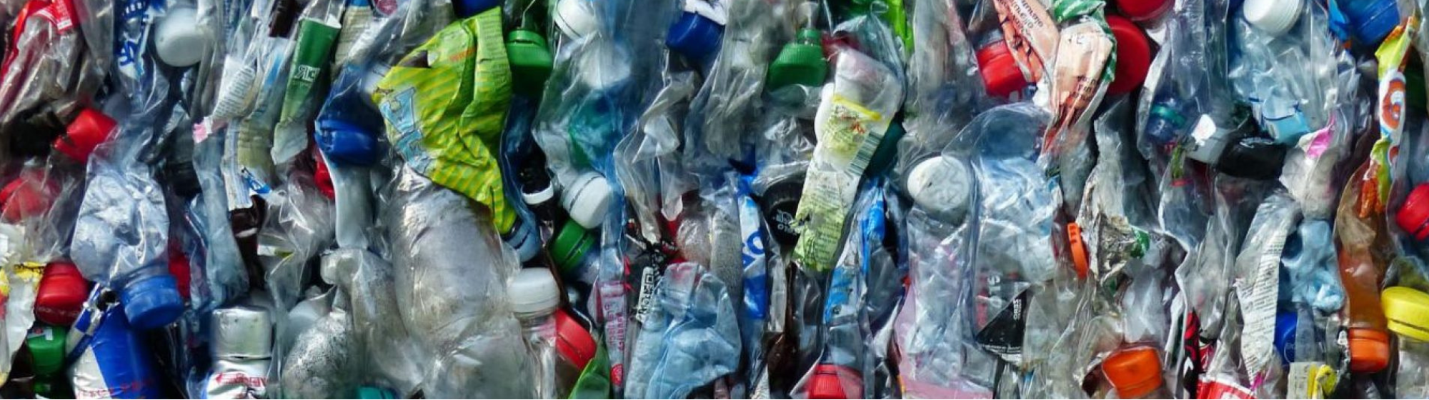
Post-consumer plastics recycling overview

Focus on recycled content requirements
Plastic is a threat to human health, wildlife, and the environment. Washington’s new plastics reduction law, RCW 70A.245, requires producers of many common, single-use plastics to include a minimum percentage of recycled material in their products. This policy drives development of new markets for Washington’s recyclable plastic and reduces economic dependence on virgin plastics.

Recycled content requirements phased in through 2036
The law requires the amount of post-consumer recycled content (PCRC) in each product category to increase over time.
2023
15% PCRC – Most beverage containers and trash bags
2025
15% PCRC – Household cleaning and personal care products in plastic containers
2028
15% PCRC – Dairy containers and wine sold in 187 ml plastic bottles
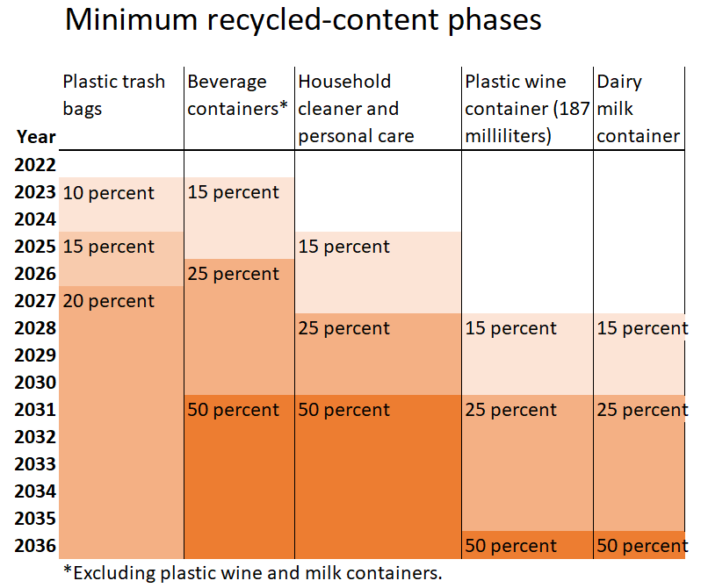

De minimus plastic producers are exempt from law’s requirements
Covered plastic producers must register annually with Ecology, pay fees to cover Ecology’s costs to oversee the PCRC program, and meet the minimum PCRC requirements.
Ecology registered 262 producers registered with Ecology. Of those, 155 met de minimis conditions. De minimis producers either sell less than a million dollars of a single covered product category into Washington or sell less than one ton of a single covered product category into Washington. De minimis producers are not required to meet the minimum PCRC requirements or pay annual fees to Ecology.

Small mountain of plastic resin sold in Washington every year
Producers reported in 2021 that a total of 196,888,431.89 pounds of plastic containers and trash bags were sold in Washington. The resin to make those products is the equivalent of about 5.4 billion water bottles. That is enough plastic to cover the Eiffel Tower twice, according to a 2019 Reuters report.

Next steps and rulemaking
In 2023 covered plastic beverage containers and plastic trash bags must meet the first phase of PCRC standards.
Ecology is conducting rulemaking to provide additional clarity and to outline the processes required but not defined in the law. The rules, including any changes in the interpretation of terms and methods, will take effect in 2024 under WAC 173-925. Rulemaking is informed by stakeholder input, economic analysis, and research by the department. You can learn more about the rulemaking process and opportunities to provide input on the PCRC rule website. You can also contact the rulemaking lead, Shannon Jones.
Shannon Jones
Rulemaking Lead
shannon.jones@ecy.wa.gov
360-742-9874

Recycled Content Team
Alli Kingfisher, Christina Kullberg,
and Heather Curtis
recycledcontent@ecy.wa.gov
To request an ADA accommodation, contact Ecology by phone at 360-409-6900, email at Mark.Hayes@ecy.wa.gov, or visit https://ecology.wa.gov/accessibility. For Relay Service or TTY call 711 or 877-833-6341

https://app.leg.wa.gov/RCW/default.aspx?cite=70A.245
https://www.reuters.com/article/us-environment-plasticbottles-backstory/backstory-mapping-the-worlds-growing-plastic-mountain-one-bottle-at-a-time-idUSKBN1WM0FX
https://ecology.wa.gov/Regulations-Permits/Laws-rules-rulemaking/Rulemaking/WAC-173-925

