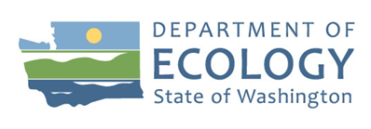
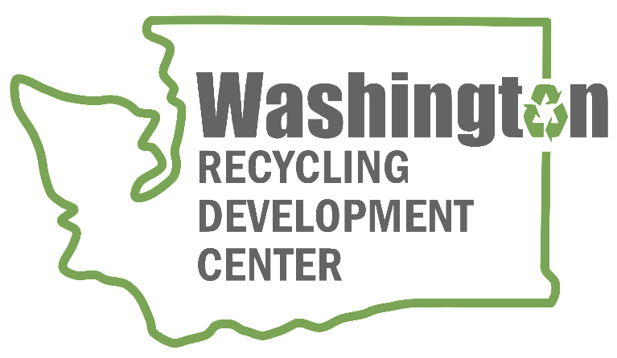

Recycling Development Center

Report to the Legislature

Solid Waste Management Program
Washington State Department of Ecology
Olympia, Washington
January 2023, Publication 22-07-032

Publication Information
This document is available on the Department of Ecology’s website at:
https://apps.ecology.wa.gov/publications/summarypages/2207032.html
Cover photo credit
- Ecology image, 2020

Related Information
Publication 20-07-022: Report to the Legislature: Recycling Development Center

Contact Information
Solid Waste Management Program
P.O. Box 47600
Olympia, WA 98504-7600
Phone: 360-407-6900

Website: Washington State Department of Ecology

ADA Accessibility
The Department of Ecology is committed to providing people with disabilities access to information and services by meeting or exceeding the requirements of the Americans with Disabilities Act (ADA), Section 504 and 508 of the Rehabilitation Act, and Washington State Policy #188.
To request an ADA accommodation, contact Ecology by phone at 360-407-6900 or email at SWMpublications@ecy.wa.gov. For Washington Relay Service or TTY call 711 or 877-833-6341. Visit Ecology's website for more information.

Department of Ecology’s Regional Offices

Map of Counties Served
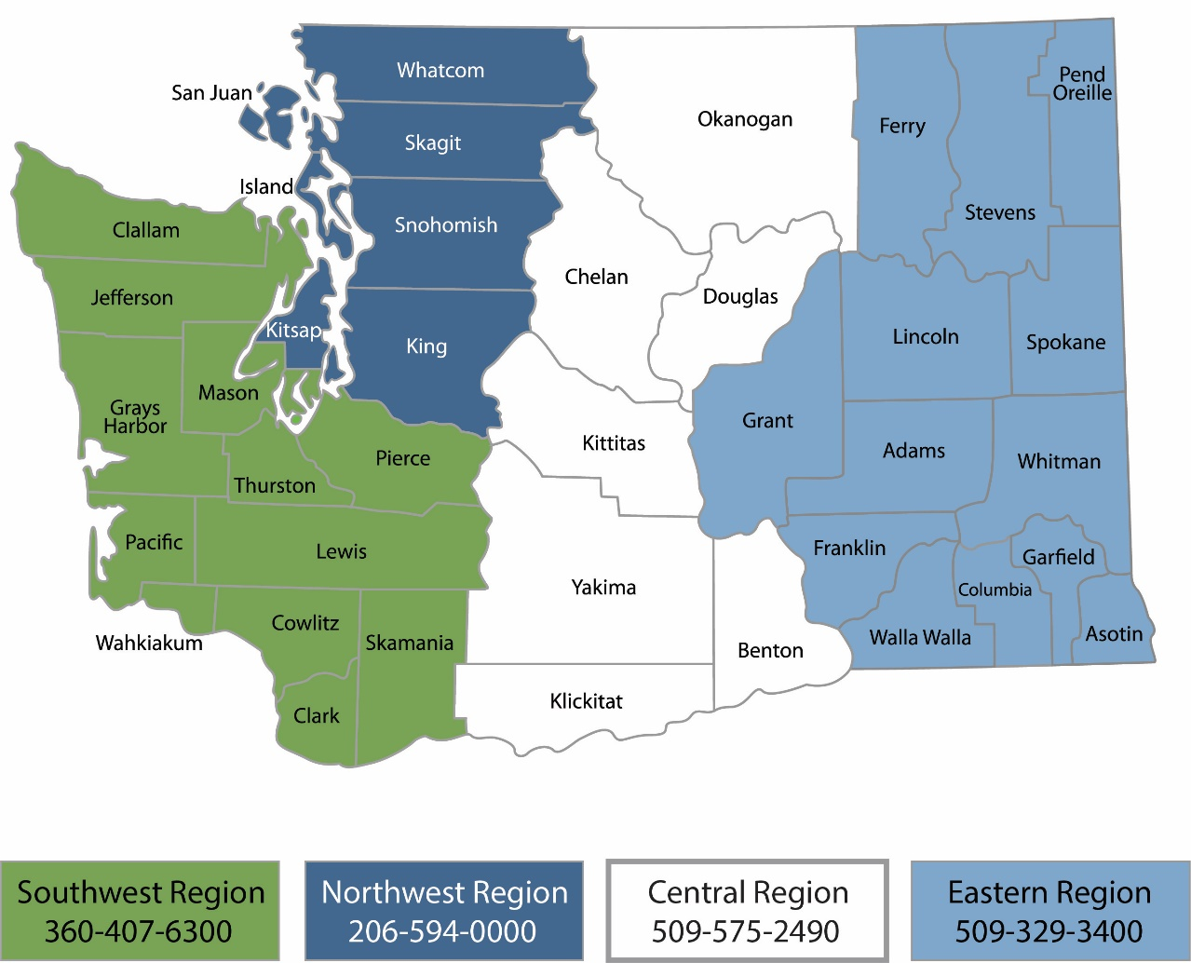
Region | Counties served | Mailing Address | Phone
Southwest | Clallam, Clark, Cowlitz, Grays Harbor, Jefferson, Mason, Lewis, Pacific, Pierce, Skamania, Thurston, Wahkiakum | PO Box 47775  Olympia, WA 98504 | 360-407-6300
Northwest | Island, King, Kitsap, San Juan, Skagit, Snohomish, Whatcom | PO Box 330316 Shoreline, WA 98133 | 206-594-0000
Central | Benton, Chelan, Douglas, Kittitas, Klickitat, Okanogan, Yakima | 1250 W Alder St  Union Gap, WA 98903 | 509-575-2490
Eastern | Adams, Asotin, Columbia, Ferry, Franklin, Garfield, Grant, Lincoln, Pend Oreille, Spokane, Stevens, Walla Walla, Whitman | 4601 N Monroe  Spokane, WA 99205 | 509-329-3400
Headquarters | Across Washington | PO Box 46700  Olympia, WA 98504 | 360-407-6000

Recycling Development Center

Report to the Legislature
Solid Waste Management Program
Washington State Department of Ecology
Olympia, WA
January 2023 | Publication 22-07-032
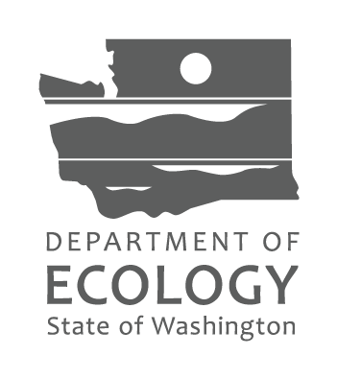

Table of Contents

Acknowledgements 7
Executive Summary 8
Advisory board accomplishments in 2021-2022 8
Center accomplishments in 2021-2022 9
Center focus for 2023-2024 9
Report to the Legislature 11
Advisory board 11
Accomplishments in 2021-2022 14
NextCycle Washington 14
Recycling studies 16
Local projects 18
Business resources 19
Market research 20
Center Work Plan 23
Summary of Challenges 25
Recycling market challenges 25
Conclusion 25
Appendix A: DRS and EPR Analysis 27
Background 27
Deposit return system (DRS) 27
Extended producer responsibility (EPR) 29
References 31
Appendix B: Solid Waste Data 34
Appendix C: Center goals and metrics 36
Appendix D: Hyperlinks 39

List of Tables and Figures

Tables
Table A - Advisory board membership 13
Table B - Recycling Development Center goals progress 38
Table C - Recycling Development Center metrics progress 39
Figures
Figure 1 - NORPAC pulper, waste pile, and paper 15
Figure 2 - Chelan glass pulverizer and glass product 16
Figure 3 - Refugee Artisans Initiative textile recovery and products 22
Figure 4 - Comparison of EPR recycling rates to Washington State’s recovery rate. 32
Figure 5 - Material recovered for recycling in 2021, tons 36
Figure 6 - Overall statewide disposed waste stream by material class, 2020-2021 37

Acknowledgements
The authors of this report thank the Recycling Development Center Advisory Board members for their support, contributions, and guidance:
- Natalie Caulkins, Republic Services
- Sam Dart, Grant County
- Corinne Drennan, Pacific Northwest National Laboratory
- Karl Englund, Board Co-Chair, Washington State University
- Kyla Fisher, AMERIPEN
- Deb Geiger, Spokane County
- Margo Gillaspy, Skagit County
- Nina Goodrich, Sustainable Packaging Coalition
- Sego Jackson, Seattle Public Utilities
- Allen Langdon, Circular Matters
- Kris Major, City of Spokane
- Scott Morgan, Board Chair, The Evergreen State College
- Chris Piercy, Kitsap County
- Mike Range, Waste Management
- Derek Ruckman, WasteXperts
- Tim Shestek, American Chemistry Council
- Jay Simmons, North Pacific Paper Company
- Heather Trim, Zero Waste Washington

Executive Summary
The Washington Department of Ecology (Ecology) and the Washington Department of Commerce (Commerce) conduct the work of the Recycling Development Center (Center). The Center provides or facilitates basic and applied research and development, marketing, and policy analysis in furthering the development of markets and processing for recycled commodities and products. (Chapter 70A.240 Revised Code of Washington (RCW)) [find all hyperlinks at the very end of this document in Appendix D]
This report updates the Legislature on the Center’s progress and activities as required by RCW 70A.240.030(3): The center must perform the following activities:
(k) Report to the legislature and the governor each even-numbered year on the progress of achieving the center's purpose and performing the center's activities, including any effects on state recycling rates or rates of utilization of postconsumer materials in manufactured products that can reasonably be attributed, at least in part, to the activities of the center.
For the 21-23 biennium, the Center received $2.4 million from the Waste Reduction, Recycling, and Litter Control Account to support 5 full time employees at Ecology and Commerce.
The primary objective of the Center is to further the development of markets for recyclable materials. Three market analysis reports identified the systemic gaps in Washington’s recycling market and for additional policy analysis. The identified gaps include:
- Consumer access and participation in recycling is inconsistent across the state.
- Material recovery facilities receive mixed materials from residents that often contain contaminants.
- Material recovery facilities often lack infrastructure to properly sort what is received.
- End-user markets remain marginal and/or emergent.
Listed below are the largest volume materials in Washington’s 5.2 million tons of municipal solid waste:

- 22.8 percent Organics
- 16.7 percent Paper
- 13.5 percent Wood Debris
- 13.2 percent Plastic
- 10.7 percent Construction Materials
- 7.5 percent Metal
- 7.4 percent Consumer Products
- 4.3 percent Residuals
- 2.3 percent Glass

The focus of the Center includes materials identified as priorities in the law, including paper and plastics. Opportunity and community priorities also focus the Center’s work on clean wood and glass. This report discusses Center accomplishments during the 2021 and 2022 calendar years.

Advisory board accomplishments in 2021-2022
Board members participated in eleven board meetings and provided guidance on Center efforts. Eleven board members’ service terms were completed, eight choose to stay on and three were newly appointed. Board members reviewed and commented on recyclable material market analyses: paper, glass, and plastic. Board meetings included presentations focused on specific materials: paper, glass, plastic, and textiles.

Center accomplishments in 2021-2022
The Center used $2.4 million of the Waste Reduction, Recycling, and Litter Control Account funds for the following efforts:
- $1,210,114 for Ecology and Commerce staff whose work included materials research reports on paper, glass, and plastic, oversight of all Center projects, management of the 2021 one-time grants, support of the advisory board, business consultations, and outreach efforts.
- $710,000 to NextCycle Washington’s online business accelerator program that supported 16 innovators with business and technical planning support and offered $10,000 seed grants to 27 small businesses.
- $324,437 for seven recycling studies funded through the competitive one-time grant program for local governments and universities. The grants funded research on recycling technology or the potential for recycling related activities in a specific jurisdiction.
- $150,000 for three pilot projects funded through a competitive one-time grant program to three local governments that supported projects focused on material reuse, wood recovery, and glass diversion.
- $100,000 for business resources funded through the competitive one-time grant program to two local governments to offer innovation challenges and an online materials marketplace.

Center focus for 2023-2024
In addition to ongoing Advisory Board work, the Center focus for 2023 and 2024 include:
- NextCycle Washington: Provide ongoing support to NextCycle Washington’s grants and accelerator opportunities to support waste reduction, reuse, and recycling innovations across the state, and similar accelerators.
- Washington Materials Marketplace: Promote and fund the services of the Washington Materials Marketplace at no cost to businesses and organizations in Washington State.
- Market research: Continue to conduct research and data analysis, provide updates to the board, and use that information to recommend actions and policies focused on market development for recyclable materials.
- Prioritization: Establish an approach to determine which actions result in positive impacts on the circular economy.
- Outreach: Provide presentations to in-state and national organizations and events, companies, universities, local governments, and others. Continue to meet with businesses interested in expanding or moving to Washington State.
- Pilot projects: Plan and initiate pilot projects for materials focused on recycling or reuse with the goal of establishing best practices.
- Industry summit: Facilitate conferences and discussions regarding existing and innovative rescue, reuse, and recycling opportunities to enhance the circular economy in Washington State. The initial summit focus on glass is provided in response to demand from interested parties in eastern Washington.

Report to the Legislature
The Washington Department of Ecology (Ecology) and the Washington Department of Commerce (Commerce) conduct the work of the Recycling Development Center (Center) as required by Chapter 70A.240 Revised Code of Washington (RCW). The Center is comprised of five state agency staff and a 14-member advisory board. The Center directs its services to businesses that transform or remanufacture waste materials into usable or marketable materials or products for use rather than disposal. The Center also provides or facilitates basic and applied research and development, marketing, and policy analysis in furthering the development of markets and processing for recycled commodities and products.
This report updates the Legislature on the Center’s progress and activities as required by RCW 70A.240.030(3): The center must perform the following activities:
(k): Report to the legislature and the governor each even-numbered year on the progress of achieving the center's purpose and performing the center's activities, including any effects on state recycling rates or rates of utilization of postconsumer materials in manufactured products that can reasonably be attributed, at least in part, to the activities of the center
Online access to Center-related information can be found on Ecology’s website and the advisory board website. Interested parties can keep up-to-date on Center work and advisory board meetings through an email list. All board meetings are open to interested parties and include an opportunity for public comment.

Advisory board
The Center operates in consultation with a 14-member advisory board. The board meets regularly and current board members are listed in Table A. Board meeting materials are posted on the advisory board website. Ecology and Commerce provided Center progress updates to the advisory board at each meeting.
Table A - Advisory board membership
Board Member | Organization | Representing
Kris Major | Spokane Solid Waste | City
Chris Piercy | Kitsap County | County
Sam Dart | Grant County | County
Heather Trim | Zero Waste Washington | Public interest group
Scott Morgan, Chair | The Evergreen State College | University
Karl Englund, Co-Chair | Washington State University | University
Corinne Drennan | Pacific Northwest National Laboratory | Research institution
Kyla Fisher | AMERIPEN | Packaging
Nina Goodrich | Sustainable Packaging Coalition | Packaging
Allen Langdon | Circular Matters | Not for profit
Mike Range | Waste Management | Solid waste management
Natalie Caulkins | Republic Services | Solid waste management
Tim Shestek | American Chemistry Council | Manufacturing
Jay Simmons | North Pacific Paper Company | Manufacturing

Board policy discussion:
The advisory board reviewed several policy approaches to stimulate market development. These policies were included in the recommendations to the legislature in December 2020 as directed by chapter 70A.520 RCW. These policy approaches included extended producer responsibility for packaging and a deposit return system for beverage containers.
Extended producer responsibility (EPR) is an environmental policy tool that transfers the financial responsibility for end-of-life management of products and packaging to producers. EPR can be applied to many product categories, including packaging and paper products. EPR for packaging and paper products can be an effective mechanism to improve recycling rates, reduce litter, incentivize system efficiencies, reduce costs for end-of-life management, and make collection and recycling more widespread and available. EPR can create incentives for producers to incorporate environmental considerations into the design of their packaging.
Deposit return systems (DRS), also called a container deposit system or bottle bill, is a legislatively designated system that places a small monetary deposit on a beverage container, paid by the consumer at the time of purchase, which is refunded when the consumer returns the container to a designated return location for reuse or recycling. DRS is considered a form of EPR in that producers are required to financially cover the operation of the system and in many cases meet specific return or recycling rates. A deposit provides a financial incentive for the user to return the beverage container. Unclaimed deposits as well as material revenues can partially cover the cost of the system; when high return rates are achieved, producers would contribute through producer fees to fund the program, similar to EPR.
Appendix A contains a preliminary analysis of the costs and benefits of these two policies, including:
- Rate impacts on solid waste utility ratepayers
- Impacts on the prices of consumer goods affected by the recommended policies
- Impacts on rates of recycling or utilization of postconsumer material

Board presentation topics:
The Center advisory board met regularly to share updates and hear topic specific information from a variety of presenters. The following recycling market topics were covered in board meetings during this report period.
Paper markets: Paper represents 16.7 percent of the material disposed in the municipal waste stream or 968,301 tons of paper. Paper packaging collected for recycling in 2021 totaled 1.1 million tons (13.6 percent of all materials recovered for recycling).
North Pacific Paper Company (NORPAC) and the American Forest and Paper Association presented to the board on paper markets progress and challenges. Board members toured the NORPAC facility in Longview, Washington, after the June 2022 board meeting.
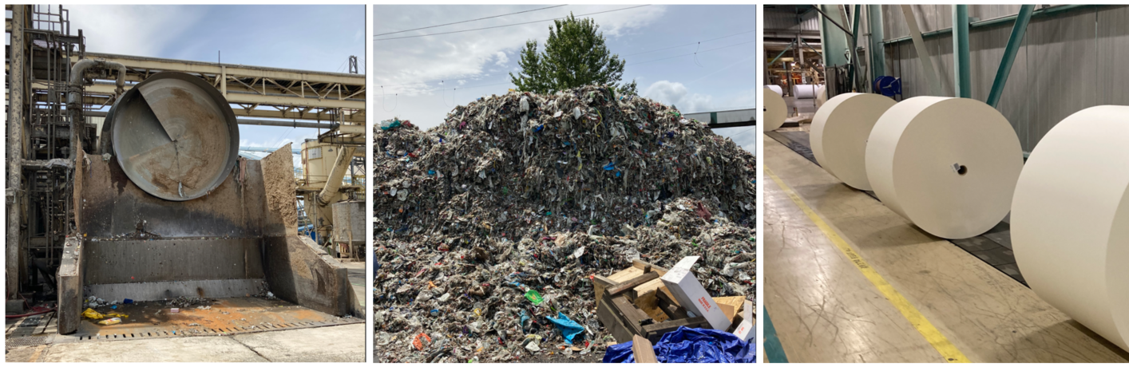
Figure 1 - NORPAC pulper, waste pile, and paper
Plastic markets: Plastic packaging represents 7.4 percent of the materials disposed in the municipal waste stream or 427,565 tons of plastic. Plastic packaging collected for recycling in 2021 totaled 96,794 tons (1.2 percent of all materials recovered for recycling).
The board received presentations on plastics in the recycling and waste stream. Ecology presented available Washington data. Cascadia Consulting presented an overview of the 2020 plastics study conducted at the request of the legislature (RCW 70A.520.030). Other presentations provided perspectives on plastic recycling markets from Waste Management, Merlin Plastics, Agilyx, Sustainable Packaging Coalition, SnoCo Packaging, and the Wrap Recycling Action Program (W.R.A.P.) flexible film pilot project.
Textile markets: Textiles represent 3.6 percent of the materials disposed in the municipal waste stream or 207,036 tons of textiles. Textiles collected for recycling in 2021 totaled 13,107 tons (0.16 percent of all materials recovered for recycling). Data on donated textiles is not collected by Ecology.
The board received presentations on textile recycling markets from Five12 Apparel, Secondary Materials and Recycled Textiles, and Regenerated Textiles.
Glass markets: Glass containers represent 1.7 percent of the materials disposed in the municipal waste stream or 99,726 tons of glass. Glass containers collected for recycling in 2021 totaled 76,890 tons (1 percent of all materials recovered for recycling).
Strategic Materials, Inc., Ardagh Group, Owens-Illinois, and the Glass Packaging Institute provided context to the board on glass recycling opportunities. Board members toured the Chelan 911 Glass Rescue operation in Chelan, Washington, after the September 2022 board meeting.
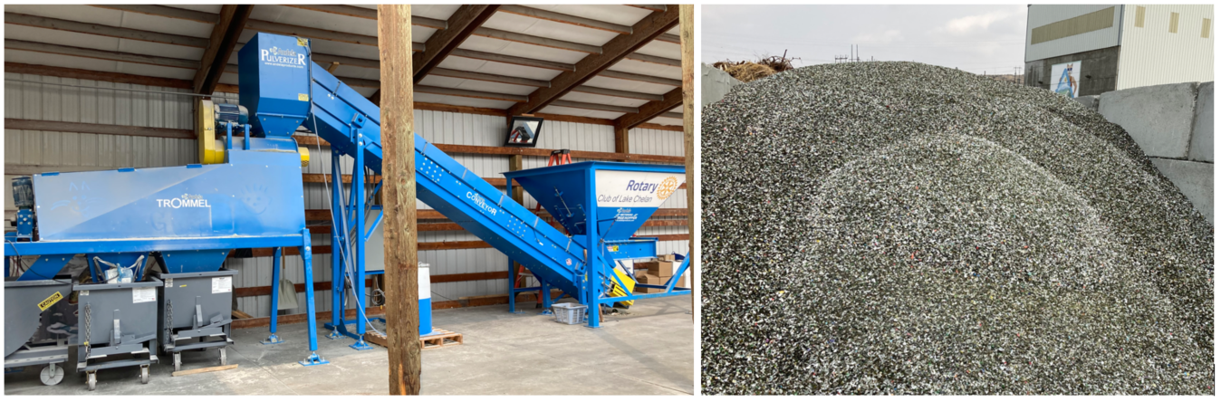
Figure 2 - Chelan glass pulverizer and glass product
Recipients of the one-time Center 2021 grants provided presentations on the results of their projects over the course of several board meetings.
Appendix B contains more details on the materials in the municipal solid waste stream. The sources for the data cited above are the 2021 Washington State Waste Characterization Study and recycling reports submitted to Ecology.

Accomplishments in 2021-2022
Center work completed during 2021 and 2022 is summarized in the following sections. In 2021, the Center offered one-time grant funds to local governments and public institutions. Those grants were used by the recipients on market development projects focused on their priorities.
- NextCycle Washington’s online business accelerator and grant program.
- Recycling studies of technologies or the potential for recycling related activities in a specific jurisdiction.
- Local projects focused on material reuse, wood recovery, and glass diversion.
- Business resources that offer an annual innovation challenge, an online materials marketplace, and one-on-one business assistance offered by Commerce.
- Market research into paper, glass, and plastic packaging.

NextCycle Washington
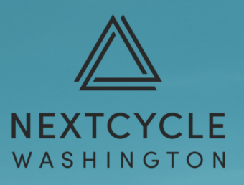
NextCycle is a business accelerator online platform owned and operated by RRS Consulting. NextCycle started in Colorado in 2018, kicked off in Michigan in 2020, and is now running in Washington state.
In 2021, the Center provided King County’s Solid Waste Division with a $50,000 one-time grant to research approaches to advance economic development opportunities for recycling markets. That one-time grant resulted in the NextCycle Washington business accelerator platform. King County, the City of Seattle, and the Center partnered on this statewide market development effort. This partnership provided over $1.2 million in funds to establish NextCycle Washington and roll out the inaugural year of activities: website development, seed grants and grant management, business technical support and assistance, and accelerator tracks.
The Center Advisory Board strongly recommends continued support, including ongoing funding, for the NextCycle Washington program.
NextCycle accelerator: The accelerator program consists of competitive challenges designed to identify and support promising circular businesses and projects. Applicants are selected to receive six-months of business and technical planning support, pitch development, and identification of funding opportunities to advance their ventures. NextCycle Washington’s business accelerator application opportunity opened in June 2022.
The NextCycle Washington teams involved in waste reduction, repair, rescue, reuse, recycling, composting, and remanufacturing selected for the 2022-2023 accelerator programming include:
- Community Gearbox, an app that facilitates the sharing, co-ownership, and mobilization of products, such as tools, games, or outdoor gear, that would otherwise be thrown away or left unused and prevents the purchase of new, community-redundant items.
- DeliverZero, a service that allows customers to choose reusable containers when ordering through the delivery platforms.
- GeerGarage, an online company that facilitates the peer-to-peer rental of outdoor gear by matching renters with available products.
- Just Right Bite, creating an insect-based pet food.
- Okapi Reusables, operating a reusable cup network at cafes and coffee shops.
- Plover, helping businesses create an upcycled product line within their brand by utilizing their unsellable inventory and pre-consumer materials.
- Refugee Artisan Initiative (RAI), expanding upcycling of materials, such as fire hoses into durable bags, by refugee and immigrant women.
- South King Tool Library, expanding the “Tool Library in a Box” model in South King County.
- Birch Biosciences Inc, developed a recycling approach for plastic using enzymes to depolymerize plastic, starting with non-bottle polyethylene terephthalate (PET).
- Book Hill Group Inc., designing products for laundry, textiles, and wardrobes that will utilize recycled content, such as garment bags and household accessories.
- Duwamish Valley Sustainability Association, a South Park youth-led team developing an engineered solution using anaerobic digestion to generate low-carbon, sustainable fuel while building community capacity to use produced fuel.
- Glacier, building AI-enabled robots that automate sorting, making recycling lower cost and more effective for recycling facilities of all sizes and budgets.
- Glass Packaging Institute, working to improve the feasibility and economics of recycling glass in underserved and more rural areas of Washington and is proposing a glass aggregation plant in Walla Walla.
- Ground2ground Glass, expanding efforts to process glass into a natural sand substitute in Walla Walla.
- Regenerated Textiles, transforming landfill-bound clothing into new materials, using technology in shipping container sized recycling modules.
- Restaurant to Garden, a decentralized, hyperlocal system in Seattle’s Chinatown that composts local restaurant food waste into fertilizer and redistributes it to community gardens.
These projects were chosen from an application pool of 26 by the NextCycle group of external subject matter experts and people with experience from industry, local governments, and communities who provide oversight and guidance to the accelerator program. They were selected based on concept feasibility, value to Washington’s circular economy, project team qualifications, as well as environmental, social, and economic impacts. Accelerator program results will be available in spring 2023.
NextCycle seed grants: Seed grants provide support for early-stage projects. The grant includes additional technical support, growth planning, and networking. The grant application process opened in fall of 2022. The grant recipients will have until June of 2023 to complete their grant funded work.

Recycling studies
Through a competitive grant program offered in January 2021, the Center funded seven projects focused on recycling technologies or the potential for activities in a specific jurisdiction. All of these projects were completed in June of 2021.
Plastic Recycling Market Development for Washington State and the Northwest Region: Washington State University (WSU) conducted this study with $108,913 in funds to provide a significant amount of background on the technical, feedstock logistics, and economics of plastics recycling. The report includes the Plastic Recycling Technology database³ that provides a detailed list of commercial, academic, government and non-government entities associated with the plastics recycling supply chain. This report provides technical background of plastic recycling methods, evaluates the potential supply chain metrics and economic feasibility, and creates a dynamic database of plastic recycling technologies. Next steps recommended in this report include ongoing tracking of the development of plastic recycling technologies.
Recycling Infrastructure in Washington State: Cascadia Consulting Group and Herrera Environmental Consultants conducted this project for King County with $50,000 in grant funds. This project initiated an infrastructure analysis for paper and plastic processing facilities in Washington State. This research built a foundational dataset and map tool able to expand to additional materials or broader geographic scope in the future. Ultimately, maintaining the dataset and map will enable better policy decisions addressing community equity issues and resource allocation to the paper and plastic recycling infrastructure systems. The results of this project could be expanded to develop a comprehensive dataset for recycling in Washington state.
Food Waste Collection and Hauling Feasibility Study: Waste Loop conducted this study for the City of Leavenworth with $50,000 in grant funds. The study evaluated commercial food collection and composting opportunities. This analysis provides information for future actions to collect and compost food waste in Leavenworth. Recommendations included additional research into residential and school diversion of food waste for Leavenworth. Recent developments in the Leavenworth area include the startup of the Winton Manufacturing compost facility in the fall of 2022. Winton’s facility will use state-of-the-art technology such as Gore-Tex fabric covers and computer-controlled aeration with fans to compost food waste and yard debris. Up to 45 percent of the City of Leavenworth’s commercial food waste could be diverted to Winton Manufacturing. That diversion is projected to save the City up to $100,000 over landfilling the food waste.
Pyrolysis System Feasibility Study for the Port of Port Townsend: TetraTech, Inc., conducted this study for the Port of Port Townsend with $49,618 in grant funds. The Port of Port Townsend was investigating the feasibility of changing their current waste management practices for plastics. This report included an analysis of the permitting required to establish this technology. The estimated plastic waste produced and collected in Jefferson County ranged from 200 tons to 500 tons per year. The study reviewed ten pyrolysis technologies and their application to the plastic volumes produced in Jefferson County. Other options for management of plastics were not included in the scope of this study. The study identified the barriers to establishing a plastics pyrolysis system for the county to address mixed plastic waste. The barriers included the capital and operational costs, which exceed the projected revenue from the fuel generated by a plastic pyrolysis system. The report concluded that pyrolysis technology was not feasible for Jefferson County or the Port of Port Townsend.
Secondary Recycling Market Feasibility Study and Preliminary Action Plan: Conducted by TetraTech for Kittitas County with $32,378 in grant funds, this study evaluated a regional, comprehensive action plan for secondary recycling markets. Kittitas County, Central Washington University, Yakima County, Grant County, and the Ellensburg Business Development Authority collaborated on the study to develop the action plan. The plan provides 49 recommendations for glass, organics, and construction and demolition waste management. Action on the report recommendations listed below has not yet been implemented:
- Glass Recycling and Reuse to collect and provide glass aggregate through public/private partnership opportunities in the region with local concrete companies or other glass recycling and reuse facilities in the state with consideration given to climate change and sustainability.
- Resource Recovery Park to centralize collected recyclable materials, establish markets and diversion methods, and develop a community resource recovery park business plan.
- Regional Organics Processing Facility developed with regional partners to manage organics through a composting facility with resale of finished compost.
Solar Photovoltaic Module Retirement in the State of Washington: Conducted by Washington State University with $29,163 in grant funds, this report provides an overview of the solar photovoltaic market in the state. The report estimates the timing of future module retirement as well as the volume and composition of the corresponding waste stream. This report provides research to inform discussions regarding the state’s photovoltaic module stewardship and takeback program (chapter 70A.510 RCW).
Market Development for Clean Wood Waste: Jefferson County Public Works conducted this study with $4,361 in grant funds. Clean wood waste was identified by the county to have potential for localized market development. This study provided the county with an analysis of that material stream. A centralized system for the collection and processing of clean wood waste does not appear to be economically viable nor the most cost-effective way to remove this material from the waste stream. Therefore, Public Works recommends a decentralized and localized system of material exchange between the producers of clean wood waste and the agricultural community that wishes to use the material for biochar production.

Local projects
In addition to the seven research studies above, the Center funded three projects focused on a local priority as determined by the grant recipient, specifically, recovery of glass, material reuse, and wood recovery.
Chelan County Glass Crusher: Chelan County Public Works used a $50,000 grant to partner with the Chelan Rotary Club to purchase the necessary equipment to establish a local glass crushing operation: 911 Glass Rescue. The Rotary Club volunteers operate the glass crusher every Saturday from 9 am to noon. The Andela 05L system crushes 1-2 tons of glass per hour, turning it into a fine sand and an aggregate with rounded edges. The resulting material is sold to local businesses and community members for landscaping, water filtration, drainfields, and agricultural uses. It its first year of operation 911 Glass Rescue processed 307,371 pounds of glass, recouped $4,500 in drop-off fees (.02 per pound or .04 per pound), received an additional $6,000 in donations, and $2,500 in product sales revenue ($5/bucket or $100/cubic yard). Without the efforts of this robust group of dedicated volunteers, glass containers in Chelan go to the landfill. Several other communities in eastern Washington are collaborating with Chelan on best practices.
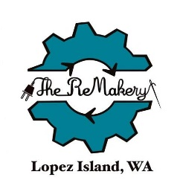
Lopez Island ReMakery: Lopez Island Solid Waste Disposal District used a $50,000 grant to establish the ReMakery. The goal of the ReMakery is to educate the community about the value of reduction, reuse, repair, and repurposing items locally to increase the local circular economy. The ReMakery offers classes, workshops, Repair Cafes, Maker-in-Residence programs, and a host of other maker events. The ReMakery has sewing machines, 3-D printers, tools for jewelry making, leather working, and electronics repair to upcycle and transform materials.
Wood Recycling Project: City of Seattle Public Utilities Department used a $49,998 grant to fund projects for three recycling/reuse, deconstruction, and salvage projects to recover clean wood. The City of Seattle continues to work on clean wood recovery from the waste stream.
- ReUse Consulting provided training to two companies new to panelized deconstruction by dismantling a 2,400 square foot home with a detached garage. The deconstructed floor panels and walls were sold to build a shed.
- Earthwise salvaged boards from school bleachers and mahogany church pews. The boards were planed and resold. Processing salvaged lumber increases its value and marketability.
- Rainier Wood and Sankofa: These two businesses partnered to divert wood products from the waste stream for reuse and for use as fuel. The recovered wood included 2x4s, plywood, and pallets.

Business resources
The Center also funded two business-focused projects through the competitive one-time grant program.
Challenge competitions: In 2021, the City of Seattle’s Office of Economic Development in partnership with Seattle Good Business Network used $35,000 in grant funds to host the Circular Innovation Challenge 2021. Participants in the Innovation Challenge proposed waste-to-market manufactured product ideas. Winners of the competition received prize money.
In 2022, the Seattle Good Business Network partnered with Zero Waste Washington to offer the PreCycle Innovation Challenge for student and business projects. The PreCycle innovation challenge received Public Participation Grant funding from Ecology as well as $10,000 from the Center.
These challenge competitions provided technical assistance, business development workshops, mentoring, and networking opportunities to innovators from across Washington State. In addition to technical assistance, pitch competition winners received cash prizes from $2,000 to $10,000.
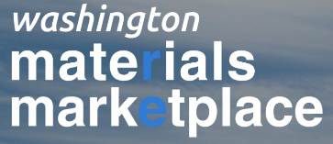
Washington Materials Marketplace: In 2021, Tacoma Environmental Services Department used $24,000 to create the Washington Materials Marketplace (Marketplace). The Marketplace creates a collaborative network of businesses, organizations, and entrepreneurs. It enables participants to easily share details on materials available or desired, identify reuse opportunities, and exchange excess materials. The online platform offers one organization’s hard-to-recycle waste and by-products for another organization’s raw material. In addition to diverting waste from landfills, these recovery activities generate significant cost savings, energy savings, and create new jobs and business opportunities.
One-on-One Business meetings: Center staff regularly held meetings with businesses to discuss expanding or bringing operations to the state. Those meetings covered businesses involved in renewable natural gas from compost, plastic recycling, hemp and cannibis waste composting, fruit processing waste, asphalt and concrete reyccling, textile recovery, and glass recycling. Conducted site visits, including Refugee Artisans Initiative.
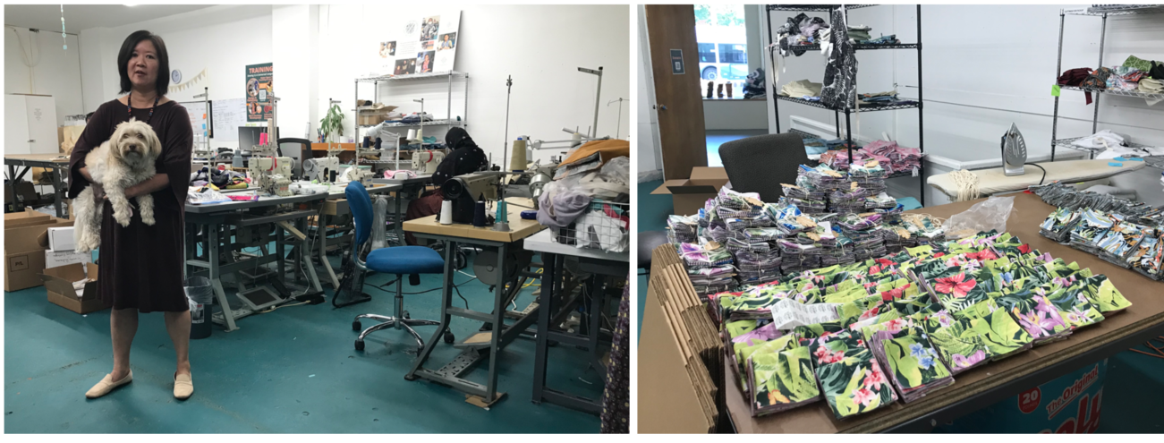
Figure 3 - Refugee Artisans Initiative textile recovery and products

Market research
The Recycling Development Center staff also conducted material-specific research.
Recyclable Material Series Reports provide an overview of waste generation, disposal, and recycling, and manufacturing for three specific recyable materials in Washington: paper, glass, and plastic. Each report provides a snapshot of available data and information and calls attention to challenges and opportunities specific to each materials. Board members provided input on these reports. The three reports identified common themes for these recyclable materials:
- Data: Common data limitations noted in the reports included:
  - Data availability – current recyclable material information needs to be improved and expanded.
  - Generation of recyclable materials – there is scant data on how much packaging is sold each year in Washington state.
  - End use of recyclable materials – it is difficult to identify the end market users of recyclable materials. The Center plans to conduct additional research and data analysis.
- Contamination: Reported levels of contamination in processed recyclables remains high (12 to 20 percent contaminants) and negatively impacts the commodity value and practical use of the materials. Contamination reduction efforts are underway through local plans focused on communication, outreach, and collaboration among the residents, solid waste collection companies, and material recovery facilities.
- Policy considerations: Policies that could improve recycling included deposit return systems, extended producer responsibility, and minimum recycled content mandates.
The Center Advisory Board strongly recommends taking actions to resolve the identified challenges and implementing policies to increase the collection and processing of consumer packaging.
Center staff prepared the following three market research papers:
Paper (June 2021): There is a robust local market for recyclable paper. There are 10 pulp and paper mills and 69 related processing facilities in Washington employing 8,000 workers. The report recommended the following additional analysis and research:
- Identify companies in Washington that make paper products that could use recyclable paper as feedstock or where use could be increased.
- Identify how processing of recyclable materials could be improved (like reducing contamination); identify needs, barriers, and opportunities.
- Research and report where increased recycled fiber content in paper product categories would be beneficial or detrimental.
- Update and expand on existing recyclable paper data, starting with the annual reports to Ecology.
- Obtain additional information about end market use and users of recyclable paper.
Glass (December 2021): Glass is infinitely recyclable and reduces manufacturers energy use, greenhouse gas emissions, and demand for virgin materials. Two glass manufacturers operate in Washington. The glass industry employs 437 workers with an economic impact of $180 million in Washington. The report recommended additional research and commented on potential policy impacts:
- Evaluate options to remove glass from the comingled recycling stream, like implementing multi-stream collection systems, increasing glass drop-off options, or implementing other policies.
- Identify operational improvements for material recovery facilities (MRFs) that result in cleaner glass.
- Identify approaches that would reduce the costs of transporting glass long distances from the source to the processing and remanufacturing.
- Identify options for increasing glass collection from commercial sources like restaurants, wineries, distilleries, or breweries.
- Research opportunities and evaluate options to increase the use of refillable glass containers and refill systems.
- Conduct additional research into the market for alternative uses of container glass and identify barriers and opportunities for bringing new end market users to Washington.
- Beverage bottle deposit return program would increase collection and quality of glass bottles for refill or recycling.
- Mandates for minimum post-consumer recycled content requirements in glass containers or for use in cement would increase demand.
- Extended producer responsibility programs for packaging would result in increased collection of glass containers for refill or recycling.
Plastic packaging (May 2022): Plastic packaging is a complex material stream, with many different resins and forms. In general, two types of plastic packaging are most commonly recycled: polyethylene terephthalate (PET) and high density polyethylene (HDPE) in bottle and jug form. The report includes a list of 87 plastic fabricators and manufacturers located in Washington State. It is difficult to determine which manufacturers in Washington’s plastic industry are using recyclable material. The report recommended research, actions, and commented on potential policy impacts:
- Facilitate research:
  - Determine the amount of plastic packaging used in Washington, by sector: residential, commercial, institutional, and industrial.
  - Identify where packaging material is collected and evaluate the quality of the processed material.
  - Refine list of plastic manufactures and recycling processors in the state and region, as well as export markets that are currently being used.
- Support market development:
  - Connect in-state and regional plastic processors and manufacturers to increase demand for and access to recyclable plastic.
  - Develop needed tools to come to entice more growth within the recycling value chain within the state and region.
- Consider policy changes:
  - Providing universal access to recycling would expand collection, require more infrastructure, and increase end markets.
  - Creating a deposit return system for beverage containers would provide a stable high quality material supply for end market users.
  - Establishing an extended producer responsibility program for packaging would require producers to fund collection services and educational materials, incentivize improved collection and recycling, lead to developing local end markets, and provide financial support to the system.

Center Work Plan
The focus for the Center going forward is summarized below. The next report to the legislature will reflect work conducted during the 2023 and 2024 fiscal years to align with agency funding cycles. That future work is summarized below.
Center Advisory Board: Regularly convene the advisory board to discuss recycling market topics and provide feedback and advice on Center work and priorities.
- Hold regular meetings of the advisory board and related subcommittees.
- Review research and reports, host presentations on recyclable materials, and relay board member advice to Ecology and Commerce on Center work.
- Leverage expertise to help refine strategy and identify target markets etc.
NextCycle Washington: The Center participated in the creation of NextCycle Washington that gives developing companies access to mentorship, investors and other support that help them become stable, self-sufficient businesses. The Center will provide ongoing support to NextCycle’s grants and accelerator opportunities to support waste reduction, reuse, and recycling innovations across the state.
- Provide funding to the NextCycle consulting team for platform development and accelerator programming.
- Fund NextCycle seed grants for statewide projects.
- Partner with state and local jurisdictions to promote and fund NextCycle. Provide support to other states operating NextCycle programs.
- Work to develop funding opportunities for NextCycle programming and innovative businesses.
Washington Materials Marketplace: In 2021, the Center funded the creation of the Washington Materials Marketplace that offers free online service for participants to easily share details on materials available or desired, identify reuse opportunities, and exchange underused materials. The Center plans to work with the platform to promote and fund the services of the Washington Materials Marketplace at no cost to businesses and organizations in Washington State.
- Develop strategy to use Washington Materials Marketplace to support a centralized, on-line “warehouse” of recyclable materials.
- Coordinate with Industrial Symbiosis Program at Commerce to share and use this resource.
Market research: Center research into recyclable materials identified data gaps in our understanding of Washington’s recycling system. We will continue to conduct research and data analysis, provide updates to the board, and use that information to develop markets for recyclable materials.
- Research recyclable materials and markets to develop recommendations for improving recycling markets and advancing environmental justice.
- Create a baseline recycling industry report, analysis of existing and potential benefits, and assessment of equity and environmental justice in the solid waste and recycling system.
Prioritization: Washington data illustrates the variety of materials in our waste stream. The Center is researching approaches to determine which actions result in positive impacts on the state’s circular economy. This analysis will be conducted to inform and possibly prioritize Center decisions and actions.
- Identify and select analytical tools and use them in Center work.
- Use data from market and baseline research efforts to prioritize actions for success.
Outreach: Center staff responds to inquiries about our work. We often provide presentations on Center activities. Outreach efforts include discussions and presentations to in-state and national organizations and events, companies, universities, local governments, and others.
- Develop specific outreach for the public and policy makers on the results of the NextCycle effort.
- Continue development of a map of businesses and other entities that participate in the collection, sorting and reuse of the recycling waste stream in Washington.
Business meetings: Commerce staff will continue to meet with businesses to discuss expanding or bringing operations to the state.
- Provide assistance as needed to support expansion or relocations.
- Conduct targeted outreach to industries focused on reuse of materials.
- Develop recruitment and fiscal data sheets to share with interested businesses.
- Host a listening session with re-processors and users of recycled materials to better understand needs
- Develop strategies to target select industries or businesses for recruitment.
Glass project: The Washington State wine industry has experienced exponential growth in recent years. As the second largest wine producer (behind California) in the nation, Washington has over 1,000 wineries that produce over 17 million cases (204 million bottles) annually; 85 percent of this wine is consumed in the state, while 53 percent of the wine bottles are landfilled.
- Work with interested parties to identify a suitable location for a wine glass diversion project—to reuse and/or recycle wine industry glass—to improve the quality and amount of glass collected, reused or recycled, and made available for purchase.
- Work with interested parties to plan and initiate an industry-specific glass reuse and/or recycling project in a Central or Eastern Washington community with the goal of establishing best practices that may be replicated statewide.
Industry summit: In 2021, the Center funded research to examine glass recycling in Washington state. The findings illustrate the challenges, recommendations, and opportunities for further research. The Center will continue to explore opportunities for reuse and recycling of glass materials for businesses, organizations, and consumer end-users throughout Washington State.
- Apply the Center’s findings to identify key stakeholders as potential conference presenters and participants.
- Use data from research efforts to prioritize topics and action items for success.
- Organize and facilitate a full-day, hybrid (in-person and virtual) discussion where stakeholders connect, learn and share information regarding existing and innovative glass reuse and recycling opportunities to enhance the circular economy.

Summary of Challenges

Recycling market challenges
A summary of the overall challenges and barriers to market development is provided:
- Limited data: current information about recyclable material needs to be improved and expanded; sales of products and packaging in the state is unknown; and end use of recyclable materials is difficult to determine. More research and outreach is required to obtain this information.
- High levels of contamination: contamination levels in processed recyclables remains high (12 to 20 percent contaminants) negatively impacting the commodity value and practical use of the materials. More robust education to residents and improved sorting infrastructure could help reduce contamination in collected materials.
- Material recovery facilities: processing capacity for these facilities is unknown, including their available operational technologies (like optical scanners). An assessment of the existing facility capacities would help inform the needs for improvement.
- Capturing materials: recovery of recyclable materials varies across the state. More robust collection and processing is needed to capture materials from the waste stream and deliver usable feedstocks to end users for remanufacturing. Transport costs are a significant barrier for heavier materials (like glass) and for more remote locations (like rural communities). Harmonizing the materials accepted and sorted for recycling would reduce resident confusion and contamination levels.
- Commercial opportunities: more research is needed to boost recovery of materials from commercial sources (like wineries or hotels). Consumer packaging reuse and refill options should be investigated. More research and outreach to commercial businesses and users of recyclable materials.
Appendix C provides an analysis of the Center’s progress on the goals and metrics established in 2020 by the advisory board.

Conclusion
Ecology, Commerce, and the Center advisory board continue to collaborate on efforts that provide or facilitate basic and applied research and development, marketing, and policy analysis in furthering the development of markets and processing for recycled commodities and products.
The highlights of the Center’s work in 2021 and 2022 included:
- One-time grants to local government partners and universities
- The inaugural year of the NextCycle Washington online business accelerator and grant program.
- Research on specific material markets for paper, glass, and plastic packaging.
Center work planned for 2023 and 2024 includes:
- Ongoing collaboration among Ecology, Commerce and the advisory board.
- NextCycle accelerator and grant opportunities
- Research and data analysis to support market development.
- Pilot projects, innovation challenges, and online material resources.
The Center report in 2024 will detail efforts accomplished during the 2023 and 2024 fiscal years to align with agency funding cycles.

Appendix A: DRS and EPR Analysis
The Center completed material market reports on paper (Center 2021a), glass (Center 2021b), and plastic (Center 2022). Each analysis of Washington markets included a summary of problems keeping materials from end markets, like the lack of high-quality materials, high levels of contamination, and low volume of postconsumer recovered materials. Each report offered solutions, from the need to collect more robust data to recommending policy changes. Potential policy solutions to improve material recovery and boost market development included a deposit return system (DRS) and extended producer responsibility (EPR). This supplement provides more details on these policies and an analysis of the policy impacts.

Background
Washington data shows a stagnant recovery rate for recyclable materials in our municipal solid waste stream, with a peak in 2011 at 57 percent recovery that has since declined to 48 percent recovery. In Washington 88 percent of single-family residents and 77 percent of multi-family residents have access to curbside collection of their recyclables. Access does not mean that they have curbside service, merely that it is offered.
Our most recent Washington data reports over 2.6 million tons of consumer packaging was generated in 2021 with a recycling rate of 49 percent (Eunomia 2022). This leaves over 1.2 million tons of packaging in the landfill or in the environment. DRS and EPR would improve our current collection of consumer packaging resulting in improved collection and delivery of more recyclable materials to be remanufactured.

Deposit return system (DRS)
Our most recent Washington data reports over 274,000 tons of beverage containers were generated in 2021 with a recycling rate of 44 percent (Eunomia 2022). That leaves over 134,000 tons of beverage containers in the landfill or littered in the environment.
A DRS is a robust system for collection and recycling of beverage containers. Under DRS, consumers pay a deposit fee at the time of beverage purchase, usually between 5 cents or 15 cents for each container. The consumer receives their money back when they return the container. A third party is designated to manage operations on behalf of the producers or distributors of the beverage containers. The third-party operator results in a more efficient and equitable program over state-run or producer managed (King County, 2020).
Beverage containers move through a DRS system from the producer delivering the container to the retailer for sale to the consumer. Consumer return options include return to retail, kiosks, or redemption centers where they redeem the deposit and the containers go to the processor (King County, December 2020). A DRS program increases overall collection, reduces contamination, and provides higher value materials (glass, plastic, and cans) to sell to end markets (King County, December 2020).
Ten states currently have DRS programs, all of which have been in place for decades. Deposit rates range from 5 cents to 10 cents. Beverages covered by the deposit include water, soda, and beer with some covering wine and liquor. Return rate of beverage containers range from 40 to 75 percent, with the higher rates commonly occurring with a 10 cent or higher deposit.

Cost and benefits
Analysis of the costs and benefits of a DRS program comes from the King County container deposit study (2020a, 2020b, 2020c). The summary below is provided as a preliminary assessment of the costs and benefits. Any DRS established in Washington law would result in an economic analysis of the costs and benefits based on the law the Legislature passes.
Explicit consideration of the costs
The annual budget to operate the DRS in Oregon was $51.9 million. In 2021, Oregon consumer refunds totaled over $199 million, the remaining unredeemed deposits totaled $38 million. Program funds come from fees paid by the beverage distributors, unredeemed deposits, and sale of collected beverage container materials (OBRC 2021). Costs of the program include operating the redemption centers and processing material as well as administration of the program. As Oregon population is just under half of Washington’s, the system could cost over $100 million to operate, with more than half of the cost covered by unredeemed deposits.
Benefits of the market-effecting policies
Many of the benefits of a DRS directly impact the market for the recovered beverage containers. In 2021, the Oregon program recovered nearly 84 percent of the containers sold in the state. That return rate reflects 1.99 billion containers which were 57 percent aluminum, 34 percent plastic, and 9 percent glass. This reflects over 84,000 tons of materials and over 48,000 metric tons of CO2 equivalent emissions reduced. Oregon’s DRS directly employs over 500 people. (OBRC 2021)
Assuming similar results in Washington, benefits would include recovery of over 80 percent of beverage containers, well above the current 44 percent rate. That would boost recovery of the 274,000 tons of beverage containers generated in 2021 from the current 134,000 tons recovered to over 219,000 tons. The King County container deposit study projected an additional 788 direct jobs in a DRS (King County 2020c). DRS benefits include recovery of high-quality materials with significantly lower contamination levels than curbside programs.
Rate impacts on solid waste utility ratepayers
Solid waste utility impacts from a DRS would include a reduction in beverage containers in the curbside bin. The impacts from a DRS on solid waste utility ratepayers is undetermined.
Disposal cost would lower as beverage containers are recovered outside the curbside system. An estimated savings of $7 million in disposal tipping costs would result from the 85,000 tons of containers recovered and removed from the disposal stream. It is possible curbside rates could increase due to the removal of valuable containers from the processing stream.
Addition of a DRS will impact the existing current collection (solid waste hauler) and processing (material recovery facility) operations. A DRS collects beverage containers through deposit return locations, resulting in a reduction in those containers in the curbside bin. This would impact the volume haulers collect, how much the material facility processes, and in turn the revenue recovered from the sale of containers.
Impacts on the prices of consumer goods
A DRS program adds a redeemable deposit to the beverage containers. That amount is usually set between 5 cents and 15 cents. While that deposit will increase the cost of any beverage included in the DRS, opportunities for consumers to reclaim that cost will be convenient.
Impacts on rates of recycling or utilization of postconsumer materials
A DRS maximizes the capture rate for beverage containers compared to curbside collection of recyclables. Beverages consumed away from home are recovered in a DRS. This increases the return of those containers to be remanufactured.
A DRS collects beverage containers separate from other recyclables, resulting in cleaner and more valuable materials, this is critically important for glass container recovery. The rate of recovery in Oregon of 80 percent far exceeds the Washington rate of 44 percent. This increase would recover 85,000 tons of beverage containers from the disposal stream.

Extended producer responsibility (EPR)
An EPR policy would require consumer packaged goods producers to fully fund recycling of consumer packaging for all residents of the state. Local governments retain their authority to conduct or oversee curbside recycling services but the producers would be responsible for meeting the performance standards. EPR offers cost savings to municipalities and residents. EPR policy would require producers of consumer packaging to:
- Fully fund recycling for all residents
- Build on existing service and infrastructure and invest in improvements
- Create and fund consistent education
- Meet mandated recycling and reuse targets
- Ensure responsible recycling
- Redesign packaging
- Use recycled materials in new products
EPR programs enhance and transform residential recycling by providing a producer funded system and reducing or removing the cost to public entities. Well-designed EPR programs achieve high recovery rates for paper, plastic, glass, and metal packaging. System improvements include more effective communication to the public, harmonized materials list, and improved overall collection, sorting, and delivery of materials to responsible end users.
In 2022, sixteen US states proposed EPR legislation for consumer packaging, including Washington. In the past two years, four consumer packaging EPR laws have passed in Maine, Oregon, Colorado, and California. Many companies now support EPR policy, seeing it as a way to generate material to meet their postconsumer recycled content goals (Ellen MacArthur Foundation, n.d.). Consumer packaging is highly sought after by end market users, Figure 4 shows the potential for improved recovery of consumer packaging in five jurisdictions using EPR compared to Washington’s current recovery rate (Ecology 2020).
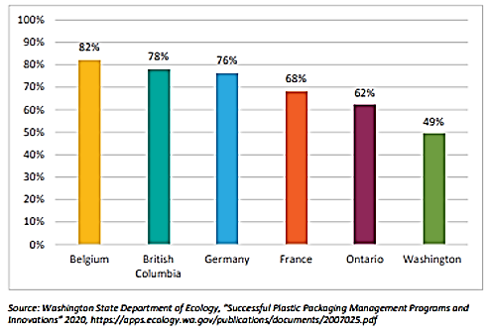
Figure 4 - Comparison of EPR recycling rates to Washington State’s recovery rate.

Cost and benefits
Analysis of the costs and benefits of an EPR program for Washington is provided by two main reports from Eunomia (2021) and Cascadia (2020). The summary below is provided as a preliminary assessment of the costs and benefits. Any EPR program established in Washington law would result in an economic analysis of the the costs and benefits based on the law the Legislature passes.
Consideration of the costs and benefits
The costs of a Washington EPR program for packaging and paper products on producers is estimated at about $334 million a year. To put this in perspective, the US consumer packaged goods sales was estimated over $720 billion for 2020 (Statista 2022).
Solid waste hauling companies and material recovery facilities would increase their revenue by 35 percent to 65 percent in an EPR program. Revenue from the increased recovery of recyclable materials is estimated to be between $16.5 to $25 million annually.
An EPR program would add $207 million through increased direct, indirect, and induced spending. That includes additional local tax revenue of $6 to $13 million annually. This impact includes the creation of 650 to 950 local jobs that contribute to a greener and more circular economy in Washington. An additional 1,000 to 1,650 new jobs would also be created indirectly due to the increase in added value to Washington’s economy. (King County 2020d)
Rate impacts on solid waste utility ratepayers
Producers would fund the cost of curbside collection of packaging and paper products eliminating that cost to the resident. The savings per household for the annual cost for recycling services in Washington is $121 to $300 (Cascadia 2020b).
Impacts on the prices of consumer goods
Recent Oregon research into grocery prices in Canadian provinces with and without EPR for packaging found no significant correlation between shelf prices and the fees producers pay to producer responsibility organizations (RRS 2021). A Columbia University study estimated an increase of 0.69 percent to grocery spending due to EPR costs and noted that cost increases may not pass on to customers (Columbia University 2022).
Impacts on rates of recycling or utilization of postconsumer materials
Almost all of Washington’s 3.2 million households would be provided residential curbside recycling (currently, only 83 percent of households have access to curbside recycling service). Curbside collection service would expand to the 360,000 households currently without service and would add 180,000 households that have access but currently do not subscribe to recycling services. Drop-off locations would be added for more types of materials.
EPR is estimated to Increase the recycling rate 40 percent. This would result in diversion of between 210,000 to 240,000 tons of material from landfills. Revenue from those recyclables is estimated to range from $16 to $25 million (Cascadia 2020b). Other economic benefits include added jobs (up to 950) and increased local tax revenue (up to $13 million). This increased material recovery and recycling would result in a reduction of greenhouse gas emissions by 565,000 to 650,000 metric tons of CO2-equivalents. (King County 2020d)

References
Cascadia Consulting Group. (2020a). Successful Plastic Packaging Management Programs and Innovations. Submitted to the Washington Department of Ecology, October 2020. Successful Plastic Packaging Management Programs and Innovations Report (wa.gov)
Cascadia Consulting Group. (2020b). Plastic Packaging in Washington Assessing Use, Disposal, and Management. Submitted to the Washington Department of Ecology, October 2020. Plastic Packaging in Washington Assessing Use, Disposal, and Management
Columbia University. (2022). Economic impacts to consumers from extended producer responsibility regulation in the consumer packaged goods sector. Economic impacts to consumers from extended producer responsibility (EPR) regulation in the consumer packaged goods sector | Academic Commons (columbia.edu)
Ellen MacArthur Foundation. (n.d.) Extended Producer Responsibility: a necessary part of the solution to packaging waste and pollution. Retrieved July 28, 2022 from Extended Producer Responsibility is a necessary part of the solution to packaging waste and pollution (ellenmacarthurfoundation.org)
Eunomia. (2021). Improving Recycling in Washington through Producer Responsibility Policy: Cost and Benefits. Improving Recycling in WA through Producer Responsibility Policy: Costs and Benefits - Eunomia, Dec. 2021 (productstewardship.net)
Eunomia. (2022). Washington Consumer Packaging and Paper Study: Recycling Rate Assessment and Recommendations. Submitted to Washington Department of Ecology, October 2022.
King County Solid Waste Division. (2020a). Executive Summary. Container Deposit Study - Executive Summary - Responsible Recycling Task Force - King County Solid Waste Division
King County Solid Waste Division. (2020b). Phase I – Inventory of Existing Container Deposit Programs. Container Deposit Study - Phase 1 - Responsible Recycling Task Force - King County Solid Waste Division
King County Solid Waste Division. (2020c). Phase II: A Beverage Container Deposit Return System for Washington – Qualitative Research and Recommendations. Container Deposit Study - Phase 2 - Responsible Recycling Task Force - King County Solid Waste Division
King County Solid Waste Division. (2020d). Phase III: Costs and Benefits of Residential Packaging and Paper Product Recycling in Washington State. Container Deposit Study - Phase 3 - Responsible Recycling Task Force - King County Solid Waste Division
Oregon Beverage Recycling Cooperative. (2021). OBRC 2021 Annual Report. About_Reports_2021_Annual.pdf (obrc.com)
Recycling Development Center (Center). (2021a). Recyclable Material Series: Glass. December 2021. Recycling Development Center – Recyclable Material Series: GLASS (wa.gov)
Recycling Development Center (Center). (2021b). Recyclable Material Series: Paper. June 2021. Recycling Development Center – Recyclable Material Series: Paper (wa.gov)
Recycling Development Center (Center). (2022). Recyclable Material Series: Plastic. December 2021. RecycledPlasticPaper_FINALMay2022.docx (live.com) and WAPlasticCompanyMap2022.xlsx (live.com)
RRS. (2021). Impact of EPR Fees for PPP on Price of Consumer Packaged Goods. Submitted to the Oregon Department of Environmental Quality on February 19, 2021. https://www.oregon.gov/deq/recycling/Documents/rscRRSconsumer.pdf
Statista. (2016). U.S. CPG sales 2015-2020, Published by Statista Research Department, June 22, 2016, website accessed on October 13, 2022. https://www.statista.com/statistics/380825/us-cpg-sales/

Appendix B: Solid Waste Data
The following information focuses on the available data for materials in Washington’s municipal solid waste (MSW) stream. Two sources of data are available from Ecology: disposal data and recovery data.
Recovery data: Every year, solid waste handling facilities report to Ecology on the materials they recover for recycling. That data comes from a variety of facilities and sources that encompass the solid waste and recycling systems in Washington. Figure 5 shows the major categories of materials collected for recycling in 2021.
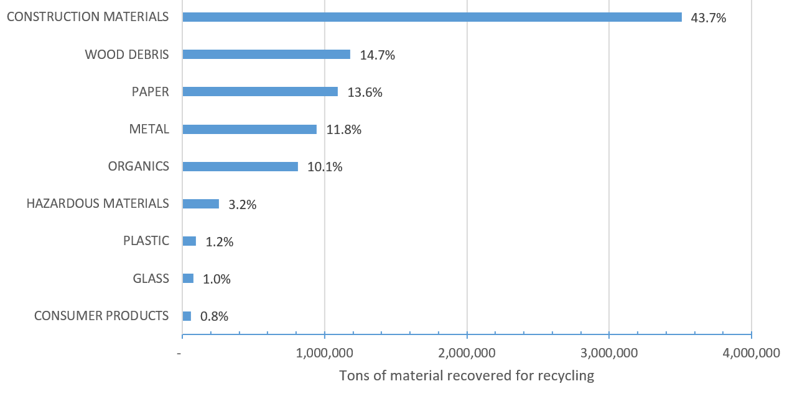
Figure 5 - Material recovered for recycling in 2021, tons
The data shown in Figure 5 indicates the largest materials recovered for recycling, by volume:

- 43.7 percent Construction Materials
- 14.7 percent Wood Debris
- 13.6 percent Paper
- 11.8 percent Metal
- 10.1 percent Organics
- 3.2 percent Hazardous Materials
- 1.2 percent Plastic
- 1.0 percent Glass
- 0.8 percent Consumer Products

Disposal data: Disposed materials are determined using the results of waste characterization studies. Every five years or so, Ecology conducts a waste characterization study of MSW from residential, commercial, and self-hauled sources. The most recent waste characterization study was completed in 2021. The proportion of each material from the study is applied to the total MSW for the years when a study is not conducted.
Figure 5 presents the composition of the overall statewide disposed waste stream by material class. The full report provides more analysis of the waste composition for the 5,805,595 tons disposed statewide in 2021. The residential sector disposed the largest amount of waste, accounting for 44.6 percent of the state’s waste stream and over 2.3 million tons. The commercial sector represents approximately 28.5 percent (1.5 million tons) of total waste, and the self-hauled sector represents the remaining 26.8 percent (1.4 million tons).
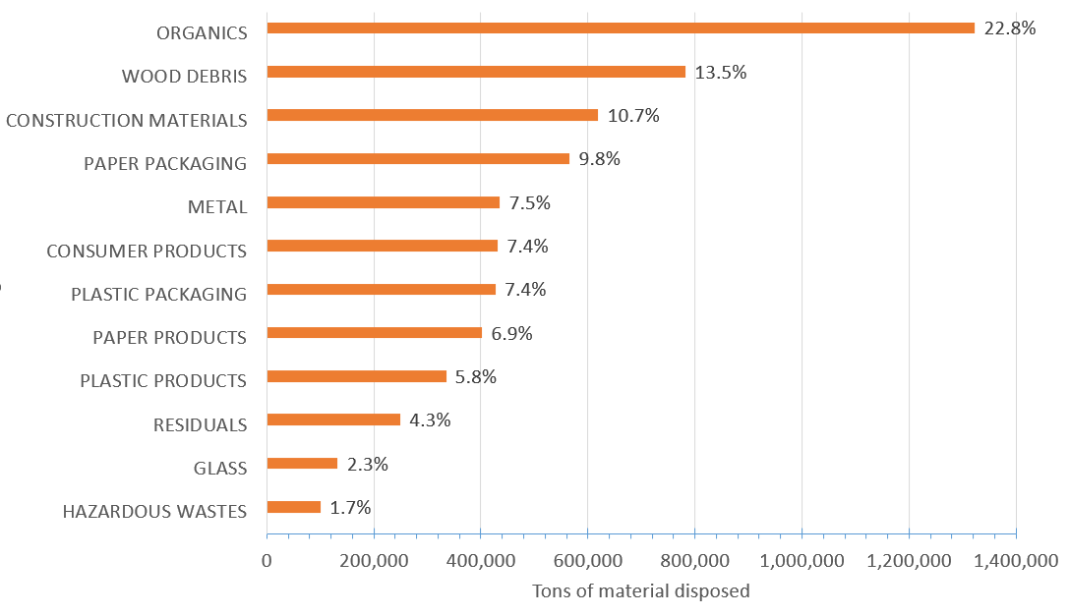
Figure 6 - Overall statewide disposed waste stream by material class, 2020-2021
The data shown in Figure 6 indicates the largest materials in the waste stream, by volume:

- 22.8 percent Organics
- 16.7 percent Paper
- 13.5 percent Wood Debris
- 13.2 percent Plastic
- 10.7 percent Construction Materials
- 7.5 percent Metal
- 7.4 percent Consumer Products
- 4.3 percent Residuals
- 2.3 percent Glass

The Center was directed in the law to initially focus on mixed waste paper and plastics. Other material categories were included in the Center’s priorities due to requests from local communities (glass) and identified as priorities by grant recipients (clean wood, photovoltaic modules).

Appendix C: Center goals and metrics
In July 2020, the Recycling Development Center advisory board created the following goals and metrics. Table B shows progress toward the Center goals in 2021 and 2022. The Center continues to work toward progress on the goals established by the advisary board. Individual columns in the table represent Center progress from NextCycle Washington, recycling studies and market research, projects, and business resources. Minimal progress is noted with an empty circle, moderate progress with a half-filled circle, and good progress with a filled circle.
Table B - Recycling Development Center goals progress
Recycling Development Center Goals | NextCycle | Studies/ Research | Projects | Business resources
Develop local and regional markets and processing for Washington’s recyclable products and materials to be transformed or remanufactured into usable or marketable products for use other than landfill disposal or incineration. | ◒ | ○ | ◒ | ◒
Support equitable economic growth by analyzing, attracting, and supporting existing and new Washington-based businesses that enable reuse of products, packaging, and other materials before they enter the waste stream, process recyclable waste materials into valuable commodities and products, use recycled content, and create local jobs, while ensuring that a social justice lens is applied throughout. | ● | ◒ | ● | ◒
Assess innovative technologies, such as new Material Recovery Facility (MRF) technologies, sorting processes, or new ways of addressing mixed plastics, and promote those that meet established criteria. | ◒ | ● | ● | ○
Collaborate with manufacturers and producers of packaging and other potentially reusable or recyclable materials to increase the ability of their packaging and products to be reduced, reused, or recycled. | ◒ | ◒ | ● | ●
Evaluate, analyze, and recommend state policies that positively affect markets for recyclable materials. | ○ | ● | ○ | ○
Collect recycled materials end use data from material recovery facility operators; public and private sector recycling and solid waste industries; manufacturers and retailers. | ○ | ● | ○ | ○
Work in partnership with product and packaging producers and other regional partners on a project that demonstrates a pathway for a specific material, showing all stages of the supply chain using a circular economy model. | ● | ◒ | ○ | ●
Table C shows where progress toward the Center metrics occurred in 2021 and 2022. Minimal progress is noted with an empty circle, moderate progress with a half-filled circle, and good progress with a filled circle. The Center continues to work toward progress on the metrics established by the advisory board.
Table C - Recycling Development Center metrics progress
Recycling Development Center Metrics | NextCycle | Studies/ Research | Projects | Business resources
Increased business use of recycled plastic or paper material – Work with 10 new or existing businesses in WA to manufacture products using plastic or paper recyclable materials, in five years. | ◒ | ◒ | ○ | ◒
Increased business use of other recyclable material and reusable products – Work with 10 new or existing businesses in WA to increase use of reusable or recyclable materials, in five years. | ◒ | ○ | ◒ | ◒
Increased reusability/recyclability of manufactured products – Work with 15 manufacturers (or their associations) to make their products reusable or recyclable (design changes), in five years. | ◒ | ○ | ○ | ◒
Increased purchasing of products with recycled content – Work with 10 manufacturers, government agencies, or institutions to implement purchasing preferences for products with recycled content, in five years. | ◒ | ○ | ○ | ◒
Recommended policy changes – Support of policies to improve recycling – examples: product stewardship for specific products, bottle deposit program, improved labeling for recyclability, in five years. | ○ | ● | ○ | ○
Completed a pilot project or initiative with packaging or other product producers, within five years that demonstrates that creating sustainable markets is possible or has fostered, enhanced, built markets for mixed waste papers or plastics or has created a template for how to create more sustainable markets for this material. | ◒ | ○ | ◒ | ◒
Collaborated with other recycling development centers, regional partners, and other stakeholders so that our successes are amplified rather than be duplicative or competitive. | ◒ | ○ | ○ | ○
Increase total amount of material recycled locally/regionally (relative to the percentage exported) – Percentage of recyclable materials that are primary/secondary processed and recycled into new transformed or remanufactured into usable or marketable products within the state or region increases by 75 percent, in five years. | ◒ | ○ | ◒ | ○
Injected economic growth and innovative technologies into Washington and the region’s recycling and processing capacity by increasing capital investment (by 50 percent) and job creation rate (by 50 percent), in five years. | ◒ | ○ | ○ | ○
Reduced the amount of recyclable material going to the landfill by at least 50 percent in five years, relative to 2015, as measured by the State Waste Characterization reports, including reductions created both by increased recycling and decreased waste generation strategies (e.g., reusable packaging). | ◒ | ○ | ◒ | ○
Reduce pulp and paper mill residuals by 50 percent, in five years. | ○ | ○ | ○ | ○

Appendix D: Hyperlinks

https://apps.ecology.wa.gov/publications/SummaryPages/2007022.html
www.ecology.wa.gov/contact
https://app.leg.wa.gov/RCW/default.aspx?cite=70A.240&full=true
https://ecology.wa.gov/Waste-Toxics/Reducing-recycling-waste/Recycling-Development-Center
https://www.ezview.wa.gov/site/alias__1962/37596/recycling_development_center_advisory_board.aspx
https://public.govdelivery.com/accounts/WAECY/subscriber/new?topic_id=WAECY_112
https://www.ezview.wa.gov/site/alias__1962/37596/recycling_development_center_advisory_board.aspx
https://apps.ecology.wa.gov/publications/SummaryPages/2007027.html
https://app.leg.wa.gov/RCW/default.aspx?cite=70A.520
https://apps.ecology.wa.gov/publications/SummaryPages/2107026.html
Washington-based accelerator supporting 16 environmental ventures with a combination of business and technical support — NextCycle Washington
https://cmec.wsu.edu/project/plastics-recycling-technology/
https://kingcounty.gov/~/media/depts/dnrp/solid-waste/linkup/documents/recycling-infrastructure-WA-paper-plastic.ashx?la=en
https://www.ezview.wa.gov/Portals/_1962/Documents/rdcab/Leavenworth-CompostingFeasibilityProject.pdf
https://www.wintonmfg.com/
https://portofpt.com/tetra-tech-pyrolysis-report-and-study-available/
https://www.co.kittitas.wa.us/uploads/documents/solid-waste/Kittitas%20County%20Secondary%20Market%20Feasibility%20Study%20Final%2006212021.pdf
https://www.ezview.wa.gov/Portals/_1962/Documents/rdcab/WSU-SolarModuleProject.pdf
https://app.leg.wa.gov/RCW/default.aspx?cite=70A.510&full=true
https://solidwaste.files.wordpress.com/2021/06/final-mkt-development-study-w-appendices-1.pdf
https://911glassrescue.org/
https://www.lopezsolidwaste.org/remakery
https://www.ezview.wa.gov/Portals/_1962/Documents/rdcab/Seattle-WoodRecyclingProject.pdf
https://seattlegood.org/circular-innovation-challenge/
https://www.precyclewa.org/
https://washington.materialsmarketplace.org/
https://apps.ecology.wa.gov/publications/SummaryPages/2007021.html
https://www.ezview.wa.gov/Portals/_1962/Documents/rdcab/PaperPaper-FINAL.pdf
https://www.ezview.wa.gov/Portals/_1962/Documents/rdcab/GlassPaper_Final.pdf
https://www.ezview.wa.gov/Portals/_1962/Documents/rdcab/RecycledPlasticPaper_April2022.docx
https://view.officeapps.live.com/op/view.aspx?src=https%3A%2F%2Fwww.ezview.wa.gov%2FPortals%2F_1962%2FDocuments%2Frdcab%2FWAPlasticCompanyMap2022.xlsx&wdOrigin=BROWSELINK
https://www.washingtonwine.org/fast-facts/
https://www.ezview.wa.gov/Portals/_1962/Documents/rdcab/2020-July-GoalsMetricsApproved.pdf
https://ecology.wa.gov/Research-Data/Data-resources/Solid-waste-recycling-data
https://apps.ecology.wa.gov/publications/documents/2107026.pdf

