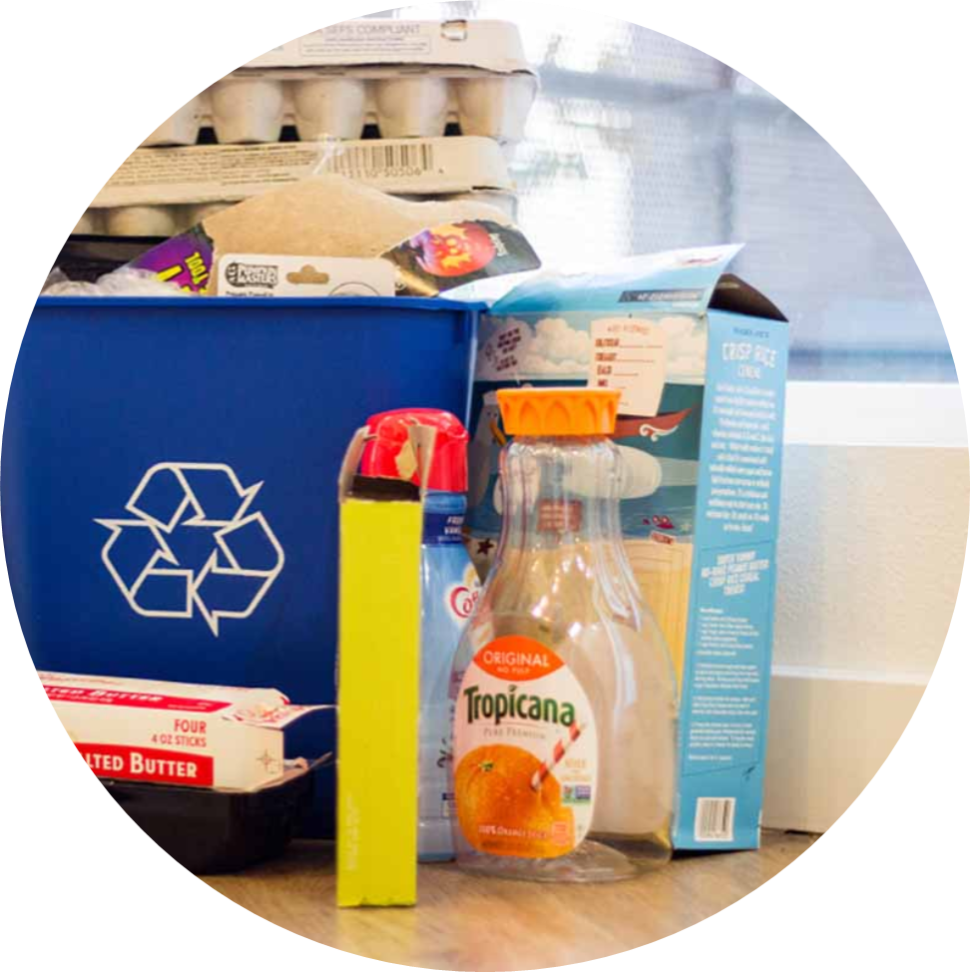
Regional Analysis of Recycling Rates of Consumer Packaging and Paper Products
Appendix to Washington Consumer Packaging and Paper Study
Publication 22-07-033
January 2023
Publication Information
This report is available on the Department of Ecology’s website at https://apps.ecology.wa.gov/ecy/publications/SummaryPages/2207033.html

Technical Leads
John Carhart

Prepared By
John Carhart
Caitlin Harrington-Smith

Quality Review
Sarah Edwards

Approved By

Sarah Edwards
(Project Director)

Eunomia Research & Consulting Inc
33 Nassau Avenue
New York NY 11222
USA
Tel +1 646 256-6792
Web www.eunomia-inc.com

ADA Accessibility
The Department of Ecology is committed to providing people with disabilities access to information and services by meeting or exceeding the requirements of the Americans with Disabilities Act (ADA), Section 504 and 508 of the Rehabilitation Act, and Washington State Policy #188.
To request an ADA accommodation, contact Ecology by phone at 360-407-6000 or email at mark.hayes@ecy.wa.gov. For Washington Relay Service or TTY call 711 or 877-833-6341. Visit Ecology's website for more information.

Table of Contents
1.0 Regional Analysis 4
1.1 Background 5
1.2 Generation 6
1.3 Recycling Rate 7
1.4 Disposal Rates 10
1.5 Conclusion 13
2.0 Regional Detailed Tables 15
2.1 Central Region 16
2.1.1 All Sectors 16
2.1.2 Residential Rates 18
2.1.3 Commercial Rates 20
2.2 East Region 22
2.2.1 All Sectors 22
2.2.2 Residential Rates 24
2.2.3 Commercial Rates 26
2.3 Northwest Region 28
2.3.1 All Sectors 28
2.3.2 Residential Rates 30
2.3.3 Commercial Rates 32
2.4 Puget Sound Region 34
2.4.1 All Sectors 34
2.4.2 Residential Rates 36
2.4.3 Commercial Rates 38
2.5 Southwest Region 40
2.5.1 All Sectors 40
2.5.2 Residential Rates 42
2.5.3 Commercial Rates 44
2.6 West Region 46
2.6.1 All Sectors 46
2.6.2 Residential Rates 48
2.6.3 Commercial Rates 50

Regional Analysis

Background
This report serves as an appendix to the Washington Consumer Packaging and Paper Study: Recycling Rate Assessment and Recommendations (“the main report”). The main report is a statewide analysis of the current state of recycling of consumer packaging and paper products (CPPP). However, in Washington waste recovery data is reported by six different Waste Generation Areas (WGAs). This appendix compares the recycling and generation rates of consumer packaging and paper products on a region-by-region basis.
The six different WGAs are shown in Figure 1 and listed below:
- The Central region
- The Northwest region
- The Puget Sound region
- The East region
- The Southwest region; and,
- The West region
Figure 1: Map of Waste Generation Areas
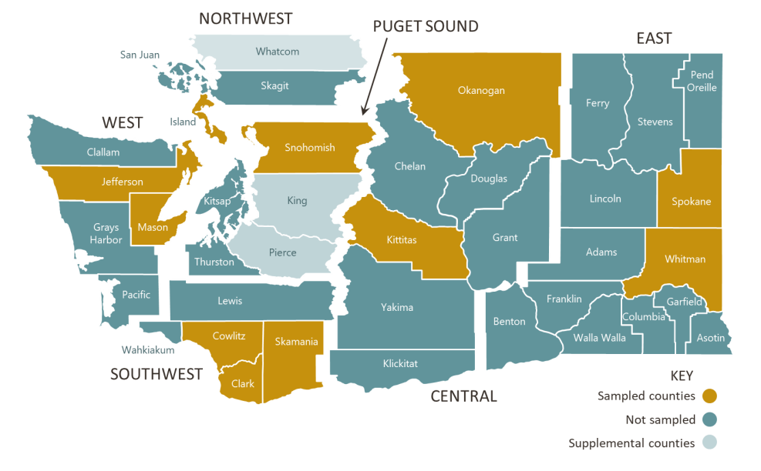
Source: 2020-2021 Washington Statewide Waste Characterization Study.
The regions vary in population and density. Table 1 below shows the population, density, and number of households (single family (SF) and multifamily (MF)) for each WGA in Washington.
Table 1: Demographics by WGA
WGA | Population (2021) | Population Density (Population per Square Mile) | Number of Households (2018) | Number of SF Households (2019) | Numbers of MF Households (2019)
Central | 593,000 (7.6%) | 28 | 244,200 | 158,900 | 85,300
East | 1,084,600 (14.0%) | 55 | 436,700 | 288,800 | 148,000
Northwest | 461,300 (5.9%) | 89 | 228,700 | 157,500 | 71,200
Puget Sound | 4,628,600 (59.6%) | 620 | 1,878,500 | 1,135,600 | 742,900
Southwest | 723,500 (9.3%) | 116 | 277,800 | 194,200 | 83,700
West | 276,100 (3.6%) | 30 | 143,700 | 101,900 | 41,800
Total | 7,767,100 (100%) |  | 3,209,600 | 2,036,900 | 1,172,900
Source: Washington Department of Ecology, GADM data, and Washington Department of Ecology (2020), Plastic Packaging in Washington: Assessing Use, Disposal and Management.
Puget Sound accounts for more than half of the state population. Puget Sound contains the city of Seattle, a population hub in the state.

Generation
This section compares the generation of consumer packaging and paper products across WGAs. Table 2 below shows the total tons generated by material category for all sectors (i.e., residential and commercial sources) in each WGA.
Table 2: Total Generation by WGA – All Sectors in tons (2021)
Material | Central | East | Northwest | Puget Sound | Southwest | West | Total
Rigid Plastic | 40,000 | 51,100 | 14,900 | 163,700 | 35,500 | 9,800 | 315,000
Flexible Plastic | 33,700 | 32,400 | 10,900 | 116,200 | 30,600 | 8,400 | 232,200
Metals | 15,200 | 16,300 | 7,300 | 61,200 | 11,700 | 4,900 | 116,600
Paper & Cardboard | 187,500 | 250,000 | 101,500 | 1,128,000 | 157,000 | 43,900 | 1,867,900
Container Glass | 23,000 | 19,000 | 10,800 | 114,500 | 7,800 | 2,600 | 177,700
All CPPP | 299,300 | 369,000 | 145,400 | 1,583,500 | 242,600 | 69,600 | 2,709,400
Beverage Containers | 35,500 | 33,700 | 14,500 | 161,700 | 14,600 | 6,900 | 266,900
Sources: Eunomia Modelling, 2021 Ecology Washington Recycling and Recovery Data, 2020-2021 Washington Statewide Waste Characterization Study, 2020 King County Material Recovery Assessment
Puget Sound accounts for more than half of the consumer packaging and paper products generated in Washington. Puget Sound includes the City of Seattle and has over 4.5 million residents, while the next closest WGA in terms of population has just over 1 million residents (East region). To see generation on a normalized level, Table 3 below shows the annual generation per capita across the WGAs.
Table 3: Generation Per Capita (lbs/capita) by WGA - All Sectors (2021)
Material | Central | East | Northwest | Puget Sound | Southwest | West | Statewide
Rigid Plastic | 135 | 94 | 65 | 71 | 98 | 71 | 81
Flexible Plastic | 114 | 60 | 47 | 50 | 85 | 61 | 60
Metals | 51 | 30 | 32 | 26 | 32 | 35 | 30
Paper & Cardboard | 632 | 461 | 440 | 487 | 434 | 318 | 481
Container Glass | 78 | 35 | 47 | 49 | 22 | 19 | 46
All CPPP | 1,009 | 680 | 630 | 684 | 671 | 504 | 698
Beverage Containers | 120 | 62 | 63 | 70 | 40 | 50 | 69
Sources: Eunomia Modelling, 2021 Ecology Washington Recycling and Recovery Data, 2020-2021 Washington Statewide Waste Characterization Study, 2020 King County Material Recovery Assessment
In each WGA, the paper and cardboard material category accounts for the most consumer packaging and paper products generated.
The Central region has the highest per capita generation rate of just over 1000 pounds per capita annually. This is more than 300 pounds more per capita than the next closest WGA, which is the East region at 680 pounds per capita. Generation per capita is higher across all material types in the Central region than the rest of the state. This may be due to demographic factors such as median income or population shifts.

Recycling Rate
Table 4: Recycling Rate by WGA – All Sectors (2021)
Material | Central | East | Northwest | Puget Sound | Southwest | West
Rigid Plastic | 8% | 9% | 29% | 31% | 9% | 28%
Flexible Plastic | 3% | 1% | 4% | 5% | 1% | 1%
Metals | 9% | 30% | 55% | 48% | 52% | 60%
Paper & Cardboard | 35% | 44% | 64% | 66% | 51% | 53%
Container Glass | 5% | 9% | 57% | 53% | 9% | 23%
All CPPP | 24% | 33% | 55% | 56% | 37% | 43%
Beverage Containers | 10% | 18% | 68% | 59% | 25% | 49%
Sources: Eunomia Modelling, 2021 Ecology Washington Recycling and Recovery Data, 2020-2021 Washington Statewide Waste Characterization Study, 2020 King County Material Recovery Assessment
Puget Sound and Northwest have the highest consumer packaging and paper products recycling rates at 56% and 55%, respectively. The other four WGAs all have recycling rates below 48%, which is the statewide consumer packaging and paper products recycling rate. The Central region has the lowest consumer packaging and paper product recycling rate at 24%. The Central region also has the lowest proportion of single-family households with access to curbside recycling at 64%. The East region has the next lowest recycling rate at 33%, and following the trend of the Central region, it has the second lowest percentage of single-family households with access curbside recycling at 66%. Figure 2 below plots the consumer packaging and paper products recycling rate versus the percent of residents (both single-family and multifamily households) which have at least the option for access to curbside recycling in each WGA.
Figure 2: All Sector CPPP Recycling Rate vs Residential Curbside Access (2021)
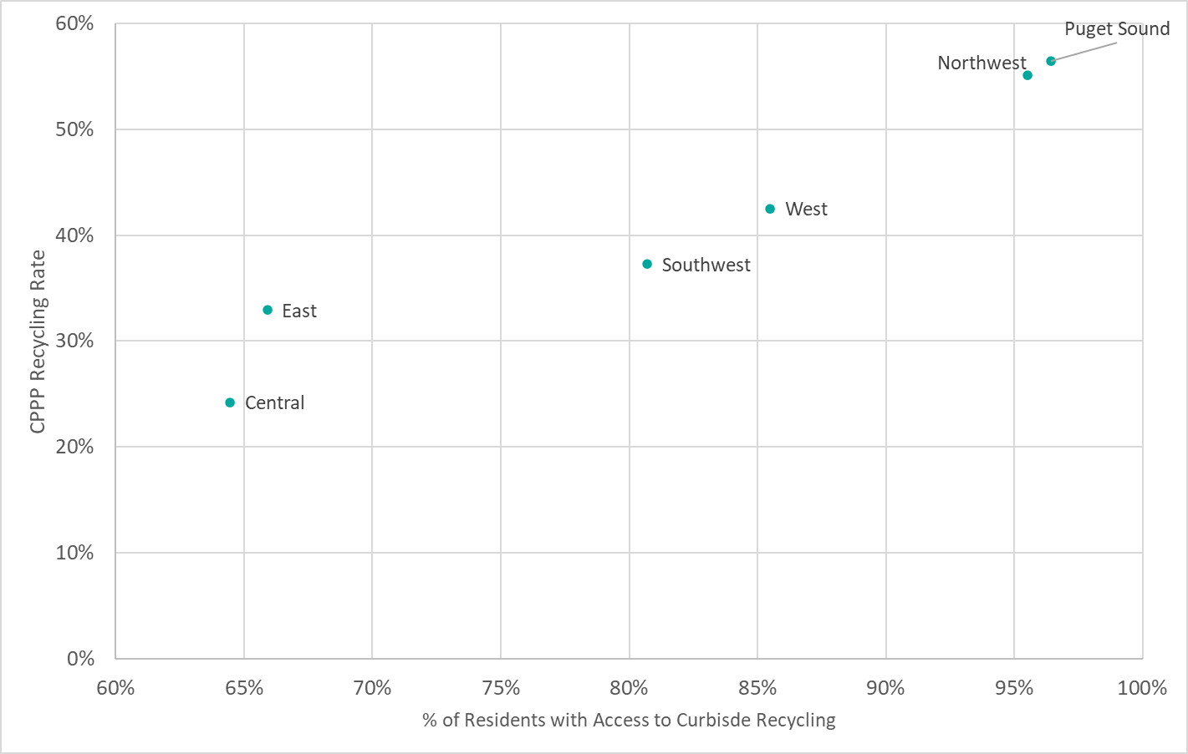
Sources: Eunomia Modelling, 2021 Ecology Washington Recycling and Recovery Data, 2020-2021 Washington Statewide Waste Characterization Study, 2020 King County Material Recovery Assessment, Washington Department of Ecology SF Recycling Access Survey.
There is no case where a WGA has a lower curbside access rate compared to other WGAs yet has a higher recycling rate than that WGA. Puget Sound has the highest level of access to curbside recycling, and it has the highest consumer packaging and paper products recycling rate.
Table 5 below shows the recycling rate by WGA for only the residential sector.
Table 5: Recycling Rate by WGA – Residential (2021)
 | Central | East | Northwest | Puget Sound | Southwest | West
Rigid Plastic | 4% | 10% | 28% | 27% | 16% | 34%
Flexible Plastic | 0% | 0% | 6% | 4% | 1% | 2%
Metals | 8% | 36% | 58% | 51% | 61% | 72%
Paper & Cardboard | 26% | 45% | 61% | 61% | 61% | 59%
Container Glass | 3% | 11% | 60% | 54% | 10% | 35%
All CPPP | 15% | 32% | 54% | 51% | 47% | 50%
Beverage Containers | 6% | 19% | 67% | 58% | 30% | 60%
Sources: Eunomia Modelling, 2021 Ecology Washington Recycling and Recovery Data, 2020-2021 Washington Statewide Waste Characterization Study, 2020 King County Material Recovery Assessment
When looking only at the residential sector, three WGAs (the Northwest, Puget Sound, and the West regions) have a consumer packaging and paper products recycling rate above 44% which is the statewide residential consumer packaging and paper products recycling rate. The Central region has the lowest residential rate and is 29 points below 44%.
The beverage container recycling rate is inconsistent in whether it is recycled more or less often than consumer packaging and paper products as a whole. In the Central, East and Southwest regions, beverage containers are recycled at a lower rate than all packaging. These regions also have low container glass to glass recycling options, which may explain the low beverage container recycling rate. Figure 3 below shows the recycling rates of container glass, beverage containers as a whole, and all CPPP for each of the six regions.
Figure 3: Beverage Container and CPPP Recycling Rates – Residential (2021)
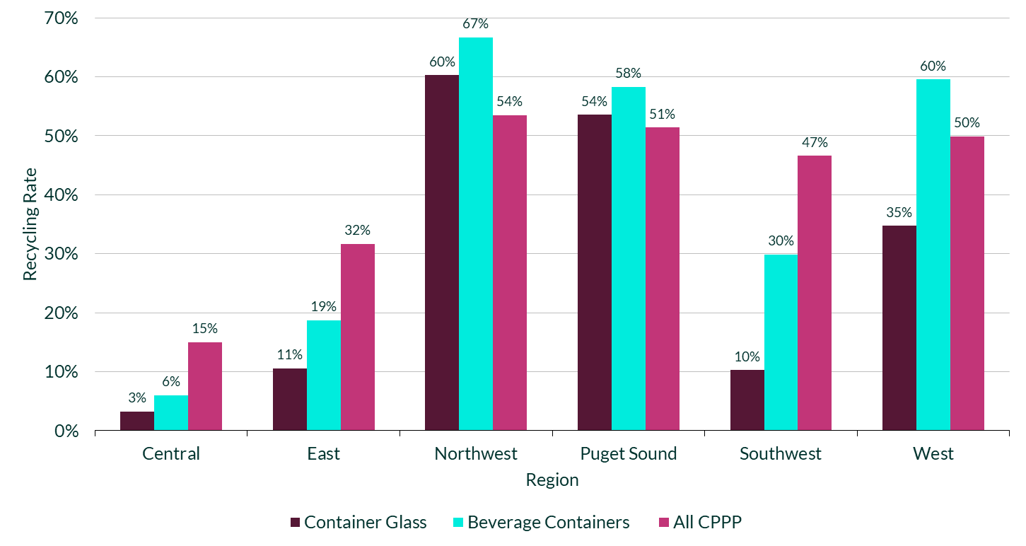
Sources: Eunomia Modelling, 2021 Ecology Washington Recycling and Recovery Data, 2020-2021 Washington Statewide Waste Characterization Study, 2020 King County Material Recovery Assessment
In the figure above, the Central, East, and Southwest regions have container glass recycling rates of 11% or lower. They also have relatively low recycling rates of all beverage containers compared to the other three regions. Glass containers appear to have a strong influence on the overall recycling rate of beverage containers, as they are the heaviest beverage container per unit. Increasing the recycling rate of glass containers may have a strong effect on increasing the recycling rate of all beverage containers.

Disposal Rates
Table 6 below shows the total tons of consumer packaging and paper products disposed (i.e., landfilled or incinerated) by each WGA, along with material specific categories.
Table 6: Tons Disposed by WGA – All Sectors (2021)
Material | Central | East | Northwest | Puget Sound | Southwest | West | Statewide
Rigid Plastic | 36,600 | 46,600 | 10,500 | 113,600 | 32,300 | 9,800 | 249,400
Flexible Plastic | 32,700 | 32,100 | 10,400 | 110,900 | 30,400 | 8,400 | 224,900
Metals | 13,800 | 11,500 | 3,300 | 31,900 | 5,500 | 4,900 | 70,900
Paper & Cardboard | 121,400 | 139,600 | 36,400 | 380,000 | 76,700 | 43,900 | 798,000
Container Glass | 22,000 | 17,300 | 4,600 | 53,400 | 7,000 | 2,600 | 106,900
All CPPP | 226,800 | 247,400 | 65,200 | 690,600 | 151,900 | 69,600 | 1,451,500
Beverage Containers | 31,800 | 27,800 | 4,600 | 66,300 | 11,000 | 6,900 | 148,400
Sources: Eunomia Modelling, 2021 Ecology Washington Recycling and Recovery Data, 2020-2021 Washington Statewide Waste Characterization Study, 2020 King County Material Recovery Assessment
Paper and cardboard is the most disposed category in each WGA. To compare the disposal quantities on a normalized basis, Table 7 below shows the pounds per capita disposed across the WGAs.
Table 7: Lbs/capita Disposed by WGA – All Sectors (2021)
Material | Central | East | Northwest | Puget Sound | Southwest | West | Statewide
Rigid Plastic | 123 | 86 | 46 | 49 | 89 | 71 | 64
Flexible Plastic | 110 | 59 | 45 | 48 | 84 | 61 | 58
Metals | 47 | 21 | 14 | 14 | 15 | 35 | 18
Paper & Cardboard | 409 | 257 | 158 | 164 | 212 | 318 | 205
Container Glass | 74 | 32 | 20 | 23 | 19 | 19 | 28
All CPPP | 765 | 456 | 283 | 298 | 420 | 504 | 374
Beverage Containers | 107 | 51 | 20 | 29 | 30 | 50 | 38
Sources: Eunomia Modelling, 2021 Ecology Washington Recycling and Recovery Data, 2020-2021 Washington Statewide Waste Characterization Study, 2020 King County Material Recovery Assessment
The central region has the highest generation per capita, as well as the lowest recycling rates. This results in the Central region having the highest disposal per capita as well at 765 pounds per capita disposed. Figure 4 below charts the overall consumer packaging and paper products disposed per capita by WGA and compares it to the statewide average.
Figure 4: CPPP Lbs/Capita Disposed by WGA – All Sectors (2021)
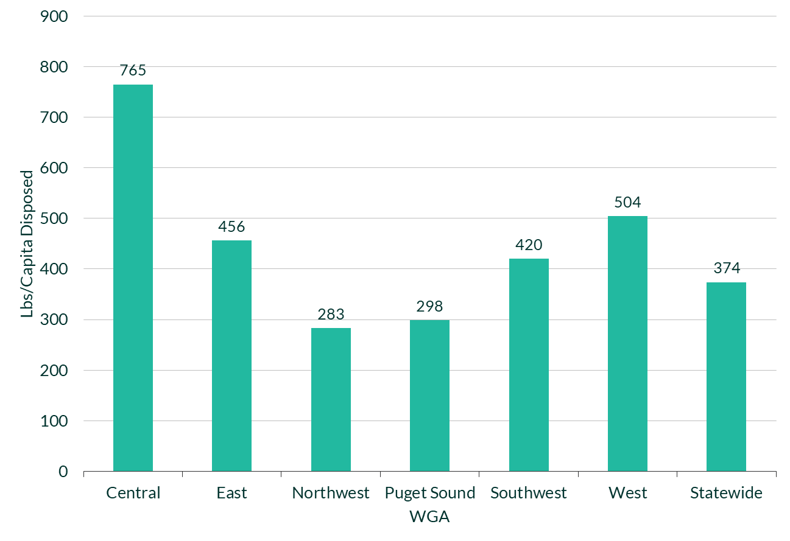
Sources: Eunomia Modelling, 2021 Ecology Washington Recycling and Recovery Data, 2020-2021 Washington Statewide Waste Characterization Study, 2020 King County Material Recovery Assessment
The Central, East, Southwest, and West regions all dispose consumer packaging and paper products at a higher rate than the state as a whole. Potential reasons for this may be due to limited access to curbside recycling in more rural areas, as the Northwest and Puget Sound each have near universal curbside access. Additionally, the statewide total is skewed towards the Puget Sound region as it accounts for over half of the state’s population.
Table 8 depicts the impact of population size as Puget Sound accounts for 48% of the total tonnage disposed in the state of Washington, and the next most populous WGA (the East) accounts for the second highest total at 17%.
Table 8: WGA Share of Total CPPP Disposed – All Sectors (2021)
 | Central | East | Northwest | Puget Sound | Southwest | West
All CPPP Disposed | 16% | 17% | 4% | 48% | 10% | 5%
Sources: Eunomia Modelling, 2021 Ecology Washington Recycling and Recovery Data, 2020-2021 Washington Statewide Waste Characterization Study, 2020 King County Material Recovery Assessment
However, as seen in Figure 4, Puget Sound has the second lowest disposal rate per capita. To achieve more of a concrete analysis of where excess material consumer packaging and paper products might be disposed, the disposal share of each WGA is compared to its population share. Figure 5 below plots the percent of total consumer packaging and paper products disposed by each WGA versus that WGA’s percentage of total state population. The purple 45-degree line shows where a region would fall if it’s percent of tonnage disposed was equal to its percent of the state population. Therefore, WGAs which are below the line dispose less than their population share might suggest. Likewise, those above the line disposed more than their share of the population.
Figure 5: CPPP Disposal Share vs Population Share (2021)
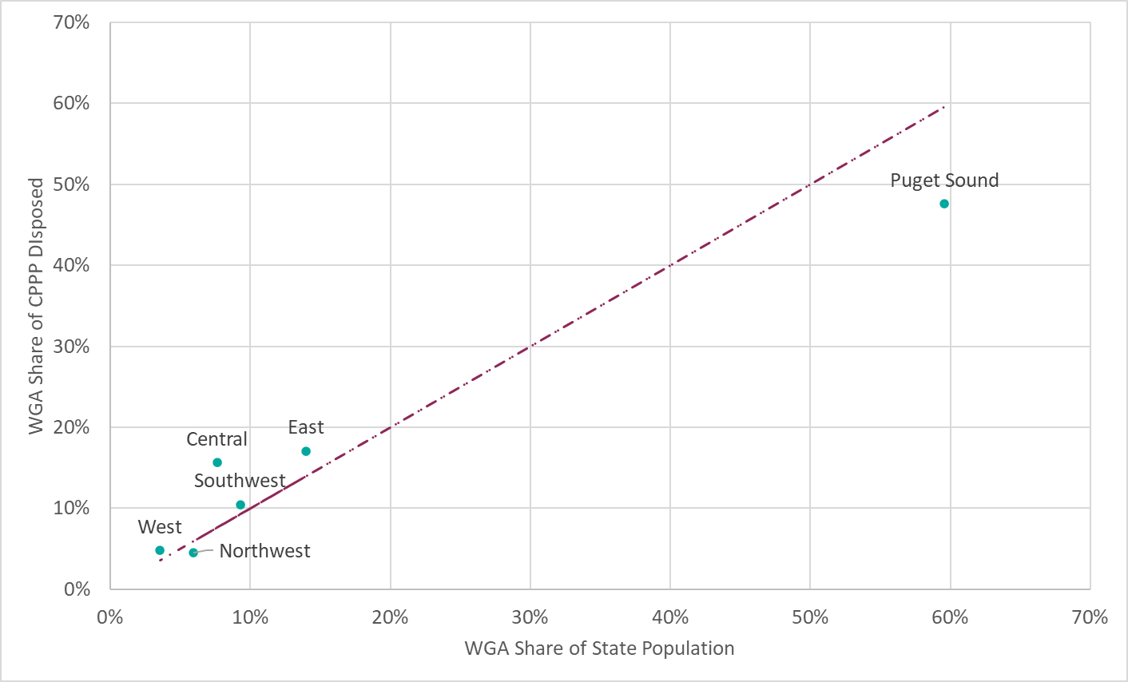
Sources: Eunomia Modelling, 2021 Ecology Washington Recycling and Recovery Data, 2020-2021 Washington Statewide Waste Characterization Study, 2020 King County Material Recovery Assessment
The Puget Sound and Northwest regions are both below the purple line in Figure 5, signifying their percentage of tonnage disposed is less than their percentage of the population. Conversely, the West, Southwest, Central, and East regions are all above the line, meaning their disposal share is greater than their population share. The Central region has the largest difference between population and disposal shares, as it has a disposal share that is 8 percentage points higher than its population share.

Conclusion
Waste Generation Areas (WGAs) that have greater access to curbside recycling, and higher recycling rates appear to dispose less consumer packaging and paper products per person than WGAs with lower curbside recycling access, lower access to recycled material end users, and low recycling rates. Puget sound has a secondary glass processor as well as a glass container manufacturer around the Seattle area. There is also a secondary glass processor in Portland, Oregon, and a glass container manufacturer in Kalama, Washington in the Southwest of the state. These glass recycling and manufacturing locations may help to explain with the Northwest, Puget Sound, Southwest and West regions have higher recycling rates than the Central and East regions, which do not have glass recycling outlets and must transport across the Cascade Mountain range to reach Seattle and Kalama. Although Puget Sound has the second highest generation per capita, it has the second lowest disposal rate per capita. The Northwest has the second lowest generation per capita and the lowest disposal rate per capita.
Two WGAs have a recycling rate for all sectors above the statewide recycling rate for all sectors of 48% (Northwest and Puget Sound), while three WGAs have a recycling rate for the residential sector above the statewide recycling rate for all sectors (Northwest, Puget Sound and West). Figure 6 below shows the residential recycling rate and all sector recycling rate for each WGA. The figure also displays the statewide average recycling rate for all sectors.
Figure 6: All Sector and Residential CPPP Recycling Rates vs Statewide Average
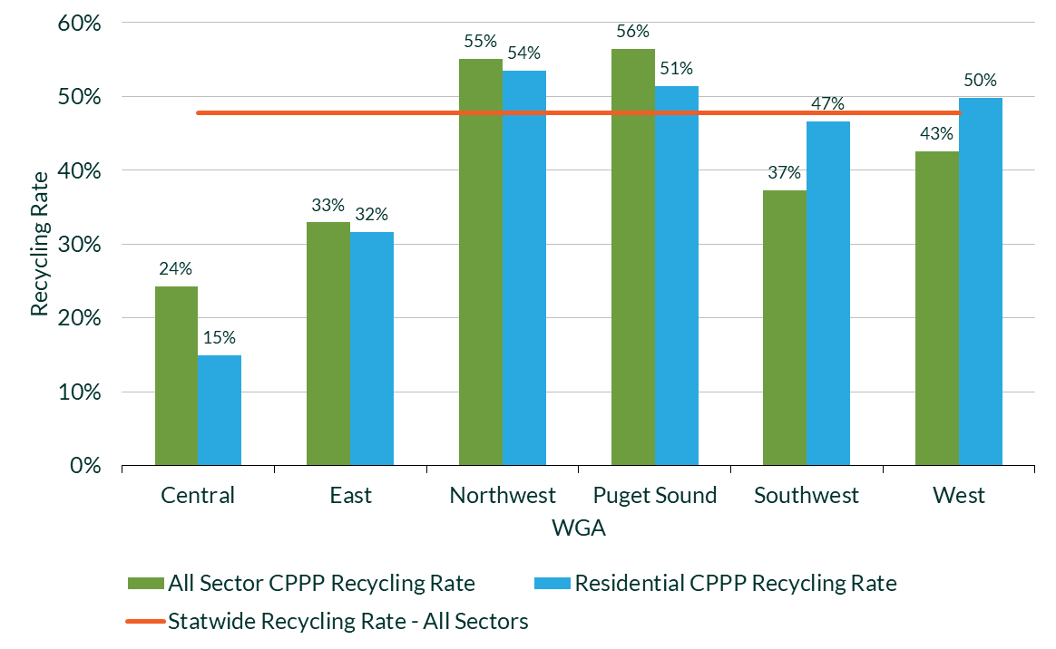
Sources: Eunomia Modelling, 2021 Ecology Washington Recycling and Recovery Data, 2020-2021 Washington Statewide Waste Characterization Study, 2020 King County Material Recovery Assessment

Regional Detailed Tables

This section includes tables showing the material flows and recycling rates for consumer packaging and paper products for the Central, East, Northwest, Puget Sound, Southwest, and West regions. For each WGA, the material flows and recycling rates are included for the following subsections:
- All Sectors: Material flows and recycling rates for consumer packaging and paper products from all sectors (including both residential and commercial sources)
- Residential: Material flows and recycling rates for consumer packaging and paper products from residential sources
- Commercial: Material flows and recycling rates for consumer packaging and paper products from commercial sources
Each subsection includes a table that provides material flows and recycling rates for seven main material categories (rigid plastic, flexible plastic, metals, paper & cardboard, container glass, all CPPP, and beverage containers) and then a table with thirty-six detailed categories of consumer packaging and paper products.
The primary sources of data that were used to estimate the findings presented in the tables below included: 2020-2021 Washington Statewide Waste Characterization Study, 2021 Ecology Statewide Disposal Totals, the 2021 Ecology Recycling Recovery Data, 2020-2021 King County Material Recovery Assessment, and the Responsible Recycling Task Force 2021 Report, Improving Recycling in Washington through Producer Responsibility Policy: Costs and Benefits - Responsible Recycling Task Force - King County Solid Waste Division.

Central Region

All Sectors
Table 9: Summary of Commercial and Residential Material Flows in tons and Recycling Rates in the Central Region (2021)
Central – All Sectors | Disposed | Disposed - MRF Residue | Total Disposed | Recycled | Total Generated | Recycling Rate
Rigid Plastic | 35,100 | 1,470 | 36,600 | 3,380 | 40,000 | 8%
Flexible Plastic | 31,400 | 1,250 | 32,700 | 1,047 | 33,700 | 3%
Metals | 13,300 | 578 | 13,800 | 1,360 | 15,200 | 9%
Paper & Cardboard | 116,900 | 4,530 | 121,400 | 65,600 | 187,500 | 35%
Container Glass | 21,500 | 498 | 22,000 | 1,090 | 23,000 | 5%
All CPPP | 218,500 | 8,330 | 226,800 | 72,530 | 299,300 | 24%
Beverage Containers | 30,700 | 1,090 | 31,800 | 3,700 | 35,500 | 10%
Table 10: Detailed Commercial and Residential Material Flows in tons and Recycling Rates in the Central Region (2021)
Central – All Sectors | Disposed | Disposed - MRF Residue | Total Disposed | Recycled | Total Generated | Recycling Rate
Total Rigid Plastics | 35,100 | 1,470 | 36,600 | 3,380 | 40,000 | 8%
#1 PET Bottles | 7,900 | 453 | 8,300 | 1,320 | 9,600 | 14%
#1 PET Beverage Containers | 6,100 | 407 | 6,500 | 1,180 | 7,600 | 16%
#1 PET Other Packaging | 3,500 | 83 | 3,600 | 308 | 3,900 | 8%
#2 HDPE Natural Bottles | 2,270 | 67 | 2,330 | 870 | 3,200 | 27%
#2 HDPE Natural Beverage Containers | 1,830 | 52 | 1,880 | 690 | 2,600 | 27%
#2 HDPE Colored Bottles | 2,900 | 83 | 3,000 | 510 | 3,400 | 15%
#2 HDPE Colored Beverage Containers | 280 | 9 | 290 | 55 | 340 | 16%
#2 HDPE Other Packaging | 3,680 | 17 | 3,680 | 78 | 3,820 | 2%
#3 PVC Packaging | 10 | 0 | 10 | 0 | 10 | 0%
#4 LDPE Packaging | 11 | 0 | 11 | 0 | 11 | 0%
#5 PP Packaging | 5,700 | 702 | 6,400 | 238 | 6,700 | 4%
#6 PS Packaging | 880 | 0 | 880 | 0 | 880 | 0%
#7 Other Packaging | 3,960 | 0 | 3,960 | 0 | 3,960 | 0%
Expanded Polystyrene Packaging | 4,400 | 67 | 4,400 | 32 | 4,500 | 1%
R/C Plastic Packaging | 26 | 0 | 26 | 0 | 26 | 0%
PLA/Compostable Packaging | 118 | 0 | 118 | 0 | 118 | 0%
Total Flexible Plastics | 31,400 | 1,250 | 32,700 | 1,047 | 33,700 | 3%
PE Plastic Bags & Film | 16,600 | 600 | 17,300 | 910 | 18,200 | 5%
Other Plastic Film & Flexible Packaging | 14,700 | 702 | 15,500 | 157 | 15,700 | 1%
Total Metals | 13,300 | 578 | 13,800 | 1,360 | 15,200 | 9%
Steel Cans | 6,900 | 114 | 7,000 | 410 | 7,400 | 6%
Aluminum Cans | 4,400 | 169 | 4,600 | 790 | 5,300 | 15%
Aluminum Beverage Containers | 3,900 | 159 | 4,100 | 760 | 4,900 | 16%
Other Nonferrous Metal | 1,980 | 295 | 2,300 | 173 | 2,500 | 7%
Total Paper & Card | 116,900 | 4,530 | 121,400 | 65,600 | 187,500 | 35%
Newspaper | 1,920 | 83 | 1,990 | 1,840 | 3,800 | 48%
Cardboard | 46,000 | 770 | 46,700 | 53,600 | 100,300 | 53%
Mixed Paper Products | 40,100 | 2,490 | 42,600 | 8,100 | 50,600 | 16%
Cartons | 6,500 | 0 | 6,500 | 4 | 6,500 | 0%
Carton Beverage Containers | 2,850 | 0 | 2,850 | 2 | 2,850 | 0%
Paper Packaging | 22,500 | 1,240 | 23,700 | 2,120 | 25,900 | 8%
Container Glass | 21,500 | 498 | 22,000 | 1,090 | 23,000 | 5%
Container Glass Beverage Containers | 15,800 | 464 | 16,300 | 1,000 | 17,200 | 6%
Total CPPP | 218,500 | 8,330 | 226,800 | 72,530 | 299,300 | 24%
Total Beverage Containers | 30,700 | 1,090 | 31,800 | 3,700 | 35,500 | 10%

Residential Rates
Table 11: Summary of Residential Material Flows in tons and Recycling Rates in the Central Region (2021)
Central - Residential | Disposed | Disposed - MRF Residue | Total Disposed | Recycled | Total Generated | Recycling Rate
Rigid Plastic | 21,000 | 170 | 21,200 | 980 | 22,200 | 4%
Flexible Plastic | 17,100 | 150 | 17,300 | 47 | 17,300 | 0%
Metals | 8,900 | 68 | 8,900 | 730 | 9,700 | 8%
Paper & Cardboard | 50,900 | 530 | 51,400 | 18,100 | 69,500 | 26%
Container Glass | 17,800 | 58 | 17,900 | 590 | 18,400 | 3%
All CPPP | 116,000 | 980 | 117,000 | 20,500 | 137,000 | 15%
Beverage Containers | 22,100 | 130 | 22,200 | 1,400 | 23,600 | 6%

Table 12: Detailed Residential Material Flows in tons and Recycling Rates in the Central Region (2021)
Central - Residential | Disposed | Disposed - MRF Residue | Total Disposed | Recycled | Total Generated | Recycling Rate
Total Rigid Plastics | 21,000 | 170 | 21,200 | 980 | 22,200 | 4%
#1 PET Bottles | 5,200 | 53 | 5,200 | 460 | 5,700 | 8%
#1 PET Beverage Containers | 4,100 | 47 | 4,100 | 410 | 4,500 | 9%
#1 PET Other Packaging | 2,400 | 10 | 2,400 | 98 | 2,500 | 4%
#2 HDPE Natural Bottles | 1,500 | 8 | 1,500 | 130 | 1,600 | 8%
#2 HDPE Natural Beverage Containers | 1,200 | 6 | 1,200 | 110 | 1,300 | 8%
#2 HDPE Colored Bottles | 1,800 | 10 | 1,800 | 140 | 1,900 | 7%
#2 HDPE Colored Beverage Containers | 180 | 1 | 180 | 15 | 190 | 8%
#2 HDPE Other Packaging | 580 | 2 | 580 | 42 | 620 | 7%
#3 PVC Packaging | 6 | 0 | 6 | 0 | 6 | 0%
#4 LDPE Packaging | 8 | 0 | 8 | 0 | 8 | 0%
#5 PP Packaging | 3,900 | 82 | 4,000 | 98 | 4,100 | 2%
#6 PS Packaging | 520 | 0 | 520 | 0 | 520 | 0%
#7 Other Packaging | 3,100 | 0 | 3,100 | 0 | 3,100 | 0%
Expanded Polystyrene Packaging | 2,100 | 8 | 2,100 | 6 | 2,100 | 0%
R/C Plastic Packaging | 26 | 0 | 26 | 0 | 26 | 0%
PLA/Compostable Packaging | 42 | 0 | 42 | 0 | 42 | 0%
Total Flexible Plastics | 17,100 | 150 | 17,300 | 47 | 17,300 | 0%
PE Plastic Bags & Film | 6,400 | 70 | 6,500 | 20 | 6,500 | 0%
Other Plastic Film & Flexible Packaging | 10,700 | 82 | 10,800 | 27 | 10,900 | 0%
Total Metals | 8,900 | 68 | 8,900 | 730 | 9,700 | 8%
Steel Cans | 4,700 | 14 | 4,700 | 250 | 5,000 | 5%
Aluminum Cans | 3,200 | 19 | 3,200 | 320 | 3,500 | 9%
Aluminum Beverage Containers | 2,800 | 19 | 2,900 | 310 | 3,200 | 10%
Other Nonferrous Metal | 980 | 35 | 1,000 | 170 | 1,200 | 14%
Total Paper & Card | 50,900 | 530 | 51,400 | 18,100 | 69,500 | 26%
Newspaper | 1,500 | 10 | 1,500 | 930 | 2,400 | 39%
Cardboard | 14,700 | 90 | 14,800 | 11,600 | 26,300 | 44%
Mixed Paper Products | 19,500 | 290 | 19,800 | 4,100 | 23,900 | 17%
Cartons | 1,300 | 0 | 1,300 | 0 | 1,300 | 0%
Carton Beverage Containers | 550 | 0 | 550 | 0 | 550 | 0%
Paper Packaging | 14,000 | 140 | 14,100 | 1,500 | 15,700 | 10%
Container Glass | 17,800 | 58 | 17,900 | 590 | 18,400 | 3%
Container Glass Beverage Containers | 13,200 | 54 | 13,300 | 540 | 13,800 | 4%
Total CPPP | 116,000 | 980 | 117,000 | 20,500 | 137,000 | 15%
Total Beverage Containers | 22,100 | 130 | 22,200 | 1,400 | 23,600 | 6%

Commercial Rates
Table 13: Summary of Commercial Material Flows in tons and Recycling Rates in the Central Region (2021)
Central - Commercial | Disposed | Disposed - MRF Residue | Total Disposed | Recycled | Total Generated | Recycling Rate
Rigid Plastic | 14,100 | 1,300 | 15,400 | 2,400 | 17,800 | 13%
Flexible Plastic | 14,300 | 1,100 | 15,400 | 1,000 | 16,400 | 6%
Metals | 4,400 | 510 | 4,900 | 630 | 5,500 | 11%
Paper & Cardboard | 66,000 | 4,000 | 70,000 | 47,500 | 118,000 | 40%
Container Glass | 3,700 | 440 | 4,100 | 500 | 4,600 | 11%
All CPPP | 102,500 | 7,350 | 109,800 | 52,030 | 162,300 | 32%
Beverage Containers | 8,600 | 960 | 9,600 | 2,300 | 11,900 | 19%
Table 14: Detailed Commercial Material Flows in tons and Recycling Rates in the Central Region (2021)
Central - Commercial | Disposed | Disposed - MRF Residue | Total Disposed | Recycled | Total Generated | Recycling Rate
Total Rigid Plastics | 14,100 | 1,300 | 15,400 | 2,400 | 17,800 | 13%
#1 PET Bottles | 2,700 | 400 | 3,100 | 860 | 3,900 | 22%
#1 PET Beverage Containers | 2,000 | 360 | 2,400 | 770 | 3,100 | 25%
#1 PET Other Packaging | 1,100 | 73 | 1,200 | 210 | 1,400 | 15%
#2 HDPE Natural Bottles | 770 | 59 | 830 | 740 | 1,600 | 46%
#2 HDPE Natural Beverage Containers | 630 | 46 | 680 | 580 | 1,300 | 45%
#2 HDPE Colored Bottles | 1,100 | 73 | 1,200 | 370 | 1,500 | 25%
#2 HDPE Colored Beverage Containers | 100 | 8 | 110 | 40 | 150 | 27%
#2 HDPE Other Packaging | 3,100 | 15 | 3,100 | 36 | 3,200 | 1%
#3 PVC Packaging | 4 | 0 | 4 | 0 | 4 | 0%
#4 LDPE Packaging | 3 | 0 | 3 | 0 | 3 | 0%
#5 PP Packaging | 1,800 | 620 | 2,400 | 140 | 2,600 | 5%
#6 PS Packaging | 360 | 0 | 360 | 0 | 360 | 0%
#7 Other Packaging | 860 | 0 | 860 | 0 | 860 | 0%
Expanded Polystyrene Packaging | 2,300 | 59 | 2,300 | 26 | 2,400 | 1%
R/C Plastic Packaging | 0 | 0 | 0 | 0 | 0 | 0%
PLA/Compostable Packaging | 76 | 0 | 76 | 0 | 76 | 0%
Total Flexible Plastics | 14,300 | 1,100 | 15,400 | 1,000 | 16,400 | 6%
PE Plastic Bags & Film | 10,200 | 530 | 10,800 | 890 | 11,700 | 8%
Other Plastic Film & Flexible Packaging | 4,000 | 620 | 4,700 | 130 | 4,800 | 3%
Total Metals | 4,400 | 510 | 4,900 | 630 | 5,500 | 11%
Steel Cans | 2,200 | 100 | 2,300 | 160 | 2,400 | 7%
Aluminum Cans | 1,200 | 150 | 1,400 | 470 | 1,800 | 26%
Aluminum Beverage Containers | 1,100 | 140 | 1,200 | 450 | 1,700 | 26%
Other Nonferrous Metal | 1,000 | 260 | 1,300 | 3 | 1,300 | 0%
Total Paper & Card | 66,000 | 4,000 | 70,000 | 47,500 | 118,000 | 40%
Newspaper | 420 | 73 | 490 | 910 | 1,400 | 65%
Cardboard | 31,300 | 680 | 31,900 | 42,000 | 74,000 | 57%
Mixed Paper Products | 20,600 | 2,200 | 22,800 | 4,000 | 26,700 | 15%
Cartons | 5,200 | 0 | 5,200 | 4 | 5,200 | 0%
Carton Beverage Containers | 2,300 | 0 | 2,300 | 2 | 2,300 | 0%
Paper Packaging | 8,500 | 1,100 | 9,600 | 620 | 10,200 | 6%
Container Glass | 3,700 | 440 | 4,100 | 500 | 4,600 | 11%
Container Glass Beverage Containers | 2,600 | 410 | 3,000 | 460 | 3,400 | 14%
Total CPPP | 102,500 | 7,350 | 109,800 | 52,030 | 162,300 | 32%
Total Beverage Containers | 8,600 | 960 | 9,600 | 2,300 | 11,900 | 19%

East Region

All Sectors
Table 15: Summary of Commercial and Residential Material Flows in tons and Recycling Rates in the East Region (2021)
East – All Sectors | Disposed | Disposed - MRF Residue | Total Disposed | Recycled | Total Generated | Recycling Rate
Rigid Plastic | 46,100 | 520 | 46,600 | 4,500 | 51,100 | 9%
Flexible Plastic | 31,700 | 470 | 32,100 | 200 | 32,400 | 1%
Metals | 11,300 | 207 | 11,500 | 4,810 | 16,300 | 30%
Paper & Cardboard | 138,000 | 1,570 | 139,600 | 110,400 | 250,000 | 44%
Container Glass | 17,200 | 181 | 17,300 | 1,630 | 19,000 | 9%
All CPPP | 243,800 | 2,988 | 247,400 | 121,460 | 369,000 | 33%
Beverage Containers | 27,400 | 388 | 27,800 | 6,000 | 33,700 | 18%
Table 16: Detailed Commercial and Residential Material Flows in tons and Recycling Rates in the East Region (2021)
East – All Sectors | Disposed | Disposed - MRF Residue | Total Disposed | Recycled | Total Generated | Recycling Rate
Total Rigid Plastics | 46,100 | 520 | 46,600 | 4,500 | 51,100 | 9%
#1 PET Bottles | 9,100 | 156 | 9,300 | 2,190 | 11,400 | 19%
#1 PET Beverage Containers | 7,100 | 143 | 7,200 | 1,900 | 9,100 | 21%
#1 PET Other Packaging | 3,770 | 30 | 3,780 | 480 | 4,300 | 11%
#2 HDPE Natural Bottles | 2,310 | 23 | 2,310 | 760 | 3,000 | 25%
#2 HDPE Natural Beverage Containers | 1,770 | 18 | 1,870 | 600 | 2,470 | 24%
#2 HDPE Colored Bottles | 2,470 | 30 | 2,480 | 560 | 3,000 | 19%
#2 HDPE Colored Beverage Containers | 235 | 3 | 246 | 61 | 300 | 20%
#2 HDPE Other Packaging | 3,400 | 6 | 3,400 | 154 | 3,500 | 4%
#3 PVC Packaging | 32 | 0 | 32 | 0 | 32 | 0%
#4 LDPE Packaging | 0 | 0 | 0 | 0 | 0 | 0%
#5 PP Packaging | 8,900 | 247 | 9,200 | 420 | 9,600 | 4%
#6 PS Packaging | 1,320 | 0 | 1,320 | 0 | 1,320 | 0%
#7 Other Packaging | 8,600 | 0 | 8,600 | 0 | 8,600 | 0%
Expanded Polystyrene Packaging | 6,100 | 23 | 6,100 | 13 | 6,100 | 0%
R/C Plastic Packaging | 0 | 0 | 0 | 0 | 0 | 0%
PLA/Compostable Packaging | 280 | 0 | 280 | 0 | 280 | 0%
Total Flexible Plastics | 31,700 | 470 | 32,100 | 200 | 32,400 | 1%
PE Plastic Bags & Film | 14,400 | 209 | 14,700 | 139 | 14,800 | 1%
Other Plastic Film & Flexible Packaging | 17,200 | 247 | 17,500 | 61 | 17,500 | 0%
Total Metals | 11,300 | 207 | 11,500 | 4,810 | 16,300 | 30%
Steel Cans | 5,000 | 41 | 5,000 | 1,080 | 6,100 | 18%
Aluminum Cans | 4,500 | 60 | 4,500 | 1,820 | 6,300 | 29%
Aluminum Beverage Containers | 3,900 | 57 | 4,000 | 1,810 | 5,800 | 31%
Other Nonferrous Metal | 1,760 | 106 | 1,880 | 1,806 | 3,690 | 49%
Total Paper & Card | 138,000 | 1,570 | 139,600 | 110,400 | 250,000 | 44%
Newspaper | 3,300 | 30 | 3,300 | 6,600 | 9,900 | 67%
Cardboard | 54,900 | 272 | 55,100 | 81,000 | 136,100 | 60%
Mixed Paper Products | 39,000 | 880 | 39,900 | 17,400 | 57,100 | 30%
Cartons | 4,100 | 0 | 4,100 | 27 | 4,100 | 1%
Carton Beverage Containers | 1,810 | 0 | 1,810 | 12 | 1,810 | 1%
Paper Packaging | 36,800 | 428 | 37,200 | 5,400 | 42,500 | 13%
Container Glass | 17,200 | 181 | 17,300 | 1,630 | 19,000 | 9%
Container Glass Beverage Containers | 12,600 | 167 | 12,700 | 1,510 | 14,300 | 11%
Total CPPP | 243,800 | 2,988 | 247,400 | 121,460 | 369,000 | 33%
Total Beverage Containers | 27,400 | 388 | 27,800 | 6,000 | 33,700 | 18%

Residential Rates
Table 17: Summary of Residential Material Flows in tons and Recycling Rates in the East Region (2021)
East - Residential | Disposed | Disposed - MRF Residue | Total Disposed | Recycled | Total Generated | Recycling Rate
Rigid Plastic | 23,900 | 400 | 24,300 | 2,700 | 27,000 | 10%
Flexible Plastic | 18,000 | 360 | 18,300 | 80 | 18,400 | 0%
Metals | 7,700 | 160 | 7,900 | 4,300 | 12,100 | 36%
Paper & Cardboard | 55,200 | 1,200 | 56,400 | 46,600 | 103,000 | 45%
Container Glass | 11,700 | 140 | 11,800 | 1,400 | 13,300 | 11%
All CPPP | 116,000 | 2,300 | 119,000 | 55,000 | 174,000 | 32%
Beverage Containers | 18,400 | 300 | 18,700 | 4,300 | 23,000 | 19%
Table 18: Detailed Residential Material Flows in tons and Recycling Rates in the East Region (2021)
East - Residential | Disposed | Disposed - MRF Residue | Total Disposed | Recycled | Total Generated | Recycling Rate
Total Rigid Plastics | 23,900 | 400 | 24,300 | 2,700 | 27,000 | 10%
#1 PET Bottles | 6,600 | 120 | 6,800 | 1,300 | 8,000 | 16%
#1 PET Beverage Containers | 5,200 | 110 | 5,300 | 1,100 | 6,400 | 17%
#1 PET Other Packaging | 2,800 | 23 | 2,800 | 280 | 3,100 | 9%
#2 HDPE Natural Bottles | 1,600 | 18 | 1,600 | 380 | 1,900 | 20%
#2 HDPE Natural Beverage Containers | 1,200 | 14 | 1,300 | 300 | 1,600 | 19%
#2 HDPE Colored Bottles | 1,500 | 23 | 1,500 | 390 | 1,900 | 21%
#2 HDPE Colored Beverage Containers | 140 | 2 | 150 | 42 | 190 | 22%
#2 HDPE Other Packaging | 1,400 | 5 | 1,400 | 120 | 1,500 | 8%
#3 PVC Packaging | 4 | 0 | 4 | 0 | 4 | 0%
#4 LDPE Packaging | 0 | 0 | 0 | 0 | 0 | 0%
#5 PP Packaging | 4,700 | 190 | 4,900 | 280 | 5,200 | 5%
#6 PS Packaging | 750 | 0 | 750 | 0 | 750 | 0%
#7 Other Packaging | 2,000 | 0 | 2,000 | 0 | 2,000 | 0%
Expanded Polystyrene Packaging | 2,500 | 18 | 2,500 | 11 | 2,500 | 0%
R/C Plastic Packaging | 0 | 0 | 0 | 0 | 0 | 0%
PLA/Compostable Packaging | 180 | 0 | 180 | 0 | 180 | 0%
Total Flexible Plastics | 18,000 | 360 | 18,300 | 80 | 18,400 | 0%
PE Plastic Bags & Film | 7,500 | 160 | 7,700 | 29 | 7,700 | 0%
Other Plastic Film & Flexible Packaging | 10,400 | 190 | 10,600 | 52 | 10,600 | 0%
Total Metals | 7,700 | 160 | 7,900 | 4,300 | 12,100 | 36%
Steel Cans | 3,300 | 32 | 3,300 | 900 | 4,200 | 21%
Aluminum Cans | 3,100 | 46 | 3,100 | 1,500 | 4,600 | 33%
Aluminum Beverage Containers | 2,700 | 44 | 2,700 | 1,500 | 4,200 | 36%
Other Nonferrous Metal | 1,300 | 82 | 1,400 | 1,800 | 3,200 | 56%
Total Paper & Card | 55,200 | 1,200 | 56,400 | 46,600 | 103,000 | 45%
Newspaper | 2,000 | 23 | 2,000 | 3,300 | 5,300 | 62%
Cardboard | 20,000 | 210 | 20,200 | 28,700 | 48,900 | 59%
Mixed Paper Products | 15,000 | 680 | 15,700 | 11,100 | 26,700 | 42%
Cartons | 1,600 | 0 | 1,600 | 3 | 1,600 | 0%
Carton Beverage Containers | 710 | 0 | 710 | 1 | 710 | 0%
Paper Packaging | 16,600 | 330 | 16,900 | 3,500 | 20,400 | 17%
Container Glass | 11,700 | 140 | 11,800 | 1,400 | 13,300 | 11%
Container Glass Beverage Containers | 8,500 | 130 | 8,600 | 1,300 | 10,000 | 13%
Total CPPP | 116,000 | 2,300 | 119,000 | 55,000 | 174,000 | 32%
Total Beverage Containers | 18,400 | 300 | 18,700 | 4,300 | 23,000 | 19%

Commercial Rates
Table 19: Summary of Commercial Material Flows in tons and Recycling Rates in the East Region (2021)
East - Commercial | Disposed | Disposed - MRF Residue | Total Disposed | Recycled | Total Generated | Recycling Rate
Rigid Plastic | 22,200 | 120 | 22,300 | 1,800 | 24,100 | 7%
Flexible Plastic | 13,700 | 110 | 13,800 | 120 | 14,000 | 1%
Metals | 3,600 | 47 | 3,600 | 510 | 4,200 | 12%
Paper & Cardboard | 82,800 | 370 | 83,200 | 63,800 | 147,000 | 43%
Container Glass | 5,500 | 41 | 5,500 | 230 | 5,700 | 4%
All CPPP | 127,800 | 688 | 128,400 | 66,460 | 195,000 | 34%
Beverage Containers | 9,000 | 88 | 9,100 | 1,700 | 10,700 | 16%
Table 20: Detailed Commercial Material Flows in tons and Recycling Rates in the East Region (2021)
East - Commercial | Disposed | Disposed - MRF Residue | Total Disposed | Recycled | Total Generated | Recycling Rate
Total Rigid Plastics | 22,200 | 120 | 22,300 | 1,800 | 24,100 | 7%
#1 PET Bottles | 2,500 | 36 | 2,500 | 890 | 3,400 | 26%
#1 PET Beverage Containers | 1,900 | 33 | 1,900 | 800 | 2,700 | 30%
#1 PET Other Packaging | 970 | 7 | 980 | 200 | 1,200 | 17%
#2 HDPE Natural Bottles | 710 | 5 | 710 | 380 | 1,100 | 35%
#2 HDPE Natural Beverage Containers | 570 | 4 | 570 | 300 | 870 | 34%
#2 HDPE Colored Bottles | 970 | 7 | 980 | 170 | 1,100 | 15%
#2 HDPE Colored Beverage Containers | 95 | 1 | 96 | 19 | 110 | 17%
#2 HDPE Other Packaging | 2,000 | 1 | 2,000 | 34 | 2,000 | 2%
#3 PVC Packaging | 28 | 0 | 28 | 0 | 28 | 0%
#4 LDPE Packaging | 0 | 0 | 0 | 0 | 0 | 0%
#5 PP Packaging | 4,200 | 57 | 4,300 | 140 | 4,400 | 3%
#6 PS Packaging | 570 | 0 | 570 | 0 | 570 | 0%
#7 Other Packaging | 6,600 | 0 | 6,600 | 0 | 6,600 | 0%
Expanded Polystyrene Packaging | 3,600 | 5 | 3,600 | 2 | 3,600 | 0%
R/C Plastic Packaging | 0 | 0 | 0 | 0 | 0 | 0%
PLA/Compostable Packaging | 100 | 0 | 100 | 0 | 100 | 0%
Total Flexible Plastics | 13,700 | 110 | 13,800 | 120 | 14,000 | 1%
PE Plastic Bags & Film | 6,900 | 49 | 7,000 | 110 | 7,100 | 2%
Other Plastic Film & Flexible Packaging | 6,800 | 57 | 6,900 | 9 | 6,900 | 0%
Total Metals | 3,600 | 47 | 3,600 | 510 | 4,200 | 12%
Steel Cans | 1,700 | 9 | 1,700 | 180 | 1,900 | 9%
Aluminum Cans | 1,400 | 14 | 1,400 | 320 | 1,700 | 19%
Aluminum Beverage Containers | 1,200 | 13 | 1,300 | 310 | 1,600 | 19%
Other Nonferrous Metal | 460 | 24 | 480 | 6 | 490 | 1%
Total Paper & Card | 82,800 | 370 | 83,200 | 63,800 | 147,000 | 43%
Newspaper | 1,300 | 7 | 1,300 | 3,300 | 4,600 | 72%
Cardboard | 34,900 | 62 | 34,900 | 52,300 | 87,200 | 60%
Mixed Paper Products | 24,000 | 200 | 24,200 | 6,300 | 30,400 | 21%
Cartons | 2,500 | 0 | 2,500 | 24 | 2,500 | 1%
Carton Beverage Containers | 1,100 | 0 | 1,100 | 11 | 1,100 | 1%
Paper Packaging | 20,200 | 98 | 20,300 | 1,900 | 22,100 | 9%
Container Glass | 5,500 | 41 | 5,500 | 230 | 5,700 | 4%
Container Glass Beverage Containers | 4,100 | 37 | 4,100 | 210 | 4,300 | 5%
Total CPPP | 127,800 | 688 | 128,400 | 66,460 | 195,000 | 34%
Total Beverage Containers | 9,000 | 88 | 9,100 | 1,700 | 10,700 | 16%

Northwest Region

All Sectors
Table 21: Summary of Residential and Commercial Material Flows in tons and Recycling Rates in the Northwest Region (2021)
Northwest – All Sectors | Disposed | Disposed - MRF Residue | Total Disposed | Recycled | Total Generated | Recycling Rate
Rigid Plastic | 10,300 | 155 | 10,500 | 4,300 | 14,900 | 29%
Flexible Plastic | 10,300 | 134 | 10,400 | 430 | 10,900 | 4%
Metals | 3,200 | 61 | 3,300 | 4,000 | 7,300 | 55%
Paper & Cardboard | 36,000 | 475 | 36,400 | 65,200 | 101,500 | 64%
Container Glass | 4,600 | 53 | 4,600 | 6,200 | 10,800 | 57%
All CPPP | 64,400 | 878 | 65,200 | 80,080 | 145,400 | 55%
Beverage Containers | 4,500 | 114 | 4,600 | 9,900 | 14,500 | 68%
Table 22: Detailed Residential and Commercial Material Flows in tons and Recycling Rates in the Northwest Region (2021)
Northwest – All Sectors | Disposed | Disposed - MRF Residue | Total Disposed | Recycled | Total Generated | Recycling Rate
Total Rigid Plastics | 10,300 | 155 | 10,500 | 4,300 | 14,900 | 29%
#1 PET Bottles | 1,260 | 48 | 1,310 | 2,050 | 3,400 | 60%
#1 PET Beverage Containers | 800 | 42 | 840 | 1,840 | 2,700 | 68%
#1 PET Other Packaging | 1,340 | 8 | 1,340 | 470 | 1,770 | 27%
#2 HDPE Natural Bottles | 460 | 7 | 460 | 770 | 1,240 | 62%
#2 HDPE Natural Beverage Containers | 380 | 5 | 380 | 600 | 990 | 61%
#2 HDPE Colored Bottles | 660 | 8 | 670 | 500 | 1,170 | 43%
#2 HDPE Colored Beverage Containers | 61 | 1 | 62 | 55 | 117 | 47%
#2 HDPE Other Packaging | 1,510 | 2 | 1,520 | 132 | 1,600 | 8%
#3 PVC Packaging | 0 | 0 | 0 | 0 | 0 | 0%
#4 LDPE Packaging | 1 | 0 | 1 | 0 | 1 | 0%
#5 PP Packaging | 2,220 | 73 | 2,320 | 380 | 2,700 | 14%
#6 PS Packaging | 460 | 0 | 460 | 8 | 470 | 2%
#7 Other Packaging | 1,380 | 0 | 1,380 | 0 | 1,380 | 0%
Expanded Polystyrene Packaging | 1,060 | 7 | 1,060 | 30 | 1,090 | 3%
R/C Plastic Packaging | 13 | 0 | 13 | 0 | 13 | 0%
PLA/Compostable Packaging | 5 | 0 | 5 | 0 | 5 | 0%
Total Flexible Plastics | 10,300 | 134 | 10,400 | 430 | 10,900 | 4%
PE Plastic Bags & Film | 3,500 | 63 | 3,600 | 310 | 3,800 | 8%
Other Plastic Film & Flexible Packaging | 6,800 | 73 | 6,800 | 134 | 7,000 | 2%
Total Metals | 3,200 | 61 | 3,300 | 4,000 | 7,300 | 55%
Steel Cans | 1,740 | 12 | 1,750 | 880 | 2,700 | 33%
Aluminum Cans | 930 | 18 | 950 | 1,720 | 2,600 | 66%
Aluminum Beverage Containers | 730 | 17 | 750 | 1,600 | 2,400 | 67%
Other Nonferrous Metal | 610 | 31 | 640 | 1,315 | 2,010 | 65%
Total Paper & Card | 36,000 | 475 | 36,400 | 65,200 | 101,500 | 64%
Newspaper | 610 | 8 | 620 | 1,860 | 2,500 | 74%
Cardboard | 15,000 | 81 | 15,100 | 45,500 | 60,600 | 75%
Mixed Paper Products | 12,500 | 258 | 12,800 | 13,300 | 26,100 | 51%
Cartons | 510 | 0 | 510 | 0 | 510 | 0%
Carton Beverage Containers | 220 | 0 | 220 | 0 | 220 | 0%
Paper Packaging | 7,200 | 124 | 7,400 | 4,400 | 11,800 | 37%
Container Glass | 4,600 | 53 | 4,600 | 6,200 | 10,800 | 57%
Container Glass Beverage Containers | 2,330 | 49 | 2,330 | 5,700 | 8,000 | 71%
Total CPPP | 64,400 | 878 | 65,200 | 80,080 | 145,400 | 55%
Total Beverage Containers | 4,500 | 114 | 4,600 | 9,900 | 14,500 | 68%

Residential Rates
Table 23: Summary of Residential Material Flows in tons and Recycling Rates in the Northwest Region (2021)
Northwest – Residential | Disposed | Disposed - MRF Residue | Total Disposed | Recycled | Total Generated | Recycling Rate
Rigid Plastic | 4,900 | 150 | 5,100 | 2,000 | 7,100 | 28%
Flexible Plastic | 3,500 | 130 | 3,600 | 250 | 3,900 | 6%
Metals | 1,700 | 59 | 1,800 | 2,500 | 4,300 | 58%
Paper & Cardboard | 14,300 | 460 | 14,700 | 23,300 | 38,000 | 61%
Container Glass | 3,100 | 51 | 3,100 | 4,700 | 7,800 | 60%
All CPPP | 27,500 | 850 | 28,300 | 32,700 | 61,100 | 54%
Beverage Containers | 2,900 | 110 | 3,000 | 6,000 | 9,000 | 67%

Table 24: Detailed Residential Material Flows in tons and Recycling Rates in the Northwest Region (2021)
Northwest – Residential | Disposed | Disposed - MRF Residue | Total Disposed | Recycled | Total Generated | Recycling Rate
Total Rigid Plastics | 4,900 | 150 | 5,100 | 2,000 | 7,100 | 28%
#1 PET Bottles | 710 | 46 | 760 | 950 | 1,700 | 56%
#1 PET Beverage Containers | 470 | 41 | 510 | 850 | 1,400 | 61%
#1 PET Other Packaging | 460 | 8 | 460 | 200 | 670 | 30%
#2 HDPE Natural Bottles | 300 | 7 | 300 | 260 | 560 | 46%
#2 HDPE Natural Beverage Containers | 240 | 5 | 240 | 200 | 450 | 44%
#2 HDPE Colored Bottles | 540 | 8 | 550 | 260 | 810 | 32%
#2 HDPE Colored Beverage Containers | 51 | 1 | 52 | 29 | 81 | 36%
#2 HDPE Other Packaging | 110 | 2 | 120 | 87 | 200 | 44%
#3 PVC Packaging | 0 | 0 | 0 | 0 | 0 | 0%
#4 LDPE Packaging | 0 | 0 | 0 | 0 | 0 | 0%
#5 PP Packaging | 1,400 | 71 | 1,500 | 200 | 1,700 | 12%
#6 PS Packaging | 220 | 0 | 220 | 4 | 220 | 2%
#7 Other Packaging | 420 | 0 | 420 | 0 | 420 | 0%
Expanded Polystyrene Packaging | 710 | 7 | 710 | 29 | 740 | 4%
R/C Plastic Packaging | 13 | 0 | 13 | 0 | 13 | 0%
PLA/Compostable Packaging | 2 | 0 | 2 | 0 | 2 | 0%
Total Flexible Plastics | 3,500 | 130 | 3,600 | 250 | 3,900 | 6%
PE Plastic Bags & Film | 1,200 | 61 | 1,300 | 130 | 1,400 | 9%
Other Plastic Film & Flexible Packaging | 2,300 | 71 | 2,300 | 130 | 2,500 | 5%
Total Metals | 1,700 | 59 | 1,800 | 2,500 | 4,300 | 58%
Steel Cans | 830 | 12 | 840 | 530 | 1,400 | 38%
Aluminum Cans | 610 | 17 | 630 | 620 | 1,200 | 52%
Aluminum Beverage Containers | 510 | 16 | 530 | 600 | 1,100 | 55%
Other Nonferrous Metal | 310 | 30 | 340 | 1,300 | 1,700 | 76%
Total Paper & Card | 14,300 | 460 | 14,700 | 23,300 | 38,000 | 61%
Newspaper | 280 | 8 | 290 | 1,300 | 1,600 | 81%
Cardboard | 4,500 | 78 | 4,600 | 12,600 | 17,200 | 73%
Mixed Paper Products | 6,800 | 250 | 7,100 | 7,400 | 14,500 | 51%
Cartons | 270 | 0 | 270 | 0 | 270 | 0%
Carton Beverage Containers | 120 | 0 | 120 | 0 | 120 | 0%
Paper Packaging | 2,300 | 120 | 2,500 | 1,900 | 4,400 | 43%
Container Glass | 3,100 | 51 | 3,100 | 4,700 | 7,800 | 60%
Container Glass Beverage Containers | 1,500 | 47 | 1,500 | 4,300 | 5,800 | 74%
Total CPPP | 27,500 | 850 | 28,300 | 32,700 | 61,100 | 54%
Total Beverage Containers | 2,900 | 110 | 3,000 | 6,000 | 9,000 | 67%

Commercial Rates
Table 25: Summary of Commercial Material Flows in tons and Recycling Rates in the Northwest Region (2021)
Northwest – Commercial | Disposed | Disposed - MRF Residue | Total Disposed | Recycled | Total Generated | Recycling Rate
Rigid Plastic | 5,400 | 5 | 5,400 | 2,300 | 7,800 | 29%
Flexible Plastic | 6,800 | 4 | 6,800 | 180 | 7,000 | 3%
Metals | 1,500 | 2 | 1,500 | 1,500 | 3,000 | 50%
Paper & Cardboard | 21,700 | 15 | 21,700 | 41,900 | 63,500 | 66%
Container Glass | 1,500 | 2 | 1,500 | 1,500 | 3,000 | 50%
All CPPP | 36,900 | 28 | 36,900 | 47,380 | 84,300 | 56%
Beverage Containers | 1,600 | 4 | 1,600 | 3,900 | 5,500 | 71%
Table 26: Detailed Commercial Material Flows in tons and Recycling Rates in the Northwest Region (2021)
Northwest – Commercial | Disposed | Disposed - MRF Residue | Total Disposed | Recycled | Total Generated | Recycling Rate
Total Rigid Plastics | 5,400 | 5 | 5,400 | 2,300 | 7,800 | 29%
#1 PET Bottles | 550 | 2 | 550 | 1,100 | 1,700 | 65%
#1 PET Beverage Containers | 330 | 1 | 330 | 990 | 1,300 | 76%
#1 PET Other Packaging | 880 | 0 | 880 | 270 | 1,100 | 25%
#2 HDPE Natural Bottles | 160 | 0 | 160 | 510 | 680 | 75%
#2 HDPE Natural Beverage Containers | 140 | 0 | 140 | 400 | 540 | 74%
#2 HDPE Colored Bottles | 120 | 0 | 120 | 240 | 360 | 67%
#2 HDPE Colored Beverage Containers | 10 | 0 | 10 | 26 | 36 | 72%
#2 HDPE Other Packaging | 1,400 | 0 | 1,400 | 45 | 1,400 | 3%
#3 PVC Packaging | 0 | 0 | 0 | 0 | 0 | 0%
#4 LDPE Packaging | 1 | 0 | 1 | 0 | 1 | 0%
#5 PP Packaging | 820 | 2 | 820 | 180 | 1,000 | 18%
#6 PS Packaging | 240 | 0 | 240 | 4 | 250 | 2%
#7 Other Packaging | 960 | 0 | 960 | 0 | 960 | 0%
Expanded Polystyrene Packaging | 350 | 0 | 350 | 1 | 350 | 0%
R/C Plastic Packaging | 0 | 0 | 0 | 0 | 0 | 0%
PLA/Compostable Packaging | 3 | 0 | 3 | 0 | 3 | 0%
Total Flexible Plastics | 6,800 | 4 | 6,800 | 180 | 7,000 | 3%
PE Plastic Bags & Film | 2,300 | 2 | 2,300 | 180 | 2,400 | 8%
Other Plastic Film & Flexible Packaging | 4,500 | 2 | 4,500 | 4 | 4,500 | 0%
Total Metals | 1,500 | 2 | 1,500 | 1,500 | 3,000 | 50%
Steel Cans | 910 | 0 | 910 | 350 | 1,300 | 27%
Aluminum Cans | 320 | 1 | 320 | 1,100 | 1,400 | 79%
Aluminum Beverage Containers | 220 | 1 | 220 | 1,000 | 1,300 | 77%
Other Nonferrous Metal | 300 | 1 | 300 | 15 | 310 | 5%
Total Paper & Card | 21,700 | 15 | 21,700 | 41,900 | 63,500 | 66%
Newspaper | 330 | 0 | 330 | 560 | 900 | 62%
Cardboard | 10,500 | 3 | 10,500 | 32,900 | 43,400 | 76%
Mixed Paper Products | 5,700 | 8 | 5,700 | 5,900 | 11,600 | 51%
Cartons | 240 | 0 | 240 | 0 | 240 | 0%
Carton Beverage Containers | 100 | 0 | 100 | 0 | 100 | 0%
Paper Packaging | 4,900 | 4 | 4,900 | 2,500 | 7,400 | 34%
Container Glass | 1,500 | 2 | 1,500 | 1,500 | 3,000 | 50%
Container Glass Beverage Containers | 830 | 2 | 830 | 1,400 | 2,200 | 64%
Total CPPP | 36,900 | 28 | 36,900 | 47,380 | 84,300 | 56%
Total Beverage Containers | 1,600 | 4 | 1,600 | 3,900 | 5,500 | 71%

Puget Sound Region

All Sectors
Table 27: Summary of Residential and Commercial Material Flows in tons and Recycling Rates in the Puget Sound Region (2021)
Puget Sound – All Sectors | Disposed | Disposed - MRF Residue | Total Disposed | Recycled | Total Generated | Recycling Rate
Rigid Plastic | 91,600 | 22,100 | 113,600 | 50,000 | 163,700 | 31%
Flexible Plastic | 91,300 | 19,600 | 110,900 | 5,300 | 116,200 | 5%
Metals | 23,200 | 8,800 | 31,900 | 29,300 | 61,200 | 48%
Paper & Cardboard | 312,000 | 68,500 | 380,000 | 748,000 | 1,128,000 | 66%
Container Glass | 45,900 | 7,500 | 53,400 | 61,200 | 114,500 | 53%
All CPPP | 563,600 | 126,400 | 690,600 | 894,000 | 1,583,500 | 56%
Beverage Containers | 50,100 | 16,100 | 66,300 | 95,000 | 161,700 | 59%
Table 28: Detailed Residential and Commercial Material Flows in tons and Recycling Rates in the Puget Sound Region (2021)
Puget Sound – All Sectors | Disposed | Disposed - MRF Residue | Total Disposed | Recycled | Total Generated | Recycling Rate
Total Rigid Plastics | 91,600 | 22,100 | 113,600 | 50,000 | 163,700 | 31%
#1 PET Bottles | 17,500 | 6,800 | 24,200 | 22,200 | 46,400 | 48%
#1 PET Beverage Containers | 11,070 | 6,000 | 17,100 | 20,000 | 37,200 | 54%
#1 PET Other Packaging | 9,700 | 1,240 | 11,000 | 5,600 | 16,500 | 34%
#2 HDPE Natural Bottles | 4,100 | 750 | 4,800 | 7,900 | 12,700 | 62%
#2 HDPE Natural Beverage Containers | 3,400 | 590 | 4,000 | 6,200 | 10,200 | 61%
#2 HDPE Colored Bottles | 5,600 | 1,240 | 6,800 | 6,200 | 13,000 | 48%
#2 HDPE Colored Beverage Containers | 502 | 136 | 630 | 670 | 1,300 | 52%
#2 HDPE Other Packaging | 4,300 | 247 | 4,600 | 1,660 | 6,200 | 27%
#3 PVC Packaging | 0 | 0 | 0 | 0 | 0 | 0%
#4 LDPE Packaging | 67 | 0 | 67 | 0 | 67 | 0%
#5 PP Packaging | 19,400 | 10,500 | 29,900 | 4,700 | 34,700 | 14%
#6 PS Packaging | 2,260 | 247 | 2,560 | 1,070 | 3,600 | 30%
#7 Other Packaging | 12,100 | 0 | 12,100 | 0 | 12,100 | 0%
Expanded Polystyrene Packaging | 15,400 | 1,000 | 16,300 | 770 | 17,100 | 5%
R/C Plastic Packaging | 280 | 0 | 280 | 0 | 280 | 0%
PLA/Compostable Packaging | 950 | 0 | 950 | 0 | 950 | 0%
Total Flexible Plastics | 91,300 | 19,600 | 110,900 | 5,300 | 116,200 | 5%
PE Plastic Bags & Film | 38,400 | 9,000 | 47,400 | 3,100 | 50,500 | 6%
Other Plastic Film & Flexible Packaging | 52,900 | 10,500 | 63,500 | 2,130 | 65,600 | 3%
Total Metals | 23,200 | 8,800 | 31,900 | 29,300 | 61,200 | 48%
Steel Cans | 9,000 | 1,730 | 10,700 | 11,500 | 22,200 | 52%
Aluminum Cans | 8,500 | 2,470 | 11,000 | 12,200 | 23,200 | 53%
Aluminum Beverage Containers | 6,720 | 2,450 | 9,200 | 11,800 | 20,900 | 56%
Other Nonferrous Metal | 5,770 | 4,550 | 10,200 | 5,540 | 15,800 | 35%
Total Paper & Card | 312,000 | 68,500 | 380,000 | 748,000 | 1,128,000 | 66%
Newspaper | 9,400 | 1,240 | 10,700 | 35,300 | 45,900 | 77%
Cardboard | 125,600 | 11,600 | 137,200 | 466,000 | 604,000 | 77%
Mixed Paper Products | 108,600 | 37,600 | 146,200 | 189,400 | 335,000 | 57%
Cartons | 13,000 | 0 | 13,000 | 156 | 13,200 | 1%
Carton Beverage Containers | 5,600 | 0 | 5,600 | 67 | 5,700 | 1%
Paper Packaging | 54,900 | 18,100 | 73,000 | 56,900 | 129,800 | 44%
Container Glass | 45,900 | 7,500 | 53,400 | 61,200 | 114,500 | 53%
Container Glass Beverage Containers | 22,690 | 6,900 | 29,600 | 56,300 | 86,000 | 65%
Total CPPP | 563,600 | 126,400 | 690,600 | 894,000 | 1,583,500 | 56%
Total Beverage Containers | 50,100 | 16,100 | 66,300 | 95,000 | 161,700 | 59%

Residential Rates
Table 29: Summary of Residential Material Flows in tons and Recycling Rates in the Puget Sound Region (2021)
Puget Sound – Residential | Disposed | Disposed - MRF Residue | Total Disposed | Recycled | Total Generated | Recycling Rate
Rigid Plastic | 68,800 | 4,200 | 72,900 | 26,900 | 99,900 | 27%
Flexible Plastic | 61,300 | 3,700 | 65,000 | 2,500 | 67,500 | 4%
Metals | 18,600 | 1,700 | 20,200 | 20,900 | 41,100 | 51%
Paper & Cardboard | 215,000 | 12,900 | 227,000 | 352,000 | 579,000 | 61%
Container Glass | 40,700 | 1,400 | 42,100 | 48,500 | 90,600 | 54%
All CPPP | 404,000 | 23,800 | 428,000 | 451,000 | 878,000 | 51%
Beverage Containers | 43,200 | 3,000 | 46,300 | 65,300 | 112,000 | 58%
Table 30: Detailed Residential Material Flows in tons and Recycling Rates in the Puget Sound Region (2021)
Puget Sound – Residential | Disposed | Disposed - MRF Residue | Total Disposed | Recycled | Total Generated | Recycling Rate
Total Rigid Plastics | 68,800 | 4,200 | 72,900 | 26,900 | 99,900 | 27%
#1 PET Bottles | 14,700 | 1,300 | 15,900 | 12,000 | 27,900 | 43%
#1 PET Beverage Containers | 10,400 | 1,100 | 11,500 | 10,800 | 22,400 | 48%
#1 PET Other Packaging | 7,500 | 240 | 7,800 | 2,900 | 10,600 | 27%
#2 HDPE Natural Bottles | 2,700 | 140 | 2,800 | 3,100 | 6,000 | 52%
#2 HDPE Natural Beverage Containers | 2,200 | 110 | 2,300 | 2,500 | 4,800 | 52%
#2 HDPE Colored Bottles | 4,500 | 240 | 4,700 | 3,800 | 8,500 | 45%
#2 HDPE Colored Beverage Containers | 420 | 26 | 440 | 410 | 850 | 48%
#2 HDPE Other Packaging | 2,100 | 47 | 2,200 | 1,200 | 3,400 | 35%
#3 PVC Packaging | 0 | 0 | 0 | 0 | 0 | 0%
#4 LDPE Packaging | 61 | 0 | 61 | 0 | 61 | 0%
#5 PP Packaging | 15,100 | 2,000 | 17,100 | 2,900 | 20,000 | 15%
#6 PS Packaging | 1,800 | 47 | 1,900 | 610 | 2,500 | 24%
#7 Other Packaging | 7,400 | 0 | 7,400 | 0 | 7,400 | 0%
Expanded Polystyrene Packaging | 11,800 | 190 | 11,900 | 490 | 12,400 | 4%
R/C Plastic Packaging | 280 | 0 | 280 | 0 | 280 | 0%
PLA/Compostable Packaging | 800 | 0 | 800 | 0 | 800 | 0%
Total Flexible Plastics | 61,300 | 3,700 | 65,000 | 2,500 | 67,500 | 4%
PE Plastic Bags & Film | 25,400 | 1,700 | 27,100 | 1,200 | 28,300 | 4%
Other Plastic Film & Flexible Packaging | 35,900 | 2,000 | 37,900 | 1,200 | 39,100 | 3%
Total Metals | 18,600 | 1,700 | 20,200 | 20,900 | 41,100 | 51%
Steel Cans | 6,000 | 330 | 6,300 | 8,600 | 14,900 | 58%
Aluminum Cans | 7,300 | 470 | 7,800 | 7,200 | 15,000 | 48%
Aluminum Beverage Containers | 6,100 | 450 | 6,600 | 7,000 | 13,500 | 52%
Other Nonferrous Metal | 5,300 | 850 | 6,100 | 5,100 | 11,200 | 46%
Total Paper & Card | 215,000 | 12,900 | 227,000 | 352,000 | 579,000 | 61%
Newspaper | 8,300 | 240 | 8,500 | 23,800 | 32,300 | 74%
Cardboard | 93,400 | 2,200 | 95,600 | 175,000 | 271,000 | 65%
Mixed Paper Products | 65,500 | 7,100 | 72,600 | 114,000 | 186,000 | 61%
Cartons | 4,700 | 0 | 4,700 | 16 | 4,700 | 0%
Carton Beverage Containers | 2,000 | 0 | 2,000 | 7 | 2,000 | 0%
Paper Packaging | 42,700 | 3,400 | 46,100 | 39,100 | 85,100 | 46%
Container Glass | 40,700 | 1,400 | 42,100 | 48,500 | 90,600 | 54%
Container Glass Beverage Containers | 22,000 | 1,300 | 23,300 | 44,600 | 68,000 | 66%
Total CPPP | 404,000 | 23,800 | 428,000 | 451,000 | 878,000 | 51%
Total Beverage Containers | 43,200 | 3,000 | 46,300 | 65,300 | 112,000 | 58%

Commercial Rates
Table 31: Summary of Commercial Material Flows in tons and Recycling Rates in the Puget Sound Region (2021)
Puget Sound – Commercial | Disposed | Disposed - MRF Residue | Total Disposed | Recycled | Total Generated | Recycling Rate
Rigid Plastic | 22,800 | 17,900 | 40,700 | 23,100 | 63,800 | 36%
Flexible Plastic | 30,000 | 15,900 | 45,900 | 2,800 | 48,700 | 6%
Metals | 4,600 | 7,100 | 11,700 | 8,400 | 20,100 | 42%
Paper & Cardboard | 97,000 | 55,600 | 153,000 | 396,000 | 549,000 | 72%
Container Glass | 5,200 | 6,100 | 11,300 | 12,700 | 23,900 | 53%
All CPPP | 159,600 | 102,600 | 262,600 | 443,000 | 705,500 | 63%
Beverage Containers | 6,900 | 13,100 | 20,000 | 29,700 | 49,700 | 60%
Table 32: Detailed Commercial Material Flows in tons and Recycling Rates in the Puget Sound Region (2021)
Puget Sound – Commercial | Disposed | Disposed - MRF Residue | Total Disposed | Recycled | Total Generated | Recycling Rate
Total Rigid Plastics | 22,800 | 17,900 | 40,700 | 23,100 | 63,800 | 36%
#1 PET Bottles | 2,800 | 5,500 | 8,300 | 10,200 | 18,500 | 55%
#1 PET Beverage Containers | 670 | 4,900 | 5,600 | 9,200 | 14,800 | 62%
#1 PET Other Packaging | 2,200 | 1,000 | 3,200 | 2,700 | 5,900 | 46%
#2 HDPE Natural Bottles | 1,400 | 610 | 2,000 | 4,800 | 6,700 | 72%
#2 HDPE Natural Beverage Containers | 1,200 | 480 | 1,700 | 3,700 | 5,400 | 69%
#2 HDPE Colored Bottles | 1,100 | 1,000 | 2,100 | 2,400 | 4,500 | 53%
#2 HDPE Colored Beverage Containers | 82 | 110 | 190 | 260 | 450 | 58%
#2 HDPE Other Packaging | 2,200 | 200 | 2,400 | 460 | 2,800 | 16%
#3 PVC Packaging | 0 | 0 | 0 | 0 | 0 | 0%
#4 LDPE Packaging | 6 | 0 | 6 | 0 | 6 | 0%
#5 PP Packaging | 4,300 | 8,500 | 12,800 | 1,800 | 14,700 | 12%
#6 PS Packaging | 460 | 200 | 660 | 460 | 1,100 | 42%
#7 Other Packaging | 4,700 | 0 | 4,700 | 0 | 4,700 | 0%
Expanded Polystyrene Packaging | 3,600 | 810 | 4,400 | 280 | 4,700 | 6%
R/C Plastic Packaging | 0 | 0 | 0 | 0 | 0 | 0%
PLA/Compostable Packaging | 150 | 0 | 150 | 0 | 150 | 0%
Total Flexible Plastics | 30,000 | 15,900 | 45,900 | 2,800 | 48,700 | 6%
PE Plastic Bags & Film | 13,000 | 7,300 | 20,300 | 1,900 | 22,200 | 9%
Other Plastic Film & Flexible Packaging | 17,000 | 8,500 | 25,600 | 930 | 26,500 | 4%
Total Metals | 4,600 | 7,100 | 11,700 | 8,400 | 20,100 | 42%
Steel Cans | 3,000 | 1,400 | 4,400 | 2,900 | 7,300 | 40%
Aluminum Cans | 1,200 | 2,000 | 3,200 | 5,000 | 8,200 | 61%
Aluminum Beverage Containers | 620 | 2,000 | 2,600 | 4,800 | 7,400 | 65%
Other Nonferrous Metal | 470 | 3,700 | 4,100 | 440 | 4,600 | 10%
Total Paper & Card | 97,000 | 55,600 | 153,000 | 396,000 | 549,000 | 72%
Newspaper | 1,100 | 1,000 | 2,200 | 11,500 | 13,600 | 85%
Cardboard | 32,200 | 9,400 | 41,600 | 291,000 | 333,000 | 87%
Mixed Paper Products | 43,100 | 30,500 | 73,600 | 75,400 | 149,000 | 51%
Cartons | 8,300 | 0 | 8,300 | 140 | 8,500 | 2%
Carton Beverage Containers | 3,600 | 0 | 3,600 | 60 | 3,700 | 2%
Paper Packaging | 12,200 | 14,700 | 26,900 | 17,800 | 44,700 | 40%
Container Glass | 5,200 | 6,100 | 11,300 | 12,700 | 23,900 | 53%
Container Glass Beverage Containers | 690 | 5,600 | 6,300 | 11,700 | 18,000 | 65%
Total CPPP | 159,600 | 102,600 | 262,600 | 443,000 | 705,500 | 63%
Total Beverage Containers | 6,900 | 13,100 | 20,000 | 29,700 | 49,700 | 60%

Southwest Region

All Sectors
Table 33: Summary of Residential and Commercial Material Flows in tons and Recycling Rates in the Southwest Region (2021)
Southwest – All Sectors | Disposed | Disposed - MRF Residue | Total Disposed | Recycled | Total Generated | Recycling Rate
Rigid Plastic | 32,300 | 77 | 32,300 | 3,200 | 35,500 | 9%
Flexible Plastic | 30,200 | 68 | 30,400 | 321 | 30,600 | 1%
Metals | 5,500 | 30 | 5,500 | 6,040 | 11,700 | 52%
Paper & Cardboard | 76,400 | 241 | 76,700 | 80,200 | 157,000 | 51%
Container Glass | 7,000 | 26 | 7,000 | 690 | 7,800 | 9%
All CPPP | 151,500 | 441 | 151,900 | 90,470 | 242,600 | 37%
Beverage Containers | 10,900 | 55 | 11,000 | 3,580 | 14,600 | 25%
Table 34: Detailed Residential and Commercial Material Flows in tons and Recycling Rates in the Southwest Region (2021)
Southwest – All Sectors | Disposed | Disposed - MRF Residue | Total Disposed | Recycled | Total Generated | Recycling Rate
Total Rigid Plastics | 32,300 | 77 | 32,300 | 3,200 | 35,500 | 9%
#1 PET Bottles | 3,100 | 24 | 3,100 | 1,560 | 4,600 | 34%
#1 PET Beverage Containers | 2,360 | 21 | 2,380 | 1,360 | 3,700 | 37%
#1 PET Other Packaging | 2,310 | 4 | 2,320 | 165 | 2,510 | 7%
#2 HDPE Natural Bottles | 1,040 | 2 | 1,040 | 530 | 1,610 | 33%
#2 HDPE Natural Beverage Containers | 840 | 1 | 840 | 420 | 1,260 | 33%
#2 HDPE Colored Bottles | 1,630 | 4 | 1,630 | 660 | 2,210 | 30%
#2 HDPE Colored Beverage Containers | 152 | 0 | 153 | 72 | 221 | 33%
#2 HDPE Other Packaging | 1,050 | 1 | 1,050 | 46 | 1,090 | 4%
#3 PVC Packaging | 10 | 0 | 10 | 0 | 10 | 0%
#4 LDPE Packaging | 9 | 0 | 9 | 0 | 9 | 0%
#5 PP Packaging | 3,940 | 37 | 3,970 | 134 | 4,100 | 3%
#6 PS Packaging | 770 | 2 | 770 | 61 | 830 | 7%
#7 Other Packaging | 13,300 | 0 | 13,300 | 0 | 13,300 | 0%
Expanded Polystyrene Packaging | 5,100 | 3 | 5,100 | 48 | 5,100 | 1%
R/C Plastic Packaging | 2 | 0 | 2 | 0 | 2 | 0%
PLA/Compostable Packaging | 51 | 0 | 51 | 0 | 51 | 0%
Total Flexible Plastics | 30,200 | 68 | 30,400 | 321 | 30,600 | 1%
PE Plastic Bags & Film | 11,700 | 31 | 11,800 | 209 | 12,000 | 2%
Other Plastic Film & Flexible Packaging | 18,500 | 37 | 18,500 | 105 | 18,600 | 1%
Total Metals | 5,500 | 30 | 5,500 | 6,040 | 11,700 | 52%
Steel Cans | 2,470 | 6 | 2,470 | 1,620 | 4,090 | 40%
Aluminum Cans | 2,090 | 9 | 2,090 | 1,090 | 3,200 | 34%
Aluminum Beverage Containers | 1,810 | 8 | 1,810 | 1,050 | 2,900 | 36%
Other Nonferrous Metal | 1,030 | 16 | 1,050 | 3,404 | 4,380 | 78%
Total Paper & Card | 76,400 | 241 | 76,700 | 80,200 | 157,000 | 51%
Newspaper | 1,360 | 4 | 1,360 | 12,800 | 14,300 | 90%
Cardboard | 30,300 | 40 | 30,400 | 56,500 | 86,900 | 65%
Mixed Paper Products | 22,800 | 131 | 22,900 | 8,700 | 31,700 | 27%
Cartons | 1,560 | 0 | 1,560 | 27 | 1,580 | 2%
Carton Beverage Containers | 680 | 0 | 680 | 12 | 690 | 2%
Paper Packaging | 20,400 | 63 | 20,500 | 2,150 | 22,600 | 10%
Container Glass | 7,000 | 26 | 7,000 | 690 | 7,800 | 9%
Container Glass Beverage Containers | 5,100 | 24 | 5,200 | 640 | 5,800 | 11%
Total CPPP | 151,500 | 441 | 151,900 | 90,470 | 242,600 | 37%
Total Beverage Containers | 10,900 | 55 | 11,000 | 3,580 | 14,600 | 25%

Residential Rates
Table 35: Summary of Residential Material Flows in tons and Recycling Rates in the Southwest Region (2021)
Southwest – Residential | Disposed | Disposed - MRF Residue | Total Disposed | Recycled | Total Generated | Recycling Rate
Rigid Plastic | 19,800 | 54 | 19,800 | 900 | 20,700 | 4%
Flexible Plastic | 20,700 | 48 | 20,800 | 270 | 21,000 | 1%
Metals | 1,900 | 21 | 1,900 | 340 | 2,300 | 15%
Paper & Cardboard | 51,500 | 170 | 51,700 | 41,200 | 93,000 | 44%
Container Glass | 3,300 | 18 | 3,300 | 260 | 3,600 | 7%
All CPPP | 97,200 | 311 | 97,500 | 42,970 | 140,600 | 31%
Beverage Containers | 4,800 | 39 | 4,900 | 980 | 5,900 | 17%

Table 36: Detailed Residential Material Flows in tons and Recycling Rates in the Southwest Region (2021)
Southwest – Residential | Disposed | Disposed - MRF Residue | Total Disposed | Recycled | Total Generated | Recycling Rate
Total Rigid Plastics | 19,800 | 54 | 19,800 | 900 | 20,700 | 4%
#1 PET Bottles | 1,000 | 17 | 1,000 | 460 | 1,500 | 31%
#1 PET Beverage Containers | 760 | 15 | 780 | 410 | 1,200 | 34%
#1 PET Other Packaging | 610 | 3 | 620 | 94 | 710 | 13%
#2 HDPE Natural Bottles | 360 | 1 | 360 | 140 | 510 | 27%
#2 HDPE Natural Beverage Containers | 290 | 1 | 290 | 110 | 410 | 27%
#2 HDPE Colored Bottles | 430 | 3 | 430 | 80 | 510 | 16%
#2 HDPE Colored Beverage Containers | 42 | 0 | 43 | 9 | 51 | 18%
#2 HDPE Other Packaging | 750 | 1 | 750 | 16 | 760 | 2%
#3 PVC Packaging | 0 | 0 | 0 | 0 | 0 | 0%
#4 LDPE Packaging | 3 | 0 | 3 | 0 | 3 | 0%
#5 PP Packaging | 940 | 26 | 970 | 63 | 1,000 | 6%
#6 PS Packaging | 330 | 1 | 330 | 31 | 360 | 9%
#7 Other Packaging | 12,300 | 0 | 12,300 | 0 | 12,300 | 0%
Expanded Polystyrene Packaging | 3,000 | 2 | 3,000 | 19 | 3,000 | 1%
R/C Plastic Packaging | 0 | 0 | 0 | 0 | 0 | 0%
PLA/Compostable Packaging | 38 | 0 | 38 | 0 | 38 | 0%
Total Flexible Plastics | 20,700 | 48 | 20,800 | 270 | 21,000 | 1%
PE Plastic Bags & Film | 8,000 | 22 | 8,000 | 190 | 8,200 | 2%
Other Plastic Film & Flexible Packaging | 12,700 | 26 | 12,700 | 72 | 12,800 | 1%
Total Metals | 1,900 | 21 | 1,900 | 340 | 2,300 | 15%
Steel Cans | 370 | 4 | 370 | 120 | 490 | 24%
Aluminum Cans | 1,100 | 6 | 1,100 | 210 | 1,300 | 16%
Aluminum Beverage Containers | 970 | 6 | 970 | 210 | 1,200 | 18%
Other Nonferrous Metal | 460 | 11 | 470 | 4 | 480 | 1%
Total Paper & Card | 51,500 | 170 | 51,700 | 41,200 | 93,000 | 44%
Newspaper | 160 | 3 | 160 | 2,700 | 2,900 | 93%
Cardboard | 22,500 | 28 | 22,500 | 32,800 | 55,300 | 59%
Mixed Paper Products | 15,000 | 92 | 15,100 | 5,000 | 20,100 | 25%
Cartons | 780 | 0 | 780 | 0 | 780 | 0%
Carton Beverage Containers | 340 | 0 | 340 | 0 | 340 | 0%
Paper Packaging | 13,100 | 44 | 13,200 | 750 | 13,900 | 5%
Container Glass | 3,300 | 18 | 3,300 | 260 | 3,600 | 7%
Container Glass Beverage Containers | 2,400 | 17 | 2,500 | 240 | 2,700 | 9%
Total CPPP | 97,200 | 311 | 97,500 | 42,970 | 140,600 | 31%
Total Beverage Containers | 4,800 | 39 | 4,900 | 980 | 5,900 | 17%

Commercial Rates
Table 37: Summary of Commercial Material Flows in tons and Recycling Rates in the Southwest Region (2021)
Southwest – Commercial | Disposed | Disposed - MRF Residue | Total Disposed | Recycled | Total Generated | Recycling Rate
Rigid Plastic | 32,300 | 77 | 32,300 | 3,200 | 35,500 | 9%
Flexible Plastic | 30,200 | 68 | 30,400 | 321 | 30,600 | 1%
Metals | 5,500 | 30 | 5,500 | 6,040 | 11,700 | 52%
Paper & Cardboard | 76,400 | 241 | 76,700 | 80,200 | 157,000 | 51%
Container Glass | 7,000 | 26 | 7,000 | 690 | 7,800 | 9%
All CPPP | 151,500 | 441 | 151,900 | 90,470 | 242,600 | 37%
Beverage Containers | 10,900 | 55 | 11,000 | 3,580 | 14,600 | 25%
Table 38: Detailed Commercial Material Flows in tons and Recycling Rates in the Southwest Region (2021)
Southwest – Commercial | Disposed | Disposed - MRF Residue | Total Disposed | Recycled | Total Generated | Recycling Rate
Total Rigid Plastics | 32,300 | 77 | 32,300 | 3,200 | 35,500 | 9%
#1 PET Bottles | 3,100 | 24 | 3,100 | 1,560 | 4,600 | 34%
#1 PET Beverage Containers | 2,360 | 21 | 2,380 | 1,360 | 3,700 | 37%
#1 PET Other Packaging | 2,310 | 4 | 2,320 | 165 | 2,510 | 7%
#2 HDPE Natural Bottles | 1,040 | 2 | 1,040 | 530 | 1,610 | 33%
#2 HDPE Natural Beverage Containers | 840 | 1 | 840 | 420 | 1,260 | 33%
#2 HDPE Colored Bottles | 1,630 | 4 | 1,630 | 660 | 2,210 | 30%
#2 HDPE Colored Beverage Containers | 152 | 0 | 153 | 72 | 221 | 33%
#2 HDPE Other Packaging | 1,050 | 1 | 1,050 | 46 | 1,090 | 4%
#3 PVC Packaging | 10 | 0 | 10 | 0 | 10 | 0%
#4 LDPE Packaging | 9 | 0 | 9 | 0 | 9 | 0%
#5 PP Packaging | 3,940 | 37 | 3,970 | 134 | 4,100 | 3%
#6 PS Packaging | 770 | 2 | 770 | 61 | 830 | 7%
#7 Other Packaging | 13,300 | 0 | 13,300 | 0 | 13,300 | 0%
Expanded Polystyrene Packaging | 5,100 | 3 | 5,100 | 48 | 5,100 | 1%
R/C Plastic Packaging | 2 | 0 | 2 | 0 | 2 | 0%
PLA/Compostable Packaging | 51 | 0 | 51 | 0 | 51 | 0%
Total Flexible Plastics | 30,200 | 68 | 30,400 | 321 | 30,600 | 1%
PE Plastic Bags & Film | 11,700 | 31 | 11,800 | 209 | 12,000 | 2%
Other Plastic Film & Flexible Packaging | 18,500 | 37 | 18,500 | 105 | 18,600 | 1%
Total Metals | 5,500 | 30 | 5,500 | 6,040 | 11,700 | 52%
Steel Cans | 2,470 | 6 | 2,470 | 1,620 | 4,090 | 40%
Aluminum Cans | 2,090 | 9 | 2,090 | 1,090 | 3,200 | 34%
Aluminum Beverage Containers | 1,810 | 8 | 1,810 | 1,050 | 2,900 | 36%
Other Nonferrous Metal | 1,030 | 16 | 1,050 | 3,404 | 4,380 | 78%
Total Paper & Card | 76,400 | 241 | 76,700 | 80,200 | 157,000 | 51%
Newspaper | 1,360 | 4 | 1,360 | 12,800 | 14,300 | 90%
Cardboard | 30,300 | 40 | 30,400 | 56,500 | 86,900 | 65%
Mixed Paper Products | 22,800 | 131 | 22,900 | 8,700 | 31,700 | 27%
Cartons | 1,560 | 0 | 1,560 | 27 | 1,580 | 2%
Carton Beverage Containers | 680 | 0 | 680 | 12 | 690 | 2%
Paper Packaging | 20,400 | 63 | 20,500 | 2,150 | 22,600 | 10%
Container Glass | 7,000 | 26 | 7,000 | 690 | 7,800 | 9%
Container Glass Beverage Containers | 5,100 | 24 | 5,200 | 640 | 5,800 | 11%
Total CPPP | 151,500 | 441 | 151,900 | 90,470 | 242,600 | 37%
Total Beverage Containers | 10,900 | 55 | 11,000 | 3,580 | 14,600 | 25%

West Region

All Sectors
Table 39: Summary of Residential and Commercial Material Flows in tons and Recycling Rates in the West Region (2021)
West – All Sectors | Disposed | Disposed - MRF Residue | Total Disposed | Recycled | Total Generated | Recycling Rate
Rigid Plastic | 6,800 | 206 | 7,000 | 2,700 | 9,800 | 28%
Flexible Plastic | 8,200 | 186 | 8,400 | 92 | 8,400 | 1%
Metals | 1,880 | 83 | 1,930 | 2,960 | 4,900 | 60%
Paper & Cardboard | 19,900 | 650 | 20,500 | 23,300 | 43,900 | 53%
Container Glass | 1,940 | 71 | 1,980 | 607 | 2,600 | 23%
All CPPP | 38,720 | 1,191 | 39,810 | 29,599 | 69,600 | 43%
Beverage Containers | 3,300 | 156 | 3,500 | 3,410 | 6,900 | 49%
Table 40: Detailed Residential and Commercial Material Flows in tons and Recycling Rates in the West Region (2021)
West – All Sectors | Disposed | Disposed - MRF Residue | Total Disposed | Recycled | Total Generated | Recycling Rate
Total Rigid Plastics | 6,800 | 206 | 7,000 | 2,700 | 9,800 | 28%
#1 PET Bottles | 1,100 | 69 | 1,160 | 1,350 | 2,500 | 54%
#1 PET Beverage Containers | 730 | 63 | 790 | 1,210 | 1,980 | 61%
#1 PET Other Packaging | 1,020 | 12 | 1,030 | 310 | 1,340 | 23%
#2 HDPE Natural Bottles | 410 | 5 | 410 | 350 | 760 | 46%
#2 HDPE Natural Beverage Containers | 340 | 4 | 340 | 270 | 610 | 44%
#2 HDPE Colored Bottles | 410 | 12 | 430 | 330 | 760 | 43%
#2 HDPE Colored Beverage Containers | 38 | 2 | 40 | 36 | 76 | 47%
#2 HDPE Other Packaging | 320 | 2 | 320 | 99 | 420 | 24%
#3 PVC Packaging | 2 | 0 | 2 | 0 | 2 | 0%
#4 LDPE Packaging | 2 | 0 | 2 | 0 | 2 | 0%
#5 PP Packaging | 1,820 | 100 | 1,860 | 264 | 2,140 | 12%
#6 PS Packaging | 183 | 0 | 183 | 0 | 183 | 0%
#7 Other Packaging | 790 | 0 | 790 | 0 | 790 | 0%
Expanded Polystyrene Packaging | 730 | 10 | 750 | 11 | 760 | 1%
R/C Plastic Packaging | 17 | 0 | 17 | 0 | 17 | 0%
PLA/Compostable Packaging | 42 | 0 | 42 | 0 | 42 | 0%
Total Flexible Plastics | 8,200 | 186 | 8,400 | 92 | 8,400 | 1%
PE Plastic Bags & Film | 4,000 | 86 | 4,200 | 42 | 4,200 | 1%
Other Plastic Film & Flexible Packaging | 4,100 | 100 | 4,300 | 50 | 4,300 | 1%
Total Metals | 1,880 | 83 | 1,930 | 2,960 | 4,900 | 60%
Steel Cans | 880 | 17 | 900 | 282 | 1,190 | 24%
Aluminum Cans | 620 | 24 | 650 | 1,470 | 2,060 | 71%
Aluminum Beverage Containers | 470 | 22 | 490 | 1,360 | 1,900 | 72%
Other Nonferrous Metal | 390 | 43 | 430 | 1,206 | 1,670 | 72%
Total Paper & Card | 19,900 | 650 | 20,500 | 23,300 | 43,900 | 53%
Newspaper | 650 | 12 | 670 | 700 | 1,370 | 51%
Cardboard | 7,100 | 110 | 7,200 | 15,700 | 22,900 | 69%
Mixed Paper Products | 7,100 | 360 | 7,500 | 5,400 | 12,800 | 42%
Cartons | 910 | 0 | 910 | 0 | 910 | 0%
Carton Beverage Containers | 400 | 0 | 400 | 0 | 400 | 0%
Paper Packaging | 4,000 | 171 | 4,200 | 1,690 | 5,800 | 29%
Container Glass | 1,940 | 71 | 1,980 | 607 | 2,600 | 23%
Container Glass Beverage Containers | 1,320 | 66 | 1,390 | 555 | 1,970 | 28%
Total CPPP | 38,720 | 1,191 | 39,810 | 29,599 | 69,600 | 43%
Total Beverage Containers | 3,300 | 156 | 3,500 | 3,410 | 6,900 | 49%

Residential Rates
Table 41: Summary of Residential Material Flows in tons and Recycling Rates in the West Region (2021)
West – Residential | Disposed | Disposed - MRF Residue | Total Disposed | Recycled | Total Generated | Recycling Rate
Rigid Plastic | 3,200 | 86 | 3,300 | 1,700 | 5,000 | 34%
Flexible Plastic | 3,000 | 76 | 3,100 | 70 | 3,100 | 2%
Metals | 1,000 | 34 | 1,000 | 2,600 | 3,600 | 72%
Paper & Cardboard | 8,100 | 270 | 8,400 | 11,900 | 20,300 | 59%
Container Glass | 1,100 | 29 | 1,100 | 590 | 1,700 | 35%
All CPPP | 16,400 | 490 | 16,900 | 16,800 | 33,700 | 50%
Beverage Containers | 1,600 | 64 | 1,700 | 2,500 | 4,200 | 60%
Table 42: Detailed Residential Material Flows in tons and Recycling Rates in the West Region (2021)
West – Residential | Disposed | Disposed - MRF Residue | Total Disposed | Recycled | Total Generated | Recycling Rate
Total Rigid Plastics | 3,200 | 86 | 3,300 | 1,700 | 5,000 | 34%
#1 PET Bottles | 560 | 28 | 580 | 830 | 1,400 | 59%
#1 PET Beverage Containers | 360 | 26 | 380 | 740 | 1,100 | 67%
#1 PET Other Packaging | 570 | 5 | 570 | 180 | 760 | 24%
#2 HDPE Natural Bottles | 190 | 2 | 190 | 160 | 350 | 46%
#2 HDPE Natural Beverage Containers | 160 | 2 | 160 | 120 | 280 | 43%
#2 HDPE Colored Bottles | 230 | 5 | 240 | 230 | 470 | 49%
#2 HDPE Colored Beverage Containers | 21 | 1 | 22 | 25 | 47 | 53%
#2 HDPE Other Packaging | 110 | 1 | 110 | 78 | 190 | 41%
#3 PVC Packaging | 0 | 0 | 0 | 0 | 0 | 0%
#4 LDPE Packaging | 1 | 0 | 1 | 0 | 1 | 0%
#5 PP Packaging | 720 | 41 | 760 | 180 | 940 | 19%
#6 PS Packaging | 83 | 0 | 83 | 0 | 83 | 0%
#7 Other Packaging | 340 | 0 | 340 | 0 | 340 | 0%
Expanded Polystyrene Packaging | 390 | 4 | 400 | 10 | 410 | 2%
R/C Plastic Packaging | 17 | 0 | 17 | 0 | 17 | 0%
PLA/Compostable Packaging | 12 | 0 | 12 | 0 | 12 | 0%
Total Flexible Plastics | 3,000 | 76 | 3,100 | 70 | 3,100 | 2%
PE Plastic Bags & Film | 1,100 | 35 | 1,200 | 25 | 1,200 | 2%
Other Plastic Film & Flexible Packaging | 1,800 | 41 | 1,900 | 45 | 1,900 | 2%
Total Metals | 1,000 | 34 | 1,000 | 2,600 | 3,600 | 72%
Steel Cans | 510 | 7 | 520 | 200 | 720 | 28%
Aluminum Cans | 250 | 10 | 260 | 1,200 | 1,400 | 86%
Aluminum Beverage Containers | 150 | 9 | 160 | 1,100 | 1,300 | 85%
Other Nonferrous Metal | 250 | 18 | 270 | 1,200 | 1,500 | 80%
Total Paper & Card | 8,100 | 270 | 8,400 | 11,900 | 20,300 | 59%
Newspaper | 500 | 5 | 510 | 490 | 1,000 | 49%
Cardboard | 2,100 | 45 | 2,100 | 6,700 | 8,800 | 76%
Mixed Paper Products | 3,200 | 150 | 3,400 | 3,600 | 6,900 | 52%
Cartons | 490 | 0 | 490 | 0 | 490 | 0%
Carton Beverage Containers | 220 | 0 | 220 | 0 | 220 | 0%
Paper Packaging | 1,800 | 71 | 1,900 | 1,200 | 3,000 | 40%
Container Glass | 1,100 | 29 | 1,100 | 590 | 1,700 | 35%
Container Glass Beverage Containers | 700 | 27 | 730 | 540 | 1,300 | 42%
Total CPPP | 16,400 | 490 | 16,900 | 16,800 | 33,700 | 50%
Total Beverage Containers | 1,600 | 64 | 1,700 | 2,500 | 4,200 | 60%

Commercial Rates
Table 43: Summary of Commercial Material Flows in tons and Recycling Rates in the West Region (2021)
West – Commercial | Disposed | Disposed - MRF Residue | Total Disposed | Recycled | Total Generated | Recycling Rate
Rigid Plastic | 3,600 | 120 | 3,700 | 1,000 | 4,800 | 21%
Flexible Plastic | 5,200 | 110 | 5,300 | 22 | 5,300 | 0%
Metals | 880 | 49 | 930 | 360 | 1,300 | 28%
Paper & Cardboard | 11,800 | 380 | 12,100 | 11,400 | 23,600 | 48%
Container Glass | 840 | 42 | 880 | 17 | 900 | 2%
All CPPP | 22,320 | 701 | 22,910 | 12,799 | 35,900 | 36%
Beverage Containers | 1,700 | 92 | 1,800 | 910 | 2,700 | 34%
Table 44: Detailed Commercial Material Flows in tons and Recycling Rates in the West Region (2021)
West – Commercial | Disposed | Disposed - MRF Residue | Total Disposed | Recycled | Total Generated | Recycling Rate
Total Rigid Plastics | 3,600 | 120 | 3,700 | 1,000 | 4,800 | 21%
#1 PET Bottles | 540 | 41 | 580 | 520 | 1,100 | 47%
#1 PET Beverage Containers | 370 | 37 | 410 | 470 | 880 | 53%
#1 PET Other Packaging | 450 | 7 | 460 | 130 | 580 | 22%
#2 HDPE Natural Bottles | 220 | 3 | 220 | 190 | 410 | 46%
#2 HDPE Natural Beverage Containers | 180 | 2 | 180 | 150 | 330 | 45%
#2 HDPE Colored Bottles | 180 | 7 | 190 | 100 | 290 | 34%
#2 HDPE Colored Beverage Containers | 17 | 1 | 18 | 11 | 29 | 38%
#2 HDPE Other Packaging | 210 | 1 | 210 | 21 | 230 | 9%
#3 PVC Packaging | 2 | 0 | 2 | 0 | 2 | 0%
#4 LDPE Packaging | 1 | 0 | 1 | 0 | 1 | 0%
#5 PP Packaging | 1,100 | 59 | 1,100 | 84 | 1,200 | 7%
#6 PS Packaging | 100 | 0 | 100 | 0 | 100 | 0%
#7 Other Packaging | 450 | 0 | 450 | 0 | 450 | 0%
Expanded Polystyrene Packaging | 340 | 6 | 350 | 1 | 350 | 0%
R/C Plastic Packaging | 0 | 0 | 0 | 0 | 0 | 0%
PLA/Compostable Packaging | 30 | 0 | 30 | 0 | 30 | 0%
Total Flexible Plastics | 5,200 | 110 | 5,300 | 22 | 5,300 | 0%
PE Plastic Bags & Film | 2,900 | 51 | 3,000 | 17 | 3,000 | 1%
Other Plastic Film & Flexible Packaging | 2,300 | 59 | 2,400 | 5 | 2,400 | 0%
Total Metals | 880 | 49 | 930 | 360 | 1,300 | 28%
Steel Cans | 370 | 10 | 380 | 82 | 470 | 17%
Aluminum Cans | 370 | 14 | 390 | 270 | 660 | 41%
Aluminum Beverage Containers | 320 | 13 | 330 | 260 | 600 | 43%
Other Nonferrous Metal | 140 | 25 | 160 | 6 | 170 | 4%
Total Paper & Card | 11,800 | 380 | 12,100 | 11,400 | 23,600 | 48%
Newspaper | 150 | 7 | 160 | 210 | 370 | 57%
Cardboard | 5,000 | 65 | 5,100 | 9,000 | 14,100 | 64%
Mixed Paper Products | 3,900 | 210 | 4,100 | 1,800 | 5,900 | 31%
Cartons | 420 | 0 | 420 | 0 | 420 | 0%
Carton Beverage Containers | 180 | 0 | 180 | 0 | 180 | 0%
Paper Packaging | 2,200 | 100 | 2,300 | 490 | 2,800 | 18%
Container Glass | 840 | 42 | 880 | 17 | 900 | 2%
Container Glass Beverage Containers | 620 | 39 | 660 | 15 | 670 | 2%
Total CPPP | 22,320 | 701 | 22,910 | 12,799 | 35,900 | 36%
Total Beverage Containers | 1,700 | 92 | 1,800 | 910 | 2,700 | 34%

eunomia-inc.com

Washington State Department of Ecology (2021) 2020-2021 Washington Statewide Waste Characterization Study.
Data provided by Department of Ecology.
Ibid.
King County Solid Waste Division (2020) Materials Recovery Facility Assessment: Recyclables Characterization.
Northwest Product Stewardship Council (2021) Improving Recycling in Washington through Producer Responsibility Policy: Costs and Benefits - Responsible Recycling Task Force - King County Solid Waste Division

