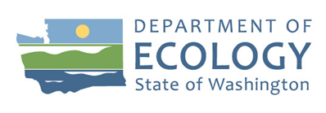
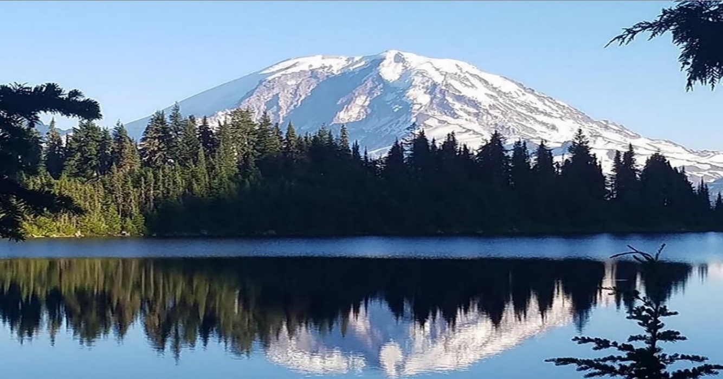

2017-2019

Public Participation Grant Program

Biennial Report
Solid Waste Management Program
Washington State Department of Ecology
Northwest Regional Office
Shoreline, Washington
December 2022, Publication 22-07-034

Publication Information
This document is available on the Department of Ecology’s website at: https://apps.ecology.wa.gov/publications/summarypages/2207034.html

Contact Information
Solid Waste Management Program
Northwest Regional Office
P.O. Box 330316
Shoreline, WA 98133-9716
Phone: 306-407-60000
Website: Washington State Department of Ecology

ADA Accessibility
Washington State Department of Ecology — www.ecology.wa.gov
- Headquarters, Olympia 360-407-6000
- Northwest Regional Office, Bellevue 425-649-7000
- Southwest Regional Office, Olympia 360-407-6300
- Central Regional Office, Union Gap 509-575-2490
- Eastern Regional Office, Spokane 509-329-3400
To request Americans with Disabilities Act accommodation, or printed materials in a format for the visually impaired, contact the Ecology ADA Coordinator at 360-407-6831 or ecyadacoordinator@ecy.wa.gov, or visit https://ecology.wa.gov/accessibility. People with impaired hearing may call Washington Relay Service at 711. People with speech disability may call TTY at 877-833-6341.

Department of Ecology’s Regional Offices

Map of Counties Served
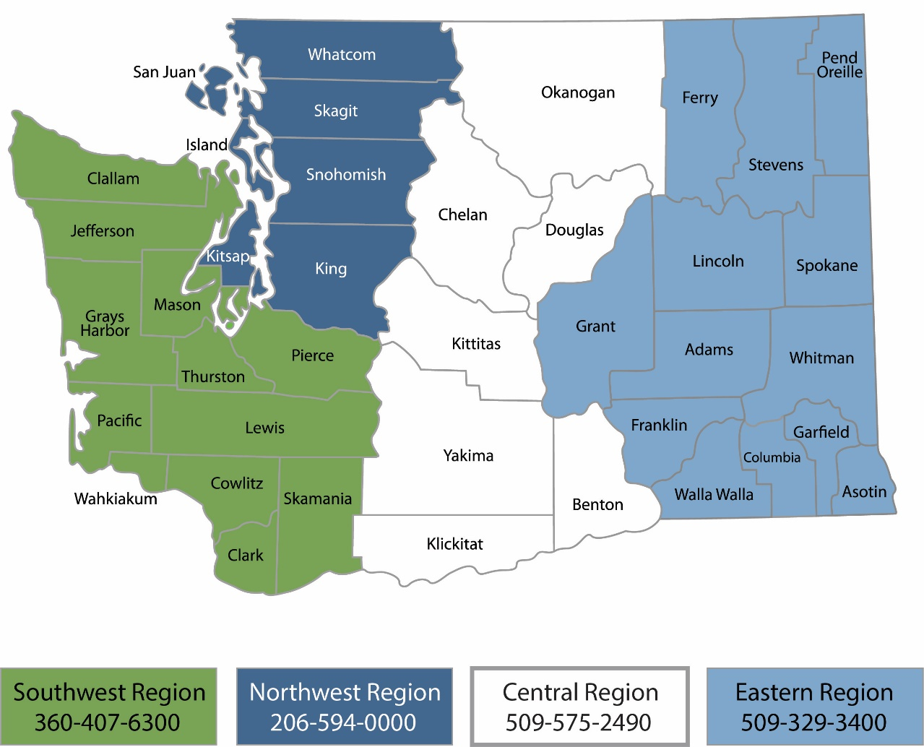
Region | Counties served | Mailing Address | Phone
Southwest | Clallam, Clark, Cowlitz, Grays Harbor, Jefferson, Mason, Lewis, Pacific, Pierce, Skamania, Thurston, Wahkiakum | PO Box 47775  Olympia, WA 98504 | 360-407-6300
Northwest | Island, King, Kitsap, San Juan, Skagit, Snohomish, Whatcom | PO Box 330316 Shoreline, WA 98133 | 206-594-0000
Central | Benton, Chelan, Douglas, Kittitas, Klickitat, Okanogan, Yakima | 1250 W Alder St  Union Gap, WA 98903 | 509-575-2490
Eastern | Adams, Asotin, Columbia, Ferry, Franklin, Garfield, Grant, Lincoln, Pend Oreille, Spokane, Stevens, Walla Walla, Whitman | 4601 N Monroe  Spokane, WA 99205 | 509-329-3400
Headquarters | Across Washington | PO Box 46700  Olympia, WA 98504 | 360-407-6000

2017-2019 Public Participation Grant Program
Biennial Report
Solid Waste Management Program
Washington State Department of Ecology
Northwest Regional Office
Shoreline, WA
December 2022 | Publication 22-07-034
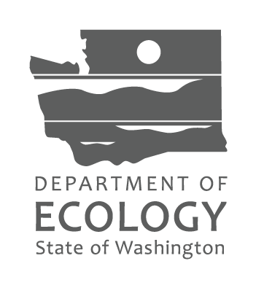

Table of Contents
List of Figures and Tables 6
Figures 6
Tables 6
Acknowledgements 7
Introduction 8
Application Process 8
Governance – WAC Guideline Changes 9
Total Applications by Rank 10
Funding Distribution 14
2017-2019 Project Outcomes 14
Contaminated Site Projects 14
Waste Management Projects 23

List of Figures and Tables

Figures
Figure 1 - Funding distribution by location of recipient. Please note: Some projects may not be visibly represented on this map due to service area overlap 14
Figure 2 - Environmental Justice Camp for Girls-Citizens for a Healthy Bay Facebook 15
Figure 3 Interactive map on Spokane Riverkeeper’s website. 19
Figure 4 - Columbia Springs repair event curtesy of Columbia Springs 24
Figure 5 - Methow Recycles Take It or Leave It facility. Ecology photo. 31

Tables
Table 1: Ecology Distribution List 8
Table 2: 2017-19 PPG Applications 10

Acknowledgements
The authors of this report thank the following people for their contribution to this study:
- Faith Wimberley
- Lynn Gooding
- Kelsey Dunn
- Blake Nelson
- Sarah Elledge

Introduction
The following report outlines the application process and performance of the 2017-2019 Public Participation Grant (PPG) program. The Public Participation Grants - 2017-2019 Application Evaluation and Selection Report outlined the application and evaluation process. The Department of Ecology (Ecology) is required to produce a report at the close of each biennium per WAC 173-321-070(6). This report is to include, at a minimum:
- The type and location of grant projects and the outcomes achieved.

Application Process
Program guidelines:
Ecology published the 2017-19 Public Participation Grant Program Guidelines on July 10, 2017. In addition to the program requirements, the guidelines included the updated program rule, chapter 173-321 WAC; the PPG application instructions; the application Screening Checklist and Evaluation Scorecard; and a copy of the General Terms and Conditions of all Ecology grants. These were all available on the PPG webpage.
Public notice:
Subscribers to a national moderate risk waste email distribution list also received the public notice. The following distribution lists administered by Ecology received the public notice via email.
Table 1: Ecology Distribution List
Name | Date | Subscribers
351-CRITERIA-FOR-MSWL-RULEMAKING | 7/20/17 | 214
BENEFICIAL-USE-DETERMINATIONS | 7/20/17 | 72
ECOLOGY-GREEN-PURCHASING | 7/25/17 | 118
ECY-PUBLIC-PARTICIPATION-GRANTS | 7/14/17, 7/18/17 | 308
ECY-SW-HANDLING-STANDARDS | 7/20/17 | 809
HHW-CESQG | 7/20/17 | 244
WA-STATE-WASTE-PLAN | 7/21/17 | 335
An abbreviated version (in English) of the program guidelines, A Quick Look, was attached to the emails. Versions of A Quick Look in English, Spanish, Vietnamese, Korean, and Chinese were also made available on the PPG webpage.
Ecology announced the funding opportunity on Ecology’s PPG webpage, Ecology’s Hanford Twitter and Facebook accounts, and Ecology’s Toxic Cleanup Program Site Register. It is unknown how many organizations and individuals received the notification secondhand through forwarded emails.

Application system:
The application was only available through the online system, Ecology’s Administration of Grants and Loans (EAGL). Ecology conducted a webinar training with systematic instructions on filling out the PPG application in EAGL. Ecology made the recording of the webinar available on the PPG webpage and sent it to the PPG Distribution List. The application was open from 8:00 a.m. July 18, 2017 through 5:00 p.m. August 11, 2017.
Applications received:
Ecology received a total of 41 completed applications. Two of the applications were determined to be ineligible based on the type of project. Thirty-nine eligible applications were scored and ranked by Ecology staff.
The total amount requested from all eligible applications was $3,918,230. The 2017-2019 budget for PPG is $2,272,000. If the total amount requested exceeds the PPG budget, the agency has the authority to limit organizations to one grant regardless of ranking (WAC 173-321-070(4)). Ecology chose to use this limitation to allow as many organizations as possible to receive funding.
Organizations that acted as “fiscal sponsors” for other organizations were not subject to the limitation. “Fiscal sponsors” administer the grant but do not implement the project.

Governance – WAC Guideline Changes
In April, 2017 the Washington State Department of Ecology (Ecology) as required under chapters 34.05 RCW and 19.85 RCW, proposed amendments to the Public Participation Grant rule (chapter 173-321 WAC; the “rule”).
The PPG rule establishes eligibility requirements and funding criteria for grants authorized by Chapter 70.105D RCW, the Model Toxics Control Act (MTCA). In 2016, Ecology obtained an independent audit of the Public Participation Grants program. Ecology enacted changes based on audit recommendations and on the agency’s experiences implementing the program. The recommended proposed rule amendments include the following:

Revising grant eligibility requirements
- Revises the wording in Chapter 173-321-010 from: “These grants shall be used to facilitate public participation in . . .” to “The purpose of these grants is to facilitate public participation in . . .” aligns the rule with its authorizing statute (Chapter 70.105D RCW).
- Change the previous requirement of “three or more unrelated persons” to “individuals” aligns the proposed rule with its authorizing statute (Chapter 70.105D.070 (7) RCW).
- Include tribal not-for-profit organizations as eligible for grants to incorporate the current practice of treating them as eligible into rule.

Modifying the grant application evaluation criteria
The amendments remove several proscriptive elements of the criteria and combines others. This is done to give more freedom to grant recipients to decide or alter specific criteria. We provide guidelines to applicants, which may contain more specific elements of the criteria we use to evaluate applications.

Evaluating eligible costs
- Add a definition of “lobbying”. Previously, guidance documents only defined this term broadly. Revising this definition, allows applicants to use grant funds to recover the costs of meeting with agency staff to discuss agency decisions using grant funds.
Increase the limit on purchase costs of equipment from $300 to $5,000 to reflect inflation since 1991 when Ecology implemented the $300 limit.

Creating an annual renewal process
Ecology has been awarding two-year grants for up to $120,000. The 2016 audit determined that we did not have the statutory authority to do so for more than one year at a time.
Chapter 70.105D.070 (7) RCW states no “grant may exceed sixty thousand dollars. Grants may be renewed annually”. This proposed change would allow Ecology to renew the grants annually for a maximum of $120,000 for two years without requiring grant recipients to submit a new application. This meets the requirement of the statute and continues the current practice of approving two year projects. The renewal will based on the grantees performance during the first year.

Total Applications by Rank
The following is the ranked list of all eligible applications along with a project description and the amount requested (the grants have not been finalized yet so the amount funded by vary slightly from the amount requested). Ecology eliminated the greyed out applications below due to limiting organizations to one grant.
Table 2: 2017-19 PPG Applications
Rank | Applicant | Request Amount | Project Title and Description (County)
1 | Latino Community Fund of WA (fiscal sponsor for Front and Centered) | 120,000 | The Mapping To Mobilizing Project The recipient will identify and map highly impacted communities near hazardous waste sites. The recipient will then train community leaders in engaging citizens in addressing environmental hazards. (Location: Yakima, Clark, Cowlitz)
2 | Columbia Riverkeeper | 120,000 | A Vision for Hanford The recipient will conduct outreach to Yakama Nation citizens and Washington residents to engage in cleanup decisions on the Hanford nuclear site. (Location: Yakima, Yakama Nation, Benton)
3 | Duwamish River Cleanup  Coalition | 120,000 | Duwamish River Cleanup Community Engagement Project The recipient will conduct community education/outreach to involve residents; tribal members; waterfront users; small businesses; and environmental, health, and justice advocates in efforts to clean, restore, and prevent recontamination of the Duwamish River Superfund/MTCA site. (Location: King)
*4 | Sustainable Connections | 100,000 | Toward Zero Waste: Food Redistribution Initiative The recipient will reduce food waste by redistributing unclaimed food from restaurants and events to individuals who use services from hot meal distribution organizations. (Location: Whatcom)
*5 | Zero Waste Washington | 120,000 | Repair Cafes for Waste Prevention in Tacoma The recipient will hold "repair cafés" and conduct waste prevention education. At "repair cafes", residents bring broken items ranging from small appliances to clothing to be repaired for free by community members. (Location: Pierce)
6 | Futurewise | 119,989 | Algona/Auburn Groundwater Plume Community Education and Participation The recipient will increase community education and participation related to groundwater plumes associated with the Boeing Fabrication Auburn site through outreach and activities for residents, students and parents, and businesses in Algona and Auburn. (Location: King)
7 | Mt. Baker Housing | 119,050 | Mt Baker Healthy Neighborhood Center The recipient will manage technical work groups and host public meetings on contaminated site cleanups and improvements to community waste reduction and recycling collection. (Location: King)
8 | Columbia Springs | 120,000 | Clark County Repair Café The recipient will hold free "repair cafes" throughout Clark County targeting low-income neighborhoods. (Location: Clark)
9 | Seattle Tilth (fiscal sponsor for South King Tool Library) | 104,530 | South King Tool Library The recipient will establish and promote usage of a tool lending library to reduce waste; facilitate tool sharing, repair and reuse; increase the use of "green" tools; and educate the public about waste management in south King and north Pierce counties. (Location: King, Pierce)
10 | The Lands Council | 57,000 | Improving Public Health, Water Quality, & Stewardship of the Spokane River The recipient will raise awareness of health risks in low-income/non-English speaking communities from PCB contamination in the Spokane River. (Location: Spokane)
11 | Latino Community Fund of WA | 110,000 | Bilingual Waste Management Education and Outreach for Latino Community The recipient will provide bilingual education, outreach, and avenues for Latino community members in Central Washington to engage in sustainable waste management practices. (Location: Yakima)
12 | Thurston County Food Bank | 85,649 | Waste Less Food The recipient will increase the amount of perishable edible food diverted from disposal to hunger relief organizations in Thurston County through videos, newsletters, websites, and social media as well as direct outreach to local schools. (Location: Thurston)
*13 | Sustainable Connections | 100,275 | Toward Zero Waste—Whatcom County as a Gold Standard
14 | Center for Justice | 100,366 | Spokane River Toxics Education and Reduction Project The recipient will provide public education and outreach on toxic contamination, ongoing cleanup efforts, and actions that community members can take at home to help address the problem. (Location: Spokane, Lincoln)
*15 | Zero Waste Washington | 120,000 | Plastics and Litter Reduction Project: Assessment, Messaging and Education
16 | Seattle Tilth | 120,000 | Community Education Around Food Waste Prevention The recipient will offer a series of classes, workshops, and community meals with messaging on food waste prevention. The recipient will also conduct a volunteer training program with an emphasis on waste reduction to build community capacity around food waste prevention. (Location: King)
17 | ReUse Works | 83,566 | Whatcom County Textile Waste Project The recipient will provide accessible solutions for the community to engage in textile waste reduction via responsible use, reuse, and disposal. (Location: Whatcom)
18 | Capitol Hill Housing  Foundation | 104,470 | CHH Affordable Housing: Healthy Homes Education Program Initiative The recipient will develop and implement guidelines to reduce waste and toxins produced in the construction and operation of their properties. The recipient will also implement a resident education program in their properties to support tenants in reducing toxins in their homes. (Location: King)
19 | Methow Recycles | 70,693 | Laying the Foundation for Zero Waste in the Methow Valley The recipient will promote waste reduction through "repair cafes", education and outreach at public events, multi-lingual education, and volunteer training. (Location: Okanogan, Colville Confederated Tribes)
20 | Heart of America NW  Research Center | 120,000 | Involving Statewide Public & Highly Impacted Populations in Hanford Cleanup The recipient will involve the public statewide in Hanford cleanup decisions with focused work enabling Native American, Latinos, and other highly exposed populations to comment on cleanup decisions. (Location: Benton, Yakama Nation, Spokane, King, Clark)
21 | Citizens for a Healthy Bay | 120,000 | Commencement Bay and Puyallup River Watershed Pollution Prevention Project The recipient will engage citizens in hazardous site cleanups through public forums and workshops, bay patrols, and habitat restoration and storm drain marking events. (Location: Pierce)
22 | Lake Roosevelt Forum | 45,400 | Community Engagement in EPA Upper Columbia River RI/FS The recipient will improve understanding and encourage public involvement in the cleanup of Lake Roosevelt through conferences, tours, public meetings, outreach materials, a website, and activities with students. (Location: Stevens, Lincoln, Ferry)
23 | Hanford Challenge | 120,000 | Support and Inspire Public Participation in Hanford Cleanup The recipient will encourage public involvement in the Hanford cleanup with plain-language information provided in public meetings, presentations, and events. (Location: King, Benton, Kittitas, Walla Walla, Yakima)
24 | Pacific NW Pollution  Prevention Resource Center | 94,131 | Reducing Contaminants to Puget Sound from Boatyard and Do-It-Yourself Refinishing The recipient will provide education to boat owners to reduce contamination from do-it-yourself boat restoration/refinishing. (Location: King, Jefferson)
Funding cutoff 2,274,844
PPG Budget 2,272,000
Unfunded applicants:
25 | NW Center for Alternatives to Pesticides | 69,628 | Advancing Pesticide Alternatives to Protect Washington's Communities (Location: Pacific)
26 | Pacific Shellfish Institute | 39,950 | Scoop it! Bag It! Recycle It! Pilot to remove dog waste from landfills. (Location: Thurston)
27 | Advocates for a Cleaner Tacoma | 100,000 | Tacoma Environmental Mapping (Location: Pierce)
28 | YMCA of Greater Seattle | 72,412 | Youth in Action: Stewardship, Education & Leadership (Location: King)
29 | Olympic Environmental Council | 57,325 | Rayonier Pulp Mill-Port Angeles Harbor Hazardous Waste Cleanups (Location: Clallam)
30 | Environmental Coalition of  South Seattle | 120,000 | Green-Duwamish Business & Industry Information and Resources (Location: King)
31 | Pacific NW Pollution  Prevention Resource Center | 98,172 | Toxics Reduction in the Auto Body Industry in Washington State (Location: King)
32 | Sustainable Obtainable  Solutions | 120,000 | Intercepting the Biomass Waste Stream: An Online Resource (Location: Clallam, Adams, Ferry, Grays Harbor, Okanogan, Stevens, Yakima)
33 | Discover Your Northwest (fiscal sponsor for Coastsavers) | 81,449 | Community Stewardship of Washington's Seashore Conservation Area (Location: Grays Harbor, Pacific)
34 | Georgetown Crime Prevention & Community Council | 120,000 | Georgetown PSC Cleanup Community Analysis & Outreach (Location: King)
35 | Jenna Durkee | 100,000 | Yakima Area Wide Lead and Arsenic Soil Contamination Education (Location: Yakima)
36 | Institute for Neurotoxicity and Neurological Disorders (fiscal sponsor for CHE-WA) | 104,175 | Promoting Collaboration for Health and the Environment (Location: King)
37 | Environmental Coalition of  South Seattle | 120,000 | Waste Management: Mobile Food Vendors (Location: King)
38 | Institute for Neurotoxicity and Neurological Disorders | 119,000 | Keeping Shooting Range Users Healthy and Safe (Location: Statewide)
39 | Institute for Neurotoxicity and  Neurological Disorders | 101,000 | Particles on the Wall: Amplifying the Voices of Hanford (Location: Statewide)
Total Eligible Funds Requested: 3,918,230
Grants not funded per WAC 173-321-070 (4):
13 | Sustainable Connections | 100,275 | Toward Zero Waste—Whatcom County as a Gold Standard (Location: Whatcom)
15 | Zero Waste Washington | 120,000 | Plastics and Litter Reduction Project: Assessment, Messaging and Education (Location: King, Greater Puget Sound area)
Total Unfunded per WAC 173-321-070(4) 220,275
* Applicant submitted two applications that scored above the funding threshold. Ecology chose not to fund the applicants’ second project to allow as many organizations as possible to receive funding.

Funding Distribution
The awarded projects were distribute spanned across the State of Washington.
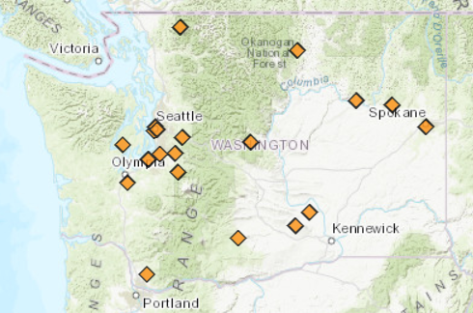
Figure 1 - Funding distribution by location of recipient. Please note: Some projects may not be visibly represented on this map due to service area overlap

2017-2019 Project Outcomes

Contaminated Site Projects

Citizens for a Healthy Bay
Project Title
Commencement Bay and Puyallup River Watershed Pollution Prevention Project
Agreement Number
W2RPPG-1719-CiHeBa-00004
Total Cost
$242,382
Ecology Share
$120,000
Total Disbursed
$120,000
Project Description
Citizens for a Healthy Bay empowered community members to become actively engaged on contaminated site cleanups and other industrial activity in the Tacoma tide flats.
Overall Goal
The overall goal was to employ all of the resources of the organization, including the expertise and experience of staff, board members and professional and community volunteers from throughout Pierce County, to implement the most effective programs to protect the Puyallup River watershed and Commencement Bay from contamination.
Outcomes
- Lead 190 Bay Patrols of Commencement Bay.
- Held 4 stakeholder meetings to discuss the Occidental Chemical cleanup.
- Hosted 8 events with over 200 community volunteers to plant trees, beach cleanups, and marking over 400 storm drains.
- Provided 20 classroom lessons on wetland ecology.
- Led 19 field trips for students to learn about water quality.
- Led two sessions of the Environmental Justice Camp for Girls.
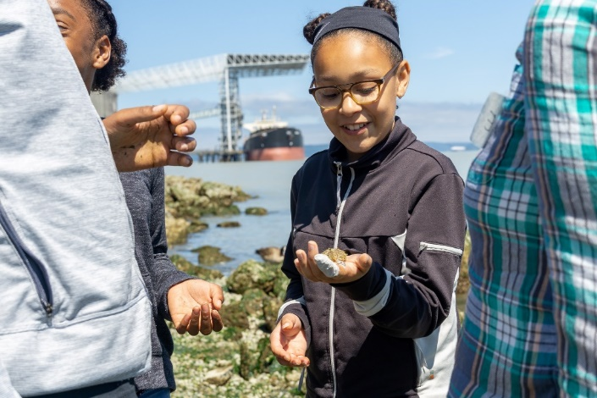
Figure 2 - Environmental Justice Camp for Girls-Citizens for a Healthy Bay Facebook

Hanford Challenge
Project Title
Support and Inspire Public Participation in Hanford Cleanup

Agreement Number
W2RPPG-1719-HanCha-00010
Total Cost
$120,000
Ecology Share
$120,000
Total Disbursed
$120,000
Project Description
The project supported broad and diverse participation in the Hanford cleanup by
- Disseminating information about cleanup decisions and policy in materials, presentations, public meetings, and events.
- Providing mentorship community support for young people interested in Hanford cleanup.
- Facilitating conversations about Hanford cleanup with a broad representation of interests
- Nurturing an online community via email, social media, websites, and blog posts.
Overall Goal
The goal was to support and inspire the public to be involved with Hanford cleanup through regular public events, public education, collaborations, and social media outreach.
Outcomes
- Holding their 8th annual Forum to Inspire Conversations for Hanford stakeholder groups.
- Participated in the Hanford Advisory Board.
- Conducted 14 events to increase awareness on the Hanford cleanup process.

Heart of America Northwest Research Center
Project Title
Involving the Public and Highly Impacted Communities in the Hanford Cleanup
Agreement Number
W2RPPG-1719-HeANRC-00042
Total Cost
$150,000
Ecology Share
$120,000
Total Disbursed
$120,000

Project Description
Heart of America Northwest Research Center involved the public statewide in Hanford cleanup decisions with focused work enabling Native American, Latino, and other highly impacted populations to comment on Hanford cleanup decisions. They also participated in the Hanford Advisory Board, held workshops across Washington State, and provided educational and training opportunities for students.
Overall Goal
The project goal was to enable the public to understand and effectively participate in cleanup decisions for Hanford’s 50 mile Columbia River Corridor and Central Plateau.
Outcomes
- Involving over 1,100 participants in workshops and other events around the state.
- Held the first ever Yakama Nation Hanford forum with 95 participants.
- Made over 2,000 phone calls to inform the public about meetings or comment periods.

Duwamish River Cleanup Coalition
Project Title
Duwamish River Cleanup Community Engagement Project
Agreement Number
W2RPPG-1719-DuRiCC-00011
Total Cost
$130,000
Ecology Share
$120,000
Total Disbursed
$119,882
Project Description
DRCC conducted community education and engagement programs to involve residents; fishers; tribal members; waterfront workers; recreational users; small businesses; and environmental, health and justice advocates in efforts to clean, restore and prevent recontamination of the Duwamish River Superfund/MTCA site.
Overall Goal
The goal of the project was to educate, engage, and empower affected stakeholders and the Duwamish Valley and greater Seattle community in efforts to clean up the Duwamish River Superfund/MTCA site. Advise and assist EPA and ECOLOGY in the cleanup and restoration of the site and related pollution prevention and health protection programs (e.g., fishing advisories and “institutional controls”). And, represent residents of the Duwamish Valley on the Round Table.
Outcomes
- Facilitated four Duwamish Alive! events engaging over 2,000 volunteers.
- Hosted 10 site tours for over 500 affected residents and stakeholders.
- Led more than 15 community presentations for over 275 people.

Latino Community Fund of Washington (for Front and Centered)
Project Title
The Mapping to Mobilizing Project
Agreement Number
W2RPPG-1719-LatCFW-00060
Total Cost
$120,000
Ecology Share
$120,000
Total Disbursed
$117,967
Project Description
Through a fiscal sponsorship with the Latino Community Fund of Washington, Front and Centered identified and mapped highly-impacted communities in proximity to hazardous waste sites and provided information and tools to help local leaders organize their communities to address environmental hazards.
Overall Goal
The overall goal of the Mapping to Mobilizing Project was to build knowledge, skills and capacity within highly impacted communities to participate effectively in addressing the environmental hazards they face.
Outcomes
- Front and Center was instrumental in the development of the Environmental Health Disparities index for the Washington Tracking Network maintained by the Department of Health. The Environmental Health Disparities index is now used in the Public Participation Grant application evaluation process to measure the priority for outreach to highly-impacted communities.

Center for Justice (for Spokane Riverkeeper)
Project Title
Spokane River Toxics Education and Reduction
Agreement Number
W2RPPG-1719-CenfJu-00064
Total Cost
$100,362

Ecology Share
$100,362
Total Disbursed
$100,362
Project Description
Through a fiscal sponsorship with the Center for Justice, Spokane Riverkeeper provided public education and outreach on toxic contamination issues, ongoing cleanup efforts, and actions that community members can take at home.
Overall Goal
The specific goals of this project were to educate the public as to the challenges facing the Spokane River; current regulatory and collaborative efforts to address this challenge; and actions individuals can take to support River cleanup.
Outcomes
- Contacted over 5,000 community members at river cleanup events, tour of industrial facilities, and classroom visits.
- Developed an interactive map for their website showing cleanups along the Spokane River.
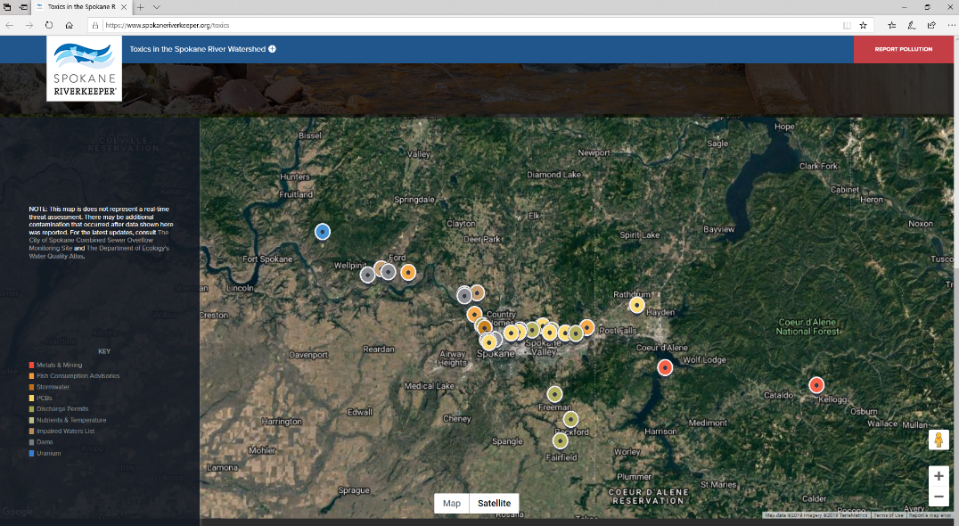
Figure 3 Interactive map on Spokane Riverkeeper’s website.

The Lands Council
Project Title
Improving Public Health, Water Quality, and Stewardship of the Spokane River
Agreement Number
W2RPPG-1719-TLC-00018

Total Cost
$90,000
Ecology Share
$90,000
Total Disbursed
$89,954
Project Description
This project raised awareness of health risks of toxic contamination in economically disadvantaged communities and among underprivileged youth by involving them in education, clean-up, and restoration activities; and fostering acceptance of green infrastructure as an environmentally-sound and cost-effective way to manage PCB-contaminated stormwater runoff on-site.
Overall Goal
This project’s goal was to protect public health, improve water quality, and enhance stewardship of the Spokane River, aquifer, and watershed.
Outcomes
- Conducted outreach at 9 beaches.
- Completed 120 surveys to measure public knowledge of pollutants.
- Distributed 130 health advisories to river fishers.
- Collected 3.4 tons of garbage and recyclables along the river with approximately 800 volunteers.
- Mailed 1,837 informational brochures on contaminated stormwater management.

Lake Roosevelt Forum
Project Title
Community Engagement in EPA Upper Columbia River RI/FS
Agreement Number
W2RPPG-1719-LaRoFo-00013
Total Cost
$136,250
Ecology Share
$45,400
Total Disbursed
$45,377
Project Description
The Community Engagement in EPA Upper Columbia River RI/FS project improved public understanding and encouraged public involvement in the Remedial Investigation and Feasibility Study (RI/FS) of Lake Roosevelt. Outreach included a conference, tour, public meetings, creation and distribution of a Public Guide, print and electronic newsletters, website, and activities with upper elementary classes.
Overall Goal
The overall goal of the Community Engagement in EPA Upper Columbia River RI/FS project was to improve public understanding and encourage public involvement in the Remedial Investigation and Feasibility Study (RI/FS) of Lake Roosevelt.
Outcomes
- Hosted the 2018 Lake Roosevelt Forum Conference with 294 attendees.
- Conducted a bus tour of Lake Roosevelt cleanup points of interest for 56 people including community members, elected officials, and natural resource managers.
- Held two Student Discovery Days for 259 students.
- Held the Lake Roosevelt Water Festival for 440 students and teachers.

Mt. Baker Housing
Project Title
Mt Baker Healthy Neighborhood Center
Agreement Number
W2RPPG-1719-MtBaHo-00066
Total Cost
$145,000
Ecology Share
$119,050
Total Disbursed
$42,068
Project Description
The project was to promote and facilitate community engagement in sustainability practices in the Mt. Baker Village neighborhood center.
Overall Goal
The goals included:
- Improve the ability of the professional community to engage low-income, non-English speaking residents in sustainable development.
- Educate community members about healthy home and community practices and civic engagement.
- Engage high school students in contaminated site investigation and public communication;
- Facilitate stakeholder groups to address complex multifaceted community environmental challenges of waste management and vehicle use reduction.
- Conduct public outreach around these issues and neighborhood redevelopment.

Outcomes
- Reduced community outreach.
- The recipient had a key staff member leave and they were unable to finish the project.

Futurewise
Project Title
Algona/Auburn Groundwater Plume Community Education and Participation

Agreement Number
W2RPPG-1719-Future-00006
Total Cost
$125,627
Ecology Share
$119,990
Total Disbursed
$31,809
Project Description
Through this project, Futurewise facilitated community education and participation related to groundwater plumes associated with the Boeing Fabrication Auburn site, through targeted outreach and activities for audiences of immediate residents, greater area residents, students and their parents, and businesses in the cities of Algona and Auburn.
Overall Goal
The overall goal was to engage audiences (residents, businesses, students) in Algona and Auburn in Ecology’s cleanup process so that they understand the investigation and cleanup, are comfortable giving public comment and input, and are assisted with understanding the technical details.
Outcomes
- Ecology’s Remedial Investigation/Feasibility Study that was a required precursor to implementing this project was not completed during the grant period so Futurewise was unable to complete part of their agreement.
- Hosted the 2018 Algona Days Health Fair, which brought health vendors to the public.
- Engaged 125 youth in green certification training through the Toxics and Teens pilot.

Waste Management Projects

Zero Waste Washington
Project Title
Repair cafés for waste prevention in Tacoma
Agreement Number
W2RPPG-1719-ZeWaWa-00049
Total Cost
$120,000
Ecology Share
$120,000
Total Disbursed
$120,000
Project Description
Zero Waste Washington, in partnership with the Tacoma Tool Library, created and held repair cafés and conducted waste prevention education.
Overall Goal
The goal of this project was to educate the public and create repair café events for waste prevention so that fewer resources are consumed and fewer GHGs are emitted in the extraction, production, transportation, and disposal of consumer products.
Outcomes
- Conducted outreach at 14 community events.
- Conducted 12 Fix-It Fairs that served 654 community members.
- Repaired 326 items preventing 1984 pounds of landfilled waste.

Columbia Springs
Project Title
Clark County Repair Cafe
Agreement Number
W2RPPG-1719-ColSpr-00001
Total Cost
$120,000
Ecology Share
$120,000
Total Disbursed
$119,915
Project Description
Columbia Springs held a series of Repair Cafés - free community events where skilled 'fixers' volunteer to lend their skills to residents who bring in their broken items for repair.
Overall Goal
The overall goal was to reduce the number of household items sent to the landfill and to inspire a “repair” mindset in the community.
Outcomes
- Held 15 repair event serving over 1,622 clients.
- Repaired over 1,600 items by utilizing 1,885 volunteer hours.
- Held 3 formal trainings for volunteers increasing their volunteer base from 20 to 150.
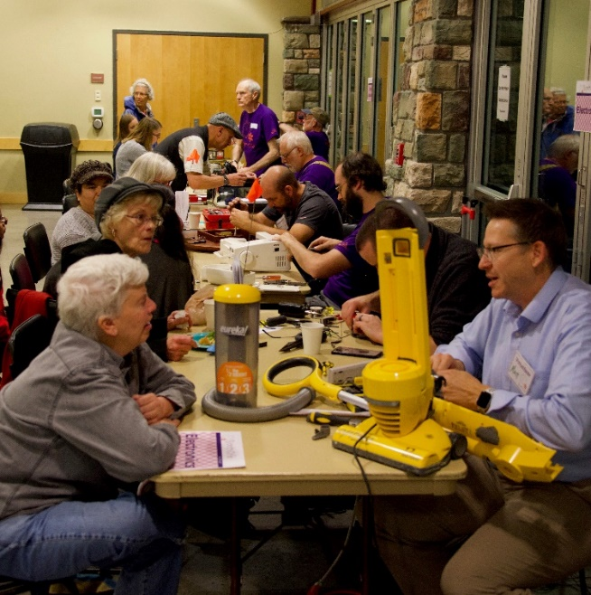
Figure 4 - Columbia Springs repair event curtesy of Columbia Springs

Seattle Tilth
Project Title
Community Education Around Food Waste Prevention
Agreement Number
W2RPPG-1719-SeaTil-00003
Total Cost
$283,780
Ecology Share
$120,000
Total Disbursed
$111,036
Project Description
Seattle Tilth provided education and outreach through two mechanisms: a series of classes, workshops and community meals with messaging on wasted food prevention; and a stewardship-driven volunteer training program with an emphasis on waste reduction.
Overall Goal
The overall goal was to increase understanding of the wasted food issue among low-income communities and to decrease the amount of consumer food that goes to waste in King County.
Outcomes
- Hosted 12 community kitchen meals emphasizing food waste prevention with 800 participants.
- Delivered 19 classes and workshops on food waste prevention with 634 participants.
- Trained 55 volunteers on food waste prevention who volunteered 150 hours at more than 50 events reaching 1,000 individuals.

Latino Community Fund of Washington
Project Title
Bilingual Waste Management Education and Outreach for Latino Community
Agreement Number
W2RPPG-1719-LatCFW-00048
Total Cost
$110,000
Ecology Share
$110,000
Total Disbursed
$110,000
Project Description
The Latino Community Fund of Washington provided bilingual education and outreach to Latino community members in Central Washington in waste management practices. The project emphasized access to information and resources about waste management practices for primarily Spanish-speaking community members through education workshops in Spanish, and translating materials into Spanish, as needed.
Overall Goal
The overall goal was to increase awareness, information, and culturally relevant resources among non-English and English speaking Latino residents in Yakima County about sustainability and environment, and their relevance to our communities. This lead to an increase in community readiness to learn and implement waste management practices.
Outcomes
- Conducted a survey of 700 Latino community members to assess their knowledge of waste management issues.
- Held a series of 10 workshops for community members to connect them with local waste management resources.

Seattle Tilth (fiscal sponsor for South King Tool Library)
Project Title
South King Tool Library
Agreement Number
W2RPPG-1719-SeaTil-00015
Total Cost
$154,148
Ecology Share
$104,530
Total Disbursed
$104,530

Project Description
Through a fiscal sponsorship from Seattle Tilth, the South King Tool Library established and promoted usage of a tool lending library to reduce waste and educate the public about waste management and environmental stewardship in South King and North Pierce Counties.
Overall Goal
The overall goal of this project was to open a public tool lending library that serves South King and North Pierce Counties, providing outreach and education and maximizing the life of tools, property and household goods through community sharing and tool recycling.
Outcomes
- Reached 8,000 community members at events and meetings.
- Registered 161 households with the South King Tool Library.
- Repaired 962 items from 246 households at Repair Cafes.
- Repaired 90% of items brought into the Repair Cafes.

Sustainable Connections
Project Title
Toward Zero Waste—Food Redistribution Initiative in Whatcom County

Agreement Number
W2RPPG-1719-SusCon-00022

Total Cost
$100,000
Ecology Share
$100,000
Total Disbursed
$100,000
Project Description
Toward Zero Waste—Food Redistribution Initiative reduced the amount of food going to the landfill from restaurants and events by redistributing unclaimed food to those in need of hot meals.
Overall Goal
The overall goal of the Toward Zero Waste-Food Redistribution Initiative was to reduce restaurant and event food from the waste stream, provide hot meals to those in need, and educate businesses and the public on reducing wasted food.
Outcomes
- Recovered a total of 52,692 pounds of food.
- 49,341 pounds for human consumption for a total of 39,061 meals
- 2,267 pounds not served due to food safety.
- 3,351 pound redistributed for animal consumption.

Pacific Northwest Pollution Prevention Resource Center
Project Title
Reducing Contaminants to Puget Sound from Boatyard and Do-It-Yourselfers
Agreement Number
W2RPPG-1719-PNPPRC-00052
Total Cost
$94,130
Ecology Share
$94,130
Total Disbursed
$94,017

Project Description
The project provided commercial boatyard operators and boat owners education and technical assistance on restoration and refinishing best management practices, and toxics alternatives assessments.

Overall Goal
The overall goal was to reduce toxics pollution, including PCBs, phthalates, heavy metals and other paint biocides, to Puget Sound.
Outcomes
- One boatyard in a lower-income Washington community added dangerous waste collection for paint dust.
- One boatyard extended zinc anode recycling to all boaters (not just previous customers.
- One marine retailer started offering zinc and anode recycling services.
- Facebook post relating to anodes with 165,021 impressions (people who saw the anodes ad) and 277 clicks to watch the video and learn more.
YouTube video “Antifouling Paint Removal Best Practices” with 2,821 views at the time of this publication.

Thurston County Food Bank
Project Title
Waste Less Food Program
Agreement Number
W2RPPG-1719-ThCoFB-00065
Total Cost
$85,650
Ecology Share
$85,650
Total Disbursed
$85,563
Project Description
This project is a collaborative effort to divert perishable, edible food from the waste stream to hunger relief agencies and ultimately low and moderate-income households. The project leverages the relationship the RECIPIENT has with North Thurston Public Schools and the community support of local hunger relief agencies to create greater community awareness and to build a sustainable food recovery system and model.
Overall Goal
The goal of this project is to divert more food waste from disposal. The project will engage businesses to encourage donations and changes in current practices, it will engage students and their families creating a better understanding of the issues and leading to behavior changes at home, and it will reach the public to increase the number of volunteers supporting food diversion and behavior change. Strategies will include an innovative educational art project, school garden activities, targeted media, and public presentations.

Outcomes
- One thousand one hundred students from North Thurston Public School District created stencil art used in public art demonstration.
- Sixty-five school district administration, teachers, students and community members experienced artwork unveiling and viewing.
- Two thousand, four hundred and eighty six students participated in school garden field trips and volunteering.
- Grocery food rescue grew from 12 to 19 locations.
- Restaurant food rescue grew from 26 to 47 locations.
- School food rescue grew from six to nine locations.
- Five donor businesses’ gave 2,544,491 pounds of food, an increase from 1,794,952 pounds in the prior 2 years.

Reuse Works
Project Title
Whatcom County Textile Waste Project
Agreement Number
W2RPPG-1719-ReUWor-00031
Total Cost
$83,566
Ecology Share
$83,566
Total Disbursed
$78,755

Project Description
ReUse Works conducted community education and engagement to increase awareness around textile waste issues and promote community-based solutions for textile waste reduction via responsible use, reuse, and disposal.
Overall Goal
The overall goal of the project was to raise awareness about the issue of textile waste and provide community resources including information on where to donate unwanted textiles, how to responsibly purchase long-lasting clothing, and how to repair and repurpose textiles.
Outcomes
- Kept more than 279,500 pounds of textile waste from disposal.

Capitol Hill Housing Foundation
Project Title
CHH Affordable Housing - Healthy Homes Education Program Initiative
Agreement Number
W2RPPG-1719-CaHiHF-00029
Total Cost
$104,470
Ecology Share
$104,470
Total Disbursed
$77,690

Project Description
Through this project, Capital Hill Housing Foundation developed and implemented the Healthy Homes Education Program guidelines to reduce waste and toxics produced in the construction and operation of their properties. They also implemented a resident education program to support tenants in reducing toxics in their homes.
Overall Goal
The overall goal of the Healthy Homes Education Program was to create a lasting impact on construction and operations, resident knowledge, behavior, and health, and the broader environment.
Outcomes
- Developed the Healthy Homes Design Guidelines for new properties.
- Developed the Healthy Homes Resident Handbook for tenants.
- Provided outreach to 101 households in six languages, English, Spanish, Amharic, Vietnamese, Somali, and Tigrinya.
- Distributed 200 green cleaning kits at Healthy Homes outreach events.

Methow Recycles
Project Title
Laying the Foundation for Zero Waste in the Methow Valley
Agreement Number
W2RPPG-1719-MetRec-00016
Total Cost
$70,690
Ecology Share
$70,690

Total Disbursed
$70,689
Project Description
Methow Recycles introduced new waste reduction and reuse offerings, increased access to and simplified recycling and home composting, particularly for those with limited English proficiency. This project reduced the amount of landfilled waste by sharing expertise with others in Okanogan County.
Overall Goal
The overall goal was to help the community reduce waste by creating more opportunities for reuse, repairing, sharing, and exchanging materials.
Outcomes
- Served 194 community members at 10 repair events.
- Fixed 219 pf 274 broken items, a 80% success rate.
- Repurposed 1,369 items at the Take It or Leave It facility.
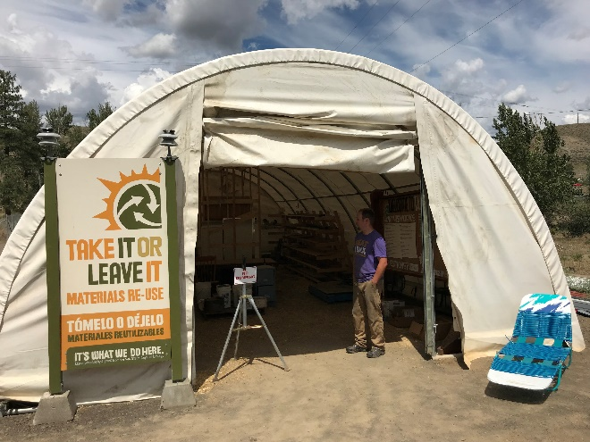
Figure 5 - Methow Recycles Take It or Leave It facility. Ecology photo.

www.ecology.wa.gov/contact

