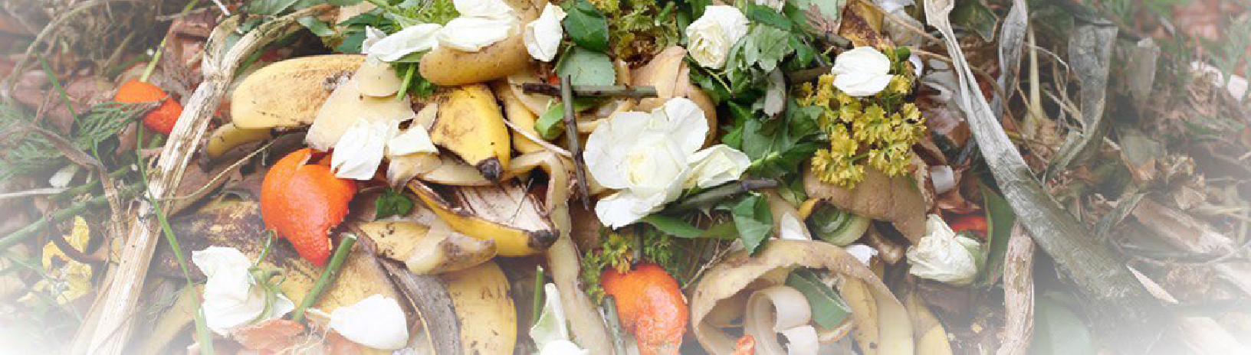
2022 Organics Management Law
Focus on Organics Management Law - Overview

Purpose and Goals
The Organics Management Law of 2022 was passed as ESSHB1799 and supports the Washington Legislature’s 2021 Climate Commitment Act (CCA), a sweeping law that sets carbon emission limits and requires the state to reduce its carbon output 45% by 2030, 70% by 2040, and 95% by 2050.
To help meet the state’s CCA emission targets, implementation of the new law will reduce methane by diverting organic materials from municipal landfills towards beneficial uses. Instead of landfilling organic materials, we can reduce methane emissions by creating compost and crop nutrients, feed livestock, and getting food to people at risk of hunger.
The Organics Management Law affects everyone in the state. Successful implementation of the law will require coordination across public and private industry stakeholders. This law’s comprehensive approach adds or amends more than 20 state laws and establishes goals that require action by state and local agencies, residents, and businesses alike.
- By 2025, 20% of previously disposed edible food must be recovered for consumption, relative to 2015 levels.
- By 2030, 75% of previously disposed organic materials must be diverted from landfills, relative to 2015 levels.
A general overview follows, addressing some of the new requirements established by the Organics Management (OM) law.

Compost procurement
The new OM law includes provisions to strengthen markets for compost in the state. These include requiring cities and counties which provide curbside collection of organic materials or have a population greater than 25,000 to adopt compost procurement ordinances by Jan. 1, 2023. In addition, these jurisdictions will need to report to Ecology the amount of organic material diverted from the landfill and the quantities and sources of compost they purchase every two years, starting in December 2024. For more details, a Compost Procurement Focus Sheet is available at Organics Management - Compost Procurement Ordinances and Reporting.

Business collection requirements
Per RCW 70A.205.545, the OM law phases in organics collection requirements for certain businesses, beginning July 1, 2024. The requirements for businesses to arrange for organics collection depend on the volume of organic material they generate weekly and on the availability of collection and processing services for organic materials, including food waste. Working with interested parties, by July 1, 2023, Ecology will post a list of cities and counties where organic material and food waste collection is available to businesses. For more details, a Business Collection Focus Sheet is available at Organics Management - Business Collection Requirements

Center for Sustainable Food Management
The Food Center will serve as a hub for food waste reduction efforts statewide and will help implement the Use Food Well Washington Plan. The Food Center may perform at least 13 different functions identified in the OM law to meet statewide goals to reduce food waste and increase recovery of edible food. Established at Ecology, the Food Center will be operational by Jan. 1, 2024.

Organics management facility sites
To meet the state’s diversion goals, we will need more capacity to process organic materials. Several areas of the OM law address the lack of capacity. Beginning July 2024, cities and counties updating, developing, or amending their solid waste management plans and comprehensive plans must identify siting areas for organic management facilities.

Labeling for compostable products
The OM law introduces new product color requirements for identifying plastic bags, films, and food serviceware as compostable, amending chapter 70A.455 RCW. The 2022 change requires Ecology to establish a complaint forum and begin enforcing the labeling and color requirements to prevent “greenwashing” by July 1, 2024. These amendments may help reduce contamination at compost facilities that accept compostable serviceware and bags by reducing customer confusion about what products are and are not compostable.

Collection requirements
Beginning Jan. 1, 2027, cities and counties that meet specific population and organic collection service requirements must provide organic collection services to all residential and non-residential customers at least every other week, or at least 26 weeks per year. Ecology will work with interested parties to identify barriers to organic material collection. The barriers will be the basis for issuing renewable five-year waivers to jurisdictions from the requirements set in RCW 70A.205.540.
Rulemaking
Organics Management Team
organics@ecy.wa.gov
(509) 960-1290
To request ADA accommodation including materials in a format for the visually impaired, call Ecology at 360-407-6381
or visit https://ecology.wa.gov/accessibility. People with impaired hearing may call Washington Relay Service at 711. People with speech disability may call TTY at 877- 833-6341

Four different areas in the OM law give Ecology rulemaking authority. All rulemaking is optional and may be used to: 1. Implement requirements of the law associated with diversion goals, 2. Implement the Food Center, 3. Enforce the product degradability requirements, or 4. Develop waivers for jurisdictions that cannot provide organic material collection service.

Food donations and farms
The OM law also amended the Washington Good Samaritan Act (RCW 69.80.031) to make it easier to donate food. These amendments will increase the amount of food recovered to feed people in need. The amendments allow for food donations after the passage of a date on a date label, if the date label is not safety related. The amendments also allow a qualified donor to donate food directly to a consumer. Both amendments will increase the amount of edible food going to feed people
Compost facilities and farms also benefit from the OM law through a program to reimburse farmers that purchase compost and compost spreading equipment. This program will improve soil health and will strengthen markets for compost as production of compost increases across the state.

Scope and collaboration
Successful implementation of the law will require coordination across public and private industry stakeholders. Working together, Washingtonians will reduce methane emissions from landfills and:
- increase edible food rescue
- increase organic material collection
- increase capacity to process organic materials
- increase markets for processed organic materials

Related information
- Subscribe to our Organics Management email. Set up your account, choose Solid Waste Management, then Organics Management.

https://apps.ecology.wa.gov/publications/SummaryPages/2207026.html
https://apps.ecology.wa.gov/publications/SummaryPages/2207025.html
https://public.govdelivery.com/accounts/WAECY/subscriber/new?topic_id=WAECY_146

