Why did we measure litter?
Litter impacts road safety, our environment, and the wellbeing of our communities. Washington State Departments of Transportation and Ecology (Ecology) together spend more than $12 million annually on litter cleanup efforts. Unfortunately, they can only pick up a small portion of the waste that accumulates on the ground. If we know the types and amounts of litter present, we can help develop strategies to prevent litter and littering behavior, and measure progress over time. The focus sheet and final report will be available at https://ecology.wa.gov/Waste-Toxics/Solid-waste-litter/Litter/Litter-studies.

How did we measure litter?
In this study, we collected litter from 182 randomly selected sites across Washington state. Sites were categorized into five main groups: 1) roadways, 2) interchanges (on- and off- ramps), 3) rest areas, 4) parks, and 5) recreational areas. We sorted the litter by type (for example, glass bottles, cigarette butts, cardboard boxes, plastic film), counted the number of pieces of litter, and weighed the samples of litter. Using this data from 182 sites in Washington, we estimated the yearly average pounds and pieces of waste.

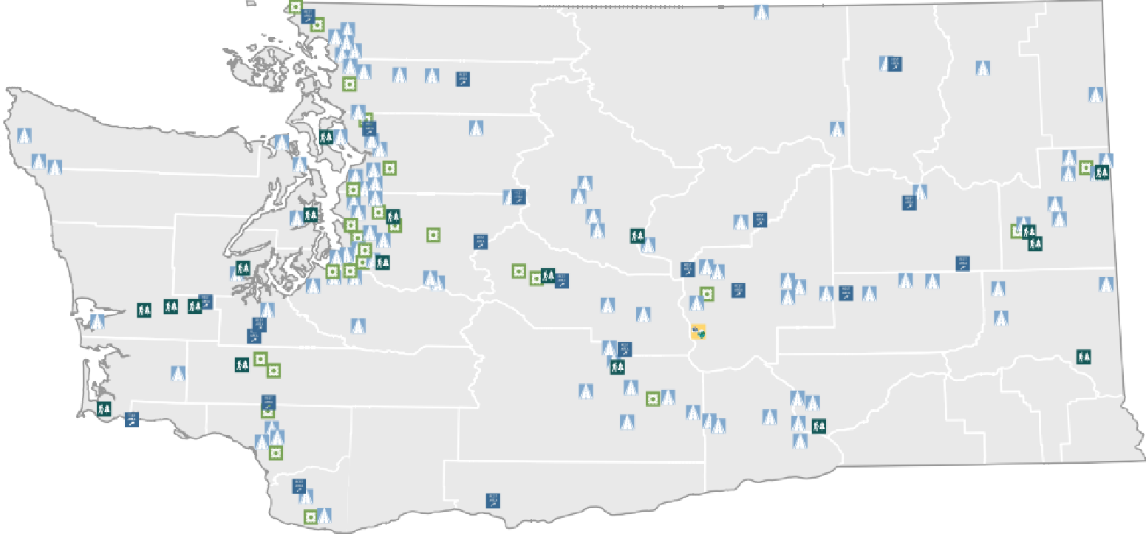

182

sites
sampled

104
Roadways
(Urban and Rural)

26
Interchanges
(On- and Off- Ramps)

26
Rest Areas
along Highways

18
State and
County Parks

8
DNR and
DFW
Lands

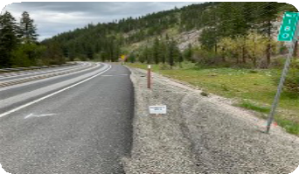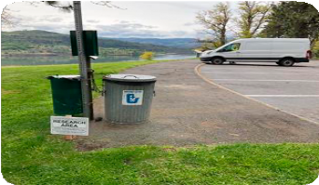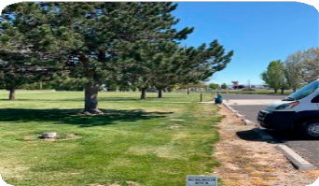Roadways and interchanges, rest areas, parks, and state-owned lands were included in the study.

Washington State 2022
LITTER STUDY
FOCUS SHEET

Publication 23-07-009 - Litter Study Fact Sheet

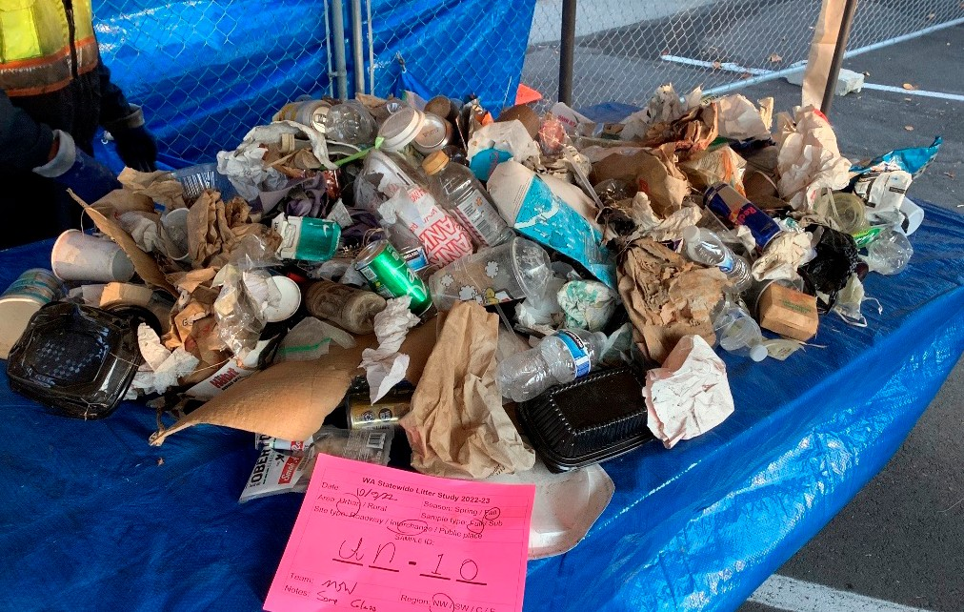Where did we measure litter?
We measured litter along roadways, interchanges, and at high-use areas of rest areas, parks, and certain public lands. Many of these sites were used in the 1999 and 2004 litter studies, and we used the Washington Environmental Health Disparities Map to ensure representation across diverse communities.

Roadways include all 81,021 miles of public roads from interstate highways to small neighborhood streets, including land areas within
15 feet of the side of the road—the approximate throwing distance 15’
from a moving vehicle. This amounts to nearly 6.4 billion square feet
or 147,311 acres of litterable roadway area.
Interchanges are on-ramps and off-ramps for highways. Washington has 590 interchanges, and we measured litter in land areas falling within 15 feet of each interchange. This adds up to more than 470 million square feet, or 10,794 acres of litterable interchange area.
We measured litter in the high-use parts of rest areas located along highways. Examples include parking lots, picnic tables, and permanent restrooms or other buildings.
Washington’s highway rest areas have 230 acres of high-use areas.
We measured litter in the high-use areas of state and county parks. High-use areas are places that typically have visitors every day during summer. For parks, these areas
include parking areas, campsites, trails, ball fields, picnic and play areas, and permanent restrooms or other buildings. Washington’s state and county parks have 83,888 acres of high-use areas.
We measured litter on high-use areas of land owned by the Washington State Department of Natural Resources (DNR) and Department of Fish and Wildlife (DFW). Examples of these areas include parking areas, campsites, trails, and permanent restrooms or other buildings. DFW and DNR lands have 2,112 acres of high-use areas.

How much is littered each year in Washington? Where is it happening?
Statewide, 37.8 million pounds are littered per year, which is 4.8 pounds per person per year. These pounds are made up of 7.1 billion items per year, which is about 5 pounds (or 897 pieces) of litter per person per year.

In total, roadways get the most pounds per year (nearly 18.5 million pounds) and high-use areas of state and county parks get the most pieces per year (3.4 billion pieces). But the picture changes when we consider how large each area is. When we look at litter per acre,
interchanges get the most pounds and pieces per year,
37.8 million
pounds of litter each year
18.5
million
That’s nearly 5 pounds (or 897 pieces) of litter per person every year
7.7
million
10.6
million
.04
million
1
million

and roadways get the fewest.
Roadways Interchanges
Rest Areas
Parks DNR + DFW
lands

Site type | Total pounds  per year | Total pieces  per year | Pounds per acre  per year | Pieces per acre  per year
Roadways | 18,496,200 | 1,858,555,848 | 126 | 12,617
Interchanges | 7,695,600 | 1,630,078,616 | 713 | 151,017
Highway Rest Areas | 38,000 | 17,860,849 | 165 | 77,656
State & County Parks | 10,618,000 | 3,404,009,782 | 127 | 40,578
DNR & DFW Lands 946,000 |  | 141,717,935 | 448 | 67,101

TOTAL LITTER 37,793,800 7,052,223,030 155 28,863

Which types of roadways get the most and least litter per mile per year?

Interstates get the most litter (1,579 pounds and 73,580 pieces per mile per year). They get almost as much litter as all other
roadways combined and are also the most difficult and dangerous roadways

1 mile, 1 year
Litter accumulation along roadways
(pounds and pieces per mile per year)
All Roadways Urban
Rural Interstates Arterial Collector
Local

22,939
228

48,903
402

to clean. Local roads get the least (143 pounds and 18,051 pieces per
151
11,559

mile per year).
1,579
73,580

Urban roads get two to four times more litter than rural roads. Urban

499

61,751

roads get 402 pounds and 48,903 pieces while rural roads get 151 pounds and 11,559 pieces of litter per mile per year.
238

143
16,015

18,051

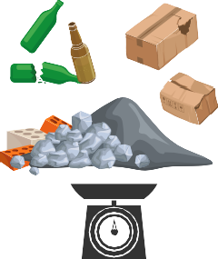
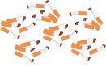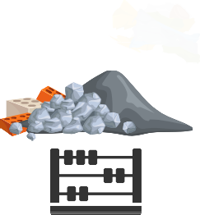What items are littered the most?
The most littered items vary by site type and by whether we’re measuring pounds or pieces. The top three littered items across site types by pounds are glass beer bottles, construction and demolition debris, and cardboard boxes. The top three littered items across site types by pieces are cigarette butts, construction and demolition debris, and food wrappers and snack bags.

 | Site type | Top three litter items by pounds | Top three litter items by pieces
 | Roadways | - Glass beer bottles  - Construction and demolition debris  - Miscellaneous materials  (Example: small and hard to identify items) | - Cigarette butts  - Other plastic  (Example: packing insulation, zip ties, and other hard to identify plastic litter pieces)  - Other paper  (Example: sticky notes, books, envelopes)
 | Interchanges | - Miscellaneous materials  - Other plastic  - Cigarette butts | - Cigarette butts  - Other plastic  - Other foam  (Example: egg cartons and packing peanuts)
 | Rest Areas | - Miscellaneous materials  - Cigarette butts  - Other metal  (Example: hard to identify metal objects) | - Cigarette butts  - Other metal  - Other paper
 | State and County Parks | - Non-food plastic packaging  - Auto rubber products  (Example: tire shards or treads)  - Vehicle debris | - Cigarette butts  - Other paper  - Other plastic
 | DNR & DFW  Lands | - Glass beer bottles  - Miscellaneous materials  - Construction and demolition debris | - Cigarette butts  - Bottle caps and tabs  - Construction and demolition debris

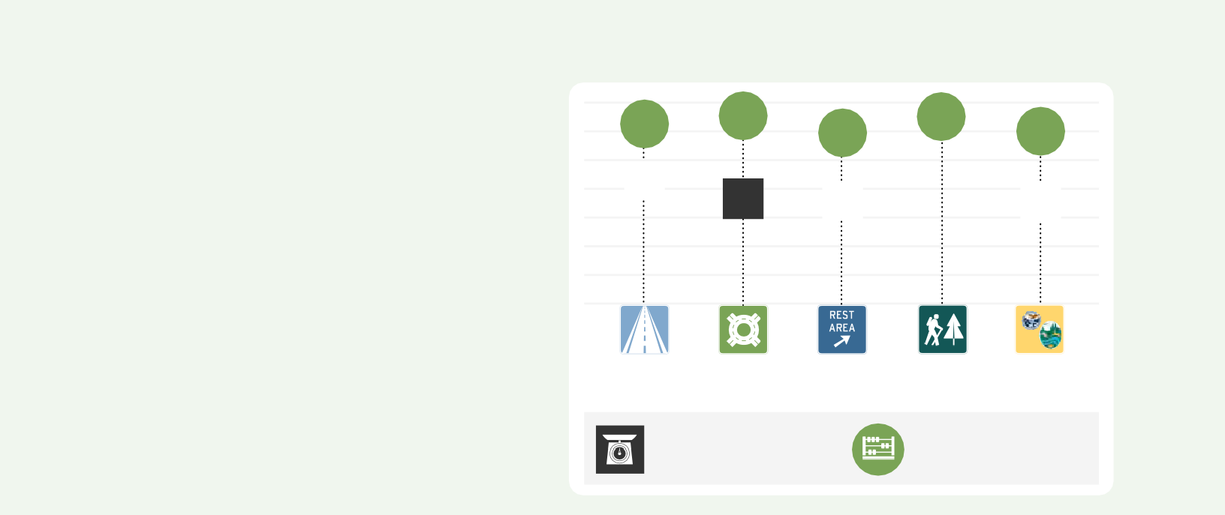How much of Washington’s litter is taxable?
Percentage of littered pounds that are taxable
Percentage of littered pieces that are taxable
Washington’s Litter Tax was established in

1971 to help meet the costs of litter cleanup statewide. The tax rate and 13 covered items have not changed in over 50 years. Current revenues do not cover what it costs to clean up the amounts or types of litter we find today.

Today, 69-76 percent of littered pieces are covered by the litter tax, while only 42- 62 percent of littered pounds are covered. The difference is because many of the
73% 76%

44%
52%

69%
43%
76%

62%

69%

42%

items covered by the tax—such as cigarette butts, food wrappers, and snack bags—are lightweight, while many of the heavier littered items are not covered. See a full list of items at dor.wa.gov/taxes-rates/other-taxes/litter-tax.
Roadways Interchanges
Rest Areas
Parks DNR + DFW lands

